Hussam Hashem

James Clark

Dr. Yugyung Lee

CS 551

April 12, 2013

**Fourth Increment Report**

# Project Video

<http://www.youtube.com/watch?v=tpyO93txp8c>

# Testing

More inconclusive tests and failures. We continue to run tests where we know the results already pass. We’re trying to do this as a demonstration of NUnit. However, where the application succeeds, our tests fails. There’s a disconnect between testing a web service through its WSDL and running methods through NUnit. For example, pass a value of 1 and the word “letter” at this location <http://localhost:8412/Assets/WebServices/CanvasService.asmx?op=GetRelativeHeight> and see a result of 1.2941176466020761. Running this in the test fails, so what’s the bug?

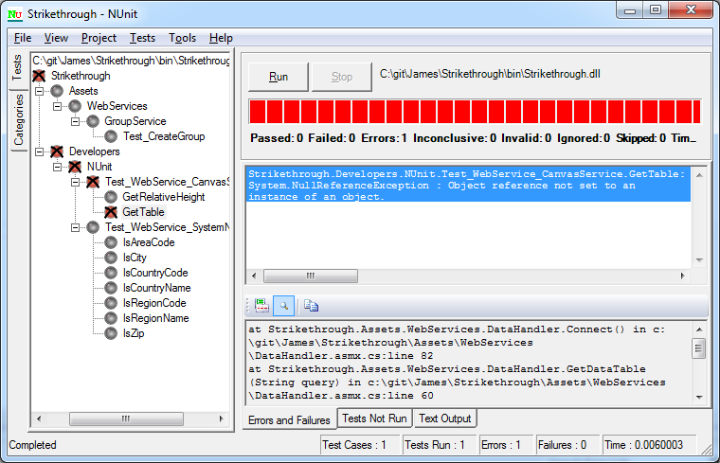

# Mobile UI

Standard login page

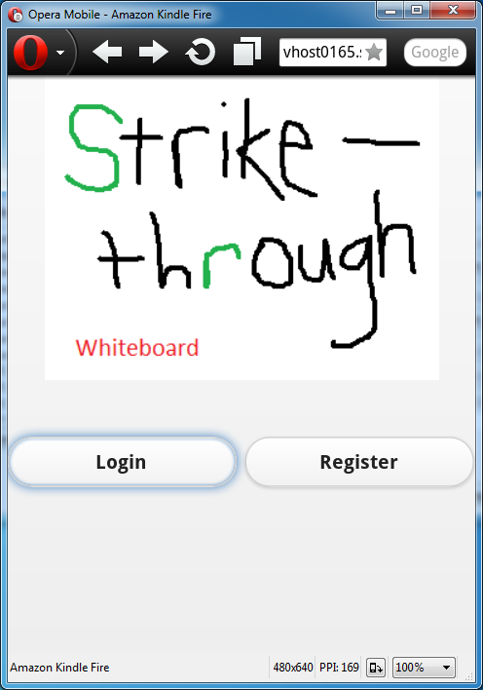

Collapsible menu system

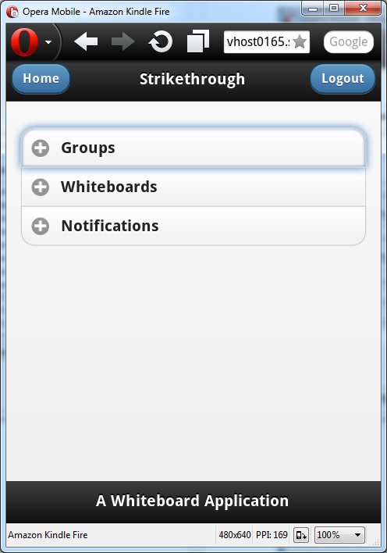

Features HTML5 canvas with toolbars

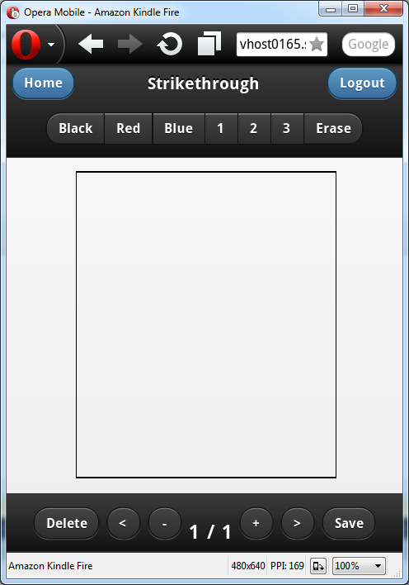

Draw and save

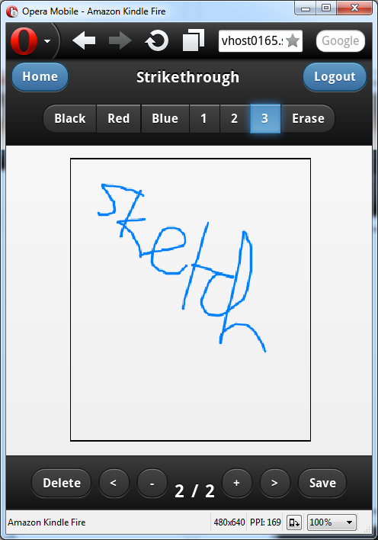

Save dialog

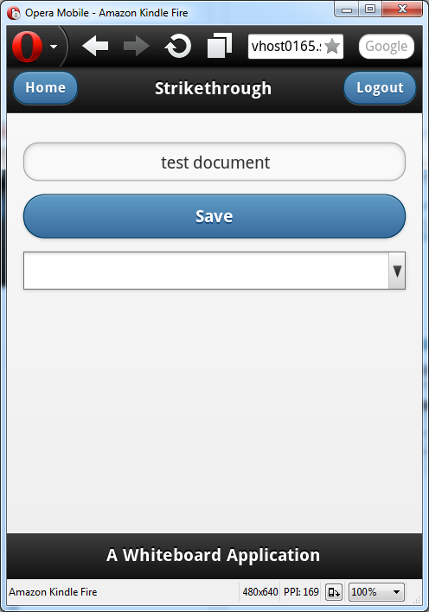

Load document

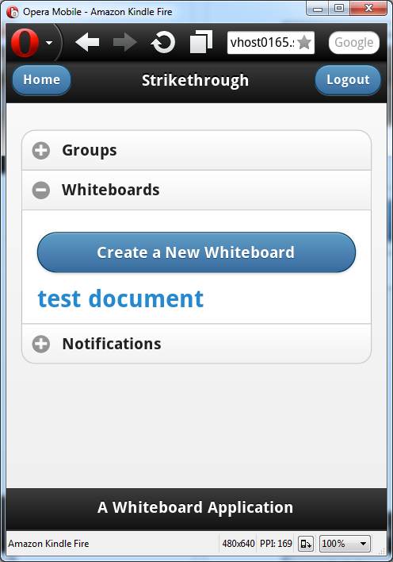

Draw on top of previous document and save again

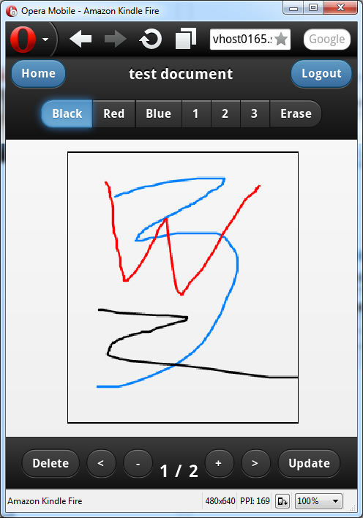

Open after changes

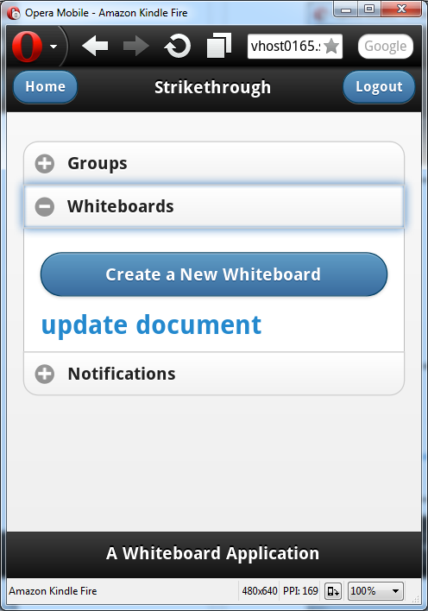

Changes applied

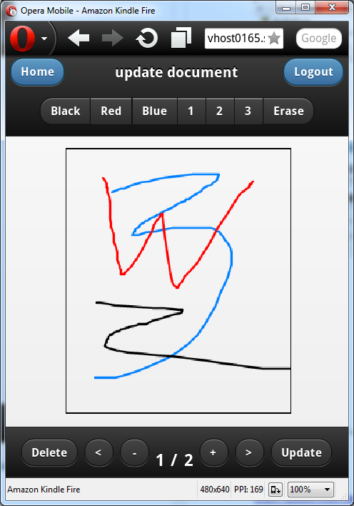

# Project Management

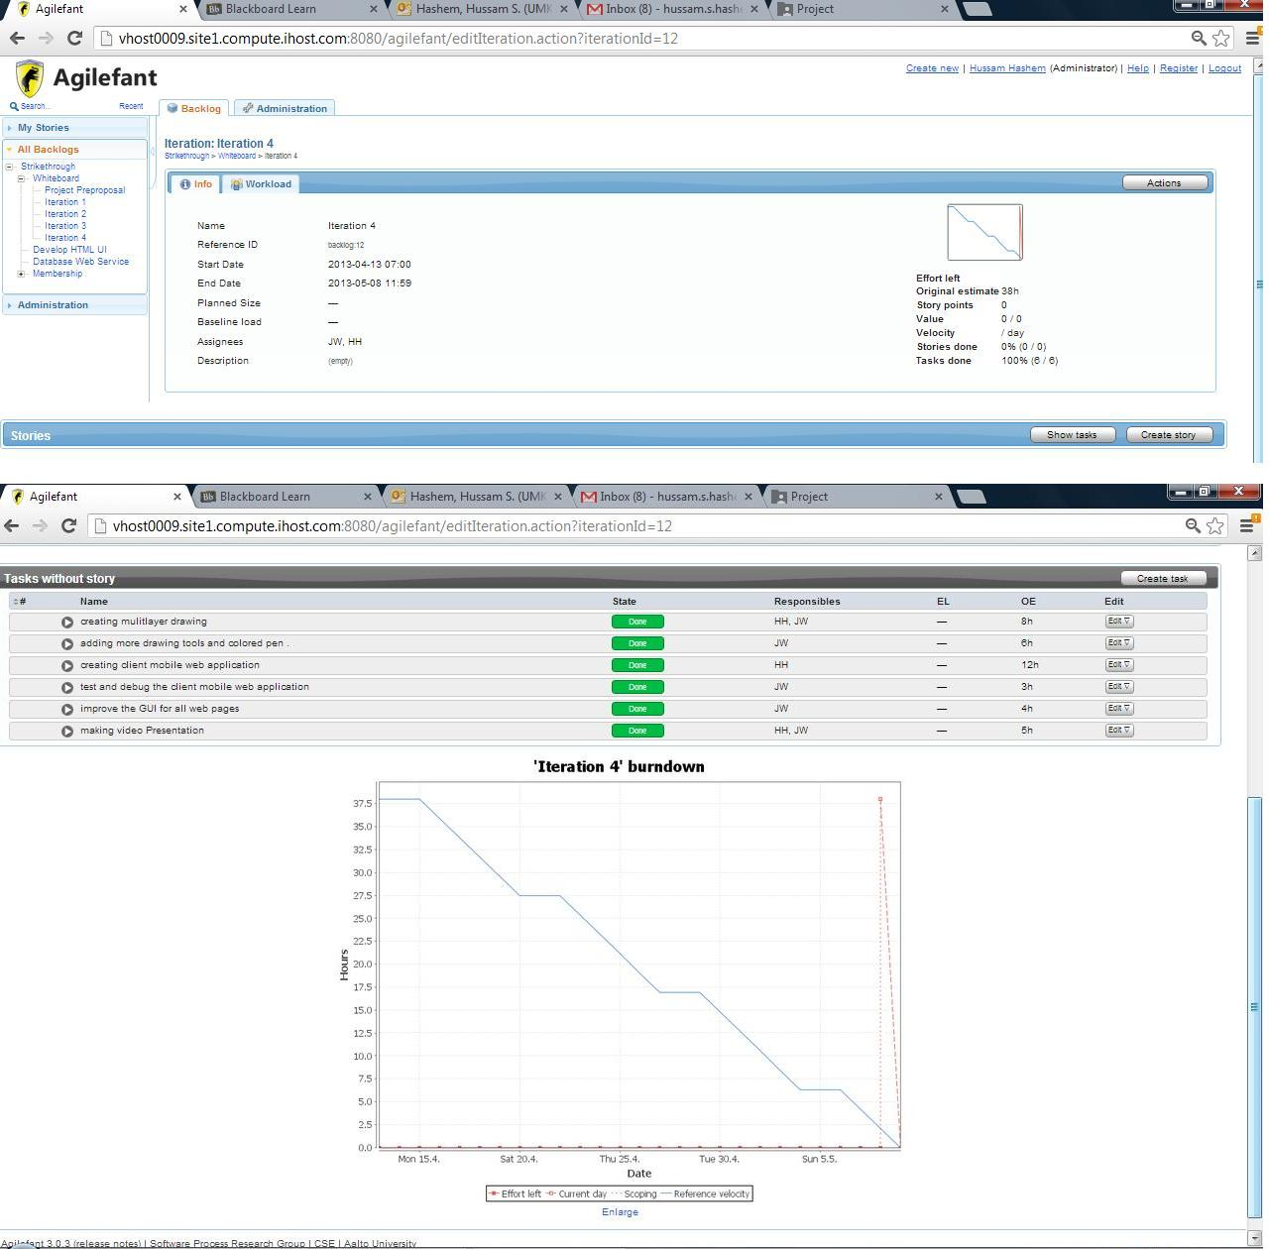

# GitHub

<https://github.com/JamesWClark/Strikethrough/tree/possible-final>

# Web Services

The new web service for this iteration is called GroupService, and is located at <http://localhost:8412/Assets/WebServices/CanvasService.asmx?WSDL>

# WSDL

<http://localhost:8412/Assets/WebServices/CanvasService.asmx?WSDL>

This XML file does not appear to have any style information associated with it. The document tree is shown below.

<wsdl:definitions xmlns:tm="http://microsoft.com/wsdl/mime/textMatching/" xmlns:soapenc="http://schemas.xmlsoap.org/soap/encoding/" xmlns:mime="http://schemas.xmlsoap.org/wsdl/mime/" xmlns:tns="vhost0165.site1.compute.ihost.com"xmlns:soap="http://schemas.xmlsoap.org/wsdl/soap/" xmlns:s="http://www.w3.org/2001/XMLSchema" xmlns:soap12="http://schemas.xmlsoap.org/wsdl/soap12/" xmlns:http="http://schemas.xmlsoap.org/wsdl/http/"xmlns:wsdl="http://schemas.xmlsoap.org/wsdl/" targetNamespace="vhost0165.site1.compute.ihost.com">

<wsdl:types>

<s:schema elementFormDefault="qualified" targetNamespace="vhost0165.site1.compute.ihost.com">

<s:element name="GetDimensions">

<s:complexType>

<s:sequence>

<s:element minOccurs="1" maxOccurs="1" name="x" type="s:int"/>

<s:element minOccurs="1" maxOccurs="1" name="y" type="s:int"/>

</s:sequence>

</s:complexType>

</s:element>

<s:element name="GetDimensionsResponse">

<s:complexType>

<s:sequence>

<s:element minOccurs="0" maxOccurs="1" name="GetDimensionsResult" type="tns:Pair"/>

</s:sequence>

</s:complexType>

</s:element>

<s:complexType name="Pair">

<s:sequence>

<s:element minOccurs="0" maxOccurs="1" name="First"/>

<s:element minOccurs="0" maxOccurs="1" name="Second"/>

</s:sequence>

</s:complexType>

<s:element name="GetTable">

<s:complexType>

<s:sequence>

<s:element minOccurs="0" maxOccurs="1" name="userId" type="s:string"/>

<s:element minOccurs="0" maxOccurs="1" name="tableId" type="s:string"/>

</s:sequence>

</s:complexType>

</s:element>

<s:element name="GetTableResponse">

<s:complexType>

<s:sequence>

<s:element minOccurs="0" maxOccurs="1" name="GetTableResult">

<s:complexType>

<s:sequence>

<s:any minOccurs="0" maxOccurs="unbounded" namespace="http://www.w3.org/2001/XMLSchema" processContents="lax"/>

<s:any minOccurs="1" namespace="urn:schemas-microsoft-com:xml-diffgram-v1" processContents="lax"/>

</s:sequence>

</s:complexType>

</s:element>

</s:sequence>

</s:complexType>

</s:element>

<s:element name="GetRelativeWidth">

<s:complexType>

<s:sequence>

<s:element minOccurs="1" maxOccurs="1" name="pixelHeight" type="s:int"/>

<s:element minOccurs="0" maxOccurs="1" name="paperType" type="s:string"/>

</s:sequence>

</s:complexType>

</s:element>

<s:element name="GetRelativeWidthResponse">

<s:complexType>

<s:sequence>

<s:element minOccurs="1" maxOccurs="1" name="GetRelativeWidthResult" type="s:double"/>

</s:sequence>

</s:complexType>

</s:element>

<s:element name="GetRelativeHeight">

<s:complexType>

<s:sequence>

<s:element minOccurs="1" maxOccurs="1" name="pixelWidth" type="s:int"/>

<s:element minOccurs="0" maxOccurs="1" name="paperType" type="s:string"/>

</s:sequence>

</s:complexType>

</s:element>

<s:element name="GetRelativeHeightResponse">

<s:complexType>

<s:sequence>

<s:element minOccurs="1" maxOccurs="1" name="GetRelativeHeightResult" type="s:double"/>

</s:sequence>

</s:complexType>

</s:element>

<s:element name="JsonifyDocument">

<s:complexType>

<s:sequence>

<s:element minOccurs="0" maxOccurs="1" name="table">

<s:complexType>

<s:sequence>

<s:any minOccurs="0" maxOccurs="unbounded" namespace="http://www.w3.org/2001/XMLSchema" processContents="lax"/>

<s:any minOccurs="1" namespace="urn:schemas-microsoft-com:xml-diffgram-v1" processContents="lax"/>

</s:sequence>

</s:complexType>

</s:element>

</s:sequence>

</s:complexType>

</s:element>

<s:element name="JsonifyDocumentResponse">

<s:complexType>

<s:sequence>

<s:element minOccurs="0" maxOccurs="1" name="JsonifyDocumentResult" type="s:string"/>

</s:sequence>

</s:complexType>

</s:element>

</s:schema>

</wsdl:types>

<wsdl:message name="GetDimensionsSoapIn">

<wsdl:part name="parameters" element="tns:GetDimensions"/>

</wsdl:message>

<wsdl:message name="GetDimensionsSoapOut">

<wsdl:part name="parameters" element="tns:GetDimensionsResponse"/>

</wsdl:message>

<wsdl:message name="GetTableSoapIn">

<wsdl:part name="parameters" element="tns:GetTable"/>

</wsdl:message>

<wsdl:message name="GetTableSoapOut">

<wsdl:part name="parameters" element="tns:GetTableResponse"/>

</wsdl:message>

<wsdl:message name="GetRelativeWidthSoapIn">

<wsdl:part name="parameters" element="tns:GetRelativeWidth"/>

</wsdl:message>

<wsdl:message name="GetRelativeWidthSoapOut">

<wsdl:part name="parameters" element="tns:GetRelativeWidthResponse"/>

</wsdl:message>

<wsdl:message name="GetRelativeHeightSoapIn">

<wsdl:part name="parameters" element="tns:GetRelativeHeight"/>

</wsdl:message>

<wsdl:message name="GetRelativeHeightSoapOut">

<wsdl:part name="parameters" element="tns:GetRelativeHeightResponse"/>

</wsdl:message>

<wsdl:message name="JsonifyDocumentSoapIn">

<wsdl:part name="parameters" element="tns:JsonifyDocument"/>

</wsdl:message>

<wsdl:message name="JsonifyDocumentSoapOut">

<wsdl:part name="parameters" element="tns:JsonifyDocumentResponse"/>

</wsdl:message>

<wsdl:portType name="CanvasServiceSoap">

<wsdl:operation name="GetDimensions">

<wsdl:input message="tns:GetDimensionsSoapIn"/>

<wsdl:output message="tns:GetDimensionsSoapOut"/>

</wsdl:operation>

<wsdl:operation name="GetTable">

<wsdl:input message="tns:GetTableSoapIn"/>

<wsdl:output message="tns:GetTableSoapOut"/>

</wsdl:operation>

<wsdl:operation name="GetRelativeWidth">

<wsdl:input message="tns:GetRelativeWidthSoapIn"/>

<wsdl:output message="tns:GetRelativeWidthSoapOut"/>

</wsdl:operation>

<wsdl:operation name="GetRelativeHeight">

<wsdl:input message="tns:GetRelativeHeightSoapIn"/>

<wsdl:output message="tns:GetRelativeHeightSoapOut"/>

</wsdl:operation>

<wsdl:operation name="JsonifyDocument">

<wsdl:input message="tns:JsonifyDocumentSoapIn"/>

<wsdl:output message="tns:JsonifyDocumentSoapOut"/>

</wsdl:operation>

</wsdl:portType>

<wsdl:binding name="CanvasServiceSoap" type="tns:CanvasServiceSoap">

<soap:binding transport="http://schemas.xmlsoap.org/soap/http"/>

<wsdl:operation name="GetDimensions">

<soap:operation soapAction="vhost0165.site1.compute.ihost.com/GetDimensions" style="document"/>

<wsdl:input>

<soap:body use="literal"/>

</wsdl:input>

<wsdl:output>

<soap:body use="literal"/>

</wsdl:output>

</wsdl:operation>

<wsdl:operation name="GetTable">

<soap:operation soapAction="vhost0165.site1.compute.ihost.com/GetTable" style="document"/>

<wsdl:input>

<soap:body use="literal"/>

</wsdl:input>

<wsdl:output>

<soap:body use="literal"/>

</wsdl:output>

</wsdl:operation>

<wsdl:operation name="GetRelativeWidth">

<soap:operation soapAction="vhost0165.site1.compute.ihost.com/GetRelativeWidth" style="document"/>

<wsdl:input>

<soap:body use="literal"/>

</wsdl:input>

<wsdl:output>

<soap:body use="literal"/>

</wsdl:output>

</wsdl:operation>

<wsdl:operation name="GetRelativeHeight">

<soap:operation soapAction="vhost0165.site1.compute.ihost.com/GetRelativeHeight" style="document"/>

<wsdl:input>

<soap:body use="literal"/>

</wsdl:input>

<wsdl:output>

<soap:body use="literal"/>

</wsdl:output>

</wsdl:operation>

<wsdl:operation name="JsonifyDocument">

<soap:operation soapAction="vhost0165.site1.compute.ihost.com/JsonifyDocument" style="document"/>

<wsdl:input>

<soap:body use="literal"/>

</wsdl:input>

<wsdl:output>

<soap:body use="literal"/>

</wsdl:output>

</wsdl:operation>

</wsdl:binding>

<wsdl:binding name="CanvasServiceSoap12" type="tns:CanvasServiceSoap">

<soap12:binding transport="http://schemas.xmlsoap.org/soap/http"/>

<wsdl:operation name="GetDimensions">

<soap12:operation soapAction="vhost0165.site1.compute.ihost.com/GetDimensions" style="document"/>

<wsdl:input>

<soap12:body use="literal"/>

</wsdl:input>

<wsdl:output>

<soap12:body use="literal"/>

</wsdl:output>

</wsdl:operation>

<wsdl:operation name="GetTable">

<soap12:operation soapAction="vhost0165.site1.compute.ihost.com/GetTable" style="document"/>

<wsdl:input>

<soap12:body use="literal"/>

</wsdl:input>

<wsdl:output>

<soap12:body use="literal"/>

</wsdl:output>

</wsdl:operation>

<wsdl:operation name="GetRelativeWidth">

<soap12:operation soapAction="vhost0165.site1.compute.ihost.com/GetRelativeWidth" style="document"/>

<wsdl:input>

<soap12:body use="literal"/>

</wsdl:input>

<wsdl:output>

<soap12:body use="literal"/>

</wsdl:output>

</wsdl:operation>

<wsdl:operation name="GetRelativeHeight">

<soap12:operation soapAction="vhost0165.site1.compute.ihost.com/GetRelativeHeight" style="document"/>

<wsdl:input>

<soap12:body use="literal"/>

</wsdl:input>

<wsdl:output>

<soap12:body use="literal"/>

</wsdl:output>

</wsdl:operation>

<wsdl:operation name="JsonifyDocument">

<soap12:operation soapAction="vhost0165.site1.compute.ihost.com/JsonifyDocument" style="document"/>

<wsdl:input>

<soap12:body use="literal"/>

</wsdl:input>

<wsdl:output>

<soap12:body use="literal"/>

</wsdl:output>

</wsdl:operation>

</wsdl:binding>

<wsdl:service name="CanvasService">

<wsdl:port name="CanvasServiceSoap" binding="tns:CanvasServiceSoap">

<soap:address location="http://localhost:8412/Assets/WebServices/CanvasService.asmx"/>

</wsdl:port>

<wsdl:port name="CanvasServiceSoap12" binding="tns:CanvasServiceSoap12">

<soap12:address location="http://localhost:8412/Assets/WebServices/CanvasService.asmx"/>

</wsdl:port>

</wsdl:service>

</wsdl:definitions>