Introduction
Within my workplace I work within a large team, which focuses on many projects of many different kinds, and because of this large scale of both team and projects, it is crucial for project managers to have a full understanding of the resources available to them. A key persisting issue relates to the amount of time a developer can dedicate to any specific project, as project managers tend to work on an assumption that when a developer is assigned to a project, the developer would be solely working on that project, not realising that the developers usually allocate 20% of their work week (~1 day in a work week) to ‘Business As Usual’ (BAU) tasks. During project management planning this is often not taken into account with project timelines, so for example, for a 5 week project, it is assumed the developer would be working solely on this, but taking into account the BAU work this could extend the timeline by a day per week, resulting in a six week timeline, causing a week long unexpected delay. As well as this, some developers may not be solely focused on one project, their workload, and subsequently their time, could be split between several projects. This in conjunction with the 20% BAU Commitment can lead to unrealistic timelines, which is not ideal for the team or the wider business.

My proposed ‘Minimum Viable Product’ (MVP) solution is to implement a ‘resources allocation’ tracker, which will be used by team members like project managers as well as those assigning work to other team members to track which projects each team member is a part of, their role within the project (as this could vary), as well as the percentage of their time that will be allocated to this project. This MVP Will store and load this data from a CSV file, and will display a clear User Interface allowing Project managers to more easily track the actually amount of time any of their resources are allocated to the project for, allowing easier and clearer timeline creation. The Application will also provide functionality to Add an employee to a project, and set their allocation to each project, also allowing any of these values to be edited and exported into the CSV file.

Design
Full Figma Prototype
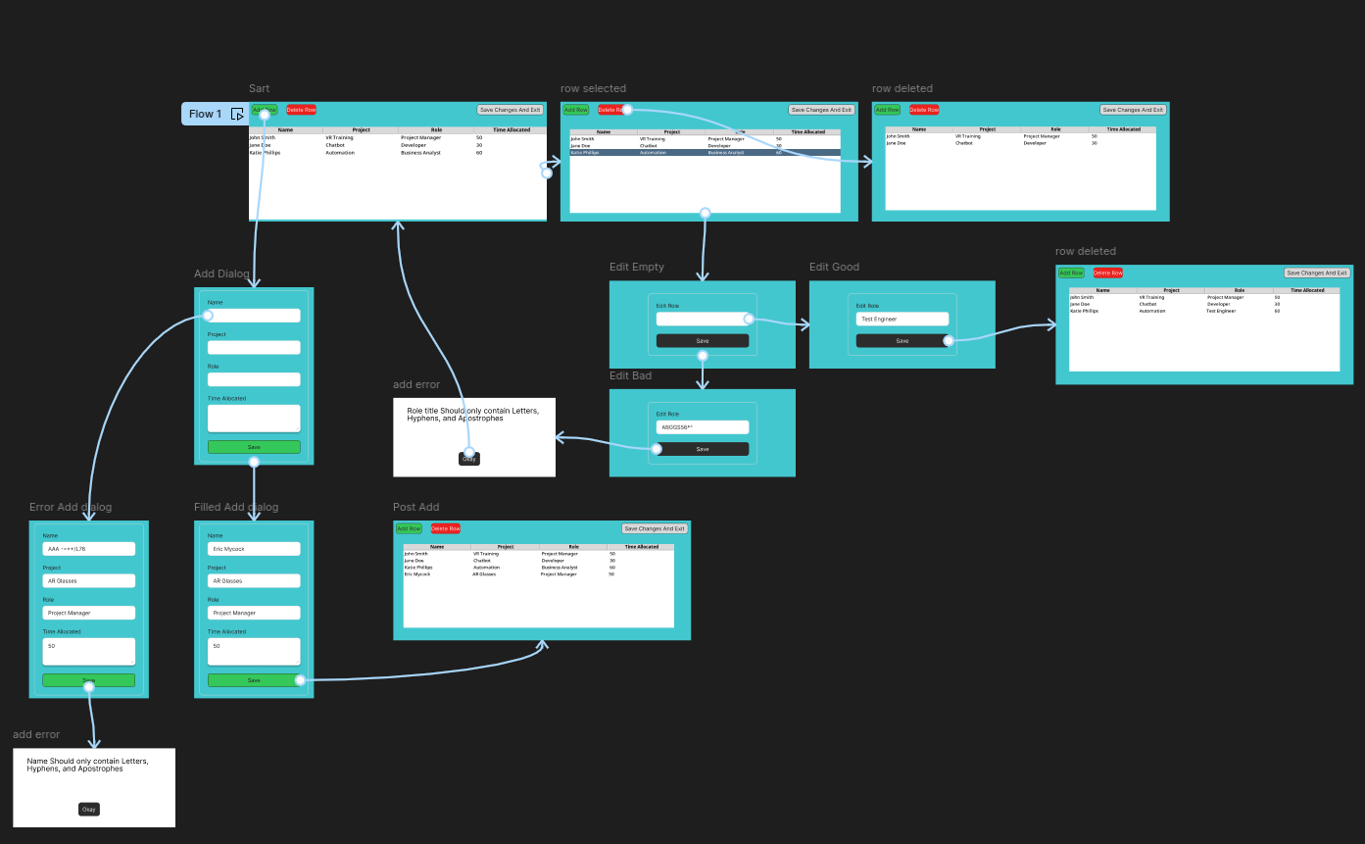

Flow for adding a row, with example error
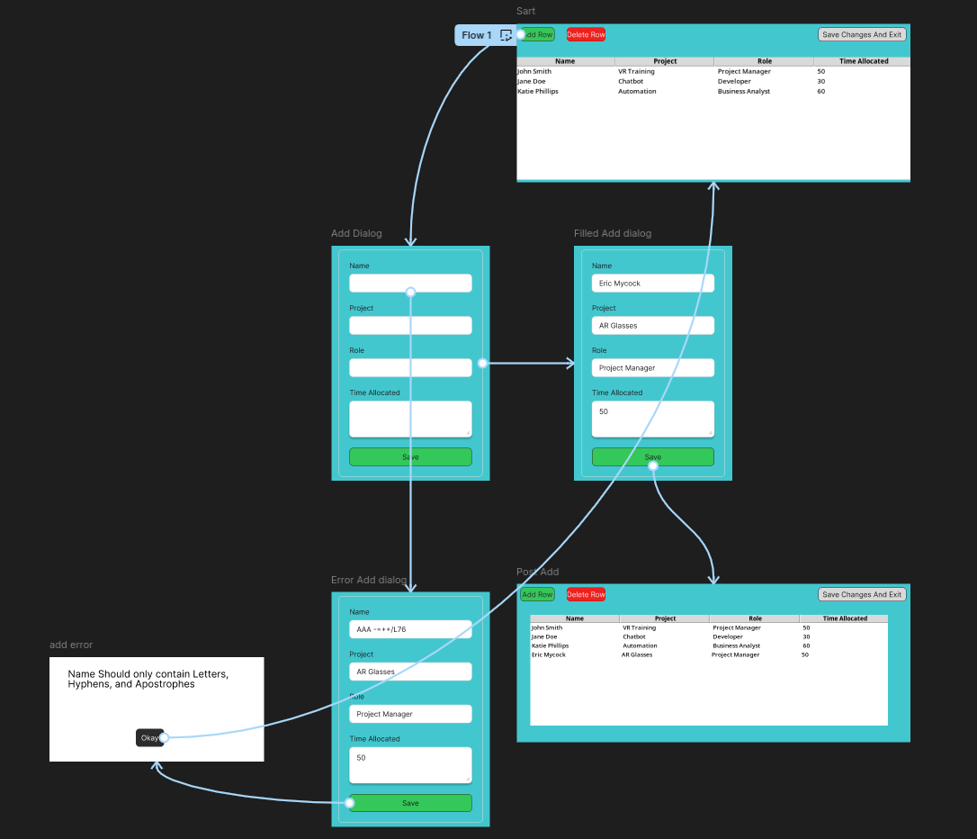

Flows for editing and deleting data with error
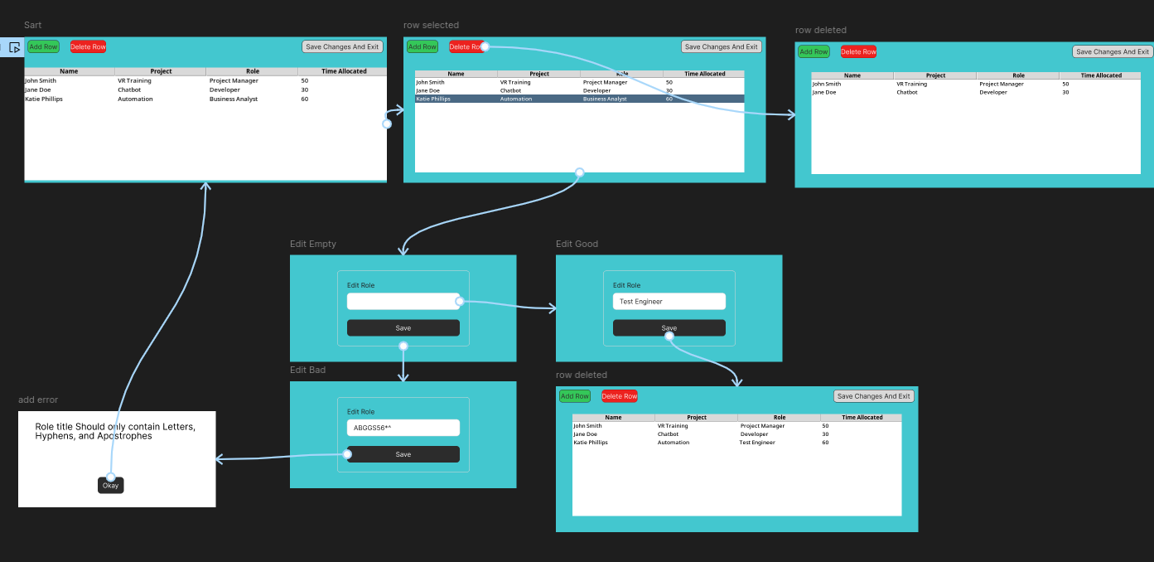

Link to Figma Prototype flow:

https://www.figma.com/proto/P07ySYuUPjrwwZlsSFoYOy/Resource-Allocator?node-id=1-2&t=nA6QWD1YuUJlCh8T-0&scaling=min-zoom&content-scaling=fixed&page-id=0%3A1&starting-point-node-id=1%3A2

Functional Requirements:
- The program should provide a clear and intuitive interface
- The program should be able to import the allocation data from a CSV file.
- The program should be able to write edited data into the allocation CSV file.
- The program should launch into a Tkinter window on application start.
- The main program window should display a table of the data imported from the CSV file.
- The main program window should feature 3 buttons for Adding / Removing a row and saving the changes before closing the program.
- The user should be able to double-click any value in the table in order to edit the value.
- The add and edit row actions should open up a new window with input dialogue dependent on the value being changed.
- If the user attempts to delete a row without selecting one, the program will pop up informing them that they need to select a row first.
- If the user attempts to input data that is not intended for the value type (such as a string for percentage time allocated), the program will cancel the 'change' operation informing them of the reason the data was invalid.
- If the program fails to load the CSV, either due to incorrect formatting or due to the file being missing, the program will inform the user, and the user will be presented with an empty Treeview to make changes to.

Non-Functional Requirements:
- Destructive actions (like deletion) should be marked in red to indicate to the user that the item will be removed.
- Creative actions like adding a row or saving a value change should be marked in green.
- The error messages throughout the program should be informative to the user, and if values need updating to reflect the error, then the error should explain the reason the value did not pass the validation checks.

Class Diagram
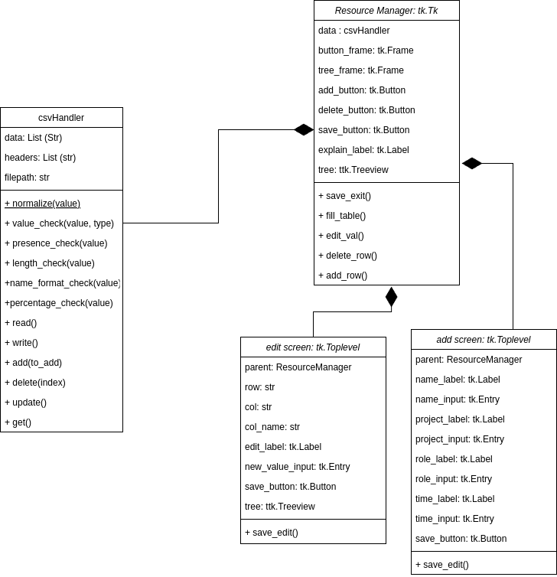

Testing Strategy
My Testing Strategy for my proposed MVP would be to preform a mix of automated and manual white box testing. White box testing is a type of testing that gives the tester access to the source code, so that they are aware of how the project works from an internal perspective. This is usually preformed by a developer during a code review. The Automated testing would be preformed in the form of unit tests using the pytest library. Unit testing is the process of automatically testing small ‘pure’ functions, so that we can guarantee that the execution of the function with a standard input will always give the same output (for example a function for squaring a number or normalizing a name), this automated testing will also be used to test edge cases for user input validation as my code splits each check into its own function called based on the value type, which can be supplied by the pytest module. Following running the test script pytest will display the results in the console, stating which tests have passed and failed, and for failed tests what each variable was set to at the time of failure. Unit testing is not able to test all components of an application such as GUI elements as well as more complex functions, so these will have to be tested manually using a test script, which will break down what is being tested, any input the should be required and the expected result, The tester will follow the test scripts and pass or fail a test by comparing the expected result to the actual result.

