For the testing of the Minimum Viable Product (MVP) Produced for Summative 1, Testing this application is paramount to this project, as in testing the application I will be able to ensure a smooth user experience, without crashes or unexpected errors, ensuring a user is still able to use the application. I will use white box testing, which assumes the tester has a low level knowledge of the source code, and therefore focuses on the internal system mechanisms. This is ideal as I am the designer, developer and tester for this project, which gives me a deep understanding of how to program works. This style of testing will primarily use a mix of unit testing and scripted manual testing. Unit testing, by definition, means to test the smallest isolated functional unit of code, usually done via an automated script in which I specify the expected result for any function I wish to test. This is ideal as it allows me to test specific functions like input validation functions, with a given input and an expected output. Unfortunately unit tests are very low level tests which means they cannot be used to easily test graphical user interface (GUI) elements, and parts of my code that will be tested using this strategy will call on GUI elements that will need to be interacted with, this takes an automation element out of testing as the tester would now have interact at several steps. In order to circumvent this I will use mocking. Mocking is used in unit testing to ensure the focus is on the unit code being tested and not any functions or objects external to the functional unit. such as tkinter GUI elements, in the case of my unit testing this means that I can create mocks objects to replace the GUI elements and test that the GUI elements are called with specific parameters, like if an error box is called with the correct error message. There are some elements of a GUI program that cannot be tested by unit testing so in order to ensure the program is tested fully I will also create test scripts which detail user actions in the program and the expected result, this test script should be usable by any user used for UAT Testing. The below test script passes every test listed.

The base dataset used for testing is as follows:
John Smith, VR Training, Project Manager, 50
Jane Doe, Chatbot, Developer, 30
Katie Phillips, Automation, Business Analyst, 60

Test Case Scripts

Test Case Number | Test Case Title | Steps | Expected result | Actual Result | Evidence | Pass?
 | Main Application Initialisation | 1. Start program  2. Confirm main window opens | Main window is present with green ‘Add Row’ Button, Red ‘Delete Row’ Button, White ‘Save’ Button, Data Table | Main window is present with green ‘Add Row’ Button, Red ‘Delete Row’ Button, White ‘Save’ Button, Data Table | 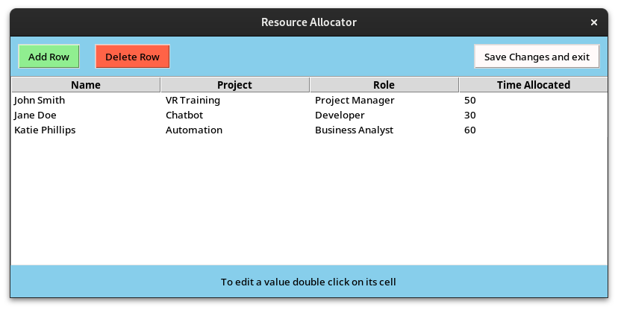 | Y
 | Data is loaded and visible | 1. start program  2. confirm result | Data loaded is from allocations csv file and visible in the treeview table | Data loaded is from allocations csv file and visible in the treeview table |  | Y
 | Program loads if csv not found | 1. (Ensuring no allocations csv is present) start program  2. confirm result | Error stating csv couldn’t be loaded | Error stating csv couldn’t be loaded | 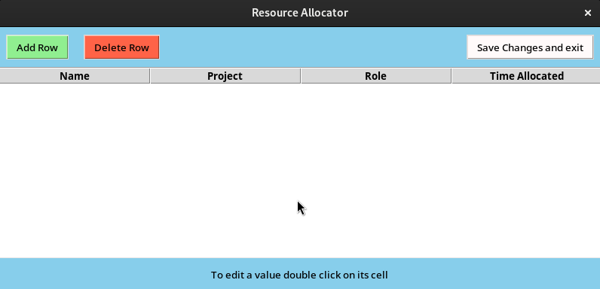  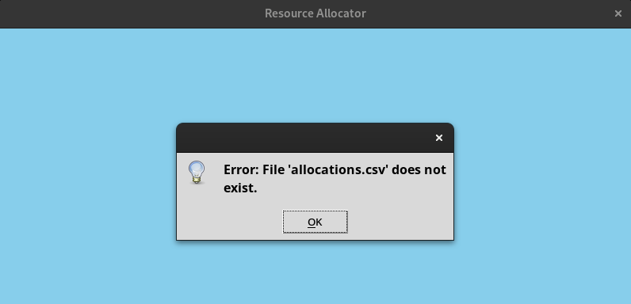 | Y
 | Delete row button with unselected row | 1. start program  2. press delete row  3. confirm result | An error appears stating the user should select a row to delete first | An error appears stating the user should select a row to delete first | 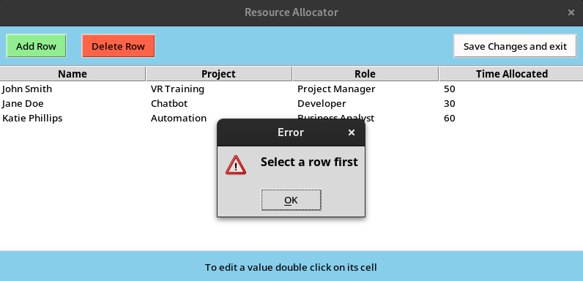 | Y
 | Edit Menu on double click | 1. start program  2. double click any value  3. confirm result | A window should appear allowing the user to edit the selected value | A window should appear allowing the user to edit the selected value | 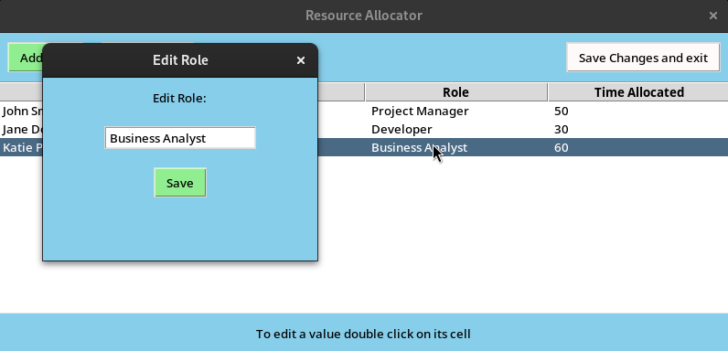 | Y
 | Edit Value with valid input | 1. start program  2. double click on any ‘Business Analyst’  3. change the value to ‘Tester’  4. Click Save  5. Confirm Result | Tree has Updated, Business analyst is replaced with Tester | Tree has Updated, Business analyst is replaced with Tester | 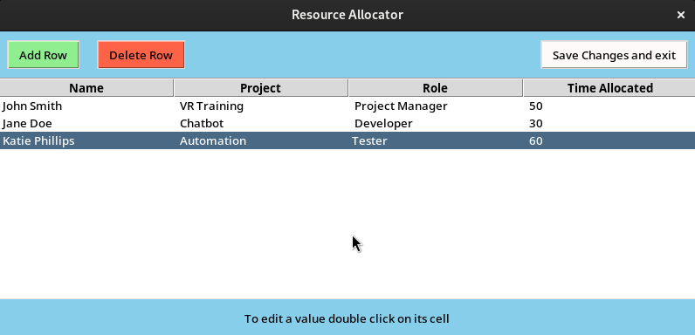 | Y
 | Presence Error | 1. start program  2. double click on any value  3. change it to a blank input  4. click save  5. confirm result | Error box asking user to input a value | Error box asking user to input a value | 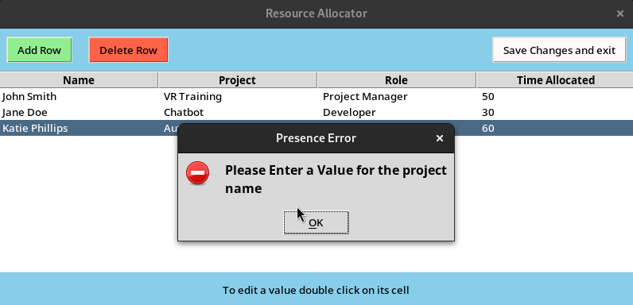 | Y
 | Length Error | 1. start program  2. double click on any value  3. input value below 3 characters in length  4. click save  5. confirm result | Error box asking user to input a value between 3 and 35 characters | Error box asking user to input a value between 3 and 35 characters | 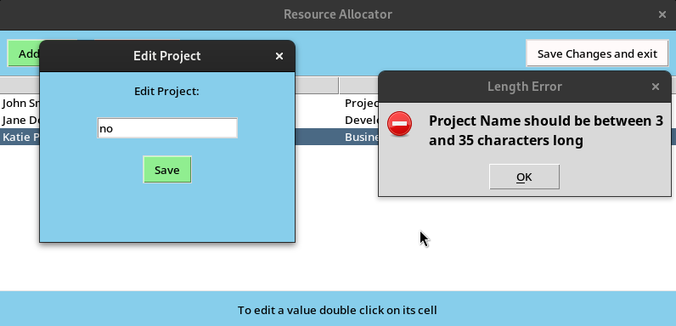 | Y
 | Pattern Error | 1. start program  2. double click on any value  3. change it to an input of 3+ non-name special characters  4. click save  5. confirm result | Error box asking user to input a value containing only letters, -, ‘ | Error box asking user to input a value containing only letters, -, ‘ | 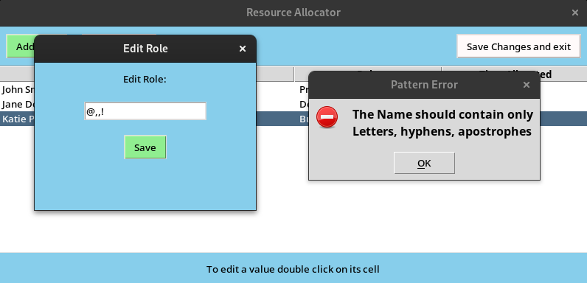 | Y
 | Range Error | 1. start program  2. double click on any ‘time allocated’ value  3. change it to a value above 80  4. click save  5. confirm result | Error box asking user to input a value between 1-80 | Error box asking user to input a value between 1-80 | 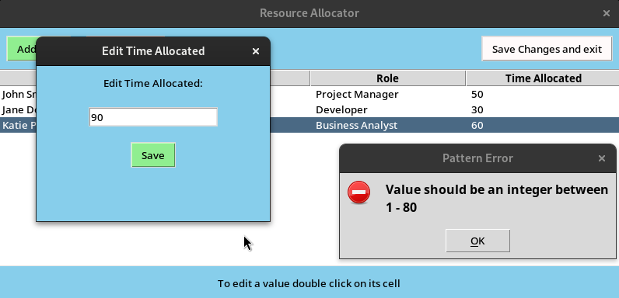 | Y
 | Add menu on Add Button click | 1. start program  2. click add button  3. confirm result | Menu to add new row containing an input box for each value and a Save button | Menu to add new row containing an input box for each value and a Save button | 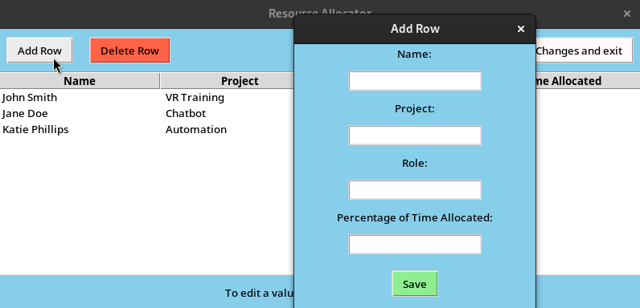 | Y
 | Add menu prevents erroneous data | 1. start program  2. click add button  3. enter erroneous data  4. click save  5. confirm result | Error box stating value check error | Error box stating value check error | 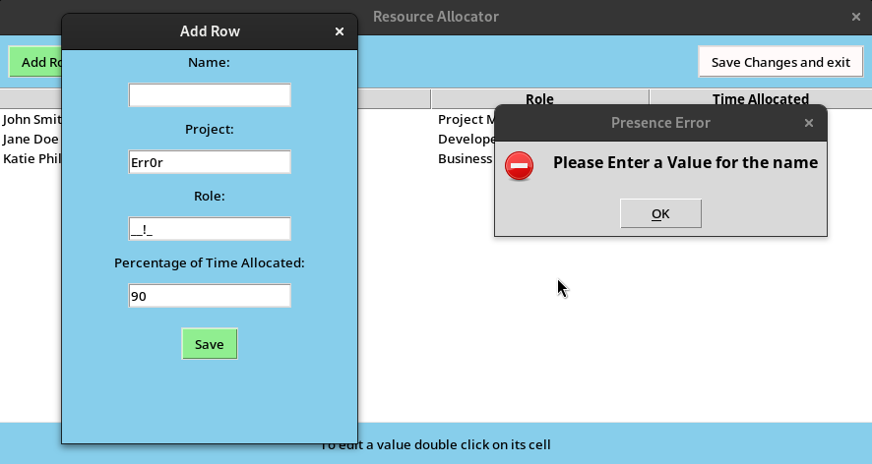 | Y
 | Add menu adds new row | 1. start program  2. click add button  3. enter valid data  4. click save  5. confirm result | New row added to table | New row added to table | 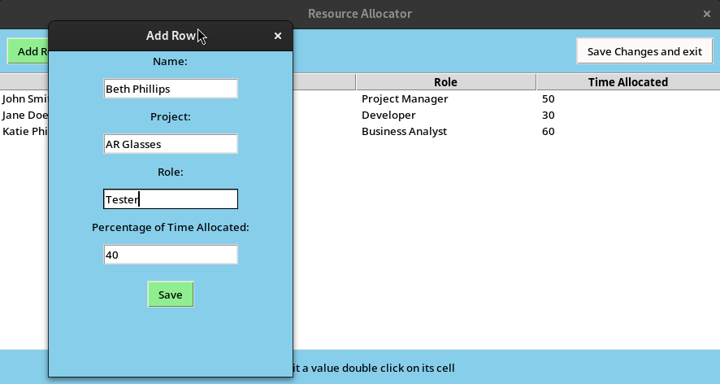  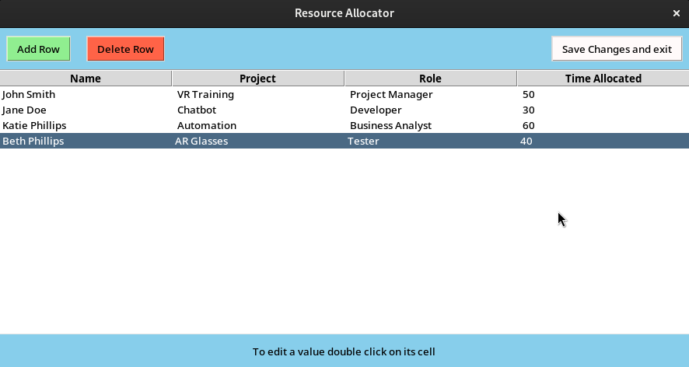 | Y
 | Save and exit button writes changes to file | 1. start program  2. make changes  3. press save  4. confirm file update | File Updated | File Updated | 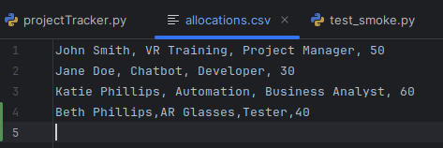  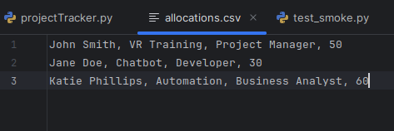 | Y

Unit Testing
For my unit testing I made use of the pytest system due to its interoperability with the unittest framework, specifically the patch utility for mocking objects like error boxes. As the first step in creating my unit tests I wrote a smoke test file. A smoke test is used to check if the testing framework is operating as expected by making assertions we know to be true or false like 5 = 5, 5 > 4, 0 = False, “me” is a string. My Unit tests will be primarily focused on the csvHandler class as this class is what handles and stores the data. The other classes in my program primarily handle the GUI elements.
My main testing script is split into several functions, the first of which is a set up function which is used to instantiate the csvHandler object for each test its needed it, as specifically change the file path for the csv to the test dataset.

Then the first test tests each value type returns true when presented with a valid value.
Value check is the csv handler function being tested here, and it accepts 2 parameters, being the value being checked and the value type, it then uses the value type to determine which tests are necessary, for each validation type it runs the test and either returns true or false, if any of the validation checks return false then the value_check function as a whole will return false, but if they all pass then the function will return true.

def test_value_checks_valid():
csv_test = setup()
assert csv_test.value_check("John Doe", "name") == True
assert csv_test.value_check("AR Glasses", "project") == True
assert csv_test.value_check("Developer", "role") == True
assert csv_test.value_check("50", "time allocated") == True
assert csv_test.value_check("50%", "time allocated") == True

time allocated is tested twice to check if it also accepts a % with the value.

The next test function will check for each possible error type for each type of value using erroneous data. When my program detects an error it would usually pop up with a GUI error message stating the issue, however this would go against the idea of unit testing being automated, as a tester would have to respond okay to the error message to continue the program. This issue is circumvented by the use of mocking. In this case I used the unittest.mock patch utility. Patching works by adding the @Patch decorator and specifying what object you would like to mock. In this case its tkinter.messagebox.showerror.

@patch('tkinter.messagebox.showerror')
def test_value_checks_invalid_name (mock_errorbox):
csv_test = setup()
assert csv_test.value_check("68476", "name")==False
mock_errorbox.assert_called_with(title="Pattern Error", message="The Name should contain only Letters, hyphens, apostrophes")
assert csv_test.value_check("me", "name")==False
mock_errorbox.assert_called_with(title="Length Error", message="Name should be between 3 and 35 characters long")
assert csv_test.value_check(" ", "name") == False
mock_errorbox.assert_called_with(title="Presence Error", message="Please Enter a Value for the name")

As shown above the @Patch decorator is included and this allows us to pass a parameter called mock_errorbox to the function. This object will ‘fill in’ for the showerror GUI Component, so when a failing value check is tested the check being preformed will return false, which will both return the value check function as false, as well as trigger the message box with a title and message parameter. The mock object uses the function assert_called_with, with the expected parameters that the message box would be called with, and passes if the error box is called with expected parameters, rather than displaying the GUI Element.

The next 3 tests are similar as the same validation checking takes place, just using different values

The next function, is similar to those previous, however the value type tested is time allocated, so different checks are called as part of this process, with a new error type, being range error validation being introduced (the value should be between 1-80)

The following function is used to test some possible edge cases:
@patch('tkinter.messagebox.showerror')
def test_value_checks_edge_cases (mock_errorbox): # tests possible edge cases
csv_test = setup()
assert csv_test.value_check("1", "time allocated")==True
assert csv_test.value_check("0", "time allocated") == False
mock_errorbox.assert_called_with(title="Pattern Error", message="Value should be an integer between 1 - 80")
assert csv_test.value_check("aaaaaaaaaaaaaaaaaaaaaaaaaaaaaaaaaaaaaaaaaaaaaaaaaaaaaaaaaaaaaaaaaaaaaaaaaaaaaaaaaaaaaaaaaaaaa", "name") == False
mock_errorbox.assert_called_with(title="Length Error", message="Name should be between 3 and 35 characters long")
assert csv_test.value_check(" ", "role") == False #non-breaking space character ctrl shift U 00a0
mock_errorbox.assert_called_with(title="Presence Error", message="Please Enter a Value for the role title")
The first checks the lowest allowed value for time allocated, the next checks the value 0 as allowing 0 allocated time in this data set would be redundant. The next tests an extreme out of bounds length check, which, being greater then 35, should fail. For the final test the empty space value may appear the same as the previous test in this font however the character is a non-breaking space, a unicode character that appears similar to a space but acts differently (an example use case is to prevent an automatic line break between words), In some systems, due to the difference between this and a space, the character may not be picked up as whitespace, so I included it in my test to ensure data integrity.

The next set of functions test the csv handlers ability to read from, and write to the csv file as well as adding and removing rows from the data set.

It was for these tests that the test data set was created, to allow modification and change during tests without damaging the production file. The first test simply reads the csv and compares the stored data to the known contents of the file, testing reading functionality. The add test does not call from the main dataset but instead tests if the data is appended to the stored data set. The delete test tests the capability to remove specific indexes from the data set. The write test function removes a row from the dataset reads in the new dataset, compares with the original set and then restores the original(for other tests).

The final test preformed tests the normalization functions of the csvHandler, which are used to ensure that the data passed and saved are in the Ideal format, which would, for titles, remove excess whitespace, lower all characters and set the first character of each word to upper case, however, since in my program, when editing values, this function is called regardless of value type it was also important to test that it had no effect on time allocated value types.

All of these tests were run using pytest with the -v flag for verbose results, and on the first test run 1 of the tests failed, specifically being the edgecases:
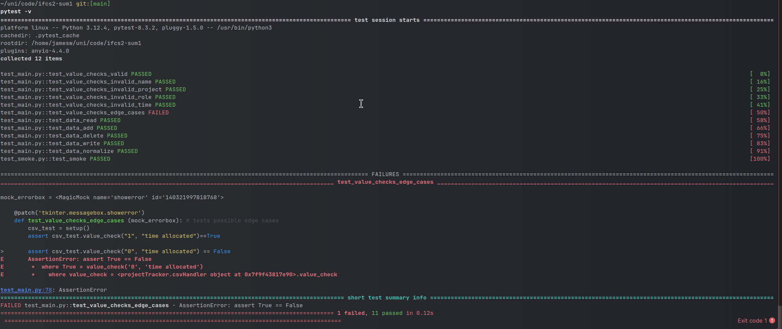
This error stated that the time allocation 0 check has failed, meaning 0 was taken as valid.
This was due to these lines of code:
pattern = re.compile(r"^(80|[1-7]?[0-9])%?$")
return bool(pattern.match(value))
The regex incorrectly takes 0 as part of my solution to accept intergers that were multiples of 10.
This issue was fixed by introducing the following regex:
pattern = re.compile(r"^([1-7]?[1-9]|[1-8]0)%?$")
which first searches all numbers between 1-79 that aren’t divisible by 10, and then specifically checks for multiples of 10 between 10 and 80. This eliminated the failed test resulting in a 100% pass rate between all 11 tests including the smoke test.
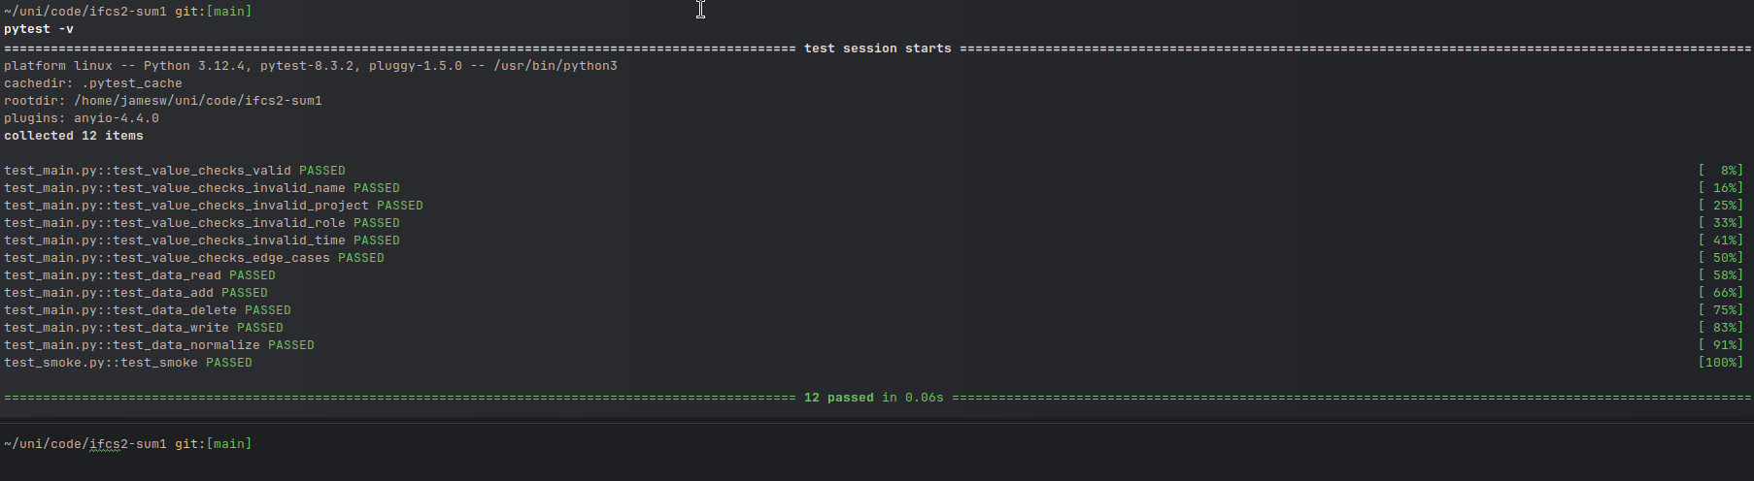
Reflections

Critically reflecting on this MVP project I believe that there are several changes needed before this application could be considered Fit for purpose within my workplace. Although my project does meet all of the functional and non-functional requirements laid out previously, I don’t believe the current format is an effective way to handle the tracking of this data, primarily due to its implementation using csv’s as the primary data source. In my opinion this tool could be made much more effective by the implementation of databases, for several reasons. A database system would allow for the dataset to become normalized, avoiding repetitive data that comes from, for example, the same employee being split across multiple projects. A change to databases could also expand possible system expansions, as it would be easier to add new tables and have them be interoperable with the current table, allowing additional project issues to be solved, such as holiday or days-in-leiu tracking, using, for example, the microsoft dataverse database system would allow integration of this project into more systems. With the inclusion of a database model, it could also be possible to implement specific views based on the user, allowing, for example, project managers to only see information relevant to their projects, or team members to see their designated allocations. An additional function that would be ideal would be a searching function, which could be used to filter to a specific project, for project planning, or a specific person for personal time planning. This would be beneficial due to the large team size, as this MVP was only tested with a small data set, however with a large team and multiple team members being split across multiple projects, the unfiltered view will become difficult and clunky to navigate. These would be key features I would look to implement in a following sprint in order to make the project more suitable to the workplace.

As part of my MVP Testing, only white box testing was preformed as I was the only tester, meaning testing was preformed with a low level understanding of the source code. Since there was no UAT Testing it is very possible I missed some form of edge case or common practice a user may preform that I was unaware of. The Test scripts were written with idea of end user testers preforming them and specific requirements for input were left out to ensure users would input data similarly to how they would in day-to-day operation, however the Test scripts likely don not cover every possible scenario.

In the development of this project, I have developed a strong understand of the basics of Object Oriented Programming within python, as well as how to develop GUI applications. Additionally this project has taught me about many different forms of testing that a project may go through for various different reasons, which complements my previous work alongside testers as a business analyst.

