Greek and Latin in Scientific Terminology, Lecture 5

Andrew Dunning

22 July 2014

# Final Exam

## Date and Location

* Wednesday, 20 August 2014
* 9 am to 11 am (2 hours)
* IB 110

## Content

* The exam is cumulative, and drawing on material from both the Greek and Latin portions of the course.

# Agenda

## Last Class

* Learned:
  + Greek diminutive suffixes.
  + Greek verb-forming suffixes.
* Read [Soutis (2006)](http://dx.doi.org/10.1016/j.jpedsurg.2006.03.011), a very advanced example of what you'll be doing for your final vocabulary analysis.
* Examined words used for counting in Greek.

## This Class

* Writing a practice test.
* Touching on the history of anatomical terminology.

# Practice Test

## I. Historical Questions

1. Which of the following languages are *not* an immediate source of English anatomical terminology, according to Turmezei (2012)?
   1. Latin and Greek
   2. Arabic
   3. **Hittite**
   4. Middle Dutch
   5. Old English
2. What is a *suffix*?
   1. a stem adjoined to a root in order to produce a mitochondrion
   2. **a morpheme added at the end of a word to form a derivative**
   3. an element placed at the beginning of a word to adjust or qualify its meaning
3. Which of the following is the singular form of the word *phenomena*?
   1. *phenomene*
   2. ***phenomenon***
   3. *phenomena*
   4. *phenomenia*
   5. *phenomenona*

## II. Dissect

Analyse the following words and give the meanings of the elements. E.g. *dissection*: dis/sect/ion = apart from / cut / action suffix.

## allochiria

* allo/chir/ia, other or different/hand/quality or condition = 3 marks

## protagonist

* prot/agon/ist, first/contest/agent = 3 marks

## parabolic

* para/bol/ic, by the side of/a throw/pertaining to, like = 3 marks

## epidermoid

* epi/derm/oid, upon or on/skin/in the shape of = 3 marks

## dichromatism

* di/chromat/ism, twice/colour/result of action, condition = 3 marks

## anaesthetize

* an/aesthet/ize, not/feeling/to do = 3 marks

## III. Match

Indicate the correct definition of the following words and provide their Greek and Latin roots.

## hydrotropism

1. absence of the sense of smell
2. **response to stimulus of water**
3. inflammation of the urinary bladder

* Derivation
  + hydro/trop/ism water/turn/condition of (4 marks)

## malacology

1. **the branch of zoology that deals with molluscs**
2. the branch of zoology that deals with the malacca
3. the branch of biology that deals with the relations of malachites to their surroundings

* Derivation
  + malaco/logy, soft/science of (3 marks)

## laparoscopy

1. a surgical incision into the abdominal cavity, for diagnosis or in preparation for major surgery
2. a low caesarian section
3. **a surgical procedure in which a fibre-optic instrument is inserted through the abdominal wall to view the organs in the abdomen**

* Derivation
  + laparo/scopy, abdomen/to view (3 marks)

## IV. Define

Provide the definition of the following Greek stems (worth 1 point each).

## 1. ENNE(A)-

* ‘nine’

## 2. PTO-

* 'to fall'

## 3. -idium

* 'little'

## 4. ISCH-

* ‘to suppress’

## 5. LIP-

* ‘fat’

## 6. THANAT-

* ‘death’

## 7. BLEPHAR-

* ‘eyelid’

## 8. CHEIL-, CHIL-

* ‘lip’

## 9. CHRON-

* ‘time’

## 10. -plasty

* ‘formation’, ‘plastic surgical operation’

## 11. KINE- (CINE-)

* ‘to move’

## 12. ENTER-

* ‘intestine’

## 13. ERG-

* ‘work’

## 14. BLEP-

* ‘to see’

## 15. LAL-

* ‘to talk’

## 16. LEI-

* ‘smooth’

## 17. HYPN-

* ‘sleep’

## 18. OLIG-

* ‘few’, ‘scanty’

## 19. ICHTHY-

* ‘fish’

## 20. MEN-

* ‘moon’, ‘menstruation’

## V. Transliterate

Rewrite the following Greek words using the English alphabet (1 point each).

## ἀνατομία

* anatomia

## Ἀσία

* Asia

## ἄλφα

* alpha

## ἱστορία

* historia

## βίος

* bios

# Roots, Part I

## BRACHY-

* ‘short’
* BRACHY-ODONT or BRACHY-DONT, a molar tooth with a low crown; BRACHY-PODUS; BRACHY-logy, concise or shortened expression

## CAC-, (KAK-)

* ‘bad’
* CACO-PHON-y; CAC-ESTHE-sia, any morbid sensation; CAC-OSM-ia, imaginary odours, particularly putrefactive odours

## CAU-, CAUS-

* ‘to burn’
* CAUS-tic; en-CAUS-tic; CAUM-ESTHE-sia, experience of a sense of heat when temperature is not high; CRYO-CAUT-ery, the destruction of tissues by application of extreme cold; CAUT-er-ize to apply an agent capable of burning or destroying tissue

## CLI-, CLEI-; CLEIST-

* ‘to close’; ‘closed’
* CLEISTO-GAM-y, state of having small, inconspicuous, self-fertilizing flowers; fertilization without opening of florets; CORE-CLI-sis, pathologic closure or obliteration of the pupil

## CLY(S)-

* ‘to wash’
* cata-CLYSM; ENTERO-CLY-sis, injection of a fluid preparation into the rectum; hypo-DERMO-CLY-sis, introduction of large quantities of fluids into subcutaneous tissues

## CROT-

* ‘pulse beat’
* TRI-CROT-ism, the condition of having three waves corresponding to one pulse beat

## DOLICH-

* ‘long’
* DOLICHO-PLATY-CEPHAL-us, a person having a long skull which is unusually broad; DOLICHO-RRHINE, having a long nose

## EDE-

* ‘to swell’
* EDE-ma, excessive accumulation of fluid in tissue spaces; ARTHR-EDE-ma, edema affecting the joints; TROPH-EDE-ma, edema due to damaged nourishment or nerve supply

## LEPT-

* ‘thin’, ‘delicate’
* DOLICHO-LEPTO-CEPHAL-us, a person whose skull, in addition to being long, is also high and narrow; LEPTO-DERMAT-ous, thin-skinned

## LOG-

* ‘word’, ‘speech’, ‘reason’
* ana-LOG-ous; dys-LOG-ia, difficulty in expression of words by speech; LOGO-PLEG-ia, loss of power of uttering articulate speech

## MES-

* ‘middle’
* MESO-POTAM-ia; MESO-PHYTE, plant thriving in a temperate climate with a normal amount of moisture; MESO-POD-ium; middle part of the molluscan foot

## MYX-

* ‘mucus’, ‘slime’
* MYX-oma, connective tissue tumour composed of cells of stellate and spindle form with processes separated by mucoid material; MYXO-POD-ium, a slimy PSEUDO-POD-ium

## OXY-, OX-

* ‘sharp’, ‘acid’, ‘oxygen’
* PAR-OXY-sm; OXY-GEN; OXY-BLEP-sia, acuteness of vision; OXY-DACTYL, having slender, tapering digits; OXY-PHIL-ous, tolerating only *acidic* soils or substrates

## PETR-

* ‘rock’
* PETR-OL-eum; PETER; PETRO-PHIL-ous, attached to or living on rocks, especially used of marine life

## PHON-

* ‘sound’, ‘voice’
* TELE-PHONE; BARY-PHON-ia a heavy or deep quality of voice; RHINO-PHON-ia, nasal tone in the speaking voice

## PHOT-

* ‘light’
* PHOTO-GRAPH; PHOTO-LY-tic, of a substance which is decomposed by action of light; PHOTO-TROPH-ic, requiring light as a source of energy in nutrition

## POIE-

* ‘to make’
* PO-et; ONOMATO-POE-ia; ANGIO-POIE-sis, the process by which certain cells cause the formation of blood vessels in new tissue; HIDRO-POIE-sis, formation of sweat

## PRESBY-

* ‘old’
* PRESBY-CUS-is, progressive hearing loss occurring with age; PRESBYO-PHREN-ia, failure of the sense of location and memory in the aged

## PYR-, PYRET-; PYREX-

* ‘fire’, ‘fever’; ‘fever’
* PYRETO-GEN-ic, causing fever; PYRETO-LY-sis, reduction of fever

## RHIZ-, -RRHIZ-

* ‘root’
* POLY-RRHIZ-al, having many roots; RHIZO-SPHERE, soil immediately surrounding the root system of a plant

# Terms from Classical Mythology

## ammonia

* In mythology
  + Ἄμμων: Amun was a supreme god of the ancient Egyptians, identified with the sun god Ra, and in Greek and Roman times with Zeus and Jupiter (under the name Ammon).
* In science
  + a colourless gas with a characteristic pungent smell, which dissolves in water to give a strongly alkaline solution
* Why? The *OED* suggests: 'The corruption to armoniac found in medieval Latin, French, and English, was perhaps due to an association with the Greek ἁρμονία fastening or joining, from the use of gum ammoniac as a cement, or of sal ammoniac in the joining of metals.'

[Museo Barracco: Jupiter Ammon](https://commons.wikimedia.org/wiki/File:Museo_Barracco_-_Giove_Ammone_1010637.JPG#mediaviewer/File:Museo_Barracco_-_Giove_Ammone_1010637.JPG)

## hermaphrodite

* In mythology
  + Hermaphroditus was a son of Hermes and Aphrodite, with whom the nymph Salmacis fell in love and prayed to be forever united.
  + As a result Hermaphroditus and Salmacis became joined in a single body which retained characteristics of both sexes.
* In science
  + a person or animal having both male and female sex organs or other sexual

## narcissism

* In mythology
  + Narcissus was a beautiful youth who rejected the nymph Echo and fell in love with his own reflection in a pool. He pined away and was changed into the flower that bears his name.
* In science
  + excessive interest in or admiration of oneself and one's physical appearance

## aphrodisiac

* In mythology
  + from Aphrodite (Venus), the goddess of beauty, fertility, and sexual love
* In science
  + a food, drink, or other thing that stimulates sexual desire:

Sandro Botticelli, 'La Nascita di Venere'

## Achilles tendon

* In mythology
  + Achilles was a hero of the Trojan War, son of Peleus and Thetis. During his infancy his mother plunged him in the Styx, thus making his body invulnerable except for the heel by which she held him.
  + During the Trojan War Achilles killed Hector but was later wounded in the heel by an arrow shot by Paris and died.
* In science
  + the tendon connecting calf muscles to the heel.
* Achilles heel: a weakness or vulnerable point

# Reading Practice

## ἀσπάραγος

* asparagos

## βαπτίζω

* baptizō (dip, immerse): baptize

## Ἄτλας

* Atlas

## Ἀσία

* Asia

## βάρος

* baros (weight): barometer, millibar

## γλωσσίς

* glōssis (tongue): polyglot

## ἄρκτος

* arktos (bear, Ursa Major, pole star)

## ναυτικός

* nautikos (sailor, ship): aeronautics, astronaut, nautical

## ἀρθρίτις

* arthritis (inflammation of the joint; *arthron* = joint)

## μακρός

* makros (long): macrobiotic, macroeconomics

## σύστημα

* sustēma (system): systematic

## θεραπεία

* therapeia (healing): therapeutics

## γῆρας

* gēras (old age): geriatric

## γυνή

* gunē (woman): gynecology, misogynist

## θησαυρός

* thēsauros (storehouse, treasure): thesaurus, treasure

## ἦθος

* ēthos (moral): ethics

## γάμμα

* gamma: gamut (from *gamma ut*)

## φαντασία

* phantasia (imagination): fantasy, fantastic, fantasia

## στροφή

* strophē (turning): catastrophe (from cata-, 'down')

## κίνημα

* kinēma (movement): cinema, cineamatic

# [Efficacy of Pneumococcal Nontypable](http://www.plosmedicine.org/article/info%3Adoi%2F10.1371%2Fjournal.pmed.1001657) *[Haemophilus influenzae](http://www.plosmedicine.org/article/info%3Adoi%2F10.1371%2Fjournal.pmed.1001657)* [Protein D Conjugate Vaccine](http://www.plosmedicine.org/article/info%3Adoi%2F10.1371%2Fjournal.pmed.1001657)

* pneumococcal
* pneumonia
* acute otitis media (AOM)
* *Haemophilus influenzae*
* alveolar
* *Streptococcus pneumoniae*
* septicaemia
* meningitis
* mucosal
* immunogenicity
* vaccination
* protocol
* opsonophagocytic
* antigens
* inhibition

# Anatomical Terminology

## Articles

* [Dirckx (2006)](http://dx.doi.org/10.1016/B0-08-044854-2/04268-1): summary of premodern influences.
* [Kachlík et al. (2008)](http://link.springer.com/10.1007/s00276-008-0357-y): discussion of modern attempts to standarize nomenclature.

## Words and the History of Science

* The *humours* (Latin, *humor*) were originally bodily fluids: this sense survives in 'aqueous humour' and 'vitreous humour', and were thought to affect one's mood.
  + Four humours: blood, phlehm, yellow bile (*chole*), black bile (*melan chole*).
  + Thus the terms 'choleric', 'melancholy' (literally an excess of black bile).
* *Disaster* literally means 'ill-starred'.
* A *lunatic* was so called because it was thought that the moon caused temporary insanity.
* The term *jovial* apparently comes from a supposition that those born under the planet Jupiter were good-tempered because of its influence.

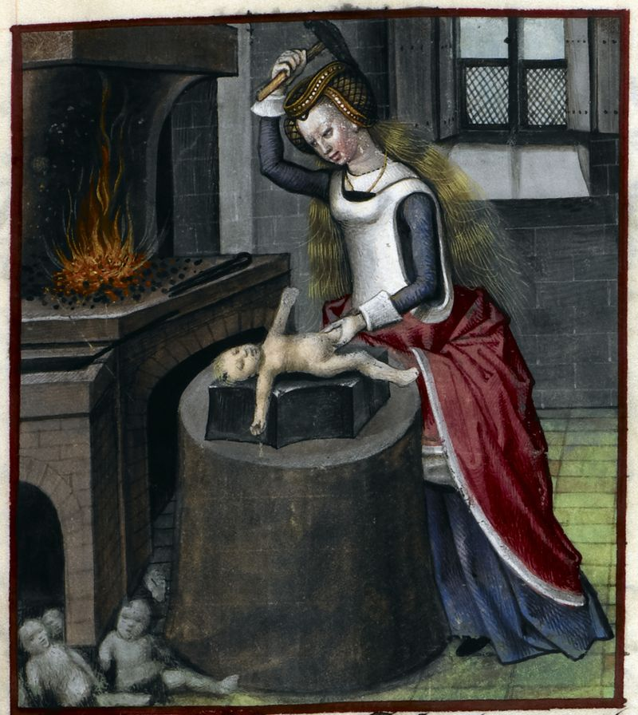

[Detail of a miniature of Nature forging a baby, from Roman de la Rose, Netherlands (Bruges), c. 1490 - c. 1500, Harley MS 4425, f. 140r](http://britishlibrary.typepad.co.uk/digitisedmanuscripts/2013/07/royal-babies-and-celebrated-infants.html)

## Autopsy

* *autos* ‘self’ + *optos* ‘seen’ (i.e. 'personal observation')
* Widely practised, contrary to popular belief, [before the modern era](http://news.harvard.edu/gazette/story/2011/04/debunking-a-myth/).

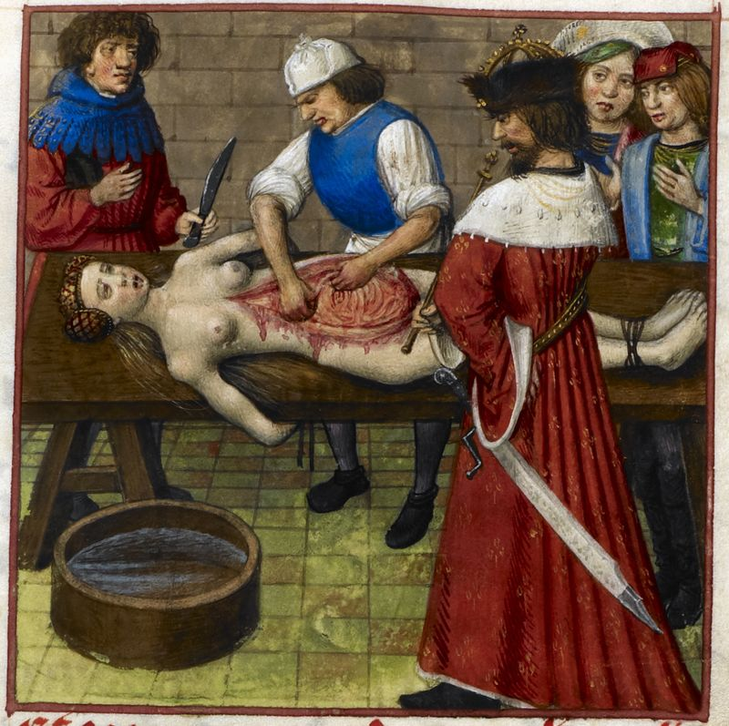

[Detail of a miniature of Nero watching while his mother Agrippina is dissected, Harley MS 4425, f. 59r](http://britishlibrary.typepad.co.uk/digitisedmanuscripts/2014/01/sex-and-death-in-the-roman-de-la-rose.html)

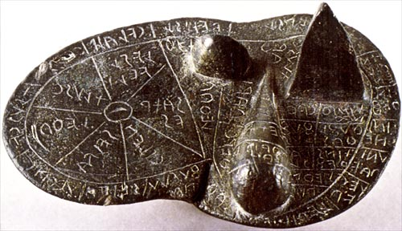

Etruscan Bronze Liver of Piacenza

# Roots, Part II

## GLAUC-

* ‘silvery’, ‘grey-green’
* a-GLAUC-OP-sia, green-blindness

## GON(Y)-, GONAT-

* ‘knee’
* GON-ALG-ia, pain in the knee joint; GON-ARTHR-itis, inflammation of the knee joing; GONATO-CELE, tumour of the knee

## (H)APT-; (H)APH-

* ‘to touch’; ‘sense of touch’
* HAPH-ALGE-sia, a sensation of pain experience on the mere touching of an object; HAPT-ics, the branch of psychology dealing with the tactile sense; syn-APSE, the region of connection between two neurons

## KARY-, CARY-

* ‘nucleus’, ‘nut’
* CARYO-CLAS-tic, agent which splits the cell nucleus; KARYO-GAM-y, the fusion of cell nuclei, as in fertilization

## KERAT-, CERAT-, KER-, CER-

* ‘horn’, ‘horny tissue’, ‘cornea’
* RHINO-CER-os; BRACHY-CER-ous, short-horned, or with short antennae; KERAT-oma, a horny thickening of the skin; KERATO-MALAC-ia, softening of the cornea

## LEPID-

* ‘scale’
* HOMO-LEPID-ous, having one kind of scales; LEPIDO-SAUR-ia, reptiles with scaly skin, including lizards and snakes

## NEM-, NEMAT-

* ‘thread’
* MICRO-NEM-ous, furnished with short filaments; NEMAT-ode, roundworm

## NOS-

* ‘disease’
* NOSO-GEO-GRAPH-y, the geography of endemic diseases; NOSO-PHYTE, any pathogenic vegetable organism; PHOTO-NOS-us, disease from intense or glaring light, such as snow blindness

## ONC-, -ONCUS, ‘tumour’, ‘swelling’

* ONCO-logy; ADEN-ONCUS, an enlargement or tumour of a gland; par-OPTHALM-ONC-osis, development of tumour near the eye

## PHRA-

* ‘to speak’
* PHRA-se; para-PHRA-se; peri-PHRA-sis; a-PHRA-sia, loss of power to utter connected phrases; em-BOLO-PHRA-sia, insertion of meaningless words into speech, embololalia

## PNEUM-, PNEUMAT-

* ‘air’, ‘gas’
* PNEUMAT-iz-ation, progressive development of, or state of having, air-filled cavities in the bone related to PNEUMON-, ‘lung’

## PHYLAC(T)-

* ‘to guard’, ‘to protect’
* pro-PHYLACT-ic; cata-PHYLAX-is, movement and transportation of phylactic agents, such as leukocytes, to the site of an infection (X=c+s)

## PORPHYR-

* ‘purple’
* PORPHYR-in, a heterocyclic ring derived from porhin, named for its deep-red or purple colour; PORPHYR-in-uria, the excretion in the urine of an abnormal amount of porphyrin

## SARC-

* ‘flesh’
* SARCO-PHAG-us; SARCO-BI-ont, living on flesh; SARCO-CARP, the fleshy or pulpy part of a fruit

## SCLER-

* ‘hard’
* SCLER-osis; SCLER-a, the sclerotic coat of the eyeball, i.e., the firm fibrous outer layer of the eyeball; SCLERO-MENINX, dense fibrous lining of the cranial cavity and spinal canal, dura mater

## SEP-

* ‘to rot’, ‘to putrefy’
* a-SEP-tic, pertaining to the exclusion of microorganisms causing decay; anti-SEP-tic, preventing SEP-sis or poisoning by destruction of or exclusion of microorganisms from body tissue

## SIT-

* ‘food’
* para-SITE; apo-SIT-ia, aversion to or loathing of food; SITO-therapy, the use of food for therapeutic purposes, a.k.a. DIETO-therapy; SITO-TROP-ism, tendency to turn in the direction of food

## SPLEN-

* ‘spleen’
* SPLEN-etic; GASTRO-SPLEN-ic, relating to the stomach and spleen; SPLEN-ALG-ia, pain originating in the spleen

## STEN-

* ‘narrow’
* STENO-GRAPH-y, shorthand; STENO-COR-iasis, narrowing of the pupil; STENO-STOMAT-ous, narrow-mouthed

## STERE-

* ‘solid’, ‘three-dimensional’
* STEREO-PHON-ic; STEREO-ARTHRO-LY-sis, loosening stiff joints by operation or manipulation; STEREO-PLASM, more solid part of a protoplasm, opp. of HYDRO-PLASM

# *[Hemigrapsus sanguineus](https://peerj.com/articles/472/)* [in Long Island salt marshes](https://peerj.com/articles/472/)

* *Hemigrapsus sanguineus*
* *Uca pugilator*
* *Carcinus maenas*
* *Ulva lactuca*

# Roots, Part III

## CYN-

* ‘dog’
* CYN-ic; CYNO-CEPHAL-ous, with the head shaped like a dog’s; CYNO-POD-ous, with non-retractile claws

## HAPL-

* ‘single’, ‘simple’
* HAPLO-id, have the number of chromosomes characteristic of mature germ cells for the organism in question; HAPL-OP-ia, single vision, as opposed to DIPL-OP-ia

## KYM-, CYM-

* ‘wave’
* KYMO-GRAPH, an instrument for recording physiologic cycles or actions in a patient; MYO-KYM-ia, constant quivering of a muscle; CYMO-TRICH-ous, having wavy hair

## LEMM(A)-

* ‘sheath’, ‘husk’
* MYO-LEMMA or SARCO-LEMMA, the sheath of muscular fibre; NEURO-LEMMA, delicate elastic membrane outside medullary sheath of nerve fibre; LEMMO-CYTE, a formative cell for the neurolemma

## LYMPH-

* ‘water’, ‘lymph’
* CYTO-LYMPH, cell-sap, the fluid part of protoplasm; KARYO-LYMPH, nuclear sap; LYMPHO-CYTE, a small mononuclear cell of blood or lymph; LYMPH-ADEN-oma, tumourlike enlargement of a lymph gland

## MIT-

* ‘thread’
* MITO-sis, indirect or karyokinetic cell division, with chromosome formation, etc.; MITO-GENE-sis, formation as a result of mitosis

## ORNIS-, ORNITH-

* ‘bird’
* ORNITHO-logy; HELI-ORNITH-idae, a family of tropical aquatic birds comprising the sun grebes; ORNITHO-philous, of flowers pollinated through the agency of birds

## PALE- (PALAE-)

* ‘old’, ‘ancient’
* PALAE-ONTO-logy; PALAEO-GRAPH-y; PALAEO-ENCEPHAL-on, the phylogenetically old part of the brain

## PHA-; PHEM-

* ‘to speak’; ‘voice’
* a-PHEM-ia an inability to articulate words or sentences due to a central lesion; HETERO-PHEM-ia, the unconscious saying of one thing while another is meant

## PHRAG-

* ‘to block up’, ‘to wall in’
* dia-PHRAG-m; em-PHRAC-tic, any agent that obstructs the function of an organ, especially the excretory function of the skin

## PLAN-

* ‘wandering’
* PLAN-et; ANGIO-PLAN-ia, irregularity or abnormality in the course of a vessel (ANGI-ec-TOP-ia); a-PLANO-GAM-ete, a nonmotile, conjugating germ cell of various plants and animals; PLANO-mania, a morbid desire for wandering

## PLEUR-

* ‘side’, ‘rib’, ‘pleura’
* an-ISO-PLEUR-al, bilaterally asymmetrical; eu-DI-PLEUR-al, symmetrical about a median plane, bilaterally symmetrical; PLEUR-ODYN-ia, pain in the abdominal wall; PLEURO-SOMATO-SCHIS-is, lateral abdominal fissure

## -PLO-

* ‘folded’, ‘fold’ (as in ‘threefold’)
* DI-PLO-ma; DI-PLO-m-at; DI-PLO-CEPHAL-us, an organism with two heads; HETERO-PLO-id, not having a multiple of the basic HAPLO-id number of chromosomes; TETRA-PLO-id, with four times the normal haploid number of chromosomes

## PNE(A)-, PNEUST-

* ‘breathing’
* amphi-PNEUST-ic, having both gills and lungs throughout life history; HOLO-PNEUST-ic, with all spiracles open for respiration; hyper-PNEA, increase in depth of inspiration

## RHAPH-, -RRHAPH-

* ‘to sew’
* RHAPE, the seamlike union of the two lateral halves of a part or organ (as of a tongue); dys-RAPH-ism, defective raphe formation, defective

## SPA-

* ‘to draw’, ‘to jerk’
* SPAS-m; anti-SPAS-tic, anti-SPASM-od-ic, or SPAS-m-o-LY-tic, an agent relieving convulsions or spasmodic pains

## STAPHYL-

* ‘bunch of grapes’, ‘uvula’
* BRACHY-STAPHYL-ine, having a short alveolar arch; STAPHYLO-COCC-us, spherical bacteria sometimes occurring in clusters; STAPHYLO-RRAPH-y, repair of a cleft palate by plastic operation and suture

## STETH-

* ‘chest’
* MESO-STETH-ium, middle part of the sternum in vertebrates; MICRO-STETHO-PHONE, a STEHO-SCOPE that amplifies the sounds heard

## XEN-

* ‘host’, ‘stranger’, ‘foreigner’
* XENO-phobia; peri-XEN-itis, inflammation around a foreign body embedded in the tissues; XENO-CHROMA, the effect of foreign pollen producing a change in colour of fruit; XENO-LITH, a fragment of a rock included in another rock

# Figurative Usage

## Delirium

* from Latin *delirare* ‘deviate, be deranged’ (literally ‘deviate from the furrow’), from *de-* ‘away’ + *lira* ‘ridge between furrows’ (i.e. in ploughing a field)

## Muscle

* from Latin *musculus*, diminutive of mus ‘mouse’ (some muscles being thought to be mouse-like in form)

## Cancer

* from Latin, ‘crab or creeping ulcer’, translating Greek *karkinos*, said to have been applied to such tumours because the swollen veins around them resembled the limbs of a crab.
* *canker* was the usual form until the 17th century.

## Acetabulum

* in modern Anatomy, the socket of the hip bone, into which the head of the femur fits.
* in Zoology, any cup-shaped structure, especially a sucker.
* from Latin, *acetum* ‘vinegar’ + *-abulum*, denoting a container.

## Anthrax

* Greek *anthrax, anthrak-* ‘coal, carbuncle’, with reference to its appearance of fiery red pustules.

## Inoculate

* Originally used in horticulture: from Latin *inoculat-* ‘engrafted’, from the verb *inoculare*, from *in-* ‘into’ + *oculus* ‘eye, bud’.
* The sense ‘vaccinate’ (i.e. injecting) dates from the early 18th century.

# Roots, Part IV

## BALAN-

* ‘acorn’, ‘the glans penis’
* BALAN-idae, sessile barnacles comprising acorn barnacles; BALAN-oid, acorn-shaped (of barnacles); BALAN-itis inflammation of the glans penis

## BRY-

* ‘moss’
* BRYO-PHYTE, any of the mosses or liverworts; BRYO-logy the science dealing with mosses and liverworts

## CAMP(T)-, CAMPYL-

* ‘bent’
* a-CAMP-sia, inflexibility or rigidity of a joint or limb; GONY-CAMP-sis, deformity of the knee due to abnormal bending or curving

## CARP-

* ‘wrist’
* CARP-itis, arthritis of the carpal join in domestic animals CARP-ectomy, excision of a carpal bone or bones; meta-CARP-al, part of hand between carpus and phalanges

## CERC-

* ‘tail’
* LEPTO-CERC-al, with long, slender, tapering tail, as some fishes; LOPHO-CERC-al, having a rayless caudal fin like a ridge

## CLEID-

* ‘clavicle’
* HYPO-CLEID-ium, the interclavicle

## DOCH-

* ‘to take or receive’
* ELAEO-DOCH-on, the preen gland or oil gland of birds; SIALO-DOCHO-plasty, plastic surgery of a salivary gland duct

## ECH-

* ‘echo’, ‘repetition’
* ECHO-ACU-sia, the subjective sensation of hearing echoes following sounds heard normally; ECHO-LAL-ia, the meaningless repetition of words spoken by others

## GANGLI-

* ‘mass of nerve tissue’, ‘small cyst or swelling’
* DI-PLO-GANGLI-ate, with ganglia in pairs; GANGLIO-CYTE, a ganglion cell outside the central nervous system

## GLI-

* ‘glue’
* NEURO-GLI-a, fibrous or protoplasmic cells supporting nerve cells and nerve fibres; GLI-osis, excessive development of neuroglia

## IN-

* ‘fibre’, ‘muscle’
* INO-CHONDR-itis, inflammation of fibrocartilage; INO-TROP-ic, pertaining to influences that modify muscle contraction

## RHACH(I)-, RACH(I)-, -RRACH-

* ‘the spine’
* RHACHIO-CAMP-sis, curvature of the spine; RACHI-ODYN-ia, spasmodic pain in the spinal column

## -RRHAG-

* ‘excessive discharge, usually of blood’
* ENTERO-RRHAG-ia, intestinal haemorrhage; BALANO-RRHAG-ia, haemorrhage from the glans penis

## SPHYGM-

* ‘pulse’
* SPHYGMO-GRAPH, instrument for graphically recording pulse and variations in blood pressure; SHYGMO-GRAM, the tracing made by the sphygmograph

## SPONDYL-

* ‘vertebra’
* ASTERO-SPONDYL-ous, having centrum with radiating, calcified cartilage; SPONDYLO-LY-sis, dissolution or destruction of a vertebra

## STERN-

* ‘chest’, ‘breastbone’
* CHONDRO-STERN-al, pertaining to rib cartilage and sternum; SCHISTO-STERN-ia, sternal fissure

## THEL-

* ‘nipple’
* ENDO-THEL-ium, tissue lining blood and lymph vessels; EPI-THEL-ium, tissue forming epidermis and lining hollow organs; POLY-THEL-ia, the presence of supernumerary nipples; THEL-ion, central point of a nipple

## TOC-, TOK-

* ‘childbirth’
* OLIGO-TOC-ous, bearing few young; OO-TOC-ous, egg-laying

## TRE(T)-

* ‘bore’, ‘to perforate’
* a-TRETO-STOM-ia, imperforation of the mouth; TRE-ma, a foramen (an opening, orifice, hole or short passage)

## ZYM-

* ‘ferment’, ‘enzyme’
* ZYMO-sis, fermentation; ZYMO-GEN-ic, causing fermentation; en-ZYME, catalytic substance promoting chemical change; ZYMO-PHORE, active part of an enzyme (that which bears the ferment)

# Next Class

## Test on Thursday

* Same format as today's practice test.
* Vocabulary covered next class will *not* be on this test, but it will appear on the second test (7 August).

## Read

* [Paluzzi et al. (2012)](http://dx.doi.org/10.1002/ca.22053): discussing the sometimes unusual history of terms in neuroanatomy. Be sure to examine the illustrative photos.