Greek and Latin in Scientific Terminology, Lecture 5

Andrew Dunning

24 July 2014

# Halfway There!

# Evolving Meanings

## Change and Decay

* Meaning is not static or straightforward. As we have seen, one word does not always mean the same thing every time it is used.
* Just like meanings can vary from one occurrence of a word to another, they can vary over time.

## Metaphor

* META-PHOR is a transfer of meaning.
* Thus ‘gland’ comes from the Latin word for ‘acorn’, but structures that were thought to look like acorns took that name as well, owing to the resemblance.

## Mythology

* Many English words, both in technical and non-technical language, take their name from Classical Mythology.
* Thus we have ‘aphrodisiac’ from Aphrodite, ‘narcissism’ from Narcissus, and the ‘Achilles tendon’ from the hero of the *Iliad*.

## The History of Science

* Science itself is not static. Not only are new discoveries made all the time, but old theories and, indeed, entire paradigms are sometimes overthrown.
* Many words are left behind by discarded theories. Thus we have ‘sanguine’ and ‘melancholic’ from the theory of the four humours.
* Similarly, ‘disaster’, ‘lunacy’ and ‘jovial’ can all be traced to the belief in astrology.

## Linguistic change

* Not only can the meanings of words change substantially, but so can their forms. Not all words with a Greek or Latin origin were deliberately coined by scholars; some of them just evolved over time, and with this comes change.
  + Thus ‘date’ (the fruit, that is) comes from the Greek DACTYL.
  + ‘Almond’ actually comes from the Greek AMYGDALA.
  + ‘Frenzy’ was originally PHREN-itis.
  + ‘Gillyflower’ was originally KARYO-PHYLL-on, or ‘nut-leaf’

# Anatomical Terminology

## Articles

* [Dirckx (2006)](http://dx.doi.org/10.1016/B0-08-044854-2/04268-1): summary of premodern influences.
* [Kachlík et al. (2008)](http://link.springer.com/10.1007/s00276-008-0357-y): discussion of modern attempts to standarize nomenclature.

## Words and the History of Science

* The *humours* (Latin, *humor*) were originally bodily fluids: this sense survives in 'aqueous humour' and 'vitreous humour', and were thought to affect one's mood.
  + Four humours: blood, phlehm, yellow bile (*chole*), black bile (*melan chole*).
  + Thus the terms 'choleric', 'melancholy' (literally an excess of black bile).
* *Disaster* literally means 'ill-starred'.
* A *lunatic* was so called because it was thought that the moon caused temporary insanity.
* The term *jovial* apparently comes from a supposition that those born under the planet Jupiter were good-tempered because of its influence.



[Detail of a miniature of Nature forging a baby, from Roman de la Rose, Netherlands (Bruges), c. 1490 - c. 1500, Harley MS 4425, f. 140r](http://britishlibrary.typepad.co.uk/digitisedmanuscripts/2013/07/royal-babies-and-celebrated-infants.html)

## Autopsy

* *autos* ‘self’ + *optos* ‘seen’ (i.e. 'personal observation')
* Widely practised, contrary to popular belief, [before the modern era](http://news.harvard.edu/gazette/story/2011/04/debunking-a-myth/).

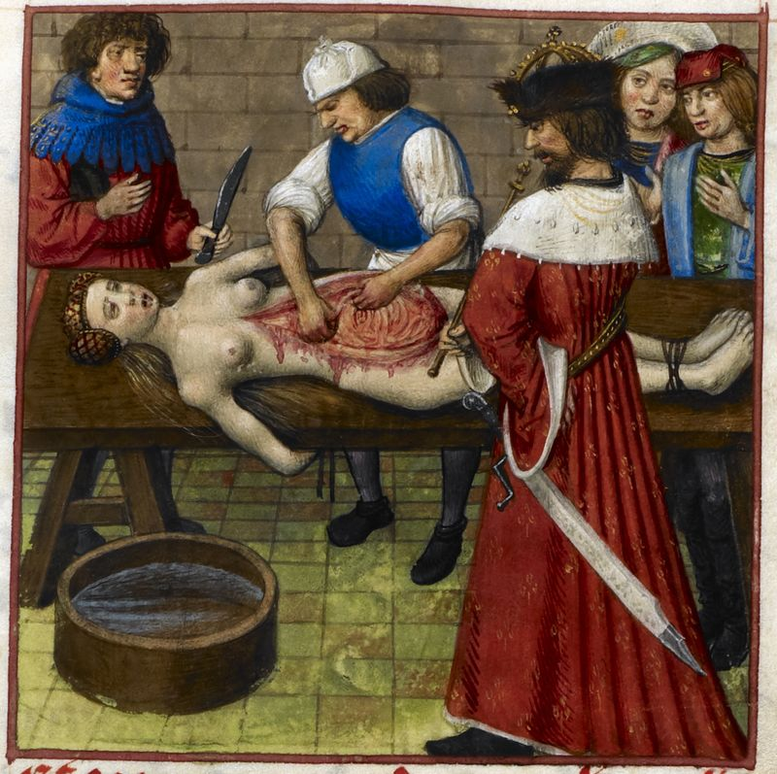

[Detail of a miniature of Nero watching while his mother Agrippina is dissected, Harley MS 4425, f. 59r](http://britishlibrary.typepad.co.uk/digitisedmanuscripts/2014/01/sex-and-death-in-the-roman-de-la-rose.html)

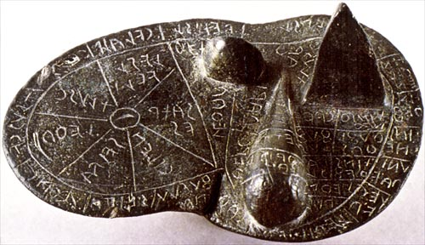

Etruscan Bronze Liver of Piacenza

# Figurative Usage

## Delirium

* from Latin *delirare* ‘deviate, be deranged’ (literally ‘deviate from the furrow’), from *de-* ‘away’ + *lira* ‘ridge between furrows’ (i.e. in ploughing a field)

## Muscle

* from Latin *musculus*, diminutive of mus ‘mouse’ (some muscles being thought to be mouse-like in form)

## Cancer

* from Latin, ‘crab or creeping ulcer’, translating Greek *karkinos*, said to have been applied to such tumours because the swollen veins around them resembled the limbs of a crab.
* *canker* was the usual form until the 17th century.

## Acetabulum

* in modern Anatomy, the socket of the hip bone, into which the head of the femur fits.
* in Zoology, any cup-shaped structure, especially a sucker.
* from Latin, *acetum* ‘vinegar’ + *-abulum*, denoting a container.

## Anthrax

* Greek *anthrax, anthrak-* ‘coal, carbuncle’, with reference to its appearance of fiery red pustules.

## Inoculate

* Originally used in horticulture: from Latin *inoculat-* ‘engrafted’, from the verb *inoculare*, from *in-* ‘into’ + *oculus* ‘eye, bud’.
* The sense ‘vaccinate’ (i.e. injecting) dates from the early 18th century.

# Roots, Part I

## ADELPH-

* ‘brother’, ‘sibling’
* PHIL-ADELPH-ia; IS-ADELPH-ia, conjoined twins united by unimportant tissues, with each body being normal in the development of all essential organs; ADELPH-ous, joined together in bundles, as filaments of stamens

## ANCON-

* ‘elbow’
* ANCON-eus, a small muscle at the back of the elbow joint; ANCON-itis, inflammation of the elbow joint

## CALYPT(R)-

* ‘hidden’
* CALPYTO-BRANCHI-ate, with gills not visible from the exterior; CALYPTO-BLAST-ic, pertaining to hydroids in which gonophore is contained in a gonotheca

## CHORD-

* ‘cord’
* NOTO-CHORD, the dorsal supporting axis of lowest vertebrates

## CHOR(I)-

* ‘fetal membrane’ (chorion), ‘tunic of the eye-ball’ (choroid)
* CHORIO-BLAST-osis, abnormal proliferation of cells of the chorion; CHOROID-itis, inflammation of the choroid coat of the eye

## CLON(US)-

* ‘muscle spasm’
* CLONO-GRAPH, apparatus for recording spasmodic movements of the head, lower jaws, trunk, etc.

## COLL(A)-

* ‘glue’
* COLLA-GEN, the albuminoid substance of the white fibre of connective tissue, cartilage and bone; COLLO-oid, a gelatinous substance which does not readily diffuse through animal or vegetable membrane

## EC-, (OEC-, OEK-), OIK-, OIC-

* ‘house’
* ECO-nomy; ECO-logy, that part of biology which deals with the relationship between organisms and their surroundings; GYN-OEC-ium, pistils, carpels and female organs of a flower

## NOT-

* ‘the back’
* NOT-an-ENCEPHAL-ia, congenital absence of the cerebellum; STENO-NOT-al, with a very small thorax, as a worker insect

## OM-

* ‘shoulder’
* ACR-OM-ion, the flat, long process formed by the lateral extension of the scapular spine situated just above the glenoid cavity; met-ACR-OM-ion, posterior branch process of the acromion process

## OPISTH-

* ‘behind’
* OPISTH-ion, median point of posterior margin of the foramen magnum (i.e., the opening in the skull for the spinal cord); OPISTH-ODONT, having back teeth only

## PHY-

* ‘to grow’
* apo-PHY-sis, a process, outgrowth or projection of some part or organ, as of a bone; DACTYLO-sym-PHY-sis, syndactyly (having some or all digits united, naturally or as a malformation)

## POR-

* ‘passage’, ‘pore’
* POR-ous; POLY-POR-in, antibiotic derived from POLY-PORE fungus; POR-ENCEPHAL-itis, encephalitis with a tendency to form cavities

## PTY-; PTYAL-

* ‘to spit’; ‘saliva’
* PTYALO-CELE, a cyst containing saliva; PYO-PTY-sis, expectoration of pus

## RHABD-

* ‘rod’
* RHABDO-MY-oma, tumour of striated muscle; RHABDO-phobia, morbid fear of being beaten, unreasoning fear at the sight of a stick

## SPOR-

* ‘seed’, ‘spore’
* dia-SPOR-a; ANGIO-SPOR-ous, having spores contained in a theca or spore capsule; SPORO-GON-y, spore formation (= SPORO-GENE-sis); TRICHO-SPOR-osis, fungous infection of a hair shaft

## STIG-

* ‘pricking’, ‘mark’, ‘point’
* STIG-ma; a-STIG-mat-ism, the faulty vision which results from irregularity in the curvature of one or more refractive surfaces of the eye, preventing rays of light from coming to a single focus; OSTEO-STYX-is, surgical puncturing of a bone (here X = G+s)

## TEL(E)-

* ‘completion’, ‘end’, ‘purpose’
* TELEO-logy; a-TELO-GNATH-ia, imperfect development of a jaw; TELO-KINE-sis, last stage of mitosis

## TROCH-

* ‘wheel’, ‘disk’
* TROCO-CEPHAL-ia, an abnormal roundness of the skull caused by premature union of frontal and parietal bones; CEPHALO-TROCH-a, a tubellarian larva with eight processes around the mouth

## XYL-

* ‘wood’
* XYLO-PHONE; XYLO-PHYTE, a woody plant; XYL-oma, a tree tumour; XYLO-TOM-ous, able to bore or cut wood; XYLO-PHAG-ous, wood-eating

# Specialization of Meaning

## disease

* Originally referred to any lack of ease.
* Now a discomfort caused by illness.

## physics

* originally 'the study of the natural universe'
* now 'the branch of science concerned with the nature and properties of matter and energy'

## radish

* originally 'root' (Latin *radix, radic-*)
* now 'a swollen pungent-tasting edible root, especially a variety which is small, spherical, and red, and eaten raw with salad'

## insanity

* originally 'lack of health' (Latin *insanus,* from *in-* ‘not’ + *sanus* ‘healthy’)
* now 'the state of being seriously mentally ill'

## grand mal

* in French, simply means 'great sickness’
* used specifically to mean 'a serious form of epilepsy with muscle spasms and prolonged loss of consciousness'

# Generalization of Meaning

## excruciating

* originally referred to literal torture on a cross (Latin *crux, cruc-* ‘a cross’)
* now 'intensely painful' or even 'very embarrassing, awkward, or tedious'

## eradicate

* originally 'to tear up by the roots’
* now 'destroy completely; put an end to'

## crescent

* originally referred to the moon; from Latin *crescere,* ‘grow’
* can now refer to anything shaped like the new moon

# [*Hemigrapsus sanguineus* in Long Island salt marshes](https://peerj.com/articles/472/)

* *Hemigrapsus sanguineus*
* *Uca pugilator*
* *Carcinus maenas*
* *Ulva lactuca*

# Diseases Named from Symptoms

## hydrophobia

* rabies, especially in humans
* Technically, however, the word only describes a symptom: an extreme or irrational fear of water.

## diabetes

* lit. 'syphon'; from Greek dia- ‘through’ + BA- 'to go'
* Apparently refers to the urinary discharge that accompanies the disease.

## diphtheria

* an acute and highly contagious bacterial disease causing inflammation of the mucous membranes, formation of a false membrane in the throat which hinders breathing and swallowing, and potentially fatal heart and nerve damage by a bacterial toxin in the blood
* from Greek *diphthera* ‘skin, hide’

## cirrhosis

* a chronic disease of the liver marked by degeneration of cells, inflammation, and fibrous thickening of tissue
* from Greek *kirrhos* ‘tawny’ (because this is the colour of the liver in many cases)

## myxoedema

* swelling of the skin and underlying tissues giving a waxy consistency, typical of patients with underactive thyroid glands
* Greek MYX- 'mucus' + OEDEMA- 'swelling'

## hemorrhoid

* a swollen vein or group of veins in the region of the anus
* from Greek *haimorrhoides* (*phlebes*) ‘bleeding (veins)’, from *haima* ‘blood’ + an element related to *rhein* ‘to flow’.

## shingles

* a painful acute inflammation of the nerve ganglia, with a skin eruption often forming a girdle around the middle of the body.
* from Latin *cingulum* ‘girdle’ (*cingere* ‘gird’)

## leprosy

* a contagious disease that affects the skin, mucous membranes, and nerves, causing discolouration and lumps on the skin and, in severe cases, disfigurement and deformities
* from Latin *lepra* ‘scaly’

# Roots, Part II

## ALEX-

* ‘to ward off’
* ALEX-ANDER; ALEX-in, a complex substance with the capacity, in cooperation with antibody and cellular elements, to destroy a variety of pathogenic organisms and other foreign substances

## ANTR-

* ‘cavity’, ‘sinus’
* ANTR-itis, maxillary sinusitis; ANTRO-CELE, an accumulation of fluid in the maxillary sinus

## BRONCH(I)-

* ‘air tube’
* BRONCH-ADEN-itis, inflammation of bronchial lymph nodes; BRONCH-itis, inflammation of mucous membrane of bronchial tubes

## CHLAMYD-

* ‘cloak’, ‘envelope’
* CHLAMYDO-SAUR-us, a genus of reptiles including the frilled lizard of Australia; HETERO-CHLAMYD-eous, having a calyx differing from the corolla in colour

## CHY-; CHYM-, CHYL-

* ‘to pour’; ‘juice’
* CHY-me, the viscid fluid contents of the stomach, consisting of food which has undergone gastric digestion; CYTO-CHYL-ema, the interreticular portion of protoplasm, cell-juice

## CONDYL-

* ‘knob’, ‘knuckle’
* CONDYLE, any rounded eminence such as occurs in the joints of many bones; CONDYL-oma, a wartlike growth or tumour

## CORM-

* ‘trunk of a tree or body’
* RHIZO-CORM, an underground stem like a single-jointed rhizome, a bulb; SCHISTO-CORM-us, having a cleft thorax

## GON(I)-

* ‘angle’
* PENTA-GON; MICRO-GONI-SCOPE, an apparatus for measuring extremely small angles, as in ophthalmology

## HAL-

* ‘salt’
* HAL-ite, rock salt; HALO-PHYTE, a shore plant, a plant capable of living on salt; HALO-GEN, any one of the nonmetallic elements: iodine, chlorine, bromine, fluorine

## PALI(N)-

* ‘again’, ‘black’
* PALIN-DROME; PALIN-ODE; PALIN-DROM-ia, recurrence or intensification of a disease; PALI-OP-sia, recurrence of a visual impression after stimulus has ceased

## POIKIL-

* ‘varied’, ‘irregular’, ‘mottled’
* POIKILO-CYTE, a large red blood cell or irregular shape; POIKILO-THERMAL, a cold-blooded animal, of which the temperature varies with its surroundings

## PYCN-, PYKN-

* ‘thick’, ‘frequent’ PYCNO-meter, instrument for determining the specific gravity of fluids

## PYL(E)-

* ‘gate’, ‘entrance’
* THERMO-PYL-ae; apo-PYLE, exhalant pore of a sponge; MICRO-PYLE, aperture for admission of pollen tube at ovule apex; PYLE-THROMBO-PHLEB-itis, inflammation and thrombosis of the portal vein

## SPERM(A)-, SPERMAT-

* ‘seed’, ‘semen’
* COELO-SPERM, a carpel hollow on its inner surface; GYMNO-SPERM-ous, having seeds not enclosed in a true ovary, as conifers; SPERMATO-ZOON, a male reproductive cell; SPERMATO-CYST, a seminal sac

## SPHEN-

* ‘wedge’
* SPHEN-oid, a basal compound skull bone of some vertebrates, including humans; SPHEN-oid-itis, inflammation of the sphenoid air sinus

## SPIR-

* ‘coil’
* SPIR-al; ACRO-SPIRE, the first shoot or sprout, being spiral, at the end of a germinating seed; SPIR-eme, threadlike appearance of nuclear chromatin during the prophase of mitosis

## SYRING-, (SYRINX)

* ‘pipe’, ‘tube’
* DACRYO-SYRINX, a lacrimal fistula, or a syringe for use in lacrimal ducts; SIALO-SYRINX; a salivary fistula, or a syringe for use in salivary ducts; SYRINGO-PHIL-us, genus of parasitic mites that live in the gullets of birds

## TA-

* ‘to stretch’
* BRONCHI-ec-TA-sis, dilatation of bronchi; IRIDO-TA-sis, stretching the iris, as in the treatment of glaucoma; PHLEB-ec-TA-sia, dilatation of a vein, varicosity

## TON-

* ‘stretching’, ‘tension’
* TONE; TON-us, the state of partial contraction characteristic of normal muscle; a-TON-ia, absence of tonus; OPTHALMO-TONO-meter, an instrument for measuring inter-ocular tension; PSYCH-en-TON-ia, mental strain or overwork

## TRACHEL-

* ‘neck’
* LAPARO-TRACHELO-tomy, low caesarean section in which the peritoneal cavity is not opened, the approach being through the neck (*cervix*) of the uterus; TRACHELO-SYRINGO-RRHAPH-y, operation for vaginal fistula with stitching of the *cervix uteri* (the neck of the uterus)

# Words You Might Not Recognize

## date

* the fruit is from Greek DACTYL- ‘finger’ (because of the finger-like shape of its leaves)

## dropsy

* old-fashioned or less technical term for oedema
* shortening of *idropesie,* earlier form of obsolete *hydropsy,* from Greek *hudrōps* ‘dropsy’, from *hudōr*/HYDR- ‘water’

## sciatica

* pain affecting the back, hip, and outer side of the leg, caused by compression of a spinal nerve root in the lower back, often owing to degeneration of an intervertebral disc
* from Greek *iskhiadikos*/ISCHI- ‘relating to the hips, subject to sciatica’

## elixir

* a magical or medicinal potion
* We have the word via medieval Latin from Arabic *al-'iksīr,* from *al* ‘the’ + *'iksīr*, probably from Greek *xērion* ‘powder for drying wounds’ (from *xēros* ‘dry’)

## frenzy

* from Greek *phrēn* ‘mind’
* in ancient Greece, 'phrenitis' (an inflammation of the brain)

## almond

* from Greek *amugdalē*/AMYGDAL-

## ague

* malaria or another illness involving fever and shivering
* from medieval Latin *acuta* (*febris*) ‘acute (fever)’

## grotto

* a small picturesque cave, especially an artificial one in a park or garden
* via Latin from Greek *kruptē*/CRYPT-, 'hidden'

## gillyflower

* via medieval Latin from Greek *karuophullon* (from *karuon*/KARY- ‘nut’ + *phullon*/PHYLL- ‘leaf’). The ending was altered by association with *flower,* but *gilliver* survived in dialect

# Coming Up: Latin