Greek and Latin in Scientific Terminology, Lecture 7

Andrew Dunning

29 July 2014

# SALVETE!

## Welcome to a new language: Latin!

* Latin is the language of ancient Latium, now Lazio, the region around Rome.
* With the expansion of Roman power, Latin was spoken in various forms across Europe. Very often it developed into what are now known as the Romance Languages.

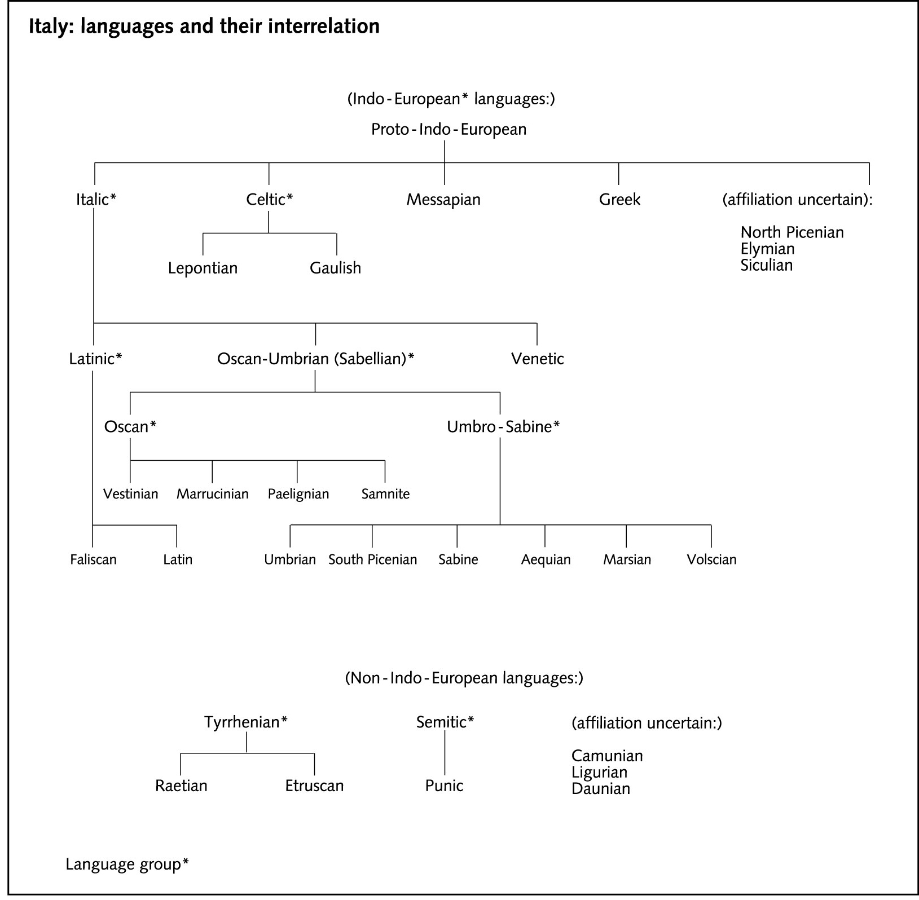

Languages and Their Intersection

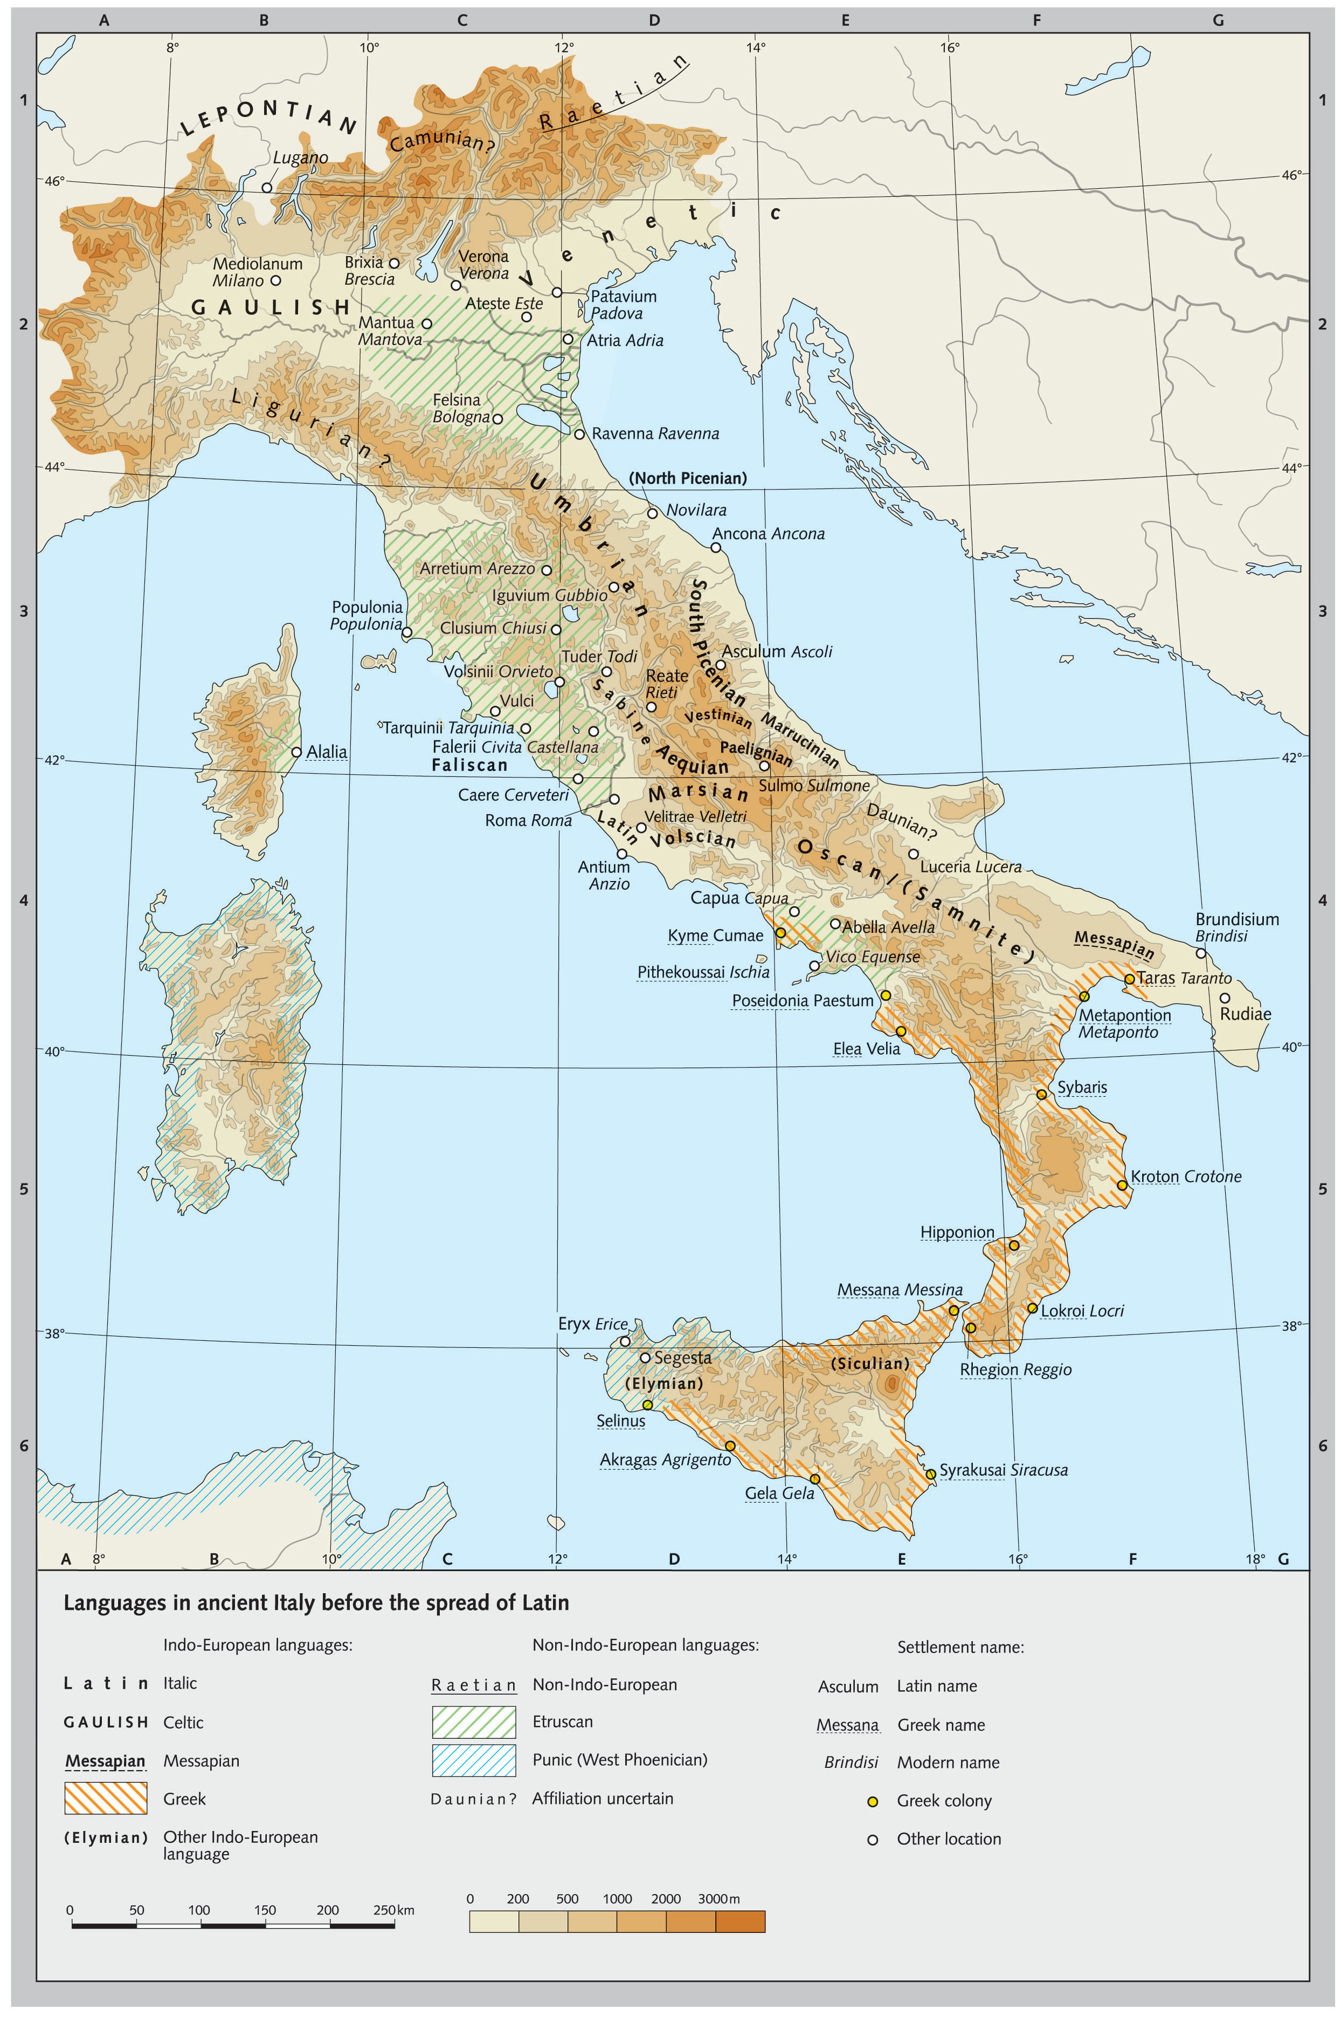

Languages In Italy Before Latin

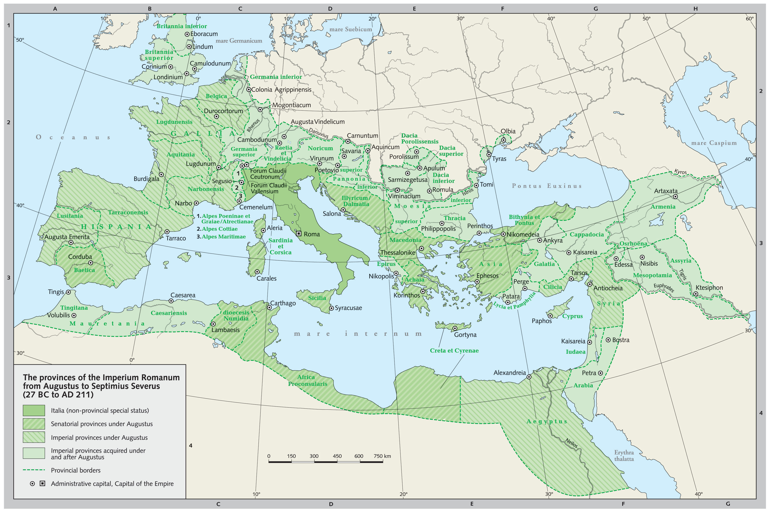

Imperium Romanum

* Classical Latin, even more than Classical Greek, was for many centuries a central part of the education of European elites. As a consequence, its contribution to scientific language has been immense.
* We will learn Latin bases, suffixes and prefixes in just the way in which we learned those coming from Greek.
* We will also, however, learn real Latin nouns and adjectives, since sometimes these occur on their own in scientific writing.
* Latin bases sometimes occur in English on their own, with or without an extra final *-e*:
  + FORT-, ‘strong’ – fort
  + VERB-, ‘word’ – verb
  + GRAV-, ‘heavy’ – grave
* More often, bases are combined with prefixes and suffixes:
  + in-, ‘on’ + GRAV-, ‘heavy’ + esc-, ‘to become’ + -ent, ‘-ing’ = ingravescent
  + FIN-, ‘end’ + -al, ‘pertaining to’ + -ity, ‘state of’ = finality
* Connecting vowels in Latin are most often *i* or *o*, but other vowels can be used:
  + SACR-, ‘sacred’ + i + FIC-, ‘to make’ + -e = sacrifice
  + SACR- + o + SANCT-, ‘sacred’ = sacrosanct
* Greek and Latin prefixes, suffixes and bases sometimes combine, but not nearly as often as they combine within each group:
  + AUTO- (Gr. ‘self’) + MOB- (Lat. ‘to move’ + -ile = automobile
  + hyper- (Gr. ‘over’) + TENS (Lat. ‘to stretch’) + ion = hypertension

## Phonetic Change

* Often when a prefix is added to a base that starts with a consonant, the last consonant of the prefix is ‘assimilated’ to the first consonant of the base.
  + ex-, ‘from’ + FECT-, ‘to make’ = effect
  + in-, ‘not’ + LEG-, ‘to read’ + -ible = illegible
  + ob-, ‘against’ + FEND-, ‘to hit’ = offend
  + sub-, ‘under’ + FER-, ‘to bear’ = suffer
* A final *n* in a prefix will become *m* before a *p* or a *b*.
  + in-, ‘not’ + POSS, ‘to be able’ + -ible = impossible
  + con-, ‘with’ + PLET + e = complete
* Sometimes the base itself will change when a prefix is added. You will learn these variant forms as you learn bases.
  + FACT- gives ‘factory’ and ‘manufacture’, but also ‘effect’ and ‘defect’
  + SED- gives ‘sedentary’, but also ‘reside’

# Prefixes

## ab-, a-, abs-

* ‘away from’, ‘from’
* abduction, abnormal, aversion, avocation, abstraction, abstain

## ad-, ac-, ag- (etc.)

* ‘to’, ‘toward’, ‘near’
* adrenal, adverb, access, aggression, alleviate
* NB: Assimilation will cause the last consonant of this prefix to become the same as the first consonant of the root.

## ambi-, ambo-

* ‘both’, ‘around’
* ambidextrous, ambition, ambisexual, amboceptor, ambosexual

## ante-

* ‘before’, ‘in front of’
* antechamber, antecedent

## circum-, circu-

* ‘around’
* circumference, circumstance, circuitous

## con-, com-, co-, etc.

* ‘with’, ‘together’, ‘very’
* conduct, confine, compose, compress, correspond, cooperate, collect
* NB: Assimilation will cause the last consonant of this prefix to become the same as the first consonant of the root.

## contra-, contro-

* ‘opposite’, ‘against’ (through French, counter-)
* contradict, contraceptive, controversy, controvert, counteract, counterindicate

## de-

* ‘down’, ‘away’, ‘off’, ‘thoroughly’
* describe, descend, depression

## dis-, di-, dif-

* ‘apart’, ‘in different directions’, ‘thoroughly’
* dissect, dispersion, divorce, digress, divert, differ, diffusion

## ex-, e-, ef-

* ‘out’, ‘from’, ‘removal’, ‘completely’
* exclude, expel, exclamation, emit, elect, elongate, effective
* NB: after ex- an initial s in a root sometimes disappears, as in ex-(S)PECT and ex-(S)PIRE.

## extra-, extro-

* ‘outside of’, ‘beyond’
* extraordinary, extrasensory, extrovert

## in-, im-, etc.

* ‘into’, ‘on’ (through French, *en-*)
* incision, induce, illuminate, imprint, irrigation, enclose
* NB: Assimilation will cause the last consonant of this prefix to become the same as the first consonant of the root.

## intra-, intro-

* ‘within’
* intramural, introduce, introvert

## in-, im-, etc.

* ‘not’
* infirm, inefficient, impossible, illegible, irresponsible
* NB: Assimilation will cause the last consonant of this prefix to become the same as the first consonant of the root.

## infra-

* ‘below’
* infrared, infrahuman, infraspecific

## inter-

* ‘between’, ‘among’
* interrupt, intercept, interact

## juxta-

* ‘by the side of’, ‘close to’
* juxtaposition, juxtaspinal

## ob-, etc.

* ‘against’, ‘toward’, ‘completely’
* obstruct, obstacle, obvious, oppose, offer, occur
* NB: Assimilation will cause the last consonant of this prefix to become the same as the first consonant of the root.

## per-

* ‘through’, ‘wrongly’, ‘completely’
* perfect, permeate, pervade, perjury

## post-

* ‘behind’, ‘after’
* postpone, postscript, postgraduate

## pre- (prae-)

* ‘before’, ‘in front of’
* prevent, prepare, precaution, praenomen, praetorian

## pro-

* ‘forward’, ‘in front of’
* progress, project, prolong

## re-, red-

* ‘back’, ‘again’, ‘against’
* reduce, reject, recede, redundant, redemption

## retro-

* ‘backwards’, ‘behind’
* retroactive, retrospective, retrograde

## se-

* ‘aside’, ‘away’
* secede, select, secrete

## sub-, sus-, suc-, etc.

* ‘under’, ‘up from under’, ‘somewhat’
* submarine, subscribe, submerge, suspend, suffer, support
* NB: Assimilation will cause the last consonant of this prefix to become the same as the first consonant of the root.

## super-, supra-

* ‘above’
* supernatural, superstructure, supersonic, suprarenal

## trans-, tran-, tra-

* ‘across’, ‘through’
* transmit, transfer, transfusion, transcribe, transcend, trajectory, travesty, tradition

## ultra-

* ‘beyond’
* ultraviolet, ultramodern, ultrasonic

# The Latin Alphabet

## 23 Letters

A B C D E F G H I K L M N O P Q R S T V X Y Z

* I and J, U and V were treated as the same character in writing, but in the Middle Ages they were pronounced differently.
* W was a medieval invention (literally a double U).



Inscription on Trajan's Column



Rustic Capitals

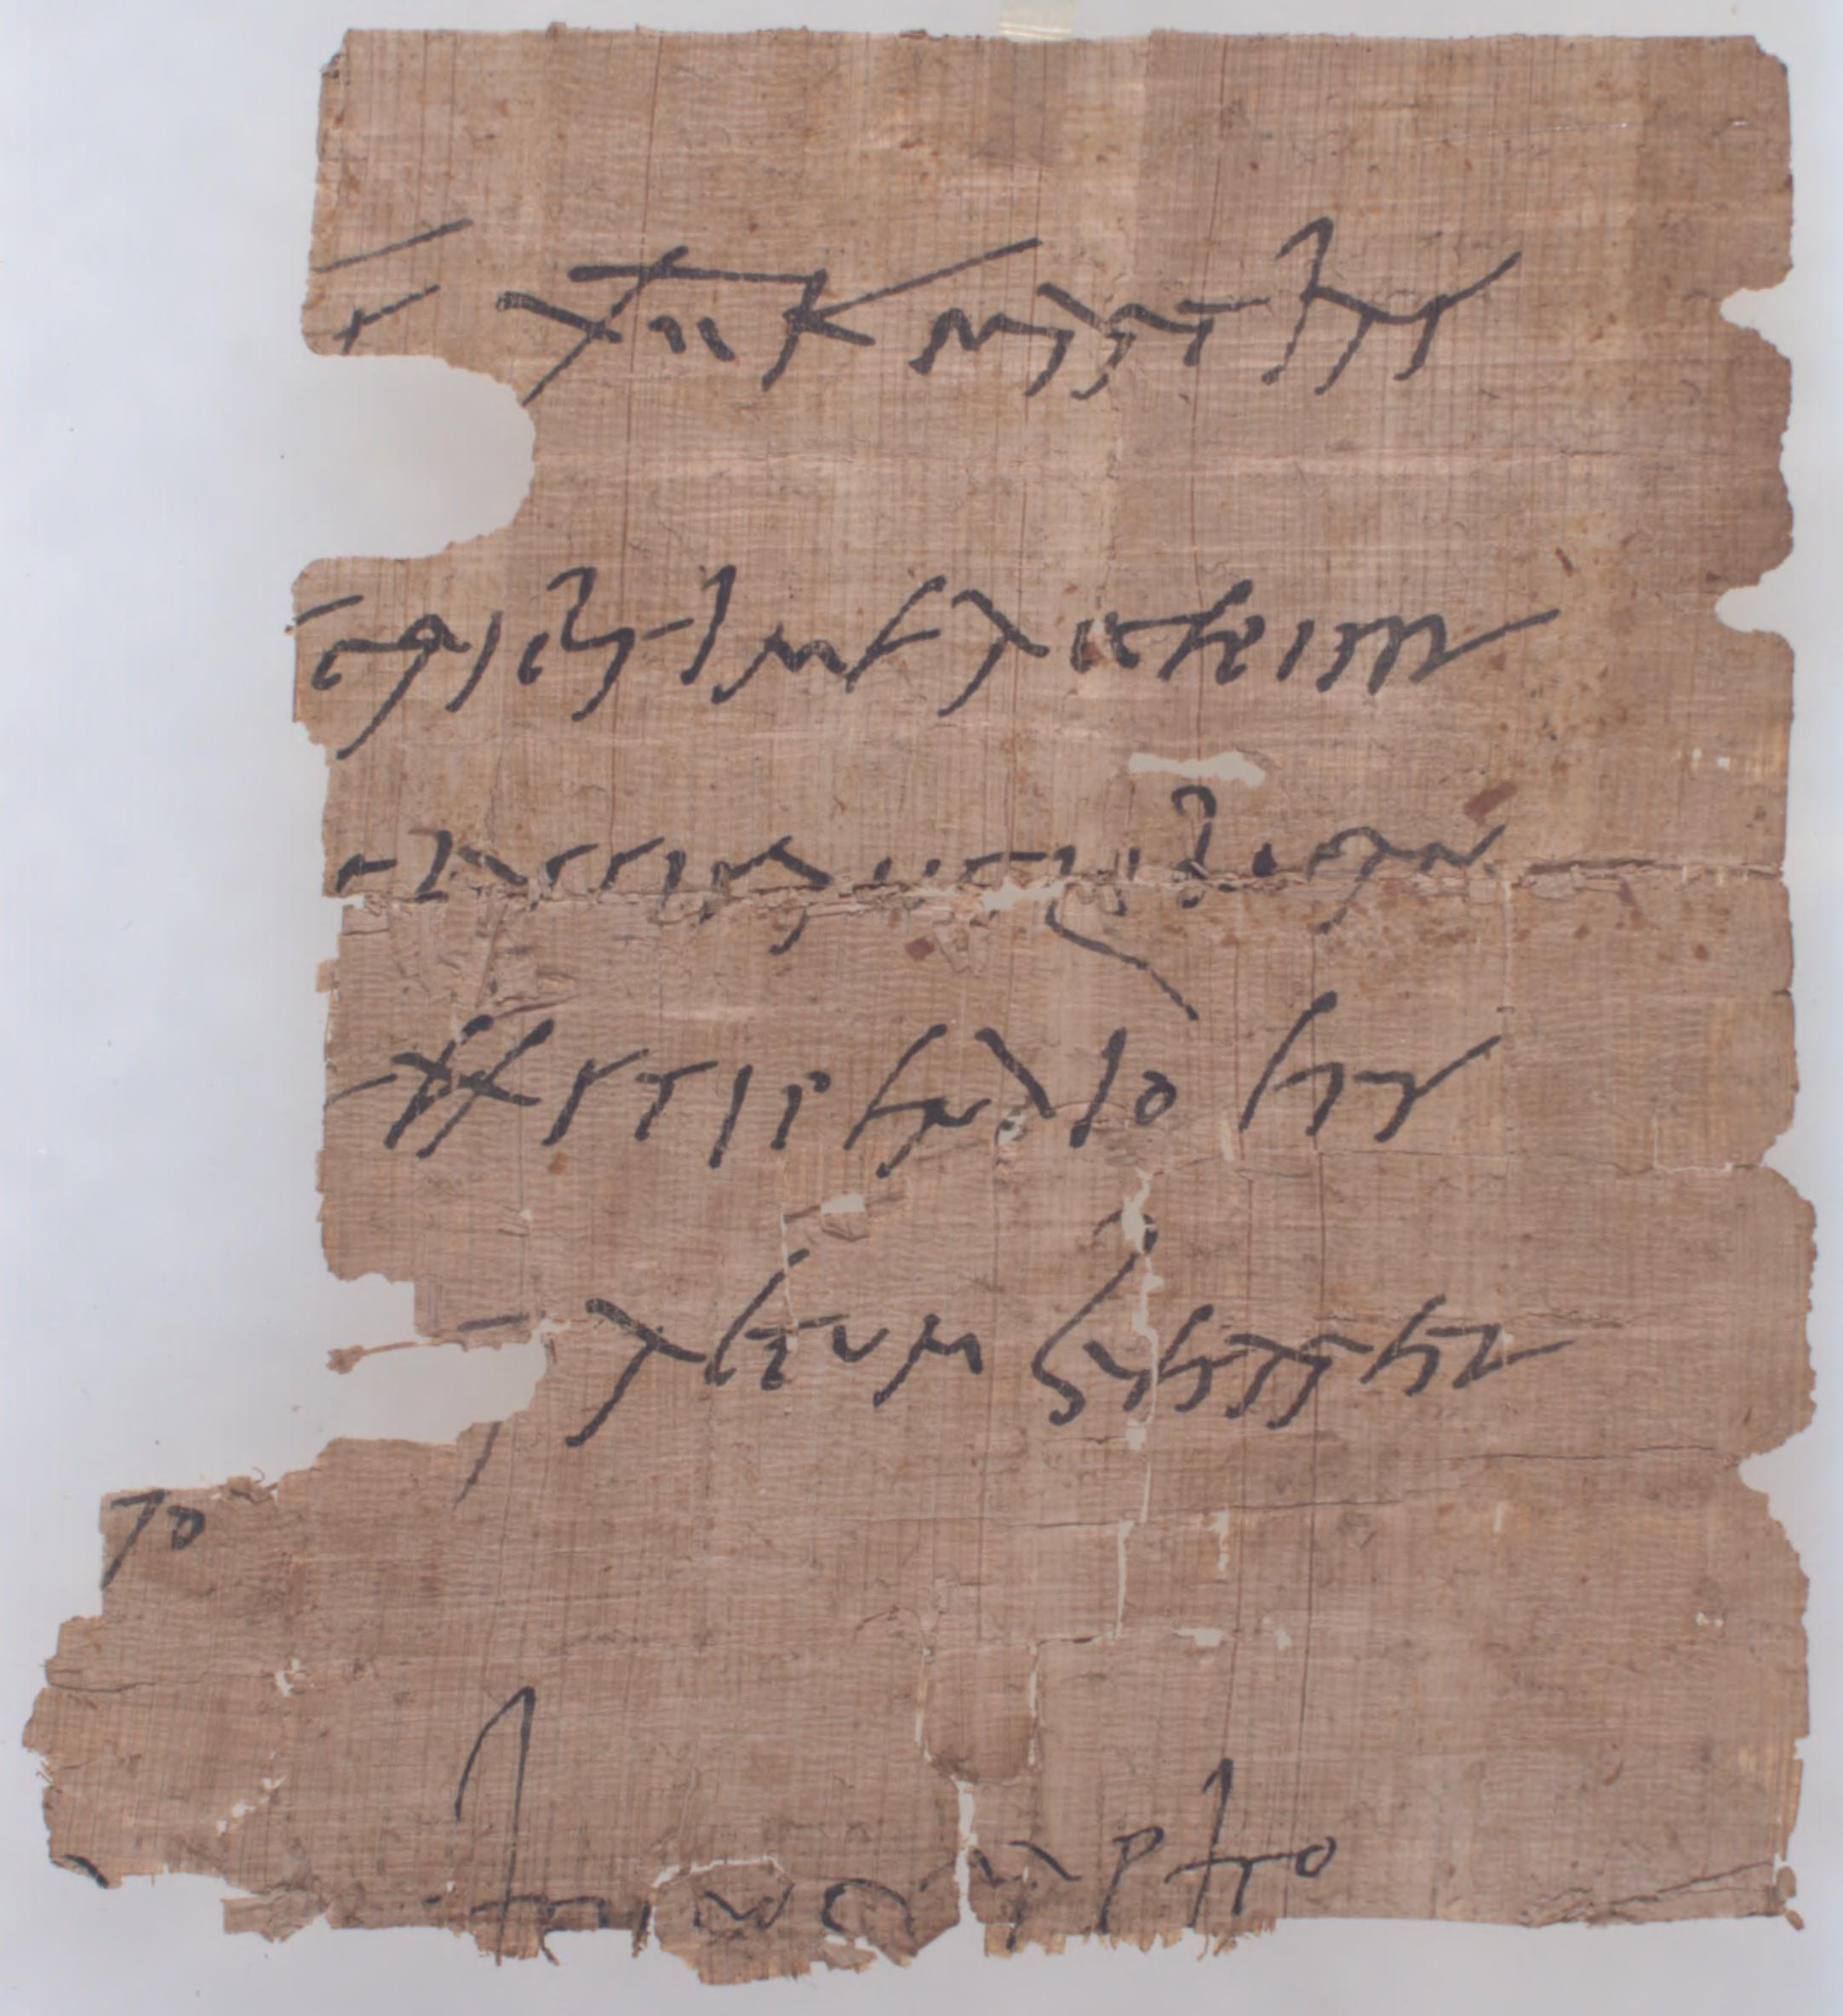

[P.Mich.Inv. 4301](http://www.lib.umich.edu/writing-graeco-roman-egypt/latin_cursive.html)

# Roots, Part I

## CAUD-

* ‘tail’ (*cauda*)
* e-CAUD-ate, without a tail; NUDI-CAUD-ate, having a tail not covered with hair or fur; SACRO-CAUD-al, pertaining to the sacrum and tail region

## CEREBR-

* ‘brain’ (*cerebrum*)
* CEREBR-al; CEREBR-in, a nitrogenous glycoside obtained from brain and similar tissue

## CID-, CIS-

* ‘to cut’, ‘to kill’
* MATRI-CIDE; REGI-CIDE; CON-CISE; suc-CISE, abrupt, appear as if a part were cut off; in-CIS-ura, a notch, depression or indentation, as in bone, stomach, liver, etc.

## DORS-

* ‘back’
* ante-DORS-al, situated in front of the dorsal fin in fish; DORS-ALG-ia, pain in the back; DORSO-CAUD-ad, to or toward the dorsal surface and caudal end of the body

## DUC-, DUCT-

* ‘to lead’, ‘to draw’
* DUCT; de-DUCT-ion; ab-DUCT-ion, withdrawal of a part from the axis of the body or of an extremity; LEVO-DUCT-ion, movement to the left, especially of the eye

## ERR-

* ‘to wander’, ‘to deviate’
* ERR; ERR-or; ERR-ata; ERR-ant, with a tendency toward moving, straying or deviating

## FLEX-, FLECT-

* ‘to bend’
* re-FLECT-ion; re-FLEX, an involuntary, invariable, adaptive response to a stimulus; retro-FLEX-ion, the state of being bent backwards

## FUND-, FUS-

* ‘to pour’, ‘to melt’ (through French, FOUND-)
* FUS-ion; dif-FUSE, spread out; per-FUS-ion, the introduction of fluids into tissues by their injection into arteries, or the passage of fluids through spaces

## GREG-

* ‘flock’, (*grex*)
* con-GREG-ate; se-GREG-ate; e-GREG-ious; GREG-arious, tending to herd together, or growing in clusters

## LACT-

* ‘milk’ (*lac*)
* LACT-at-ion, the period during which the child is nourished from the breast, or the formation or secretion of milk; LACTI-FER-ous, forming or carrying milk

## LATER-

* ‘side’ (*latus*)
* LATERI-GRADE, walking sideways, as a crab; ambi-LATER-al, relating to or affecting both sides; HETERO-LATER-al, pertaining to or situated on the opposite

## MEDI-

* ‘middle’ (*medius*)
* MEDI-ate; MEDIO-DORS-al, on the median line of the back

## OV-

* ‘egg’ (*ovum*)
* OV-ul-at-ion; BIN-OV-ular, pertaining to two ova, applies to twinning; OVI-CIDE, an insecticide effective against an egg stage

## PON-, POSIT-, -POSE

* ‘to place’, ‘to put’ (through French, POUND-)
* ex-PON-ent; im-POUND; ap-POSIT-ion, the state of being in juxta-POSIT-ion or proximity; trans-POSIT-ion, a change of position

## RUG-

* ‘wrinkle’ (*ruga*)
* RUGA, a fold or wrinkle, as of the mucous membrane of certain organs; RUG-os-ity, a condition exhibiting many folds in a tissue or integument

## SANGUI(N)-

* ‘blood’ (*sanguis*)
* SANGU-ine; SANGUI-MOT-or, of or relating to the circulation of blood; con-SANGIN-eous, related by birth or blood

## SICC-

* ‘dry’ (*siccus*)
* ex-SICC-ata, dried specimens; ex-SICC-ant, drying or absorbing moisture; SICC-ant, drying, tending to make dry

## VAL-

* ‘to be strong’, ‘to be well’
* VAL-id; VALE-DICT-ory; bi-VAL-ent, applies to paired homologous chromosomes; VAL-ence, capacity of atoms to combine with other atoms in different proportions

## VARIC-

* ‘twisted and swollen (vein)’ (*varix*)
* VARIC-ose, descriptive of blood vessels that are dilated, knotted and tortuous; NEURO-VARIC-osis, a varicosity on a nerve fibre; VARIX (pl. varices), prominent ridges across the whorls of univalve shells; VARIC-eal, relating to or involving a varix; VARICO-cele, a mass of varicose veins in the spermatic cord

## VERT-, VERS-

* ‘to turn’
* VERTEX, the highest point (Latin 'whirlpool, crown of a head'), from which the word *vertical* comes; a-VERS-ion; VERS-at-ile, hung or attached near the middle and moving freely, as an anther; VERSI-COLOUR-ed, changing from one colour to another in different lights

# Hybrid Words

## Dirckx (1977)

* Some scientists have periodically raised the opinion that words combining multiple languages should not exist.
* In fact, Latin borrowed from Greek even in classical times.
* Much of our medical terminology originates with writings attributed to Hippocrates (of the Hippocratic Oath; ca. 460–ca. 370 BC).
* Celsus (first century AD) is a major source for early Roman usage of medical terminology.
* Thus, Latin suffixes have often used on Greek roots, especially since the Middle Ages:
  + e.g. *pterygion* and *teinesmos* became *pterygium* and *tenesmus*
  + Greek adjectival endings took on Latin form: *kardiakos* becoming *cardiacus*
  + Latin adjectival suffixes began to be appended to Greek nouns, as in *arterialis*, from *arteria*.
* Conversely, Greek suffixes such as *-itis*, *-osis*, and *-otomía* have been used with Latin roots:
  + conjunctivitis
  + granuloma
  + tuberculosis
* Greek prefixes were also attached to Latin stems (epidural, pararectal) and Latin prefixes to Greek stems (subdiaphragmatic, retropharyngeal).
* The combination of Greek and Latin stems in a single word did not nonetheless become common until the nineteenth century; there is still some debate over this.
* Thus, we have both phlebography (pure Greek) and venography (Latin/Greek).

# Roots, Part II

## ARTICUL-

* ‘joint’ (*articulus*)
* inter-ARTICUL-ar, between articulating parts of bones (applies to certain ligaments and fibrocartilages); BI-ARTICUL-ar, two-jointed

## BUCC-

* ‘cheek’, ‘mouth’ (*bucca*)
* BUCC-al, relating to the cheek or mouth; BUCCO-LINGU-al, pertaining to the cheeks and tongue; BUCCO-VERS-ion, condition of tooth’s being out of the line of the normal occlusion in the buccal direction

## CLUD-, CLUS-, CLOS-

* ‘to close’, ‘to shut’
* con-CLUDE; in-CLUS-ive; e-CLOS-ion, the act of emerging from the pupal case, or of hatching from the egg; ex-CLUS-ion, the process of shutting out in a surgical operation by which part of an organ is disconnected but not excised

## CORD-

* ‘heart’ (*cor*)
* ac-CORD; con-CORD; CORD-ate, heart-shaped; sub-CORD-ate, tending to be heart-shaped; post-CORDI-al, situated behind the heart; pre-CORD-ium the area of the chest overlying the heart

## COST-

* ‘rib’ (*costa*)
* COST-ate, with one or more longitudinal ribs or ridges; BI-COST-ate, having two longitudinal ridges or ribs, as a leaf; sub-COST-ALG-ia, pain beneath the ribs or over a subcostal nerve

## CRUR-

* ‘leg’ (*crus*)
* CRURA (pl. of CRUS); the shanks, or leg-like or columnar structures GENITO-CRUR-al, pertaining to genitalia and leg

## CUR(R)-, CURS-

* ‘to run’, ‘to go’
* CURR-ent; oc-CUR; con-CUR; ex-CURR-ent, pertaining to ducts, channels or canals where there is an outgoing flow, or with an undivided main stem, or having midrib projecting beyond the apex

## DENT-

* ‘tooth’ (*dens*)
* in-DENT; TRI-DENT; DENT-ition, the process of teething, or the arrangement of the teeth; DENT-in, a hard, elastic substance, chemically resembling bone, composing the greater part of teeth; DENT-icle, a small, toothlike process

## FEBR-

* ‘fever’, (*febris*)
* FEBR-ile, pertaining to or characterized by fever; FEBR-icula, a slight and transient fever

## FER-

* ‘to bear’, ‘to carry’, ‘to produce’
* suf-FER; re-FER; trans-FER; af-FER-ent, bringing toward (applies to nerves carrying impulse to nervous centres); OVI-FER-ous, serving to carry eggs; PROLI-FER-ate, to multiply

## FOLI-

* ‘leaf’ (*folium*)
* FOLI-age; FOLI-aceous, having the form or texture of a foliage leaf; pre-FOLI-at-ion, the form and arrangement of foliage leaves in a bud; ef-FOLI-at-ion, shedding of leaves

## HER-, HES-

* ‘to stick’
* ad-HER-ent, attached to a substratum; co-HES-ion, the attractive force between the same kind of molecules; ad-HESIO-tomy, the surgical cutting or division of adhesions

## JECT-

* ‘to throw’, JACUL-, ‘dart’ (*jaculum*)
* e-JECT; re-JECT; pro-JECT-ile; OVI-JECT-or, a highly muscular part of the oviduct in many nematode worms that forces the eggs through the genital pore; JACULAT-ory, darting out, capable of being emitted

## MUR-

* ‘wall’ (*murus*)
* inter-MUR-al, situated between the walls of an organ; extra-MUR-al, outside the wall of an organ; MUR-al, pertaining to a wall, as a mural pregnancy

## NOMIN-, NOM-

* ‘name’ (*nomen*)
* NOMIN-al; NOMINAL-ism; para-NOM-ia, nominal aphasia, characterized by an inability name objects; BI-NOM-ial, consisting of two names

## RADI-

* ‘spoke of a wheel’, ‘ray’ (*radius*)
* RADI-ate; RADIO-re-CEPT-or, a terminal organ for receiving light or temperature stimuli; RADI-ole, a spine of a sea urchin; RADIO-therapy treatment of disease by x-rays, radium and other radioactive substances

## SEMIN-

* ‘seed’ (*semen*)
* dis-SEMIN-at-ion; SEMIN-al; SEMIN-at-ion, dispersal of seeds, discharge of spermatozoa; SEMIN-uria, discharge of semen in the urine

## TEG-, TECT-

* ‘to cover’
* pro-TECT; de-TECT; TEG-men, the inner seed coat, or a covering structure or roof, esp. the thin plate over the tympanic atrium; sub-TEG-min-al, under the tegmen or inner coat of a seed

## TUSS-

* ‘cough’ (*tussis*)
* TUSS-ive, pertaining to or caused by a cough; TUSS-ilago, a genus of plants used as a remedy for cough

## VEN-

* ‘vein’ (*vena*)
* RECTI-VEN-ous, having straight veins; VEN-at-ion, the system or disposition of veins; VEN-ule, small vein of a leaf or insect wing

# [A ‘Terror of Tyrannosaurs’](http://www.plosone.org/article/info%3Adoi%2F10.1371%2Fjournal.pone.0103613)

## Your Words

* pathology
* tyrannosaurids, tyrannosauridae
* gregariousness
* palaeontology
* locomotion, locomotor
* oviraptorosaurian
* osteology, osteological
* ichnologic, ichnofamily
* metatarsus
* proximodistal
* daspletosaurus
* *Gorgosaurus libratus*
* phalanges
* tibiotarsus
* astragalus
* tridactyl
* mesaxonic
* palaeoichnological
* Cretaceous
* theropod
* intertarsal

# Roots, Part III

## ARBOR-

* ‘tree’ (*arbor*)
* ARBOR-eous, treelike or pertaining to trees; ARBOR-iz-at-ion, a conformation or arrangement resembling the branching of a tree

## CAL-

* ‘to be warm’
* CALE-FACI-ent, an externally applied medicine that causes a sensation of warmth; de-CAL-esc-ence, the decrease in temperature when rate of heat absorption exceeds rate of heat input

## CARIN-

* ‘keel’ (*carina*)
* CARINA, any keel-like structure, as at the tracheal bifurcation; para-CARIN-al, beside a carina, especially the urethral carina

## CERN-, CRET-, CRE-

* ‘to separate’, ‘to distinguish’, ‘to secrete’
* se-CERN-ment, secretion, applied to the function of a glad; in-CRET-ion, internal secretion, se-CRET-agogue, substance promoting or causing secretion

## CILI-

* ‘eyelid’, ‘eyelash’ (*cilium*)
* super-CILI-ous; CILIA, hairlike, vibratile outgrowths of the ectoderm; CILI-ata, a class of phylum Protozoa characterized by the presence of cilia; CILIO-GRADE; progressing by movement of cilia

## CORN(U)-

* ‘horn’ (*cornu*)
* CORNU-COPIA; UNI-CORN; BI-CORNU-te, with two hornlike processes; CAVI-CORN, hollow-horned, applies to some ruminants; CORNI-FIC-ation, degenerative process by which cells of epithelium are converted into dead, horny tissue

## CUB-, CUMB-, CUBIT-

* ‘to lie’
* suc-CUMB; in-CUMB-ent; in-CUB-us; pro-CUMB-ent, prone, lying face down (in dentistry, said of a tooth whose long axis approaches the horizontal); suc-CUB-ous, with each leaf covering part of the leaf beneath it

## DORM-, DORMIT-

* ‘to sleep’
* DORMIT-ory; ob-DORMIT-ion, numbness of a part due to interference with nervous function, sensation of a part ‘being asleep’; DORMIT-ive, inducing sleep

## FOET-, (FET-)

* ‘offspring’ ‘foetus’
* FET-at-ion, the formation of a fetus, pregnancy; ex-FET-at-ion, extopic or extrauterine pregnancy

## FRANG- (-FRING-), FRAG-, FRACT-

* ‘to break’, ‘to bend’
* FRACT-ion; FRAG-ment; FRACT-ure; re-FRACT, to cause the deviation of a ray of light from a straight line in passing obliquely from one transparent medium to another of different density

## GRAD-, GRESS-

* ‘to step’, ‘to go’
* DIGITI-GRADE, walking with only digits touching the ground; ORTHO-GRADE, walking or standing in the upright position; sub-PLANTI-GRADE, incompletely plantigrade, walking with the heel slightly elevated

## LINGU-

* ‘tongue’, ‘language’ (*lingua*)
* LINGU-ist-ics; BI-LINGU-al; FISSI-LINGU-al, having a bifid or cleft tongue; LINGUO-VERS-ion, displacement of a tooth on the lingual side of its proper occlusion

## MENT-

* ‘chin’ (*mentum*)
* MENT-al, pertaining to the chin; sub-MENT-al, beneath the chin; MENT-alis, a muscle of the lower lip

## PLIC-, PLICIT-

* ‘to fold’
* PLICA, a fold of skin or membrane; com-PLIC-ate, folded (said of leaves or of insect wings); PLIC-at-ion, the act or process of folding

## POT-

* ‘to be powerful’
* POT-ent-ial; OMNI-POT-ent; UNI-POT-ent, giving rise to only one cell or tissue type (said of an embryonic or multiplying cell); POT-ent-at-ion,effect of a substance which, when, added to another, makes the latter more potent as a drug

## PUR-

* ‘pus’ (*pus*)
* PUR-ulent, containing, consisting of, or forming pus; sup-PUR-ate, to form pus; PURO-HEPAT-itis, suppurative inflammation of the liver

## REN-

* ‘kidney’ (*ren*)
* ad-REN-al, adjacent to the kidneys, or relating to or derived from adrenal glands or their secretion; sub-RENI-form, slightly kidney-shaped; RENO-TROP-ic, specifically attracted to kidney tissue

## SON-

* ‘sound’ (*sonus*)
* ultra-SON-ic, pertaining to sounds with a frequency above that of audible sound; SONI-FIC-at-ion, the act or process of producing sounds, as stridulation of insects

## SUD-

* ‘to sweat’
* ex-SUD-at-ion, process of oozing out slowly; SUDORI-FIC, inducing sweating; SUD-at-orium, a hot air bath or a room for such a bath

## TRUD-, TRUS-

* ‘to push’, ‘to thrust’
* in-TRUDE; in-ob-TRUS-ive; ex-TRUS-ion, a forcing out (in dentistry, extension of a tooth beyond the occlusal plain)