SPM 4670
Hai Wang

UML Coursework & Presentation

You are asked to capture the requirements, analyze, and design for the system your client want to build.

Default system
Your client wants to develop a banking system with online interfaces for Duke’s Bank. Duke’s Banking can be used by (i) bank clerks and administrators to manage customers, their accounts and details, and record various banking transactions (e.g., depositing, withdrawing etc.) and (ii) by customers to access account histories and perform transactions in person or over the Web, where several devises of mobile (e.g. mobile phone, PDA) or fixed nature (e.g. laptop, PCs) can be used. Customers can also interact with the online banking system through ATM terminals connected to the online system to access account histories and perform transactions. Customer accounts and transaction information are maintained in databases connected to the online system.

- Analyse the client’s requirements stating your own assumptions. The specification you provide should reflect your client’s (e.g., Duke’s Bank) needs and views. Be precise and concise.

- Use Goal-Oriented RE to model the goals in your system-to-be.

- Elicit a set of functional and non-functional requirements for the client’s system

  - Express the functional & non-functional requirements with a unique ID for easing traceability,
  - Group your requirements into sensible sets (e.g., user interface, depositing, etc.),
  - Prioritise your requirements using the MoSCow criteria.

- Identify and document the scope of the first release of your system in an RUP elaboration sense. Continue the analysis and design restricted to this release.

- Use UML to document the analysis and design of your system to a professional level. The UML description of your system should carry at least one diagram from each of the UML modelling diagrams sketched in Figure 1: you may omit use case diagrams and merge both deployment/component and state/activity diagrams. You should follow the format discussed in the lectures related to UML.

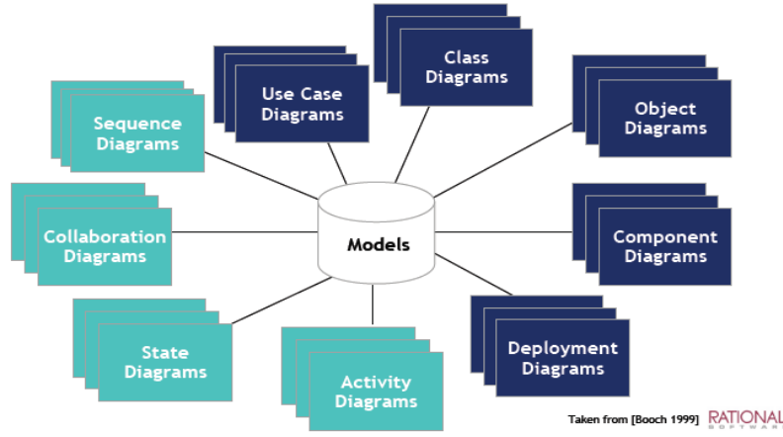

Figure 1. UML Diagrams

  - Provide an Activity Diagram for your system. Use Forks and Swim lanes as appropriate. Write down appropriate use case description(s) for this diagram.
  - Perform Class Analysis:
    - Perform noun-verb analysis of your requirements document; identify the potential classes and potential operations for these classes using what discussed in Lectures,
    - Perform responsibility-driven analysis for the system to identify potential classes. Derive your CRC (i.e., Class, Responsibility, and collaborators)
    - Produce a first-cut Class Diagram to combine the consolidated results of using the above two techniques – i.e., noun-verb analysis and responsibility-driven analysis to obtain classes.
    - Refine your Class Diagram. This should provide details on attributes, operations, relationships, visibility, multiplicity, etc).
  - Provide Object Diagram(s) for your system.
  - Provide Sequence Diagrams for three selected scenarios.
  - Provide Collaboration Diagrams for three selected scenarios.
  - Select a subsystem of interest from the described scope: list the possible states and possible events for this subsystem. Provide a state diagram which models the state and events.
  - Provide a Deployment Diagram.
- Your reflection on this coursework.

Requirements:

- This exercise will be assessed in two components: a written report (75 marks) and a presentation (25 marks). Prepare a summary presentation (15 minutes) covering representative aspects of your analysis. Reports need to be submitted before 5th March Via email (h.wang10@aston.ac.uk). Use “CS4670 Coursework Submission” in the email subject heading. The presentation will take place on 9th March.
- Be consistent in using the naming across all your diagrams and their supporting documentations.
- Strive for sensible assumptions and professional modeling.
- Make your own judgment in what should be modeled, documented, and be presented.

To be confirmed

