Introduce of mfeeg
Outline of EEG analyses and workflow of mfeeg.
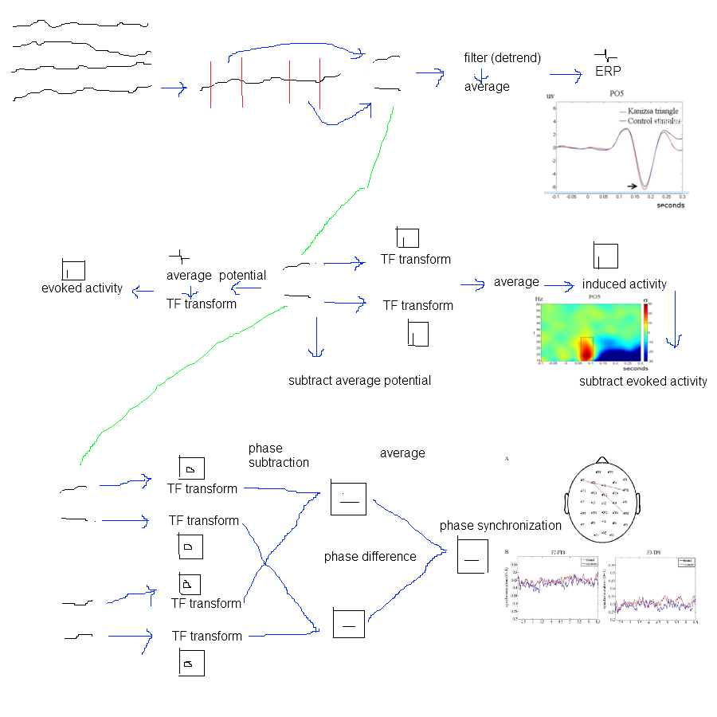
Outline of EEG analyses.

data format and file naming
raw data: sample × electrode; sbj_raw.mat.
epoch data: trial × epoch sample × electrode; sbj_epo.mat.
erp data: electrode × epoch sample; sbj_erp.mat
time frequency data: frequency × epoch sample × electrode; sbj_tf.mat
synchronization & coherence (electrode pair) data: frequency × epoch sample × electrode pair; sbj_syn.mat

others:
event code file. Event × sample point. sbj_ecd.mat.

file naming
subject _ data format _ condition _ subcondition.mat

sample rates, sample points and time points
use actual sample points rather than time points
data conversion & data post-conversion
Tutorial
Single subject analysis and scripts, with sample data.

rereference (po6)
with without
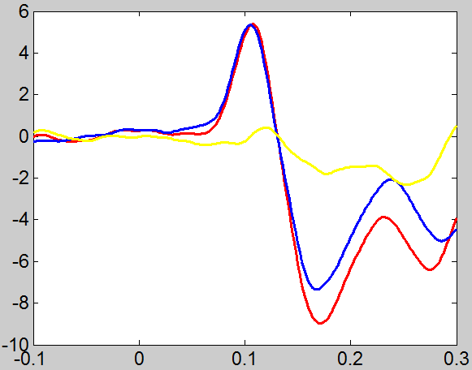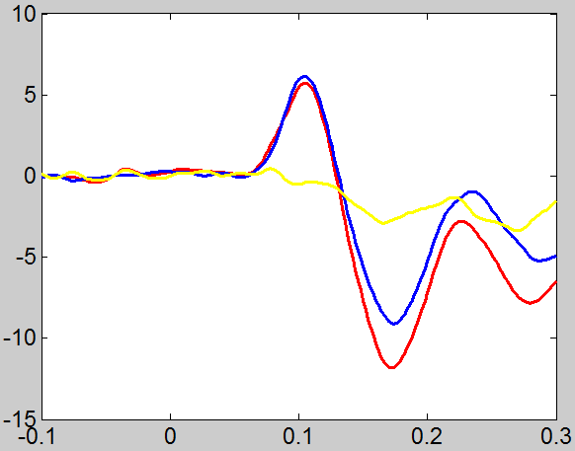

Group analysis and scripts.
Factors to affect tf display (po6) with rereference
power
without normalize
tfboth tfnplone tf npltwo tfpl plf
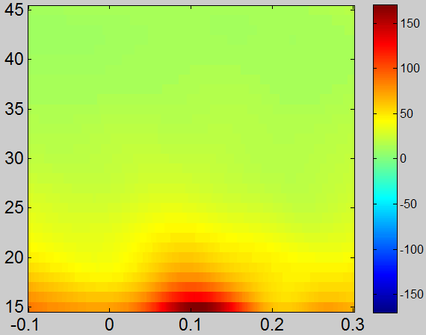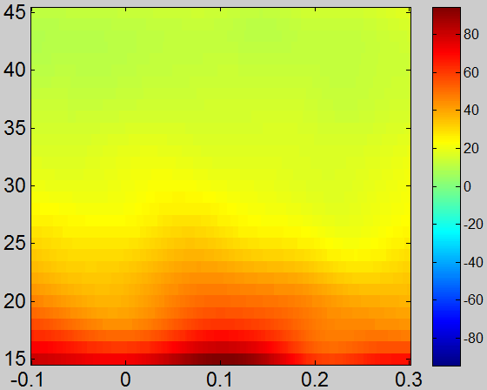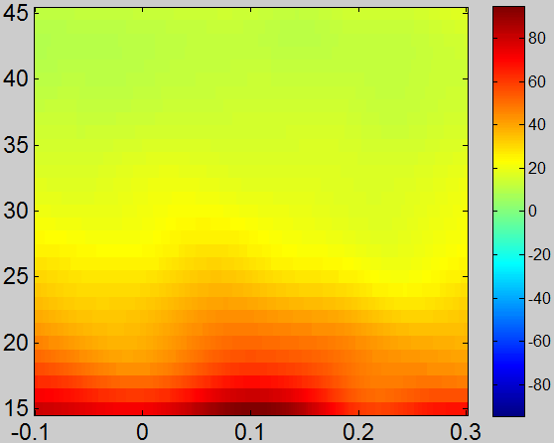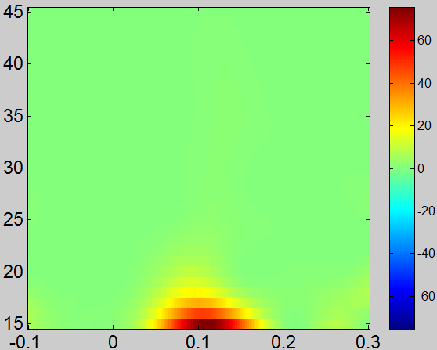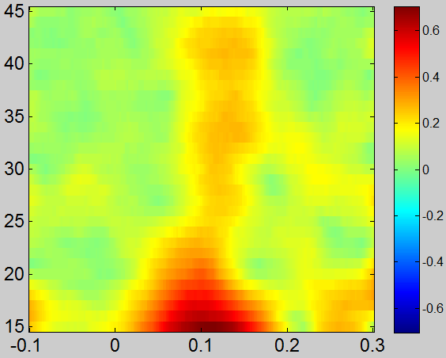
power
with normalize2
tfboth tfnplone tf npltwo tfpl plf
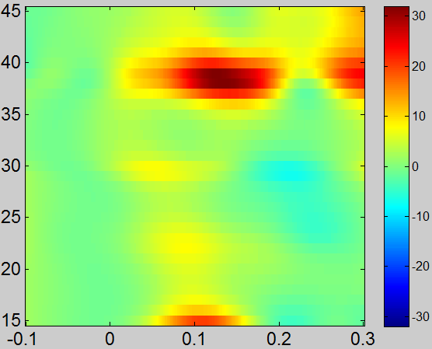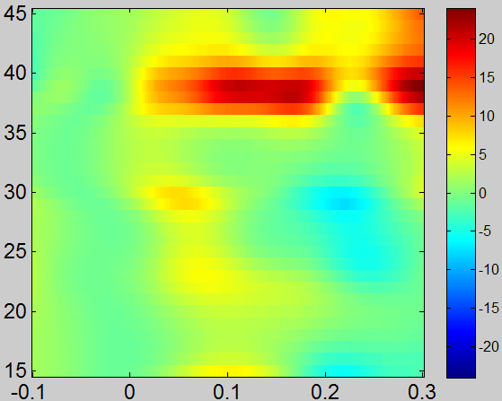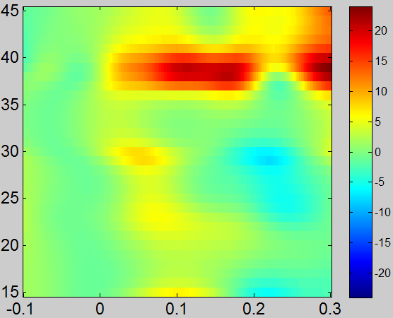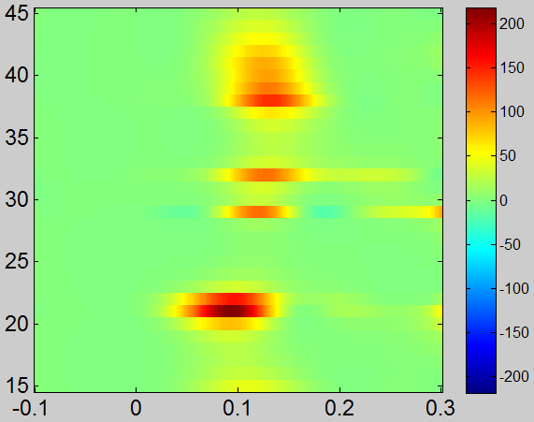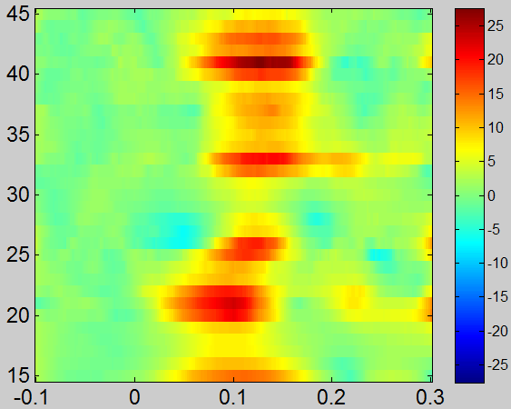

power
normalize1 3
tfnplone
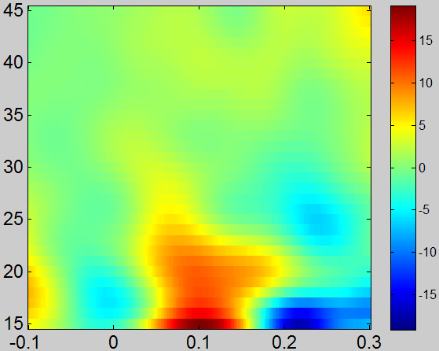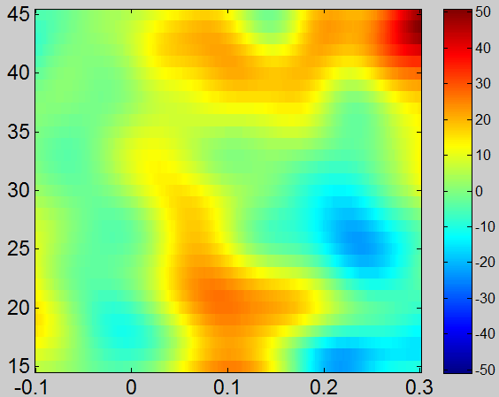
without rereference
with normalize2
tfboth tfnplone tfpl plf

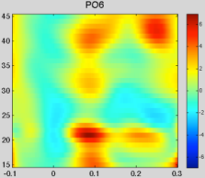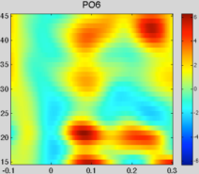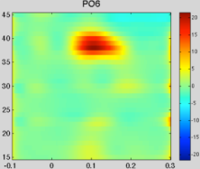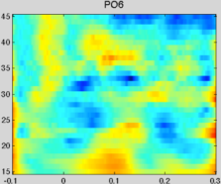
normalize1 3
tfnplone
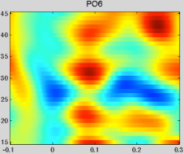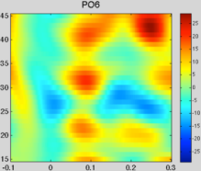

db. with rereference
without normalize
tfboth tfnplone tfnpltwo tfpl plf
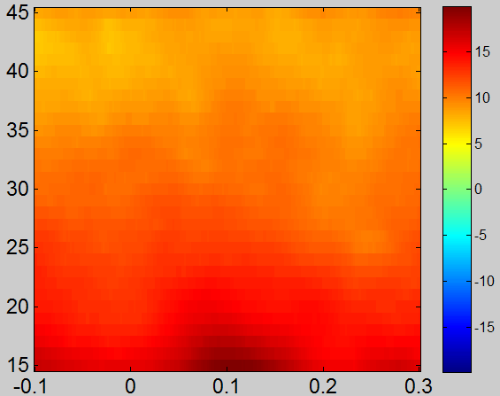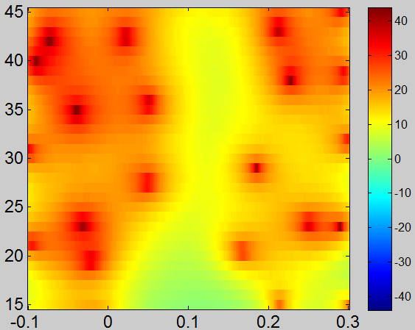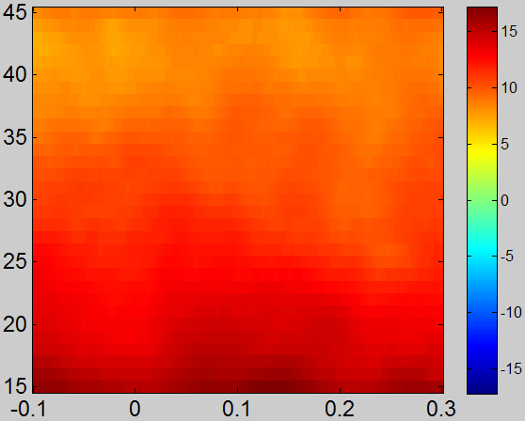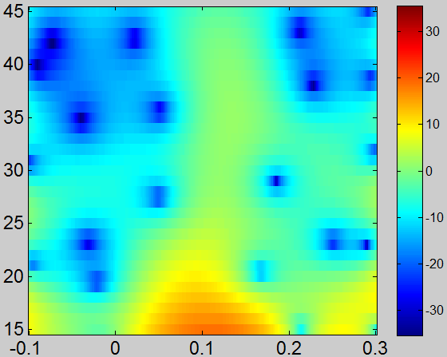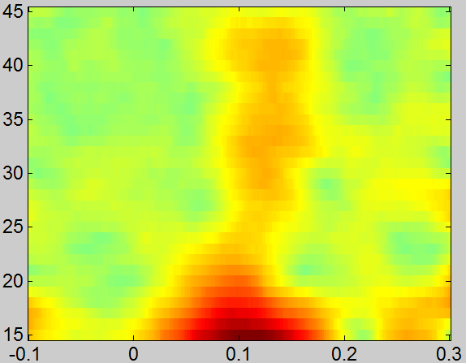
with normalize2
tfboth tfnplone tfpl plf
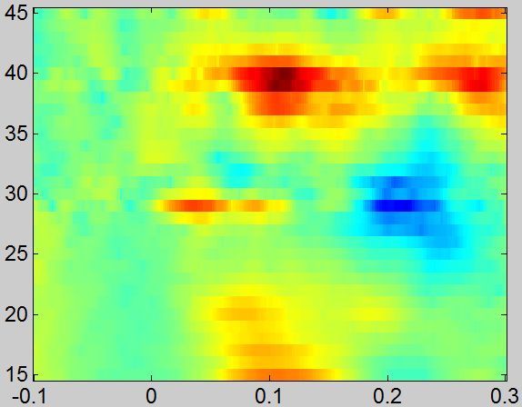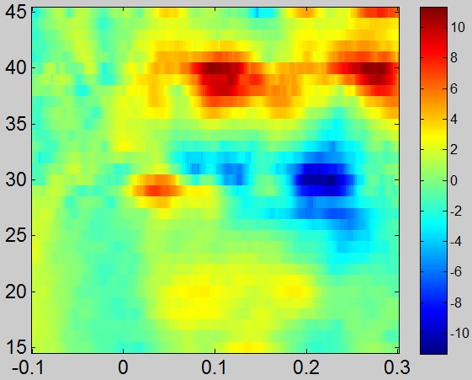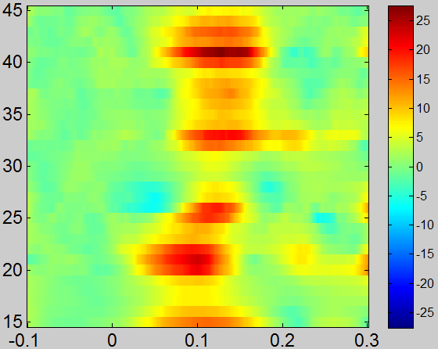
Functions

Core functions
preprocessing
Mf_epoch
Mf_eegafr

Erp
Mf_eegfilter
Mf_eegrmb
Mf_eegavg

Tf
Mf_eegtf
Mf_tfnorm

Phase synchronization
Mf_eegsync

Statistic
Mf_erpstat
Mf_erpstat_correct
Mf_tfstat
Mf_tfstat_correct

Mf_image
Mf_drawerp
Mf_drawtf
Mf_eegsync_draw
Mf_topo2d

Functions called by core functions

Other analysis functions

Miscellaneous functions

Function relationship
Mf_ev22ecd
Mf_epoch
Mf_epoafr (mf_epofilter, mf_epormb, mf_epo_keeptrial)
Mf_epofilter(mf_filter)
Mf_epoavg

Mf_drawerp (axcopy & copyaxis – from eeglab)
Mf_drawtf (axcopy & copyaxis – from eeglab)
mf_topo2D

mf_eoptf (mf_tfcm(mf_cmorlet), conv_srz, related function mf_cmorlet_character, mf_cmorlet_range)
mf_tfnorm()

ncw
fixed ncw
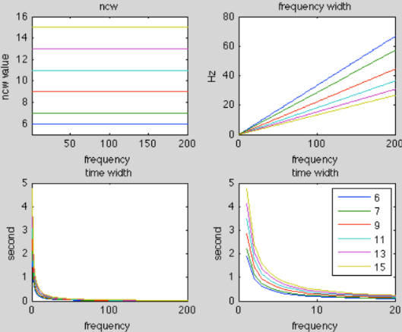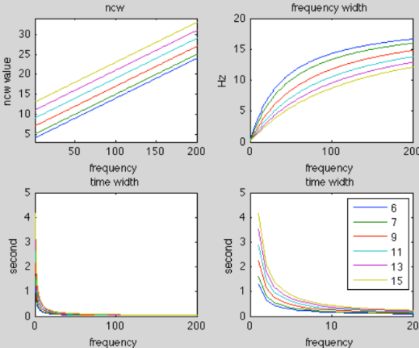
fixed ncw ncw=6 at 20 Hz, varying ncw, step=0.1
as can be seen, the problem of fixed ncw is two coarse frequency resolution at high frequencies and two coarse time resolution at low frequencies. In addition, frequency resolution linearly changed while time resolution exponentially changed.
By linearly increasing ncw , the problems are reduced.
In practice and with the literature, for gamma band > 20 Hz, a time window less than 100ms should be used, so ncw =6 at 20 Hz. The step would change, especially, time resolution at low frequencies. When step = 0.16, 0.21, 0.24, time window at 1 Hz are around 1s, between 0.5~1s, around 0.5s. In practice, I use step=0.21 for most cases.
ncw=6 at 20 Hz, step=0.21. which is good for most case, since ncw is varying.
(20Hz, ncw=6, freq window=6.667Hz, time window=0.096s)
(3Hz, ncw=2.43, freq window=2.469Hz, time window=0.258s)
(1Hz, ncw=2.01, freq window=0.995Hz, time window=0.640s)
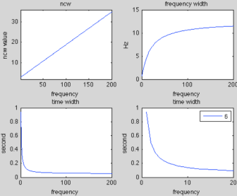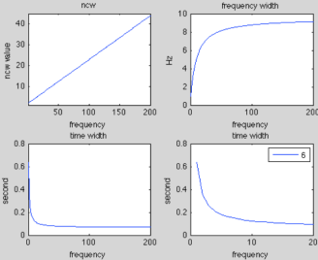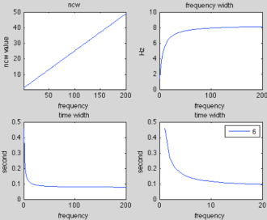
step = 0.16 step = 0.21 step=0.24

for step =0.2, for ncw=6 at 35 Hz, ncw will <0 at 1 Hz.

Use increasing ncw step with ncws at 35 Hz.
In practice, using ncw=7 will be fine for all case.

Sample
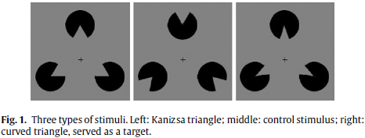
Xiang Wu et al, 2009.
stimuli. 400ms. ISI 1~1.5s. 200 trial for each.
Acquisition. Neuroscan. 64 chs. 500Hz.
Analyze. -200ms ~ 400ms (-10~200 points). +-75uv. 0.01~30 Hz. curved triangle is not included in analyses.

raw data: (acquired by Neuroscan)
sbj01.cnt
sbj01.ev2

%%%
data format converstion
"kanizsa_post_convert"

transform "cnt" file to .dat file (txt file). (using Neuroscan. "save" only data information)
trasform .dat to mat
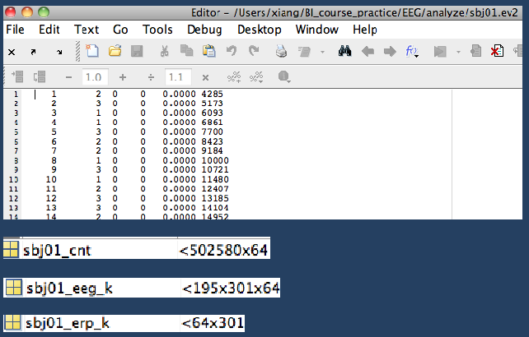
for stimulating, need event code and timing.
for Neuroscan ev2 file, use "mf_ev22ecd"

%%%
epoch file
"kanizsa_epo.m"

epoch: "mf_epoch.m"
afr:"mf_epoafr.m"
reref:"mf_eporeref.m"

%%%
erp
"kanizsa_erp.m"

filt: "mf_epofilter.m:
remove baseline: "mf_epormb"
average: "mf_epoavg"

%%%
tf
"kanizsa_tf.m"

time frequency transform: "mf_tf.m"
tf normalize: "mf_tfnorm"

