CS-521 Homework Assignment 1 ~ JAMES HARDY

**Instructions**

* Please read the Assignment Directions below.

**Assignment Directions**

Answer the following questions in this document (drawn from pages 78 – 79 in the text)

1. What is a program?

*A program is a human readable essay that says how to solve a problem. It is also executable by a computer,* (BU MET CS 521 MODULE 1).

1. Python is an interpreted language. What does “interpreted” mean in this context?

*Rather than utilizing the method used by other languages, (multiple steps of compiling and translating – C++) python is dynamically typed. The python interpreter then takes this code written by humans, and converts it to bytecode; from there the computer takes instructions based on that bytecode. This creates an environment in which it is faster to debug, test, and write code. Unfortunately, this tradeoff comes with performance negatives when scaled out to large levels of data/memory. Compiled languages like java and C# are able to consistently perform faster than interpreted language-based applications (eg. python) in certain situations. Even still, the convenience aspect of python’s interpreter allows it to execute many complex functions with extreme efficiency when compared to java and C#.*

1. What is a Python *comment?* How do you indicate a comment? What purpose do they serve?

*# OR “”” “””*

*#Python comments are written with # - the pound sign. (It is also possible in some IDE’s to use “”” to start a block comment.)*

*Comments are extremely important when it comes to readability by humans. Sometimes code is around for a long time; and outlasts employees and developers who wrote the code. Readability is arguably more important than functionality; as code is difficult to maintain if the original person who wrote it is no longer around. If nobody knows what any of the variables mean, or* ***why*** *certain logic is being executed, then perfectly functional code can quickly become useless and non-functional when requirements are updated. Code that is functional, but inefficient is difficult to improve without proper comments.*

1. What is a *namespace* in Python?

“A namespace is a collection of currently defined symbolic names along with information about the object that each name references. You can think of a namespace as a [dictionary](https://realpython.com/python-dicts) in which the keys are the object names and the values are the objects themselves. Each key-value pair maps a name to its corresponding object,” (Real_Python, 2021)

Types: Built-in, global, enclosing, local, namespace. LEGN

1. Whitespace:
   1. What is whitespace in Python?

*Whitespace is used to delineate how code is nested within itself and other code. It says what node is a child to which parent / grandparent node etc.*

*“Indenting a line is like adding an opening curly brace, and de-denting is like a closing curly brace.” (unspecifiedwordpress, 2019)*

*“Whitespace is used to denote blocks. In other languages curly brackets ({ and }) are common. When you indent, it becomes a child of the previous line. In addition to the indentation, the parent also has a colon following it.”(Stack Overflow, 2016)*

* 1. When does whitespace matter?

*Indentation and whitespace are extremely important in python, and not paying proper attention to indentation will result in improper nesting of code; and this will CHANGE THE OUTPUT. It is therefore crucial to understand where a piece of code ‘belongs’.*

* 1. When does whitespace not matter?

*Within lines, there is no difference to the amount of whitespace. However, sometimes adding whitespace on a single line can improve readability.*

1. Explain the difference between a statement and an expression. Give an example of both and explain what is meant by a statement having a *side effect.*

*Statement: Print(‘hello world!’) - Tells the computer to do something, but values are not changed. Vs. Expression: x = 27 % 7 -Explicitly changes the value of a variable.*

“In general, any lasting effect that occurs in a function, not through its return value, is called a side effect. There are three ways to have side effects:

Printing out a value. This doesn’t change any objects or variable bindings, but it does have a potential lasting effect outside the function execution, because a person might see the output and be influenced by it.

Changing the value of a mutable object.

Changing the binding of a global variable,” (RUNSTONE, 2021)

1. Mixed operations:
   1. What type results when you divide an integer by a float? A float by an integer?

*In python 3: Both situations will yield a float:*

*10.5 /5 = 2.1 100 /50.1 = 1.996 100.1/50 = 2.002*

* 1. Explain why that resulting type makes sense (as opposed to some other type).

*It is more specific and accurate to how math works. Also we can always round the answer to an integer using int().*

1. Consider integer values of a, b, and c, and the expression (a + b) * c. In mathematics, we can substitute square brackets, [], or curly braces, {}, for parentheses, (). Is that same substitution valid in Python? Try it.

*This will not work, because in python the {} braces have a specific function related to dictionaries and sets. We are telling the computer that we have a dictionary or set; rather than an expression. ( a molecule rather than an atom) This is affecting our output:*

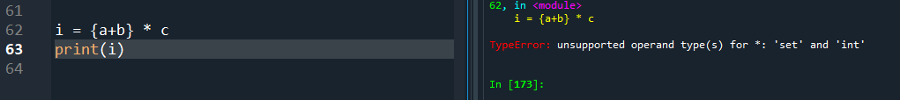

*Correct syntax: (variables were pre-defined outside of screenshot).*



1. Assignment:

my_int = 5  
my_int = my_int + 3  
print(my_int)

* 1. If you execute the three lines of code above, what will be printed?   
     Explain your answer using the rules of assignment.



[67] Initializes variable and temporarily assigns integer 5 to it.

[68] Updates the value of variable by adding 3 to 5. This line comes after 67, so it will be executed next; updating our variable to its current state; discarding its previous state.

[69] Calls the print function with parameter of our variable. This will show us whatever value was assigned to the my_int variable.

* 1. Rewrite the line my_int = my_int + 3 using the += symbol



1. Assignment:  
     
    my_var1 = 7.0  
    my_var2 = 5  
    print(my_var1 % my_var2)  
     
   If you execute these three lines of code, what will be printed?

*Error message due to improper indentation (if entered as above…).*



Fixing the indentation yields the correct result:

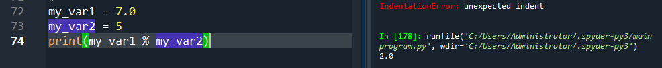

**Where to submit?**

Click Assignments in the Navigation Area and then click on the title of the assignment to enter the submission area and upload your response.

# References

*clouds.eos.ubc.ca*. (2021). Retrieved from https://clouds.eos.ubc.ca/~phil/courses/atsc301_private/whirlwind/02-Basic-Python-Syntax.html

*Real_Python*. (2021). Retrieved from https://realpython.com/python-namespaces-scope/

*RUNSTONE*. (2021). Retrieved from https://runestone.academy/runestone/books/published/fopp/Functions/SideEffects.html#:~:text=There%20are%20three%20ways%20to,value%20of%20a%20mutable%20object.

*unspecifiedwordpress*. (2019). Retrieved from https://unspecified.wordpress.com/2011/10/18/why-pythons-whitespace-rule-is-right/