**PRACTICAL: 2**

**AIM:**

Create a simple weather application that displays a hardcoded temperature for a given city.

This simple weather application demonstrates basic HTML structure for user input, CSS styling for layout and appearance, and JavaScript functionality to handle user interactions and display dynamic content.

It provides a foundational example of building an interactive web application using essential front-end technologies.

Technologies Used: HTML, CSS, JavaScript (ES6)

**THEORY:**

**1. HTML (HyperText Markup Language)**

Defines the structure of the app:

* Input field for city name
* Button to display weather
* Section to show hardcoded temperature

**2. CSS (Cascading Style Sheets)**

Styles the layout and appearance:

* Centers elements
* Adds spacing and colors
* Makes the app clean and user-friendly

**3. JavaScript (ES6)**

Adds interactivity:

* Handles button click (event handling)
* Fetches user input and shows hardcoded temperature (DOM manipulation)
* Uses functions to organize logic

**CODE:**

|  |
| --- |
| **//index.html**  <!DOCTYPE html>  <html lang="en">  <head>    <meta charset="UTF-8" />    <meta name="viewport" content="width=device-width, initial-scale=1.0" />    <title>Weather App</title>    <link rel="stylesheet" href="style.css" />  </head>  <body>    <div class="container">      <h1>Weather App</h1>      <input type="text" id="cityInput" placeholder="Enter City Name" />      <button id="getWeatherBtn">Click here to Get Weather</button>      <p id="weatherResult"></p>    </div>    <script src="script.js"></script>  </body>  </html>  **//script.js**  // Hardcoded weather data  const weatherData = {    Ahmedabad: '40°C',    Mumbai: '32°C',    Delhi: '38°C',    Bengaluru: '28°C',    Chennai: '34°C'  };  // Event listener for the button  document.getElementById('getWeatherBtn').addEventListener('click', () => {    const city = document.getElementById('cityInput').value.trim();    const result = document.getElementById('weatherResult');    if (weatherData[city]) {      result.textContent = `The weather in ${city} is ${weatherData[city]}`;    } else {      result.textContent = `Sorry, no weather data available for "${city}"`;    }  });  **//style.css**  body {    margin: 0;    padding: 0;    font-family: Arial, sans-serif;    background-color: #c0392b;    display: flex;    justify-content: center;    align-items: center;    height: 100vh;  }  .container {    background-color: #c0392b;    text-align: center;    padding: 40px;    border-radius: 8px;    color: white;  }  input[type="text"] {    padding: 10px;    width: 250px;    margin-bottom: 10px;    border: none;    border-radius: 4px;  }  button {    padding: 10px 20px;    border: none;    background-color: white;    color: black;    cursor: pointer;    border-radius: 4px;  }  #weatherResult {    margin-top: 15px;    color: #f8d7da;  } |

**OUTPUT:**

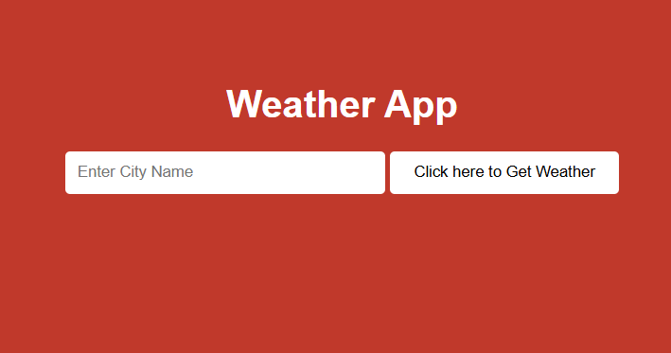 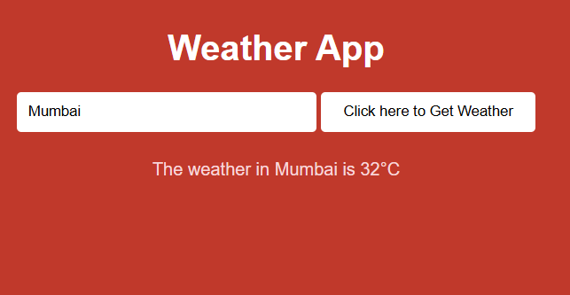

**LATEST APPLICATIONS:**

In todays time html css and javascript are great stepping stones to get into the world of learning web development, a lot of simple websites use this tech stack to reduce complexity and cost of hostings.

**LEARNING OUTCOME:**

By performing this practical II got a thorough understanding of basic web technologies and terms. And how the frontend and backend connect in a real website. I also learnt about form inputs and outputs

**REFERENCES:**

1. **Html:** <https://www.freecodecamp.org/learn/2022/responsive-web-design/learn-html-by-building-a-cat-photo-app/step-66>
2. **CSS:** <https://www.w3schools.com/css/>