Lung cancer

Table of Contents

Motivation 1

Introduction 1

Net Architecture 1

Preprocess 1

U-net 1

KNN/Random Forest/XGBoost 1

Conclusions and Discussion 1

Future Recommendations 1

Bibliography 1

# Introduction

## Motivation

Our main motivation for the project has been the yearning for exploring the field of machine learning and especially deep learning. Deep learning has become a buzz word in the late years.

More specifically, this project revolves a fascinating medical field of Lung cancer diagnosis which both of us haven’t encountered during our engineering studies at the Technion.

Furthermore, we wished to elevate our coding skills in both Matlab and Python.

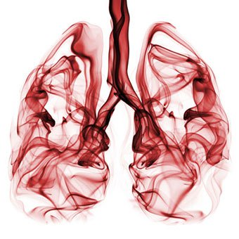

## Theory

### Lung Cancer

Cancer of the lung, like all cancers, results from an abnormality in the body's basic unit of life, the cell. Normally, the body maintains a system of checks and balances on cell growth so that cells divide to produce new cells only when new cells are needed. Disruption of this system of checks and balances on cell growth results in an uncontrolled division and proliferation of cells that eventually forms a mass known as a [tumor](https://www.medicinenet.com/tumor_grade/article.htm).

Tumors can be benign or [malignant](https://www.medicinenet.com/cancer_101_pictures_slideshow/article.htm); when we speak of "cancer," we are referring to those tumors that are malignant. Benign tumors usually can be removed and do not spread to other parts of the body. Malignant tumors, on the other hand, often grow aggressively locally where they start, but tumor cells also can enter into the bloodstream or lymphatic system and then spread to other sites in the body.

The principal function of the lungs is to exchange gases between the air we breathe and the blood. Through the lung, carbon dioxide is removed from the bloodstream and oxygen enters the bloodstream. The right lung has three lobes, while the left lung is divided into two lobes and a small structure called the lingula that is the equivalent of the middle lobe on the right.

The major airways entering the lungs are the bronchi, which arise from the trachea, which is outside the lungs. The bronchi branch into progressively smaller airways called [bronchioles](https://www.medicinenet.com/image-collection/bronchioles_picture/picture.htm) that end in tiny sacs known as alveoli where gas exchange occurs. The lungs and chest wall are covered with a thin layer of tissue called the pleura.

Lung cancers can arise in any part of the lung, but 90%-95% of cancers of the lung are thought to arise from the epithelial cells, the cells lining the larger and smaller airways (bronchi and bronchioles); for this reason, lung cancers are sometimes called bronchogenic cancers or bronchogenic carcinomas. ([Carcinoma](https://www.medicinenet.com/cancer_101_pictures_slideshow/article.htm) is another term for cancer.) Cancers also can arise from the pleura (called mesotheliomas) or rarely from supporting tissues within the lungs, for example, the blood vessels[. [1]](https://www.cancer.gov/types/lung) [[2]](https://www.medicinenet.com/lung_cancer/article.htm)

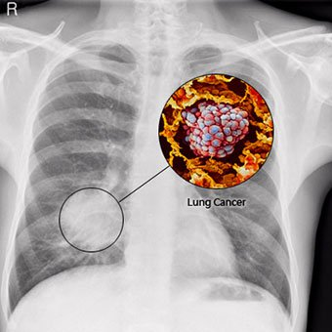

Figure 1: Lungs with a visible malignant tumor

### Machine Learning and Deep learning

Machine learning is an application of artificial intelligence (AI) that provides systems the ability to automatically learn and improve from experience without being explicitly programmed. Machine learning focuses on the development of computer programs that can access data and use it learn for themselves.

The process of learning begins with observations or data, such as examples, direct experience, or instruction, in order to look for patterns in data and make better decisions in the future based on the examples that we provide. The primary aim is to allow the computers learn automatically without human intervention or assistance and adjust actions accordingly.

Some machine learning methods:

Machine learning algorithms are often categorized as supervised or unsupervised.

* **Supervised machine learning algorithms** can apply what has been learned in the past to new data using labeled examples to predict future events. Starting from the analysis of a known training dataset, the learning algorithm produces an inferred function to make predictions about the output values. The system is able to provide targets for any new input after sufficient training. The learning algorithm can also compare its output with the correct, intended output and find errors in order to modify the model accordingly.
* In contrast, **unsupervised machine learning algorithms** are used when the information used to train is neither classified nor labeled. Unsupervised learning studies how systems can infer a function to describe a hidden structure from unlabeled data. The system doesn’t figure out the right output, but it explores the data and can draw inferences from datasets to describe hidden structures from unlabeled data.

Deep learning (also known as deep structured learning or hierarchical learning) is part of a broader family of [machine learning](https://en.wikipedia.org/wiki/Machine_learning) methods based on [learning data representations](https://en.wikipedia.org/wiki/Learning_representation), as opposed to task-specific algorithms. Learning can be [supervised](https://en.wikipedia.org/wiki/Supervised_learning), [semi-supervised](https://en.wikipedia.org/wiki/Semi-supervised_learning) or [unsupervised](https://en.wikipedia.org/wiki/Unsupervised_learning).

Some representations are loosely based on interpretation of information processing and communication patterns in a biological [nervous system](https://en.wikipedia.org/wiki/Nervous_system), such as [neural coding](https://en.wikipedia.org/wiki/Neural_coding) that attempts to define a relationship between various stimuli and associated neuronal responses in the [brain](https://en.wikipedia.org/wiki/Brain).

Deep learning architectures such as [deep neural networks](https://en.wikipedia.org/wiki/Deep_learning#Deep_neural_networks), [deep belief networks](https://en.wikipedia.org/wiki/Deep_belief_network) and [recurrent neural networks](https://en.wikipedia.org/wiki/Recurrent_neural_networks) have been applied to fields including [computer vision](https://en.wikipedia.org/wiki/Computer_vision), [speech recognition](https://en.wikipedia.org/wiki/Automatic_speech_recognition), [natural language processing](https://en.wikipedia.org/wiki/Natural_language_processing), audio recognition, social network filtering, [machine translation](https://en.wikipedia.org/wiki/Machine_translation), [bioinformatics](https://en.wikipedia.org/wiki/Bioinformatics) and [drug design](https://en.wikipedia.org/wiki/Drug_design), where they have produced results comparable to and in some cases superior to human experts. [3] [4]

#### Convolutional Neural Network (CNN)

Convolutional neural networks are a special type of feed-forward networks. These models are designed to emulate the behavior of a visual cortex. CNNs perform very well on visual recognition tasks. CNNs have special layers that allow the network to encode certain images properties.

##### Convolutional Layer

The Conv-layer is the core building block of a Convolutional Network that does most of the computational heavy lifting.

The CONV layer’s parameters consist of a set of learnable lters. Every lter is small spatially (along width and height), but extends through the full depth of the input volume. For example, a typical lter on a layer of a ConvNet might have size 5x5x3 (i.e. 5 pixels width and height, and 3 because images have depth 3, the color channels). During the forward pass, we slide (more precisely, convolve) each lter across the width and height of the input volume and compute dot products between the entries of the lter and the input at any position. As we slide the lter over the width and height of the input volume we will produce a 2- dimensional activation map that gives the responses of that lter at every spatial position. Intuitively, the network will learn lters that activate when they see some type of visual feature such as an edge of some orientation. Now, we will have an entire set of lters in each CONV layer (e.g. 12 lters), and each of them will produce a separate 2- dimensional activation map. We will stack these activation maps along the depth dimension and produce the output volume.

Local Connectivity. When dealing with high-dimensional inputs such as images, as we saw above it is impractical to connect neurons to all neurons in the previous volume. Instead, we will connect each neuron to only a local region of the input volume. The spatial extent of this connectivity is a hyperparameter called the receptive eld of the neuron (equivalently this is the lter size). The extent of the connectivity along the depth axis is always equal to the depth of the input volume. It is important to emphasize again this asymmetry in how we treat the spatial dimensions (width and height) and the depth dimension: The connections are local in space (along width and height), but always full along the entire depth of the input volume.

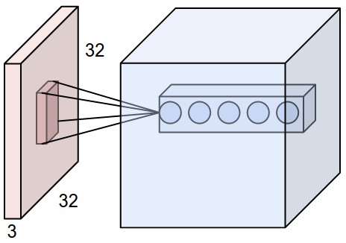

Figure 2: An example input volume in red (e.g. a 32x32x3 CIFAR-10 image), and an example volume of neurons in the Convolutional layer. Each neuron in the convolutional layer is connected only to a local region in the input volume spatially, but to the full depth (i.e. all color channels). Note, there are multiple neurons (5 in this example) along the depth, all looking at the same region in the input - see discussion of depth columns in text below.

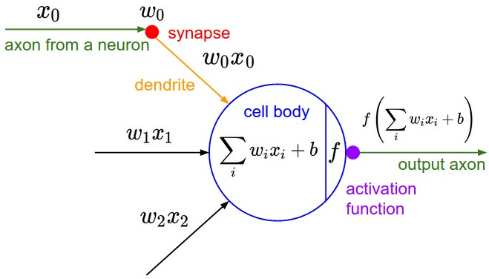

Figure 3: The neurons from the Neural Network chapter remain unchanged: They still compute a dot product of their weights with the input followed by a non-linearity, but their connectivity is now restricted to be local spatially.

##### Pooling Layer

It is common to periodically insert a Pooling layer in-between successive convolutional layers in a Conv-Net architecture. Its function is to progressively reduce the spatial size of the representation to reduce the amount of parameters and computation in the network, and hence to also control over fitting. The Pooling Layer operates independently on every depth slice of the input and resizes it spatially, using the MAX operation. The most common form is a pooling layer with filters of size 2x2 applied with a stride of 2 down-samples every depth slice in the input by 2 along both width and height, discarding 75% of the activations. Every MAX operation would in this case be taking a max over 4 numbers (little 2x2 region in some depth slice). The depth dimension remains unchanged.

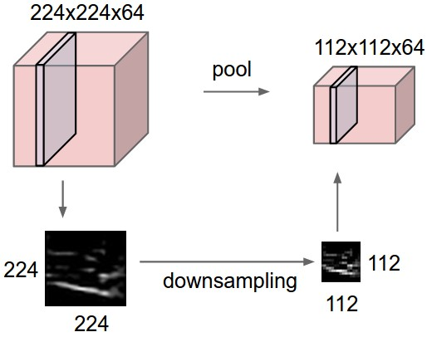

Figure 4: Pooling layer

##### Normalization Layer

Many types of normalization layers have been proposed for use in ConvNet architectures, sometimes with the intentions of implementing inhibition schemes observed in the biological brain. However, these layers have since fallen out of favor because in practice their contribution has been shown to be minimal, if any.

##### Rectified Linear Unit (ReLU) layer

A ReLU layer performs a threshold operation to each element of the input, where any value less than zero is set to zero. This Is a non-linear layer. In simple words, the ReLU layer will apply the function f(x)=max(0,x) in all elements on a input tensor, without changing it's spatial or depth information.

##### Fully-connected layer

Neurons in a fully connected layer have full connections to all activations in the previous layer, as seen in regular Neural Networks. Their activations can hence be computed with a matrix multiplication followed by a bias offset. [5]

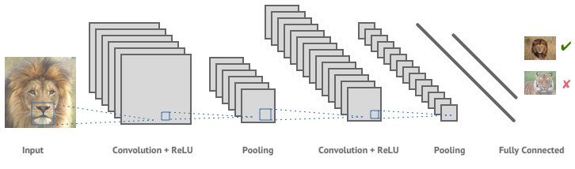

Figure 5: An example for a convolutional neural network (CNN)

### The Kaggle competition

# Net Architecture

# Preprocess

# U-net

# KNN/Random Forest/XGBoost

# Conclusions and Discussion

# Future Recommendations

# Bibliography

|  |  |
| --- | --- |
| [1] | NCI, "Lung Cancer—Patient Version," NIH, gov. |
| [2] | M. Melissa Conrad Stöppler, "Lung Cancer". |
| [3] | L. Scagliarini, "What is Machine Learning?". |
| [4] | Wikipedia, "Deep Learning". |
| [5] | Stanford, "CS231n Convolutional Neural Networks for Visual Recognition". |