PO Extractor
Sky East User Guide
Sky East 用户指南
For Sky East Purchase Contract Users / 适用于 Sky East 采购合同用户
This guide is for Sky East users with a standard (non-admin) account.
本指南适用于具有标准（非管理员）账户的 Sky East 用户。

1. Getting Started — Logging In
1. 入门 — 登录
Open your browser and navigate to the PO Extractor URL provided by your administrator. You will see the login screen below.
打开浏览器，访问管理员提供的 PO Extractor 网址。您将看到如下登录界面。

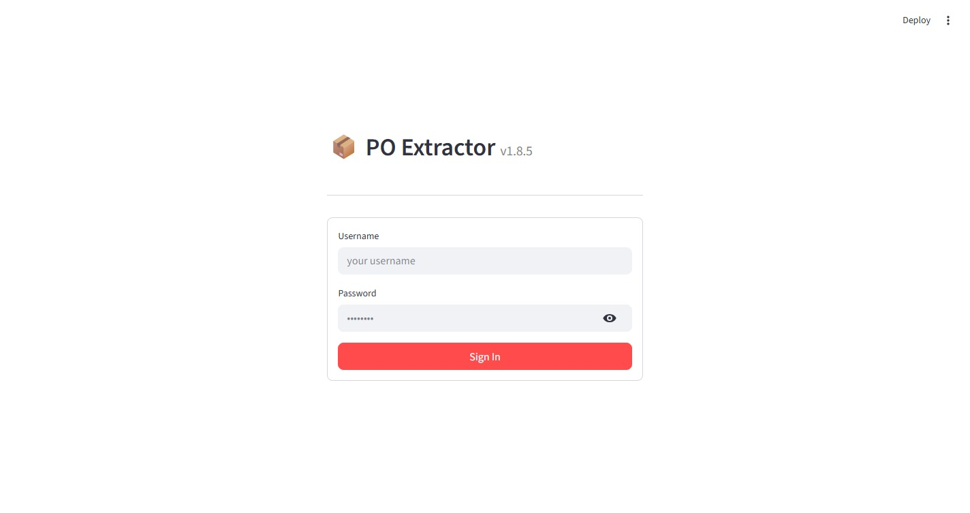
Figure 1 – Login screen / 图 1 – 登录界面

Steps to log in:
登录步骤：
- Username: Enter your username in the Username field.
用户名：在用户名输入框中输入您的用户名。
- Password: Enter your password in the Password field.
密码：在密码输入框中输入您的密码。
- Sign In: Click the Sign In button.
登录：点击"登录"按钮。

After a successful login you will land on the main dashboard. Click the Sky East tab in the top navigation bar to begin working with purchase contracts.
登录成功后，您将进入主仪表板。点击顶部导航栏中的 Sky East 标签页，开始处理采购合同。

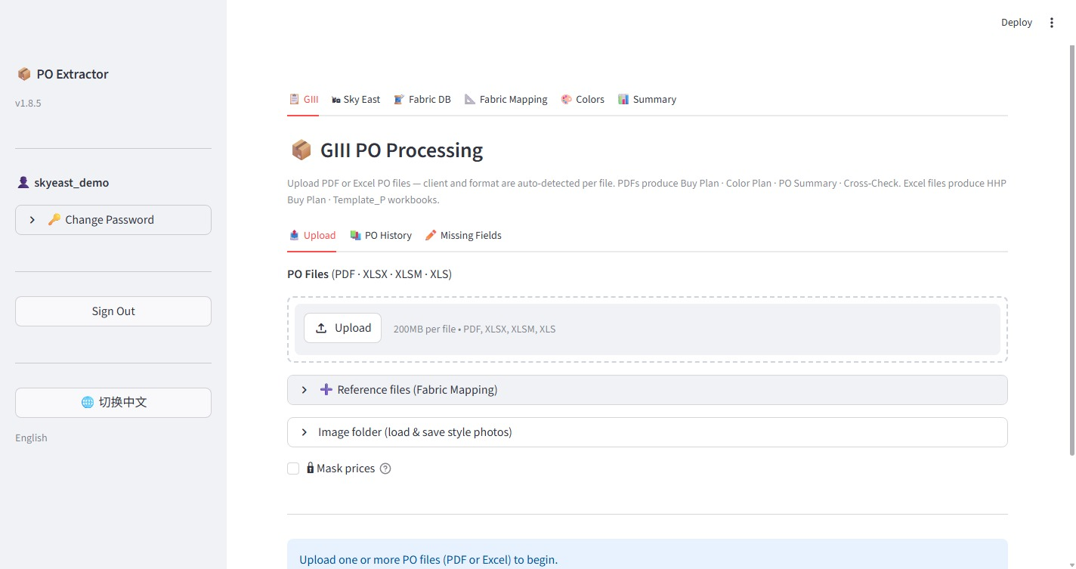
Figure 2 – Main dashboard after login (Sky East tab is in the top navigation bar) / 图 2 – 登录后的主仪表板（顶部导航栏中的 Sky East 标签页）

2. Sky East Purchase Contracts
2. Sky East 采购合同
The Sky East tab is your main workspace. It contains three sub-tabs: New Contracts, Contract History, and Missing Fields.
Sky East 标签页是您的主要工作区，包含三个子标签页：新建合同、合同历史 和 缺失字段。

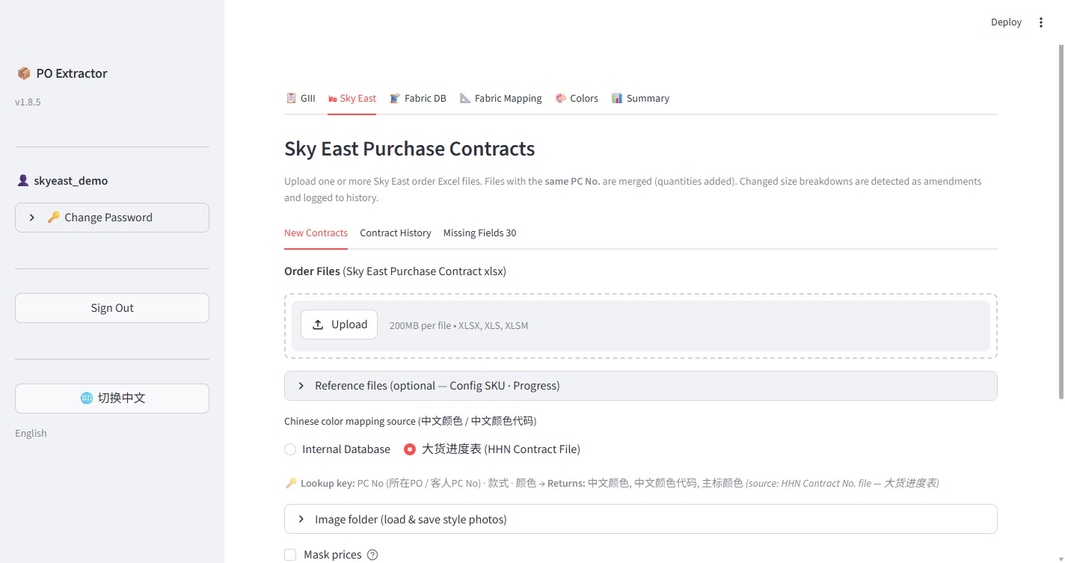
Figure 3 – Sky East tab — New Contracts / 图 3 – Sky East 标签页 — 新建合同

2.1 Uploading a New Contract
2.1 上传新合同
The New Contracts sub-tab is where you upload Sky East purchase contract Excel files for processing.
在"新建合同"子标签页中，您可以上传 Sky East 采购合同 Excel 文件进行处理。

Step 1 — Upload Order Files
第一步 — 上传订单文件
Under Order Files (Sky East Purchase Contract xlsx), click the Upload button and select one or more Sky East purchase contract Excel files (XLSX, XLS, or XLSM format, up to 200 MB per file).
在"订单文件（Sky East 采购合同 xlsx）"区域，点击"上传"按钮，选择一个或多个 Sky East 采购合同 Excel 文件（XLSX、XLS 或 XLSM 格式，每个文件最大 200 MB）。

Note: Files with the same PC No. are automatically merged — quantities are added together. If size breakdowns have changed, the system detects it as an amendment and logs it to Contract History.
注意：相同 PC 编号的文件会自动合并——数量相加。若尺码分配有所变化，系统将识别为修改并记录至合同历史。

Step 2 — Reference Files (Optional)
第二步 — 参考文件（可选）
The Reference files section is optional but recommended. Click the arrow to expand it.
参考文件部分为可选，但建议上传。点击箭头展开该区域。

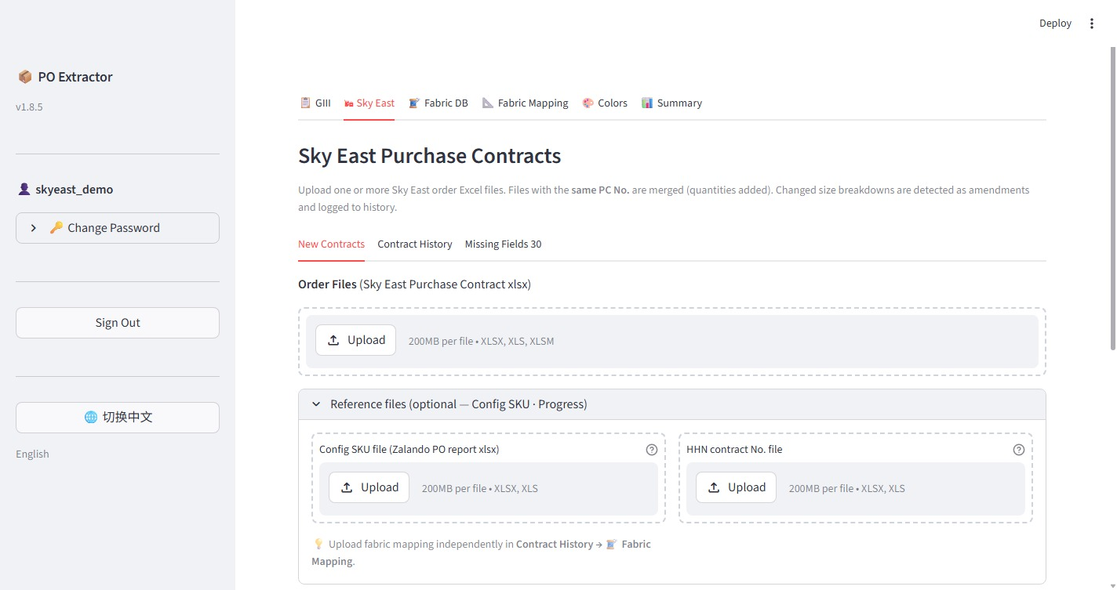
Figure 4 – Reference files section expanded / 图 4 – 参考文件区域已展开

- Config SKU file (Zalando PO report xlsx): Upload the Zalando PO report to cross-reference style and SKU data.
Config SKU 文件（Zalando PO 报表 xlsx）：上传 Zalando PO 报表，用于款式和 SKU 数据交叉核对。
- HHN contract No. file: Upload the HHN 大货进度表 (Progress Tracker) Excel file to enable automatic Chinese color mapping.
HHN 合同编号文件：上传 HHN 大货进度表 Excel 文件，以启用自动中文颜色映射。

Step 3 — Chinese Color Mapping Source (中文颜色 / 中文颜色代码)
第三步 — 中文颜色映射来源
Below the reference files, choose how the system should look up Chinese color names:
在参考文件下方，选择系统查找中文颜色名称的方式：
- Internal Database — Use the built-in color translation table maintained in the Colors tab.
内部数据库 — 使用颜色标签页中维护的内置颜色翻译表。
- 大货进度表 (HHN Contract File) — Look up Chinese color names directly from the HHN Progress Tracker file uploaded in Step 2. Recommended when the progress tracker is available.
大货进度表（HHN 合同文件） — 直接从第二步上传的 HHN 大货进度表中查找中文颜色名称。有进度表时推荐使用此选项。

Step 4 — Process and Download
第四步 — 处理与下载
Once files are uploaded and settings are configured, click the Process button (scroll down to find it). The system will process the contracts and generate:
文件上传并完成设置后，点击"处理"按钮（向下滚动可找到）。系统将处理合同并生成以下文件：
- Buy Plan workbook — the main output Excel file
买手计划工作簿 — 主要输出 Excel 文件
- 核料 (Nukuryou) workbook — fabric requisition summary
核料工作簿 — 面料申请摘要

Download buttons will appear after processing is complete. Click each button to save the files to your computer.
处理完成后将显示下载按钮。点击各按钮将文件保存至您的电脑。

2.2 Contract History
2.2 合同历史
Click the Contract History sub-tab to view all previously saved contracts.
点击"合同历史"子标签页，查看所有已保存的合同。

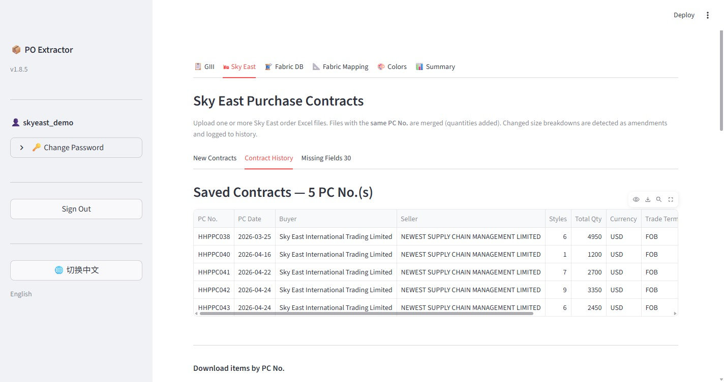
Figure 5 – Contract History showing saved PC numbers / 图 5 – 合同历史：显示已保存的 PC 编号

The table displays all saved contracts with columns: PC No., PC Date, Buyer, Seller, Styles, Total Qty, Currency, Trade Terms.
表格显示所有已保存合同，包含：PC 编号、PC 日期、买方、卖方、款数、总数量、货币和贸易条款。

Downloading by PC No.
按 PC 编号下载
Scroll down to the Download items by PC No. section. Select one or more PC numbers from the list and click the download button to regenerate and download the Buy Plan workbook for those specific contracts.
向下滚动至"按 PC 编号下载条目"区域。从列表中选择一个或多个 PC 编号，点击下载按钮，即可重新生成并下载对应合同的买手计划工作簿。

2.3 Missing Fields
2.3 缺失字段
Click the Missing Fields sub-tab to view and fix items that have incomplete data (e.g., missing Fabric No. or HHN Contract No.).
点击"缺失字段"子标签页，查看并修正数据不完整的条目（如缺少面料编号或 HHN 合同编号）。

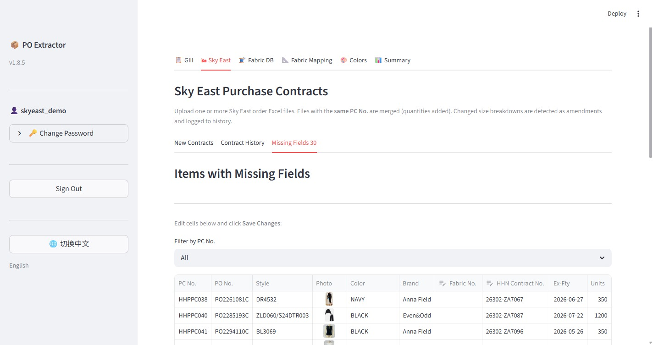
Figure 6 – Missing Fields tab showing items with incomplete data / 图 6 – 缺失字段标签页：显示数据不完整的条目

- Use the Filter by PC No. dropdown to narrow down the list to a specific purchase contract.
使用"按 PC 编号筛选"下拉菜单，将列表缩小至特定采购合同。
- Click directly on a cell in the table to edit it inline.
直接点击表格中的单元格进行行内编辑。
- After making your corrections, click Save Changes to update the database.
更正完成后，点击"保存更改"更新数据库。

3. Order Summary
3. 订单摘要
Click the Summary tab in the top navigation bar to see an aggregated overview of all your orders.
点击顶部导航栏中的"摘要"标签页，查看所有订单的汇总概览。

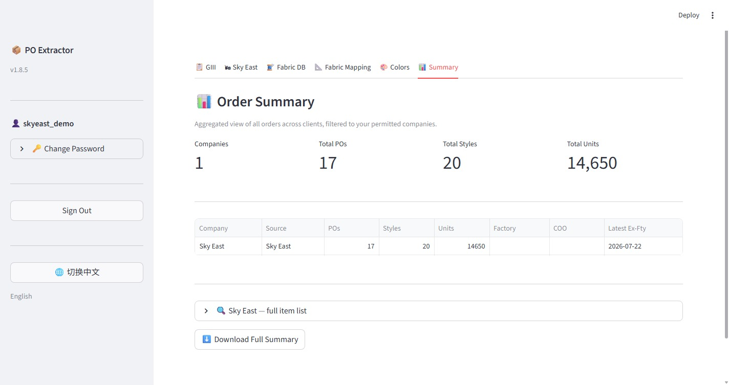
Figure 7 – Order Summary showing total POs, styles, and units / 图 7 – 订单摘要：显示总 PO 数、款数和数量

The summary shows:
摘要显示：
- Companies — number of companies you have access to
公司 — 您有权访问的公司数量
- Total POs — total number of purchase orders
总 PO 数 — 采购订单总数
- Total Styles — total style count across all orders
总款数 — 所有订单的款式总数
- Total Units — total quantity across all orders
总数量 — 所有订单的总数量

The table below breaks down the totals by company. Expand Sky East — full item list to browse all individual items, and click Download Full Summary to export the data to Excel.
下方表格按公司分类汇总。展开"Sky East — 完整条目列表"可浏览所有单独条目，点击"下载完整摘要"可将数据导出至 Excel。

4. Colors Reference Table
4. 颜色参考表
Click the Colors tab in the top navigation bar to view the English-to-Chinese color name mapping table.
点击顶部导航栏中的"颜色"标签页，查看英文到中文的颜色名称映射表。

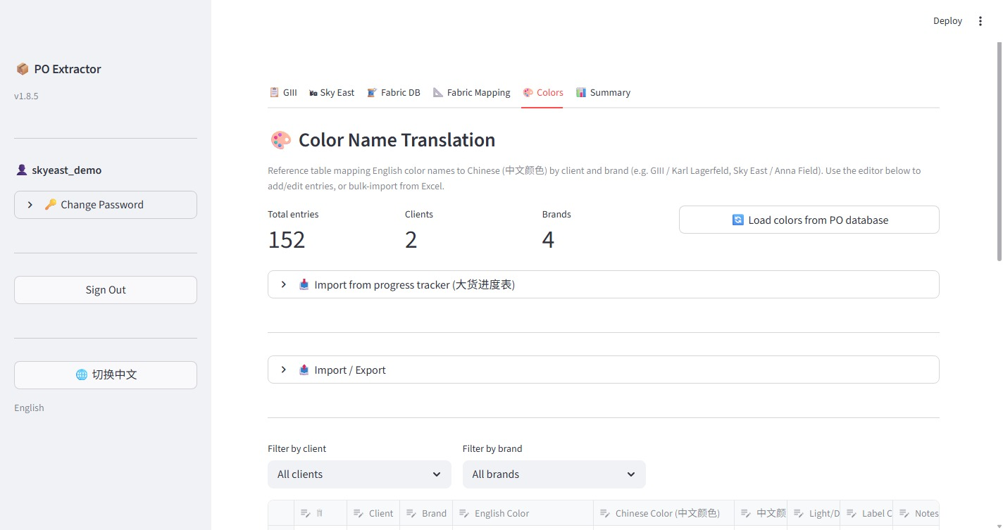
Figure 8 – Color Name Translation table / 图 8 – 颜色名称翻译表

This table maps English color names to their Chinese equivalents (中文颜色) by client and brand. It is used by the system when Internal Database is selected as the color mapping source.
该表格按客户和品牌，将英文颜色名称映射至对应的中文颜色名称。当颜色映射来源选择"内部数据库"时，系统将使用此表格。

Note: As a standard user, you can view the color table. If you notice a missing or incorrect color mapping, contact your administrator to have it updated.
注意：作为标准用户，您可以查看颜色表格。如发现颜色映射缺失或有误，请联系管理员进行更新。

5. Account Management
5. 账户管理

5.1 Changing Your Password
5.1 修改密码
In the left sidebar, click Change Password (click the arrow to expand it). Enter your current password, then enter and confirm your new password, and click Save.
在左侧边栏中，点击"修改密码"（点击箭头展开）。输入当前密码，然后输入并确认新密码，点击"保存"。

5.2 Signing Out
5.2 退出登录
In the left sidebar, click the Sign Out button to log out of the application.
在左侧边栏中，点击"退出登录"按钮，退出应用程序。

Tips and Notes
提示与注意事项
- File formats: Order files must be Excel format (XLSX, XLS, XLSM). PDF files are not supported for Sky East contracts.
文件格式：订单文件必须为 Excel 格式（XLSX、XLS、XLSM）。Sky East 合同不支持 PDF 文件。
- Same PC No. merging: If you upload two files with the same PC number, their quantities are combined. The system will flag any size breakdown changes as amendments.
相同 PC 编号合并：若上传两个 PC 编号相同的文件，其数量将被合并。系统会将任何尺码分配变化标记为修改。
- Language: The interface supports English and Chinese. Click the 切换中文 button in the sidebar to switch to Chinese.
语言：界面支持英文和中文。点击侧边栏中的"切换中文"按钮可切换至中文界面。
- Contact your administrator if you need access to additional companies or encounter any login issues.
请联系管理员，如需访问其他公司或遇到登录问题。

