PO Extractor
Sky East User Guide
For Sky East Purchase Contract Users
This guide is for Sky East users with a standard (non-admin) account.

1. Getting Started — Logging In
Open your browser and navigate to the PO Extractor URL provided by your administrator. You will see the login screen below.

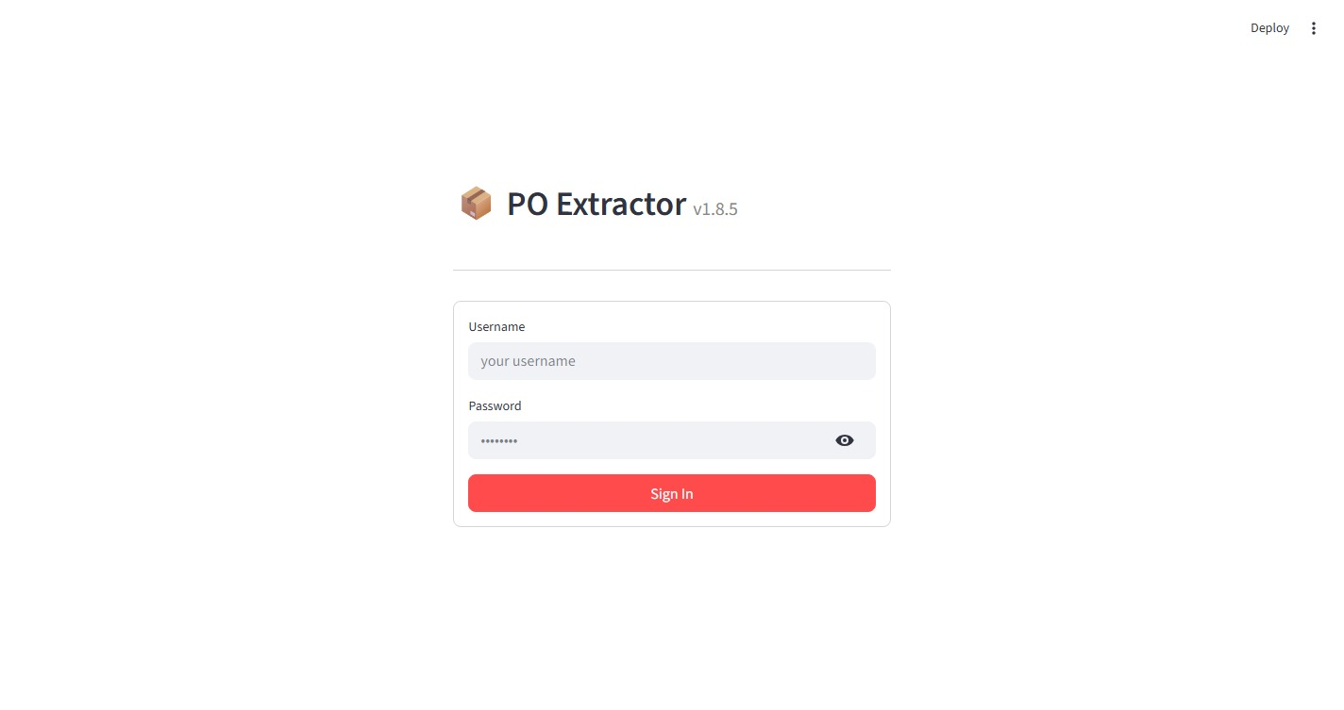
Figure 1 – Login screen

Steps to log in:
- Username: Enter your username in the Username field.
- Password: Enter your password in the Password field.
- Sign In: Click the Sign In button.

After a successful login you will land on the main dashboard. Click the Sky East tab in the top navigation bar to begin working with purchase contracts.

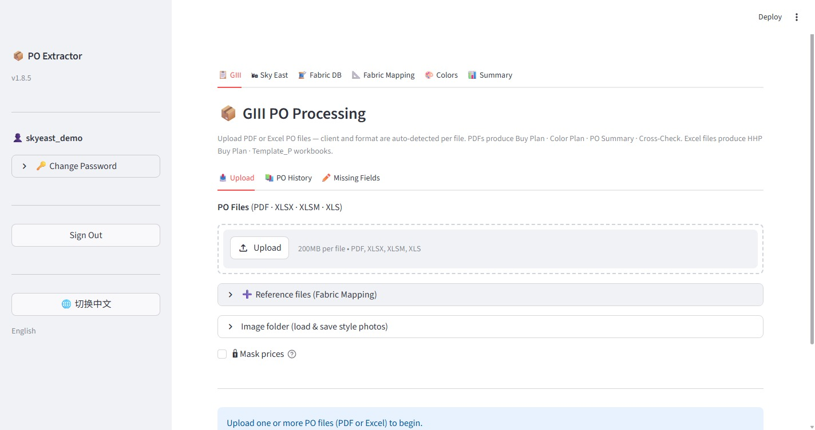
Figure 2 – Main dashboard after login (Sky East tab is in the top navigation bar)

2. Sky East Purchase Contracts
The Sky East tab is your main workspace. It contains three sub-tabs: New Contracts, Contract History, and Missing Fields.

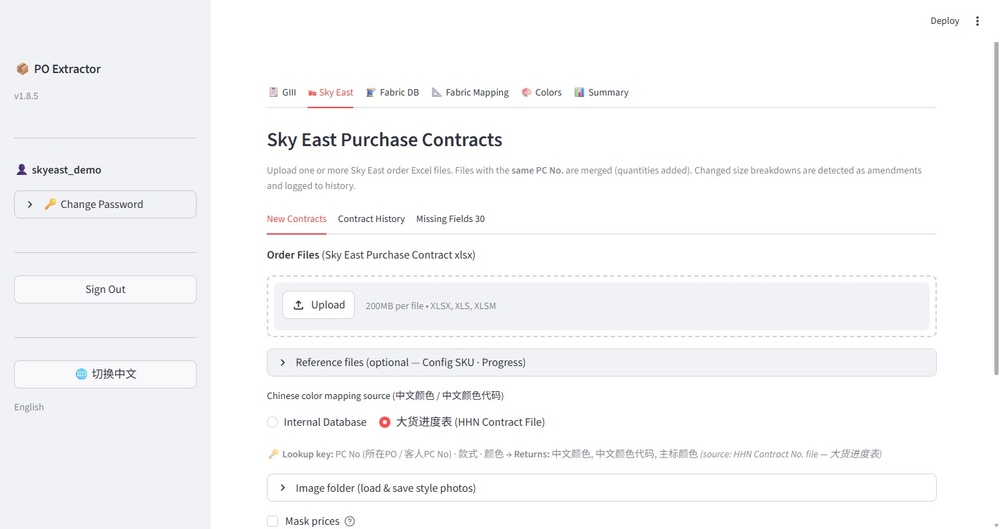
Figure 3 – Sky East tab — New Contracts

2.1 Uploading a New Contract
The New Contracts sub-tab is where you upload Sky East purchase contract Excel files for processing.

Step 1 — Upload Order Files
Under Order Files (Sky East Purchase Contract xlsx), click the Upload button and select one or more Sky East purchase contract Excel files (XLSX, XLS, or XLSM format, up to 200 MB per file).

Note: Files with the same PC No. are automatically merged — quantities are added together. If size breakdowns have changed, the system detects it as an amendment and logs it to Contract History.

Step 2 — Reference Files (Optional)
The Reference files section is optional but recommended. Click the arrow to expand it.

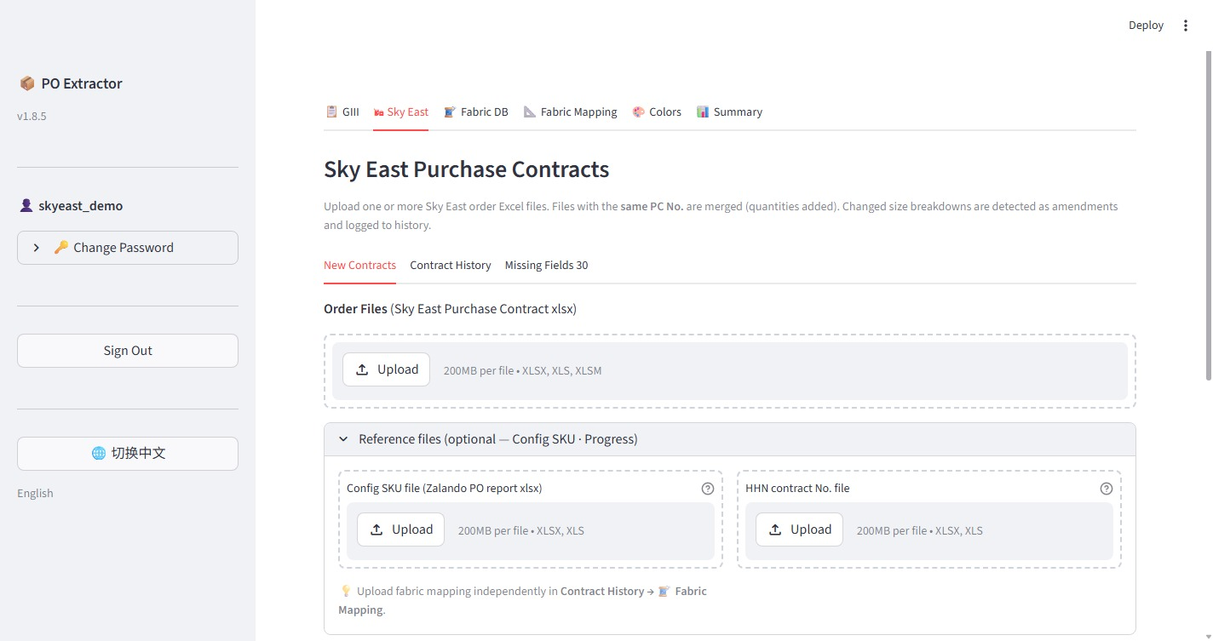
Figure 4 – Reference files section expanded

- Config SKU file (Zalando PO report xlsx): Upload the Zalando PO report to cross-reference style and SKU data.
- HHN contract No. file: Upload the HHN 大货进度表 (Progress Tracker) Excel file to enable automatic Chinese color mapping.

Step 3 — Chinese Color Mapping Source (中文颜色 / 中文颜色代码)
Below the reference files, choose how the system should look up Chinese color names:
- Internal Database — Use the built-in color translation table maintained in the Colors tab.
- 大货进度表 (HHN Contract File) — Look up Chinese color names directly from the HHN Progress Tracker file uploaded in Step 2. Recommended when the progress tracker is available.

Step 4 — Process and Download
Once files are uploaded and settings are configured, click the Process button (scroll down to find it). The system will process the contracts and generate:
- Buy Plan workbook — the main output Excel file
- 核料 (Nukuryou) workbook — fabric requisition summary

Download buttons will appear after processing is complete. Click each button to save the files to your computer.

2.2 Contract History
Click the Contract History sub-tab to view all previously saved contracts.

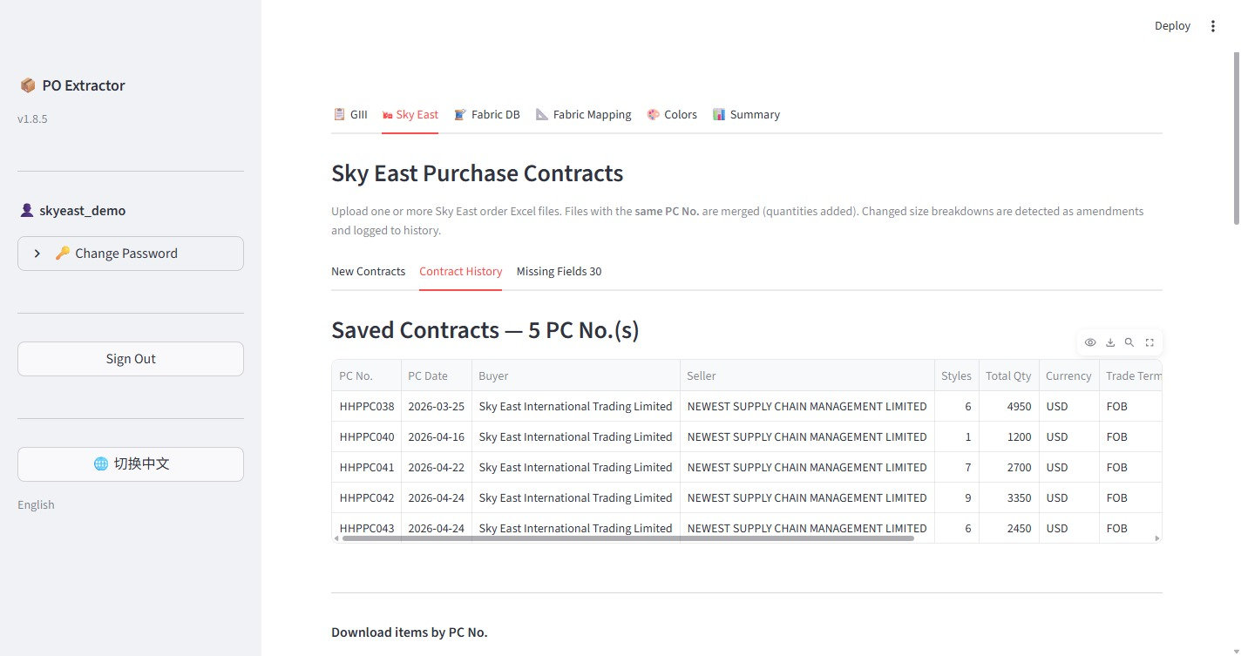
Figure 5 – Contract History showing saved PC numbers

The table displays all saved contracts with columns: PC No., PC Date, Buyer, Seller, Styles, Total Qty, Currency, Trade Terms.

Downloading by PC No.
Scroll down to the Download items by PC No. section. Select one or more PC numbers from the list and click the download button to regenerate and download the Buy Plan workbook for those specific contracts.

2.3 Missing Fields
Click the Missing Fields sub-tab to view and fix items that have incomplete data (e.g., missing Fabric No. or HHN Contract No.).

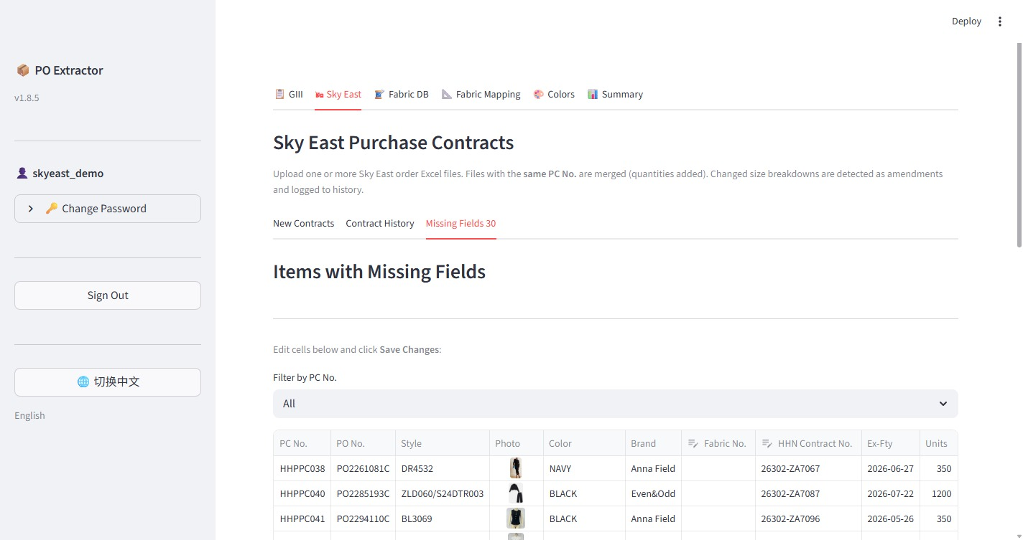
Figure 6 – Missing Fields tab showing items with incomplete data

- Use the Filter by PC No. dropdown to narrow down the list to a specific purchase contract.
- Click directly on a cell in the table to edit it inline.
- After making your corrections, click Save Changes to update the database.

3. Order Summary
Click the Summary tab in the top navigation bar to see an aggregated overview of all your orders.

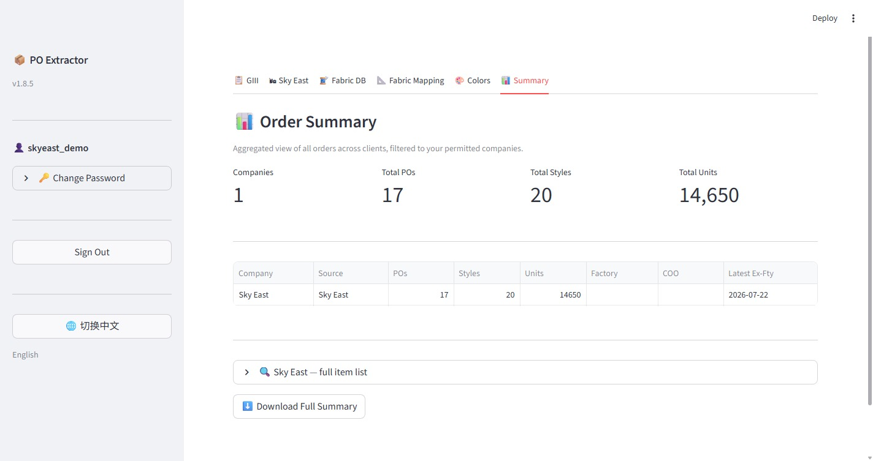
Figure 7 – Order Summary showing total POs, styles, and units

The summary shows:
- Companies — number of companies you have access to
- Total POs — total number of purchase orders
- Total Styles — total style count across all orders
- Total Units — total quantity across all orders

The table below breaks down the totals by company. Expand Sky East — full item list to browse all individual items, and click Download Full Summary to export the data to Excel.

4. Colors Reference Table
Click the Colors tab in the top navigation bar to view the English-to-Chinese color name mapping table.

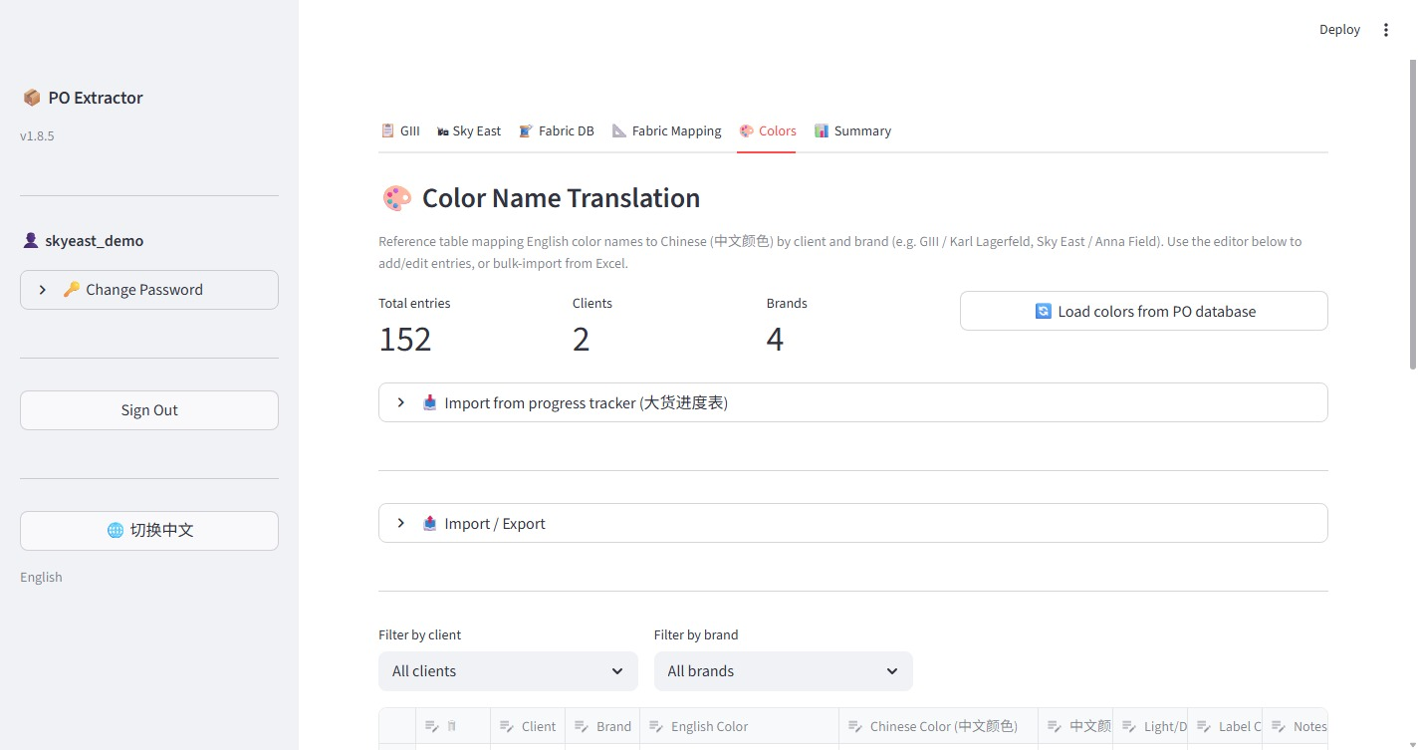
Figure 8 – Color Name Translation table

This table maps English color names to their Chinese equivalents (中文颜色) by client and brand. It is used by the system when Internal Database is selected as the color mapping source.

Note: As a standard user, you can view the color table. If you notice a missing or incorrect color mapping, contact your administrator to have it updated.

5. Account Management

5.1 Changing Your Password
In the left sidebar, click Change Password (click the arrow to expand it). Enter your current password, then enter and confirm your new password, and click Save.

5.2 Signing Out
In the left sidebar, click the Sign Out button to log out of the application.

Tips and Notes
- File formats: Order files must be Excel format (XLSX, XLS, XLSM). PDF files are not supported for Sky East contracts.
- Same PC No. merging: If you upload two files with the same PC number, their quantities are combined. The system will flag any size breakdown changes as amendments.
- Language: The interface supports English and Chinese. Click the 切换中文 button in the sidebar to switch to Chinese.
- Contact your administrator if you need access to additional companies or encounter any login issues.

