## 字段说明

|  |  |  |
| --- | --- | --- |
| 字段名 | 含义 | 备注 |
| abnormal_data | 警告表数据 | 所有的警告表都是这个 |
| abnormal_rate | 通过率 | 饼图 |
| fields_abnormal | 字段的异常总计 | 字段的警告,异常数量都是这个 |
| fields_sum | 字段总计 |  |
| table_sum | 数据表总计 |  |
| table_abnormal | 数据表异常统计 | 表的未通过检核,有异常都是这个 |
|  |  |  |

## P 3-1 今日核检结果

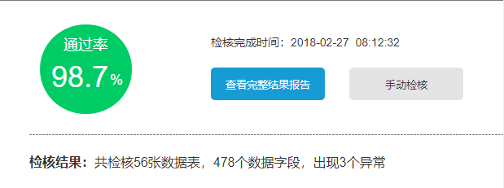

路由: /examination/general_report/statisti

传入参数格式:

page: 1

pageSize: 10

返回数据格式:

{

"code": 200,

"data": {

"abnormal_rate": 0.667, 通过率

"exam_date": "Fri, 18 May 2018 00:00:00 GMT", 检核完成时间

"fields_abnormal": 36, 异常

"fields_sum": 131, 数据字段

"table_sum": 6 数据表

},

"msg": "ok",

"total": 5

}

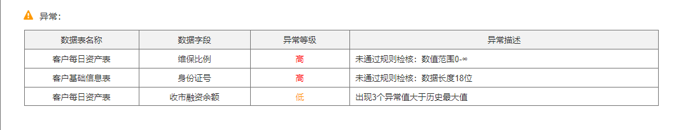

路由: /examination/general_report/abnormal_table

传入参数格式:

page: 1

pageSize: 10

返回数据格式:

{

"code": 200,

"data": [

{

"abnormal_detail": "异常值太多", 异常描述

"abnormal_level": "高", 异常等级

"field_name": "exchange_fare2", 数据字段

"id": 254,

"tbl_name": "fact_cust_stock_detail" 数据表名称

},

{

"abnormal_detail": "异常值太多",

"abnormal_level": "高",

"field_name": "exchange_fare3",

"id": 255,

"tbl_name": "fact_cust_stock_detail"

},

{

"abnormal_detail": "异常值太多",

"abnormal_level": "高",

"field_name": "fare1",

"id": 256,

"tbl_name": "fact_cust_stock_detail"

},

{

"abnormal_detail": "异常值太多",

"abnormal_level": "高",

"field_name": "fare2",

"id": 257,

"tbl_name": "fact_cust_stock_detail"

},

{

"abnormal_detail": "异常值太多",

"abnormal_level": "高",

"field_name": "post_amount",

"id": 258,

"tbl_name": "fact_cust_stock_detail"

},

{

"abnormal_detail": "异常值太多",

"abnormal_level": "高",

"field_name": "standard_fare0",

"id": 259,

"tbl_name": "fact_cust_stock_detail"

}

],

"msg": "ok",

"total": 36

}

## P3-1-1 今日检核结果-查看完整结果报告

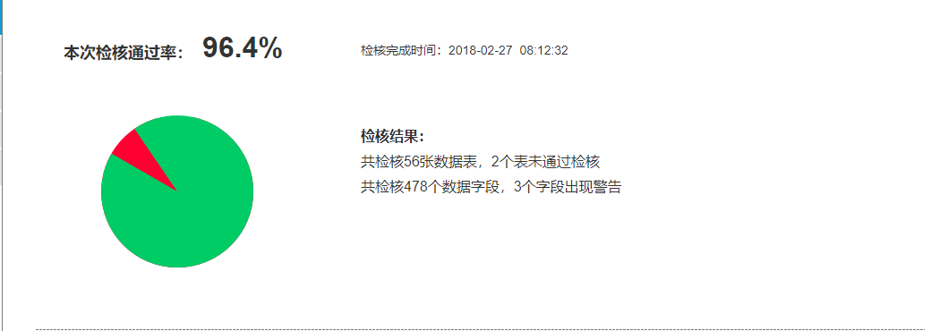

路由: /examination/detail_report/statistic

传入参数格式:

page: 1

pageSize: 10

返回数据格式:

{

"code": 200,

"data": {

"abnormal_rate": 0.714, 通过率

"fields_abnormal": 61, 字段出现警告

"fields_sum": 165, 数据字段

"table_abnormal": 5, 数据表

"table_sum": 7 未通过检核

},

"msg": "ok",

"total": 5

}

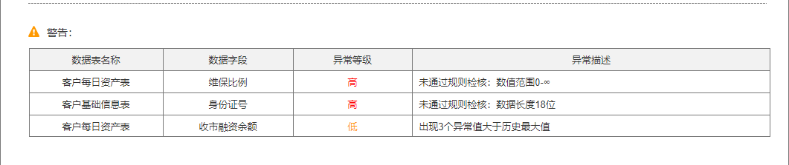

路由: /examination/detail_report/abnormal_table

传入参数格式:

page: 1

pageSize: 10

返回数据格式:

{

"code": 200,

"data": [

{

"abnormal_detail": "\u5f02\u5e38\u503c\u592a\u591a", 异常描述

"abnormal_level": "\u9ad8", 异常等级

"field_name": "fund_begin_balance", 数据字段

"id": 224,

"tbl_name": "agg_cust_balance" 数据表名称

},

{

"abnormal_detail": "\u5f02\u5e38\u503c\u592a\u591a",

"abnormal_level": "\u9ad8",

"field_name": "fund_close_balance",

"id": 225,

"tbl_name": "agg_cust_balance"

},

{

"abnormal_detail": "\u5f02\u5e38\u503c\u592a\u591a",

"abnormal_level": "\u9ad8",

"field_name": "fund_begin_balance",

"id": 226,

"tbl_name": "agg_cust_balance"

},

{

"abnormal_detail": "\u5f02\u5e38\u503c\u592a\u591a",

"abnormal_level": "\u9ad8",

"field_name": "fund_close_balance",

"id": 227,

"tbl_name": "agg_cust_balance"

},

{

"abnormal_detail": "\u5f02\u5e38\u503c\u592a\u591a",

"abnormal_level": "\u9ad8",

"field_name": "close_interest_day",

"id": 228,

"tbl_name": "agg_cust_statistics_info"

},

{

"abnormal_detail": "\u5f02\u5e38\u503c\u592a\u591a",

"abnormal_level": "\u9ad8",

"field_name": "close_interest_fin_day",

"id": 229,

"tbl_name": "agg_cust_statistics_info"

},

{

"abnormal_detail": "\u5f02\u5e38\u503c\u592a\u591a",

"abnormal_level": "\u9ad8",

"field_name": "close_interest_fin_year",

"id": 230,

"tbl_name": "agg_cust_statistics_info"

},

{

"abnormal_detail": "\u5f02\u5e38\u503c\u592a\u591a",

"abnormal_level": "\u9ad8",

"field_name": "close_interest_fin_yesterday",

"id": 231,

"tbl_name": "agg_cust_statistics_info"

},

{

"abnormal_detail": "\u5f02\u5e38\u503c\u592a\u591a",

"abnormal_level": "\u9ad8",

"field_name": "close_interest_year",

"id": 232,

"tbl_name": "agg_cust_statistics_info"

},

{

"abnormal_detail": "\u5f02\u5e38\u503c\u592a\u591a",

"abnormal_level": "\u9ad8",

"field_name": "close_interest_yesterday",

"id": 233,

"tbl_name": "agg_cust_statistics_info"

}

],

"msg": "ok",

"total": 61

}

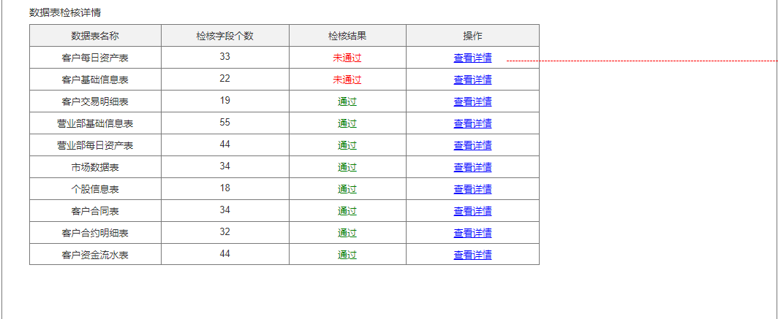

路由: /examination/detail_report/tables

传入参数格式:

page: 1

pageSize: 10

返回数据格式:

{

"code": 200,

"data": [

{

"exam_fields_count": 3, 检核字段个数

"exam_result": "0", 检核结果

"id": 53,

"tbl_name": "agg_cust_balance" 数据表名称

},

{

"exam_fields_count": 3,

"exam_result": "1",

"id": 54,

"tbl_name": "agg_cust_rank"

},

{

"exam_fields_count": 2,

"exam_result": "0",

"id": 55,

"tbl_name": "agg_cust_balance"

},

{

"exam_fields_count": 56,

"exam_result": "0",

"id": 56,

"tbl_name": "agg_cust_statistics_info"

},

{

"exam_fields_count": 65,

"exam_result": "0",

"id": 57,

"tbl_name": "fact_cust_stock_detail"

},

{

"exam_fields_count": 2,

"exam_result": "1",

"id": 58,

"tbl_name": "agg_cust_rank"

},

{

"exam_fields_count": 34,

"exam_result": "0",

"id": 59,

"tbl_name": "schema_activity_statistics"

}

],

"msg": "ok",

"total": 7

}

## P3-1-2 查看详情 触发

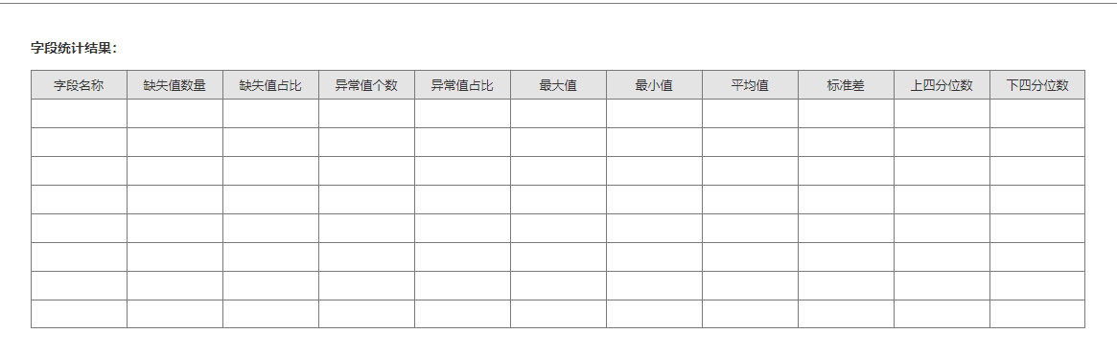

路由: /examination/detail_report/detail_page

传入参数格式:

"table_name": "agg_cust_balance"

page: 1

pageSize: 10

返回数据格式:

{

"code": 200,

"data": [

{

"abnormal_value_num": 1717, 异常值个数

"abnormal_value_prop": 0.1717, 异常值占比

"field_en_name": "fund_begin_balance", 字段名称

"lower_quartile": 0.0, 下分位数

"max_value": 8457570.0, 最大值

"mean_value": 33110.7, 平均值

"min_value": 0.0, 最小值

"missing_value_num": 0, 缺失值数量

"missing_value_prop": 0.0, 缺失值占比

"std_value": 247401.0, 标准差

"upper_quartile": 824.938 上分位数

}

],

"msg": "ok",

"total": 1

}

## P3-2 历史报告

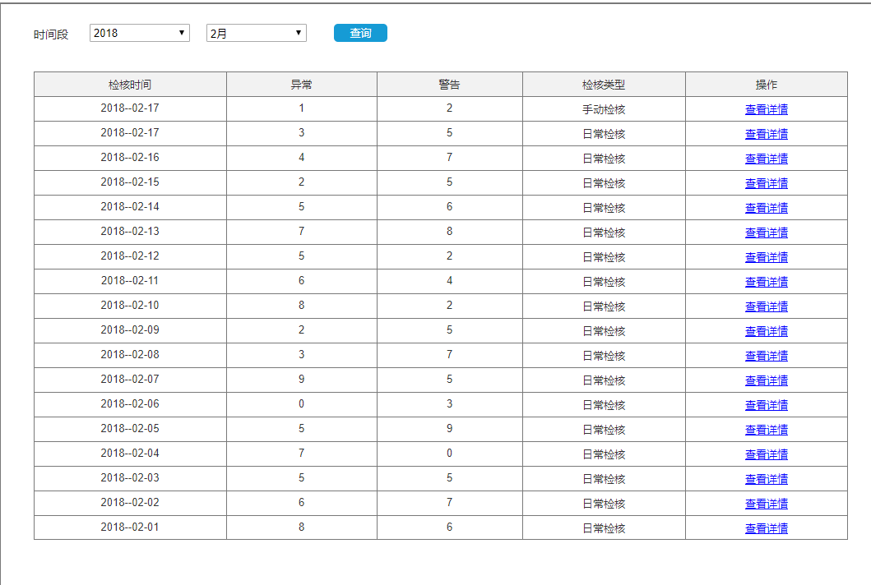

路由: /examination/history_report

传入参数格式:

"year": "2018",

"month": "5"

page: 1

pageSize: 10

返回数据格式:

{

"code": 200,

"data": [

{

"abnormal": 4, 警告

"exam_date": "2018-05-15", 检核时间

"failed": 2, 异常

"status": "日常检核" 检核类型

}

],

"msg": "ok",

"total": 1

}

## P3-3 规则配置

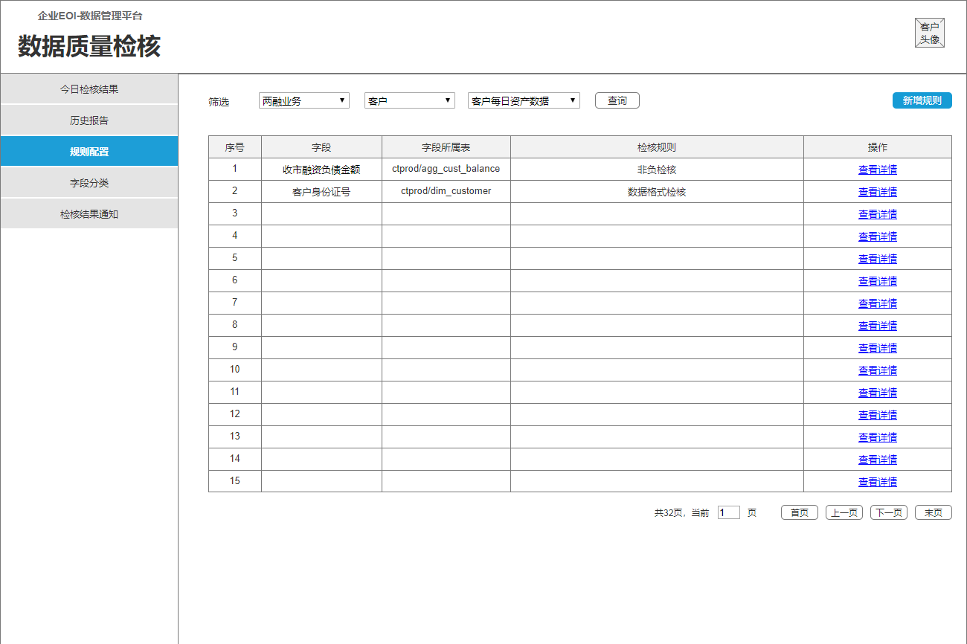

路由: /examination/rule_set

传入参数格式:

"category": "1_2_70"

page: 1

pageSize: 1

返回数据格式:

{

"code": 200,

"data": [

{

"belong_to": "dmp/test", 字段所属表

"field_ch_name": "表1", 字段

"rule": "1" 检核规则

}

],

"msg": "ok",

"total": 1

}

## P3-3-1 新增规则

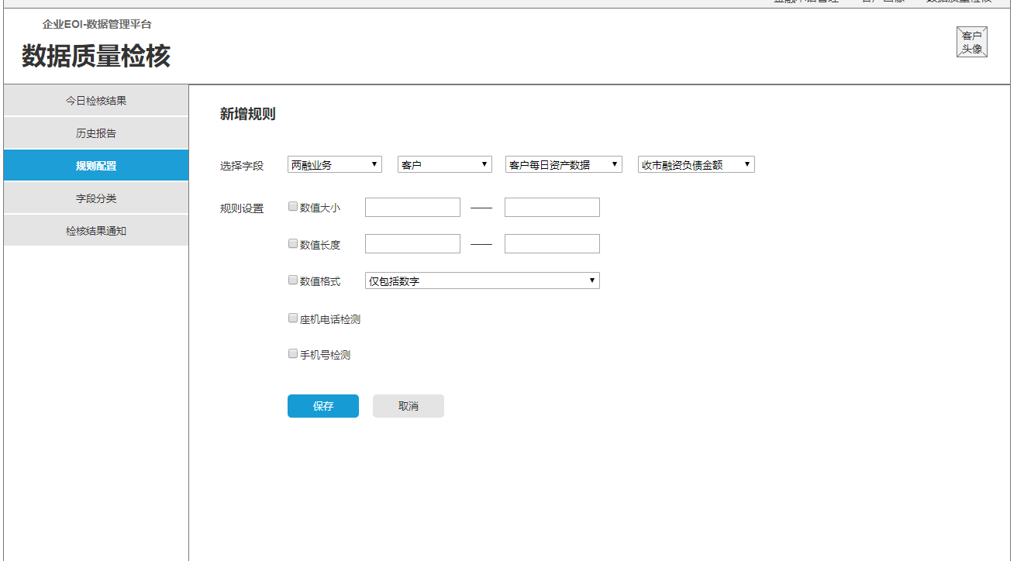

路由: /examination/rule_set/add_rule

传入参数格式:

{

"category": "1_2_70_1", 最上面的身份证号

“field_en_name”: “init_date” 英文字段名

“number_range”: “0-100” 数值大小

length_range : 0-100 数值长度

number_format: 1 数值格式

tel_number_check: 1 座机电话检测

phone_number_check: 1 手机号检测

}

返回数据格式:

{

"code": 200,

"data": "",

"msg": "ok",

"total": 0

}

## P3-4 字段分类

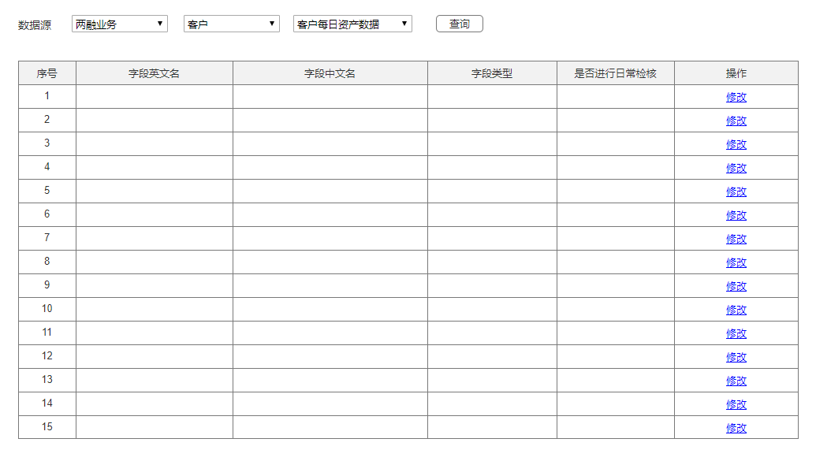

路由: /examination/field_category

传入参数格式:

"category": "1_2_70"

返回数据格式:

{

"code": 200,

"data": [

{

"detect_or_not": "是", 是否进行日常检核

"field_ch_name": null, 字段中文名

"field_en_name": "fund_begin_balance", 字段英文名

"field_type": "数值类", 字段类型

"id": 9

}

],

"msg": "ok",

"total": 1

}