**House**

Looking around my house this present moment, I saw my Graphical Calculator that had pulled me out of many a dire situation during my exams involving calculations of various sorts. This brings back memories.

I indeed do love my calculator. But…. Wait! Does it have more names associated to it, as I had just learnt from this course itself, where it can be classified as a computer? Oh golly! We recall that during the earlier section of the module, it was defined as such, that a computer is, in itself, *a device that accepts input, and processes it in some way to produce a result automatically, the output*. Let’s redefine the calculator to be a handheld computer instead with our new understanding.

Well, through a cursory glance on the surface, the calculator has buttons on it.

This allows for entries to be done through the a combination of entries generated by depressing buttons on the calculator, and this would subsequently generate results that is the output, such as that of solutions to equations, graphs and tables accordingly with what is imputed.

Instances of accepted data would be data inputted into an existing pre-ordained framework within the calculator itself, as illustrated below:

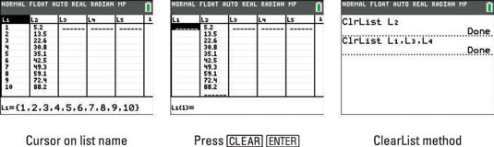

Consequently, this will, through embedded algorithms within the calculator software, allow for the obtaining of the outputs with regards to the entered inputs into the framework that is linked to a respective algorithm within the calculator.

The results of using the calculator varies with the intent of its user and the respective subject association to that of using the calculator. For instance, when we use the calculator to calculate hypothesis testing in the area of statistics, we can evaluate the customer satisfaction rate with regards to a new product launch at a nearby Supermart in the neighborhood, to see if it’s still worthwhile stocking the product with regards to the trade-offs incurred, or that of calculating conditional probabilities that are hard to be estimated unless we follow an established framework/formula to obtain the results, i.e. through the application of Bayes’ Theorem to find out the probability of a patient suffering from cancer given that certain symptoms have occurred, from enquiring and calculating accordingly from the patients who have been diagnosed with cancer about their recollection of occurrence of symptoms, working through requisite methods to arrive at optimal solutions from the output of the calculator from preexisting inputs.