Designing an AI-Based Adaptive Human-Computer Interface
James (GitHub: jamesris1)
University of the Cumberlands
[Course Number and Name]
[Instructor Name]
August 30, 2026

Designing an AI-Based Adaptive Human-Computer Interface
An adaptive user interface changes aspects of its presentation or behavior in response to information about the user, task, or context. Adaptive interfaces were introduced to address usability problems that arise when one fixed interface must serve many situations (Akiki et al., 2014). In this project, adaptation occurs inside a chatbot: the system infers language, sentiment, urgency, and desired response density from the current message.
The implementation is intentionally transparent and limited. It does not collect identity data, track behavior across sessions, or infer protected characteristics. Instead, a deterministic analyzer maps visible words in the current message to four documented signals. Those signals are shown back to the user in a status card, making the adaptation observable.
The adaptive stage then changes the instructions sent to the model. A user who appears frustrated receives a calm, step-by-step style; an urgent message leads with the next action; a request for a brief answer limits response density; and Spanish markers select Spanish. The same logic produces a transparent offline demonstration when no OpenAI key is configured.

Adaptive Interfaces, Intelligent Interfaces, and AI-Based HCI
An intelligent user interface uses computational intelligence to improve the interaction, while an adaptive interface specifically changes to fit inferred context. The concepts overlap but are not identical. A system can be intelligent without adapting its interface, such as a fixed chat box connected to a powerful model. It can also adapt through simple rules without using a learned model.
AI-based adaptive human-computer interaction combines the two ideas: AI or computational inference interprets context, and the interaction changes because of that interpretation. Recent HCI research on just-in-time objectives describes systems that infer a user's immediate goal from context and use that goal to steer downstream AI output (Lam et al., 2026). This project uses a smaller, explainable version of that pattern.
The relationship can be summarized as a pipeline: user message, context inference, adaptation decision, changed response behavior, and visible feedback. Keeping each stage separate supports testing and allows future replacement of the heuristic analyzer with a validated sentiment or language model.

Adaptive Implementation
Figure 1 demonstrates the adaptive path. The prompt contains frustration, a request for a short answer, and a same-day deadline. The analyzer labels the message English, Needs support, High urgency, and Compact response. The offline response acknowledges that a calmer, step-by-step style may help and explains how to enable a live model.
Figure 1
Adaptive Chatbot Response and Visible Context Signals
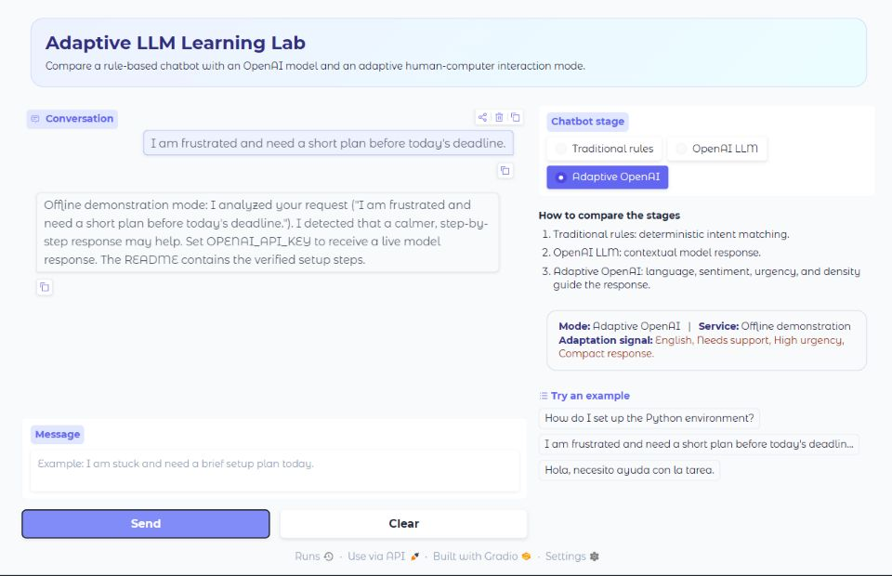
Note. Created from the verified local project run.
The interface does not change color solely because a user appears frustrated, because emotion is not a reliable proxy for visual accessibility needs. Instead, it changes conversational behavior and exposes the decision. This avoids turning an uncertain sentiment inference into an intrusive visual judgment.

Evaluation, Privacy, and Usability
Evaluation must cover both inference accuracy and user benefit. The automated tests confirm English and Spanish detection, support and urgency signals, compact-response selection, and adaptive instruction construction. Figure 2 shows the full verification environment. Manual browser testing confirmed that stage changes, message submission, history updates, and the status panel work together.
Figure 2
Adaptive Application Verification
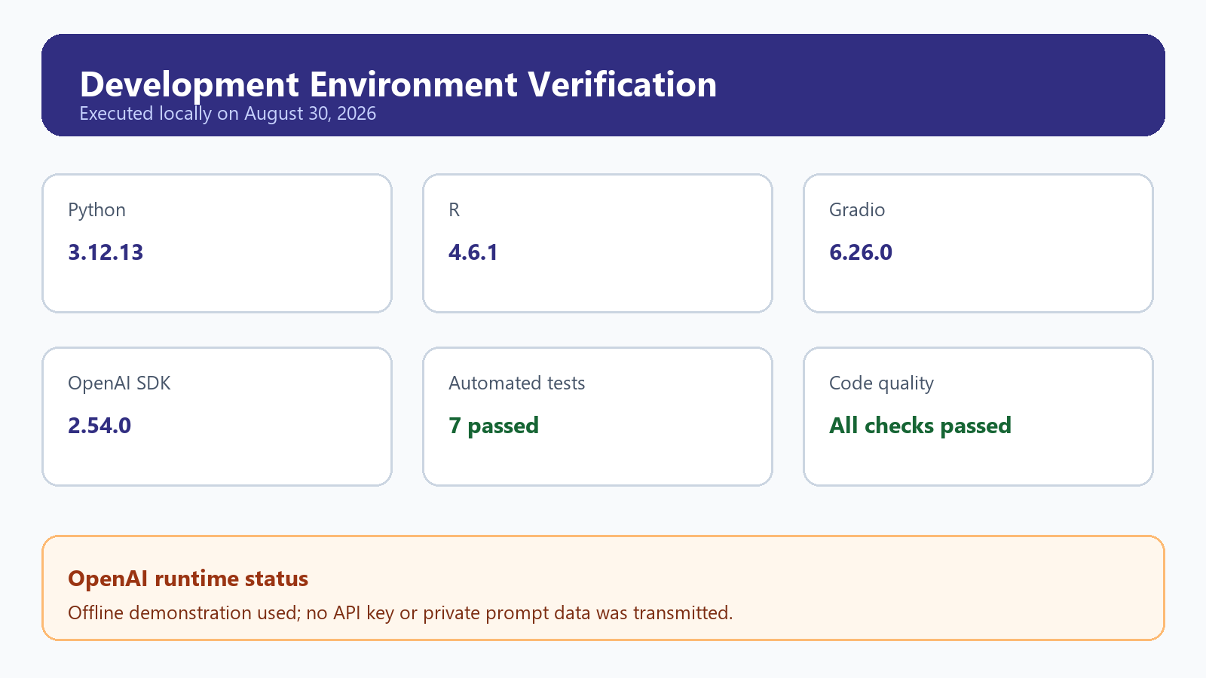
Note. Created from the verified local project run.
Privacy improves when adaptation uses only the current message and discards inferred signals after the session. The current design does not persist a user profile. It also communicates whether OpenAI is live or offline. These choices support informed use, although a production system would still require a privacy notice, accessibility review, misuse testing, and a way for users to disable adaptation.

Limitations, Improvements, and Lessons Learned
Keyword inference can misread sarcasm, mixed languages, quoted text, and culturally specific expressions. The current Spanish detector recognizes only a small set of markers, and sentiment categories are deliberately broad. These limitations are acceptable for a classroom prototype only because the signals are visible, the consequences are low stakes, and the system makes no lasting profile.
A future version could let users correct the detected language, tone, and response length before generation. It could compare the heuristic results with a validated classifier, measure false positives, and perform user testing with informed consent. The interface could also offer explicit accessibility controls such as text size and contrast rather than inferring accessibility needs from emotion.
The exercise showed that adaptation is not merely decoration. It is a decision process that should have a stated purpose, measurable signals, constrained actions, feedback, and user control. The strongest part of this prototype is the separation between context analysis, model instructions, and interface status. That structure makes the system easier to explain, test, challenge, and improve.

References
Akiki, P. A., Bandara, A. K., & Yu, Y. (2014). Adaptive model-driven user interface development systems. ACM Computing Surveys, 47(1), Article 9. https://doi.org/10.1145/2597999
Gradio. (n.d.). Themes. https://www.gradio.app/guides/themes
Lam, M. S., Shaikh, O., Xu, H., Guo, A., Yang, D., Heer, J., Landay, J. A., & Bernstein, M. S. (2026). Just-in-time objectives: A general approach for specialized AI interactions. Proceedings of the 2026 CHI Conference on Human Factors in Computing Systems. https://doi.org/10.1145/3772318.3790713
OpenAI. (2026). Create a model response. https://developers.openai.com/api/reference/cli/resources/responses/methods/create

