Creating a Reproducible Development Environment for AI and Data-Science Exercises
James (GitHub: jamesris1)
University of the Cumberlands
[Course Number and Name]
[Instructor Name]
August 30, 2026

Creating a Reproducible Development Environment for AI and Data-Science Exercises
I selected a lightweight Python virtual environment instead of Anaconda because the course instructions permit any development environment that supports GitHub integration. Python's venv module creates an isolated environment with its own interpreter and installed packages, and the documentation recommends keeping the environment out of source control (Python Software Foundation, 2026). This approach met the assignment requirement while avoiding changes to unrelated Python installations.
The verified environment uses Python 3.12.13, R 4.6.1, Gradio 6.26.0, and the OpenAI Python SDK 2.54.0. I pinned those versions in the requirements files, added an environment-variable template, and ran a Hello World smoke test. Figure 1 records the versions and quality gates observed during the local run.
Figure 1
Development Environment Verification
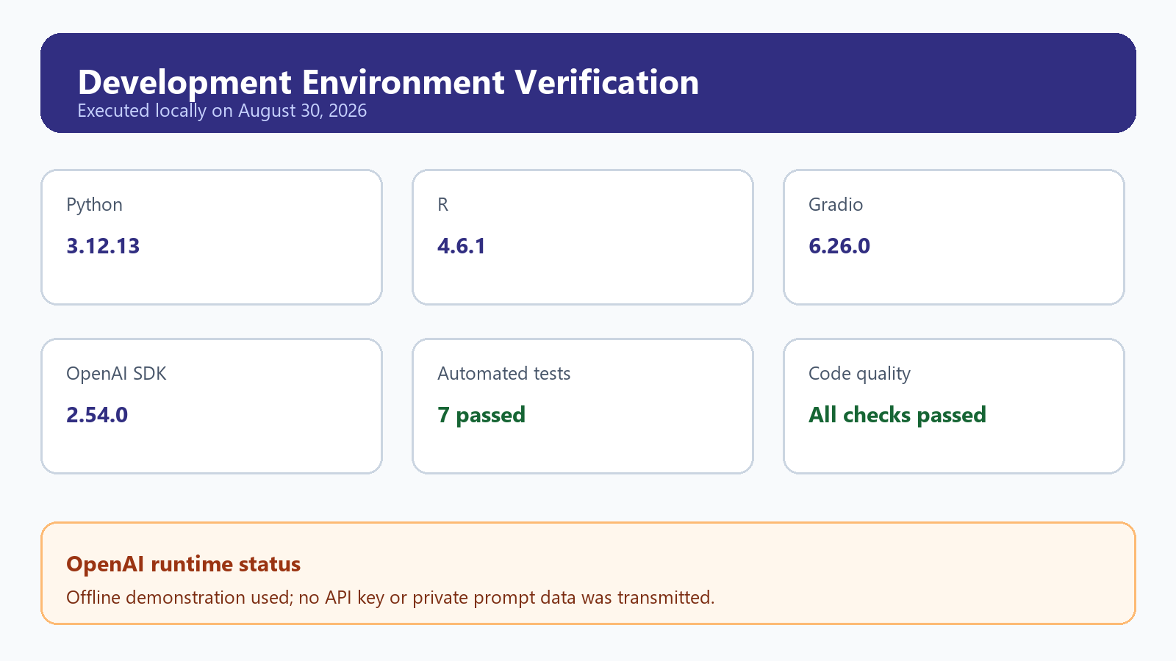
Note. Created from the verified local project run.

Python Analysis and Program Development
The Python exercise loads a synthetic ten-week study dataset, calculates learning trends, and produces a customized two-panel visualization. The upper panel tracks quiz scores against a target of 90; the lower panel compares weekly Python and R practice hours. This goes beyond a default graph by using a deliberate color palette, an annotated improvement value, a target line, labeled axes, and a source note.
I also wrote a study-plan recommender that is more complex than a temperature conversion. It examines recent score change, the target-score gap, total practice by language, and confidence. It then chooses the less-practiced language and recommends a minimum amount of additional work plus concrete actions. Figure 2 shows the executed Python output.
Figure 2
Python Learning-Progress Analysis
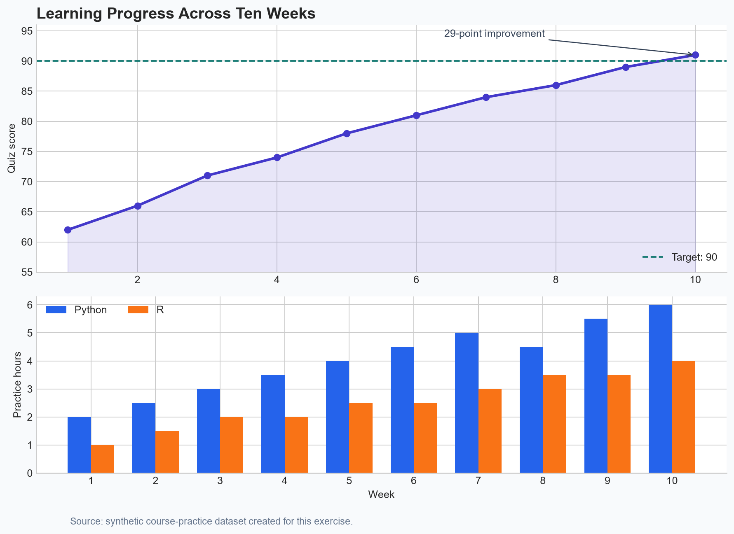
Note. Created from the verified local project run.

R Analysis, Git Integration, and Lessons Learned
R was not initially installed, so I installed R 4.6.1 and implemented the same analysis using base R. R is both a programming language and an environment for statistical computing and graphics (R Foundation, 2026). The script reads the shared CSV file, calculates the same recommendation fields, writes a summary, and creates the graph in Figure 3. Matching inputs and outputs across languages made comparison easier.
Figure 3
R Learning-Progress Analysis
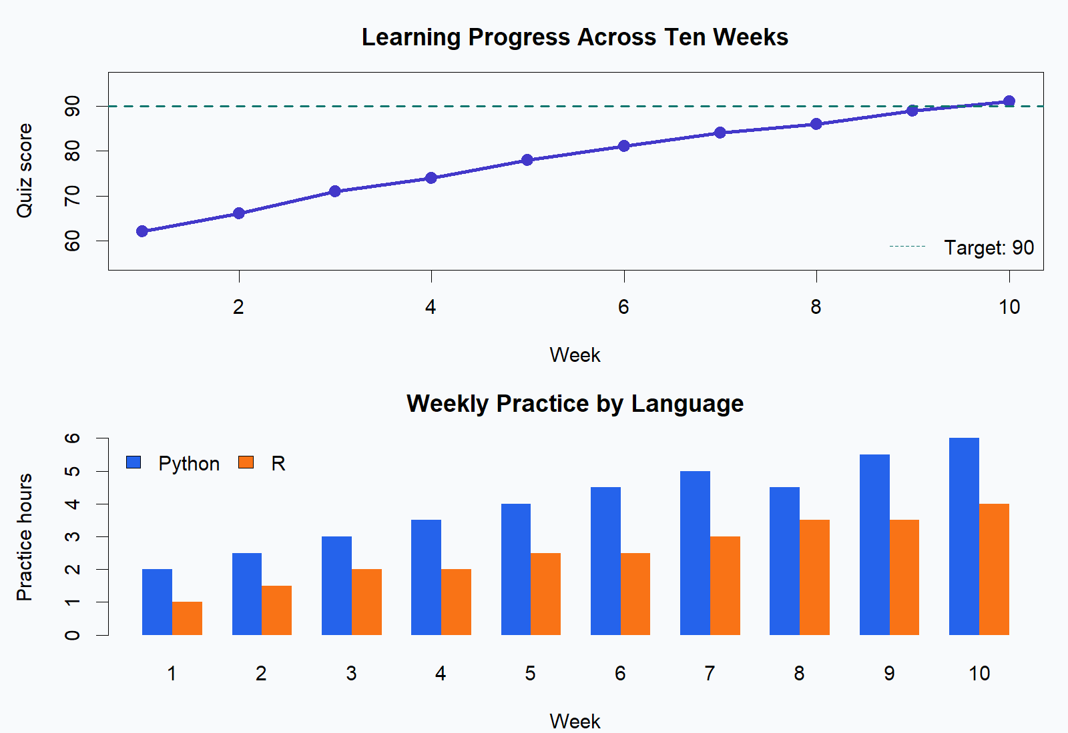
Note. Created from the verified local project run.
The main mitigation strategy was reproducibility: source files and exact dependencies are committed, but the generated virtual environment is ignored. Seven tests and a code-quality check passed. The project is linked to a local Git repository and is ready for the private GitHub remote after authentication. I learned that a development environment is not merely installed software; it includes repeatable dependencies, source control, validation commands, and documentation that another person can follow.

References
Dennis, A. L. (n.d.). Create a development environment exercise [Course handout]. University of the Cumberlands.
Python Software Foundation. (2026). venv: Creation of virtual environments (Python 3.12.13 documentation). https://docs.python.org/3.12/library/venv.html
R Foundation. (2026). What is R? https://www.r-project.org/about.html
Gradio. (n.d.). Creating a chatbot fast. https://www.gradio.app/guides/creating-a-chatbot-fast

