Creating and Preparing a Private GitHub Repository for an AI Course Portfolio
James (GitHub: jamesris1)
University of the Cumberlands
[Course Number and Name]
[Instructor Name]
August 30, 2026

Creating and Preparing a Private GitHub Repository for an AI Course Portfolio
For this exercise, I organized the work as one private-ready repository named adaptive-llm-course-portfolio under the GitHub username jamesris1. It preserves the progression from development setup to traditional, model-powered, and adaptive chatbot projects. GitHub describes a repository as an owned project space for code, files, issues, and collaboration settings (GitHub, n.d.). I kept source, tests, reports, figures, and submission instructions together while excluding local environments and secrets.
Figure 1 separates executable source from evidence and reports so an instructor can locate each assignment deliverable quickly.
Figure 1
Planned Repository Structure and Assignment Organization
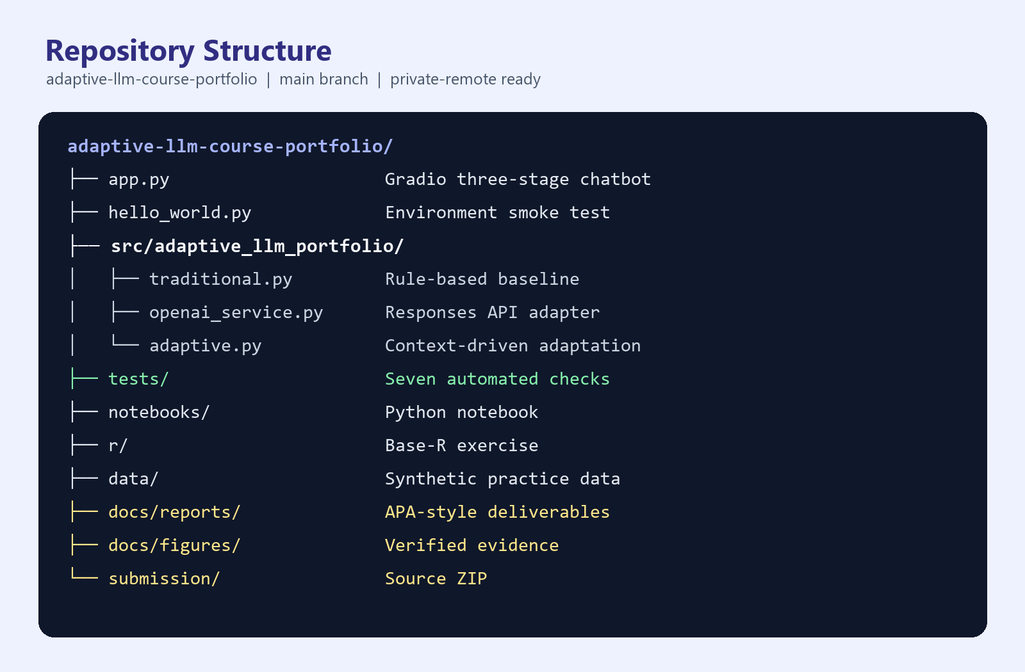
Note. Created from the verified local project run.

Initialization, Version Control, and Privacy
I initialized the repository on a main branch and configured the commit identity locally for jamesris1. I used a repository-specific configuration rather than changing unrelated global settings. The .gitignore file excludes the Python virtual environment, local environment variables, caches, test artifacts, logs, and generated ZIP files. This decision reduces the risk of committing an API key or machine-specific dependency files.
The largest practical challenge was that the working browser session was not authenticated to GitHub. I therefore completed the reversible local work first: directory design, application code, tests, reports, and a clean source package. I did not invent an instructor username or create a public repository as a substitute. The intended remote is https://github.com/jamesris1/adaptive-llm-course-portfolio, but final private-repository creation and push require an authenticated jamesris1 session.
A second challenge involved balancing completeness with portability. The local .venv directory proves that the environment works, but Python documentation explains that virtual environments are disposable and should not be checked into source control (Python Software Foundation guidance is discussed in the companion environment report). I preserved exact package versions in requirements files instead. This allows the instructor to recreate the environment without receiving thousands of generated dependency files.

Collaboration and Submission Readiness
GitHub's current instructions place collaborator invitations under the repository Settings area. The owner opens Collaborators, selects Add people, searches for the exact username, and sends the invitation (GitHub, n.d.). The course handout asks for read access; however, GitHub explains that a personal private repository uses owner and collaborator roles, and collaborators receive write access rather than a separate read-only personal-repository role (GitHub, n.d.). I documented this platform constraint instead of claiming that a nonexistent permission level was enabled.
The remaining user-owned step is to obtain the instructor's GitHub username from the course announcement and invite that exact account. The submission checklist also requires confirmation that the repository is private and the invitation is pending or accepted. Figure 2 summarizes the local verification completed before the remote handoff.
Figure 2
Verified Development and Repository Readiness
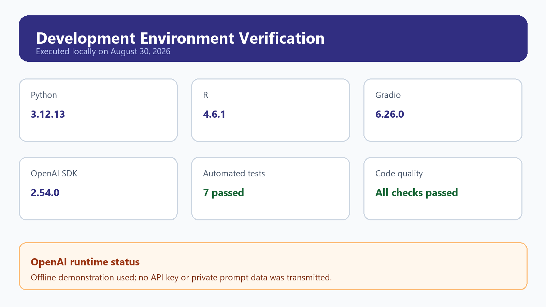
Note. Created from the verified local project run.

References
Dennis, A. L. (n.d.). Exercise: Create a private GitHub repo and share it with the instructor [Course handout]. University of the Cumberlands.
GitHub. (n.d.). Getting started with your GitHub account. https://docs.github.com/en/get-started/onboarding/getting-started-with-your-github-account
GitHub. (n.d.). Inviting collaborators to a personal repository. https://docs.github.com/en/repositories/managing-your-repositorys-settings-and-features/repository-access-and-collaboration/inviting-collaborators-to-a-personal-repository
GitHub. (n.d.). Permission levels for a personal account repository. https://docs.github.com/en/repositories/managing-your-repositorys-settings-and-features/repository-access-and-collaboration/permission-levels-for-a-personal-account-repository

