EE1520 Spring 2025 | Homework #1 (10%)

Due: April 11, 2025

This assignment is related to C/C++, Unix file systems and stools such as Make. You need to know every single line of the code you submitted (for interactive grading). You can copy code from online sources but you must know how it works.
[online resources for tar and make (and it is important for you to learn the concept of separate compilation]
https://www.interserver.net/tips/kb/use-tar-command-linux-examples/
https://www.cs.colby.edu/maxwell/courses/tutorials/maketutor/
https://www.cs.bu.edu/teaching/cpp/separate-compilation.html

Part 1: (7%) split a large file into fixed-size pieces and re-join them

As common file/database size is getting much larger these days, it is handy to be able to break them into small pieces for the purpose of storage or internet transfer, and then to heal them back together to the original form whenever needed. For this homework assignment, we will build such tools --

(Programs) myHeal and myBreak are two utility programs for separating a giant file into smaller-sized chunks and re-assembling the chunks back to their original.

myBreak: the myBreak program will separate the source file, typically very large file size, into fixed-size chunks (for example, 1 MB a piece). The program takes the following arguments:

usage: ./myBreak <source> <prefix> <chunk size (K)>

Here is an example ➔

(base) MBP:myBreakHeal sfwu$ ls -l toID_sorted_Lall_LIS.xls
-rw-r--r-- 1 sfwu staff 710779752 Sep 30 12:15 toID_sorted_Lall_LIS.xls

(base) MBP:myBreakHeal sfwu$ ./myBreak toID_sorted_Lall_LIS.xls myPrefix 65536
starting myPrefix.00000000000000000000000000000000
starting myPrefix.00000000000000000000000000000001
starting myPrefix.00000000000000000000000000000002
starting myPrefix.00000000000000000000000000000003
starting myPrefix.00000000000000000000000000000004
starting myPrefix.00000000000000000000000000000005
starting myPrefix.00000000000000000000000000000006
starting myPrefix.00000000000000000000000000000007
starting myPrefix.00000000000000000000000000000008
starting myPrefix.00000000000000000000000000000009
starting myPrefix.00000000000000000000000000000010
done... [11] chunks produced for toID_sorted_Lall_LIS.xls

myHeal: the myHeal program will re-generate the original file broken by the myBreak program. For error handling, the program needs to detect if any chunk is missing and also the chunk size of incorrect.

Here is the example ➔

(base) MBP:myBreakHeal sfwu$ ./myheal source_toID.csv myPrefix 65536 11
putting myPrefix.00000000000000000000000000000000
putting myPrefix.00000000000000000000000000000001
putting myPrefix.00000000000000000000000000000002
putting myPrefix.00000000000000000000000000000003
putting myPrefix.00000000000000000000000000000004
putting myPrefix.00000000000000000000000000000005
putting myPrefix.00000000000000000000000000000006
putting myPrefix.00000000000000000000000000000007
putting myPrefix.00000000000000000000000000000008
putting myPrefix.00000000000000000000000000000009
putting myPrefix.00000000000000000000000000000010
done... [11] chunks produced for source_toID.csv

(base) MBP:myBreakHeal sfwu$ ls -l source_toID.csv
-rw-r--r-- 1 sfwu staff 710779752 Sep 30 13:46 source_toID.csv

(base) MBP:myBreakHeal sfwu$ diff toID_sorted_Lall_LIS.xls source_toID.csv
(base) MBP:myBreakHeal sfwu$

The source code of a reference implementation of myBreak.c and myHeal.c have been provided.

*** NOW *** we provided another version of myBreak.c, called ee1520_Break.c. The only difference is that now parameters such as chunk number, chunk size and chunk prefix will be recorded under a meta file. Your assignment is to write a program called ee1520_Heal.c to reproduce the original file using the information specified in the meta file.

Please note that the diff program is used to compare the original file and the healed version, and there is no difference which means the heal process was correctly done.
https://www.geeksforgeeks.org/diff-command-linux-examples/

For this part of homework, we will provide some testing scenarios.

For Part 1 of HW#1, please follow the steps:
- Create a subdirectory ee1520_s2025, and then cd ee1520_s2025. (mkdir, cd)
- Create a subdirectory hw1, and then cd hw1.
- Put all your programs and Makefile under the hw1 directory.
- You should also provide a README file to explain how to run your program.
- cd ..
- tar zcvf ee1520_s2025_hw1_submission_<your_user_id>.tar.gz hw1
- upload ee1520_s2025_hw1_submission_<your_user_id>.tar.gz to ??? hw1.

The following three criteria will be considered for your hw1 grade –

        - “diff” original file and healed one (4% -- compile/makefile readme warning)
        - Chunk missing detected (1%)
        - Chunk size mismatched (except the last one) (1%)
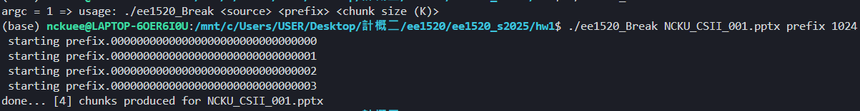
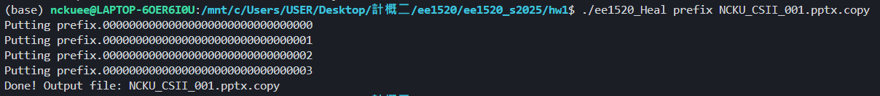
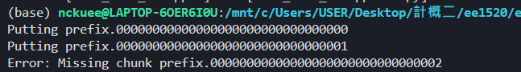
Part 2: (3%) questions to answer during the interactive grading

For the myBreak and myHeal programs, we need to heal the file before we can use it. For example, if the target file is a DVD movie (just an example), we will need to obtain all the chunks and heal it back to its original form before we can watch the movie. However, if we only watch a specific part of the movie, this seems to be unnecessary. Therefore, please write down a high level design or description (HINT: sparse_test.c) regarding how we can start using the file without having to heal all the chunks first? High level thoughts only. No more than one page. Bonus: if you can write a POC (proof of concept) demonstration program, it would be the best way to present your idea.

