Software Requirement Specification

for

TMC Entrance Examination Answer Sheet Recognition and Scoring System

List of Figures
Figure No. | Description | Page
Figure 1.0 | Login Use Case | 41
Figure 2.0 | Admin Dashboard Use Case | 42
Figure 3.0 | Answer Key Management Use Case | 42
Figure 4.0 | Result Management Use Case | 43
Figure 5.0 | System Management - User Management Use Case | 44
Figure 6.0 | System Management - Setting Use Case | 45
Figure 7.0 | AI-Based Answer Sheet Recognition Home Scanner Use Case | 45
Figure 8.0 | Identify Applicant Use Case | 46
Figure 9.0 | Examination Result Use Case | 46
Figure 10.0 | Admin Log-in Prototype | 47
Figure 11.0 | Admin Dashboard Prototype | 47
Figure 12.0 | Answer Key Management Prototype | 48
Figure 13.0 | Answer Key Management Prototype – Add New Answer Key | 48
Figure 14.0 | Result Management Prototype - Folders | 49
Figure 15.0 | Result Management Prototype – Add New Folder | 49
Figure 16.0 | Result Management Prototype - Table | 50
Figure 17.0 | System Management - User Management Prototype | 50
Figure 18.0 | User Management Prototype – Add User | 51
Figure 19.0 | System Management - Settings Prototype | 51
Figure 20.0 | Staff Login Prototype | 52
Figure 21.0 | AI-Based Answer Sheet Recognition - Home Scanner Prototype | 52
Figure 22.0 | Identify Application Prototype | 53
Figure 23.0 | Examination Result Prototype | 53

List of Tables

Table No. | Description | Page
Table 1.0 | Definition of Terms | 33

Overview

The TMC Entrance Examination Answer Sheet Recognition and Scoring System is an intelligent solution designed to modernize the evaluation process for entrance exams at Trinidad Municipal College (TMC). By integrating Optical Mark Recognition (OMR) and computer vision, the system automates the detection and scoring of multiple-choice answer sheets. This addresses the significant time and accuracy challenges associated with manual checking, providing a faster and more reliable process for the Admissions Office.

Project Summary

The TMC Entrance Examination Answer Sheet Recognition and Scoring System is proposed to improve the process of checking multiple-choice entrance examination answer sheets at Trinidad Municipal College (TMC). Manual checking requires exam personnel to identify marked responses, compare them with an answer key, and calculate scores, which can become time-consuming when processing numerous answer sheets. Previous studies have demonstrated that automated Optical Mark Recognition (OMR) can significantly reduce the time required for answer-sheet processing while providing reliable recognition results [1], [2].
The system will consist of a mobile application for capturing and scanning answer sheets and a web-based administrative platform for managing answer keys, examination records, and results. The mobile component is supported by research demonstrating the feasibility of using smartphone-captured images for automated answer processing, although image conditions such as camera angle, paper position, and image distortion must be considered [3].
The system will integrate Computer Vision and Optical Mark Recognition (OMR) to identify shaded responses from captured answer sheets. Research on OMR-based assessment has shown that image-processing techniques can recognize marked responses and automate the collection or evaluation of answer-sheet data [1], [4]. After recognition, the system will compare the detected responses with the official answer key and automatically compute the applicant's score.
The proposed system therefore focuses on reducing repetitive manual checking, improving consistency in answer recognition and scoring, and providing an organized process for examination evaluation. The web-based component will allow authorized personnel to manage and review examination information, while the mobile application will support the initial scanning and recognition of answer sheets.

Definition, Acronyms, and Abbreviations

Terms | Definition
AI | Artificial Intelligence - The simulation of human intelligence processes by computer systems, specifically used for recognizing and interpreting data from scanned documents.
Android | A mobile operating system developed by Google, used for the mobile application in this project.
OMR | Optical Mark Recognition - The technology used to detect the presence or absence of a mark on a scanned image.
RA 10173 | Republic Act No. 10173, also known as the Data Privacy Act of 2012.
TMC | Trinidad Municipal College - The client and target institution for this project.
SRS | Software Requirements Specification

Table 1.0 Definition of Terms

References

[1] J. Muangprathub, O. Shichim, Y. Jaroensuk, and S. Kajornkasirat, (2018). “Automatic Grading of Scanned Multiple Choice Answer Sheets,” International Journal of Engineering and Technology, vol. 7, no. 2. Available at: https://doi.org/10.14419/ijet.v7i2.23.11910
[2] C. Han, A. Krishna K., P. V., M. Castro, et al., (2025). “A Study and Implementation of Customizable Optical Mark Recognition Sheets for Assessments,” 2025 IEEE Frontiers in Education Conference (FIE). Available at: https://doi.org/10.1109/FIE63693.2025.11328230
[3] X. Li, T. Yue, X. Huang, Z. Yang, and G. Xu, (2019). “BAGS: An Automatic Homework Grading System Using the Pictures Taken by Smart Phones,” arXiv. Available at: https://arxiv.org/abs/1906.03767
[4] T. D. Quy, P. T. T. Nga, and N. V. H. Dung, (2021). “Application of Optical Mark Recognition Techniques to Survey Answer Sheets at Dalat University,” Dalat University Journal of Science, vol. 11, no. 1, pp. 93–103. Available at: https://doi.org/10.37569/DalatUniversity.11.1.791
[5] Y. Hernández-Mier, M. A. Nuño-Maganda, S. Polanco-Martagón, G. Acosta-Villarreal, and R. Posada-Gómez, (2025). “Unsupervised Optical Mark Recognition on Answer Sheets for Massive Printed Multiple-Choice Tests,” Journal of Imaging, vol. 11, no. 9, p. 308. Available at: https://doi.org/10.3390/jimaging11090308

Overall Description
The TMC Entrance Examination Answer Sheet Recognition and Scoring System is designed to be a comprehensive tool for automating the checking and scoring of entrance examination answer sheets at Trinidad Municipal College. The system aims to enhance the efficiency and accuracy of the scoring process by leveraging Artificial Intelligence and Optical Mark Recognition technologies to process shaded multiple-choice answer sheets.
In this section, the overall description of the TMC Entrance Examination Answer Sheet Recognition and Scoring System shall be outlined, including the system's essential features, functionality, constraints, assumptions, and dependencies. All data gathered as part of the software requirement specification shall be the basis for the concept of the system.

Product Perspective
Answer sheet recognition and scoring systems are essential tools for educational institutions to ensure the effective and efficient scoring of multiple-choice assessments. These systems provide a structured approach to check and score answer sheets with improved speed and accuracy compared to manual methods. The system specifically addresses the processing of shaded multiple-choice answer sheets, where applicants darken bubbles to indicate their responses.
The system will be using different pioneering technologies in the development and fulfillment of the product's features. For the back-end or server-side, the system will be using Laravel, and React.js, Tailwind CSS, JavaScript for the web front-end. For the mobile front-end, the system will be using React Native. The AI/ML module for OMR will be developed using Python and PyTorch to detect and interpret shaded bubbles on scanned answer sheets. It will also impose MVC Architecture as its coding pattern while having MySQL as the database server and Apache or Nginx as its web server.

Product Functions
This subsection of the SRS provides the summary of the major functions that the TMC Entrance Examination Answer Sheet Recognition and Scoring System will perform.
Hence, from the viewpoint of the end-users, the system offers various functionalities:
- Dashboard: Provides an at-a-glance overview of applicant totals, examination counts, passing statistics, and recent platform activities.
- Answer Key Management: Allows users to create, edit, and maintain answer keys for different examinations.
- Result Management: Enables viewing, filtering, organizing, and exporting of examination results.
- System Management: Enables administrators to create and manage user accounts, assign roles, and configure system-wide settings.
- AI-Based Answer Sheet Recognition: Scan uploaded answer sheets and utilize AI-powered Optical Mark Recognition (OMR) for automatic answer detection.
- Score Computation: Automatically compute examination scores with instant pass/fail determination.
- Mobile Camera: Enables users to scan and upload answer sheets directly using their phone camera.

User Characteristics

The potential users are identified, classified, and described as follows:
Administrator Access:
- Dashboard
- Answer Key Management
- Result Management
- System Management
- User Management
- Settings
Entrance Examination Staff Access:
- AI-Based Answer Sheet Recognition
- Mobile Camera

Constraints

A constraint is any limitation or risk that must be accounted for over the duration of the project life cycle. The solution will be impossible if any of these limitations are violated.

2.4.1. Hard Constraints

Hard constraints are constraints that are absolutely non-negotiable. This must be satisfied by any feasible solution to the model.
- Answer Key Management Constraint: The system shall only allow administrators to create, edit, and manage answer keys. Staff users shall not have access to this function.
- Answer Choices Constraint: The system shall only support answer choices A, B, C, and D. Other answer choices (e.g., E, True/False) shall not be accepted.
- Answer Sheet Format Constraint: The system shall only process single-page shaded multiple-choice answer sheets. Other answer sheet formats shall not be processed.
- User Role Constraint: The system shall strictly enforce role-based access. Staff users shall only have access to scanning and results viewing. They shall not have access to user management or answer key management.
- Mobile Platform Constraint: The mobile application shall only be available for Android devices. iOS devices shall not be supported.
- Data Privacy Constraint: The system shall comply with the Data Privacy Act of 2012 (RA 10173) in storing and handling applicant names and scores.
- Scope Constraint: The system is strictly focused on checking and scoring only. It shall not include examination scheduling, applicant registration, test administration, or admission decision features.

2.4.2. Soft Constraints

Soft constraints, on the other hand, are constraints that could be negotiated once in a while.
- Image Quality Constraint: The OMR engine performs best with clear, well-lit images. The system may have difficulty processing blurry or poorly lit images, requiring staff to retake photos.
- Recognition Accuracy Constraint: The system aims for at least 95% accuracy in detecting shaded bubbles. Some degree of error may occur with ambiguous or incomplete shading.

Assumptions and Dependencies
An assumption is defined as a statement that is generally considered to be true without any proof or evidence, while dependency simply means that one task or activity is reliant on another one. The following are assumptions and dependencies made in order to maximize system utilization:
- User Hardware and Operating System Compatibility: It assumes that users have computers with hardware specifications and operating systems compatible with modern web browsers for the web application and Android smartphones with cameras capable of capturing clear images of shaded answer sheets for the mobile application.
- Security Measures: Users will have some basic security measures in place, such as firewalls and antivirus software, to complement the browser's built-in security features.
- User Technical Savvy: The design and usability of the system assume a certain level of technical proficiency among users, enabling them to navigate, use features, and operate the mobile application effectively.
- Software Dependencies: The application server and database system may depend on other software components or libraries that need to be present or installed on the target system.
- Backup and Recovery Solutions: The integrity and availability of data depend on external backup and recovery solutions that users must implement to protect against data loss or corruption.
- Answer Sheet Standardization: The success and accuracy of the AI model are highly dependent on a consistent and known physical format of the single-page shaded multiple-choice answer sheets provided by TMC, including the position and size of bubbles.
- Image Quality: The OMR engine's performance depends on the quality of images captured. Staff training and clear instructions are necessary to ensure acceptable image capture of shaded answer sheets.
- Shading Quality: The system assumes that applicants will darken bubbles sufficiently to be detected by the OMR engine. The system should be robust enough to handle variations in shading intensity.
- Answer Key Availability: The system assumes that the official answer key for each examination will be provided by the Admissions Office in a timely manner for entry into the system.
- Applicant Identification: The system assumes that staff will correctly enter the applicant's full name for proper association with scoring results.

Specific Requirements

This section of the SRS identifies the system's hardware and software interfaces; the user interface's fundamental prototypes; the functional and performance requirements; design constraints; and software system attributes.

External Interfaces Requirements

External Interfaces Requirements specify hardware and software with which a system or component must interface. This section provides information to ensure that the system will communicate properly with external components.

3.1.1. Hardware Interfaces

A computer server is necessary to implement the software's server-client architecture. This contains the user's accessible websites and database. Below are the minimal hardware specifications:
Server:
- Processor: Intel Core i5-10210U
- RAM: 8GB
- Main Drive: 256GB SSD
Mobile Device:
- Android Smartphone with a camera capable of capturing clear, well-lit images of single-page shaded multiple-choice answer sheets.

3.1.2. Software Interfaces

Server:
Operating System: Windows 11 or Ubuntu 20.04+
Database Server: MySQL
Web Server: Apache 2.4.37 or Nginx
Programming Language: PHP (Laravel), Python (for AI/ML OMR module)
Front-end Design: React.js, Tailwind CSS
AI/ML: Python, PyTorch, OpenCV (for OMR bubble detection)
Client:
- Web Browser: Modern browsers (Chrome, Firefox, Edge)
- Mobile Application: React Native (Android) with camera integration for capturing shaded answer sheets.

Functional Requirements

3.2.1. Use Case

3.2.1.1 Login Use Case

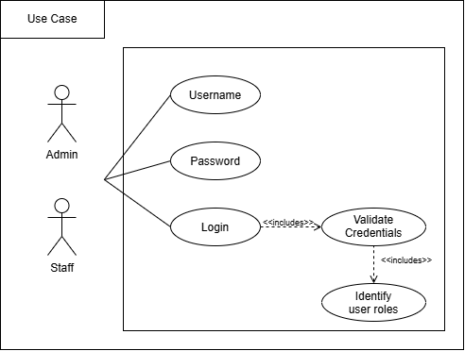
Figure 1.0 Login Use Case
3.2.1.2 Admin Dashboard Use Case
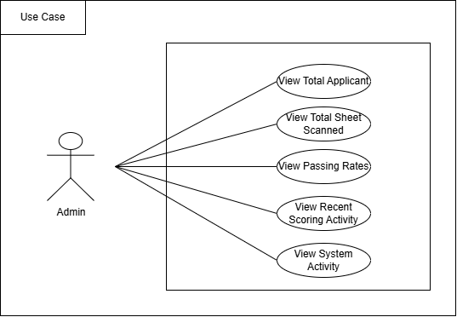
Figure 2.0 Admin Dashboard Use Case

3.2.1.3 Answer Key Management Use Case
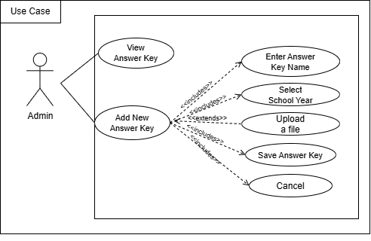
Figure 3.0 Answer Key Management Use Case

3.2.1.4 Result Management Use Case
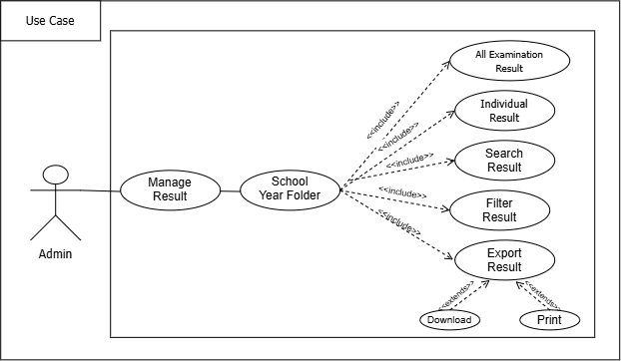
Figure 4.0 Result Management Use Case

3.2.1.5 System Management -User Management Use Case
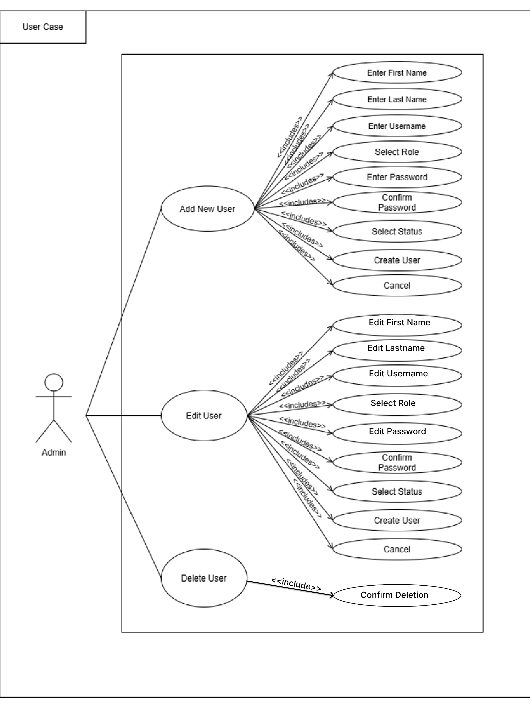

Figure 5.0 System Management - User Management Use Case

3.2.1.6 System Management - Settings Use Case
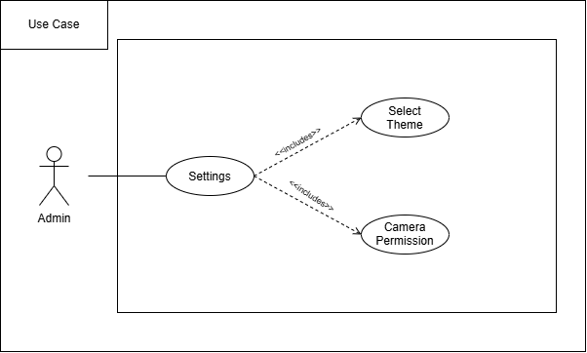
Figure 6.0 System Management - Settings Use Case

3.2.1.7 AI-Based Answer Sheet Recognition Home Scanner Use Case
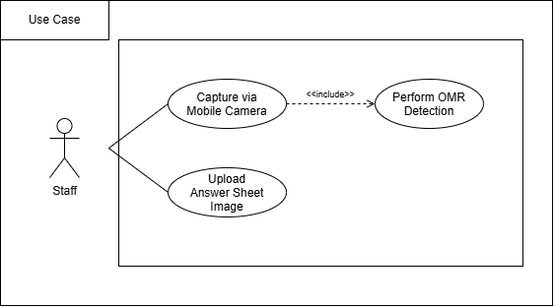
Figure 7.0 AI-Based Answer Sheet Recognition Home Scanner Use Case

3.2.1.8 Identify Applicant Use Case
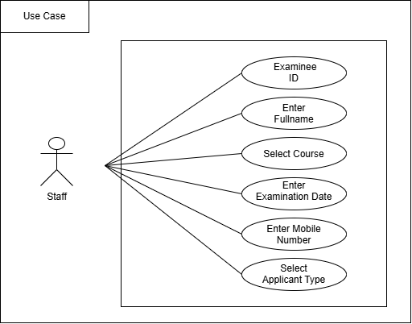
Figure 8.0 Identify Applicant Use Case

3.2.1.9 Examination Result Use Case
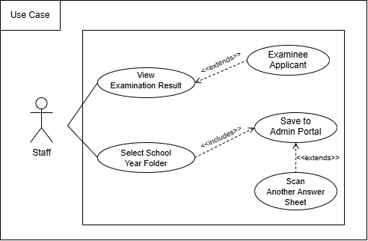

Figure 9.0 Examination Result Use Case

3.2.2. Prototype

3.2.2.1 Web Prototype
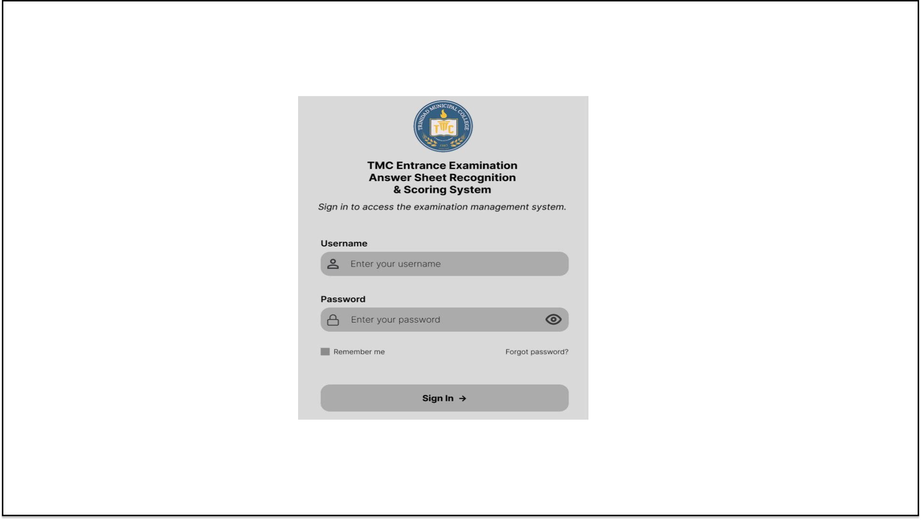
3.2.2.1.1 Admin Log-in Prototype
Figure 10.0 Admin Log-in Prototype

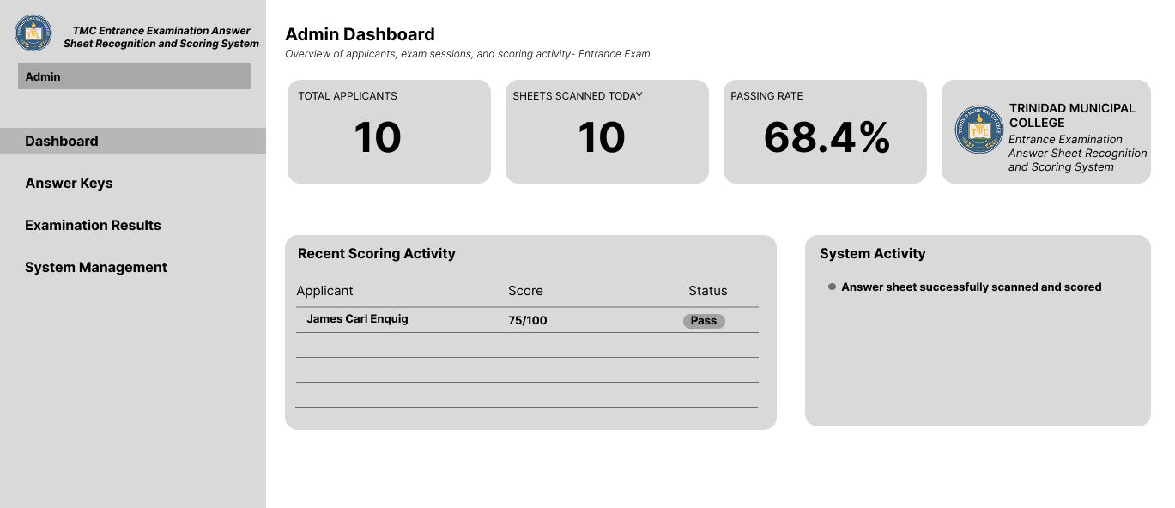
3.2.2.1.2 Admin Dashboard Prototype

Figure 11.0 Admin Dashboard Prototype
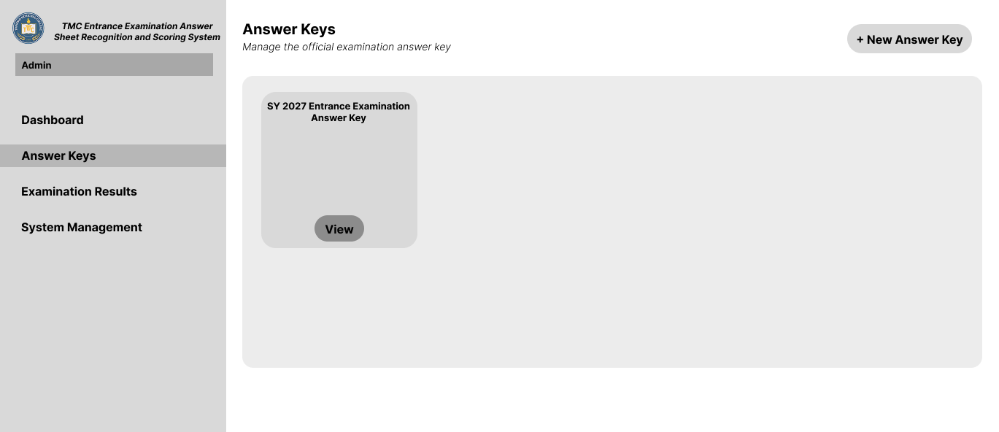
3.2.2.1.3 Answer Key Management Prototype

Figure 12.0 Answer Key Management Prototype

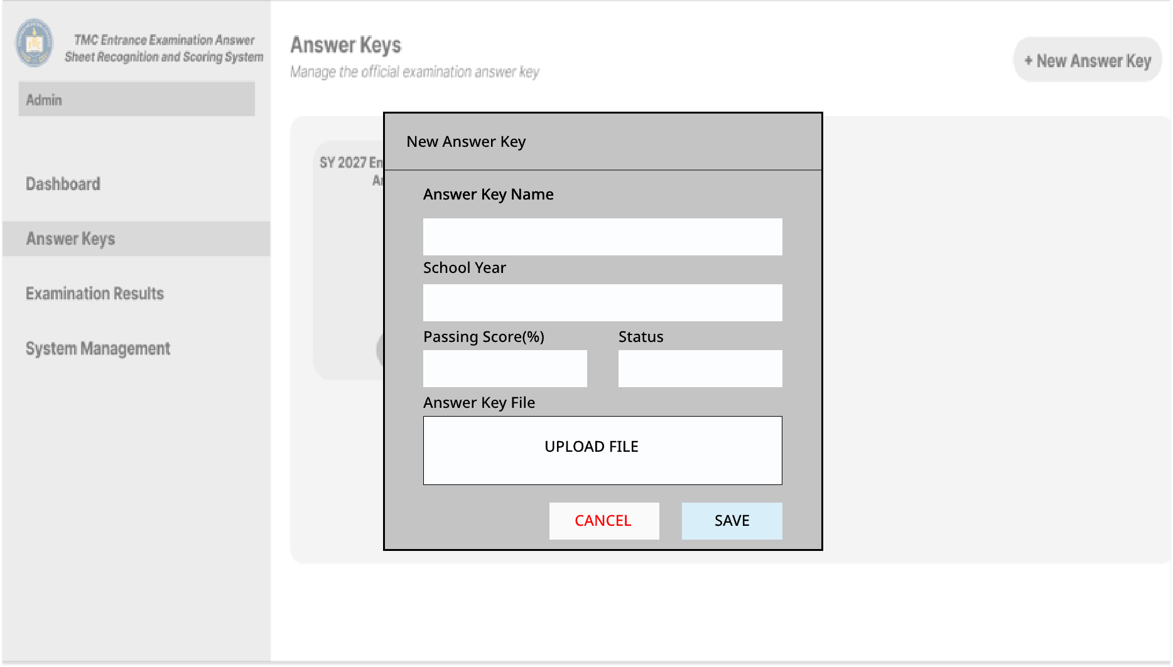
3.2.2.1.4 Answer Key Management Prototype – Add New Answer Key

Figure 13.0 Answer Key Management Prototype - Add New Answer Key
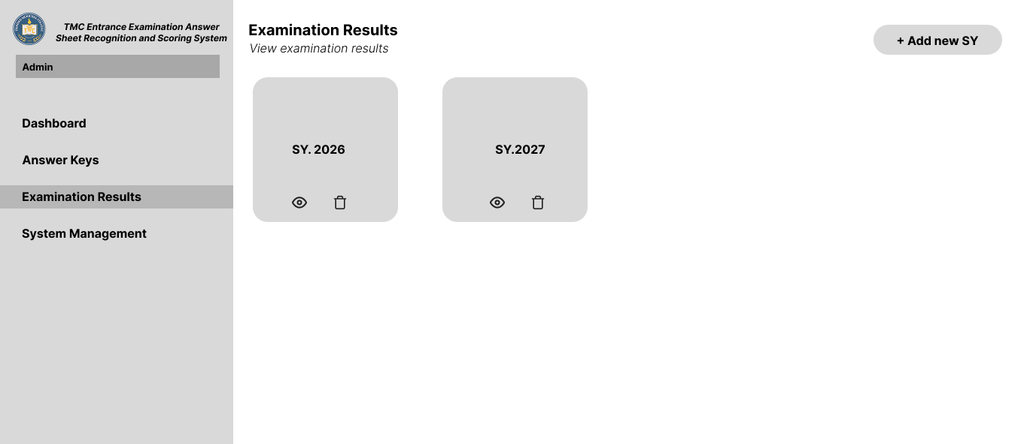
3.2.2.1.5 Result Management Prototype - Folders

Figure 14.0 Result Management - Folders Prototype

3.2.2.1.6 Result Management Prototype – Add New Folder
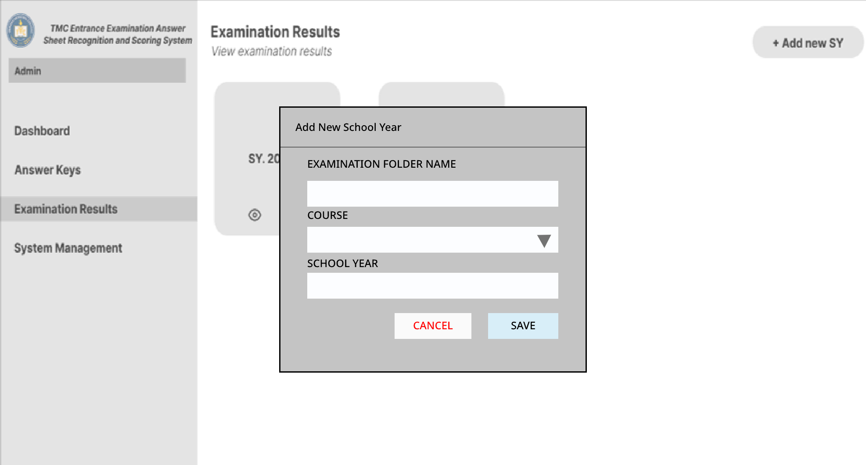

Figure 15.0 Result Management Prototype – Add New Folder
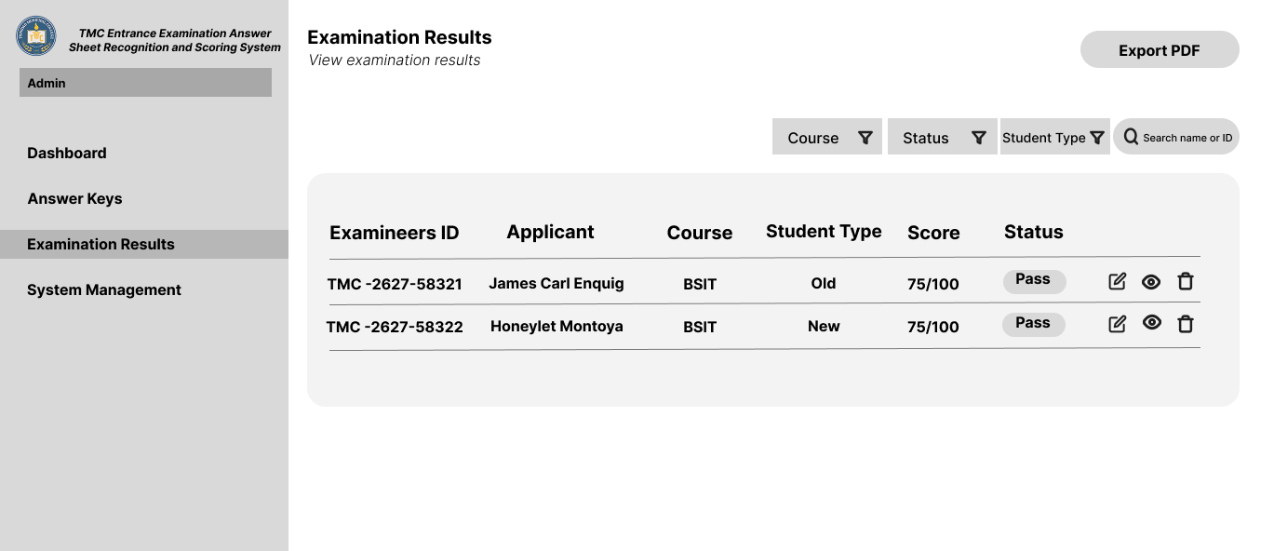
\3.2.2.1.7 Result Management Prototype – Table

Figure 16.0 Result Management Prototype – Table

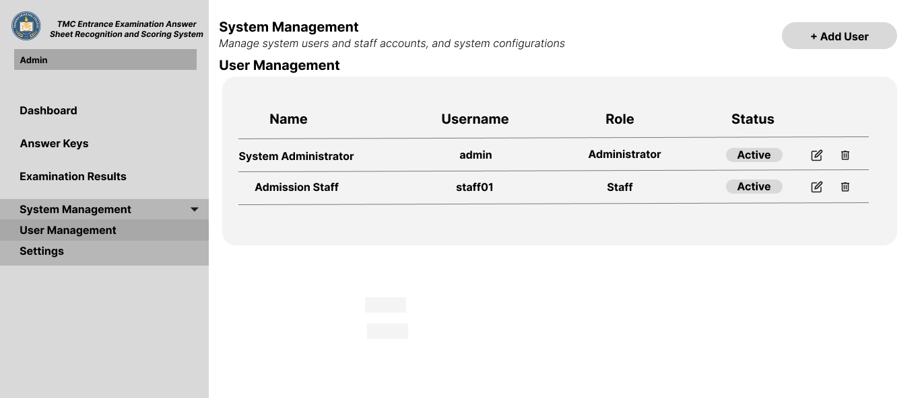
3.2.2.1.8 System Management - User Management Prototype

Figure 17.0 System Management - User Management Prototype
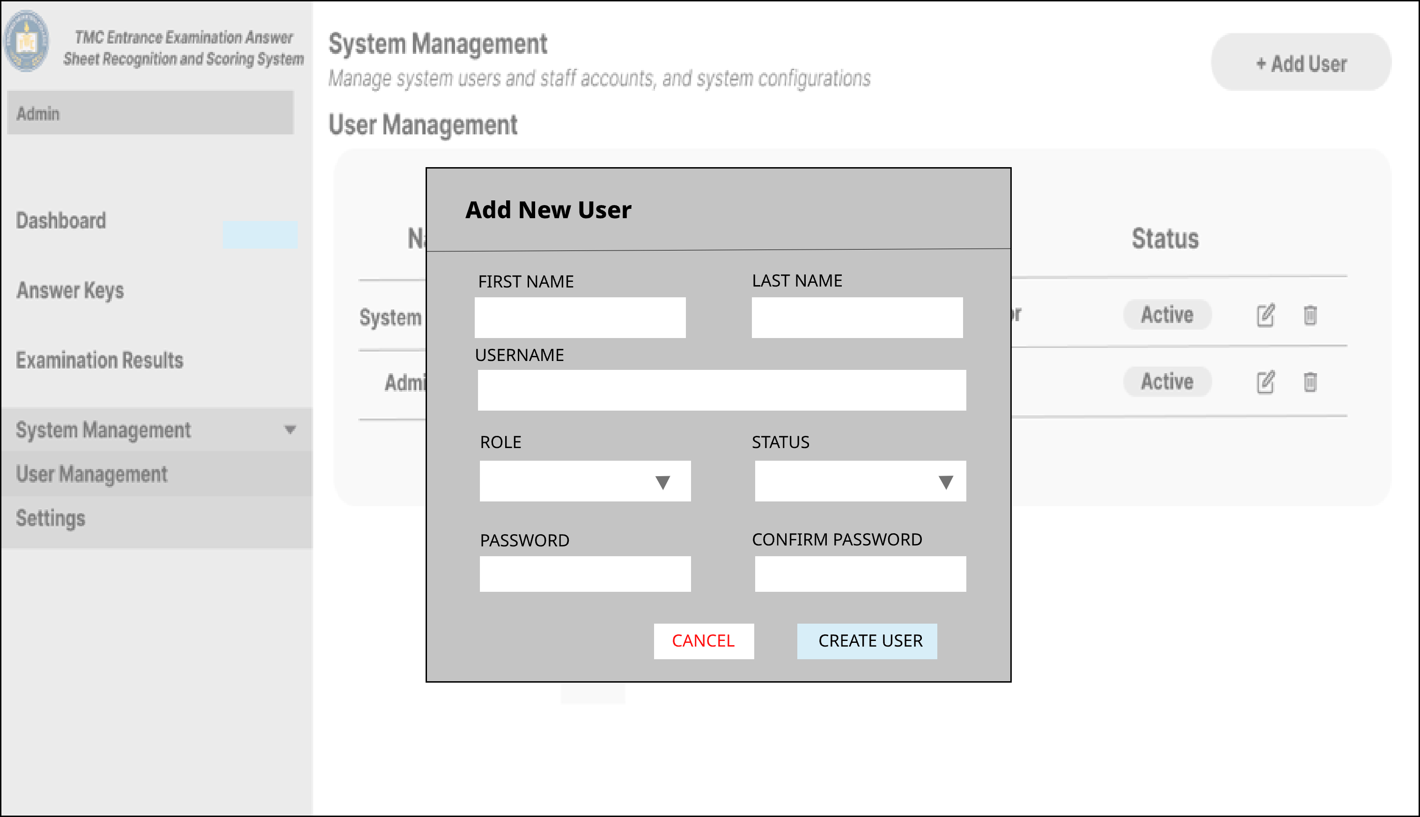
3.2.2.1.9 User Management Prototype – Add User

Figure 18.0 User Management Prototype – Add User

3.2.2.1.10 System Management - Settings Prototype
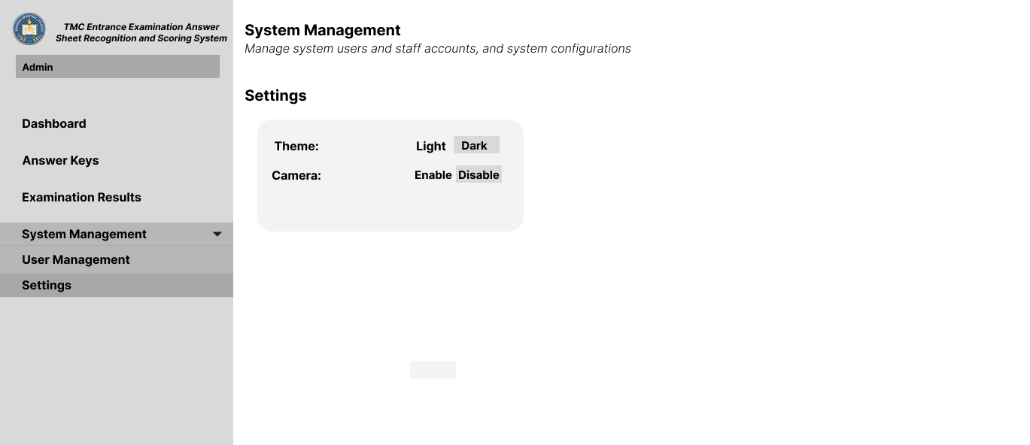

Figure 19.0 System Management- Settings Prototype
3.2.2.2 Mobile Prototype
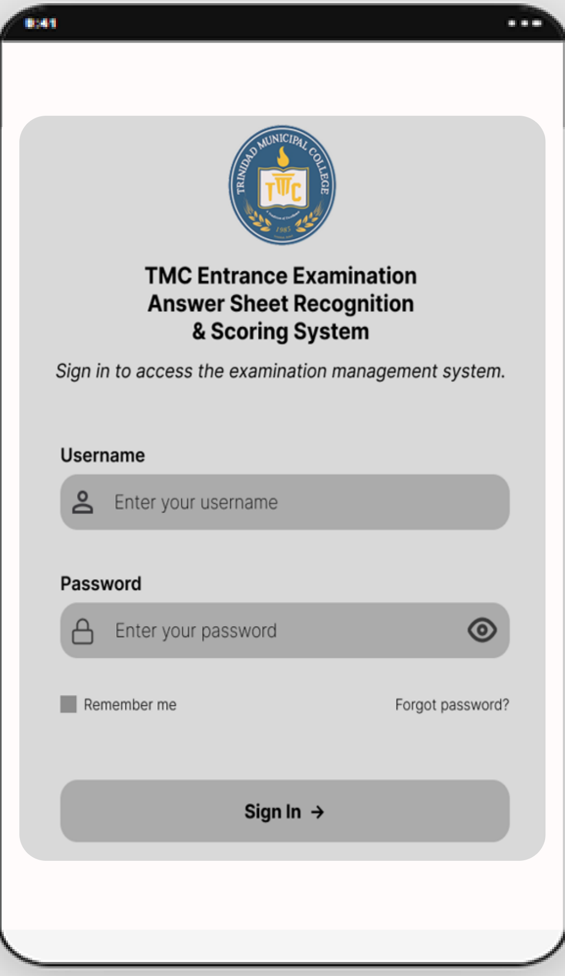
3.2.2.2.1 Staff Login Prototype

Figure 20.0 Staff Login Prototype

3.2.2.2.2 AI-Based Answer Sheet Recognition - Home Scanner Prototype
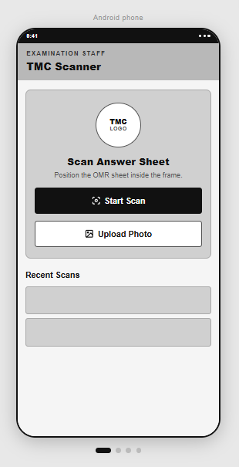
Figure 21.0 AI-Based Answer Sheet Recognition- Home Scanner Prototype

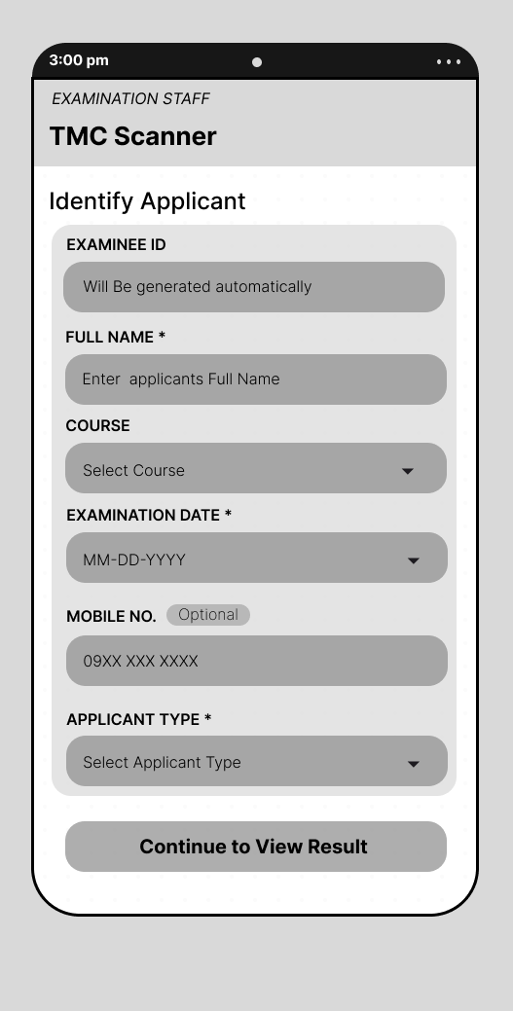
3.2.2.2.3 Identify Applicant Prototype

Figure 22.0 Identify Applicant Prototype
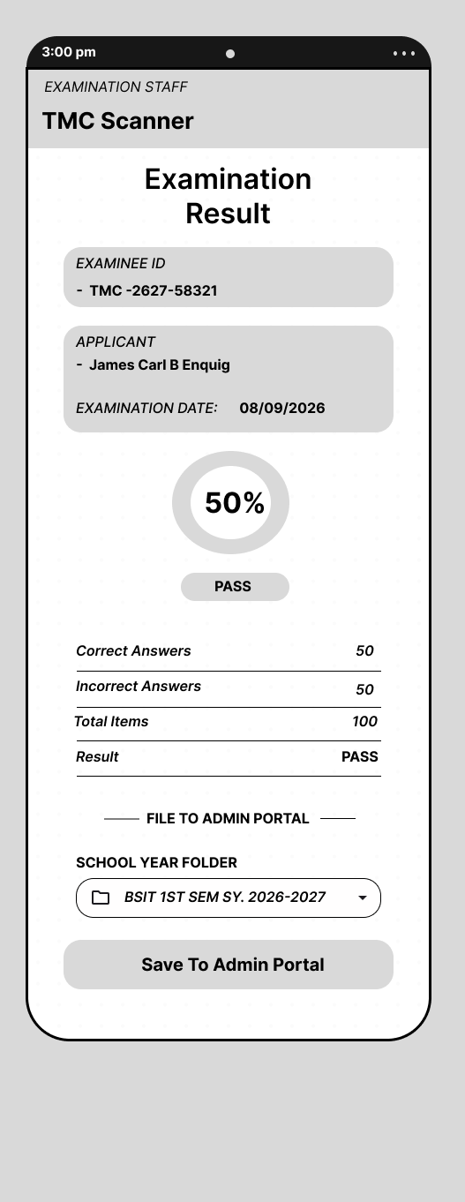
3.2.2.2.4 Examination Result Prototype

Figure 23.0 Examination Result Prototype

Performance Requirements

Performance requirements define how well the system performs certain functions to meet its intended goals. It helps to ensure that the system functions efficiently and effectively, meeting user expectations and business needs.

3.3.1. Execution Time

In general, the execution time of a system or a specific process within a system refers to the amount of time it takes for the system or process to complete its operations. This can be influenced by a wide range of factors including, but not limited to, system hardware, software efficiency, current system load, and the specific tasks being executed. The system must complete the automated checking and scoring for a single shaded answer sheet within seconds of submitting the image.

3.3.2. Efficiency

The project enhances the ability of TMC to process entrance examination answer sheets more efficiently. The system shall significantly improve the efficiency of the checking and scoring process, with an expected reduction in total processing time by at least 70% compared to manual checking of shaded multiple-choice answer sheets. Achieving high efficiency requires careful planning, continuous improvement, and the commitment of sufficient resources.

Design Constraints

This section specifies design constraints that can be imposed by other standards, hardware limitations, etc.

3.4.1. Software Language

The system is developed using a variety of languages:
- Backend: PHP (Laravel)
- Web Front-end: JavaScript (React.js)
- Mobile Front-end: JavaScript (React Native)
- AI/ML Module: Python (for OMR detection of shaded bubbles)

3.4.2. Graphical-User Interface

An amalgam of CSS, HTML, JavaScript, and a few frameworks and APIs make up the graphical user interface. The system also employs React.js for the web interface and React Native for the mobile interface. The mobile interface will prominently feature a camera view for capturing single-page shaded multiple-choice answer sheets.

Software System Attributes

The TMC Entrance Examination Answer Sheet Recognition and Scoring System, which aims to automate the checking and scoring of entrance examination answer sheets, relies on several crucial software system attributes.

3.5.1. Reliability

The system must be reliable. Ensures that the data collected and reported are correct and reflective of actual scores computed. The OMR engine must correctly detect and interpret shaded bubbles on answer sheets. The scoring engine must ensure 100% accuracy in its calculations. It is essential that the system correctly identifies shaded responses to prevent erroneous scores.

3.5.2. Availability

The system should be available during operational hours of the Admissions Office, particularly during examination periods. Minimal downtime is required to ensure the checking and scoring process is not disrupted.

3.5.3. Security

The system must incorporate robust security features to protect sensitive data, including applicant names, scores, and answer keys. This includes implementing role-based access control (RBAC) to ensure users only access information relevant to their duties. All data must be stored and transmitted securely, in compliance with the Data Privacy Act (RA 10173).

3.5.4. Maintainability

The system must be designed using a modular architecture (e.g., separate modules for OMR, scoring, and user management) to facilitate future updates and maintenance. Standard software development practices, including version control and comprehensive documentation, will be followed.

3.5.5. Portability

The system is designed to be deployable on a local server at TMC. The web application should be compatible with commonly used web browsers (e.g., Chrome, Firefox, Edge). The mobile application is specifically designed for the Android operating system.

