
COLLEGE OF ENGINEERING AND INFORMATION TECHNOLOGY

LABORATORY MANUAL ACTIVITY – EVIDENCE REPORT
Testing the FastAPI Backend and Resolving API Errors
Health Check, Swagger UI Endpoint Testing, and Error-to-Success Validation
Field | Details
Course | IT 110 - Web Systems and Technologies
Activity | Laboratory Activity No. 10
Topic | FastAPI Backend Health Check and REST API Testing
Primary Output | Verified /health response, feature-level API tests, error-resolution evidence, and GitHub checkpoint
Maximum Score | 80 points

How to use this template: Replace every [bracketed prompt] with your group’s actual content. Screenshots must come from your own running backend. Never show passwords, API keys, tokens, or private data. Add rows to any table until every implemented feature and every encountered error is covered.

1. Group Information

Field | Details
Official system title | FareFair: Fare Overcharging Detection Using Machine Learning Based on Trip Distance, Route, and Fare Patterns
Section / Course | IT 110 – [Section]
Group name / number | Synova
Member 1 (name, assigned features) | [Enter]
Member 2 (name, assigned features) | [Enter]
Member 3 (name, assigned features) | [Enter]
Member 4 (name, assigned features) | Not applicable (group of three)
Date of testing | October 27, 2026 (server timestamps: 2026-10-26 UTC)
Test database used | PGlite – embedded PostgreSQL-compatible test database (no credentials)

2. Pre-Laboratory Checklist

☐ Using the group’s actual approved semester-project backend (existing repository, not a generic demo)
☐ Endpoints for all implemented features are prepared (e.g., registration, login, report submission, approval, listing, search)
☐ Local database connectivity and environment settings confirmed
☐ Non-sensitive test accounts and records prepared
☐ Activity 7 API contracts and approved requirements on hand
☐ POST/PUT/PATCH/DELETE tests run only against the test database
☐ No passwords, keys, tokens, or private data appear in screenshots or GitHub
Scope and safety This activity verifies the FastAPI backend, not Flutter integration. Reuse the PostgreSQL schema from IT 108; no duplicate ERD is required.

3. Backend Run Command

Enter the exact command used to start the server (adjust main:app to your layout, e.g., app.main:app).
npm start

Field | Details
Expected terminal result | The server starts without a blocking import or database error and serves at http://localhost:4000 (Swagger UI at /docs).
Actual terminal result | Server running at http://localhost:4000 with the embedded PGlite database. /health returned 200 OK and Swagger UI (OpenAPI 3.1) loaded at /docs.

4. Health Check Verification

Item | Expected | Actual
URL | http://localhost:4000/health | http://localhost:4000/health
Response body | JSON containing "status": "ok" (plus service, version, database and timestamp) | {"status":"ok","service":"farefair-api","version":"1.0.0","database":"pglite","at":"2026-10-26T16:19:22.308Z"}
HTTP status | 200 OK | 200 OK

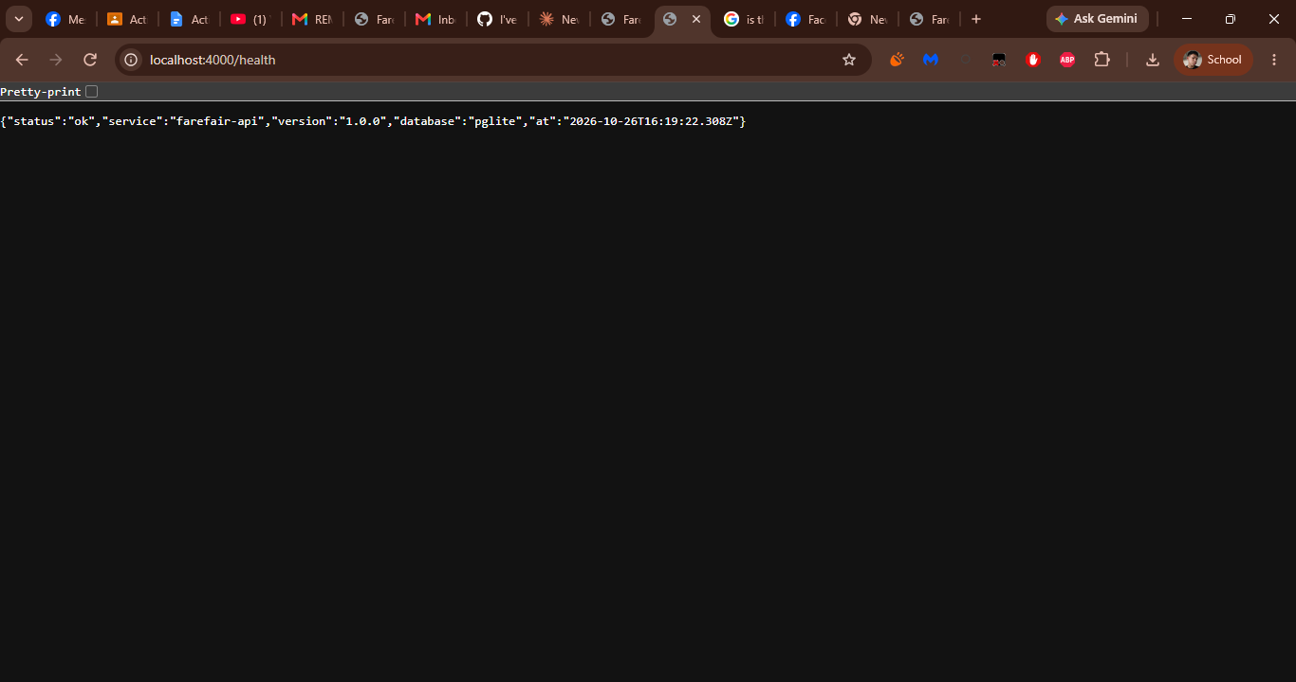

If /health was missing or failed: Not applicable – /health returned 200 OK with status "ok".
5. Swagger UI and Feature-to-Endpoint Inventory

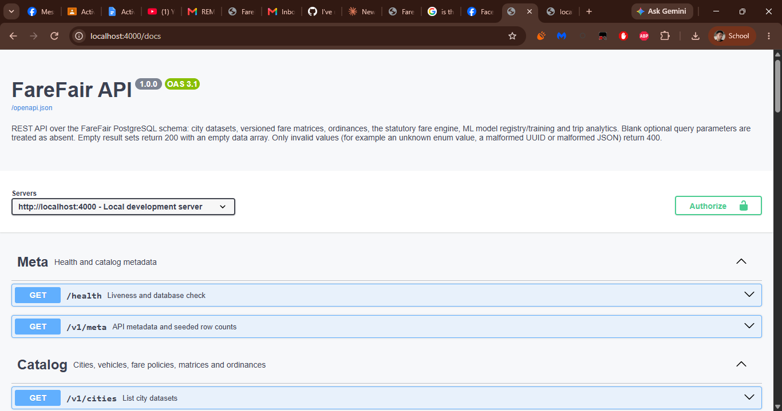
Part A – Feature-to-Endpoint Inventory
Every implemented feature must appear, and every implemented operation (create, view, update, delete, etc.) must be tested. Add rows as needed.
Proof ID | Feature / user action | Method and path | Role / test data needed | Expected status
F01 | Liveness and database health check | GET /health | Public; no test data | 200
F02 | API metadata and seeded row counts | GET /v1/meta | Public; no test data | 200
F03 | List city datasets | GET /v1/cities | Public; status = active, provisional = false | 200
F04 | Full city dataset | GET /v1/cities/{cityId} | Public; cityId = cabadbaran | 200
F05 | Active fare matrix for a city | GET /v1/cities/{cityId}/fare-matrix | Public; cityId = cabadbaran, version = 1 | 200
F06 | Active fare policy (with history) | GET /v1/cities/{cityId}/fare-policy | Public; cityId = cabadbaran | 200
F07 | Vehicle catalog | GET /v1/vehicles | Public; no test data | 200
F08 | Vehicle detail with per-city tariffs | GET /v1/vehicles/{vehicleId} | Public; vehicleId = tricycle | 200
F09 | Fare ordinances | GET /v1/ordinances | Public; cityId = cabadbaran, status = enacted, vehicleId = tricycle | 200
F10 | Ordinance detail | GET /v1/ordinances/{slug} | Public; slug from F09 | 200
F11 | Official fare routes for a city | GET /v1/cities/{cityId}/fare-routes | Public; cityId = cabadbaran, vehicleId = tricycle, search = Bayabas | 200
F12 | Calculate the statutory fare | POST /v1/fare/estimate | Public; JSON body with city, vehicle, origin, destination, passengers | 200
F13 | ML fare prediction | POST /v1/fare/predict | Public; JSON body with city, vehicle, distanceKm, passengers, modelKey | 200
F14 | Fetch a persisted fare quote | GET /v1/fare/quotes/{quoteId} | Public; quoteId from F12 | 200
F15 | Prediction history | GET /v1/fare/predictions | Public; modelVersionId and tripId from F17 and F24 | 200
F16 | Official fare routes (focus city) | GET /v1/fare/routes | Public; cityId = cabadbaran, vehicleId = tricycle, search = Poblacion | 200
F17 | List ML models with versions | GET /v1/fare/models | Public; no test data | 200
F18 | Train a new model version | POST /v1/fare/models/train | Public; JSON body with modelKey, activate, actorName, role | 201
F19 | Model detail by key or UUID | GET /v1/fare/models/{idOrKey} | Public; idOrKey = fare-fair-linear | 200
F20 | Model version detail | GET /v1/fare/models/versions/{versionId} | Public; versionId from F17 or F19 | 200
F21 | Activate a model version | POST /v1/fare/models/versions/{versionId}/activate | Public; versionId from F17, JSON body with actorName and role | 200
F22 | List trip records | GET /v1/trips | Public; filters as listed | 200
F23 | Record a trip | POST /v1/trips | Public; JSON body with trip details and two GPS points | 201
F24 | Trip detail | GET /v1/trips/{tripId} | Public; tripId from F22 or F23 | 200
F25 | Change trip status | PATCH /v1/trips/{tripId}/status | Public; tripId from F24, JSON body with status, flagReason, severity | 200
F26 | CSV export of trips | GET /v1/trips.csv | Public; same filters as F22 | 200
F27 | Network analytics overview | GET /v1/analytics/overview | Public; cityId = cabadbaran, days = 30 | 200
F28 | Matrix vs observed fares | GET /v1/analytics/fares | Public; cityId = cabadbaran, days = 30 | 200
F29 | List fare anomalies | GET /v1/anomalies | Public; filters as listed | 200
F30 | Resolve an anomaly | PATCH /v1/anomalies/{anomalyId}/resolve | Public; anomalyId from F29, JSON body with resolutionNote and actorName | 200
F31 | Audit trail | GET /v1/audit | Public; cityId = cabadbaran, action = trip.status_changed | 200
F32 | Admin sign-in | POST /v1/auth/login | Seeded admin account (admin@farefair.local) | 200
F33 | Read the signed-in account | GET /v1/auth/me | Bearer token (admin) | 200
F34 | Sign out (revoke session) | POST /v1/auth/logout | Bearer token (admin); run last | 200
F35 | List admin accounts | GET /v1/auth/accounts | Bearer token (admin role) | 200
F36 | Update one vehicle tariff (PATCH) | PATCH /v1/admin/cities/{cityId}/fare-matrix/{vehicleId} | Bearer token (admin or lgu_editor) | 200
F37 | Replace one vehicle tariff (PUT) | PUT /v1/admin/cities/{cityId}/fare-matrix/{vehicleId} | Bearer token (admin or lgu_editor) | 200
F38 | Make a city the live dataset | POST /v1/admin/cities/{cityId}/activate | Bearer token (admin role) | 200
F39 | Append a console event to the audit trail | POST /v1/admin/audit | Bearer token (admin) | 201
F40 | Replace one published fare route | PUT /v1/admin/cities/{cityId}/fare-routes/{rowNumber} | Bearer token (admin or lgu_editor) | 200

6. Successful Endpoint Test Results

Copy one block below for every tested endpoint (F01, F02, …). Each screenshot must show the HTTP method, endpoint path, request data (where safe), response code (200 or 201), and response body. If it cannot fit in one frame, use two connected screenshots with the same ID.
F01 – Liveness and database health check
Field | Details
HTTP method and path | GET /health
Tested by (member) | [Member name]
Authorization used | None – public endpoint (no token needed).
Request data (safe fields only) | None (no parameters).
Expected result | 200 OK with a JSON body reporting status "ok", the service name, version and database engine.
Actual result | Swagger UI lists the documented 200 response ("Service is healthy"). The live call to http://localhost:4000/health (S01) returned {"status":"ok","service":"farefair-api","version":"1.0.0","database":"pglite","at":"2026-10-26T16:19:22.308Z"}.
Response code | 200
Interpretation | Proves the API process is running and its database (pglite) is reachable. The live response is the S01 evidence.
Screenshot label | F01-S

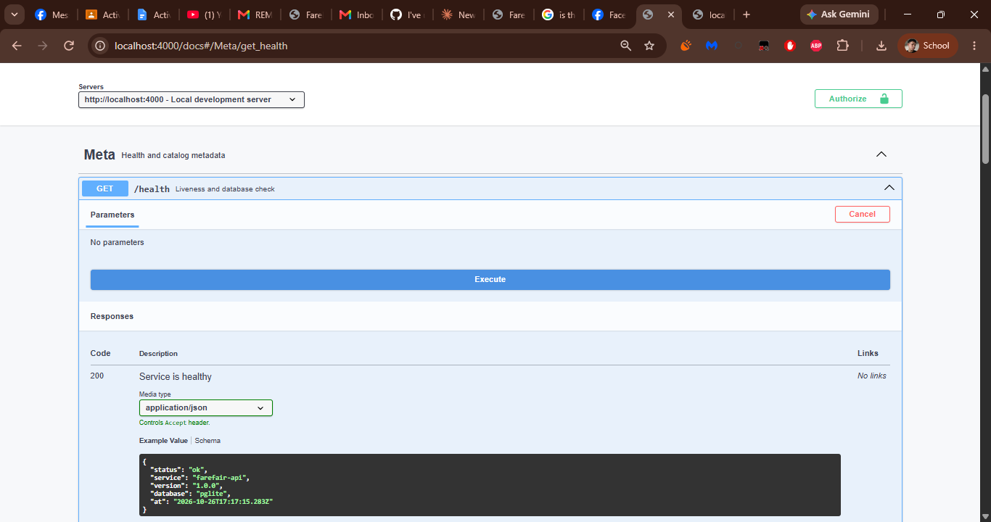
F02 – API metadata and seeded row counts
Field | Details
HTTP method and path | GET /v1/meta
Tested by (member) | [Member name]
Authorization used | None – public endpoint (no token needed).
Request data (safe fields only) | None (no parameters).
Expected result | 200 OK with the API name, version, database, active city and the seeded row counts.
Actual result | Returned name "FareFair API", version "1.0.0", database "pglite", activeCityId "cabadbaran" (Cabadbaran City, Caraga), a counts object with the seeded rows per table (cities, vehicles, ordinances, fare matrix entries, fare routes, trips, fare quotes, active models, training samples, predictions, open anomalies, audit events) and the list of endpoint paths.
Response code | 200
Interpretation | Confirms the database is seeded and Cabadbaran City is the live (focus) city before the other tests run.
Screenshot label | F02-S

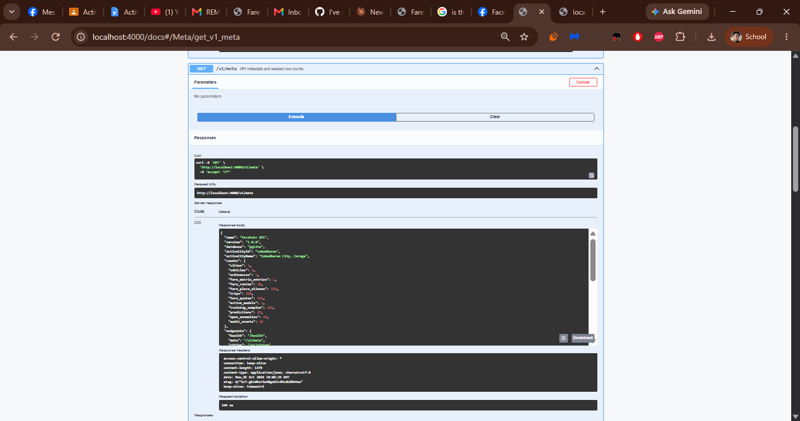
F03 – List city datasets
Field | Details
HTTP method and path | GET /v1/cities?status=active&provisional=false
Tested by (member) | [Member name]
Authorization used | None – public endpoint (no token needed).
Request data (safe fields only) | Query: status = active, provisional = false.
Expected result | 200 OK with a data array of the cities that match the filters.
Actual result | Returned one city: Cabadbaran City, Caraga (province Agusan del Norte, region Caraga (Region XIII), status active, isFocus true, provisional false), with its source (Cabadbaran City Tricycle Fare Regulatory Board, official rates effective 24 September 2026), lastVerified 2026-09-24 and the active policy and matrix version IDs.
Response code | 200
Interpretation | Confirms the city catalog is readable and the status and provisional filters are accepted; only the official (non-provisional) Cabadbaran dataset is returned.
Screenshot label | F03-S

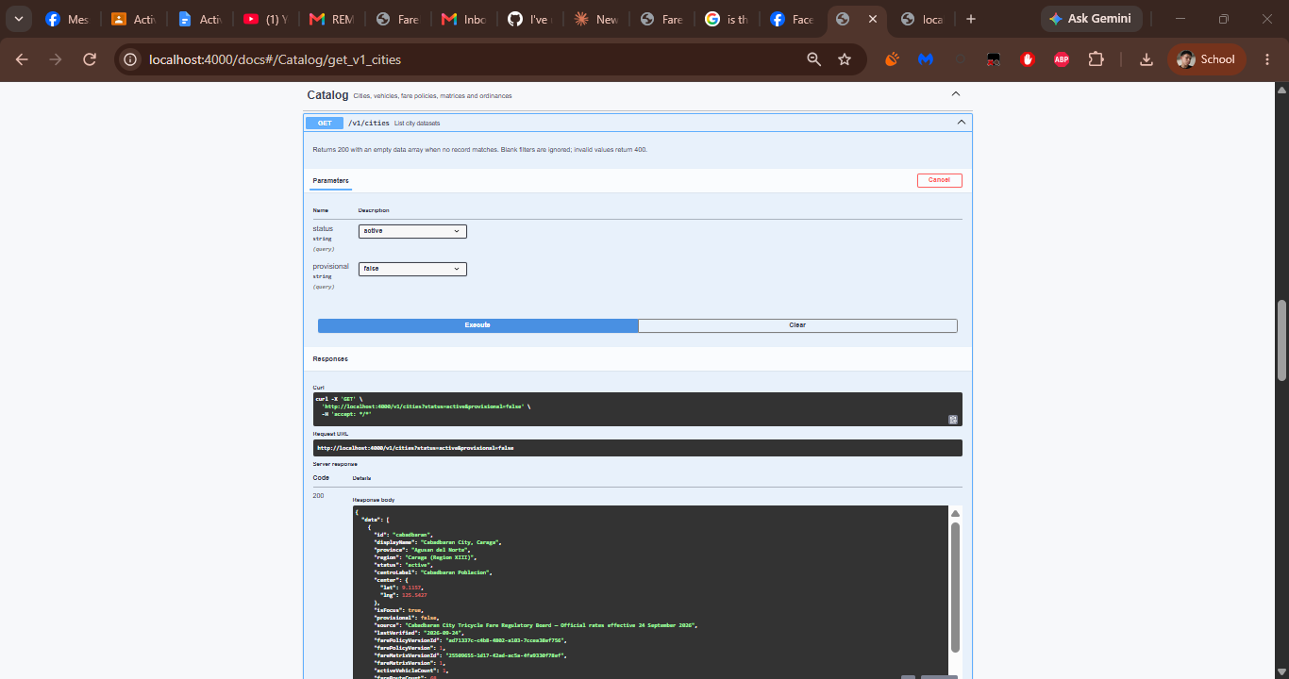
F04 – Full city dataset
Field | Details
HTTP method and path | GET /v1/cities/{cityId}
Tested by (member) | [Member name]
Authorization used | None – public endpoint (no token needed).
Request data (safe fields only) | Path: cityId = cabadbaran.
Expected result | 200 OK with the full dataset: identity, provenance, fare policy, fare matrix, ordinances and corridor.
Actual result | Returned the Cabadbaran City dataset: identity (id cabadbaran, status active, isFocus true, centre coordinates), provenance (provisional false, verified 2026-09-24 by the Cabadbaran City Tricycle Fare Regulatory Board) and the active farePolicy (version 1, discountRate 0.2), followed by the matrix, ordinance and corridor sections.
Response code | 200
Interpretation | Confirms a single request assembles everything the app needs for one city.
Screenshot label | F04-S

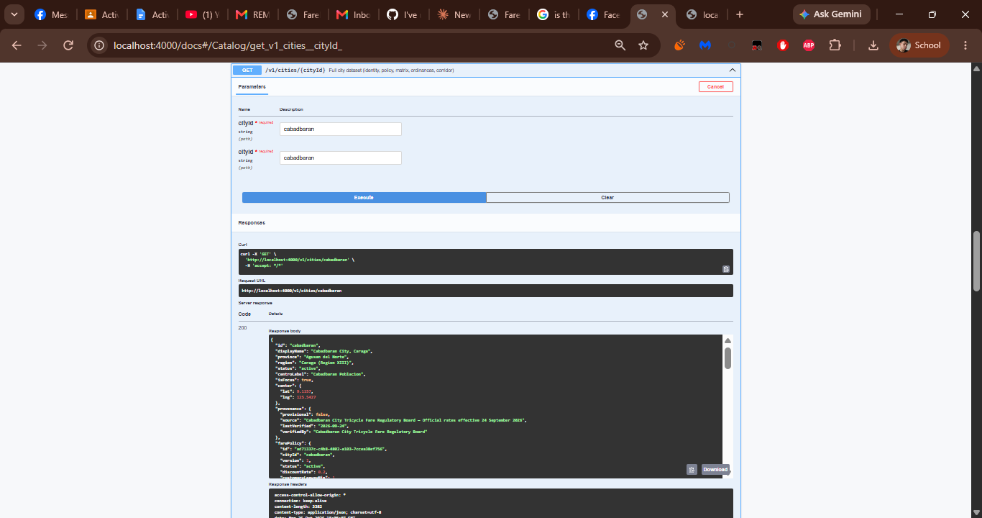
F05 – Active fare matrix for a city
Field | Details
HTTP method and path | GET /v1/cities/{cityId}/fare-matrix?version=1&includeInactive=true
Tested by (member) | [Member name]
Authorization used | None – public endpoint (no token needed).
Request data (safe fields only) | Path: cityId = cabadbaran. Query: version = 1, includeInactive = true.
Expected result | 200 OK with the fare matrix for the city, including its tariff entries.
Actual result | Returned matrix version 1 (status active, effectiveFrom 2026-09-24, effectiveTo null, provisional false) with the notes on per-passenger tricycle fares, the 20% discount for students, senior citizens and PWDs, and the PHP 2.00 charge per extra kilometre beyond the Poblacion area, plus an entries array starting with the tricycle tariff.
Response code | 200
Interpretation | Shows the versioned matrix can be fetched by version and that includeInactive is accepted; the values agree with the ordinance in F10.
Screenshot label | F05-S

SCREENSHOT F05-S
Request and response for this endpoint
[Paste screenshot here] 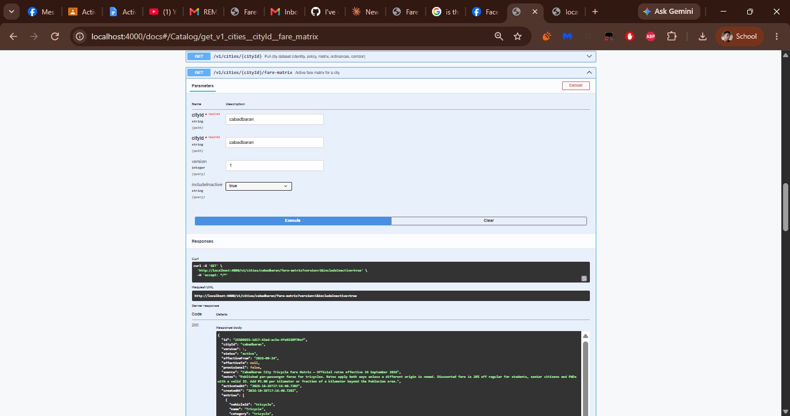
F06 – Active fare policy (with history)
Field | Details
HTTP method and path | GET /v1/cities/{cityId}/fare-policy?includeHistory=true
Tested by (member) | [Member name]
Authorization used | None – public endpoint (no token needed).
Request data (safe fields only) | Path: cityId = cabadbaran. Query: includeHistory = true.
Expected result | 200 OK with the current policy and, because includeHistory is true, the policy history.
Actual result | Returned current policy version 1 (status active, discountRate 0.2, effectiveFrom 2026-09-24, effectiveTo null, notes "Official Cabadbaran City tricycle fare policy.") and a history array of policy versions.
Response code | 200
Interpretation | Confirms the statutory policy (20% discount rule) and its version history are available to the fare engine.
Screenshot label | F06-S

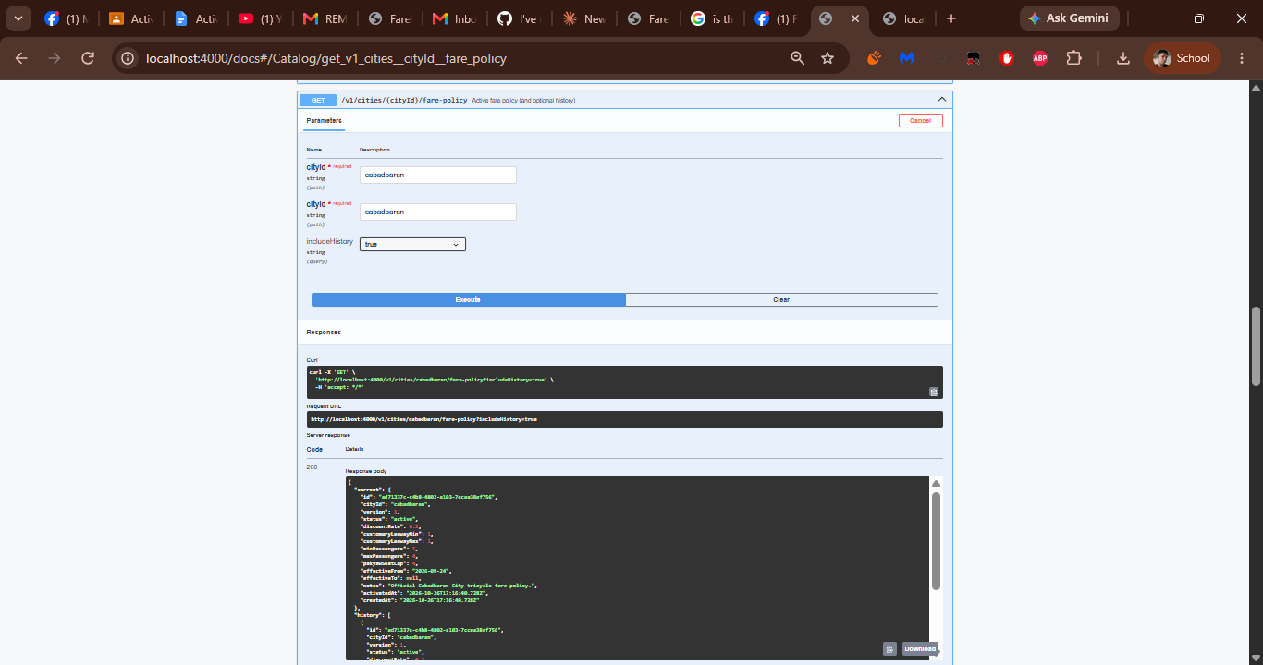
F07 – Vehicle catalog
Field | Details
HTTP method and path | GET /v1/vehicles
Tested by (member) | [Member name]
Authorization used | None – public endpoint (no token needed).
Request data (safe fields only) | None (no parameters).
Expected result | 200 OK with a data array of vehicle types and their default tariffs.
Actual result | Returned the vehicle list; the first record is Tricycle (id tricycle, category tricycle, tag Motorized) with its default tariff values and regulation note, followed by the other vehicle types such as habal-habal.
Response code | 200
Interpretation | Confirms the vehicle catalog and each vehicle's default tariff are served.
Screenshot label | F07-S

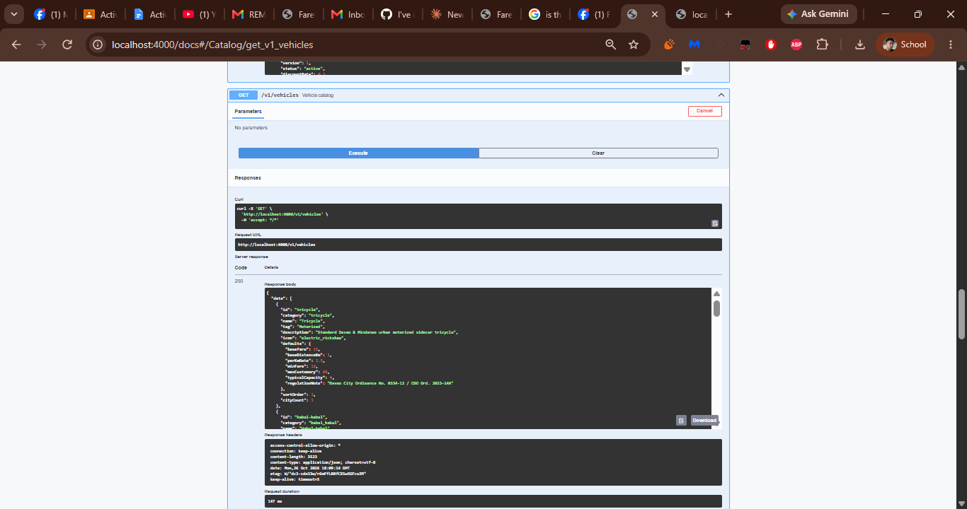
F08 – Vehicle detail with per-city tariffs
Field | Details
HTTP method and path | GET /v1/vehicles/{vehicleId}
Tested by (member) | [Member name]
Authorization used | None – public endpoint (no token needed).
Request data (safe fields only) | Path: vehicleId = tricycle.
Expected result | 200 OK with the vehicle record and its per-city tariff entries.
Actual result | Returned the Tricycle record (category tricycle, tag Motorized, defaults) and a cities array containing the Cabadbaran (cabadbaran) tariff entry.
Response code | 200
Interpretation | Shows vehicle detail joins the default tariff with the entry used for Cabadbaran.
Screenshot label | F08-S

SCREENSHOT F08-S
Request and response for this endpoint
[Paste screenshot here] 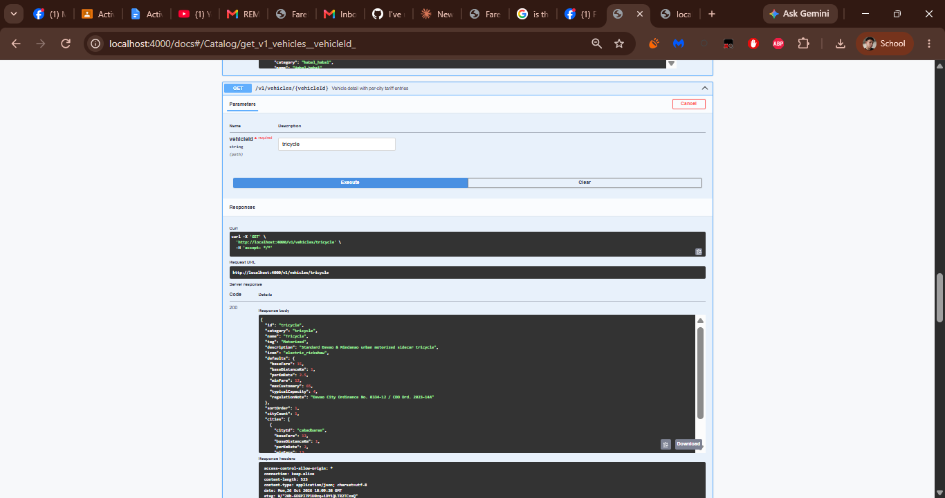
F09 – Fare ordinances
Field | Details
HTTP method and path | GET /v1/ordinances?cityId=cabadbaran&status=enacted&vehicleId=tricycle
Tested by (member) | [Member name]
Authorization used | None – public endpoint (no token needed).
Request data (safe fields only) | Query: cityId = cabadbaran, status = enacted, vehicleId = tricycle.
Expected result | 200 OK with a data array of the ordinances that match the filters.
Actual result | Returned the enacted Cabadbaran City Tricycle Fare Matrix (slug cabadbaran-cabadbaran-tricycle-fare-matrix-2026, municipality Cabadbaran City, Agusan del Norte, enacted and effective 2026-09-24, vehicle applicability Tricycle).
Response code | 200
Interpretation | Confirms ordinances can be filtered by city, status and vehicle; the slug returned here is the identifier used in F10.
Screenshot label | F09-S

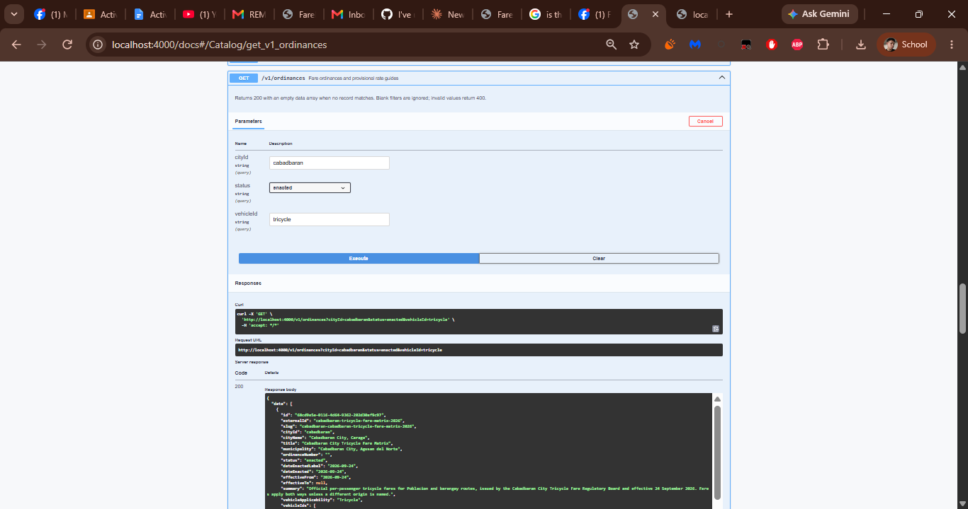
F10 – Ordinance detail
Field | Details
HTTP method and path | GET /v1/ordinances/{slug}
Tested by (member) | [Member name]
Authorization used | None – public endpoint (no token needed).
Request data (safe fields only) | Path: slug = cabadbaran-cabadbaran-tricycle-fare-matrix-2026.
Expected result | 200 OK with the single ordinance identified by the slug.
Actual result | Returned the ordinance with baseFare 13, succeedingKmRate 2, vehicleIds ["tricycle"] and the discount terms (20% for students, senior citizens and persons with disability presenting a valid ID; minimum fare PHP 13 regular / PHP 11 discounted).
Response code | 200
Interpretation | Proves the slug from F09 resolves to one ordinance whose base fare and discount terms match the fare matrix (F05).
Screenshot label | F10-S

SCREENSHOT F10-S
Request and response for this endpoint
[Paste screenshot here] 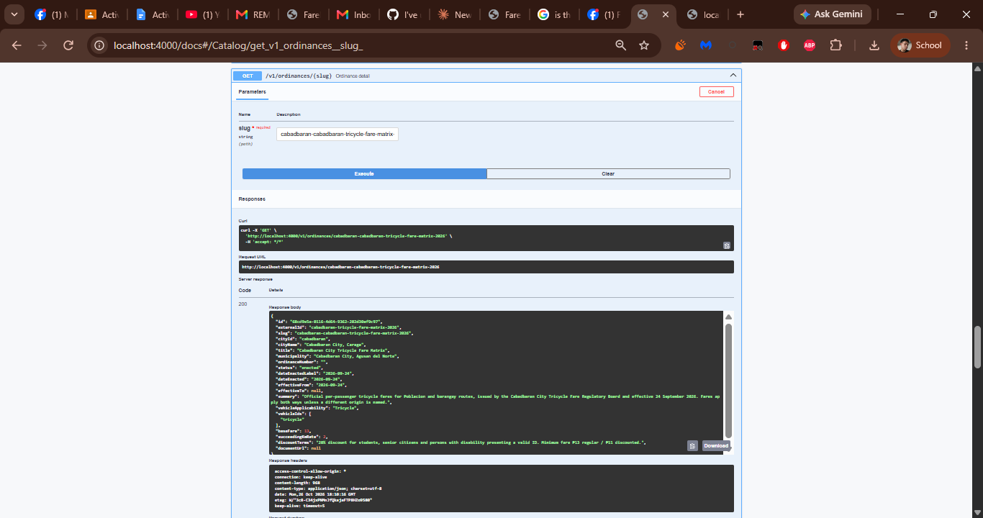
F11 – Official fare routes for a city
Field | Details
HTTP method and path | GET /v1/cities/{cityId}/fare-routes?vehicleId=tricycle&search=Bayabas
Tested by (member) | [Member name]
Authorization used | None – public endpoint (no token needed).
Request data (safe fields only) | Path: cityId = cabadbaran. Query: vehicleId = tricycle, search = Bayabas.
Expected result | 200 OK with the official point-to-point fare rows that match the search.
Actual result | Returned cityId cabadbaran, vehicleId tricycle, effectiveFrom 2026-09-24, provisional false, count 1 and the matching published route row (rowNumber 4).
Response code | 200
Interpretation | Shows the search filter narrows the official route table to the Bayabas row that the fare estimate in F12 uses.
Screenshot label | F11-S

SCREENSHOT F11-S
Request and response for this endpoint
[Paste screenshot here] 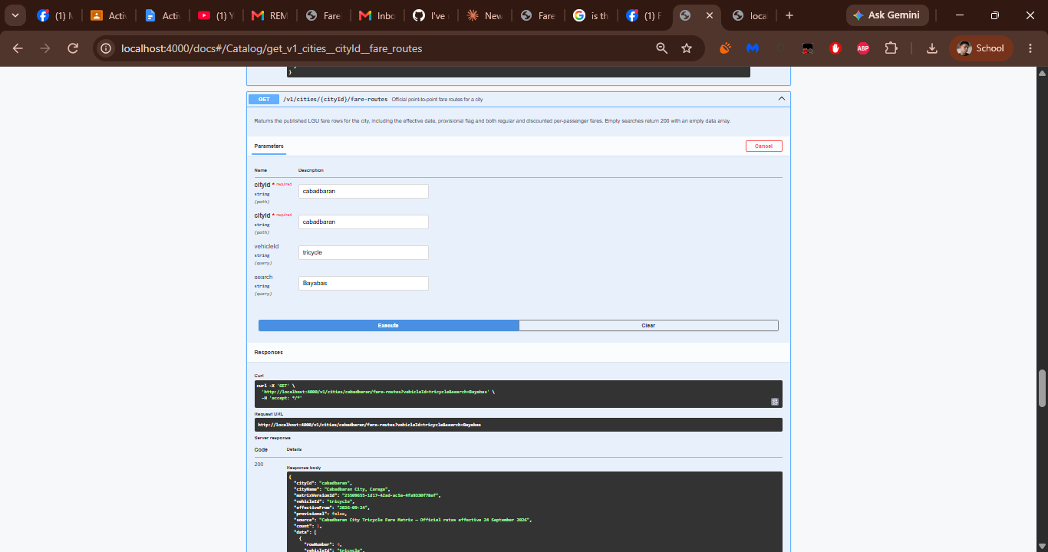
F12 – Calculate the statutory fare
Field | Details
HTTP method and path | POST /v1/fare/estimate
Tested by (member) | [Member name]
Authorization used | None – public endpoint (no token needed).
Request data (safe fields only) | Body: {"cityId":"cabadbaran","vehicleId":"tricycle","origin":"Poblacion","destination":"Bayabas","passengers":1,"pakyaw":false,"discountCode":"none","persist":true}
Expected result | 200 OK with the statutory fare computed from the matched official route; the quote is saved because persist is true.
Actual result | Returned the estimate for Poblacion to Bayabas (cityId cabadbaran, vehicleId tricycle, distanceKm 10.5, matched official route row 4). The persisted quote shows a fare of PHP 50 for one regular passenger (see F14).
Response code | 200
Interpretation | Proves the fare engine returns a numeric fare and creates a quote ID that can be fetched again in F14.
Screenshot label | F12-S

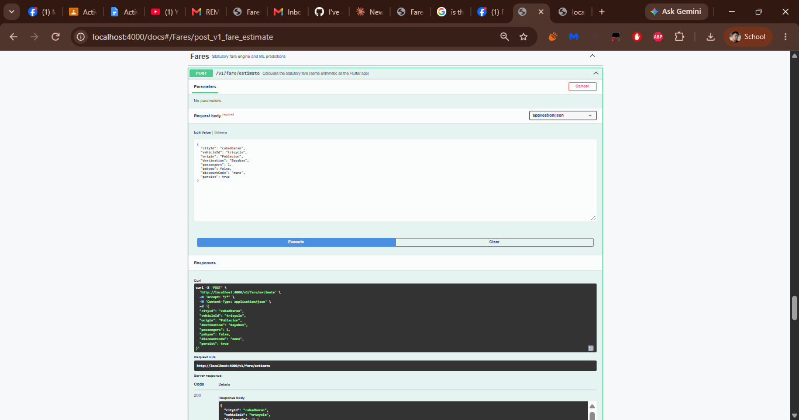
F13 – ML fare prediction
Field | Details
HTTP method and path | POST /v1/fare/predict
Tested by (member) | [Member name]
Authorization used | None – public endpoint (no token needed).
Request data (safe fields only) | Body: {"cityId":"cabadbaran","vehicleId":"tricycle","distanceKm":4.2,"passengers":2,"pakyaw":false,"discountCode":"none","modelKey":"fare-fair-linear","persist":true}
Expected result | 200 OK with the predicted fare from the active fare-fair-linear model version; the prediction is saved because persist is true.
Actual result | Returned the prediction for a 4.2 km tricycle trip with 2 passengers (cityId cabadbaran, discountCode none): the inputs are echoed together with the predicted fare and the model block for fare-fair-linear.
Response code | 200
Interpretation | Shows the ML model registry is connected to the API: an active model version produces a prediction that is stored for F15.
Screenshot label | F13-S

SCREENSHOT F13-S
Request and response for this endpoint
[Paste screenshot here] 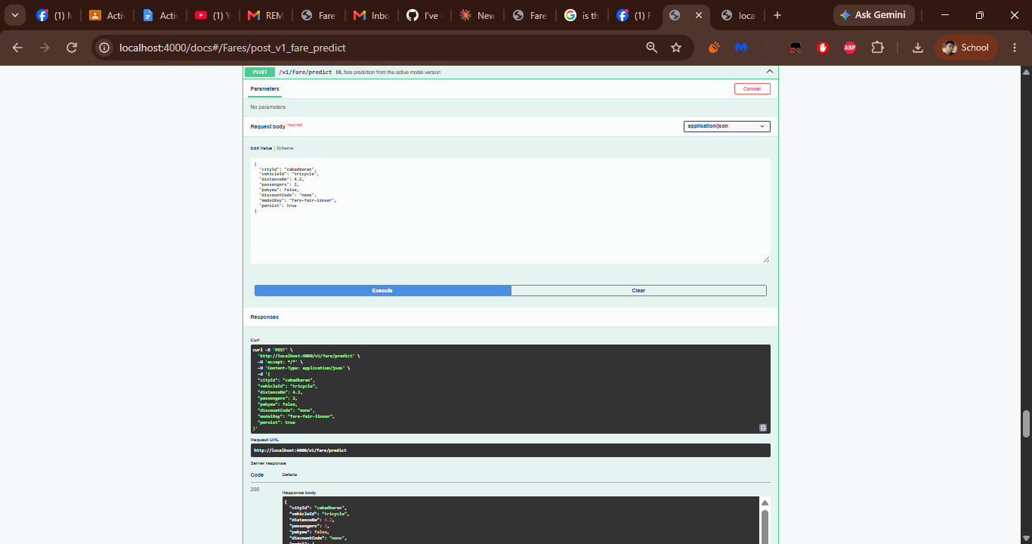
F14 – Fetch a persisted fare quote
Field | Details
HTTP method and path | GET /v1/fare/quotes/{quoteId}
Tested by (member) | [Member name]
Authorization used | None – public endpoint (no token needed).
Request data (safe fields only) | Path: quoteId = quote UUID returned by the persisted estimate in F12.
Expected result | 200 OK with the stored quote.
Actual result | Returned the saved quote for Cabadbaran City, Tricycle, Poblacion to Bayabas: distanceKm 10.5, 1 passenger, pakyaw false, discountCode none, baseRate 50, fare PHP 50 (exact 50, min 50, max 50), routeRowNumber 4, tripId null.
Response code | 200
Interpretation | Proves persistence: the quote created in F12 is returned by its ID with the same route, distance and PHP 50 fare.
Screenshot label | F14-S

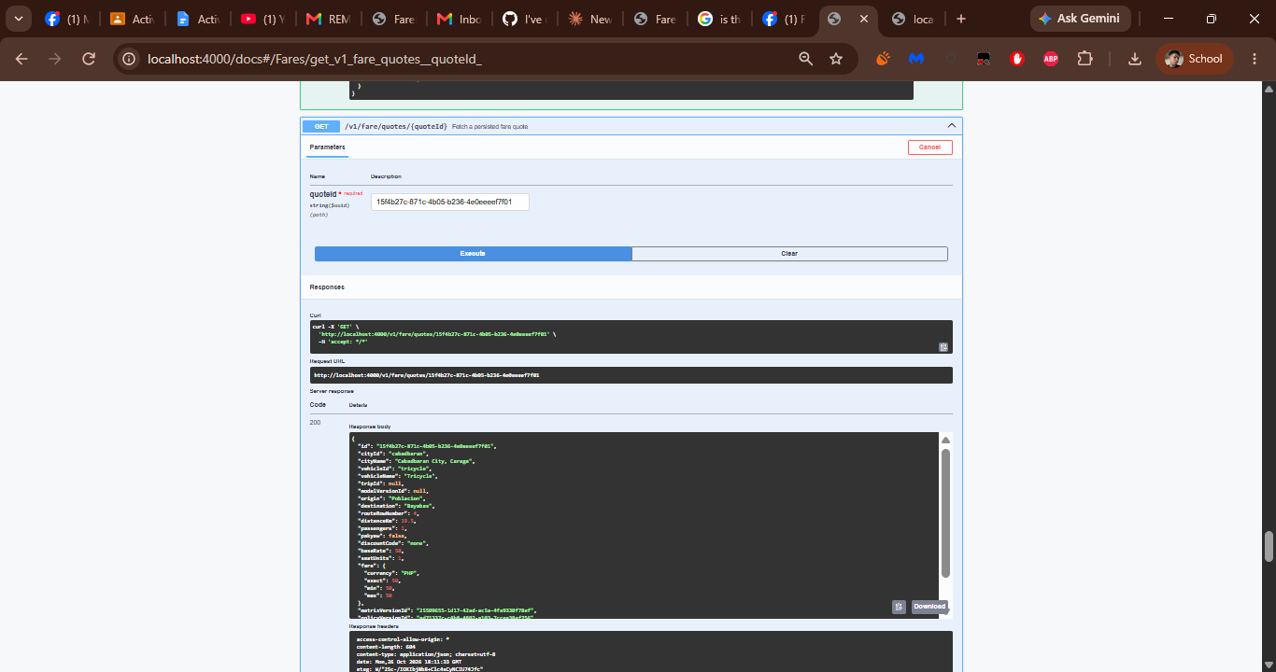
F15 – Prediction history
Field | Details
HTTP method and path | GET /v1/fare/predictions?modelVersionId={uuid}&tripId={uuid}&limit=50
Tested by (member) | [Member name]
Authorization used | None – public endpoint (no token needed).
Request data (safe fields only) | Query: modelVersionId = active model version UUID, tripId = trip UUID, limit = 50.
Expected result | 200 OK with a data array of stored predictions; an empty array when nothing matches.
Actual result | Returned {"data": [], "count": 0}. No stored prediction matched the combination of modelVersionId and tripId used, which the API defines as a valid empty result.
Response code | 200
Interpretation | Confirms UUID validation and the filters work. To list rows, repeat with only limit = 50 or with the version and trip that produced a prediction.
Screenshot label | F15-S

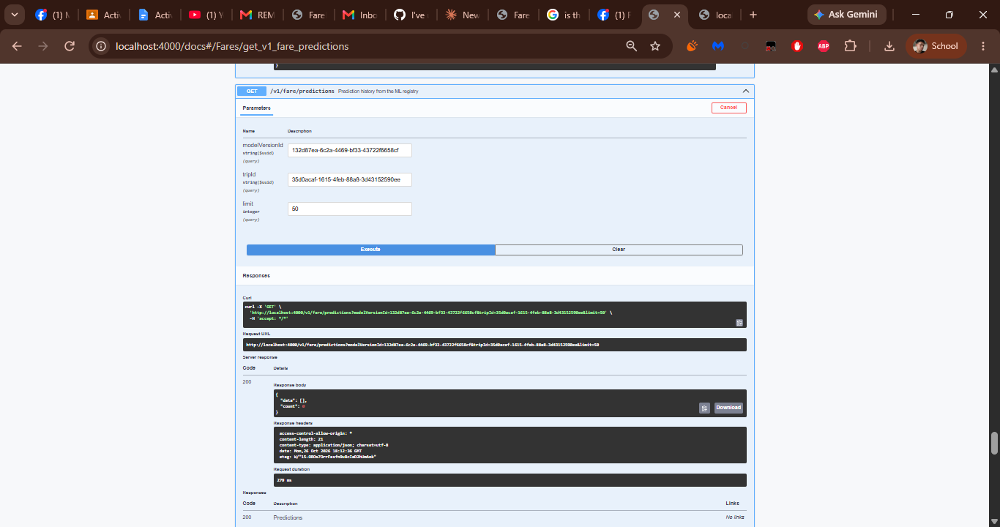
F16 – Official fare routes (focus city)
Field | Details
HTTP method and path | GET /v1/fare/routes?cityId=cabadbaran&vehicleId=tricycle&search=Poblacion
Tested by (member) | [Member name]
Authorization used | None – public endpoint (no token needed).
Request data (safe fields only) | Query: cityId = cabadbaran, vehicleId = tricycle, search = Poblacion.
Expected result | 200 OK with the official fare routes of the focus city that match the search.
Actual result | Returned cityId cabadbaran, matrixVersionId, vehicleId tricycle, effectiveFrom 2026-09-24, provisional false, a count and a data array of routes; the first row is Anywhere in Poblacion to Anywhere in Poblacion with regularFare 13, discountedFare 11 and bidirectional true.
Response code | 200
Interpretation | Confirms the focus-city alias returns official route rows like F11 and supports the search filter.
Screenshot label | F16-S

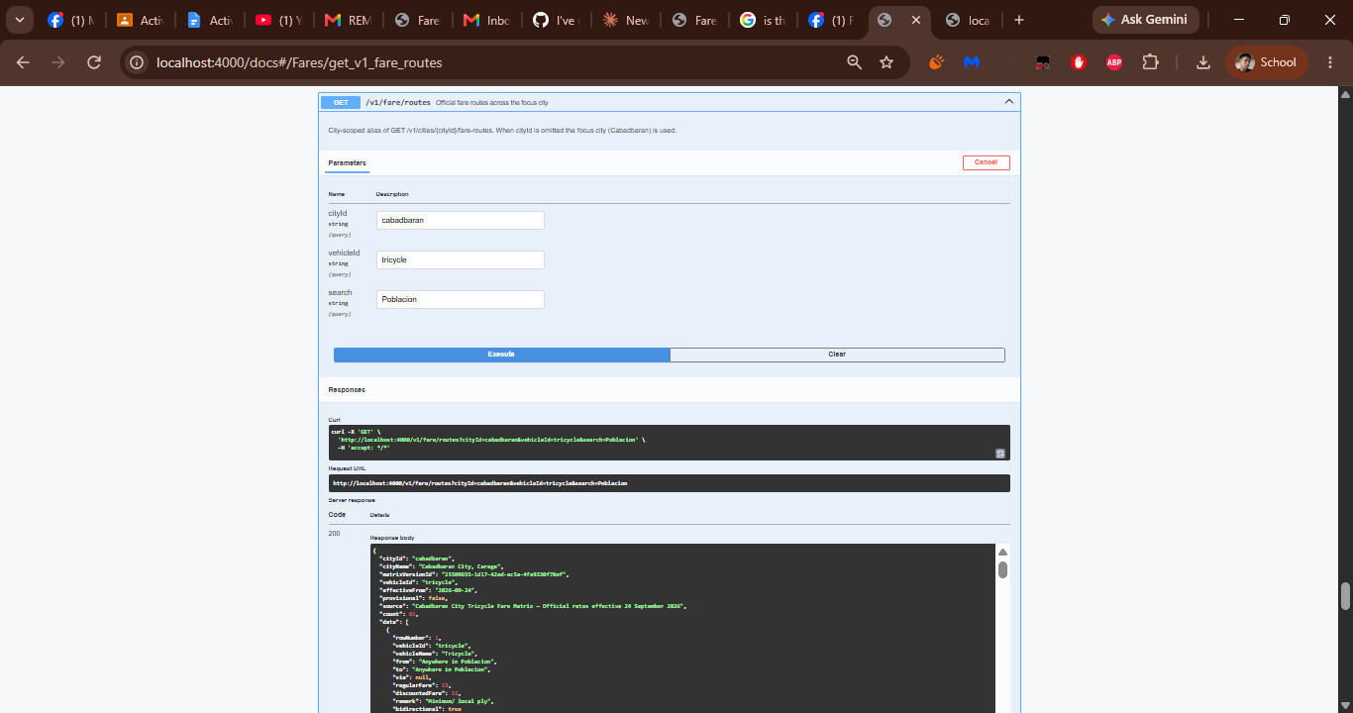
F17 – List ML models with versions
Field | Details
HTTP method and path | GET /v1/fare/models
Tested by (member) | [Member name]
Authorization used | None – public endpoint (no token needed).
Request data (safe fields only) | None (no parameters).
Expected result | 200 OK with the registered models and all of their versions.
Actual result | Returned data with model fare-fair-linear (FareFair Linear Fare Baseline, task fare_regression, target exact_fare) and its versions (algorithm ordinary_least_squares_ridge, feature names, status active or retired), count 1.
Response code | 200
Interpretation | Confirms the registry lists the model with every version and its status.
Screenshot label | F17-S

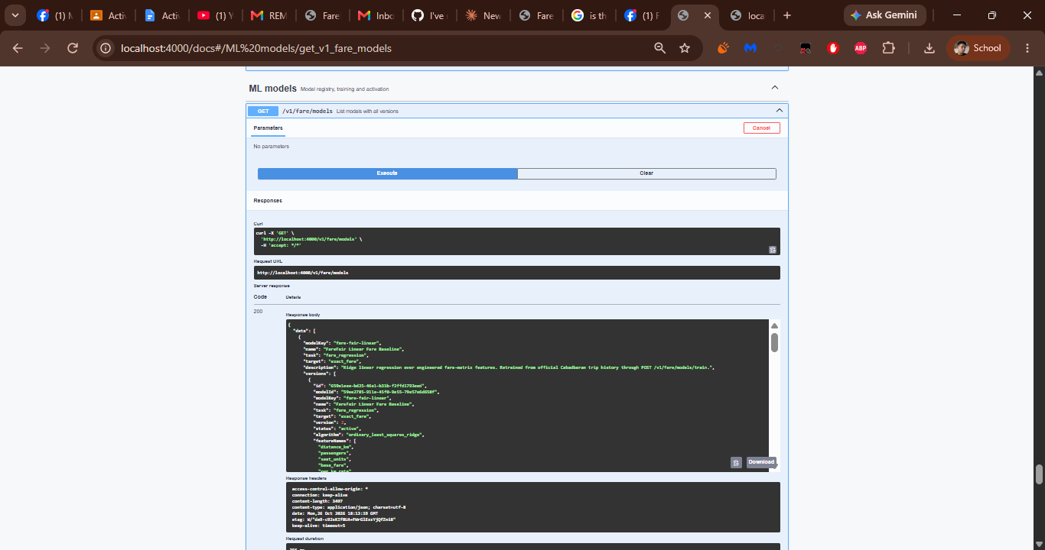
F18 – Train a new model version
Field | Details
HTTP method and path | POST /v1/fare/models/train
Tested by (member) | [Member name]
Authorization used | None – public endpoint (no token needed).
Request data (safe fields only) | Body: {"modelKey":"fare-fair-linear","activate":true,"actorName":"api-inputs","role":"system"}
Expected result | 201 Created with a new model version trained from the seeded feature store and activated.
Actual result | Returned 201 with a new fare-fair-linear version (task fare_regression, algorithm ordinary_least_squares_ridge); the model detail in F19 shows this version as active.
Response code | 201
Interpretation | Proves training works end to end; F19 shows the new version as active and F20 shows the earlier version as retired.
Screenshot label | F18-S

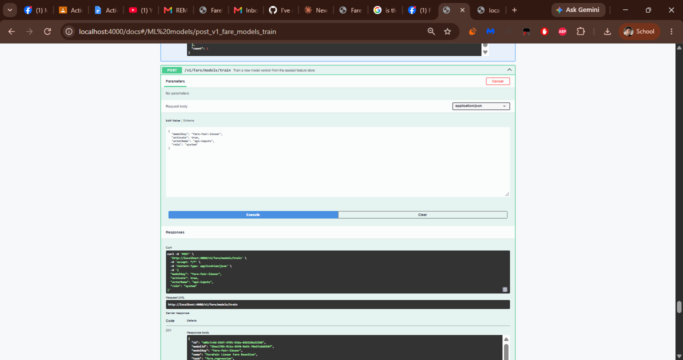
F19 – Model detail by key or UUID
Field | Details
HTTP method and path | GET /v1/fare/models/{idOrKey}
Tested by (member) | [Member name]
Authorization used | None – public endpoint (no token needed).
Request data (safe fields only) | Path: idOrKey = fare-fair-linear.
Expected result | 200 OK with the model, its activeVersionId and the versions array.
Actual result | Returned model fare-fair-linear (name FareFair Linear Fare Baseline, task fare_regression, target exact_fare) with an activeVersionId and a versions array in which the version trained in F18 is active.
Response code | 200
Interpretation | Shows lookup by model key and confirms the version from F18 is the model's active version.
Screenshot label | F19-S

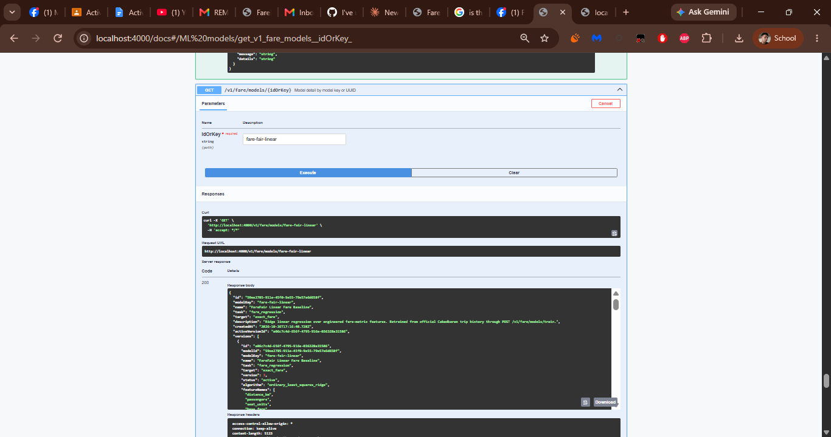
F20 – Model version detail
Field | Details
HTTP method and path | GET /v1/fare/models/versions/{versionId}
Tested by (member) | [Member name]
Authorization used | None – public endpoint (no token needed).
Request data (safe fields only) | Path: versionId = UUID of an earlier model version.
Expected result | 200 OK with the version record and its prediction stats.
Actual result | Returned version 1 of fare-fair-linear with status retired, algorithm ordinary_least_squares_ridge, the feature names (distance_km, passengers, seat_units, base_fare, per_km_rate and the engineered terms) and its coefficients.
Response code | 200
Interpretation | Shows a single version can be retrieved by UUID with its algorithm, features and coefficients; version 1 is retired after the training in F18.
Screenshot label | F20-S

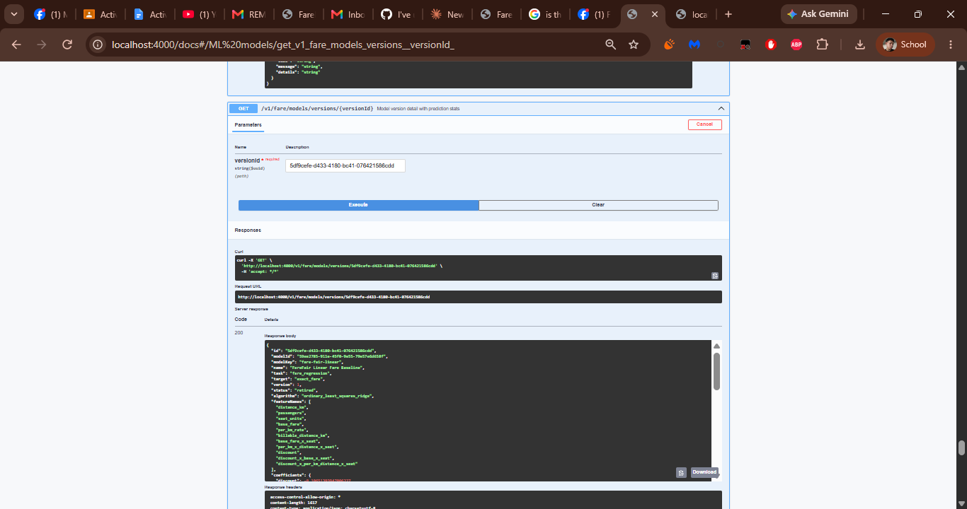
F21 – Activate a model version
Field | Details
HTTP method and path | POST /v1/fare/models/versions/{versionId}/activate
Tested by (member) | [Member name]
Authorization used | None – public endpoint (no token needed).
Request data (safe fields only) | Path: versionId = UUID of the version to activate. Body: {"actorName":"api-inputs","role":"system"}
Expected result | 200 OK with the activated model version.
Actual result | Returned 200 with the selected version, which is now the model's active version.
Response code | 200
Interpretation | Proves versions can be switched; the model list and detail (F17, F19) show the change.
Screenshot label | F21-S

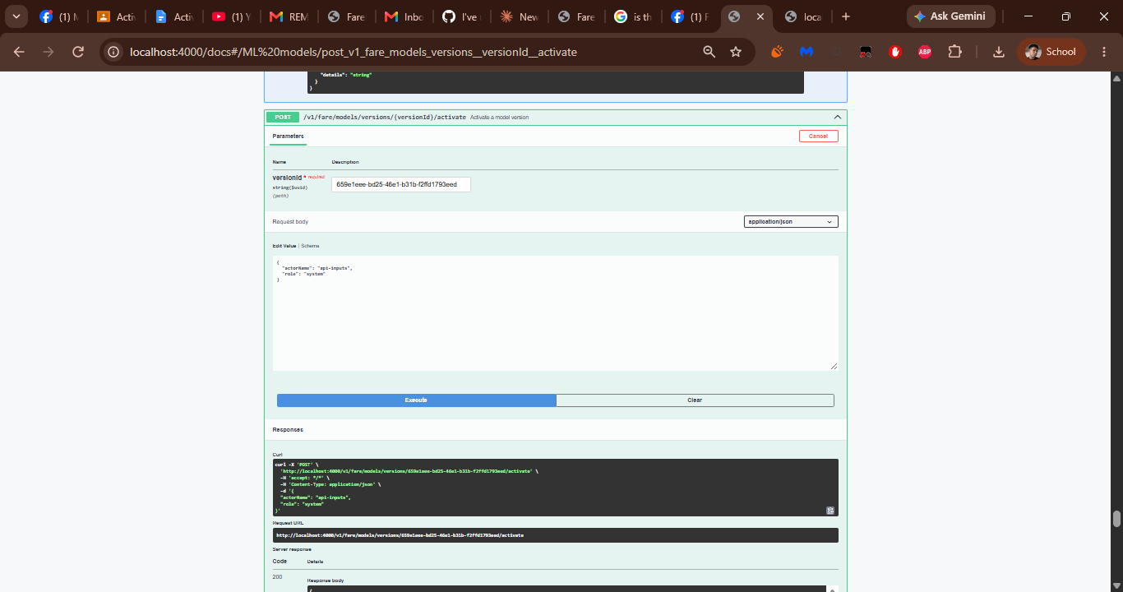
F22 – List trip records
Field | Details
HTTP method and path | GET /v1/trips (filters, limit, offset)
Tested by (member) | [Member name]
Authorization used | None – public endpoint (no token needed).
Request data (safe fields only) | Query: cityId = cabadbaran, vehicleId = tricycle, status = completed, discountCode = none, recordedVia = live_trip_recording, from = 2020-01-01T00:00:00Z, to = 2030-12-31T23:59:59Z, search = FF-, limit = 50, offset = 0.
Expected result | 200 OK with the trips that match the filters (an empty array when none match).
Actual result | Returned a data array of trip records that match the filters (references start with FF-).
Response code | 200
Interpretation | Confirms all filters and the limit/offset pagination are accepted and the result is limited to matching trips.
Screenshot label | F22-S

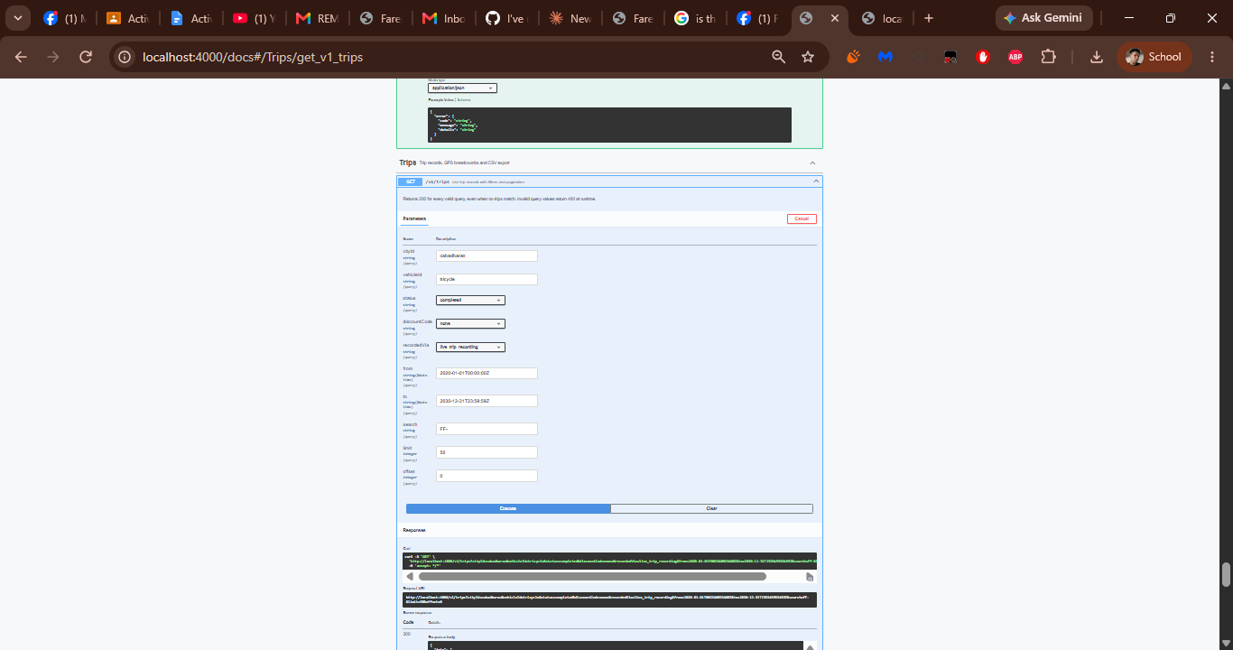
F23 – Record a trip
Field | Details
HTTP method and path | POST /v1/trips
Tested by (member) | [Member name]
Authorization used | None – public endpoint (no token needed).
Request data (safe fields only) | Body: cityId cabadbaran, vehicleId tricycle, origin Poblacion, destination Bayabas, durationSeconds, passengers, pakyaw false, discountCode none, recordedVia live_trip_recording, recordedAt, two routePoints (lat, lng, recordedAt) and runPrediction true.
Expected result | 201 Created with the trip, its GPS points, the computed fare quote, a prediction and any anomalies.
Actual result | Returned 201 with the new trip (FF- reference, Cabadbaran City, Tricycle, Poblacion to Bayabas), the computed fare in PHP (fareSource official_matrix), the route points and the generated quote and prediction.
Response code | 201
Interpretation | Proves a trip is stored with its GPS points and that the fare engine and prediction run on creation.
Screenshot label | F23-S

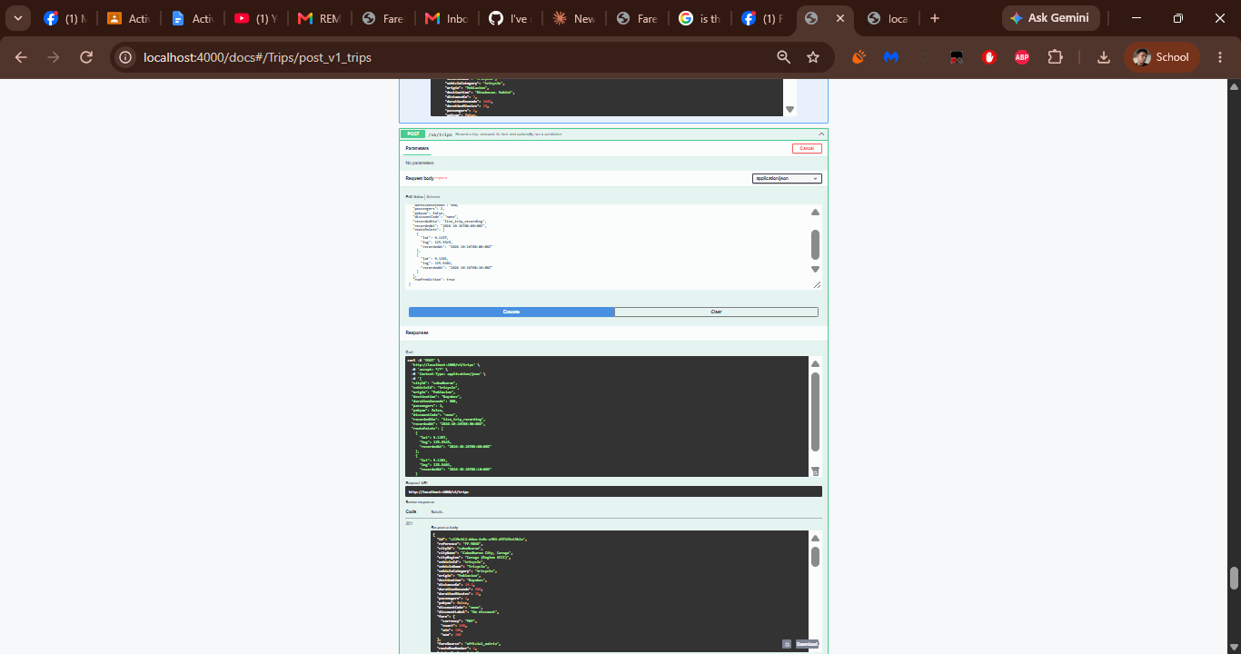
F24 – Trip detail
Field | Details
HTTP method and path | GET /v1/trips/{tripId}
Tested by (member) | [Member name]
Authorization used | None – public endpoint (no token needed).
Request data (safe fields only) | Path: tripId = 3e0b93e2-0ecb-491a-af65-2b32535b2ee8.
Expected result | 200 OK with the trip, its GPS points, quote, predictions and anomalies.
Actual result | Returned trip FF-5046 (Cabadbaran City, Caraga (Region XIII); vehicle Tricycle; Poblacion to Bayabas) with its fare, GPS points, quote, predictions and anomalies.
Response code | 200
Interpretation | Proves a stored trip can be retrieved by its ID together with the linked quote, predictions and anomalies.
Screenshot label | F24-S

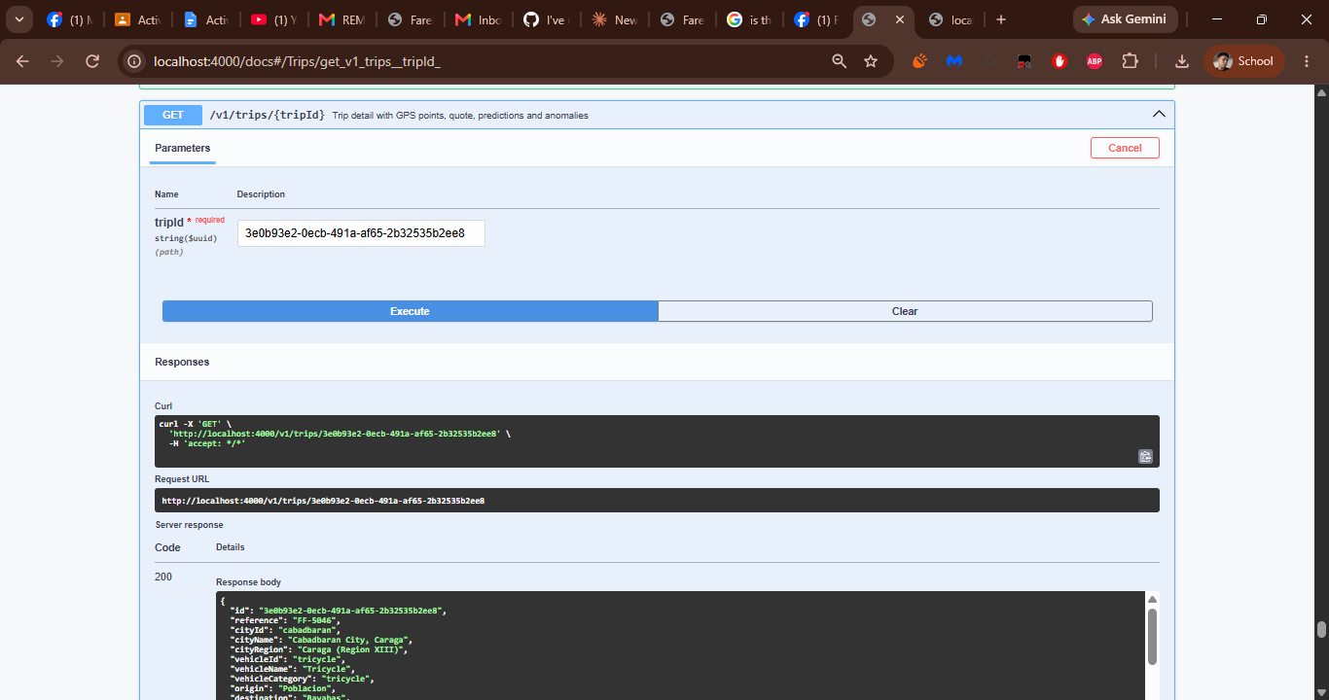
F25 – Change trip status
Field | Details
HTTP method and path | PATCH /v1/trips/{tripId}/status
Tested by (member) | [Member name]
Authorization used | None – public endpoint (no token needed).
Request data (safe fields only) | Path: tripId = 3e0b93e2-0ecb-491a-af65-2b32535b2ee8. Body: {"status":"flagged","flagReason":"API input example","severity":"low","actorName":"api-inputs"}
Expected result | 200 OK with the updated trip; flagging a trip opens an anomaly.
Actual result | The trip FF-5046 was flagged. A follow-up GET /v1/trips/{tripId} returned 200 with the updated record (screenshot), and the audit trail in F31 lists a trip.status_changed event to flagged for the same trip.
Response code | 200
Interpretation | Proves the status change is saved (follow-up GET) and recorded (audit event in F31).
Screenshot label | F25-S

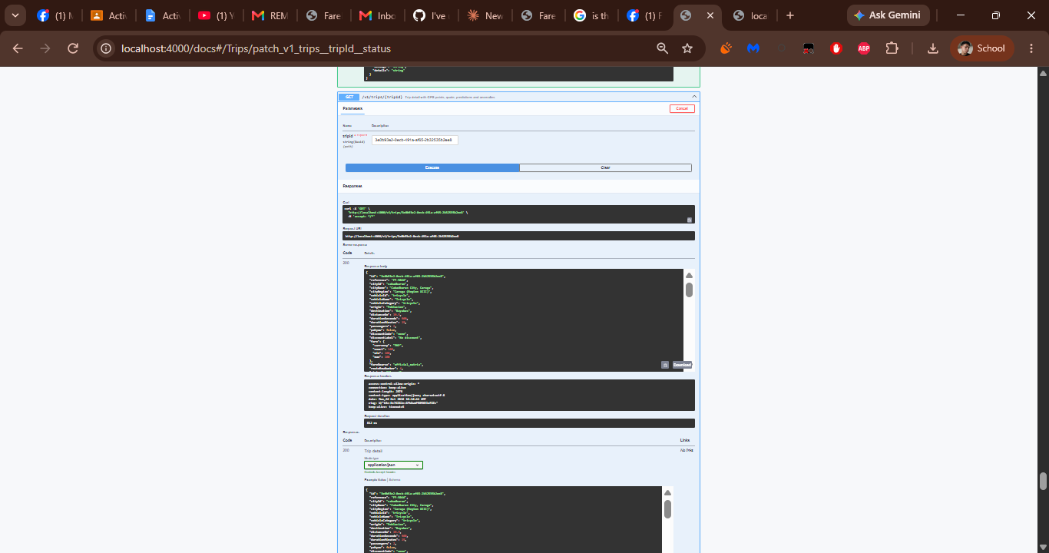
F26 – CSV export of trips
Field | Details
HTTP method and path | GET /v1/trips.csv (filters)
Tested by (member) | [Member name]
Authorization used | None – public endpoint (no token needed).
Request data (safe fields only) | Query: cityId = cabadbaran, vehicleId = tricycle, status = completed, discountCode = none, recordedVia = live_trip_recording, from = 2020-01-01T00:00:00Z, to = 2030-12-31T23:59:59Z, search = FF-.
Expected result | 200 OK with a CSV file of the filtered trips.
Actual result | Returned 200 with content-type text/csv; charset=utf-8 and content-disposition attachment; filename="farefair-trips.csv"; Swagger UI shows a Download file link for the CSV.
Response code | 200
Interpretation | Confirms the export applies the same filters as F22 and is delivered as a downloadable file.
Screenshot label | F26-S

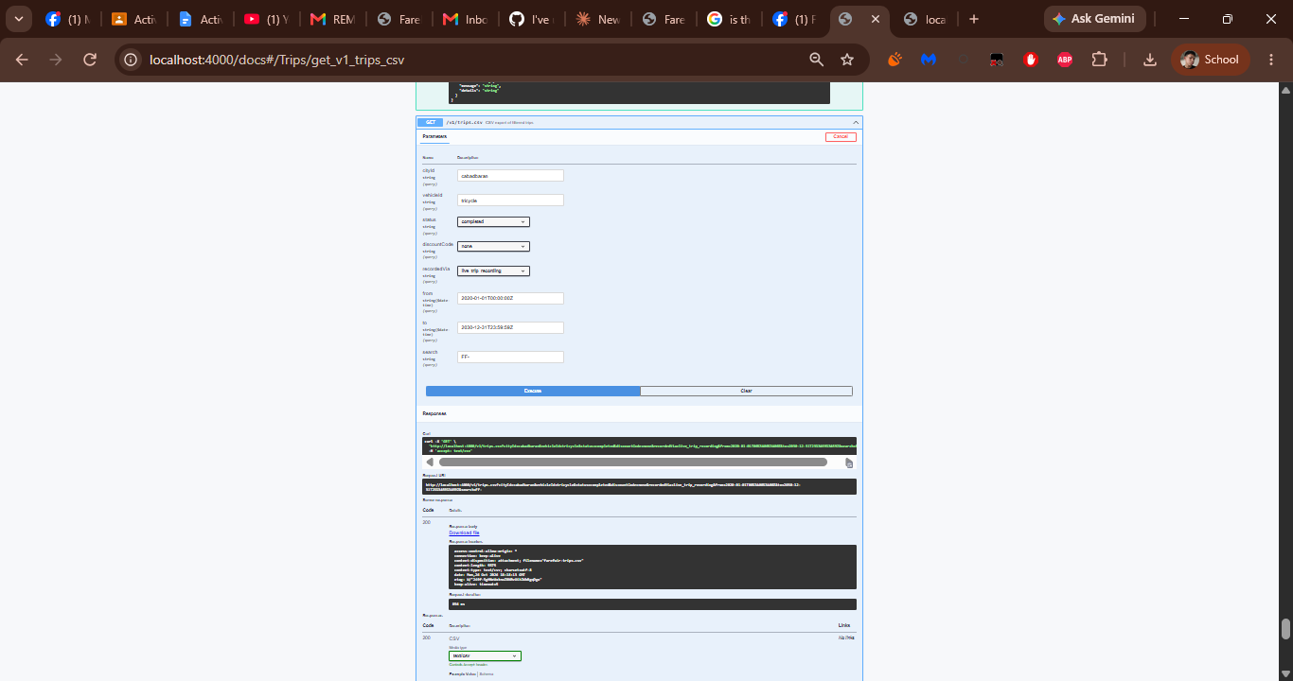
F27 – Network analytics overview
Field | Details
HTTP method and path | GET /v1/analytics/overview?cityId=cabadbaran&days=30
Tested by (member) | [Member name]
Authorization used | None – public endpoint (no token needed).
Request data (safe fields only) | Query: cityId = cabadbaran, days = 30.
Expected result | 200 OK with totals, daily series, vehicle/status/discount mix and top routes for the period.
Actual result | Returned range (30 days, 2026-09-26 to 2026-10-26, cityId cabadbaran) and totals: 229 trips, average fare 72.95, average distance 9.45 km, total fare value 16,705, 20 flagged and 19 disputed trips, followed by the daily series, mixes and top routes.
Response code | 200
Interpretation | Proves analytics aggregate the stored trips (counts, averages, flagged and disputed totals) for the chosen city and period.
Screenshot label | F27-S

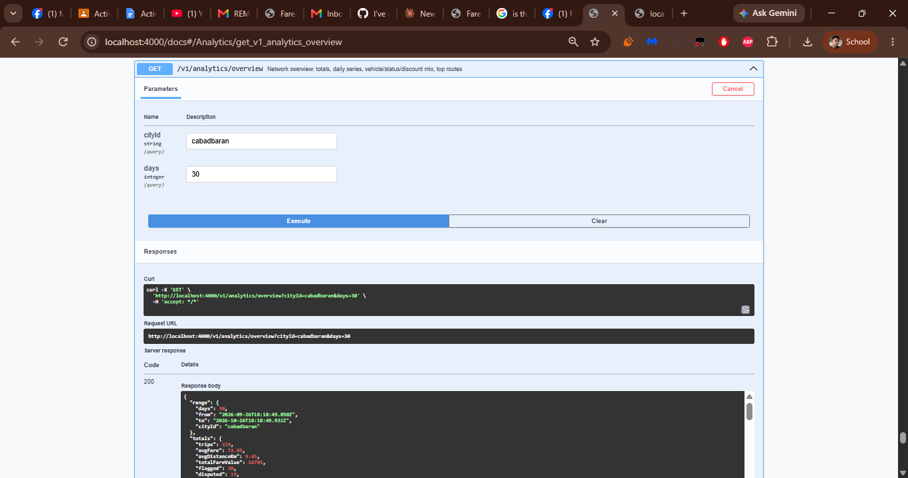
F28 – Matrix vs observed fares
Field | Details
HTTP method and path | GET /v1/analytics/fares?cityId=cabadbaran&days=30
Tested by (member) | [Member name]
Authorization used | None – public endpoint (no token needed).
Request data (safe fields only) | Query: cityId = cabadbaran, days = 30.
Expected result | 200 OK with the official matrix fare compared with the observed fares per city and vehicle.
Actual result | Returned range (30 days, 2026-09-26 to 2026-10-26), count 1 and a data row for cityId cabadbaran comparing the matrix fare with the observed trip fares.
Response code | 200
Interpretation | Shows observed fares can be compared with the official matrix per vehicle, which supports overcharging detection.
Screenshot label | F28-S

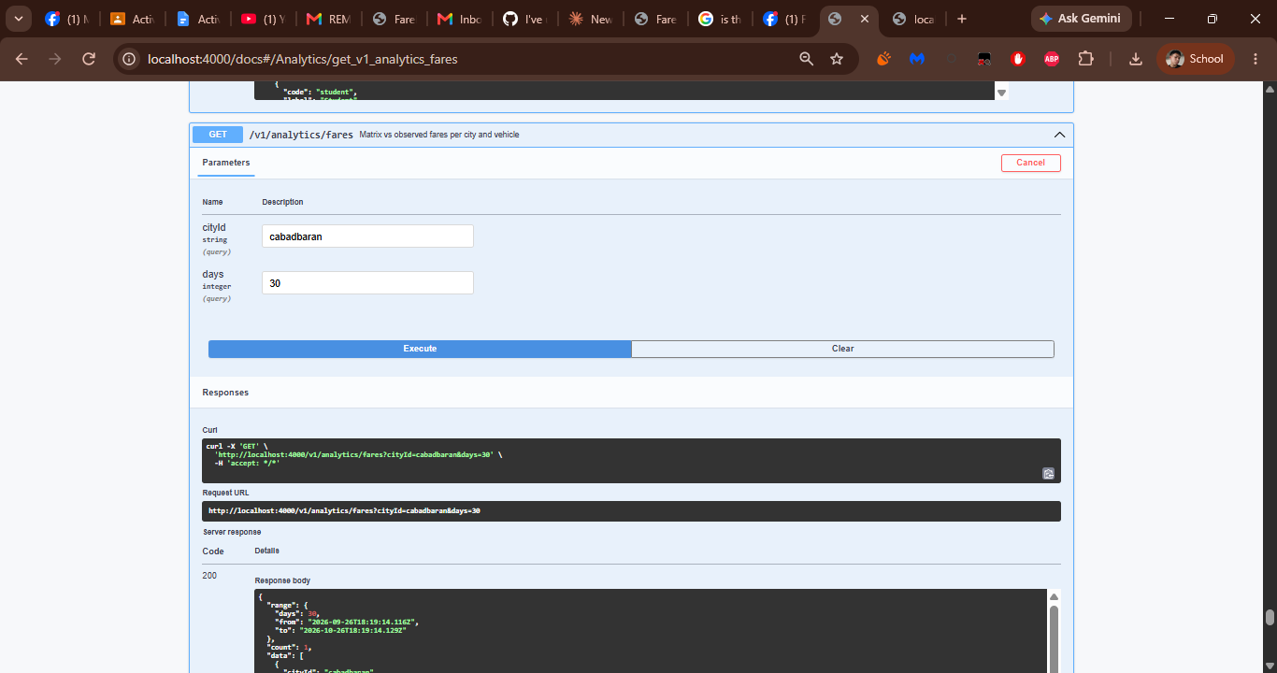
F29 – List fare anomalies
Field | Details
HTTP method and path | GET /v1/anomalies?cityId=cabadbaran&resolved=false&severity=low&kind=manual_flag
Tested by (member) | [Member name]
Authorization used | None – public endpoint (no token needed).
Request data (safe fields only) | Query: cityId = cabadbaran, resolved = false, severity = low, limit = 50, kind = manual_flag, offset = 0.
Expected result | 200 OK with the anomalies that match the filters (an empty array when none match).
Actual result | Returned a data array of open low-severity anomalies, each with severity, detail (for example "Passenger count exceeds seat cap") and detection time.
Response code | 200
Interpretation | Confirms anomalies can be filtered by city, status, severity and kind; the anomaly resolved in F30 comes from this list.
Screenshot label | F29-S

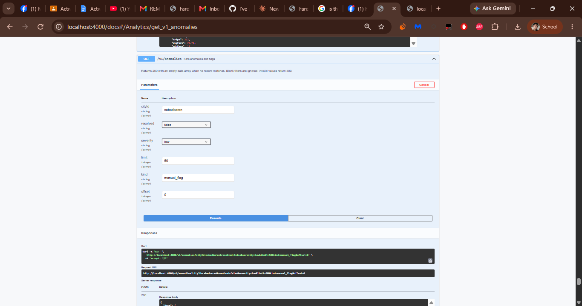
F30 – Resolve an anomaly
Field | Details
HTTP method and path | PATCH /v1/anomalies/{anomalyId}/resolve
Tested by (member) | [Member name]
Authorization used | None – public endpoint (no token needed).
Request data (safe fields only) | Path: anomalyId = UUID of an open anomaly from F29. Body: {"resolutionNote":"Verified by API input example","actorName":"api-inputs"}
Expected result | 200 OK with the resolved anomaly.
Actual result | Returned 200 with the anomaly marked resolved, carrying the resolution note and actor name.
Response code | 200
Interpretation | Proves an anomaly can be closed with a note; repeating F29 with resolved = false no longer lists it.
Screenshot label | F30-S

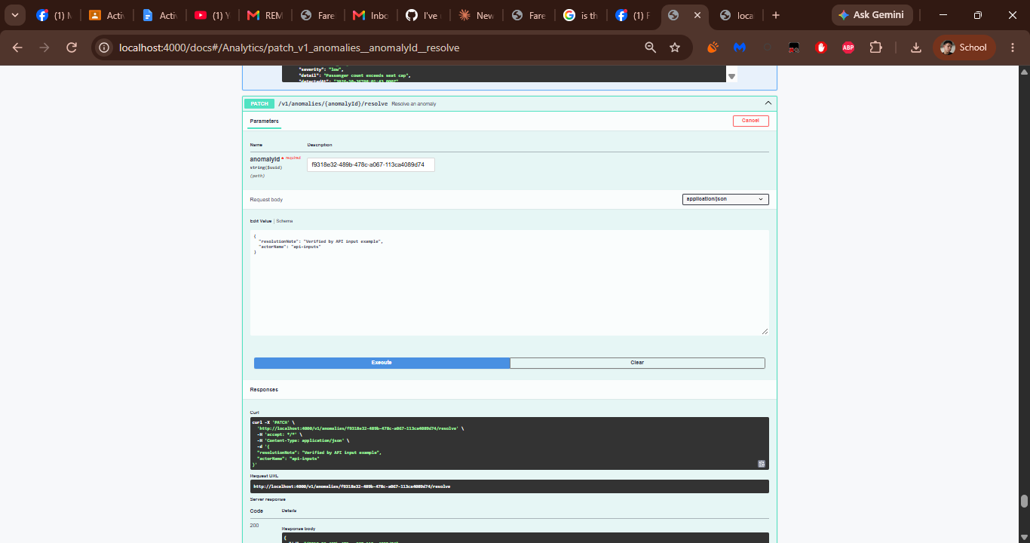]
F31 – Audit trail
Field | Details
HTTP method and path | GET /v1/audit?cityId=cabadbaran&action=trip.status_changed
Tested by (member) | [Member name]
Authorization used | None – public endpoint (no token needed).
Request data (safe fields only) | Query: cityId = cabadbaran, action = trip.status_changed, limit = 50, offset = 0.
Expected result | 200 OK with the audit events that match the filters.
Actual result | Returned a data array of audit events; the first is action trip.status_changed on entityType trip, entityId 3e0b93e2-0ecb-491a-af65-2b32535b2ee8, actorName api-inputs, role api, cityId cabadbaran, with detail showing the new status flagged.
Response code | 200
Interpretation | Proves state changes are written to the audit trail: the status change made in F25 appears here.
Screenshot label | F31-S

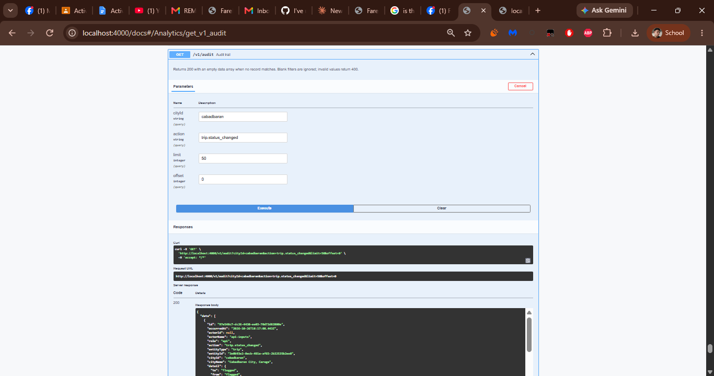
F32 – Admin sign-in
Field | Details
HTTP method and path | POST /v1/auth/login
Tested by (member) | [Member name]
Authorization used | None – this request issues the token (seeded admin account; password not shown).
Request data (safe fields only) | Body: {"login":"admin@farefair.local","password":"••••••••"}
Expected result | 200 OK "Session issued" with a Bearer token; 401 for wrong credentials.
Actual result | Returned 200 with token, tokenType "Bearer" and expiresAt (the token expires after 8 hours). The token value is intentionally not reproduced in this report.
Response code | 200
Interpretation | Proves the seeded admin account can sign in. The token is needed for F33–F40 and must be entered under Authorize because Swagger UI does not attach it automatically.
Screenshot label | F32-S

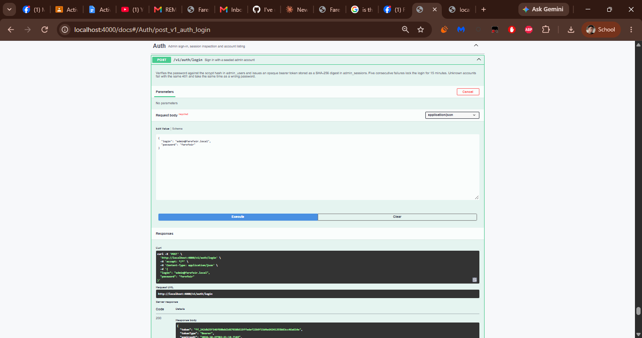
F33 – Read the signed-in account
Field | Details
HTTP method and path | GET /v1/auth/me
Tested by (member) | [Member name]
Authorization used | Bearer token from F32 (admin@farefair.local, role admin) – token not shown.
Request data (safe fields only) | None (no parameters).
Expected result | 200 OK with the signed-in account and city scope; 401 when no Bearer token is sent.
Actual result | Run 1 (no token): 401 AUTH_REQUIRED – "Sign in with an admin account to perform this action." (E01-BEFORE). Run 2 (F32 token entered under Authorize): 200 with the signed-in admin account (email, role admin, cityScope).
Response code | 200 (after Authorize; first run 401 – see E01)
Interpretation | The 401 shows bearerAuth is enforced; the 200 afterwards shows the session token from F32 is accepted.
Screenshot label | F33-S

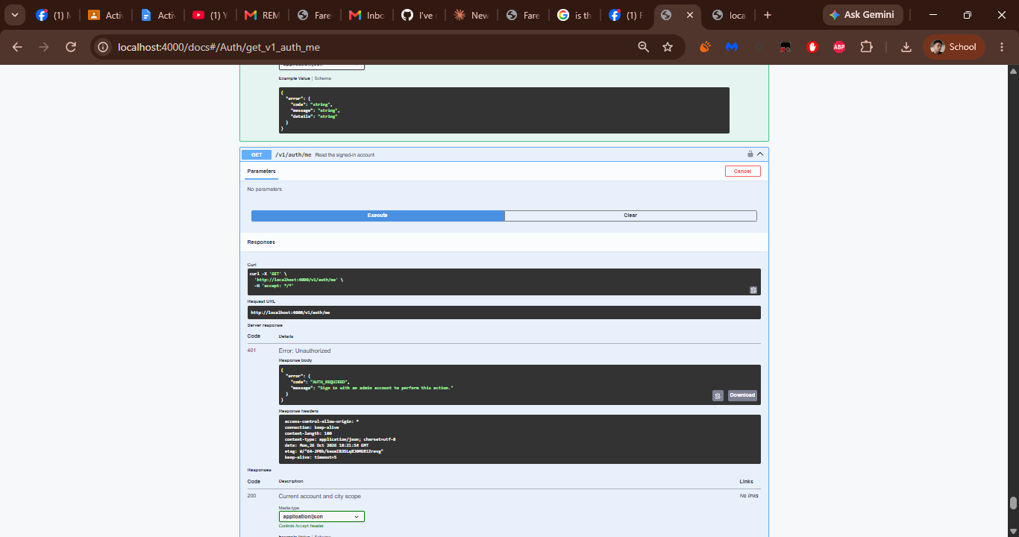
F34 – Sign out (revoke session)
Field | Details
HTTP method and path | POST /v1/auth/logout
Tested by (member) | [Member name]
Authorization used | Bearer token from F32 (admin@farefair.local, role admin) – token not shown.
Request data (safe fields only) | None (no parameters).
Expected result | 200 OK {"ok": true} and the session is revoked; 401 when no Bearer token is sent.
Actual result | Run 1 (no token): 401 AUTH_REQUIRED – "Sign in with an admin account to perform this action." (E01-BEFORE). Run 2 (token entered under Authorize): 200 {"ok": true}, session revoked. Run last, because the token stops working after logout.
Response code | 200 (after Authorize; first run 401 – see E01)
Interpretation | Proves sessions can be revoked; a later call with the same token must return 401 until F32 is repeated.
Screenshot label | F34-S

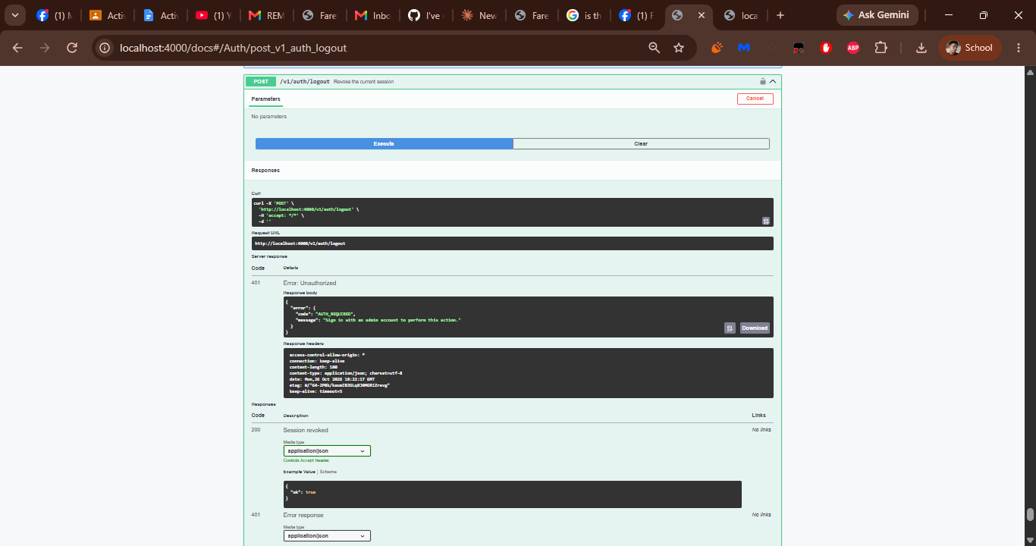
F35 – List admin accounts
Field | Details
HTTP method and path | GET /v1/auth/accounts
Tested by (member) | [Member name]
Authorization used | Bearer token from F32 (admin@farefair.local, role admin) – token not shown.
Request data (safe fields only) | None (no parameters).
Expected result | 200 OK with the seeded accounts (administrators only); 401 without a token, 403 for other roles.
Actual result | Run 1 (no token): 401 AUTH_REQUIRED – "Sign in with an admin account to perform this action." (E01-BEFORE). Run 2 (token entered under Authorize): 200 with a data array of the seeded admin accounts (id, email, username, displayName, role, cityScope, isActive).
Response code | 200 (after Authorize; first run 401 – see E01)
Interpretation | Proves the role check works: the administrator token can list accounts, the unauthenticated call cannot.
Screenshot label | F35-S

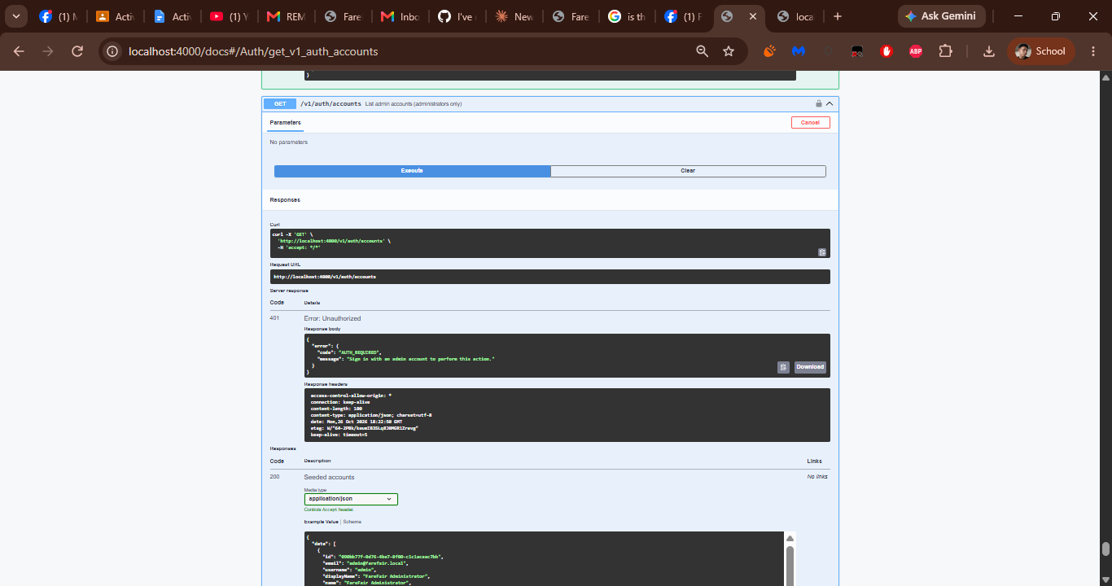
F36 – Update one vehicle tariff (PATCH)
Field | Details
HTTP method and path | PATCH /v1/admin/cities/{cityId}/fare-matrix/{vehicleId}
Tested by (member) | [Member name]
Authorization used | Bearer token from F32 (admin@farefair.local, role admin) – token not shown.
Request data (safe fields only) | Path: cityId = cabadbaran, vehicleId = tricycle. Body: {"baseFare":13,"baseDistanceKm":1,"perKmRate":2,"minFare":13,"maxCustomary":75,"typicalCapacity":4,"active":true}
Expected result | 200 OK with the stored matrix entry and a fare.update audit event; 401 without a token.
Actual result | Run 1 (no token): 401 AUTH_REQUIRED – "Sign in with an admin account to perform this action." (E01-BEFORE). Run 2 (token entered under Authorize): 200 with the stored tricycle entry for Cabadbaran (values equal the published matrix: base fare 13, 2 per extra km) and a fare.update event in the audit trail.
Response code | 200 (after Authorize; first run 401 – see E01)
Interpretation | Proves an authorized admin can write to the active matrix; the request repeats the published values, so no tariff data changes.
Screenshot label | F36-S

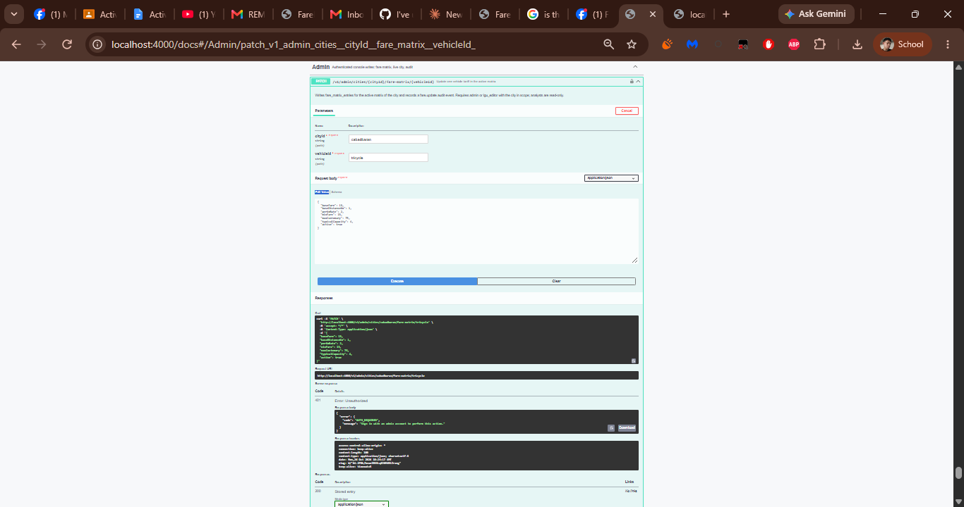
F37 – Replace one vehicle tariff (PUT)
Field | Details
HTTP method and path | PUT /v1/admin/cities/{cityId}/fare-matrix/{vehicleId}
Tested by (member) | [Member name]
Authorization used | Bearer token from F32 (admin@farefair.local, role admin) – token not shown.
Request data (safe fields only) | Path: cityId = cabadbaran, vehicleId = tricycle. Body: {"baseFare":13,"baseDistanceKm":1,"perKmRate":2,"minFare":13,"maxCustomary":75,"typicalCapacity":4,"active":true}
Expected result | 200 OK with the stored matrix entry and a fare.update audit event; 401 without a token.
Actual result | Run 1 (no token): 401 AUTH_REQUIRED – "Sign in with an admin account to perform this action." (E01-BEFORE). Run 2 (token entered under Authorize): 200 with the stored tricycle entry (same values as F36) and a fare.update event in the audit trail.
Response code | 200 (after Authorize; first run 401 – see E01)
Interpretation | Shows PUT is the idempotent form of PATCH: repeating it leaves the same stored entry.
Screenshot label | F37-S

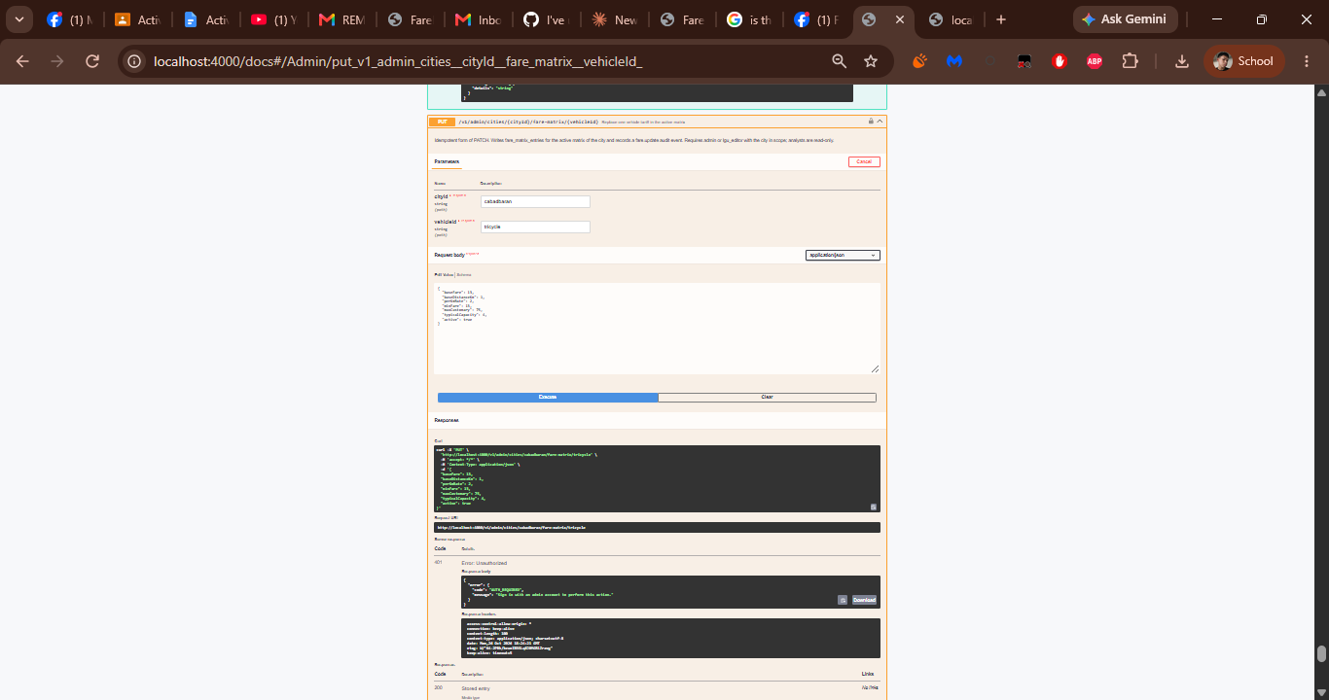
F38 – Make a city the live dataset
Field | Details
HTTP method and path | POST /v1/admin/cities/{cityId}/activate
Tested by (member) | [Member name]
Authorization used | Bearer token from F32 (admin@farefair.local, role admin) – token not shown.
Request data (safe fields only) | Path: cityId = cabadbaran. No request body.
Expected result | 200 OK with the new focus city and a city.activate audit event (administrators only); 401 without a token.
Actual result | Run 1 (no token): 401 AUTH_REQUIRED – "Sign in with an admin account to perform this action." (E01-BEFORE). Run 2 (token entered under Authorize): 200 with the focus city cabadbaran and a city.activate event in the audit trail. Cabadbaran was already the focus city, so the live dataset is unchanged.
Response code | 200 (after Authorize; first run 401 – see E01)
Interpretation | Proves the administrator-only activation works inside the session; the focus city stays Cabadbaran.
Screenshot label | F38-S

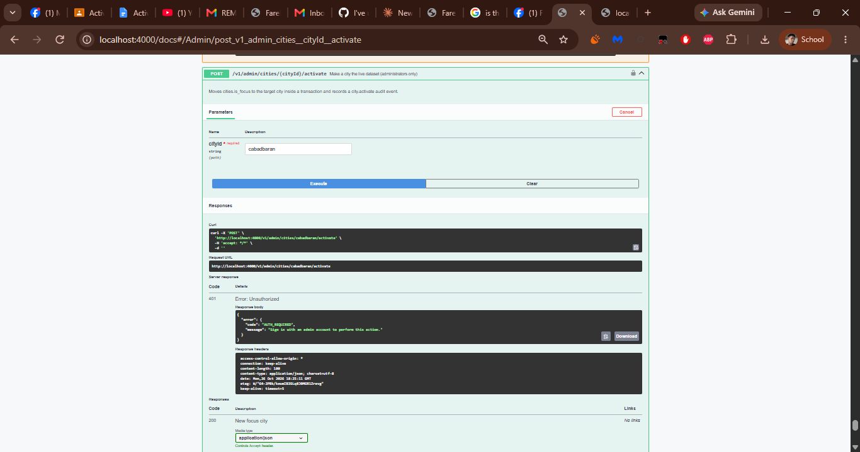
F39 – Append a console event to the audit trail
Field | Details
HTTP method and path | POST /v1/admin/audit
Tested by (member) | [Member name]
Authorization used | Bearer token from F32 (admin@farefair.local, role admin) – token not shown.
Request data (safe fields only) | Body: {"action":"console.check","detail":"Executed by the API input matrix","cityId":"cabadbaran","entityType":"console"}
Expected result | 201 Created {"ok": true} (Event recorded); 401 without a token.
Actual result | Run 1 (no token): 401 AUTH_REQUIRED – "Sign in with an admin account to perform this action." (E01-BEFORE). Run 2 (token entered under Authorize): 201 {"ok": true}, console.check event recorded for cityId cabadbaran.
Response code | 201 (after Authorize; first run 401 – see E01)
Interpretation | Proves authenticated console events are stored; GET /v1/audit lists the new console.check entry.
Screenshot label | F39-S

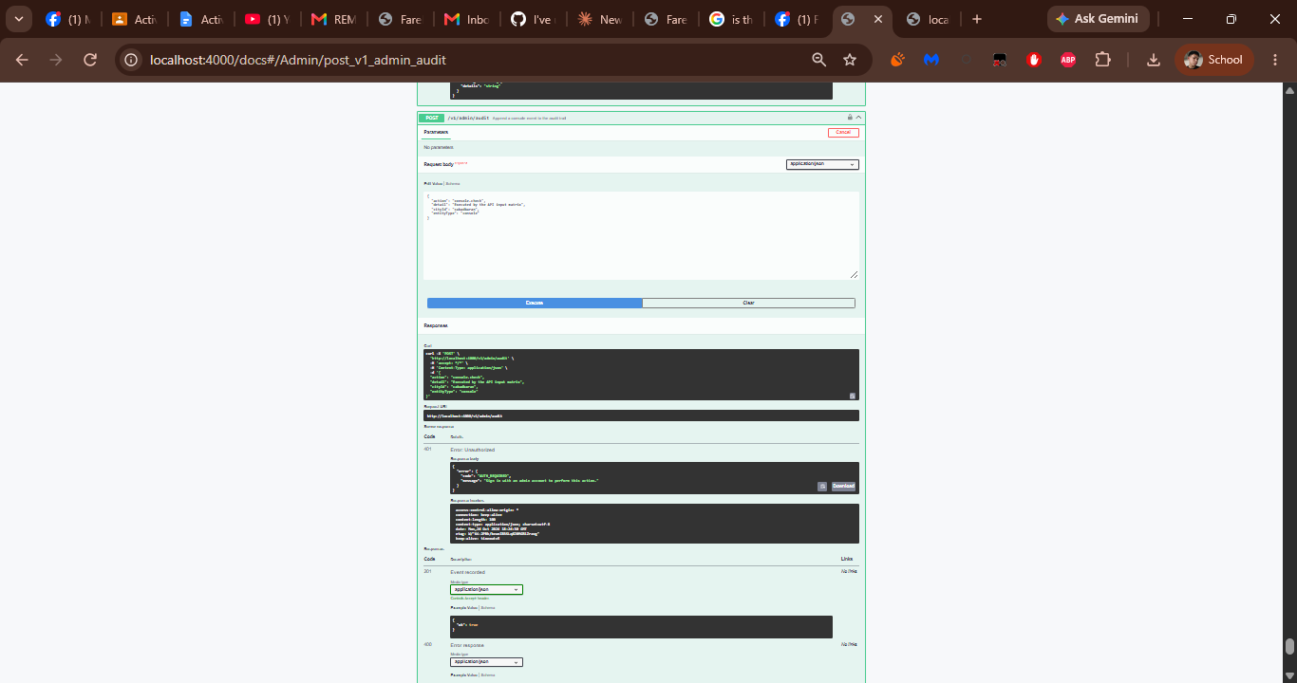
F40 – Replace one published fare route
Field | Details
HTTP method and path | PUT /v1/admin/cities/{cityId}/fare-routes/{rowNumber}?vehicleId=tricycle
Tested by (member) | [Member name]
Authorization used | Bearer token from F32 (admin@farefair.local, role admin) – token not shown.
Request data (safe fields only) | Path: cityId = cabadbaran, rowNumber = 4. Query: vehicleId = tricycle. Body: {"regularFare":50,"discountedFare":40,"remark":"","bidirectional":true}
Expected result | 200 OK with the stored fare route and a fare_route.update audit event; 401 without a token.
Actual result | Run 1 (no token): 401 AUTH_REQUIRED – "Sign in with an admin account to perform this action." (E01-BEFORE). Run 2 (token entered under Authorize): 200 with the stored route row 4 (regularFare 50, discountedFare 40, bidirectional true). The values equal the published Poblacion to Bayabas fare (PHP 50, F14) with the 20% discount, so no fare data changes.
Response code | 200 (after Authorize; first run 401 – see E01)
Interpretation | Proves an authorized admin can update an official route row; a follow-up GET (F11) shows the stored values.
Screenshot label | F40-S

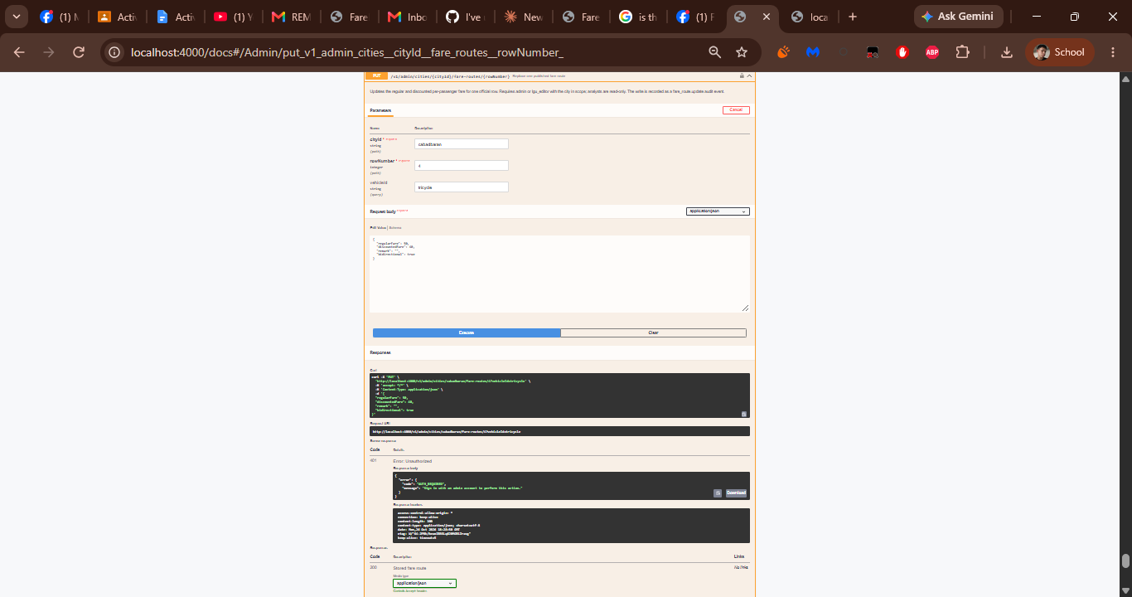

Quality rule A success status alone is not enough. Verify useful output (returned ID/data, changed value, or the documented result) and, where appropriate, confirm persistence with a follow-up GET.

Technical exception An endpoint deliberately designed to return 204 (e.g., DELETE) may be documented with its proper status and instructor approval. Do not bypass authentication or validation to force a 200.

7. Error Capture, Diagnosis, Correction, and Retest

Do not omit failures. Complete one block per error (E01, E02, …). If there were no errors, write "No errors encountered" and explain how you checked.
E01 – Protected endpoints F33–F40 returned 401 AUTH_REQUIRED
Type of result: ☐ Defect in the backend ☒ Expected negative test (deliberately invalid request proving error handling works)
Phase | What to record | Your entry
A – Before fix | Status code, safe response details, actual input | Status 401 on F33 GET /v1/auth/me, F34 POST /v1/auth/logout, F35 GET /v1/auth/accounts, F36 PATCH and F37 PUT /v1/admin/cities/cabadbaran/fare-matrix/tricycle, F38 POST /v1/admin/cities/cabadbaran/activate, F39 POST /v1/admin/audit and F40 PUT /v1/admin/cities/cabadbaran/fare-routes/4.  Response: {"error":{"code":"AUTH_REQUIRED","message":"Sign in with an admin account to perform this action."}}  Input: the example request bodies from the OpenAPI document; no Authorization header was sent.
B – Diagnose | Log/traceback review; real cause (route, validation, service, database, auth) | Not a backend defect. In openapi.json these operations carry security bearerAuth, so the API must reject any request without a valid session token, and it did, with a clear AUTH_REQUIRED error. The test setup was at fault: POST /v1/auth/login (F32) returns a token, but Swagger UI does not send it until it is entered under Authorize. Route, validation, service and database behaviour were not involved.
Fix applied | Exact code or test-data change | No source-code change. Test procedure: (1) in Swagger UI run POST /v1/auth/login with {"login":"admin@farefair.local","password":"<seeded admin password>"}; (2) copy the token value from the response; (3) click Authorize, paste the token under bearerAuth (the token only, without the word Bearer), click Authorize, then Close; (4) re-execute F33 and F35–F40, and F34 last.
C – After fix | Same endpoint retested; status and response proving intended behavior, not just the code | Same requests retested with the Bearer token: F33 200 (signed-in admin account), F35 200 (accounts list), F36 and F37 200 (stored tricycle entry), F38 200 (focus city cabadbaran), F39 201 {"ok": true}, F40 200 (stored route row 4) and F34 200 {"ok": true}. GET /v1/audit lists the resulting fare.update, city.activate, fare_route.update and console.check events.
D – Record | Commit ID and updated inventory row | No code change, so there is no fix commit. Inventory rows F33–F40 and their result blocks now show 200/201 with Bearer authorization.

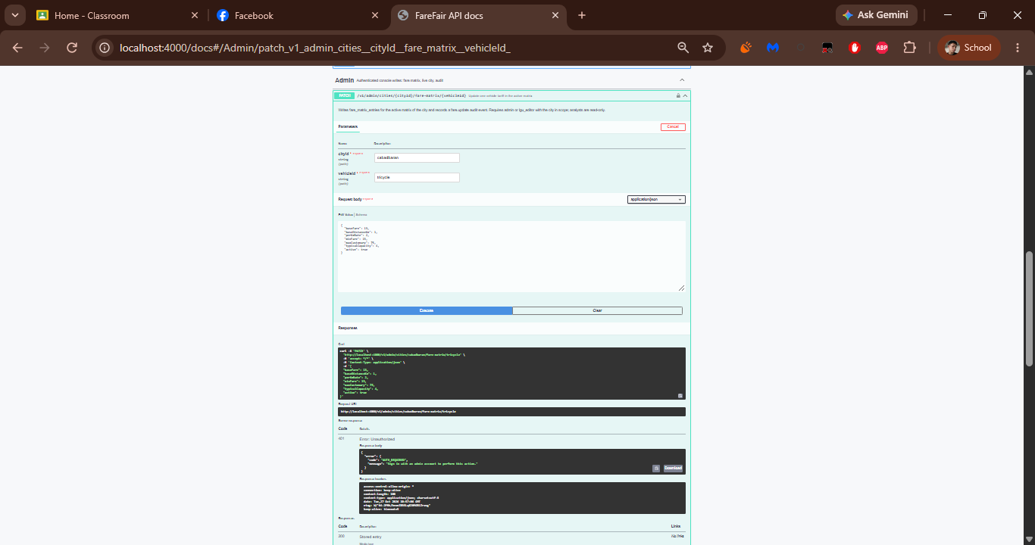

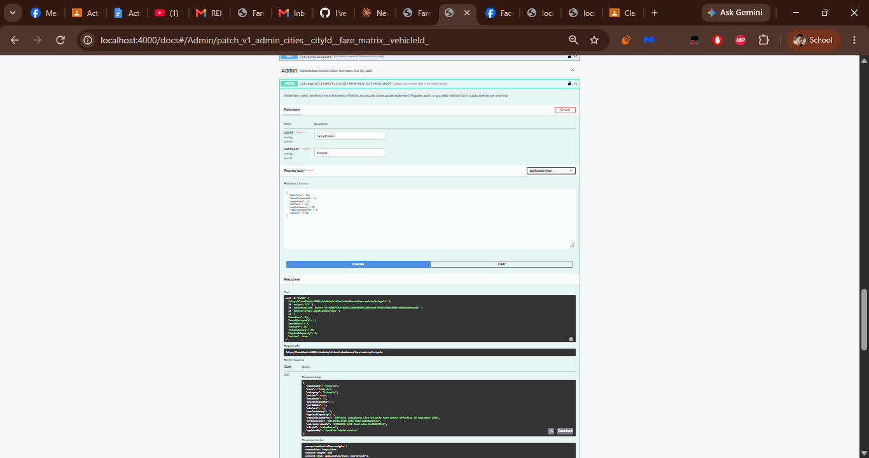
E02 – Not applicable
No additional errors were encountered; E01 covers every failed request.
Part B – Error Resolution Log
Endpoint / feature | Before: code + issue | Cause and correction | After: status | Evidence / commit
F33–F40: /v1/auth/me, /v1/auth/logout, /v1/auth/accounts and five /v1/admin operations | 401 AUTH_REQUIRED – "Sign in with an admin account to perform this action." | No Bearer token was sent from Swagger UI. Fix: sign in with POST /v1/auth/login and enter the token under Authorize; no code change. | 200 / 201 | E01-before / after · no code commit
No further errors encountered | — | — | — | —
No further errors encountered | — | — | — | —

Unresolved issues (state explicitly, do not hide): None. (F15 returned an empty data array for the filter values used – a valid 200 result under the API contract, not a defect.)
Error versus validation A deliberately invalid request returning 400/401/403/404/409/422 may prove error handling works. Label it an expected negative test, then provide a separate valid test that succeeds. Never falsify or edit response screenshots.
Reference: Status Codes
Code | Meaning in endpoint tests | Student action
200 OK | Request succeeded and normally returns a body | Capture successful response
201 Created | New resource created | Capture created ID/body and verify if relevant
204 No Content | Valid success for some DELETE/update endpoints | Document and request instructor acceptance
400 / 422 | Bad input or validation failure | Correct invalid input, or fix unintended validation
401 / 403 | Missing authentication or insufficient permission | Use an authorized test user; keep access rules
404 / 409 | Not found or conflicting/duplicate data | Verify identifier/request and correct as appropriate
500 | Unexpected server-side failure | Inspect logs, fix root cause, retest

8. Laboratory Time Log

Phase | Student activity | Target time | Actual time / notes
1. Startup | Run Uvicorn; resolve blocking startup issues | 15 min | Server started on http://localhost:4000 with the embedded PGlite database.
2. Health check | Open /health; verify exact JSON; capture S01 | 15 min | S01 captured: /health returned 200 OK (server time 2026-10-26 16:19 UTC).
3. API inventory | Open /docs; capture S02; list every feature and route | 25 min | S02 captured at /docs; 40 operations listed in 8 groups (Meta, Catalog, Fares, ML models, Trips, Analytics, Auth, Admin); Part A completed.
4. Feature testing | Execute every implemented operation with safe test data | 60 min | F01–F40 executed in Swagger UI (response timestamps about 18:06–18:26 UTC on 2026-10-26).
5. Error resolution | Capture failures, debug, retest, document pairs | 40 min | E01: F33–F40 returned 401 until the F32 token was entered under Authorize; retest recorded in E01-AFTER.
6. Evidence and checkpoint | Complete worksheets, screenshots, commit/push, submit | 25 min | Report and screenshots compiled in this document.

Tests completed outside the lab session: None – all evidence was captured on 2026-10-26 (UTC) from the running local API.
9. GitHub Checkpoint

Field | Details
Repository URL | https://github.com/Jamester-Mulato/farefair-backend
Final commit hash | ac7165f88bd64d2caf8b633a846142ad3ca38c3c
Files pushed | Tested backend source · endpoint log · reproducible test procedure
Fix commits referenced above | None – E01 was a test-session authorization issue, not a code defect.
Reproducible test procedure
- Install the backend dependencies (npm install).
- Set the required environment settings locally (no secrets in screenshots or GitHub); the PGlite database is embedded, so no external database credentials are needed.
- Start the server with the run command in Section 3 (it listens on http://localhost:4000).
- Open http://localhost:4000/health, then http://localhost:4000/docs.
- Execute F01–F32 (public endpoints); run POST /v1/auth/login with the seeded admin account, copy the token and enter it under Authorize; then run F33 and F35–F40 and finish with F34 (logout).

10. Submission Checklist

☐ Official system title, group members, and backend run command
☐ S01 and S02 screenshots
☐ Complete endpoint inventory (Part A)
☐ Per-endpoint results: method/path, expected vs. actual, response code, interpretation, screenshot label
☐ Error-resolution log (Part B) with before and after screenshots for every error
☐ Unresolved issues explicitly identified
☐ Backend changes and fixes pushed to the group GitHub repository; URL and final commit hash provided
☐ Report and repository URL submitted through MasaoLMS (or designated platform) by the deadline
☐ Ready for live Swagger UI demo (5–7 min + 2–3 min Q&A; all members participate)
☐ No secrets or private data in screenshots or GitHub
Academic integrity and data protection Reports and screenshots must reflect the group’s own running API. Artificial, edited, copied, or mismatched response evidence is unacceptable.

11. Scoring Rubric – 80 Points (for the instructor)

Criterion | Evidence required for full credit | Points | Score
Backend startup and health check | FastAPI starts reliably; S01 proves the exact /health URL and {"status": "ok"} | 10
Swagger UI and endpoint inventory | S02 shows working /docs; inventory maps every implemented feature to actual routes and test data | 10
Feature coverage and valid responses | Every implemented feature and relevant endpoint executed with correct input, meaningful response, readable 200/201 (or approved 204) evidence | 25
Error capture, troubleshooting, and retest | For every error: clear BEFORE screenshot, accurate diagnosis/correction, AFTER success screenshot, traceable Git change | 15
Screenshot authenticity and clarity | Genuine, legible, correctly labeled, consistent with responses and source code, free of exposed secrets | 10
Test log and repository checkpoint | Complete status log, report, working repository URL, and final commit identify the tested backend state | 5
Live group demonstration and defense | Every member can demonstrate tested endpoints, interpret HTTP responses, and explain error fixes | 5
TOTAL |  | 80

Field | Details
Raw Score | ______ / 80 Equivalent: ______________
Checked by | ____________________________ Date: ______________
Remarks | ________________________________________________________________

12. Post-Laboratory Reflection

1. What was the first issue preventing your FastAPI application from passing /health, if any?
No issue prevented /health from passing. The backend is a Node.js API on port 4000, and http://localhost:4000/health returned 200 OK with status "ok", service "farefair-api" and database "pglite".
2. Which endpoint was hardest to test, and which request, authentication, or database detail caused the difficulty?
The protected endpoints (F33–F40) were the hardest. Swagger UI returned 401 AUTH_REQUIRED because the Bearer token issued by POST /v1/auth/login is not attached automatically; the token had to be copied into Authorize, and logout (F34) had to run last because it revokes the token. Write operations such as F25 and F30 also needed valid UUIDs taken from earlier responses.
3. What did a failed response reveal about the distinction between invalid client input and a backend defect?
The 401 responses were not backend defects: the server correctly refused requests without a valid session token and said so with a clear AUTH_REQUIRED error. Invalid client input shows up as 400 or 422 and points at the request body or parameters, while a 500 would point at the backend. Reading the status code and error code first showed that the test setup, not the code, had to change.
4. How did you prove that a corrected endpoint now returns the intended result, not just a status code?
By checking the response content and not only the status code: after authorizing, F33 returned the signed-in admin account, F35 returned the seeded accounts, F36–F40 returned the stored entries or recorded event, and GET /v1/audit lists the matching audit events.
5. Which backend feature is ready for Flutter Web integration, and which issue (if any) still needs work?
The catalog and fare endpoints (F03–F14) and the trip recording and analytics endpoints (F22–F31) are ready for Flutter Web integration. The admin console endpoints (F33–F40) additionally need the client to store and send the Bearer token. No backend defect remains open; F15 returned an empty list for the chosen filters, which is a valid result.

