LAGOS PROPERTY MARKET INTELLIGENCE
Weekly Market Report — Lagos & Abuja
Collection date: 15 October 2026 | Report version: Weekly-2026-10-15 | Prepared for: Client

1. What This Report Is
This is the current weekly market report generated from validated, auditable listing-level observations collected for the live tracker. Each reported price is a median for the stated source and segment, with the range shown only when more than one listing is observed, listing count, source, and collection date shown so the figure can be checked rather than read in isolation.
Important: every price in this report is an online asking price published by an agent, developer, or listing platform. It is not a confirmed closed rent or sale transaction. Advertised prices may be negotiated away from the published figure. Where client closed-deal data becomes available, it can be incorporated as a ground-truth comparison.

2. Coverage & Method
- Locations: Banana Island, Old Ikoyi, Lekki Phase 1, Victoria Island, Eko Atlantic, Ikeja GRA, Asokoro, Maitama, and Wuse.
- Property types: validated flats/apartments and selected land; bedroom-level tables cover 1–5 bedrooms where usable comparable listings exist.
- Transaction types: annual rent, sale, and land sale.
- Live comparable sources: Nigeria Property Centre and PropertyPro.ng. Estate Intel is used only for public research/project context; premium or login-gated content is not bypassed.
- Estate Intel commercial arrangements: the current agreement or subscription status is not evidenced in the repository or automation settings and must be confirmed directly with the account owner/vendor. This pipeline currently uses public research pages only; it does not access premium/login-gated data.
- Reporting cadence and distribution: scheduled weekly on Mondays at 08:00 Lagos time (07:00 UTC). The automated email step runs only after quality validation and report publication; the provider send receipt confirms acceptance by the email service, not guaranteed inbox placement.
- Method: source-by-source medians from listing-level asking prices, with observed min–max ranges only where at least two listings exist; a one-listing segment is explicitly not given a range. Sample counts are shown. Only source observations from the last 7 days are included in the current snapshot. Sources are kept separate because platforms can contain different property mixes and price points.
- Additional research source assessed: Knight Frank Nigeria, Lagos Market Update H1 2026 (https://www.knightfrank.com.ng/research/lagos-market-update-13035.aspx). It is market-level context, not a feed of current listing comparables; publication figures remain separate from the live listing sample.
- Cushman & Wakefield (C&W) official insights hub assessed (https://www.cushmanwakefield.com/en/insights). A Nigeria/Lagos-specific public comparable feed was not verified in this review; local coverage and access remain to be confirmed before its figures are used.
- Current validation checks source URLs, market-node evidence, same-day collection, and a maximum source-observation age of 7 days. Cross-source matching of the same physical property is not guaranteed in this weekly snapshot.
- Deterministic source-evidence check: 336 listing rows passed; 30 were quarantined for review. This compares extracted fields with captured public listing-card text and detail URLs; it is not proof of ownership or a closed transaction.

3. Rental Market

Lagos

Banana Island — Flats/Apartments (per annum)
Segment | Reported price | Range | Plot size | Asking price/sqm | Listings (n) | Source | As of
3-bedroom | ₦50,000,000 (median) | ₦30,000,000 – ₦70,000,000 | — | — | 7 | Nigeria Property Centre | 2026-10-15 (relative)
4-bedroom | ₦65,000,000 (midpoint of 2 listings; not a stable median) | ₦50,000,000 – ₦80,000,000 | — | — | 2 | Nigeria Property Centre | 2026-10-14 (relative)

Old Ikoyi — Flats/Apartments (per annum)
Segment | Reported price | Range | Plot size | Asking price/sqm | Listings (n) | Source | As of
2-bedroom | ₦52,500,000 (midpoint of 2 listings; not a stable median) | ₦50,000,000 – ₦55,000,000 | — | — | 2 | Nigeria Property Centre | 2026-10-15 (relative)
3-bedroom | ₦40,000,000 (median) | ₦10,000,000 – ₦60,000,000 | — | — | 4 | Nigeria Property Centre | 2026-10-15 (relative)
4-bedroom | ₦40,000,000 (single observed asking price) | Not meaningful with 1 listing | — | — | 1 | Nigeria Property Centre | 2026-10-14 (relative)

Lekki Phase 1 — Flats/Apartments (per annum)
Segment | Reported price | Range | Plot size | Asking price/sqm | Listings (n) | Source | As of
1-bedroom | ₦14,000,000 (median) | ₦8,000,000 – ₦16,000,000 | — | — | 4 | Nigeria Property Centre | 2026-10-15 (relative)
1-bedroom | ₦8,250,000 (midpoint of 2 listings; not a stable median) | ₦8,000,000 – ₦8,500,000 | — | — | 2 | PropertyPro.ng | 2026-10-15 (updated)
2-bedroom | ₦16,000,000 (median) | ₦6,000,000 – ₦25,000,000 | — | — | 6 | Nigeria Property Centre | 2026-10-15 (relative)
2-bedroom | ₦20,000,000 (median) | ₦10,000,000 – ₦25,000,000 | — | — | 10 | PropertyPro.ng | 2026-10-15 (updated)
3-bedroom | ₦16,500,000 (median) | ₦10,000,000 – ₦40,000,000 | — | — | 6 | Nigeria Property Centre | 2026-10-15 (relative)
3-bedroom | ₦25,000,000 (median) | ₦25,000,000 – ₦35,000,000 | — | — | 4 | PropertyPro.ng | 2026-10-15 (updated)

Victoria Island — Flats/Apartments (per annum)
Segment | Reported price | Range | Plot size | Asking price/sqm | Listings (n) | Source | As of
1-bedroom | ₦15,250,000 (median) | ₦5,500,000 – ₦18,000,000 | — | — | 6 | Nigeria Property Centre | 2026-10-15 (relative)
2-bedroom | ₦15,000,000 (median) | ₦10,000,000 – ₦18,000,000 | — | — | 5 | Nigeria Property Centre | 2026-10-15 (relative)
3-bedroom | ₦20,000,000 (median) | ₦12,000,000 – ₦40,000,000 | — | — | 5 | Nigeria Property Centre | 2026-10-15 (relative)
4-bedroom | ₦25,000,000 (single observed asking price) | Not meaningful with 1 listing | — | — | 1 | Nigeria Property Centre | 2026-10-15 (relative)

Ikeja GRA — Flats/Apartments (per annum)
Segment | Reported price | Range | Plot size | Asking price/sqm | Listings (n) | Source | As of
2-bedroom | ₦17,500,000 (midpoint of 2 listings; not a stable median) | ₦15,000,000 – ₦20,000,000 | — | — | 2 | PropertyPro.ng | 2026-10-15 (updated)
3-bedroom | ₦35,000,000 (median) | ₦25,000,000 – ₦40,000,000 | — | — | 3 | PropertyPro.ng | 2026-10-15 (updated)
4-bedroom | ₦35,000,000 (median) | ₦25,000,000 – ₦40,000,000 | — | — | 5 | PropertyPro.ng | 2026-10-15 (updated)
5-bedroom | ₦40,000,000 (single observed asking price) | Not meaningful with 1 listing | — | — | 1 | PropertyPro.ng | 2026-10-15 (updated)

Abuja

Asokoro — Flats/Apartments (per annum)
Segment | Reported price | Range | Plot size | Asking price/sqm | Listings (n) | Source | As of
1-bedroom | ₦4,000,000 (midpoint of 2 listings; not a stable median) | ₦4,000,000 – ₦4,000,000 | — | — | 2 | Nigeria Property Centre | 2026-10-15 (relative)
1-bedroom | ₦5,500,000 (median) | ₦3,000,000 – ₦8,000,000 | — | — | 4 | PropertyPro.ng | 2026-10-12 (updated)
2-bedroom | ₦22,500,000 (median) | ₦5,000,000 – ₦27,000,000 | — | — | 4 | PropertyPro.ng | 2026-10-14 (updated)
3-bedroom | ₦20,000,000 (median) | ₦9,000,000 – ₦30,000,000 | — | — | 3 | PropertyPro.ng | 2026-10-15 (updated)
4-bedroom | ₦30,000,000 (midpoint of 2 listings; not a stable median) | ₦20,000,000 – ₦40,000,000 | — | — | 2 | PropertyPro.ng | 2026-10-15 (updated)

Maitama — Flats/Apartments (per annum)
Segment | Reported price | Range | Plot size | Asking price/sqm | Listings (n) | Source | As of
2-bedroom | ₦20,000,000 (single observed asking price) | Not meaningful with 1 listing | — | — | 1 | Nigeria Property Centre | 2026-10-14 (relative)
2-bedroom | ₦10,500,000 (midpoint of 2 listings; not a stable median) | ₦8,000,000 – ₦13,000,000 | — | — | 2 | PropertyPro.ng | 2026-10-09 (updated)
3-bedroom | ₦30,000,000 (single observed asking price) | Not meaningful with 1 listing | — | — | 1 | Nigeria Property Centre | 2026-10-15 (relative)
3-bedroom | ₦37,500,000 (midpoint of 2 listings; not a stable median) | ₦25,000,000 – ₦50,000,000 | — | — | 2 | PropertyPro.ng | 2026-10-09 (updated)
4-bedroom | ₦60,000,000 (median) | ₦30,000,000 – ₦60,000,000 | — | — | 5 | PropertyPro.ng | 2026-10-09 (updated)

4. Sales Market

Lagos

Banana Island — Flats/Apartments & Houses (sale)
Segment | Reported price | Range | Plot size | Asking price/sqm | Listings (n) | Source | As of
1-bedroom | ₦450,000,000 (single observed asking price) | Not meaningful with 1 listing | — | — | 1 | PropertyPro.ng | 2026-10-14 (updated)
2-bedroom | ₦850,000,000 (midpoint of 2 listings; not a stable median) | ₦800,000,000 – ₦900,000,000 | — | — | 2 | Nigeria Property Centre | 2026-10-15 (relative)
2-bedroom | ₦750,000,000 (median) | ₦450,000,000 – ₦1,160,000,000 | — | — | 4 | PropertyPro.ng | 2026-10-15 (updated)
3-bedroom | ₦250,000,000 (midpoint of 2 listings; not a stable median) | ₦1 – ₦500,000,000 | — | — | 2 | Nigeria Property Centre | 2026-10-15 (relative)
3-bedroom | ₦1,225,000,000 (median) | ₦850,000,000 – ₦1,500,000,000 | — | — | 4 | PropertyPro.ng | 2026-10-15 (updated)
4-bedroom | ₦867,270,000 (median) | ₦65,000,000 – ₦4,500,000,000 | — | — | 4 | PropertyPro.ng | 2026-10-15 (updated)

Source disagreement — 3 Bedroom in Banana Island: PropertyPro.ng has a median asking price of ₦1,225,000,000, compared with ₦250,000,000 on Nigeria Property Centre, a 390.0% difference. The platforms may contain different property mixes or price points; this is a reason to compare the underlying listings, not evidence by itself that either platform is wrong.

Old Ikoyi — Flats/Apartments & Houses (sale)
Segment | Reported price | Range | Plot size | Asking price/sqm | Listings (n) | Source | As of
2-bedroom | ₦450,000,000 (single observed asking price) | Not meaningful with 1 listing | — | — | 1 | Nigeria Property Centre | 2026-10-14 (relative)
2-bedroom | ₦350,000,000 (single observed asking price) | Not meaningful with 1 listing | — | — | 1 | PropertyPro.ng | 2026-10-13 (updated)
3-bedroom | ₦2,000,000,000 (single observed asking price) | Not meaningful with 1 listing | — | — | 1 | Nigeria Property Centre | 2026-10-14 (relative)
3-bedroom | ₦750,000,000 (median) | ₦600,000,000 – ₦1,680,000,000 | — | — | 9 | PropertyPro.ng | 2026-10-15 (updated)
4-bedroom | ₦1,800,000,000 (median) | ₦1,800,000,000 – ₦1,800,000,000 | — | — | 6 | Nigeria Property Centre | 2026-10-15 (relative)
4-bedroom | ₦825,000,000 (median) | ₦800,000,000 – ₦4,900,000,000 | — | — | 8 | PropertyPro.ng | 2026-10-15 (updated)
5-bedroom | ₦3,200,000,000 (single observed asking price) | Not meaningful with 1 listing | — | — | 1 | Nigeria Property Centre | 2026-10-14 (relative)

Source disagreement — 2 Bedroom in Old Ikoyi: Nigeria Property Centre has a median asking price of ₦450,000,000, compared with ₦350,000,000 on PropertyPro.ng, a 28.6% difference. The platforms may contain different property mixes or price points; this is a reason to compare the underlying listings, not evidence by itself that either platform is wrong.
Source disagreement — 3 Bedroom in Old Ikoyi: Nigeria Property Centre has a median asking price of ₦2,000,000,000, compared with ₦750,000,000 on PropertyPro.ng, a 166.7% difference. The platforms may contain different property mixes or price points; this is a reason to compare the underlying listings, not evidence by itself that either platform is wrong.
Source disagreement — 4 Bedroom in Old Ikoyi: Nigeria Property Centre has a median asking price of ₦1,800,000,000, compared with ₦825,000,000 on PropertyPro.ng, a 118.2% difference. The platforms may contain different property mixes or price points; this is a reason to compare the underlying listings, not evidence by itself that either platform is wrong.

Lekki Phase 1 — Flats/Apartments & Houses (sale)
Segment | Reported price | Range | Plot size | Asking price/sqm | Listings (n) | Source | As of
1-bedroom | ₦207,500,000 (midpoint of 2 listings; not a stable median) | ₦165,000,000 – ₦250,000,000 | — | — | 2 | Nigeria Property Centre | 2026-10-15 (relative)
1-bedroom | ₦205,000,000 (midpoint of 2 listings; not a stable median) | ₦180,000,000 – ₦230,000,000 | — | — | 2 | PropertyPro.ng | 2026-10-15 (updated)
2-bedroom | ₦290,000,000 (median) | ₦260,000,000 – ₦410,000,000 | — | — | 6 | Nigeria Property Centre | 2026-10-15 (relative)
2-bedroom | ₦255,000,000 (median) | ₦100,000,000 – ₦370,000,000 | — | — | 12 | PropertyPro.ng | 2026-10-14 (updated)
3-bedroom | ₦395,000,000 (median) | ₦370,000,000 – ₦600,000,000 | — | — | 8 | Nigeria Property Centre | 2026-10-15 (relative)
3-bedroom | ₦435,000,000 (median) | ₦400,000,000 – ₦620,000,000 | — | — | 6 | PropertyPro.ng | 2026-10-15 (added)
4-bedroom | ₦380,000,000 (single observed asking price) | Not meaningful with 1 listing | — | — | 1 | PropertyPro.ng | 2026-10-14 (updated)

Victoria Island — Flats/Apartments & Houses (sale)
Segment | Reported price | Range | Plot size | Asking price/sqm | Listings (n) | Source | As of
1-bedroom | ₦350,000,000 (single observed asking price) | Not meaningful with 1 listing | — | — | 1 | Nigeria Property Centre | 2026-10-14 (relative)
1-bedroom | ₦300,000,000 (midpoint of 2 listings; not a stable median) | ₦300,000,000 – ₦300,000,000 | — | — | 2 | PropertyPro.ng | 2026-10-15 (updated)
2-bedroom | ₦520,000,000 (median) | ₦320,000,000 – ₦540,000,000 | — | — | 10 | Nigeria Property Centre | 2026-10-15 (relative)
2-bedroom | ₦500,000,000 (median) | ₦350,000,000 – ₦550,000,000 | — | — | 9 | PropertyPro.ng | 2026-10-15 (updated)
3-bedroom | ₦340,000,000 (midpoint of 2 listings; not a stable median) | ₦220,000,000 – ₦460,000,000 | — | — | 2 | Nigeria Property Centre | 2026-10-15 (relative)
3-bedroom | ₦470,000,000 (median) | ₦450,000,000 – ₦750,000,000 | — | — | 7 | PropertyPro.ng | 2026-10-15 (updated)
4-bedroom | ₦600,000,000 (single observed asking price) | Not meaningful with 1 listing | — | — | 1 | PropertyPro.ng | 2026-10-13 (updated)

Source disagreement — 1 Bedroom in Victoria Island: Nigeria Property Centre has a median asking price of ₦350,000,000, compared with ₦300,000,000 on PropertyPro.ng, a 16.7% difference. The platforms may contain different property mixes or price points; this is a reason to compare the underlying listings, not evidence by itself that either platform is wrong.
Source disagreement — 3 Bedroom in Victoria Island: PropertyPro.ng has a median asking price of ₦470,000,000, compared with ₦340,000,000 on Nigeria Property Centre, a 38.2% difference. The platforms may contain different property mixes or price points; this is a reason to compare the underlying listings, not evidence by itself that either platform is wrong.

Ikeja GRA — Flats/Apartments & Houses (sale)
Segment | Reported price | Range | Plot size | Asking price/sqm | Listings (n) | Source | As of
3-bedroom | ₦400,000,000 (median) | ₦250,000,000 – ₦500,000,000 | — | — | 9 | PropertyPro.ng | 2026-10-15 (updated)
4-bedroom | ₦545,000,000 (median) | ₦400,000,000 – ₦550,000,000 | — | — | 4 | PropertyPro.ng | 2026-10-15 (updated)
5-bedroom | ₦1,500,000,000 (single observed asking price) | Not meaningful with 1 listing | — | — | 1 | PropertyPro.ng | 2026-10-15 (updated)

Abuja

Asokoro — Flats/Apartments & Houses (sale)
Segment | Reported price | Range | Plot size | Asking price/sqm | Listings (n) | Source | As of
3-bedroom | ₦205,000,000 (single observed asking price) | Not meaningful with 1 listing | — | — | 1 | Nigeria Property Centre | 2026-10-15 (relative)
3-bedroom | ₦190,000,000 (median) | ₦90,000,000 – ₦600,000,000 | — | — | 7 | PropertyPro.ng | 2026-10-15 (updated)
4-bedroom | ₦900,000,000 (single observed asking price) | Not meaningful with 1 listing | — | — | 1 | PropertyPro.ng | 2026-10-11 (updated)

Maitama — Flats/Apartments & Houses (sale)
Segment | Reported price | Range | Plot size | Asking price/sqm | Listings (n) | Source | As of
3-bedroom | ₦348,000,000 (single observed asking price) | Not meaningful with 1 listing | — | — | 1 | Nigeria Property Centre | 2026-10-15 (relative)

5. Land Market — and Cross-Source Discrepancies

Lagos

Banana Island — Land for sale
Segment | Reported price | Range | Plot size | Asking price/sqm | Listings (n) | Source | As of
Land | ₦4,500,000,000 (median) | ₦3,000,000,000 – ₦9,530,000,000 | 500–1,906 sqm | ₦5,000,000/sqm | 3 | Nigeria Property Centre | 2026-10-15 (relative)
Land | ₦1,500,000,000 (median) | ₦1,300,000 – ₦11,000,000,000 | 500–2,000 sqm | ₦5,500,000/sqm | 7 | PropertyPro.ng | 2026-10-14 (updated)

Source disagreement — Land in Banana Island: Nigeria Property Centre has a median asking price of ₦4,500,000,000, compared with ₦1,500,000,000 on PropertyPro.ng, a 200.0% difference. The platforms may contain different property mixes or price points; this is a reason to compare the underlying listings, not evidence by itself that either platform is wrong.

Old Ikoyi — Land for sale
Segment | Reported price | Range | Plot size | Asking price/sqm | Listings (n) | Source | As of
Land | ₦6,152,464,600 (median) | ₦5,500,000 – ₦54,000,000,000 | 375–12,000 sqm | ₦4,400,000/sqm | 6 | Nigeria Property Centre | 2026-10-15 (relative)
Land | ₦5,900,000,000 (median) | ₦4,300,000 – ₦60,000,000,000 | 550–15,000 sqm | ₦4,000,000/sqm | 10 | PropertyPro.ng | 2026-10-15 (updated)

Lekki Phase 1 — Land for sale
Segment | Reported price | Range | Plot size | Asking price/sqm | Listings (n) | Source | As of
Land | ₦1,100,000,000 (median) | ₦1,500,000 – ₦2,000,000,000 | 1,004–1,500 sqm | ₦1,225,000/sqm | 5 | Nigeria Property Centre | 2026-10-15 (relative)
Land | ₦750,000,000 (median) | ₦750,000 – ₦2,628,000,000 | 648–1,314 sqm | ₦784,615/sqm | 19 | PropertyPro.ng | 2026-10-15 (updated)

Source disagreement — Land in Lekki Phase 1: Nigeria Property Centre has a median asking price of ₦1,100,000,000, compared with ₦750,000,000 on PropertyPro.ng, a 46.7% difference. The platforms may contain different property mixes or price points; this is a reason to compare the underlying listings, not evidence by itself that either platform is wrong.

Victoria Island — Land for sale
Segment | Reported price | Range | Plot size | Asking price/sqm | Listings (n) | Source | As of
Land | ₦2,601,500,000 (midpoint of 2 listings; not a stable median) | ₦640,000,000 – ₦4,563,000,000 | 800–1,521 sqm | ₦1,900,000/sqm | 2 | Nigeria Property Centre | 2026-10-14 (relative)
Land | ₦2,200,000,000 (median) | ₦2,300,000 – ₦12,500,000,000 | 400–4,176 sqm | ₦2,315,789/sqm | 9 | PropertyPro.ng | 2026-10-15 (updated)

Source disagreement — Land in Victoria Island: Nigeria Property Centre has a median asking price of ₦2,601,500,000, compared with ₦2,200,000,000 on PropertyPro.ng, a 18.2% difference. The platforms may contain different property mixes or price points; this is a reason to compare the underlying listings, not evidence by itself that either platform is wrong.

Ikeja GRA — Land for sale
Segment | Reported price | Range | Plot size | Asking price/sqm | Listings (n) | Source | As of
Land | ₦900,000,000 (median) | ₦750,000,000 – ₦4,500,000,000 | 532–2,000 sqm | ₦1,970,865/sqm | 3 | PropertyPro.ng | 2026-10-09 (updated)

Abuja

Asokoro — Land for sale
Segment | Reported price | Range | Plot size | Asking price/sqm | Listings (n) | Source | As of
Land | ₦1,815,000,000 (median) | ₦200,000,000 – ₦97,125,000,000 | 350–10,000 sqm | ₦316,763/sqm | 6 | Nigeria Property Centre | 2026-10-15 (relative)
Land | ₦455,000,000 (median) | ₦20,000,000 – ₦4,500,000,000 | 450–2,370 sqm | ₦466,667/sqm | 20 | PropertyPro.ng | 2026-10-15 (updated)

Source disagreement — Land in Asokoro: Nigeria Property Centre has a median asking price of ₦1,815,000,000, compared with ₦455,000,000 on PropertyPro.ng, a 298.9% difference. The platforms may contain different property mixes or price points; this is a reason to compare the underlying listings, not evidence by itself that either platform is wrong.

Maitama — Land for sale
Segment | Reported price | Range | Plot size | Asking price/sqm | Listings (n) | Source | As of
Land | ₦825,000,000 (median) | ₦55,000,000 – ₦2,700,000,000 | 300–1,100 sqm | ₦1,833,333/sqm | 5 | Nigeria Property Centre | 2026-10-15 (relative)
Land | ₦3,400,000,000 (midpoint of 2 listings; not a stable median) | ₦3,000,000,000 – ₦3,800,000,000 | 1,600 sqm | ₦2,375,000/sqm | 2 | PropertyPro.ng | 2026-10-14 (updated)

Source disagreement — Land in Maitama: PropertyPro.ng has a median asking price of ₦3,400,000,000, compared with ₦825,000,000 on Nigeria Property Centre, a 312.1% difference. The platforms may contain different property mixes or price points; this is a reason to compare the underlying listings, not evidence by itself that either platform is wrong.

6. Data Quality Notes
- Asking price versus transaction price: these figures describe advertised prices, not confirmed completed deals.
- Sample size: source-level listing counts are shown beside every comparable figure; thin samples should be treated as directional rather than definitive market rates.
- Cross-source differences are retained and flagged where the observed source medians differ materially; this can reflect different inventory rather than an error by a source.
- Deduplication: the same physical property may still appear on more than one platform. Cross-source matching remains a separate data-quality improvement.
- Freshness: each comparable row carries the source-reported added/updated date and listing age. The primary analysis prefers observations from the last 7 days and excludes rows older than 14 days from the current snapshot.

7. What Happens Next
Weekly pulse: 23 new listings, 0 price increases, 0 price reductions, and 51 previous URLs were not observed in the latest scan. This is not proof those properties sold or were delisted; the source may not have returned them during this scan.
- Median apartment asking sale price increased 12.5% week on week.
- Median annual apartment rent decreased 20.0% week on week.
- Median land asking price per sqm decreased 62.1% week on week.
- The scan captured 181 more validated comparable listings than the previous snapshot.
- Continue the weekly pulse: new listings, removed listings, price moves, sample growth, source health, and source discrepancies.
- Build the monthly report from the same historical snapshots once enough observations exist for a stable month-on-month comparison.
- Widen comparable samples, strengthen cross-source deduplication, and expand city coverage only after source accessibility and data quality are validated.
Port Harcourt is not currently tracked by the live validated scraper, so this report makes no Port Harcourt price claim. The system is structured so additional city/source adapters can be added without changing the reporting model.

8. Sources & Definitions
- Live comparable listing sources: Estate Intel, Nigeria Property Centre, PropertyPro.ng
Estate Intel public-research pages are contextual references only and are not treated as comparable listing-price observations unless a public price is explicitly shown in the row.

Supplementary Sources & Commercial Status
- Knight Frank Nigeria: the official Lagos Market Update H1 2026 page was identified (https://www.knightfrank.com.ng/research/lagos-market-update-13035.aspx). The full report download requests contact details, so its published figures are not yet mixed into current listing-level medians. Any future comparison must align dates, asset class, geography, and methodology.
- Cushman & Wakefield: official public research references Lagos in a global data-centre comparison (https://www.cushmanwakefield.com/en/insights/global-data-center-market-comparison), but this is not a comparable residential apartment/land listing feed. No like-for-like Lagos residential source was verified for the current snapshot; C&W figures are therefore not included in residential medians.
- Estate Intel commercial arrangement: subscription, contract, or negotiation status cannot be verified from this repository. The tracker uses public pages only and excludes premium/login-gated values. The account owner must confirm any outstanding commercial arrangement directly with Estate Intel.

Estate Intel — Public Research Context
Segment | Reported price | Range | Plot size | Asking price/sqm | Listings (n) | Source | As of
Banana Island — G34 Residence | Public market/project context; no comparable asking price parsed | — | — | — | Public research; not a listing | Estate Intel | 7 months ago
Old Ikoyi — Ikoyi Residential Market Overview 2021 | Public market/project context; no comparable asking price parsed | — | — | — | Public research; not a listing | Estate Intel | 2026-10-15
Lekki Phase 1 — Lekki Phase 1 Residential Market Overview | Public market/project context; no comparable asking price parsed | — | — | — | Public research; not a listing | Estate Intel | 2026-10-15
Victoria Island — Bluerock Residences, VI | Public market/project context; no comparable asking price parsed | — | — | — | Public research; not a listing | Estate Intel | October 2025
Eko Atlantic — Updated - Development: Eko Pearl Towers, Eko Atlantic - Lagos | Public market/project context; no comparable asking price parsed | — | — | — | Public research; not a listing | Estate Intel | 2026-10-15
Ikeja GRA — Aurora Belle Court | Public market/project context; no comparable asking price parsed | — | — | — | Public research; not a listing | Estate Intel | 2 months ago
Asokoro — Plot No. 2779 Asokoro | Public market/project context; no comparable asking price parsed | — | — | — | Public research; not a listing | Estate Intel | 3 years ago
Maitama — Maitama is the Ikoyi of Abuja, Here's how the Highbrow Residential Market is Performing. | Public market/project context; no comparable asking price parsed | — | — | — | Public research; not a listing | Estate Intel | 2026-10-15
Wuse — Here is what you need to know about Wuse; the commercial hub of Abuja | Public market/project context; no comparable asking price parsed | — | — | — | Public research; not a listing | Estate Intel | 2026-10-15

Definitions: asking price is the price published at the time of listing; median is the middle value in the ordered set and is less distorted by extreme outliers than a mean; the listing count (n) is the number of validated comparable rows supporting that source-level figure at collection time.

Charts, Data Quality & Decision Notes
Reporting date: 15 October 2026 (UTC)
Charts use validated asking listings from the current snapshot. They are not closed-sale evidence, a full-market census, or a forecast. Charts are shown only where the comparable segment has at least 3 listings; the n label is the sample size.

Market commentary and practical actions
- Use this snapshot as an asking-price and listing-availability signal, not as evidence of completed transactions. Verify flagged outliers against original source text, prioritize segments with larger comparable samples, and treat missing coverage as unknown rather than zero supply.

Annual asking rent by location and bedroom count
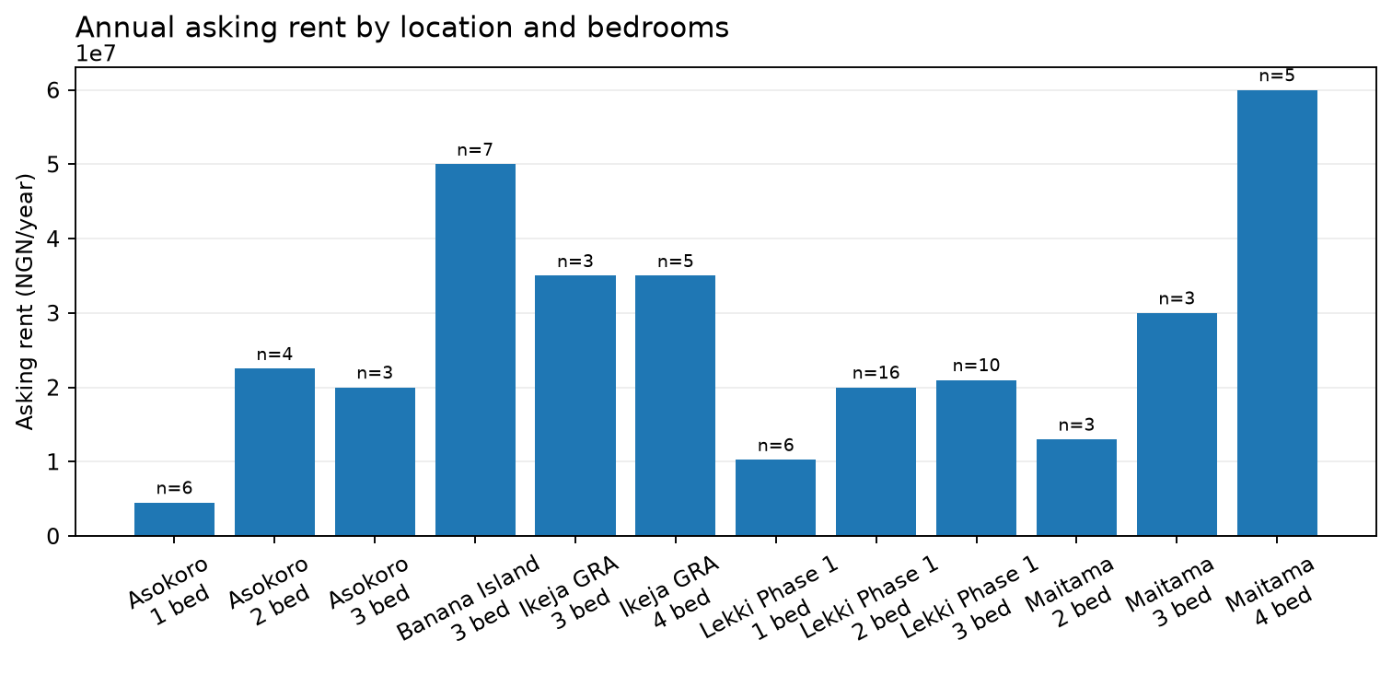

Apartment asking sale prices by location and bedroom count
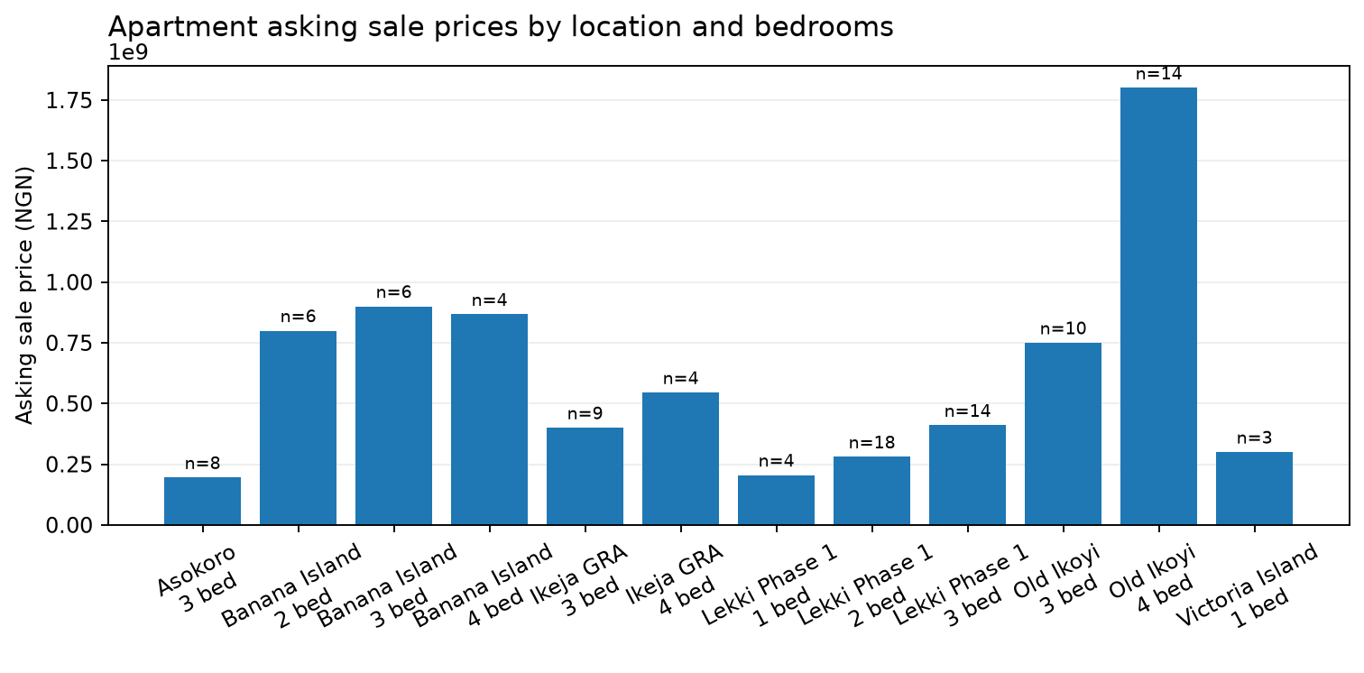

Land asking price per square metre
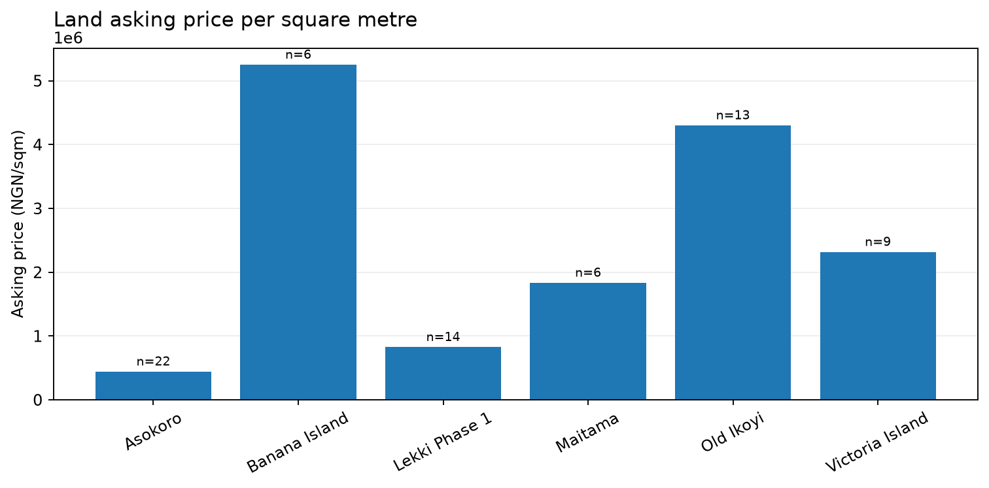

Data quality exceptions requiring source review
36 potential issue(s) were flagged. These are review prompts, not automatic deletions; confirm the original listing, property type, location, price period, currency, plot size and unit before use.
Priority / issue | Area / category | Observed value | Reason | Source
HIGH  wide_price_spread_review | Asokoro / land | — | Segment maximum is at least 10x its minimum. Check rent period, sale/rent classification, bedroom count, bulk listing, location and possible extraction/price-unit error. Do not delete solely because it is an outlier. | https://nigeriapropertycentre.com/for-sale/land/residential-land/abuja/asokoro-district/3683007-residential-land-plot
HIGH  wide_price_spread_review | Asokoro / land | — | Segment maximum is at least 10x its minimum. Check rent period, sale/rent classification, bedroom count, bulk listing, location and possible extraction/price-unit error. Do not delete solely because it is an outlier. | https://nigeriapropertycentre.com/for-sale/land/residential-land/abuja/asokoro-district/3683007-residential-land-plot
HIGH  price_outlier_review | Asokoro / land | ₦20,000,000 | Price is at least 10x above or below the segment median; verify property type, period, unit, currency and source text. Not automatically excluded. | https://propertypro.ng/property/land-for-sale-asokoro-extension-asokoro-abuja-2QGBK
HIGH  price_outlier_review | Asokoro / land | ₦97,125,000,000 | Price is at least 10x above or below the segment median; verify property type, period, unit, currency and source text. Not automatically excluded. | https://nigeriapropertycentre.com/for-sale/land/residential-land/abuja/asokoro-district/3683007-residential-land-plot
HIGH  price_outlier_review | Asokoro / land | ₦25,000,000,000 | Price is at least 10x above or below the segment median; verify property type, period, unit, currency and source text. Not automatically excluded. | https://nigeriapropertycentre.com/for-sale/land/residential-land/abuja/asokoro-district/3726853-plot-of-land
HIGH  wide_price_spread_review | Banana Island / land | — | Segment maximum is at least 10x its minimum. Check rent period, sale/rent classification, bedroom count, bulk listing, location and possible extraction/price-unit error. Do not delete solely because it is an outlier. | https://propertypro.ng/property/land-for-sale-banana-island-ikoyi-lagos-5QCGK
HIGH  wide_price_spread_review | Banana Island / land | — | Segment maximum is at least 10x its minimum. Check rent period, sale/rent classification, bedroom count, bulk listing, location and possible extraction/price-unit error. Do not delete solely because it is an outlier. | https://propertypro.ng/property/land-for-sale-banana-island-ikoyi-lagos-5QCGK
HIGH  price_outlier_review | Banana Island / land | ₦1,300,000 | Price is at least 10x above or below the segment median; verify property type, period, unit, currency and source text. Not automatically excluded. | https://propertypro.ng/property/land-for-sale-opposite-shoreline-estate-banana-island-ikoyi-lagos-8NXZS
HIGH  price_outlier_review | Banana Island / land | ₦3,300,000 | Price is at least 10x above or below the segment median; verify property type, period, unit, currency and source text. Not automatically excluded. | https://propertypro.ng/property/land-for-sale-banana-island-ikoyi-lagos-0NXZT
HIGH  price_outlier_review | Banana Island / land | ₦2,500,000 | Price is at least 10x above or below the segment median; verify property type, period, unit, currency and source text. Not automatically excluded. | https://propertypro.ng/property/land-for-sale-1st-avenue-banana-island-ikoyi-lagos-9NXZR
HIGH  wide_price_spread_review | Banana Island / sale | — | Segment maximum is at least 10x its minimum. Check rent period, sale/rent classification, bedroom count, bulk listing, location and possible extraction/price-unit error. Do not delete solely because it is an outlier. | https://propertypro.ng/property/3-bedroom-flat-apartment-for-sale-banana-island-ikoyi-lagos-6QGMX
HIGH  wide_price_spread_review | Banana Island / sale | — | Segment maximum is at least 10x its minimum. Check rent period, sale/rent classification, bedroom count, bulk listing, location and possible extraction/price-unit error. Do not delete solely because it is an outlier. | https://propertypro.ng/property/3-bedroom-flat-apartment-for-sale-banana-island-ikoyi-lagos-6QGMX
HIGH  price_outlier_review | Banana Island / sale | ₦1 | Price is at least 10x above or below the segment median; verify property type, period, unit, currency and source text. Not automatically excluded. | https://nigeriapropertycentre.com/for-sale/flats-apartments/lagos/ikoyi/banana-island/3728177-3-bedroom-furnished-luxury-waterfront-flats
HIGH  wide_price_spread_review | Banana Island / sale | — | Segment maximum is at least 10x its minimum. Check rent period, sale/rent classification, bedroom count, bulk listing, location and possible extraction/price-unit error. Do not delete solely because it is an outlier. | https://propertypro.ng/property/4-bedroom-flat-apartment-for-sale-banana-island-ikoyi-lagos-6QGBS
HIGH  wide_price_spread_review | Banana Island / sale | — | Segment maximum is at least 10x its minimum. Check rent period, sale/rent classification, bedroom count, bulk listing, location and possible extraction/price-unit error. Do not delete solely because it is an outlier. | https://propertypro.ng/property/4-bedroom-flat-apartment-for-sale-banana-island-ikoyi-lagos-6QGBS
HIGH  price_outlier_review | Banana Island / sale | ₦65,000,000 | Price is at least 10x above or below the segment median; verify property type, period, unit, currency and source text. Not automatically excluded. | https://propertypro.ng/property/4-bedroom-flat-apartment-for-sale-ocean-parade-banana-island-ikoyi-lagos-banana-island-ikoyi-lagos-6QGYT
HIGH  wide_price_spread_review | Lekki Phase 1 / land | — | Segment maximum is at least 10x its minimum. Check rent period, sale/rent classification, bedroom count, bulk listing, location and possible extraction/price-unit error. Do not delete solely because it is an outlier. | https://propertypro.ng/property/land-for-sale-off-admiralty-way-lekki-phase-1-lekki-lagos-2PXJM
HIGH  wide_price_spread_review | Lekki Phase 1 / land | — | Segment maximum is at least 10x its minimum. Check rent period, sale/rent classification, bedroom count, bulk listing, location and possible extraction/price-unit error. Do not delete solely because it is an outlier. | https://propertypro.ng/property/land-for-sale-off-admiralty-way-lekki-phase-1-lekki-lagos-2PXJM
HIGH  price_outlier_review | Lekki Phase 1 / land | ₦1,350,000 | Price is at least 10x above or below the segment median; verify property type, period, unit, currency and source text. Not automatically excluded. | https://propertypro.ng/property/land-for-sale-lekki-phase-1-lekki-lagos-4PWYY
HIGH  price_outlier_review | Lekki Phase 1 / land | ₦750,000 | Price is at least 10x above or below the segment median; verify property type, period, unit, currency and source text. Not automatically excluded. | https://propertypro.ng/property/land-for-sale-orange-island-freedom-way-lekki-phase-1-lekki-lagos-0PWYZ
HIGH  price_outlier_review | Lekki Phase 1 / land | ₦850,000 | Price is at least 10x above or below the segment median; verify property type, period, unit, currency and source text. Not automatically excluded. | https://propertypro.ng/property/land-for-sale-phase-4-orange-island-lekki-phase-1-lekki-lagos-1PTZA
HIGH  price_outlier_review | Lekki Phase 1 / land | ₦1,250,000 | Price is at least 10x above or below the segment median; verify property type, period, unit, currency and source text. Not automatically excluded. | https://propertypro.ng/property/land-for-sale-lekki-phase-1-lekki-lagos-0PFFN
HIGH  price_outlier_review | Lekki Phase 1 / land | ₦1,500,000 | Price is at least 10x above or below the segment median; verify property type, period, unit, currency and source text. Not automatically excluded. | https://nigeriapropertycentre.com/for-sale/land/residential-land/lagos/lekki/lekki-phase-1/3726561-residential-land-with-global-c-of-o
HIGH  wide_price_spread_review | Maitama / land | — | Segment maximum is at least 10x its minimum. Check rent period, sale/rent classification, bedroom count, bulk listing, location and possible extraction/price-unit error. Do not delete solely because it is an outlier. | https://propertypro.ng/property/land-for-sale-maitama-abuja-1PRYX
HIGH  wide_price_spread_review | Maitama / land | — | Segment maximum is at least 10x its minimum. Check rent period, sale/rent classification, bedroom count, bulk listing, location and possible extraction/price-unit error. Do not delete solely because it is an outlier. | https://propertypro.ng/property/land-for-sale-maitama-abuja-1PRYX
HIGH  price_outlier_review | Maitama / land | ₦55,000,000 | Price is at least 10x above or below the segment median; verify property type, period, unit, currency and source text. Not automatically excluded. | https://nigeriapropertycentre.com/for-sale/land/residential-land/abuja/maitama-district/maitama-2/3712832-300sqm-plot-of-land-in-a-secure-estate
HIGH  wide_price_spread_review | Old Ikoyi / land | — | Segment maximum is at least 10x its minimum. Check rent period, sale/rent classification, bedroom count, bulk listing, location and possible extraction/price-unit error. Do not delete solely because it is an outlier. | https://propertypro.ng/property/land-for-sale-ikoyi-crescent-off-alfred-rewane-road-old-ikoyi-ikoyi-lagos-4PKKM
HIGH  wide_price_spread_review | Old Ikoyi / land | — | Segment maximum is at least 10x its minimum. Check rent period, sale/rent classification, bedroom count, bulk listing, location and possible extraction/price-unit error. Do not delete solely because it is an outlier. | https://propertypro.ng/property/land-for-sale-ikoyi-crescent-off-alfred-rewane-road-old-ikoyi-ikoyi-lagos-4PKKM
HIGH  price_outlier_review | Old Ikoyi / land | ₦4,500,000 | Price is at least 10x above or below the segment median; verify property type, period, unit, currency and source text. Not automatically excluded. | https://propertypro.ng/property/land-for-sale-mekenwen-street-old-ikoyi-old-ikoyi-ikoyi-lagos-7PHHW
HIGH  price_outlier_review | Old Ikoyi / land | ₦60,000,000,000 | Price is at least 10x above or below the segment median; verify property type, period, unit, currency and source text. Not automatically excluded. | https://propertypro.ng/property/land-for-sale-ikoyi-crescent-off-alfred-rewane-road-old-ikoyi-ikoyi-lagos-4PKKM
HIGH  price_outlier_review | Old Ikoyi / land | ₦4,300,000 | Price is at least 10x above or below the segment median; verify property type, period, unit, currency and source text. Not automatically excluded. | https://propertypro.ng/property/land-for-sale-old-ikoyi-ikoyi-lagos-8QETL
HIGH  price_outlier_review | Old Ikoyi / land | ₦4,500,000 | Price is at least 10x above or below the segment median; verify property type, period, unit, currency and source text. Not automatically excluded. | https://propertypro.ng/property/land-for-sale-reeve-road-old-ikoyi-ikoyi-lagos-6QJAK
HIGH  price_outlier_review | Old Ikoyi / land | ₦5,500,000 | Price is at least 10x above or below the segment median; verify property type, period, unit, currency and source text. Not automatically excluded. | https://nigeriapropertycentre.com/for-sale/land/residential-land/lagos/ikoyi/old-ikoyi/3725809-residential-land-with-structures
HIGH  wide_price_spread_review | Victoria Island / land | — | Segment maximum is at least 10x its minimum. Check rent period, sale/rent classification, bedroom count, bulk listing, location and possible extraction/price-unit error. Do not delete solely because it is an outlier. | https://propertypro.ng/property/land-for-sale-victoria-island-lagos-7QFNK
HIGH  wide_price_spread_review | Victoria Island / land | — | Segment maximum is at least 10x its minimum. Check rent period, sale/rent classification, bedroom count, bulk listing, location and possible extraction/price-unit error. Do not delete solely because it is an outlier. | https://propertypro.ng/property/land-for-sale-victoria-island-lagos-7QFNK
HIGH  price_outlier_review | Victoria Island / land | ₦2,300,000 | Price is at least 10x above or below the segment median; verify property type, period, unit, currency and source text. Not automatically excluded. | https://propertypro.ng/property/land-for-sale-idowu-taylor-victoria-island-lagos-8NVXH

Source and methodology notes
- Live comparable listing sources currently represented by the pipeline: Nigeria Property Centre and PropertyPro, subject to the sources present in this run.
- Estate Intel public research is contextual and must not be mixed into listing-level asking-price medians. Premium or login-gated content is not collected.
- Knight Frank Nigeria research may be used for contextual triangulation only after confirming the publication period and definitions; it is not a live listing feed.
- Cushman & Wakefield Nigeria/Lagos residential comparable coverage has not been verified. Do not present unrelated global or data-centre research as residential evidence.
- The status of any Estate Intel paid/commercial arrangement is unconfirmed and must be confirmed directly with the account owner/vendor.
- Current tracked location coverage: six Lagos nodes (Banana Island, Old Ikoyi, Lekki Phase 1, Victoria Island, Eko Atlantic, Ikeja GRA) and three Abuja nodes (Asokoro, Maitama, Wuse). Port Harcourt is not yet included in this client report's equivalent node-level series.
- One listing is an observation, not a meaningful range or stable median. Samples below five should be treated as thin. Listing prices are asking prices, not completed transaction prices.
- Reporting schedule: Monday 08:00 Africa/Lagos. A configured schedule is not proof of inbox delivery; provider receipts and actual recipient confirmation must be checked after each run.

