At the beginning of the week, I had never really programmed before. My only prior experience had been in python for a short period last year, so the concept of a functional language was completely foreign to me. Therefore, throughout my placement here I wanted to develop my confidence in a different language, Scala. Something which I feel that I have achieved.

I came to HMRC digital with theintention of learning how the theory that I learn in my Computer Sciencce GCSE is applied in real life scenarios. For example, it had never occurred to me that developers and testers are two seperate jobs, however this is something that now makes sense to me as it allows for a more efficient workflow. Furthermore, I have realised that working in tech no longer means sitting at a desk in silence and darkness all day; everyday like in the films. Instead, the principles of agile allow teams to be versatile and able to react to various situations-something which I inted to carry forward with me.

My Project:
To begin with, I worked dilligently through a worksheet learning the basics of Scala, however I soon felt that I was not progressing as quickly as I was capable of. So, I decided to take what I had already achieved (I.e a username system) and see how I could re arrange and reproduce it. I started this process by thinking ‘what if I could create a program where a random number is generated, and the user has to guess it?’ but I found that it didn’t interest me as a concept and was largely pointless. This is when I looked at that idea from an alternative viewpoint based on usefulness, what if the score between two teams could be ‘predicted’ by an algorithm, in my opinion that could be a light-hearted game that could be used for fantasy football leagues (even though it is completely random!), to name an example.

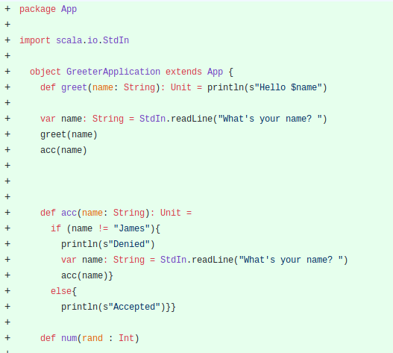
-This section of code is the username functional, if you enter the correct username, James, it will print accepted, if not it will print denied and loop back to the start.

-In this section, the math logic is displayed. The teams are each assigned a random score. Math.random generates a number between 0 and 1, which is then multiplied by 5 and then 1 is added (as a limit).

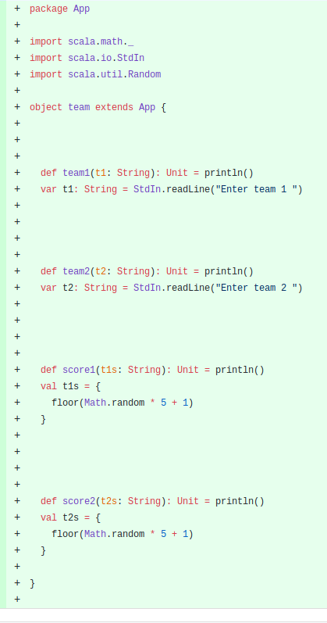

-Here, the user can select which sport they would like and the math logic will adjust the multiplier of math.random, based on average scores of that sport. E.g. basketball has a higher score than football.

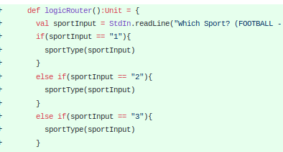

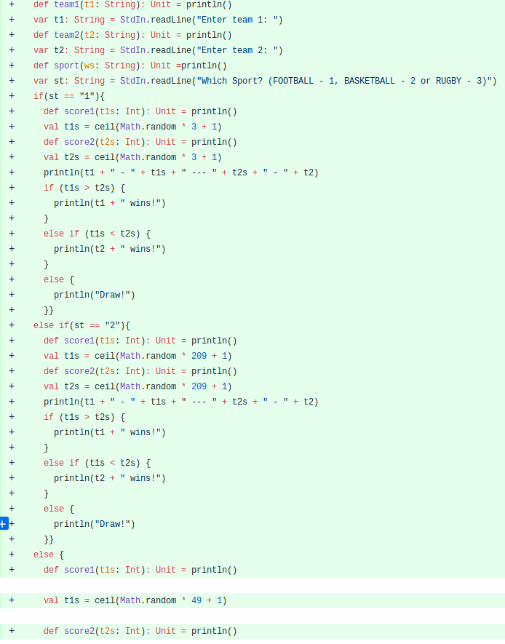

-Below, it shows how the code looks all together, along with the addition of a score comparator stating if it was a win, loss or draw (and which team that it refers to). E.g.
Portsmouth 3.0 --- 0.0 Luton
Portsmouth wins!

-In this segment, there are two examples of the code being refactored, this is when the internal structure of the code is changed but the external function remains the same. This saves space and makes the code more readable by removing repeated if statements etc. by putting them into classes (an example of a class is shown in the second picture).
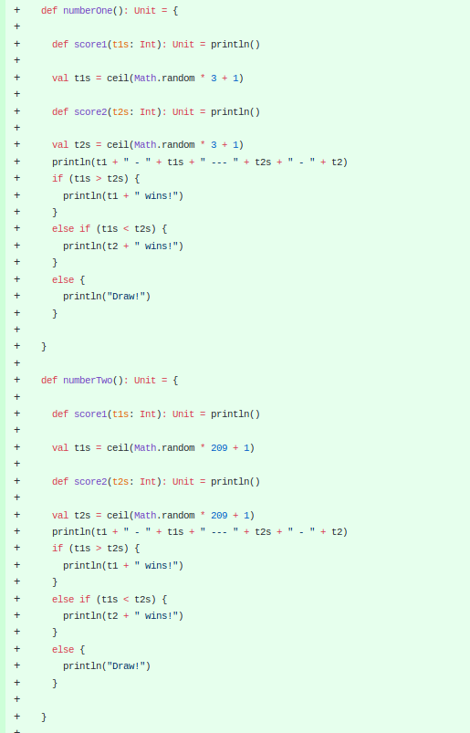
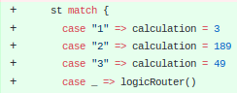

-start + scala.util.Random.nextInt((end-start)+1) generates a random number between the start and end point and adds 1 in order to generate a completely random number.

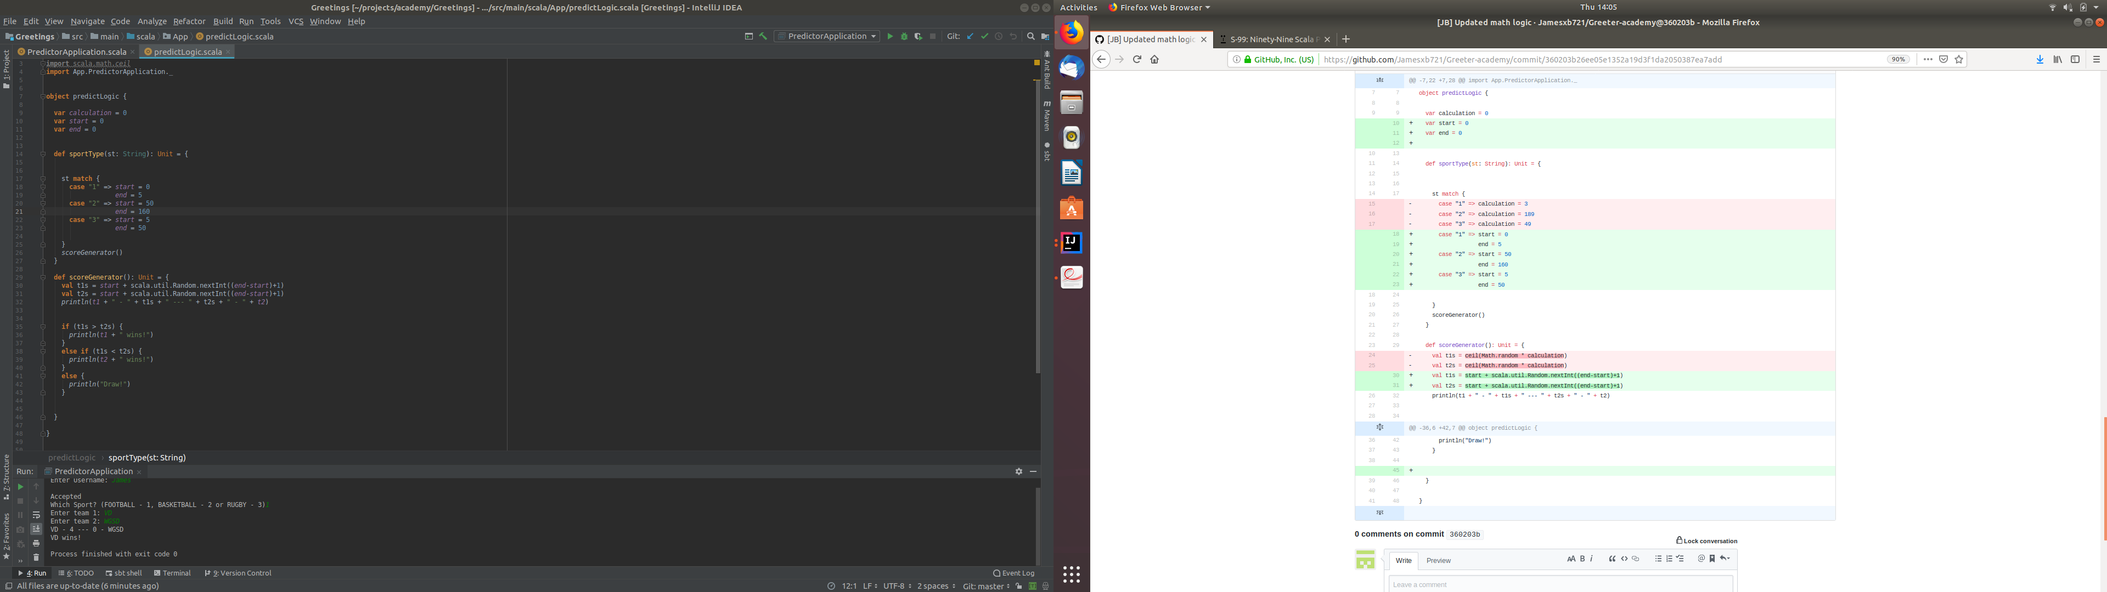

Does anybody have any questions?

To conclude, I have enjoyed a brilliant week learning new skills, developing older ones and making new connections for the future. Thank you for giving me this opportunity.

