**2024 Video Game Sales Analysis**

Yu Zhong

[Yuz380@pitt.edu](mailto:Yuz380@pitt.edu)

INFSCI 2415

**Figure**

figure 1: Total Sales by Game Genre

A bar chart displaying the total sales for each video game genre.

Key Insight: Action games dominate the market, followed by Shooter and Role-Playing games.

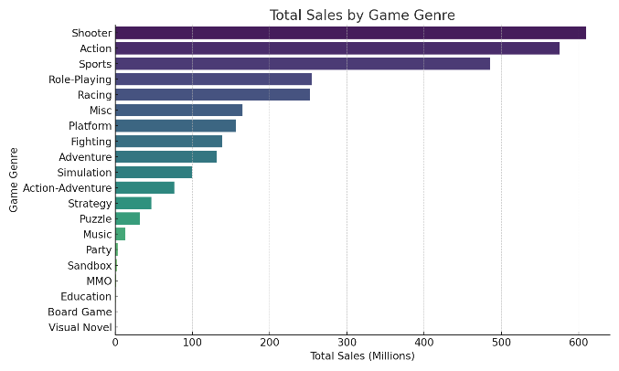

figure 2: Game Releases by Platform

A bar chart showing the count of games released per platform.

Key Insight: PlayStation and Xbox platforms host the majority of games, with Nintendo following closely.

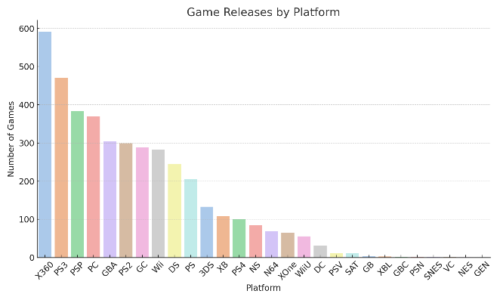

figure 3: Critic Score vs Total Sales

A scatterplot illustrating the relationship between critic scores and total sales.

Key Insight: Games with higher critic scores tend to achieve better sales, but exceptions exist.

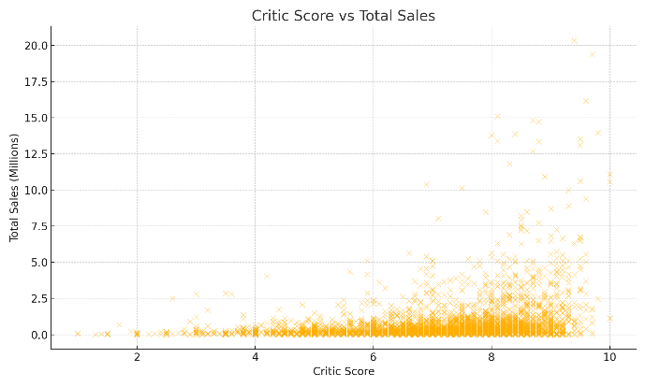

figure 4: Sales Distribution by Region

A bar chart visualizing sales in NA, JP, PAL, and Other regions.

Key Insight: North America leads in sales, followed by PAL and Japan.

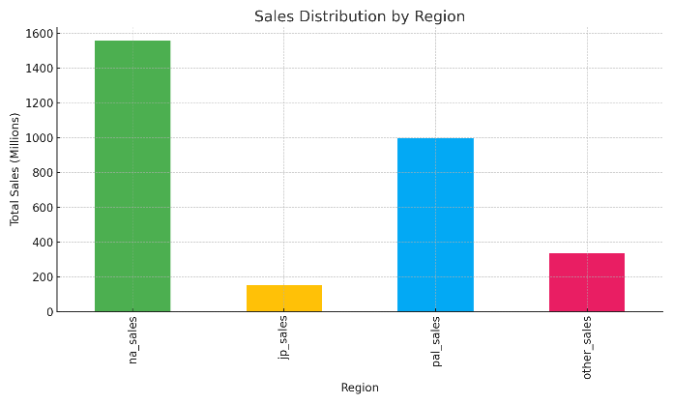

figure 5: Total Sales Over Years

A line chart showing the trend of video game sales over the years.

Key Insight: Sales peaked around 2008-2010 and declined in recent years.

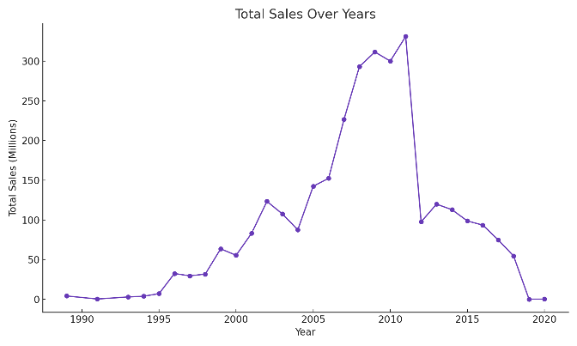

**Legend**

1. **Colors**:
   * Different colors in each chart correspond to specific categories (e.g., genres, regions).
2. **Axes**:
   * X-axis: Categories such as year, platform, or genre.
   * Y-axis: Total sales (in millions) or count, depending on the chart.
3. **Markers**:
   * Scatterplot points represent individual games.

**Findings**

1. Action games are the best-selling type of video game. This means that many players enjoy fast-paced and exciting games. Shooter games and role-playing games also have good sales, but they are not as popular as action games. Sports and simulation games have fewer sales, showing they appeal to a smaller group of players.
2. Platforms like PlayStation and Xbox have the most games and sales. These platforms are the most common for gaming, so it makes sense that they dominate the market. Nintendo has fewer games but still performs well because it has many loyal fans.
3. Critic scores are linked to game sales. When games get high scores from critics, more people buy them. However, there are a few games that do not follow this pattern.
4. North America is the largest market for video games. Europe is the second biggest, and Japan is smaller but important because it has unique games popular there.
5. Video game sales were at their highest around 2008 to 2010. After that, sales have gone down, showing the market is not as strong now as it was then.

**Data Source**

<https://www.kaggle.com/datasets/asaniczka/video-game-sales-2024>

Video game sales data, including information on genres, platforms, regional sales, and critic scores.

**Processing**

1. The dataset has over 64,000 records of video games. It includes details like the game title, platform (such as PlayStation or Xbox), genre, sales data by region (like North America or Japan), and critic scores.
2. The data was cleaned to fix missing values and make it easier to work with. Dates were converted to years so trends over time could be analyzed. Sales and other factors were grouped and summed up for better insights.
3. For the charts, Python libraries like pandas were used to organize the data, and matplotlib and seaborn were used to make the graphs. These tools helped show trends and patterns clearly.

**Visualization Tools**

Python: pandas, matplotlib, seaborn.

**Significance Statement**

This report is important because it shows what kinds of games and platforms are the most popular. It also explains how critic reviews can help games sell more copies. The data shows which regions are the biggest markets for video games, so companies know where to focus their efforts. By understanding these trends, game developers and marketers can make better choices about what games to create and how to sell them. This report also helps us understand how the gaming market has changed over time.

**GitHub Repository**

The full Python code, dataset, and this report are available at: <https://github.com/Jameszy007/INFSCI-2415-final-project.git>