

James Paton (S1111175)  
Computer Games (Software Development)

Mobile Platform Development (MHI322959)  
Coursework Documentation

*I confirm that the code contained in this file (other than that provided or authorised) is all my own work and has not been submitted elsewhere in fulfilment of this or any other award.*

**

*James Paton*

GitHub Repo:

APK:

Video demonstration:

April 2020

Documented Testing

**SearchForSubstring()**

|  |  |  |  |  |  |  |  |  |
| --- | --- | --- | --- | --- | --- | --- | --- | --- |
| **String string** | **String search** | **boolean addBold** | **boolean ensureAtEnd** |  | **Expected** | **Result** |  | **Pass / Fail** |
| A90 Ellon Rnbt to Invernettie Rnbt Peterhead - MLC | m8 | TRUE | FALSE |  | "" | "" |  | Pass |
| A86 Glen Spean, East of Roybridge | roy | TRUE | FALSE |  | A86 Glen Spean, East of <b>Roy</b>bridge | A86 Glen Spean, East of <b>Roy</b>bridge |  | Pass |
| A726 College Milton Bridge - Westbound lane closure | Milton Bridge | FALSE | FALSE |  | A726 College Milton Bridge - Westbound lane closure | A726 College Milton Bridge - Westbound lane closure |  | Pass |
| M73 NB Link Road to M8 WB Closure | M8 | TRUE | TRUE |  | M73 NB Link Road to <b>M8</b> WB Closure | M73 NB Link Road to <b>M8</b> WB Closure |  | Pass |
| M80 Whole Road | M8 | TRUE | TRUE |  | "" | "" |  | Pass |
| M77 Roadworks | M7 | FALSE | TRUE |  | "" | "" |  | Pass |
| M77 Roadworks | M77 | FALSE | TRUE |  | M77 Roadworks | M77 Roadworks |  | Pass |

**FindRoadName()**

|  |  |  |  |  |  |  |
| --- | --- | --- | --- | --- | --- | --- |
| **String sentence** | **String[] indicators** |  | **Expected** | **Result** |  | **Pass / Fail** |
| At the roundabout, take the <b>1st</b> exit and stay on <b>A77</b> | {" on <b>", " onto <b>", " toward <b>"," take the <b>"} |  | A77 | A77 |  | Pass |
| Continue straight onto <b>Killoch Pl</b> | {" on <b>", " onto <b>", " toward <b>"," take the <b>"} |  | Killoch Pl | Killoch Pl |  | Pass |
| Turn <b>right</b> onto <b>Parkhouse St</b> | {" take the <b>"} |  | "" | "" |  | Pass |
| Turn <b>right</b> onto <b>Parkhouse St</b> | {" onto <b>"} |  | Parkhouse St | Parkhouse St |  | Pass |

Test Data

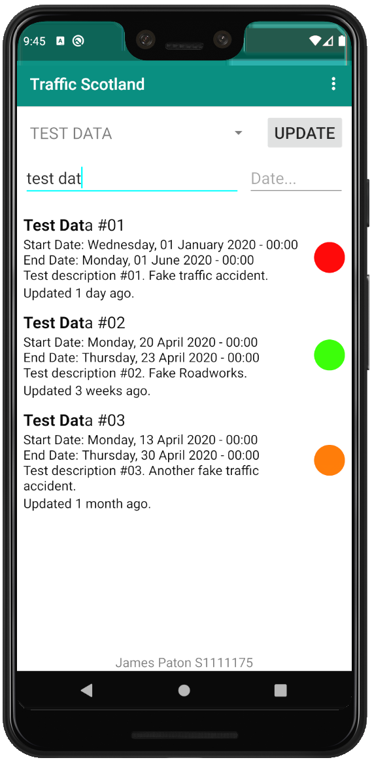

Due to the ever-changing nature of the Traffic Scotland's RSS feeds, test data was uploaded to:

<https://jamespaton.com/s/MPD_TrafficScotland_TestData.aspx>

This created a consistent test environment and can be accessed from within the app by enabling the class variable *enableTesting* inside MainActivity.java

This test data was created specifically to showcase the colour gradient representing the length of the incident as well as the interpretation of the last updated date.

This data was used to provide a more rigorous test suite, allowing the application to be tested under more real-world conditions than the previous tests allowed.

The results of these tests can be seen on the following page.

|  |  |  |  |  |  |  |  |  |
| --- | --- | --- | --- | --- | --- | --- | --- | --- |
|  | **Search** | **Date** | **Test Data** | **Found, Expected** | **Found, Result** | **Bold, Expected** | **Bold, Result** | **Pass / Fail** |
| **Test 1** | "test dat" | [None] | Test Data #01 | Yes | Yes | "Test Dat" | "Test Dat" | Pass |
|  |  |  | Test Data #02 | Yes | Yes | "Test Dat" | "Test Dat" | Pass |
|  |  |  | Test Data #03 | Yes | Yes | "Test Dat" | "Test Dat" | Pass |
| **Test 2** | "k" | [None] | Test Data #01 | Yes | Yes | "k" | "k" | Pass |
|  |  |  | Test Data #02 | Yes | Yes | "k", "k" | "k", "k" | Pass |
|  |  |  | Test Data #03 | Yes | Yes | "k" | "k" | Pass |
| **Test 3** | "fake" | [None] | Test Data #01 | Yes | Yes | "Fake" | "Fake" | Pass |
|  |  |  | Test Data #02 | Yes | Yes | "Fake" | "Fake" | Pass |
|  |  |  | Test Data #03 | Yes | Yes | "fake" | "fake" | Pass |
| **Test 4** | "acc" | [None] | Test Data #01 | Yes | Yes | "acc" | "acc" | Pass |
|  |  |  | Test Data #02 | No | No | [None] | [None] | Pass |
|  |  |  | Test Data #03 | Yes | Yes | "acc" | "acc" | Pass |
| **Test 4** | "another" | 14/04/20 | Test Data #01 | No | No | [None] | [None] | Pass |
|  |  |  | Test Data #02 | No | No | [None] | [None] | Pass |
|  |  |  | Test Data #03 | Yes | Yes | "another" | "another" | Pass |
| **Test 5** | [None] | 23/04/20 | Test Data #01 | Yes | Yes | [None] | [None] | Pass |
|  |  |  | Test Data #02 | Yes | Yes | [None] | [None] | Pass |
|  |  |  | Test Data #03 | Yes | Yes | [None] | [None] | Pass |