**James Bianco MSD 6.2A**

**Research Topic:** Facial Recognition & Tracking

**Objective:** Be able to detect & track face and apply cosmetics over face using Unity Mars to let users cosplay or dress up how they want.

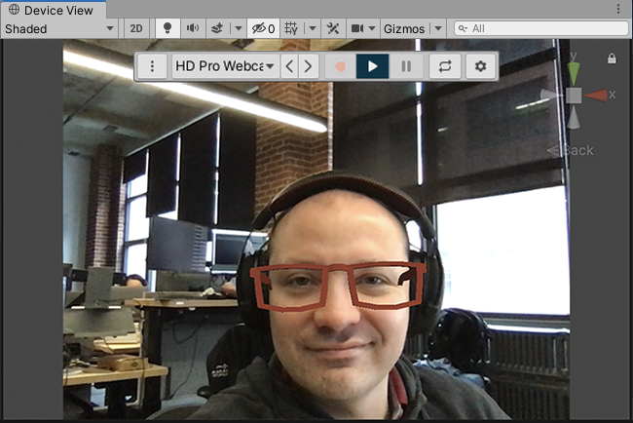**Sample Data:**

