Student name: Jami Hannus

Email address (prefer your @students.oamk.fi email if you have such address): t9haja@students.oamk.fi

Save the final version of this document as PDF and submit it for peer reviews via Moodle’s workshop tool before the deadline. Last course week is for peer reviews.

# Week 1

Question 1: With your Linux: Use curl command line tool to access some websites and inspect the received HTTP headers (example: curl -I address). Study and explain headers and related values.

Answer 1:

***jami@JamJam:~$ curl -I*** [***https://www.oamk.fi/en***](https://www.oamk.fi/en)Here I used curl and option -I what is same as --head only will ask the website for the header only

***HTTP/1.1 200 OK***

Just normal 200 http response

***Date: Tue, 31 Aug 2021 08:33:45 GMT***

The time of the request

***Server: Apache***

What server environment/program is Oamk using

***X-Powered-By: PHP/5.6.40***Omak is saying that they use PHP and version 5.6.40 but X usually means nonstandard so it could be true or not. It is also possible to suppress this

***Set-Cookie: 83c2768cf182f74e8d748df19726971f=dk2jcojkq6qrn85akbocjbocj6; path=/; secure; HttpOnly***

***cookie name and cookie value. Secure is only send when request was made with https so bit more secure. HTTP only forbids JS access to the cookie.***

***Expires: Wed, 17 Aug 2005 00:00:00 GMT***

Expiration date when it the response is stale. As its is in past the response is always stale. I think this is not good way to do this.

***Last-Modified: Tue, 31 Aug 2021 08:33:46 GMT***

When the server thinks it was last modified

***Cache-Control: no-store, no-cache, must-revalidate, post-check=0, pre-check=0***

no-store is saying don’t save the response at all and no-cache is revalidated it every time. Must revalidate says that it needs to validate it again when it is stale. And as we have expired date at 2005 response will always be stale. So many useless things. Only no-store would be enough to do the same

***Pragma: no-cache***

No cache for http/1.0 version

***Content-Type: text/html; charset=utf-8***

***Description what the content is so text and html and what is the standard encoding***

Question 2: Use curl to fetch XML formatted data from VTT’s weather station. Address is: <http://weather.willab.fi/weather.xml>

Answer 2: 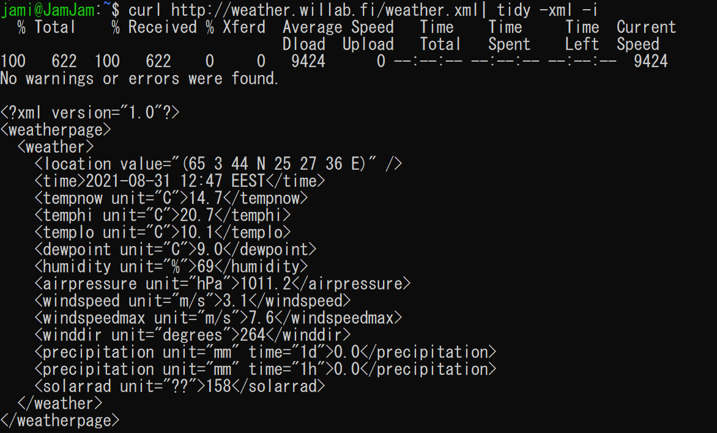

using curl and then tidy what accept xml format and then -I what indents it.

Question 3:

Install jq (JSON processing tool) to your Linux and fetch the current Kivisydän parking data with:

curl -s -L -X POST -H “Content-Type: application/json” –data “{ "query": "{carParks {name,maxCapacity,spacesAvailable} }" }” https://api.oulunliikenne.fi/proxy/graphql | jq ‘.data.carParks[8]’

Did some editing my own is now to fix the quoting problems  
curl 'https://api.oulunliikenne.fi/proxy/graphql' -d '{"query":"query {carParks{name,maxCapacity,spacesAvailable}}"}' | jq '.data.carParks[8]'

Answer 3:

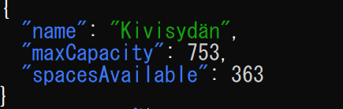

Question 4 Explain how previous one-liner works

So we send the data to the API where we it will see the query request for carparks with subfields name,maxCapacity and spaceAvailable. The server returns the whole packet as data in jason format where we will pick the 9th carPark data from using the data.carParks[8] what was the Kivisydän.

Question 1: Install Apache web server to your virtual Linux (or server provided by Oamk) and try to access it with a web browser

Answer 1: <http://www.students.oamk.fi/~t9haja00/>

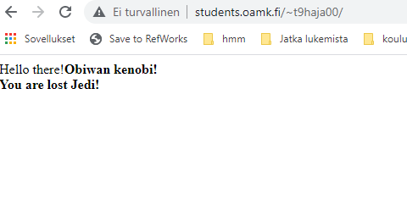

# Week 2

Question 1: Nnnn

Answer 1: Nnnn

Question 2: Nnnn

Answer 2: Nnnn

Question 3: Nnnn

Answer 3: Nnnn

Question 4: Nnnn

Answer 4: Nnnn

…

# Week 3

Question 1: Nnnn

Answer 1: Nnnn

Question 2: Nnnn

Answer 2: Nnnn

Question 3: Nnnn

Answer 3: Nnnn

Question 4: Nnnn

Answer 4: Nnnn

…

# Week 4

Question 1: Nnnn

Answer 1: Nnnn

Question 2: Nnnn

Answer 2: Nnnn

Question 3: Nnnn

Answer 3: Nnnn

Question 4: Nnnn

Answer 4: Nnnn

…

# Week 5

Question 1: Nnnn

Answer 1: Nnnn

Question 2: Nnnn

Answer 2: Nnnn

Question 3: Nnnn

Answer 3: Nnnn

Question 4: Nnnn

Answer 4: Nnnn

…

# Week 6

Question 1: Nnnn

Answer 1: Nnnn

Question 2: Nnnn

Answer 2: Nnnn

Question 3: Nnnn

Answer 3: Nnnn

Question 4: Nnnn

Answer 4: Nnnn

…

# Week 7

Question 1: Nnnn

Answer 1: Nnnn

Question 2: Nnnn

Answer 2: Nnnn

Question 3: Nnnn

Answer 3: Nnnn

Question 4: Nnnn

Answer 4: Nnnn

…

# Week 8

Question 1: Nnnn

Answer 1: Nnnn

Question 2: Nnnn

Answer 2: Nnnn

Question 3: Nnnn

Answer 3: Nnnn

Question 4: Nnnn

Answer 4: Nnnn

…