**Add Simple Product**

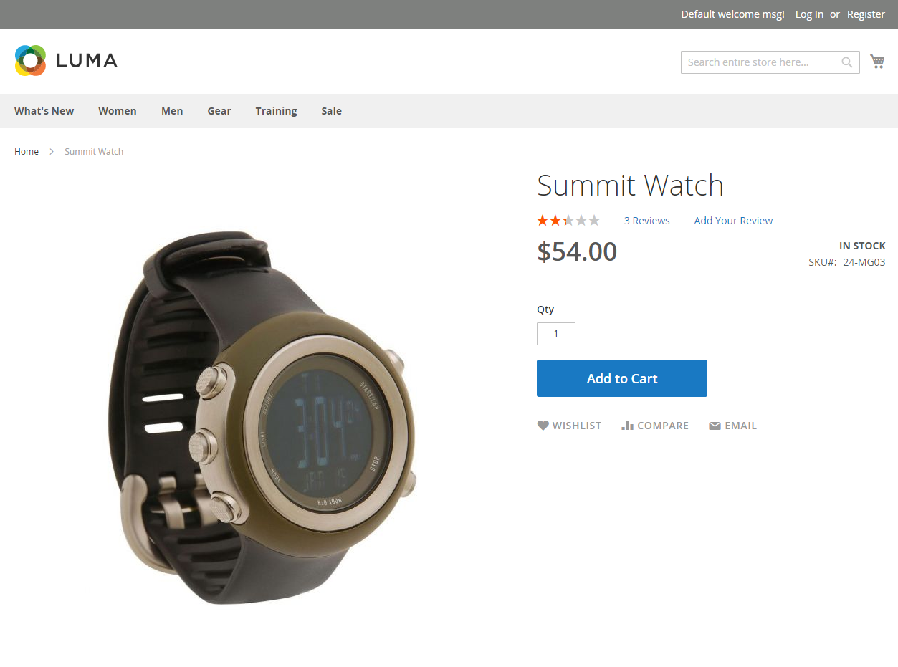

[[Open](javascript:void(0);)**Step 1: Choose the Product Type**](javascript:void(0);)

|  |  |  |
| --- | --- | --- |
|  | 1. | On the [Admin](javascript:void(0);) [sidebar](javascript:void(0);), tap Products. Then under Inventory, choose Catalog. |

|  |  |  |
| --- | --- | --- |
|  | 2. | In the upper-right corner on the Add Product (http://docs.magento.com/m2/ce/user_guide/Resources/Images/btn-save-menu_17x18.png) menu, choose Simple Product. |

*[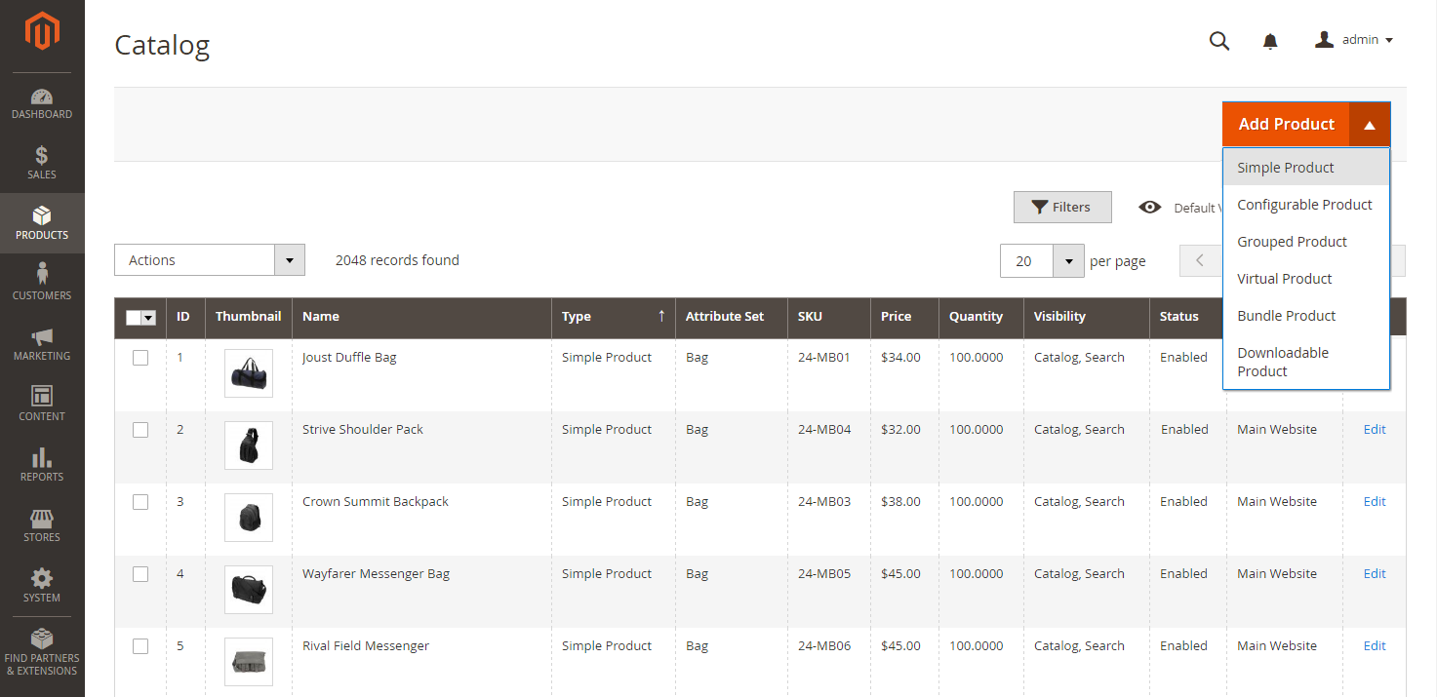](http://docs.magento.com/m2/ce/user_guide/Resources/Images/product-add-simple.png)   
Add Simple Product*

[**Step 2: Choose the Attribute Set**](javascript:void(0);)

To choose the [attribute set](http://docs.magento.com/m2/ce/user_guide/stores/attribute-sets.html) that is used as a template for the product, do one of the following:

* In the **Search** box, enter the name of the [attribute](javascript:void(0);) set.
* In the list, choose the attribute set that you want to use.

The form is updated to reflect the change.

*[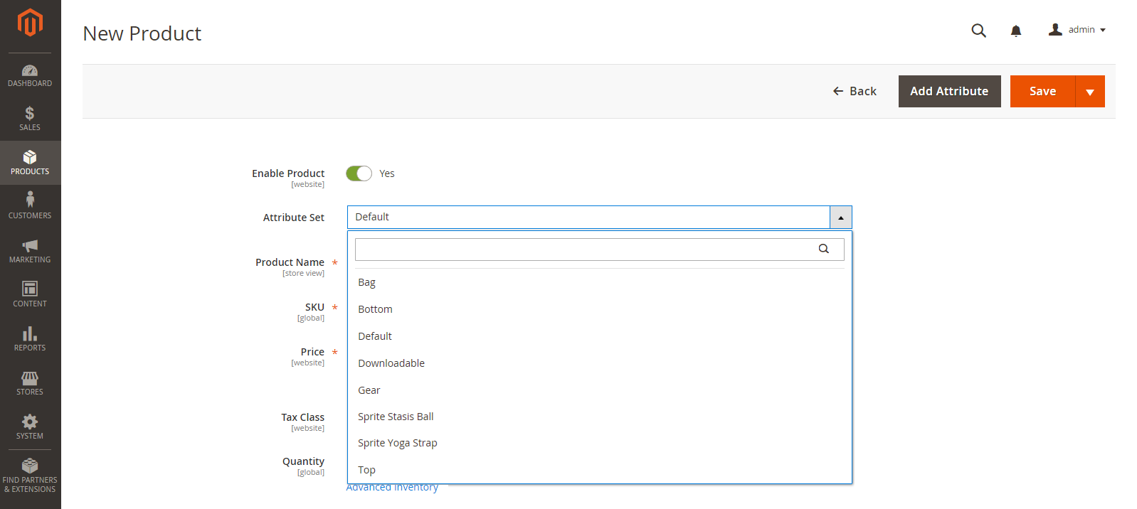](http://docs.magento.com/m2/ce/user_guide/Resources/Images/product-create-choose-attribute-set.png)   
Choose Attribute Set*

[**Step 3: Complete the Required Settings**](javascript:void(0);)

|  |  |  |
| --- | --- | --- |
|  | **1.** | Enter the product **Product Name**. |

|  |  |  |
| --- | --- | --- |
|  | **2.** | Accept the default [**SKU**](javascript:void(0);) that is based on the product name, or enter another. |

|  |  |  |
| --- | --- | --- |
|  | **3.** | Enter the product **Price**. |

|  |  |  |
| --- | --- | --- |
|  | **4.** | Because the product is not yet ready to publish,  set the **Enable Product** switch to the “No” [([http://docs.magento.com/m2/ce/user_guide/Resources/Images/btn-switch-no_32x18.png](http://docs.magento.com/m2/ce/user_guide/Resources/Images/btn-switch-no.png))](http://docs.magento.com/m2/ce/user_guide/Resources/Images/btn-switch-no.png)position. |

|  |  |  |
| --- | --- | --- |
|  | **5.** | Tap **Save** and continue. |

When the product is saved, the [Store View](http://docs.magento.com/m2/ce/user_guide/catalog/product-scope.html) chooser appears in the upper-left corner.

|  |  |  |
| --- | --- | --- |
|  | **6.** | Choose the **Store View** where the product is to be available. |

*[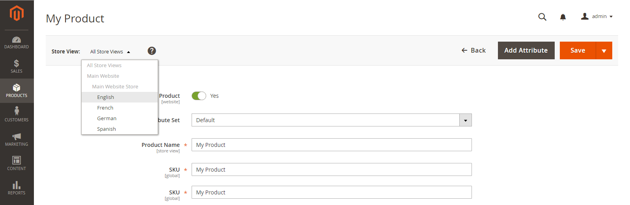](http://docs.magento.com/m2/ce/user_guide/Resources/Images/product-create-store-view-choose.png)   
Choose Store View*

[**Step 4: Complete the Basic Settings**](javascript:void(0);)

|  |  |  |
| --- | --- | --- |
|  | **1.** | Set **Tax Class** to one of the following: |

* None
* Taxable Goods

|  |  |  |
| --- | --- | --- |
|  | **2.** | Enter the **Quantity** of the product that is currently in stock. |

Take note that by default, **Stock Status** is set to “In Stock.”

|  |  |  |
| --- | --- | --- |
|  | **3.** | Enter the **Weight** of the product. |

|  |  |  |
| --- | --- | --- |
|  | **4.** | Accept the default **Visibility** setting, “Catalog, Search.” |

|  |  |  |
| --- | --- | --- |
|  | **5.** | To assign **Categories** to the product, tap the**Select…** box. Then, do either of the following: |

**Choose an existing**[**category**](javascript:void(0);)**:**

|  |  |  |
| --- | --- | --- |
|  | **a.** | Start typing in the box to find a match. |

|  |  |  |
| --- | --- | --- |
|  | **b.** | Mark the checkbox of each category that is to be assigned. |

**Create a new category:**

|  |  |  |
| --- | --- | --- |
|  | **a.** | Tap **New Category**. |

|  |  |  |
| --- | --- | --- |
|  | **b.** | Enter the **Category Name** and choose the **Parent Category** to  determine its position in the menu structure. |

|  |  |  |  |  |
| --- | --- | --- | --- | --- |
|  | **c.**Tap **New Category** |  |  |  |

|  |  |  |
| --- | --- | --- |
|  | **6.** | To feature the product in the list of[new products](http://docs.magento.com/m2/ce/user_guide/cms/widget-new-products-list.html), mark the **Set Product as New** checkbox. |

|  |  |  |
| --- | --- | --- |
|  | **7.** | Choose the **Country of Manufacture**. |

*[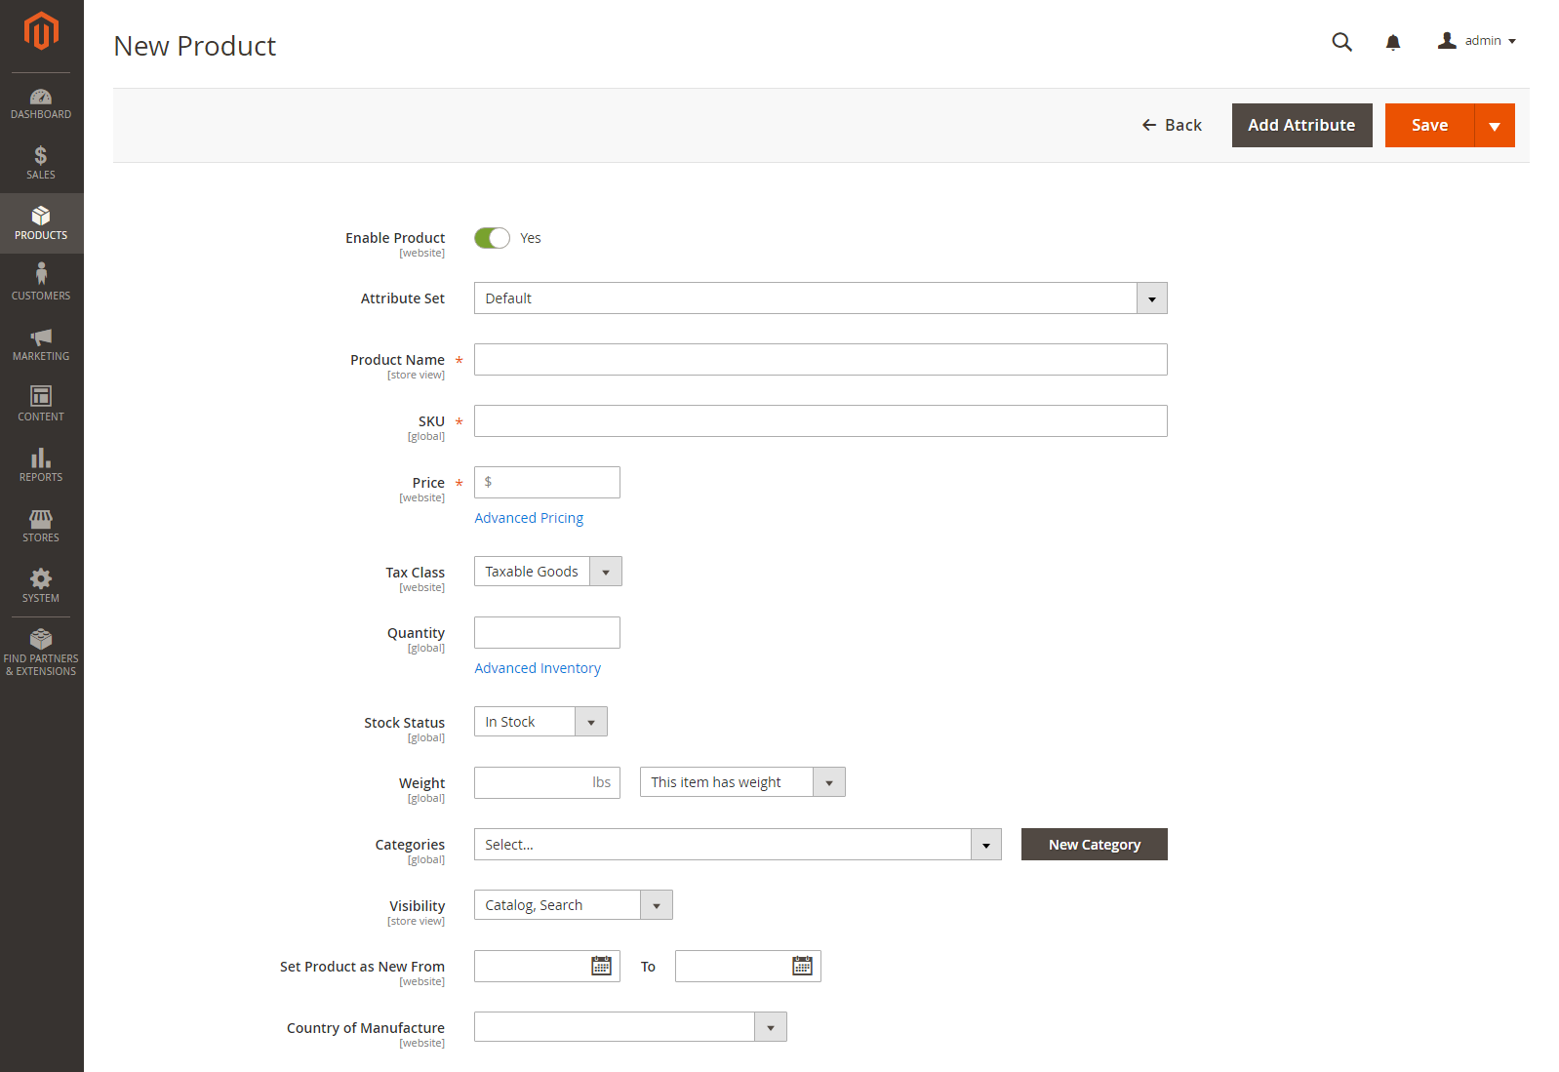](http://docs.magento.com/m2/ce/user_guide/Resources/Images/product-details-simple.png)   
Product Details*

There might be additional individual attributes that describe the product. The selection varies attribute set, and you can complete them later.

[**Step 5: Complete the Product Information**](javascript:void(0);)

Scroll down and complete the information in the following sections as needed:

* [Content](http://docs.magento.com/m2/ce/user_guide/catalog/product-content.html)
* [Images and Videos](http://docs.magento.com/m2/ce/user_guide/catalog/product-images-and-video.html)
* [Related Products, Up-Sells, and Cross-Sells](http://docs.magento.com/m2/ce/user_guide/catalog/related-products-up-sells-cross-sells.html)
* [Search Engine Optimization](http://docs.magento.com/m2/ce/user_guide/catalog/product-search-engine-optimization.html)
* [Customizable Options](http://docs.magento.com/m2/ce/user_guide/catalog/settings-advanced-custom-options.html)
* [Products in Websites](http://docs.magento.com/m2/ce/user_guide/catalog/settings-basic-websites.html)
* [Design](http://docs.magento.com/m2/ce/user_guide/catalog/settings-advanced-design.html)
* [Gift Options](http://docs.magento.com/m2/ce/user_guide/catalog/product-gift-options.html)

[**Step 6: Publish the Product**](javascript:void(0);)

|  |  |  |
| --- | --- | --- |
|  | **1.** | If you are ready to publish the product in the catalog,  set the **Enable Product** switch to the “Yes” (http://docs.magento.com/m2/ce/user_guide/Resources/Images/btn-switch-yes_32x18.png) position. |

|  |  |  |
| --- | --- | --- |
|  | **2. Do one of the following:** |  |

**Method 1: Save and Preview**

|  |  |  |
| --- | --- | --- |
|  | **1.** In the upper-right corner, tap **Save** |  |

|  |  |  |
| --- | --- | --- |
|  | **2.** | To view the product in your store, choose **Customer View** on the **Admin**http://docs.magento.com/m2/ce/user_guide/Resources/Images/btn-dropdown-blk_22x18.png menu.  The store opens in a new browser tab. |

*[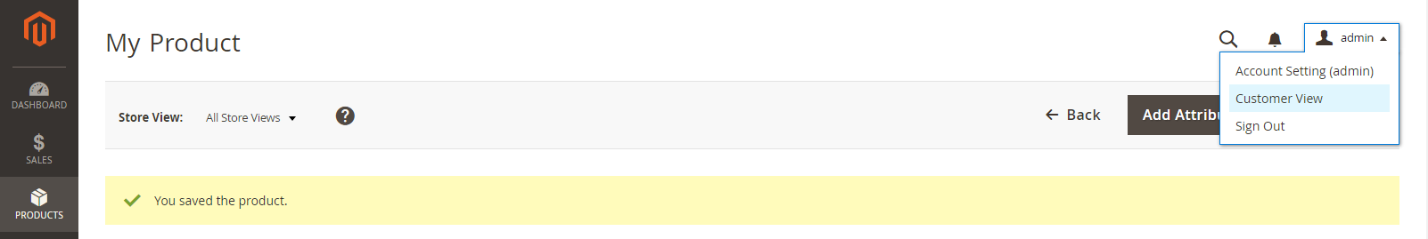](http://docs.magento.com/m2/ce/user_guide/Resources/Images/product-admin-customer-view.png)   
Customer View*

**Method 2: Save and Close**

On the **Save**  (http://docs.magento.com/m2/ce/user_guide/Resources/Images/btn-dropdown_17x18.png) menu, choose **Save & Close**.

*[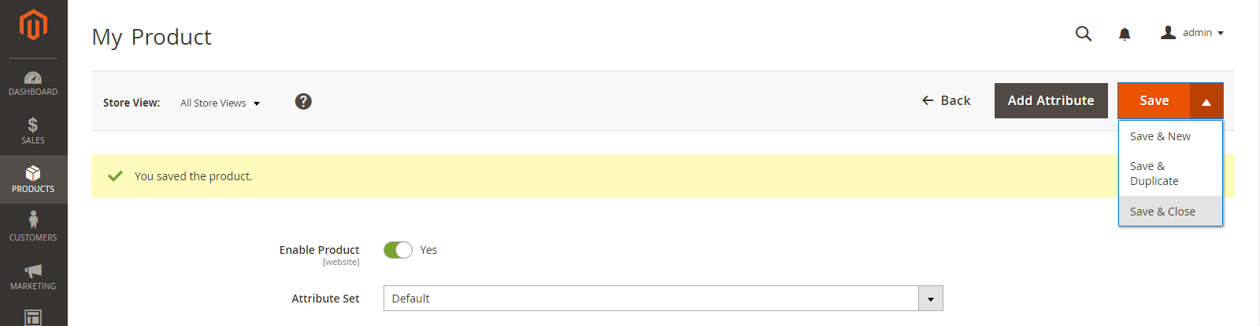](http://docs.magento.com/m2/ce/user_guide/Resources/Images/product-edit-save-close.png)   
Save & Close*