**Zodiya Website**

**1)Cart Page**

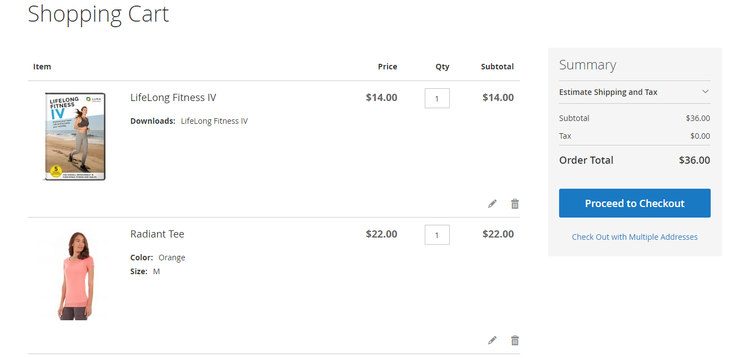

**2)Login Page**

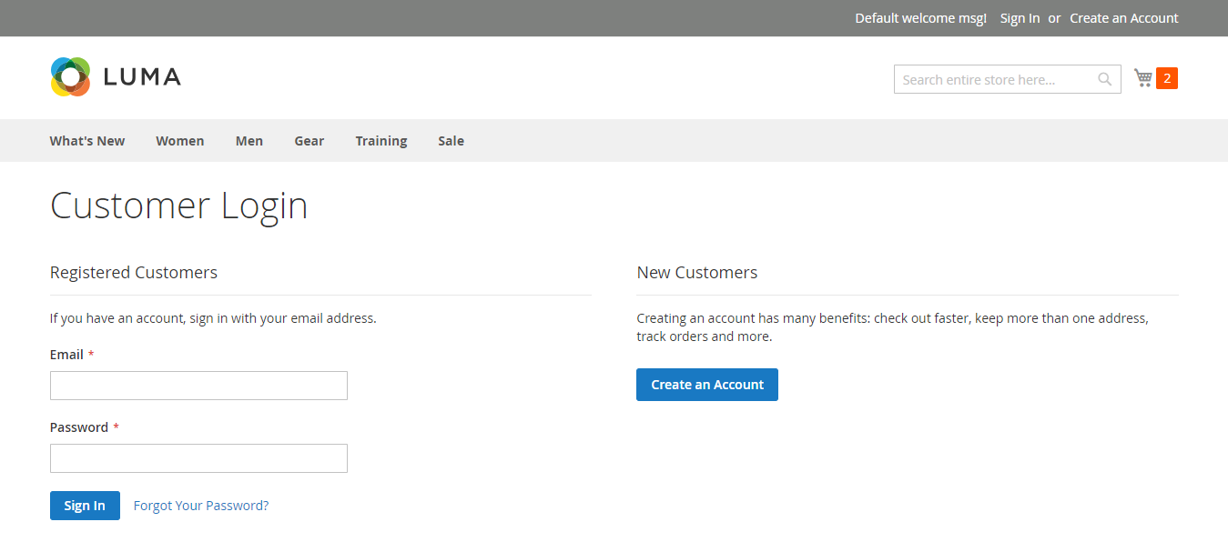

**3)Registration**

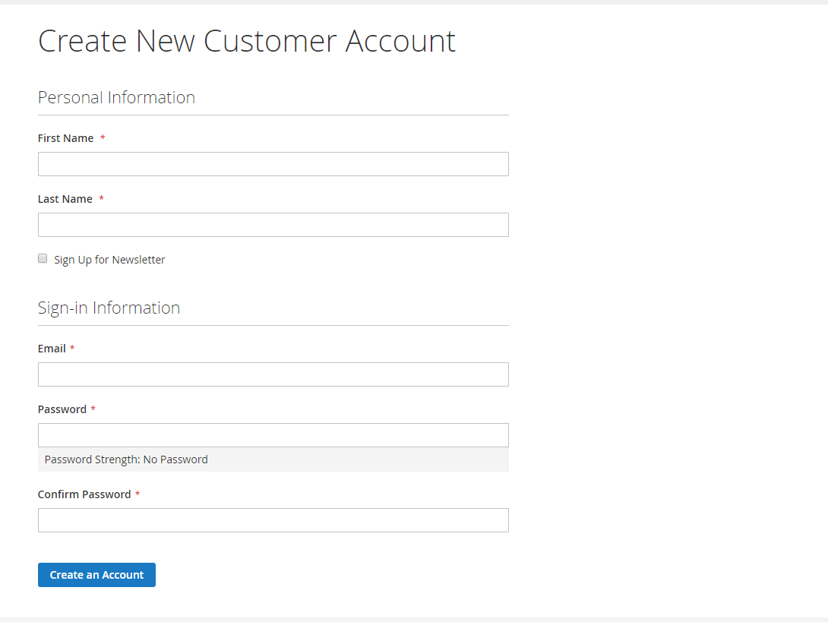

**4)Wishlist**

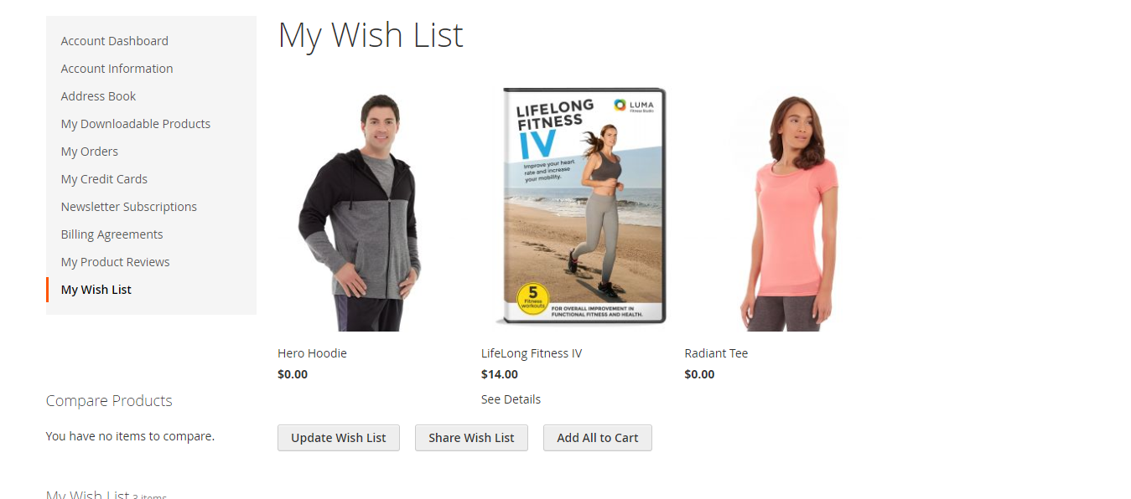

**5)Dashboard**

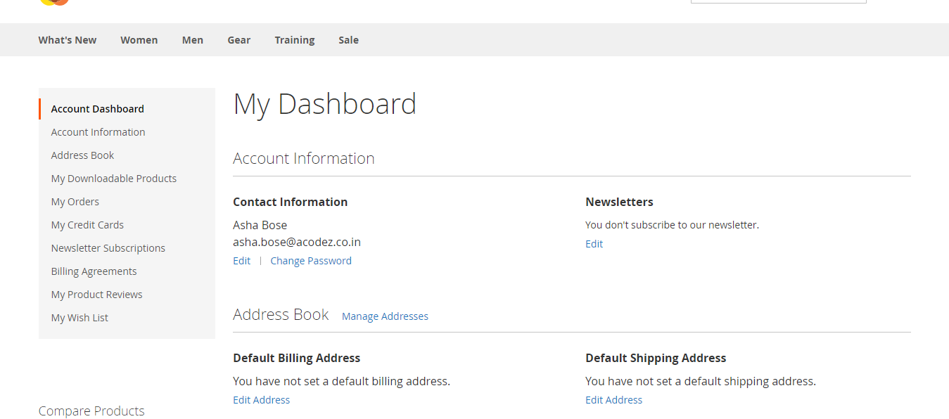

**6)Add Address**

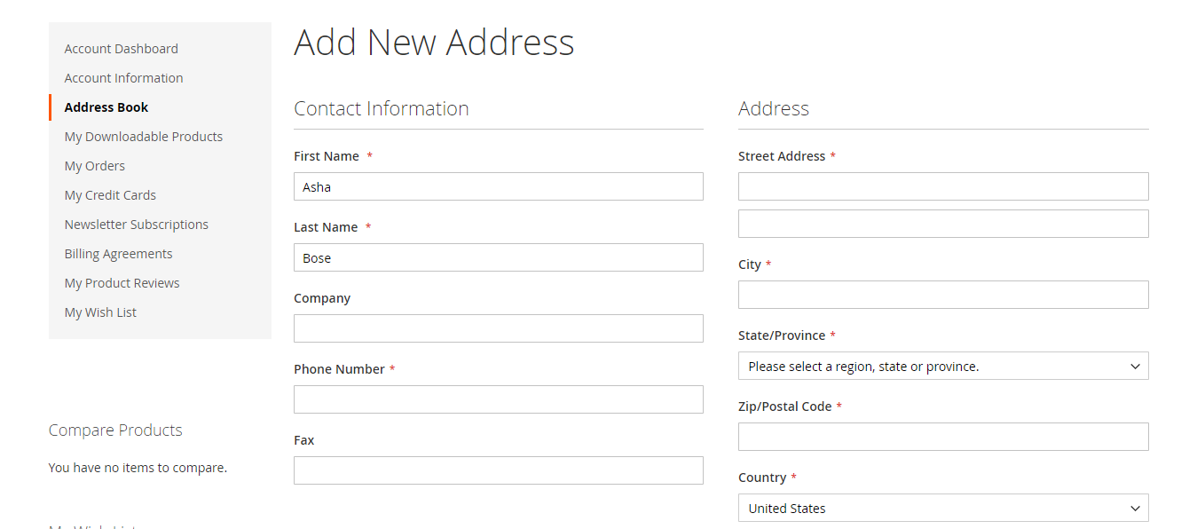

**7)Address Book**

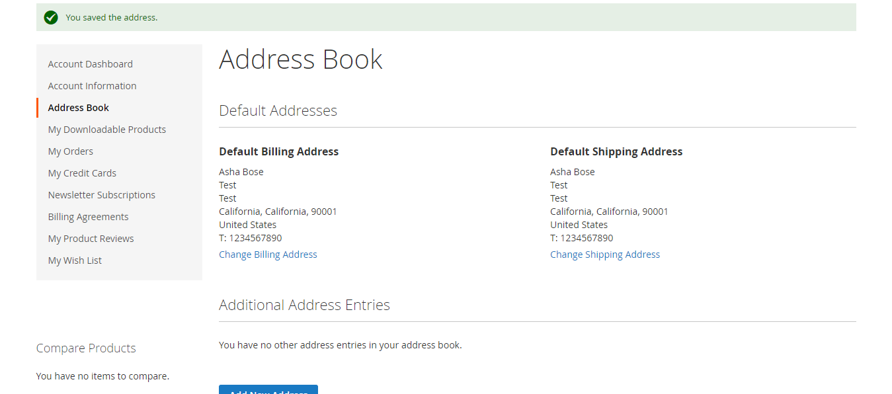

**8)Checkout**

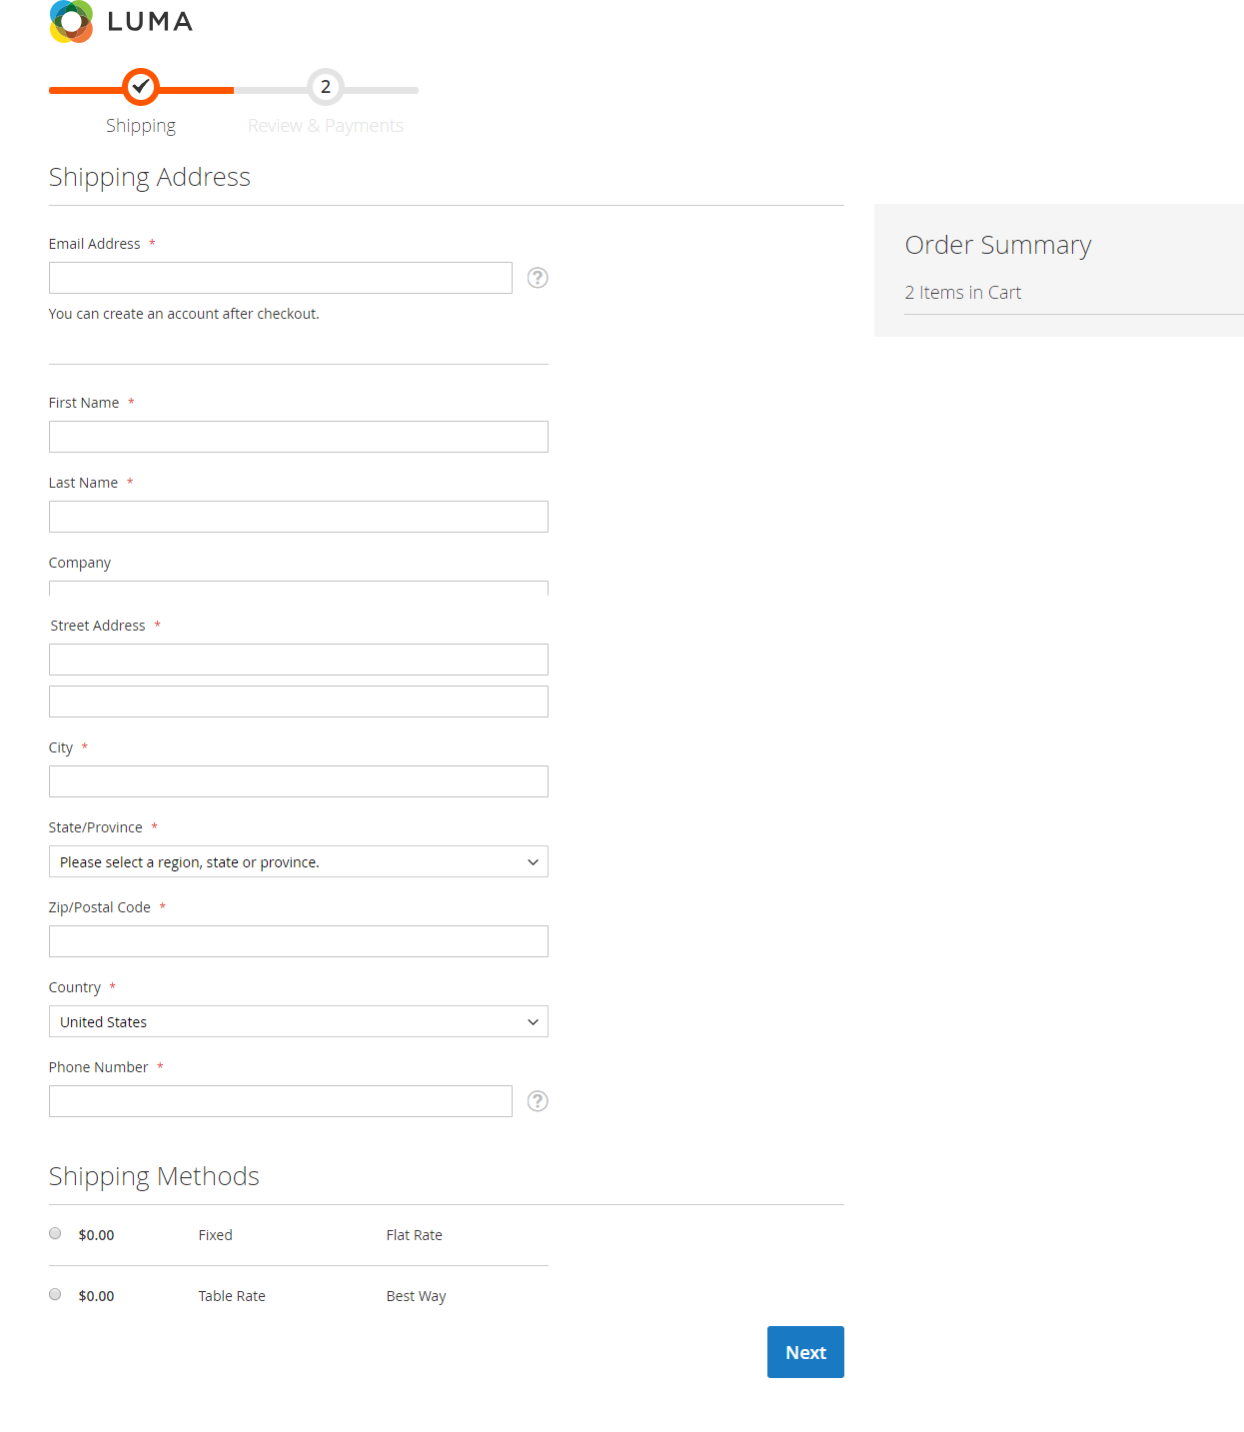

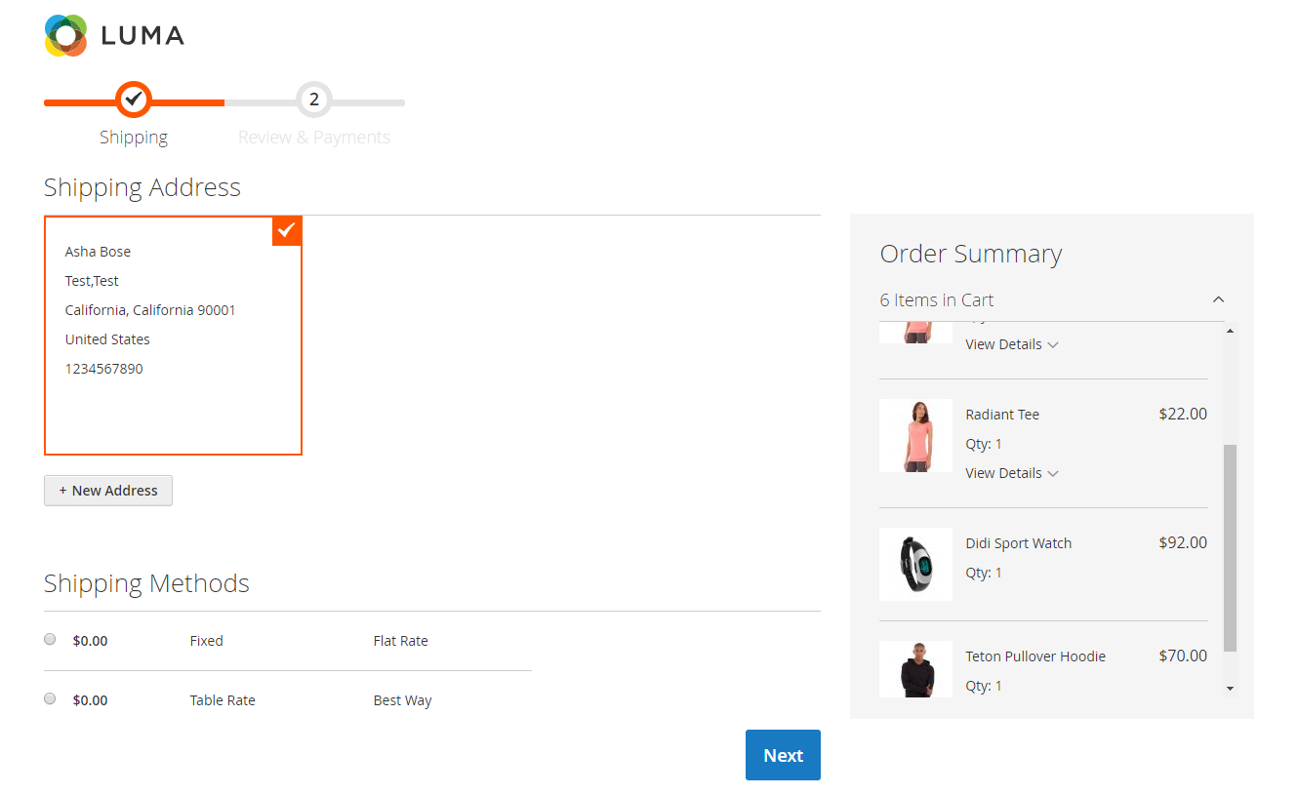

**9)Product Listing**

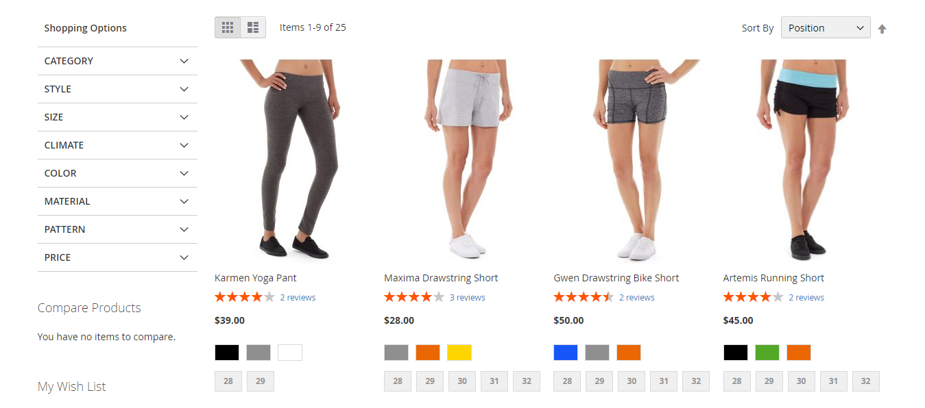

**10)Product Detail**

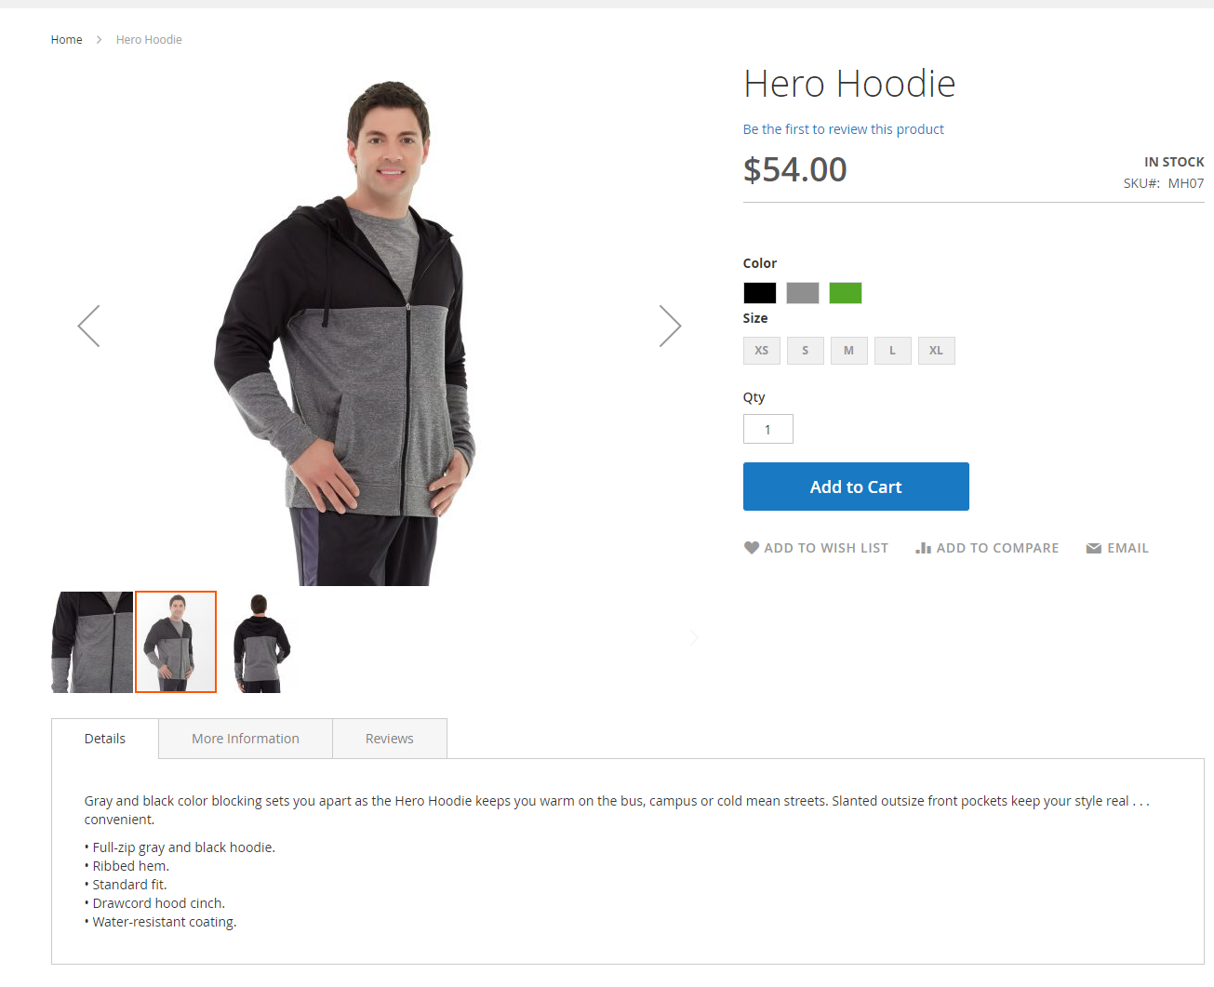

**11)Order detail**

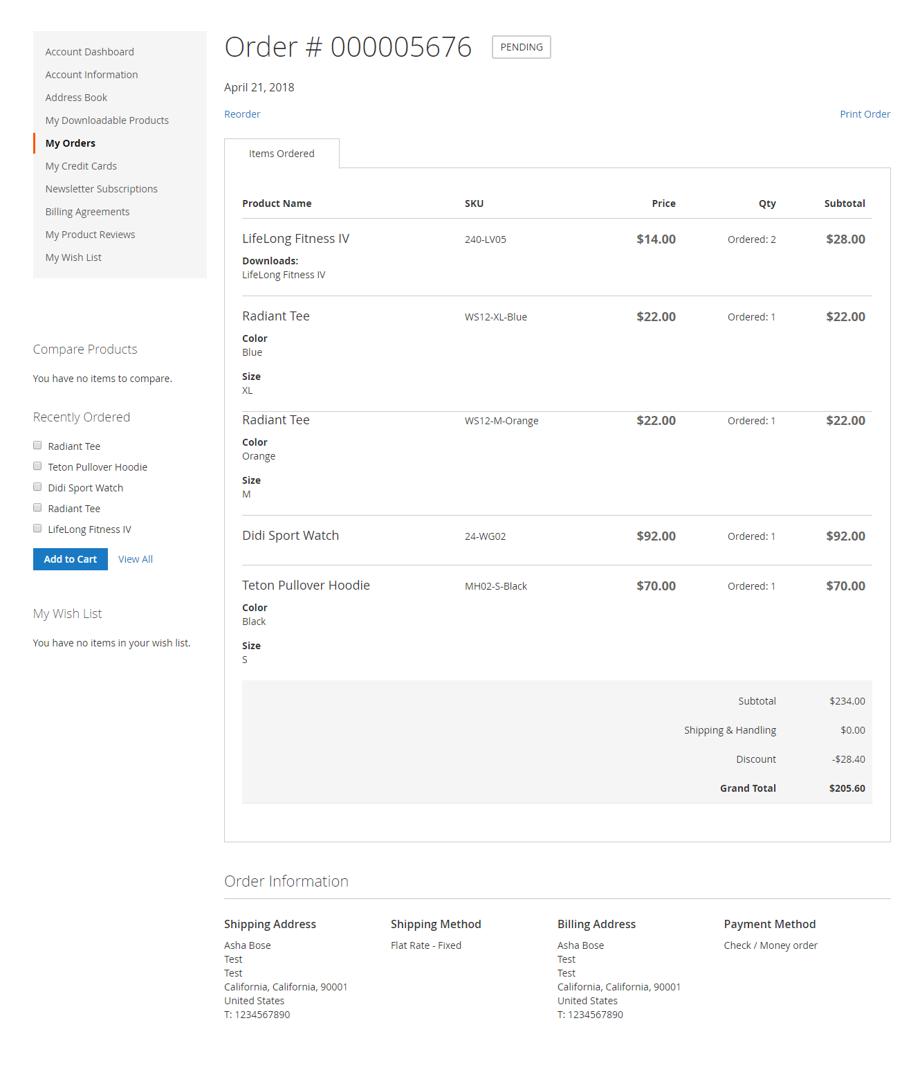

**12)Order List**

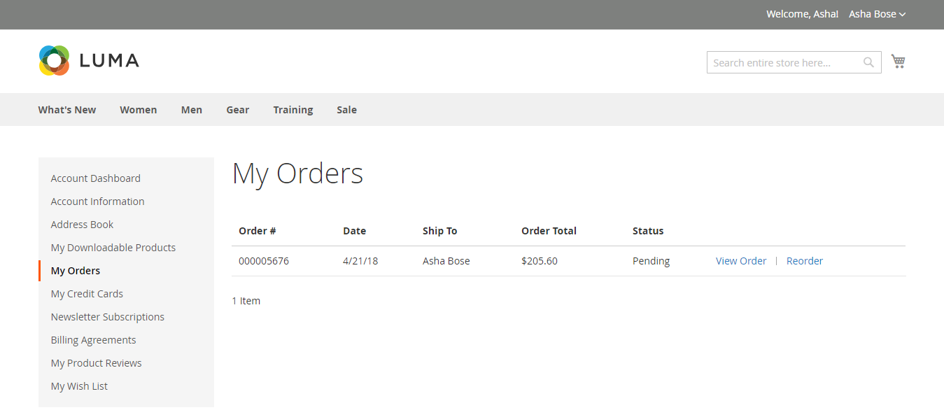

**13) Order Tracking**

**By default magento is providing option to view the order status of each order based on order Id.**

**The delivery status is able to see in default magento setting.**

**14)Product review list**

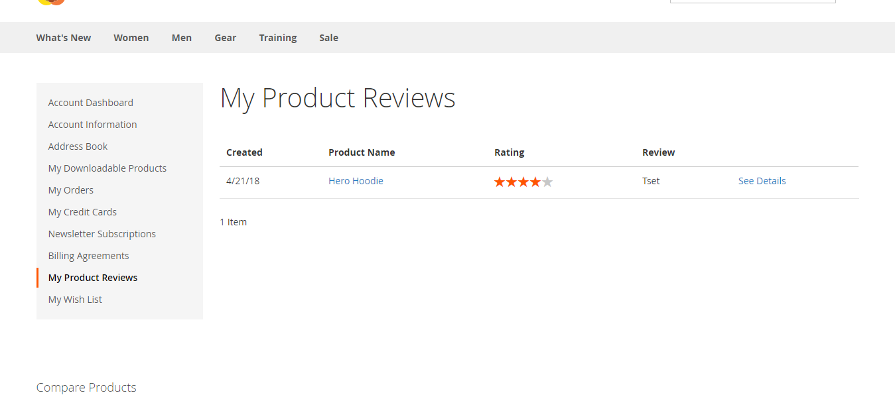

**15)Review Detail**

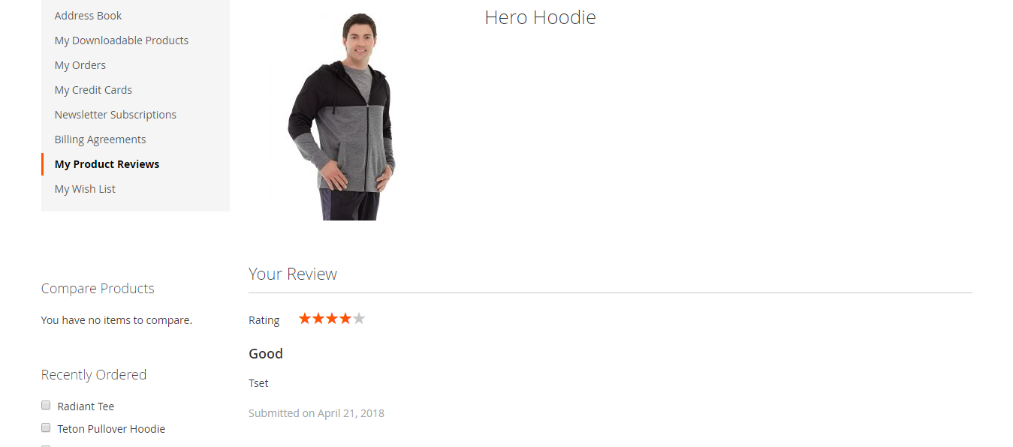

**16)Blog**

**By default magento don’t give option for blog.**

**With the integration of third party module,we can have the blog in magento site.**