University of Technology Jamaica

Mobile Computing

Mobile Website Design Assignment

Name: Patrick Forbes

ID: 1700816

Tutor: Ms Lynch

Site Map

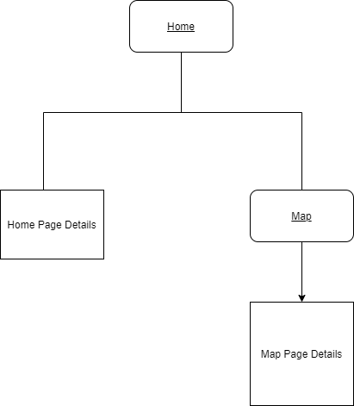

Click Stream

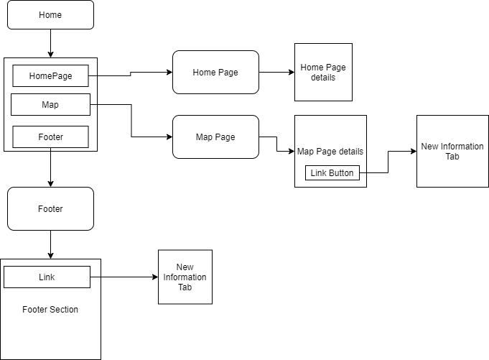

Wireframe

