Diamonds are an invaluable item and the price of diamonds depends on the carat, clarity, colour and cut. There is a positive correlation between carat and price of diamond. The aims of this research are to investigate whether the price and carat of a diamond is related to the cut of the diamond. It is hypothesised that price and carat will be able to classify the quality of the diamond’s cut ( e.g. very good, ideal).

**Method**

Dataset was extracted from Kaggle which featured various features of diamonds including carat, clarity, colour and cut. The idea was to use features carat and price to classify various cuts ranging from good to premium. Python 3 using Jupyter notebook was used and Pandas package was used to create the data frame while matplotlib was used for visualisation.

**Results**

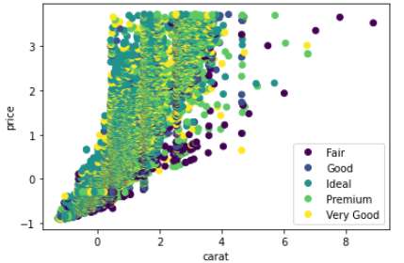

*Figure 1.* Carat and price impact on diamond cut*.*

**Discussion**

As can be seen from figure 1, there was a lot of overlap between diamond cuts suggesting diamond cut cannot be predicted from carat and price of diamond. This suggests diamond cut can not be predicted by carat and price of diamond.