Road to World Record
The peak performance index

Jamie Lawlor
Version 1
20 May 2026
https://github.com/Jamie-Lawlor/Road_to_world_record_composite_index

Table Of Contents

- Theoretical Framework……………………………………………………….………………….3
- Data Selection………………………………………………………………………………………4
- Imputation of missing data……………………………………….…………………………….6
- Multivariate Analysis………………………………………………………………..…………..13
- Normalisation……………….…………………………………………………………………….16
- Weighting and aggregation…………………………………………………….…………….17
- Links to other indices……………………………………………………………………………19
- Visualisation of the results……………………………………………………….……………20
- References…………………………………………………………………………………….……27

Theoretical Framework

Speedrunning is a subgenre of gaming where players use their knowledge of the game's architecture and game mechanics to beat a video game in the fastest time possible. By achieving this, they receive the title of world’s best in that particular game until another challenger comes along to beat their record.
For new players who want to attempt to become the world’s best, the problem I identified was the lack of understanding surrounding the dedication required to achieve a world record. While it is easy to find the time of the current world record online, this time doesn’t reflect the complex journey to achieving the recorded time.
The peak performance index provides a score reflecting the complexity of achieving a world record across 3 different genres that each have varying factors that influence a world record speedrun.
This index is comprised of 3 sub-indices with 6 variables
Sub index 1 (Peak performance):
World_record_time (The fastest time the game has been completed)
Casual_Completion (How long it takes a player to beat the game casually)
Sub index 2 (Difficulty):
World_Record_age (How old the current world record is)
World_Record_Margin (The difference between the world record holder and the runner-up)
Sub index 3 (Competition)
Total_Runs (Total attempts at the world record)
Active Runners (Current competitors)
These variables are universal to speedrunning and are easily accessible online. By utilising these variables, the peak performance index will display the complexities of achieving a world record in 30 of the most popular games across 3 popular genres.

Data selection

To collect data for my indicators, I consulted speedrun.com. Speedrun.com is the official website for world record holders. Players must record their runs, upload it to the site, and the run must be verified by an external player to receive world record status. To ensure that my index is as diverse as possible, I selected 9 games with the most total runs and 3 uncommon games across 3 distinct categories: Platformers, Role-Playing Games (RPGs) and First-Person Shooters (FPS). Along with my indicators, I collected some categorical variables that describe other factors that influence a world record.
These factors include Platform, RNG, glitches_possible, game_name and category.
Speedrun.com provides the world record time, the age of the record, the gaming platform used, total runs in the category, total active players and it allows me to calculate the margin between the world record holder and the runner-up. This allows me to gather the data for 5 out of 6 of our indicators for the index. To retrieve data for casual_completion, I consulted howlongtobeat.com. This website calculates how long it takes the average player to beat a video game, voted by players. This indicator displays the optimisation performed by speedrunners from the average completion time to the current world record.
Platform, game_name and category variables were collected from speedrun.com. The game name will identify which of the 30 games is the most difficult to achieve a world record in. The platform identifies what console the world record holder was using, there are differences between how a console/PC operates so this is an important factor to consider. The category displays which of the 3 categories the game belongs to. For glitches_possible and RNG, I consulted speedrunning attempts from youtube.com. These categorical variables will demonstrate the influence the game has over a speedrun. The glitches_possible variables highlights if the speedrunner is using any tricks that manipulate the game in an unintentional way so that they can achieve a quicker time. An example of this is pushing their character through a wall by jumping at a certain angle, creating a shortcut by manipulating the environment. RNG stands for random number generation and represents environmental factors that are present in certain games. There is no official metric for RNG, but it is a crucial variable to record as it highly influences a speedrun. If a game has no RNG, this means that a speedrun is entirely reliant on human expertise and doesn’t rely on in-game values to complete a run. A game with low RNG means that a speedrun relies on enemy patterns and if an enemy acts in a way that has been unaccounted for, the run must restart. A high RNG means that the run is entirely dependent on in-game features such as item generation, enemy behaviour or level generation. If the ideal scenario is not generated by the game, the run must restart.
Variables | Type | Role | Location
Game_name | Categorical | Not relevant | Speedrun.com
Total_Runs | Numerical | Explanatory | Speedrun.com
World_record_time | Numerical | Explanatory | Speedrun.com
World_record_age | Numerical | Explanatory | Speedrun.com
World_record_margin | Numerical | Explanatory | Speedrun.com
Casual_Completion | Numerical | Explanatory | Howlongtobeat.com
Glitches_possible | Categorical | Not relevant | Youtube.com
Platform | Categorical | Not relevant | Speedrun.com
Category | Categorical | Not relevant | Speedrun.com
Active Runners | Numerical | Explanatory | Speedrun.com
RNG | Categorical | Not relevant | Youtube.com

Imputation of missing data
A complete dataset is needed for building an index. By using a heatmap I was able to identify any sections in the dataset that may have missing values.
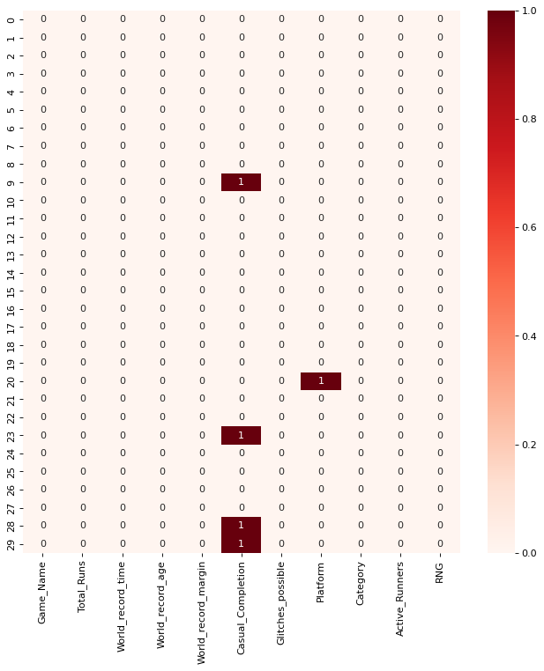
Figure 1 Heatmap indicating missing values within dataset
After analysing this heatmap, it is evident that there are 5 missing values within the dataset, 4 within casual_completion and 1 within platform. To solve this problem, I utilised single imputation. Before applying single imputation however, to ensure that all of my timed variables are being treated equally, I converted world_record_time, world_record_margin and casual_completion into seconds instead of hours and minutes.
For casual_completion I used the mean of the category to fill in the missing values within the category. This imputation will ensure that the missing values won’t create outliers within the composite indicator during multivariate analysis. For the platform category, I used the mode of the category to make an educated guess on the system that this game was apart of. This category is not being used to build the index therefore it will have no impact on the composite indicator. Now that we have a complete dataset, I checked for outliers within each category to look for any values that may impact the imputation of my data.
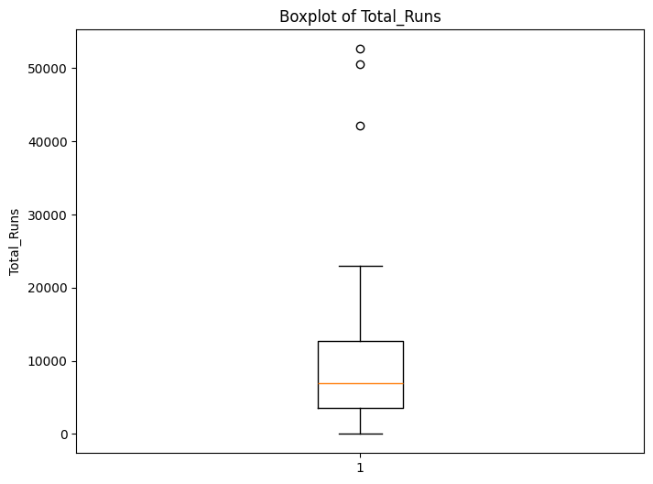
Figure 2 Boxplot of total_runs
From this graph we can see 3 clear outliers, we will keep these outliers as these outliers represent the popularity of the game and how many attempts have been taken at a world record.
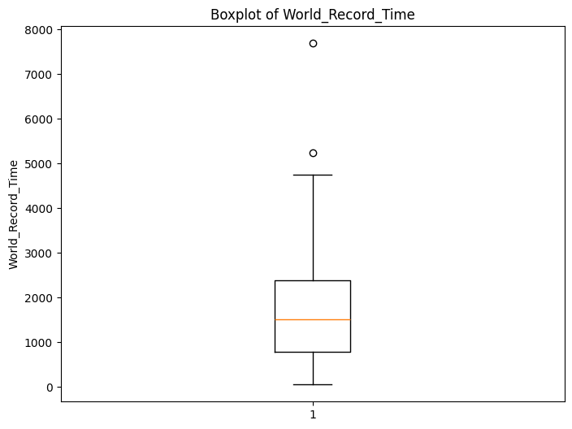
Figure 3 Boxplot of World Record Time
This boxplot represents the world record time in seconds. These outliers represent the games which require a longer amount of time to complete and require more focus and determination by the player due to the length of the speedrun. I decided to keep these outliers because they represent the variance in length between world record times and the dedication and focus required to attempt the world record.

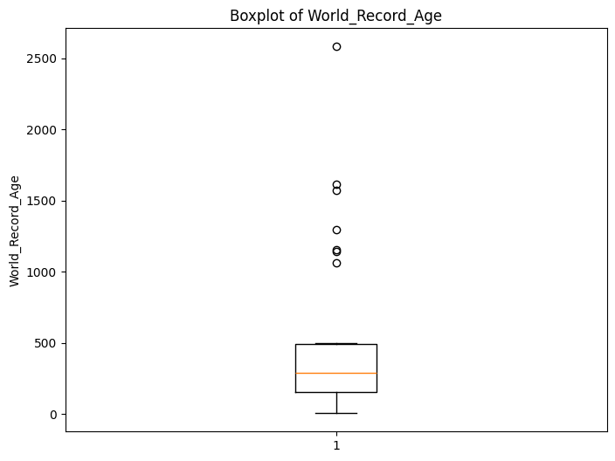
Figure 4 Boxplot of world_record_age
This boxplot represents how long a world record has been held. There are a significant number of outliers in this boxplot. I chose to keep these outliers because it represents the difficulty scale of beating a world record. If a record has been held for a 1000+ days, it demonstrates how precise and efficient the world record holder had to be to achieve their record.

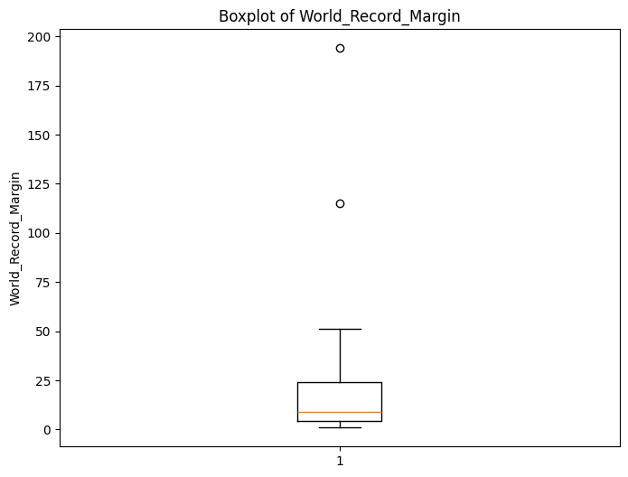
Figure 5 Boxplot for margin between the world record holder and runner-up
This data represents the margin between the world record holder and runner-up. The outliers demonstrate a wider margin which indicates to a new player that there was a significant room for improvement meaning that the record is not fully optimised yet. I chose to keep these outliers because it represents how optimised a world record is.

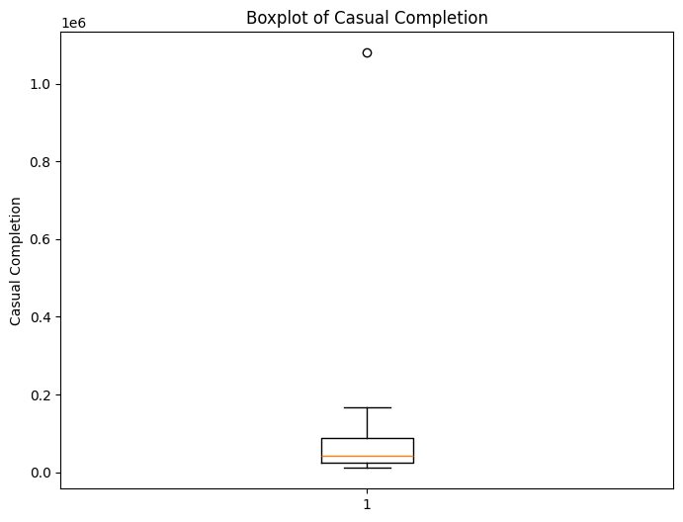
Figure 6 Boxplot of casual completion of a game
This boxplot has 1 clear outlier that is “squishing” and distorting the data. This extreme outlier represents the extreme length of a casual playthrough and the challenge of optimising your time within that game, which is why I decided to keep this outlier but have taken note of its distorting impact.

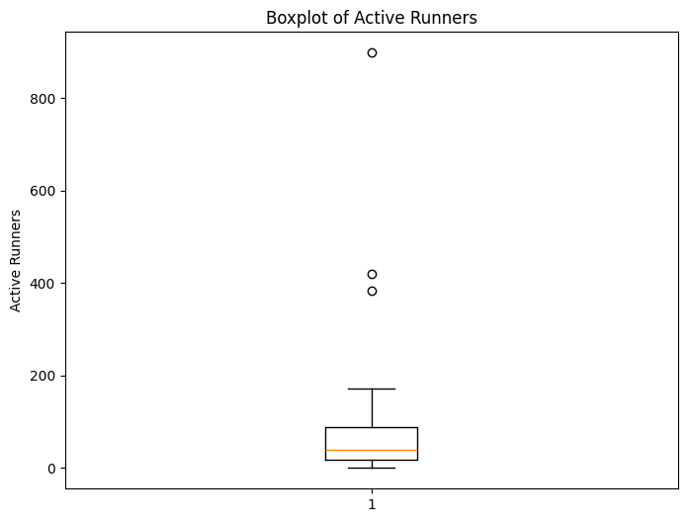
Figure 7 Boxplot of active runners
This boxplot represents the popularity of current games with speedrunners. The outliers are representing the number of competition that a new player would be faced with when attempting a world record. For this reason, I decided to keep these outliers.

My reasoning behind keeping all of the outliers presented in the data is due to the realistic impact they display. In my theoretical framework, I stated that “the problem I identified was the lack of understanding surrounding the dedication required to achieve a world record”. These outliers represent the dedication and challenges that new players will face on their journey to become a world record holder. I have noted that these outliers will impact my index due to the benchmarking issues they create.

Multivariate Analysis

When analysing the 6 indicators chosen to build the index, we are dealing with a six-dimensional dataset. To reduce the dimensions without losing any critical information I used Principal Component analysis (PCA).
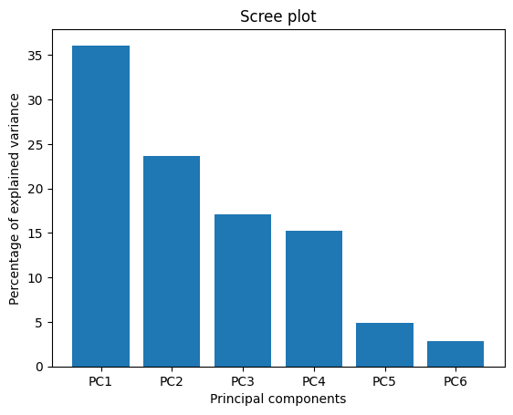
Figure 8 Scree plot display the results of PCA
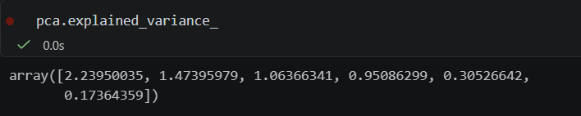
This scree plot shows the results of our principal component analysis. Due to the distortions created by the outliers, Principal Component 1 only describes 35% of the data. I consulted the Kaiser criterion, which states that you should keep any Principal components (PC) where their eigenvalues >1. I selected PC1, PC2 and PC3 to be used in cluster analysis as combined they described 77% of the data.
For my cluster analysis, I decided to use k-means clustering so that I could quickly group the data together.
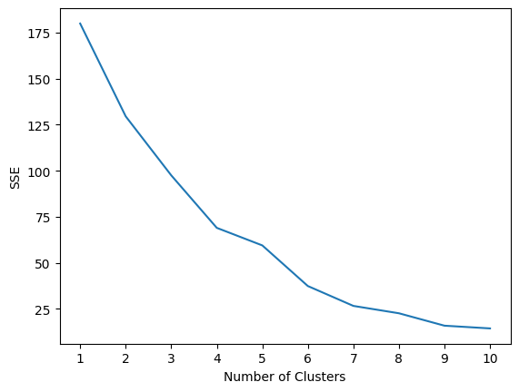
After consulting a guide on how to use the elbow method (Zach Bobbitt, 2023), it was clear that the elbow appeared in cluster 4, letting me know k = 4. After assigning each piece of data to a cluster, I created a scatter plot to visualise the groups created.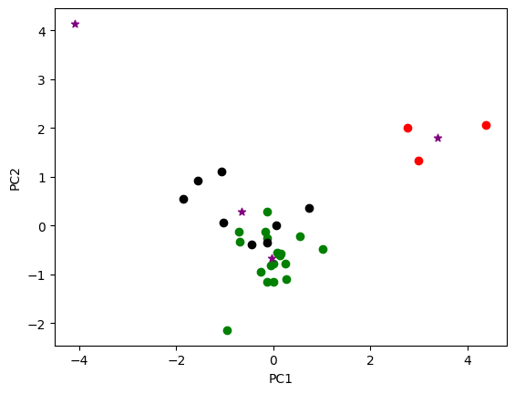
Here we can see our 4 distinct groups, green is our largest group which is a dense cluster surrounding the centroid. Black is the second largest group which appears slightly more spread around but close to the nearest centroid. Red is a smaller group that is separated from the other groups and there is a single point cluster in the top-left, this cluster is an anomaly.
Cluster | Total_num | Interpretation of clusters
0 | 18 | High amount of active_runners across all games with many world_record_margins being between 1 and 5 seconds
1 | 3 | Speedruns that have a large number of total_runs and a large active_runner count.
2 | 8 | Longer to complete speedrun with the lowest world_record_time being 2257 seconds.
3 | 1 | Outlier speedrun that has 0 active players and has a large world_record_time variable

Normalisation
As mentioned previously, converting the time variables into seconds created extremely large values. To ensure that the variables can be measured equally, I will use the MinMaxScaler(). MinMaxScaler() scales the data down into a value between 0 and 1 so that the model can treat each variable with equal fairness. In the data there have been unintentional benchmarks created due to the outliers that are present within the data. For example in casual completion, the maximum value is 1080000 seconds (300 hours), which is causing the data to compress and return low values due to the extreme value of the outlier. The next highest value in casual_completion is 0.146, further proving that the outlier is hindering the significance of the other values within the indicator.
Using Karl Pearson’s measure (geeksforgeeks.org, 2025), I checked the skew of each of my indicators
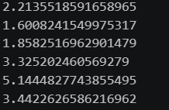
Indicator | Value | Type
Total_Runs | 2.21 | Extreme Right skew
World_record_time | 1.60 | Right skew
World_record_age | 1.86 | Right skew
World_record_margin | 3.33 | Extreme Right skew
Casual Completion | 5.14 | Extreme Right skew
Active Runners | 3.44 | Extreme Right skew

Every one of my indicators is heavily right-skewed with their values being > 0. Most notable skews are the 5.14 skew from Casual_Completion, the 3.44 skew from Active_Runners and the 3.32 skew from World_Record_Margin. This skew is a result of the data being compressed due to the significance of the outliers. My reasoning for keeping the outliers in the data as stated in section 3 was due to their realistic importance that details the reality of the speedrunning scene. I have noted that these outliers are heavily impacting the composite index.

Weighting and aggregation
For weighting and aggregation, I already discovered the importance of my variables through principal component analysis.
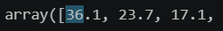
PC1 equates to 36% of variance explained, PC2 equates to 24% and PC3 equates to 17% totalling 77% of variance explained. To rescale the percentages to be used in calculating the final weights I added each of the Principal Component percentages together and then divided each PC percentage by the sum of all the percentages to get the final weight.
Final weight | PC1 | PC2 | PC3
 | 0.47 | 0.31 | 0.22

Using transpose, I ensured that each variable was properly assigned their value for PC1, 2 and 3 and then used a dot product that combine the weights together.
This provided each of my values with the appropriate weighting for aggregation for the index.
Indicator | Final weighting for index
Total_Runs | 0.17
World_record_time | 0.18
World_record_age | 0.17
World_record_margin | 0.17
Casual_completion | 0.14
Active_Runners | 0.17

Using linear aggregation, I multiplied each indicator by its weight, and the sum of these values created the composite indicator.
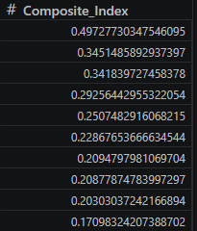

Links to other indices

After constructing my composite index, I conducted some research to compare my index to similar indexes that are available to use. I came across an index called speedstats.app. This index performs webscraping across speedrun.com, analyses the data and allocates points based on leaderboard statistics. It allows the user to filter by players, series, platforms and games.
This index is very useful for retrieving general data in regards to speedrunning, however it doesn’t describe the dedication, complexity and skill required to achieve points on their index.
The Peak performance index captures the difficulty and dedication required to achieve a world record by analysing the peak performance of world record holders and assigns a value indicating the difficulty in attempting to achieve a world record. Although the data is right skewed and has been affected by outliers, the Peak Performance Index represents the reality in how complex it is to become a world record holder and represents the challenges that will be faced.

Visualisation of the results

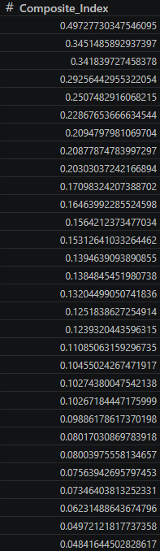

This composite index measures the difficulty surrounding becoming a world record holder. The maximum value of 0.49 indicates that this particular game requires peak performance to achieve a world record. The minimum value of 0.04 indicates to the viewer that this is a more achievable route to begin your journey to becoming a world record holder.
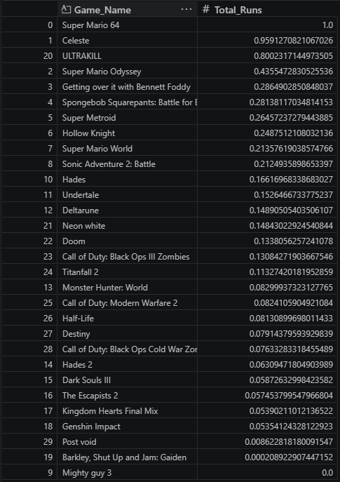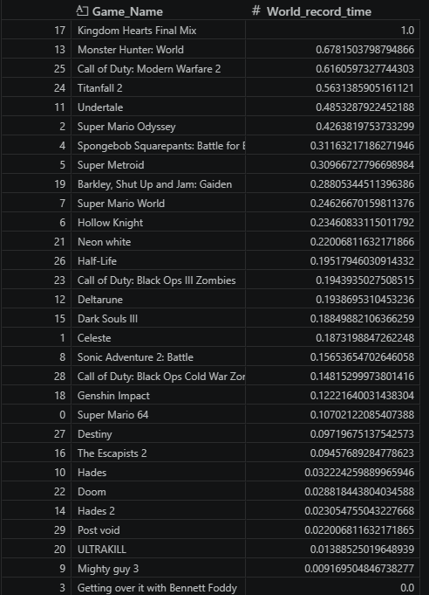

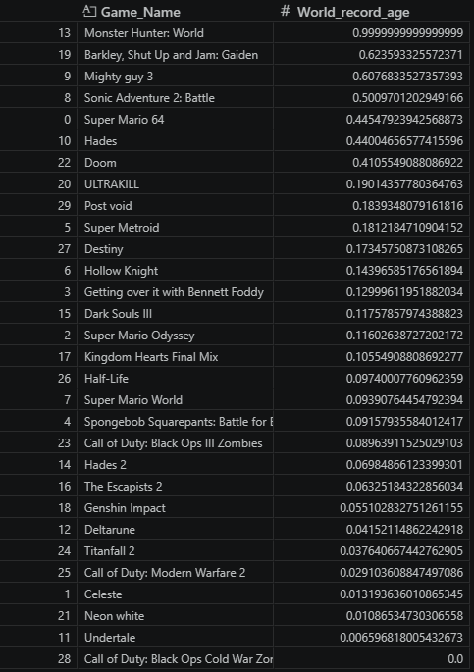

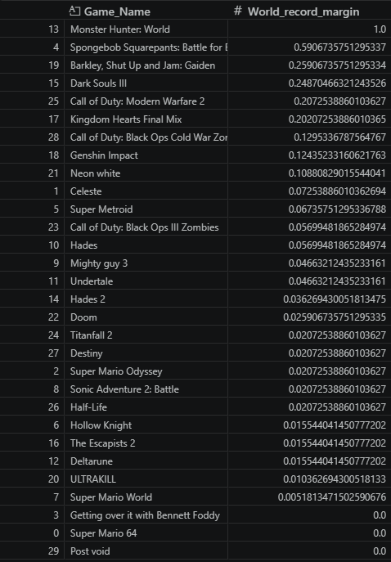

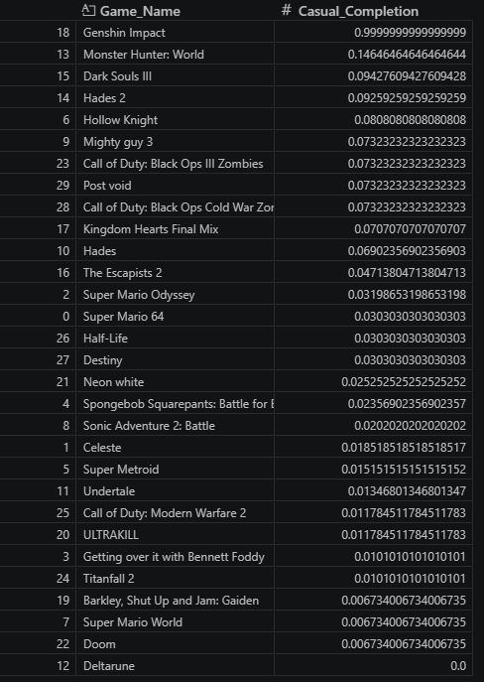

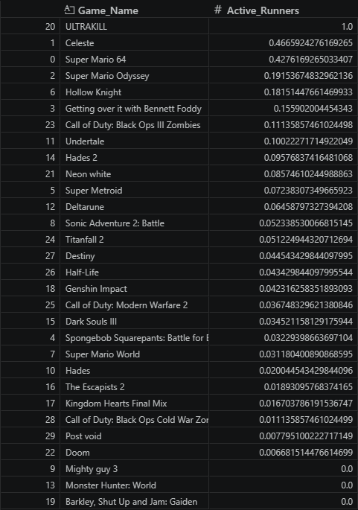

References

Speedrun.com (No Date) speedrun.com [online]. Available at: https://www.speedrun.com/ [accessed 17 May 2026].
howlongtobeat.com (No Date) howlongtobeat.com [online]. Available at: https://howlongtobeat.com/ [accessed 17 May 2026].
pandas.pydata.org (No Date) Time deltas [online]. Available at: https://pandas.pydata.org/pandas-docs/stable/user_guide/timedeltas.html [accessed 19 May 2026].
pandas.pydata.org (No Date) pandas.series.dt [online]. Available at: https://pandas.pydata.org/docs/reference/api/pandas.Series.dt.html [accessed 19 May 2026].
pandas.pydata.org(No Date) How do I select a subset of a dataframe? [online]. Available at: https://pandas.pydata.org/docs/getting_started/intro_tutorials/03_subset_data.html [accessed 19 May 2026].
Zach Bobbit (2023) How to Use the Elbow Method in Python to Find Optimal Clusters [online]. Available at: https://www.statology.org/elbow-method-in-python/ [accessed 19 May 2026].
Tempo Team (No Date) Benchmark [online]. Available at: https://www.tempo.io/glossary/benchmark [accessed 19 May 2026].
Scikit-learn.org (No Date) MinMaxScaler [online]. Available at: https://scikit-learn.org/stable/modules/generated/sklearn.preprocessing.MinMaxScaler.html [accessed 19 May 2026].
Geeksforgeeks.org (2025) Skewness – Measures and Interpretation [online]. Available at: https://www.geeksforgeeks.org/data-science/skewness-measures-and-interpretation/ [accessed 19 May 2026].
Elif Bulut, Helen Thompson (No Date) Performing principal component analysis (PCA) to determine weights for index indicators [online]. Available at: https://www.esri.com/arcgis-blog/products/api-python/analytics/performing-principal-component-analysis-pca-to-determine-weights-for-index-indicators [accessed 20 May 2026].
Economics.town (2025) Using Principal Component Analysis for Composite Indices [online]. Available at: https://economics.town/research-methods/principal-component-analysis-composite-indices/ [accessed 20 May 2026].
Muhammad Hassan (2024) Cluster Analysis – Types, Methods and examples [online]. Available at: https://researchmethod.net/cluster-analysis/ [accessed 20 May 2026].

Pastryperson. (2023). The Absurdity Of Celeste Speedrunning [video online]. Available from: https://www.youtube.com/watch?v=d1YgYezAQpg [accessed 17 May 2026].
Fir. (2019). SMO Speedrun Tutorial - New Seaside Out of Bounds Route [video online]. Available from: https://www.youtube.com/watch?v=yk8SQ_pCfmI&list=PLiinoyifvFb64od8RyqPFmVqDrFwkgaa0&index=9 [accessed 17 May 2026].

SHiFT. (2025). Any% World Record 41:03 - SpongeBob SquarePants: Battle for Bikini Bottom Speedrun [video online]. Available from: https://www.youtube.com/watch?v=Hgi2SakLPxg [accessed 17 May 2026].
DjYale. (No Date). THIS GLITCH BROKE METROID [video online]. Available from: https://youtube.com/shorts/kO-fH6f-Nzg?si=KKbMwO6EZ6HsmzDg [accessed 17 May 2026].
EasySpeezy. (2023). Hollow Knight speedruns are much harder than you think [video online]. Available from: https://youtu.be/ihZFGAc8QR8?si=nVMnnQXu_yfObwlj [accessed 17 May 2026].
Dode. (2017). Super Mario World - All Castles Speedrun 35:13 [video online]. Available from: https://youtu.be/aLDWbD3Wk18?si=kR7r3qE1n7Zfh96I [accessed 17 May 2026].
Games Done Quick. (2025). Sonic Adventure 2: Battle by DawnSR in 37:31 - Games Done Quick Express 2025 [video online]. Available from: https://youtu.be/PsmYwafvhf0?si=sA-YlWB11gBQ3h9T [accessed 17 May 2026].
Haelian. (2024). It took me 2.5 years to get this time | Hades Any% Speedrun in 6:37 [video online]. Available from: https://www.youtube.com/watch?v=t0TM3auYdNI [accessed 17 May 2026].
EasySpeezy. (2023). I tried speedrunning Undertale Genocide and it was incredibly dark [video online]. Available from: https://youtu.be/zMzN82GPZek?si=EjNqcXJFJqG9DEY4 [accessed 17 May 2026].
Tetra8BitGaming. (2025). Any% Speedrunning Deltarune Chapter 1 is Very Stressful [video online]. Available from: https://www.youtube.com/watch?v=G-UASr20tfE [accessed 17 May 2026].
EasySpeezy. (2025). Let's Speedrun The Escapists 2 (All Prisons) [video online]. Available from: https://www.youtube.com/watch?v=93mk6yyIqtk [accessed 17 May 2026].
ESA Speedrunning. (2024). Kingdom Hearts Final Mix HD [Any% (Proud)] by 97ames [video online]. Available from: https://www.youtube.com/watch?v=CruA17NLo74 [accessed 17 May 2026].
weightless. (2025). So I Broke the Genshin Speedrun World Record… Yes Really [video online]. Available from: https://www.youtube.com/watch?v=CNaJewJSagE [accessed 17 May 2026].
Faustas. (2023). Neon White - White's Heaven Rush Segmented speedrun in 27:23.33 – WR [video online]. Available from: https://www.youtube.com/watch?v=lEPKKNjJiRk [accessed 17 May 2026].
S022anti. (2022). DOOM - Knee-Deep in the Dead, Speedrun in 4m 56s [video online]. Available from: https://www.youtube.com/watch?v=CNaJewJSagE [accessed 17 May 2026].
NoahJ456. (2025). THE "DER EISENDRACHE" WORLD RECORD SPEEDRUN IS OBLITERATED. [video online]. Available from: https://www.youtube.com/watch?v=XdymEWjMjCg [accessed 17 May 2026].

tomatoanus. (2021). Speedrun of Titanfall 2 (SPEEDRUN EXPLAINED - Any%) [video online]. Available from: https://www.youtube.com/watch?v=23_1uqeLCGE [accessed 17 May 2026].
tomatoanus. (2024). How speedrunners beat Half-Life in 26 minutes (SPEEDRUN EXPLAINED - Scriptless) [video online]. Available from: https://www.youtube.com/watch?v=hToXhkxR5Kg [accessed 17 May 2026].

Camhxmmer. (2025). Wrath of the Machine Speedrun World Record (13:20) [video online]. Available from: https://www.youtube.com/watch?v=93tWzo1GnAs [accessed 17 May 2026].
IISteveII. (2022). Die Maschine Solo Easter Egg Speed Run World Record 21:31 [video online]. Available from: https://www.youtube.com/watch?v=64lLwPgStKI [accessed 17 May 2026].

Morbidly_Obese_Dog. (2025). 3:46:320 current WR for Post Void | Speedrun 7 [video online]. Available from: https://www.youtube.com/watch?v=VSqfyqsmPxw [accessed 17 May 2026].

