ZINC Michael acceptor RNN-LSTM experiments
250k molecules randomly selected from the entire 1B ZINC dataset
Architecture (LSTM):
Number of layers (‘num_layers’) | 3
Layer size (‘layer_size’) | 512
Cell type (‘cell_type’) | LSTM
Embedding layer size (‘embedding_layer_size’) | 512
Dropout (‘dropout’) | 0.2
Layer normalization (‘layer_normalization’) | True

Training regime
Number of epochs (‘num_epochs’) | 20
Shuffle (‘shuffle’) | True
Training data batch size (‘train_batch_size’) | 256
Learning rate | 0.0001
Augment (‘augment’) | 3
Learning rate scheduler (‘learning_rate_scheduler’) | “StepLR” (gamma=0.9)
Validation data samples (‘eval_num_samples’) | 256
Validation data batch size (‘eval_batch_size’) | 256

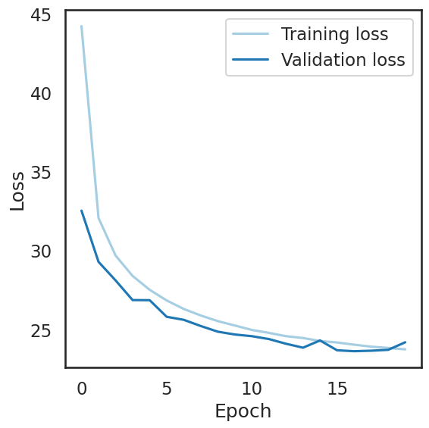
Training time (20 epochs) ~ 97 mins
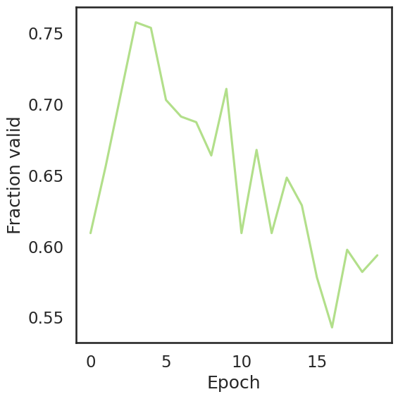

Sample of generated molecules:
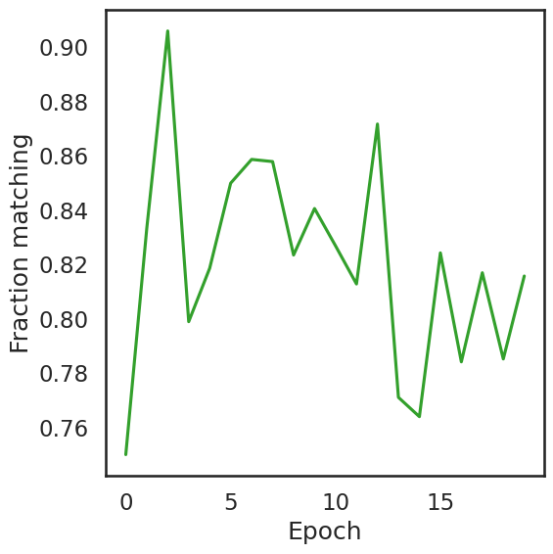
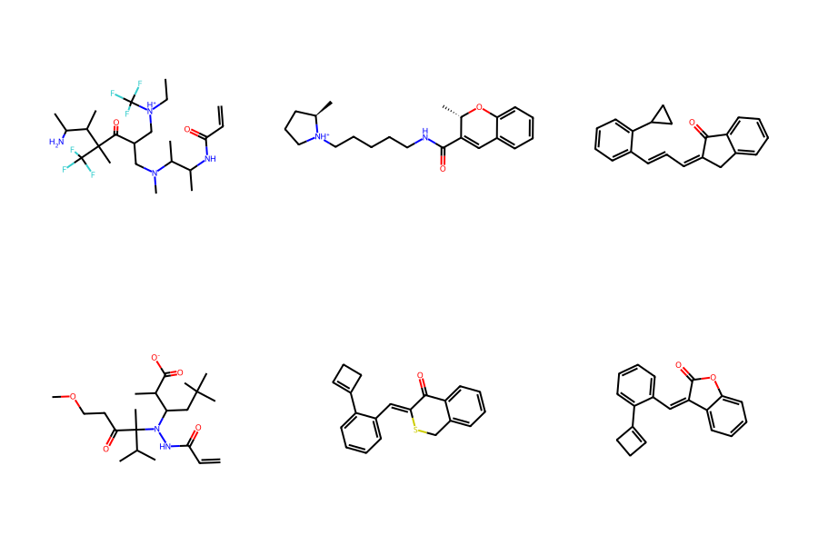

QED (quantitative estimate of drug likeness)
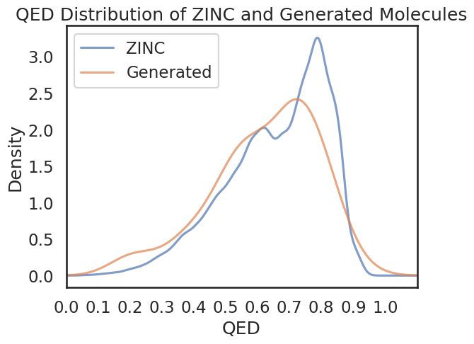

Distribution of SAS (synthetic accessibility scores)
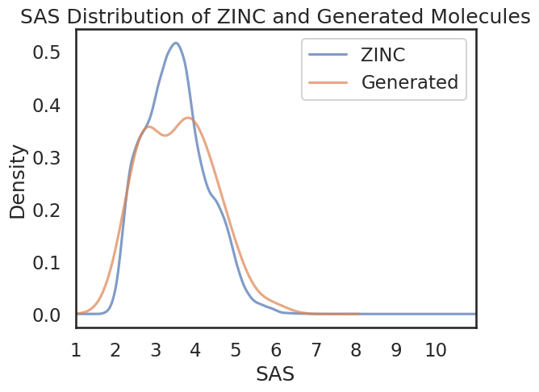

Number of Amides: 49
Number of Esters: 7
Number of Ketones: 20
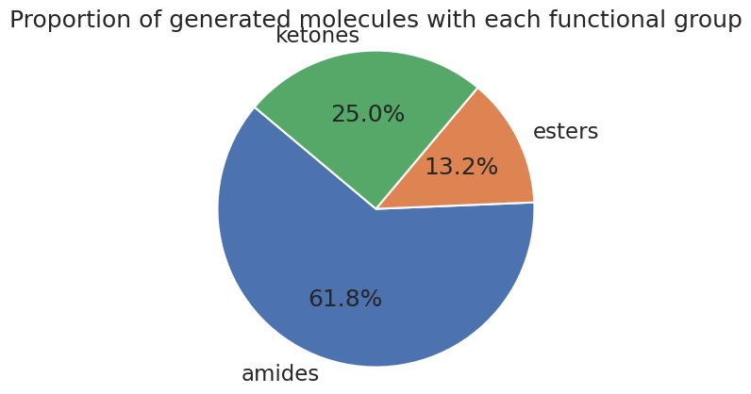

250k molecules randomly selected from the entire 1B ZINC dataset
Architecture (LSTM):
Number of layers (‘num_layers’) | 3
Layer size (‘layer_size’) | 512
Cell type (‘cell_type’) | LSTM
Embedding layer size (‘embedding_layer_size’) | 512
Dropout (‘dropout’) | 0.2
Layer normalization (‘layer_normalization’) | True

Training regime
Number of epochs (‘num_epochs’) | 10
Shuffle (‘shuffle’) | True
Training data batch size (‘train_batch_size’) | 256
Learning rate | 0.0001
Augment (‘augment’) | 3
Learning rate scheduler (‘learning_rate_scheduler’) | “StepLR” (gamma=0.9)
Validation data samples (‘eval_num_samples’) | 256
Validation data batch size (‘eval_batch_size’) | 256

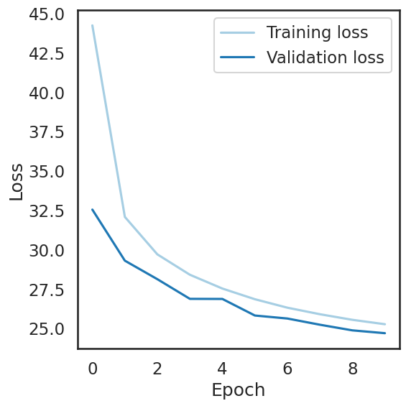
Training time (10 epochs) ~ 49 mins
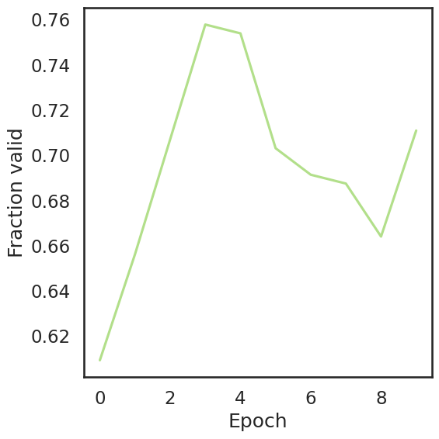
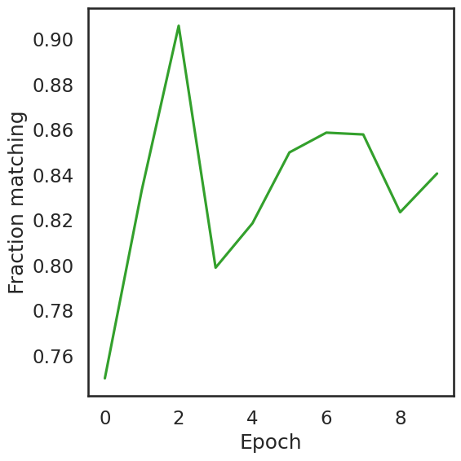
Sample of generated molecules:

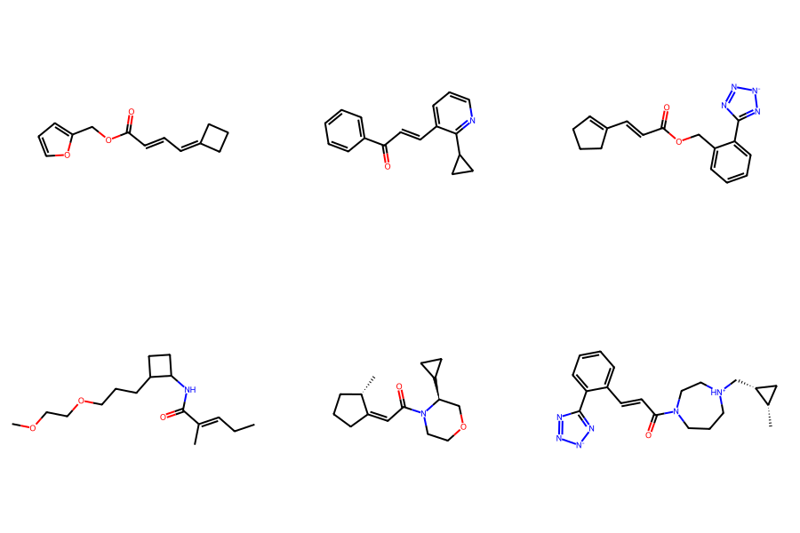

QED (quantitative estimate of drug likeness) 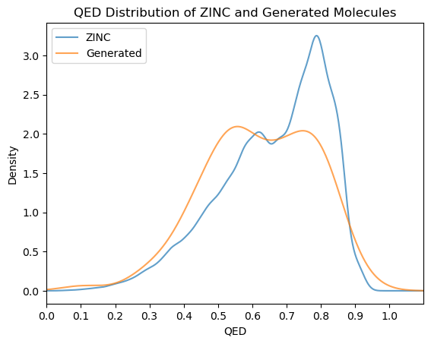

Distribution of SAS (synthetic accessibility scores)
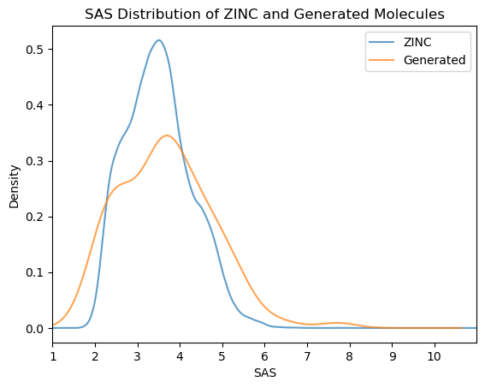
Number of Amides: 56
Number of Esters: 17
Number of Ketones: 10
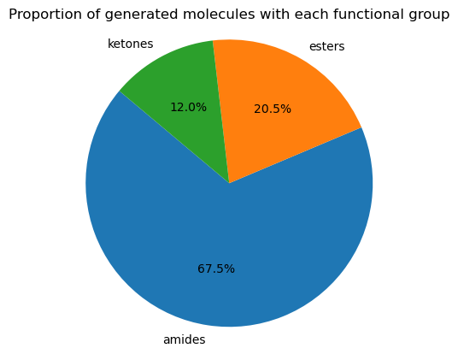

Architecture (LSTM):
Number of layers (‘num_layers’) | 3
Layer size (‘layer_size’) | 512
Cell type (‘cell_type’) | LSTM
Embedding layer size (‘embedding_layer_size’) | 512
Dropout (‘dropout’) | 0.2
Layer normalization (‘layer_normalization’) | True

Training regime
Number of epochs (‘num_epochs’) | 5
Shuffle (‘shuffle’) | True
Training data batch size (‘train_batch_size’) | 512
Learning rate | 0.0001
Augment (‘augment’) | 3
Learning rate scheduler (‘learning_rate_scheduler’) | “StepLR” (gamma=0.9)
Validation data samples (‘eval_num_samples’) | 256
Validation data batch size (‘eval_batch_size’) | 256

Training time ~26 mins
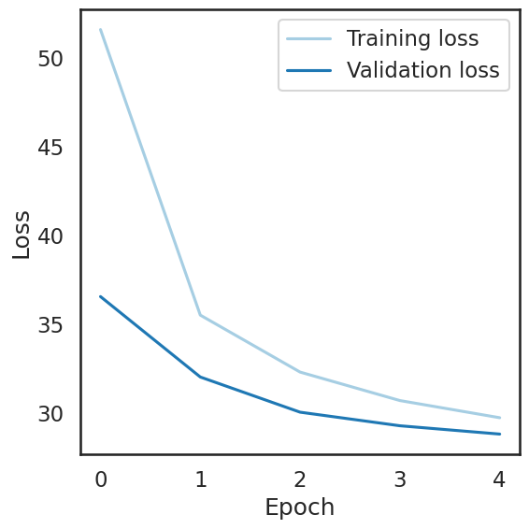
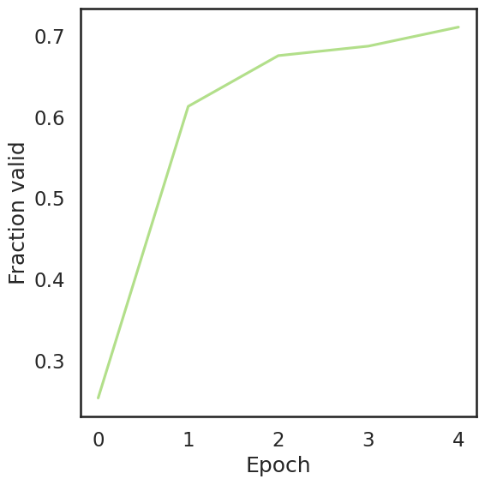

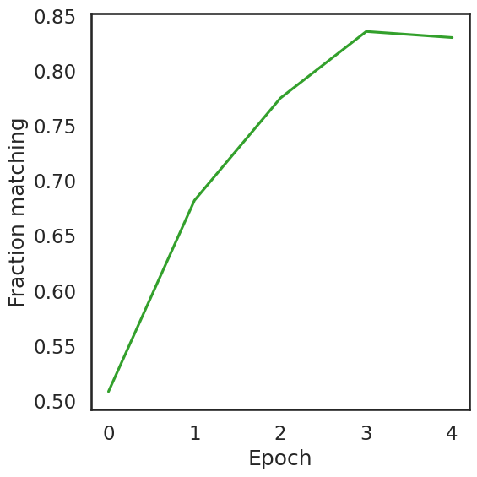

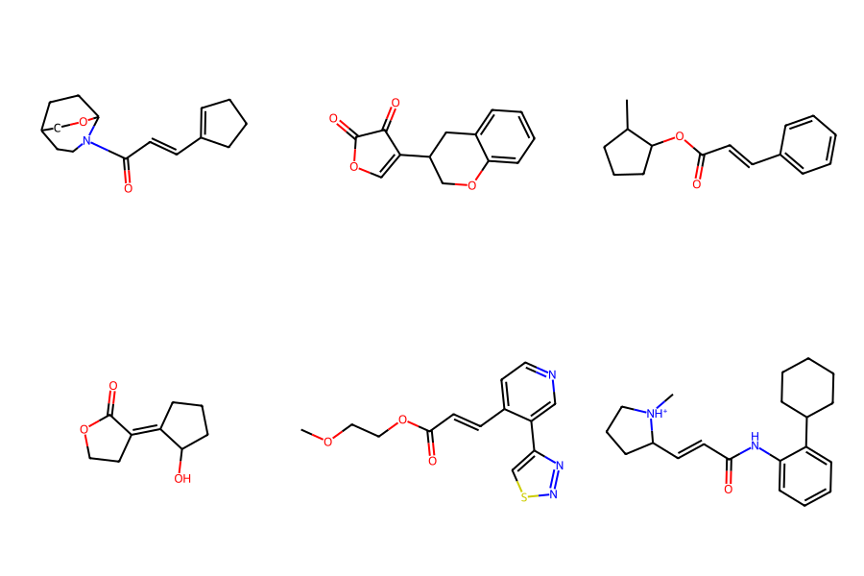
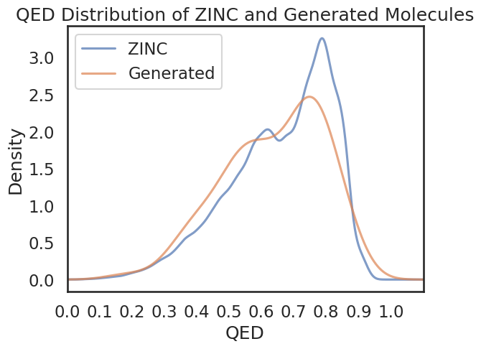
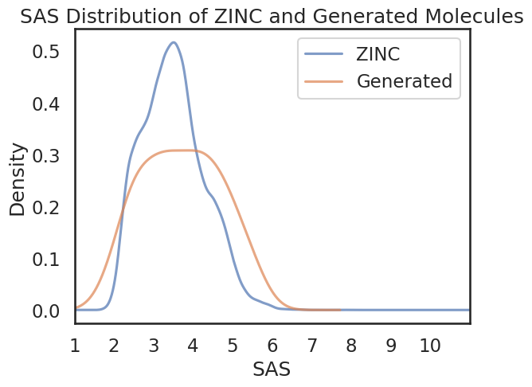
Amides: 58
Esters: 8
Ketones: 12

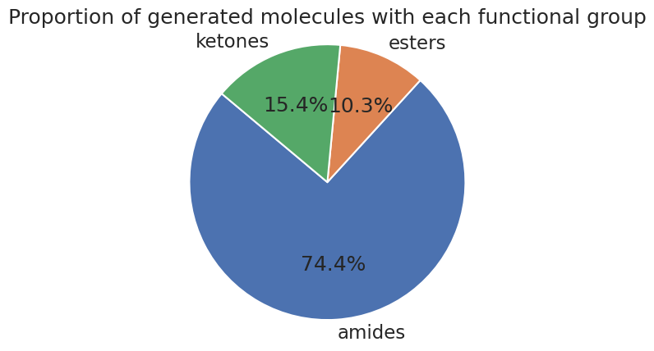
Architecture (LSTM):
Number of layers (‘num_layers’) | 3
Layer size (‘layer_size’) | 512
Cell type (‘cell_type’) | LSTM
Embedding layer size (‘embedding_layer_size’) | 512
Dropout (‘dropout’) | 0.2
Layer normalization (‘layer_normalization’) | True

Training regime
Number of epochs (‘num_epochs’) | 5
Shuffle (‘shuffle’) | True
Training data batch size (‘train_batch_size’) | 512
Learning rate | 0.00001
Augment (‘augment’) | 3
Learning rate scheduler (‘learning_rate_scheduler’) | “StepLR” (gamma=0.9)
Validation data samples (‘eval_num_samples’) | 256
Validation data batch size (‘eval_batch_size’) | 256

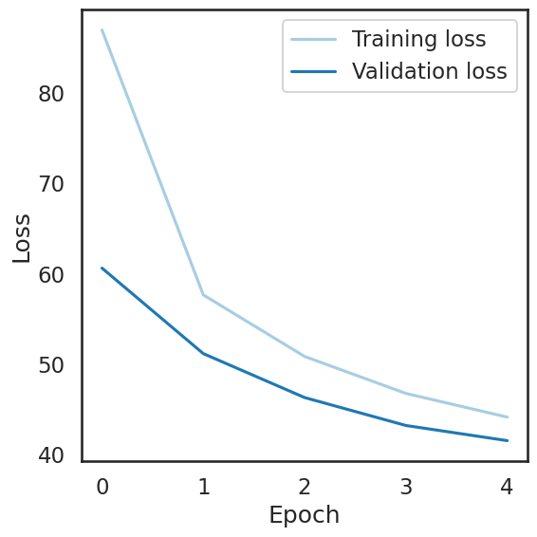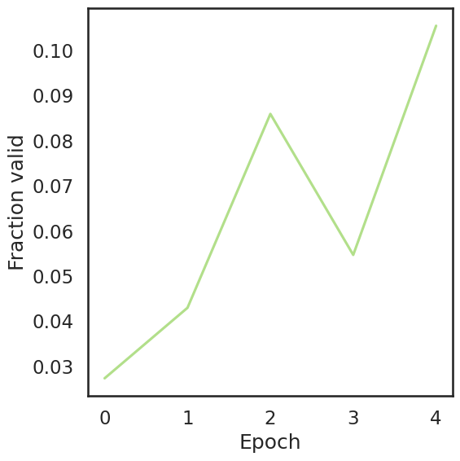
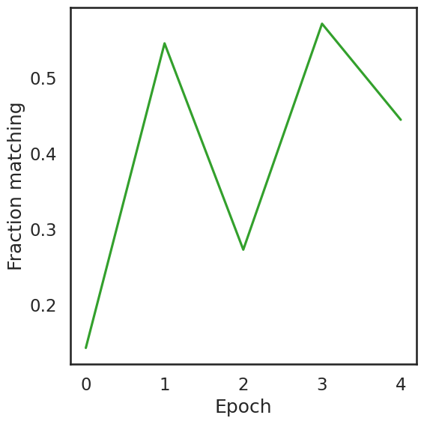
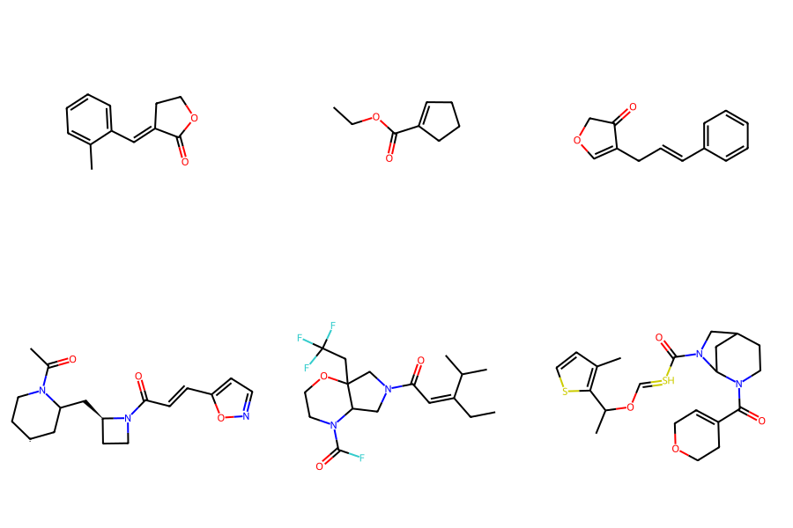
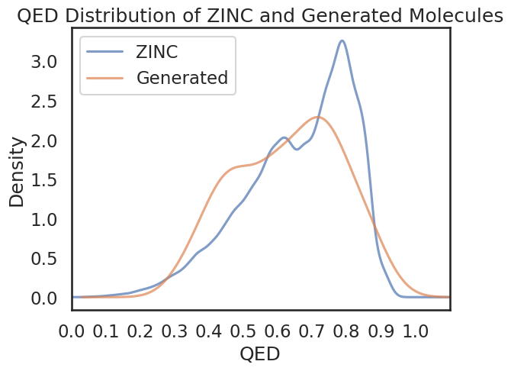
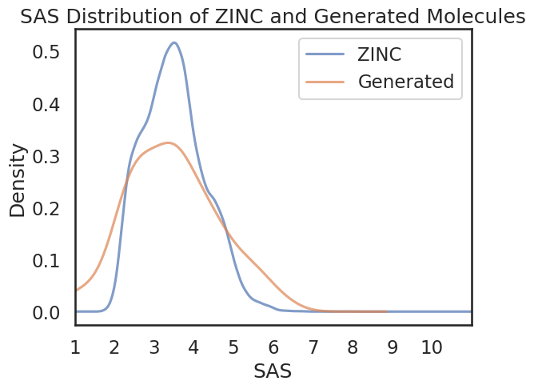
Amides: 29
Esters: 8
Ketones: 7

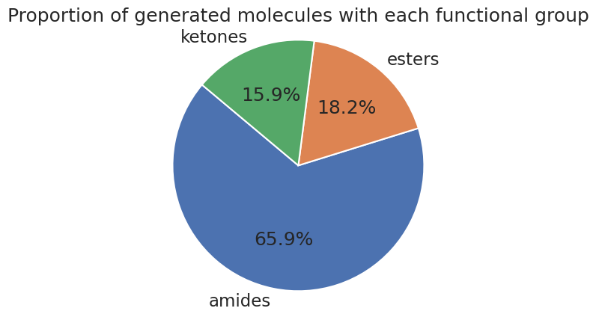

Architecture (LSTM):
Number of layers (‘num_layers’) | 3
Layer size (‘layer_size’) | 512
Cell type (‘cell_type’) | LSTM
Embedding layer size (‘embedding_layer_size’) | 512
Dropout (‘dropout’) | 0.2
Layer normalization (‘layer_normalization’) | True

Training regime
Number of epochs (‘num_epochs’) | 5
Shuffle (‘shuffle’) | True
Training data batch size (‘train_batch_size’) | 256
Learning rate | 0.00001
Augment (‘augment’) | 3
Learning rate scheduler (‘learning_rate_scheduler’) | “StepLR” (gamma=0.9)
Validation data samples (‘eval_num_samples’) | 256
Validation data batch size (‘eval_batch_size’) | 256

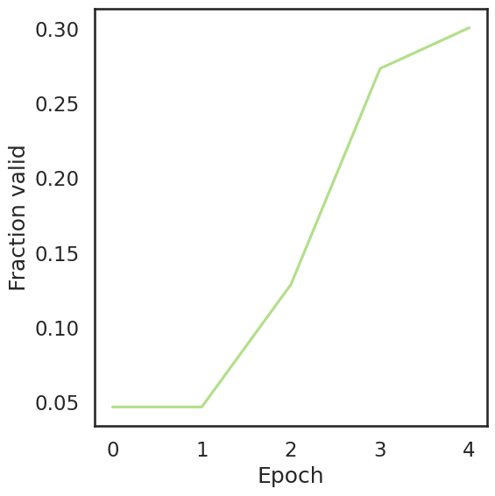
Running time ~ 33 mins
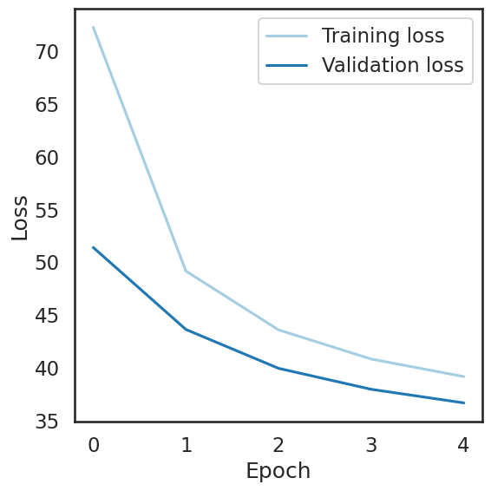

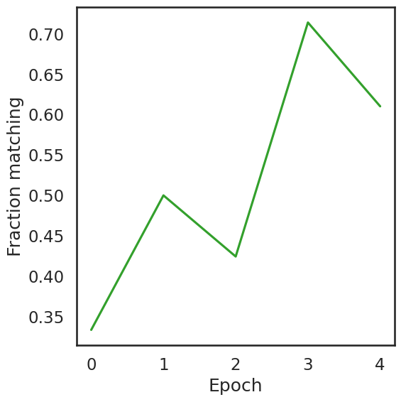

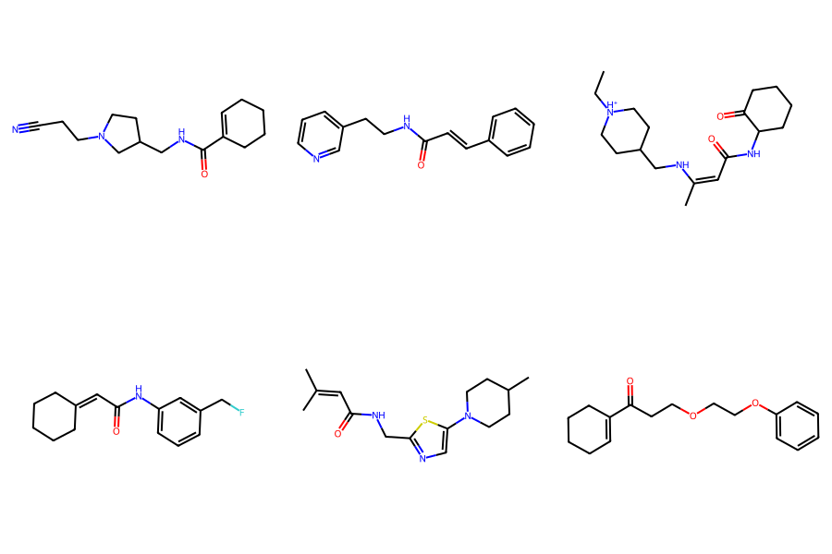

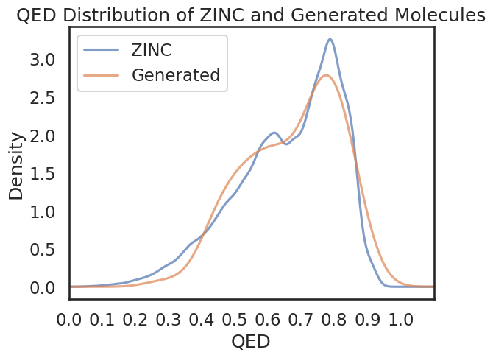
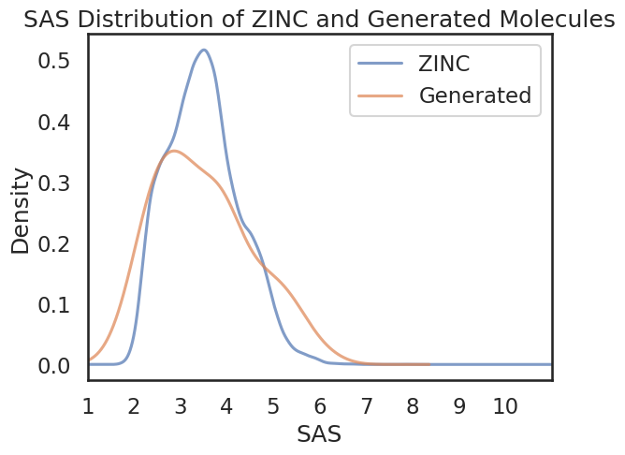

Amides: 47
Esters: 6
Ketones: 5

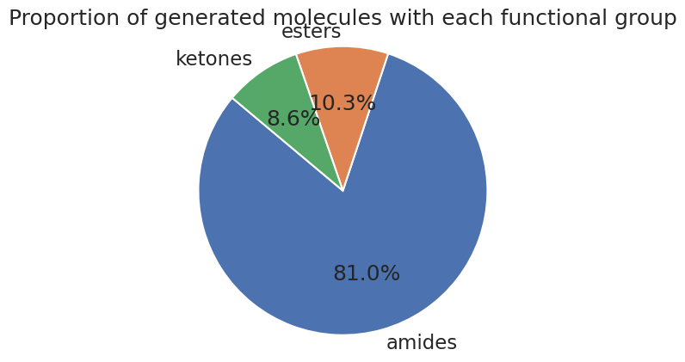

Epochs | Batch Size | Learning Rate | Time to Run | Fraction Valid | Fraction matching
20 | 256 | 1 x 10⁻⁴ | 97 mins | ~ 0.76 | ~ 0.82
10 | 256 | 1 x 10⁻⁴ | 49 mins | ~ 0.83 | ~ 0.84
5 | 512 | 1 x 10⁻⁴ | 26 mins | ~ 0.78 | ~ 0.84
5 | 512 | 1 x 10⁻⁵ | 30 mins | ~ 0.44 | ~ 0.45
5 | 256 | 1 x 10⁻⁵ | 30 mins | ~ 0. | ~ 0.

Analysis of MolWt and SMILES string length for raw 250k dataset

MolWt
count 250000.000000
mean 364.734563
std 65.375766
min 111.045153
25% 324.159769
50% 350.068389
75% 405.120004
max 968.498080

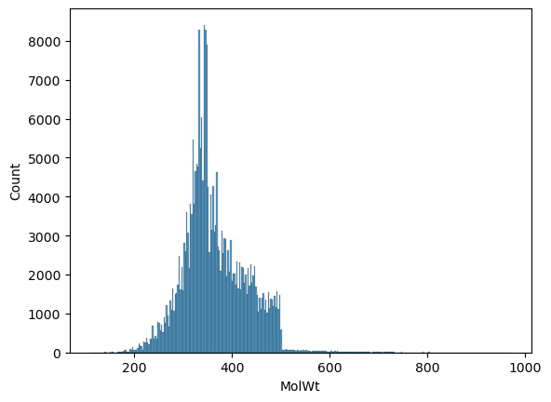

SMILES length
count 250000.000000
mean 52.680432
std 10.776727
min 13.000000
25% 45.000000
50% 52.000000
75% 59.000000
max 236.000000

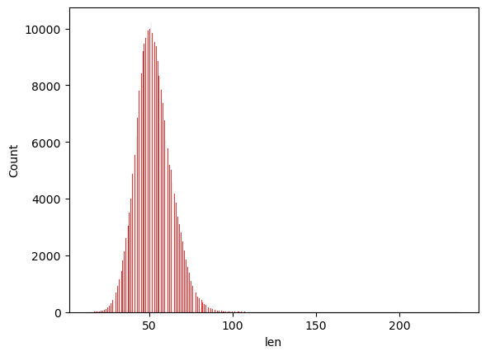

Analysis of MolWt and SMILES string length for filtered (MolWt <= 500) 250k dataset

MolWt
count 250000.000000
mean 362.256896
std 60.611323
min 111.045153
25% 323.246044
50% 349.200156
75% 403.064458
max 499.986397
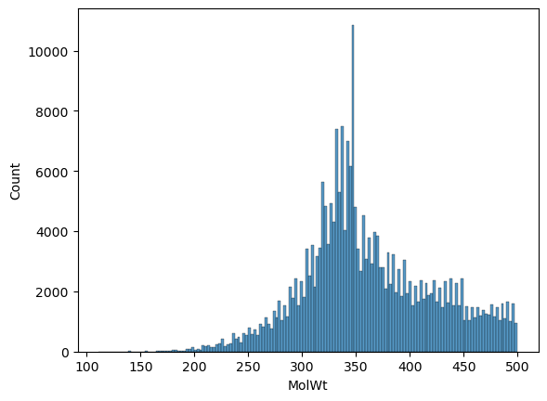

SMILES length
count 250000.000000
mean 52.391236
std 10.327327
min 13.000000
25% 45.000000
50% 52.000000
75% 59.000000
max 120.000000
