ZINC Michael acceptor RNN-LSTM experiments
250k molecules randomly selected from the entire 1B ZINC dataset and filtered to remove MolWts < 500
Architecture (LSTM):
Number of layers (‘num_layers’) | 3
Layer size (‘layer_size’) | 512
Cell type (‘cell_type’) | LSTM
Embedding layer size (‘embedding_layer_size’) | 512
Dropout (‘dropout’) | 0.2
Layer normalization (‘layer_normalization’) | True

Training regime
Number of epochs (‘num_epochs’) | 10
Shuffle (‘shuffle’) | True
Training data batch size (‘train_batch_size’) | 256
Learning rate | 0.00001
Augment (‘augment’) | 3
Learning rate scheduler (‘learning_rate_scheduler’) | “StepLR” (gamma=0.9)
Validation data samples (‘eval_num_samples’) | 256
Validation data batch size (‘eval_batch_size’) | 256

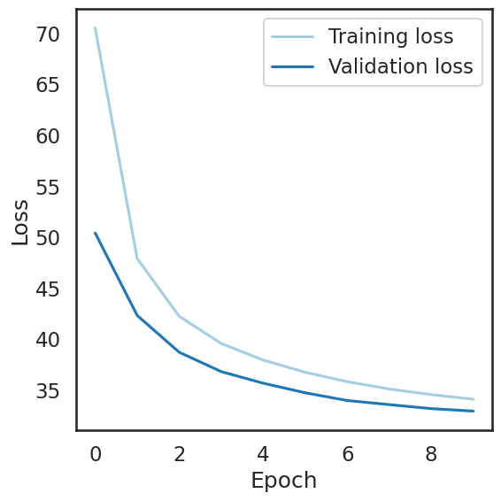
Training time (10 epochs) ~ 43 mins
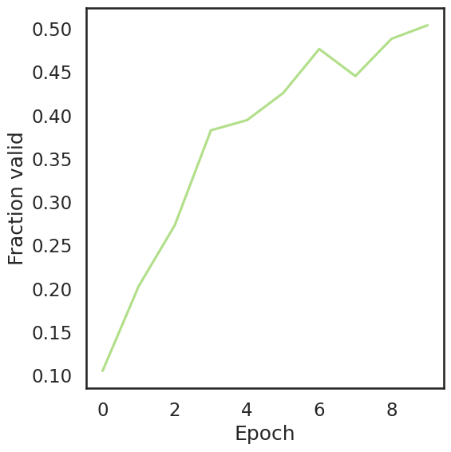

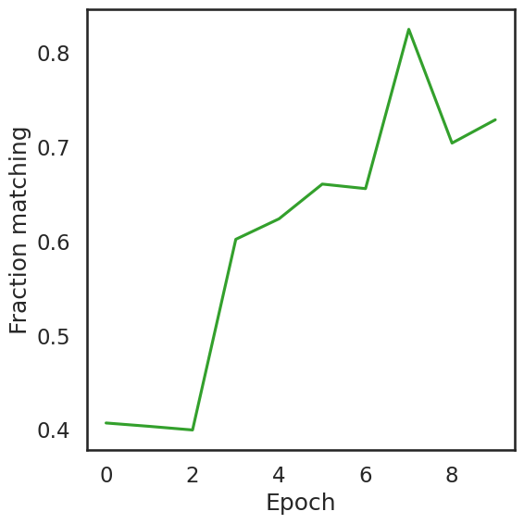
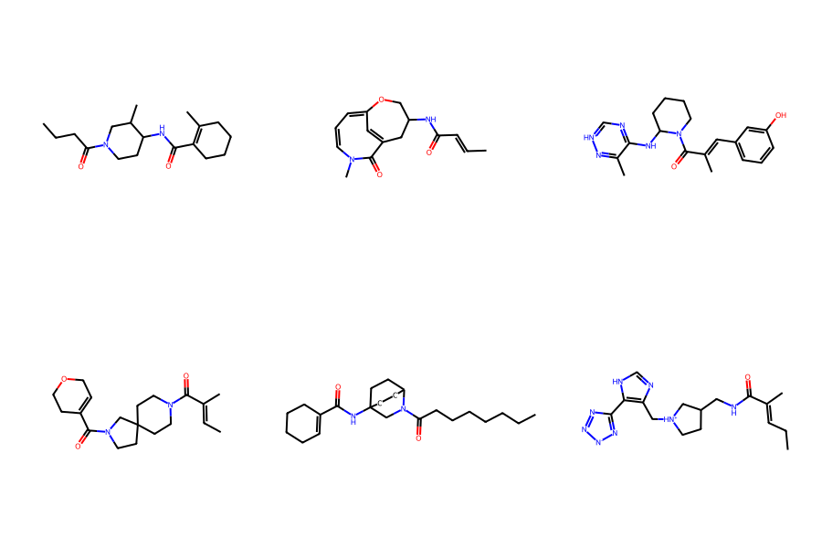
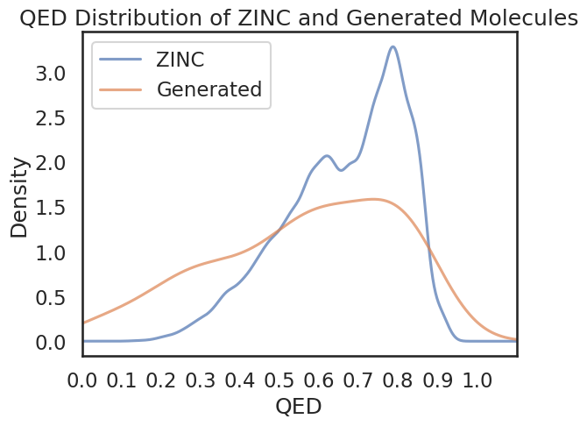
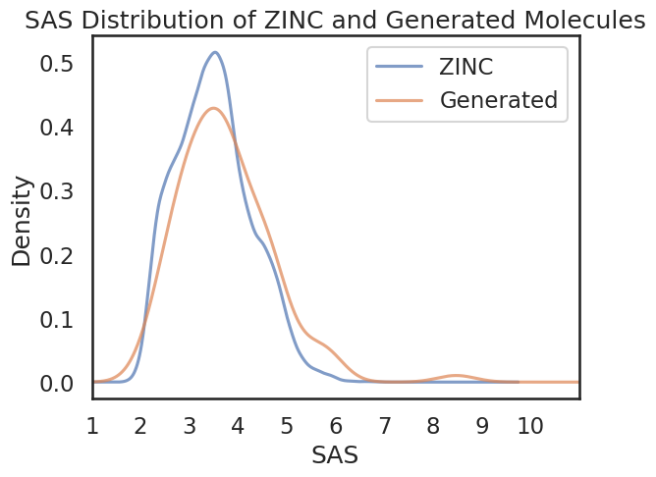

Amides: 63
Esters: 3
Ketones: 5
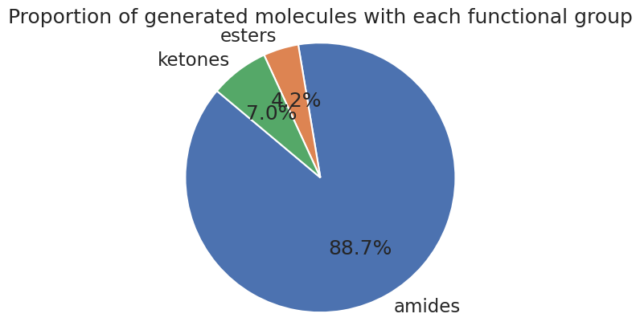

Architecture (LSTM):
Number of layers (‘num_layers’) | 3
Layer size (‘layer_size’) | 512
Cell type (‘cell_type’) | LSTM
Embedding layer size (‘embedding_layer_size’) | 512
Dropout (‘dropout’) | 0.2
Layer normalization (‘layer_normalization’) | True

Training regime
Number of epochs (‘num_epochs’) | 10
Shuffle (‘shuffle’) | True
Training data batch size (‘train_batch_size’) | 512
Learning rate | 0.0001
Augment (‘augment’) | 3
Learning rate scheduler (‘learning_rate_scheduler’) | “StepLR” (gamma=0.9)
Validation data samples (‘eval_num_samples’) | 256
Validation data batch size (‘eval_batch_size’) | 256

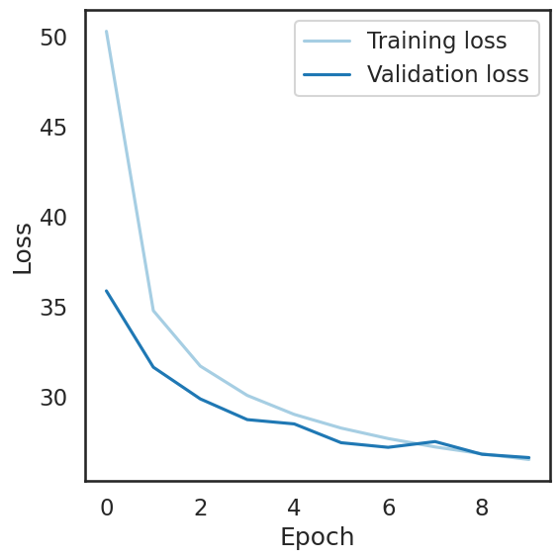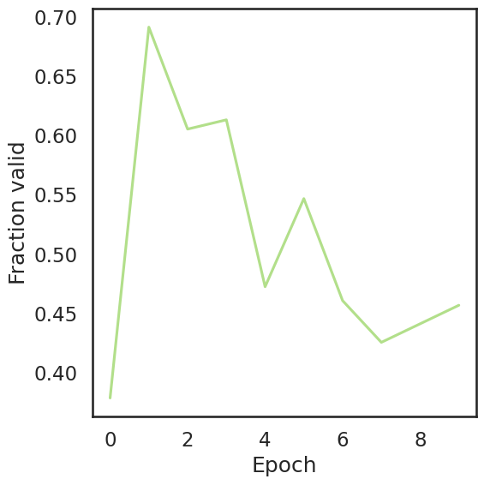
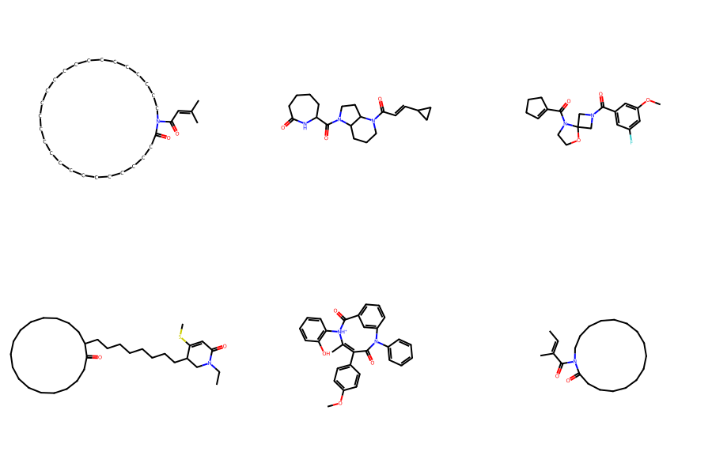
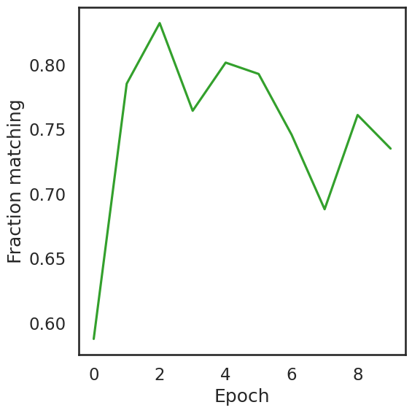

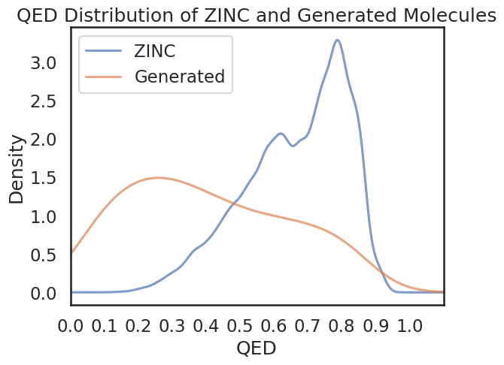
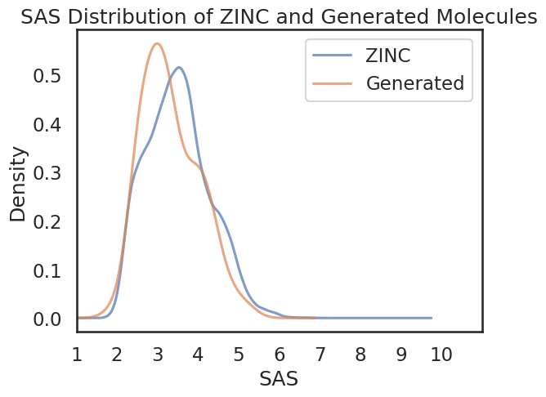

Amides: 43
Esters: 8
Ketones: 2
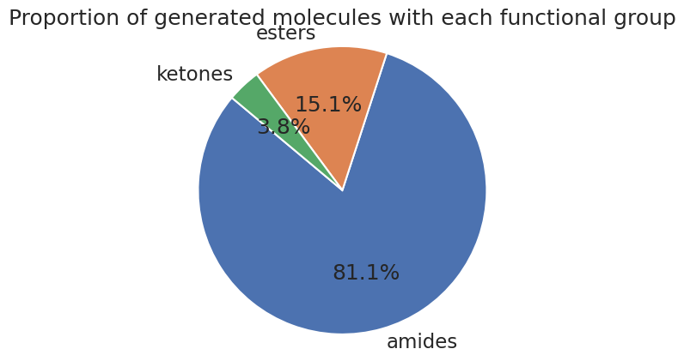

Architecture (LSTM):
Number of layers (‘num_layers’) | 3
Layer size (‘layer_size’) | 512
Cell type (‘cell_type’) | LSTM
Embedding layer size (‘embedding_layer_size’) | 512
Dropout (‘dropout’) | 0.2
Layer normalization (‘layer_normalization’) | True

Training regime
Number of epochs (‘num_epochs’) | 20
Shuffle (‘shuffle’) | True
Training data batch size (‘train_batch_size’) | 512
Learning rate | 0.0001
Augment (‘augment’) | 3
Learning rate scheduler (‘learning_rate_scheduler’) | “StepLR” (gamma=0.9)
Validation data samples (‘eval_num_samples’) | 256
Validation data batch size (‘eval_batch_size’) | 256

Running time (20 epochs) ~ 82 mins
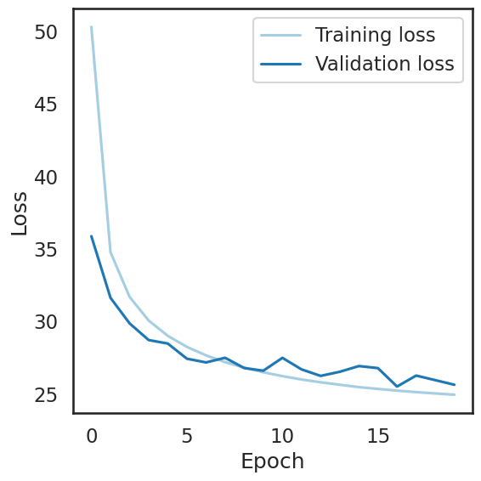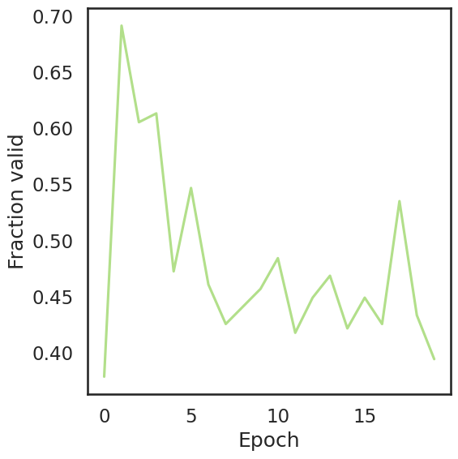
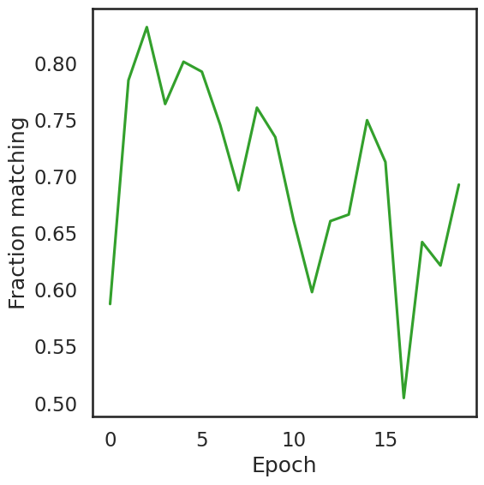
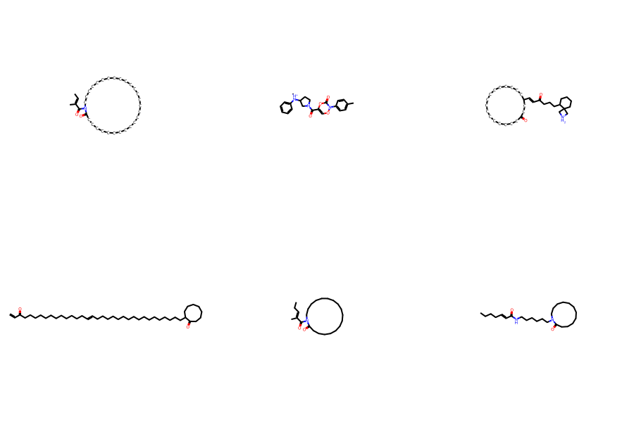
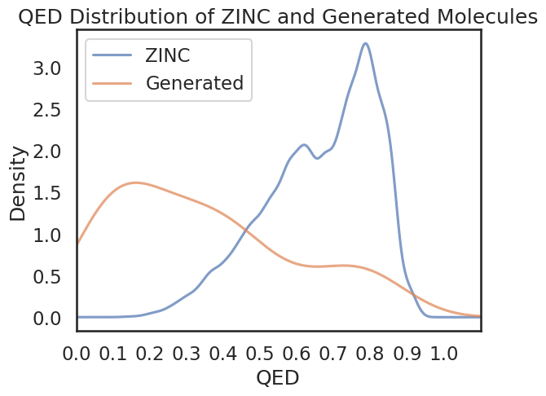

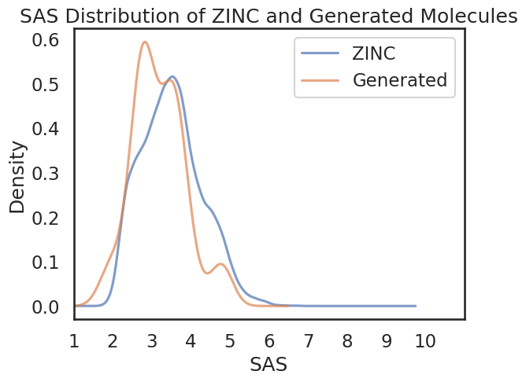
Amides: 44
Esters: 12
Ketones: 8
