ZINC Michael acceptor RNN-LSTM experiments

Tranche (chunk) “00”

Architecture (LSTM):
Number of layers (‘num_layers’) | 3
Layer size (‘layer_size’) | 512
Cell type (‘cell_type’) | LSTM
Embedding layer size (‘embedding_layer_size’) | 512
Dropout (‘dropout’) | 0.2
Layer normalization (‘layer_normalization’) | True

Training regime
Number of epochs (‘num_epochs’) | 10
Shuffle (‘shuffle’) | True
Training data batch size (‘train_batch_size’) | 1024
Augment (‘augment’) | 3
Learning rate scheduler (‘learning_rate_scheduler’) | “StepLR” (gamma=0.9)
Validation data samples (‘eval_num_samples’) | 256
Validation data batch size (‘eval_batch_size’) | 256

Training time (10 epochs) ~ 2,000 seconds / 28mins
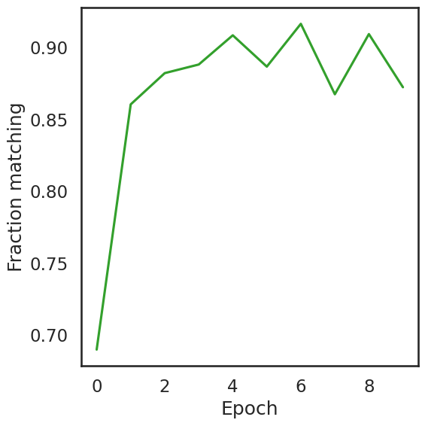
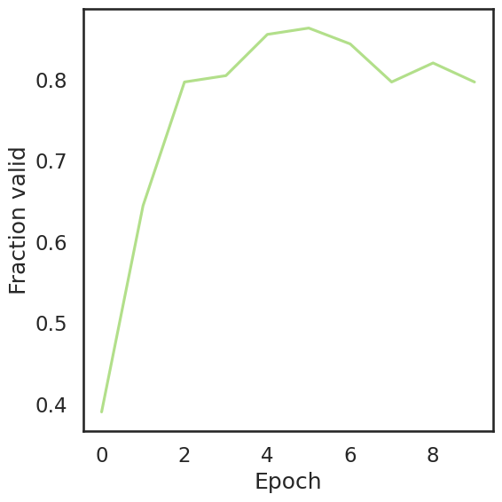
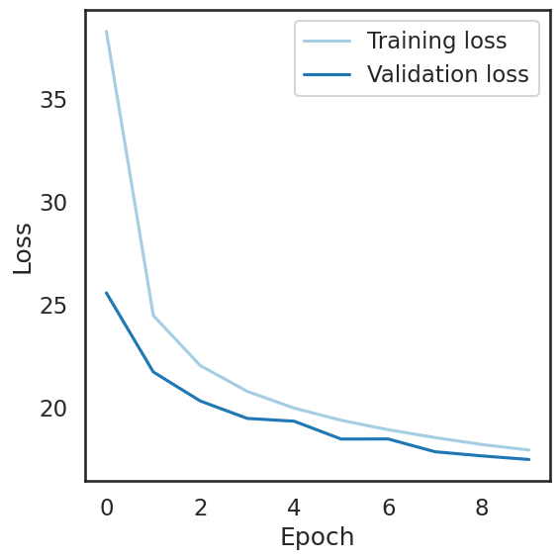

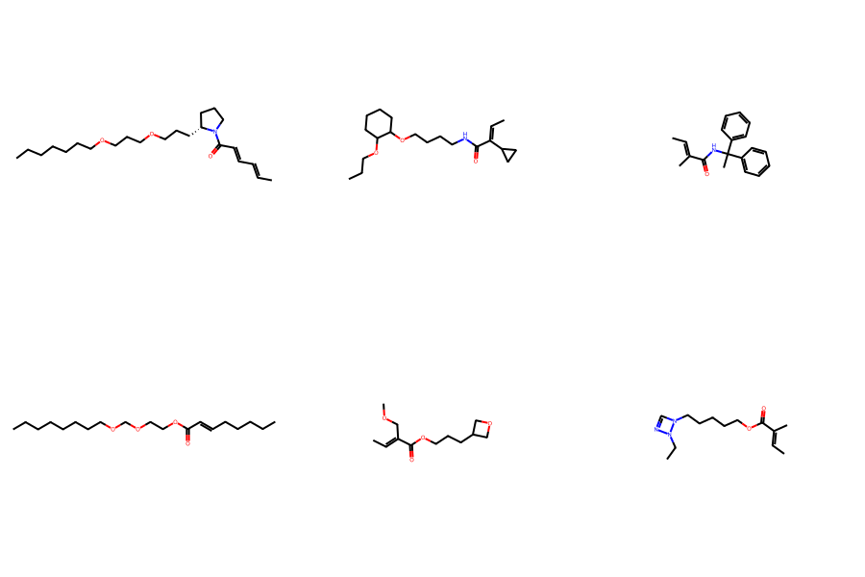
Sample of generated molecules:
QED (quantitative estimate of drug likeness)
Possibly low due to long alkyl chains (glycol ethers)
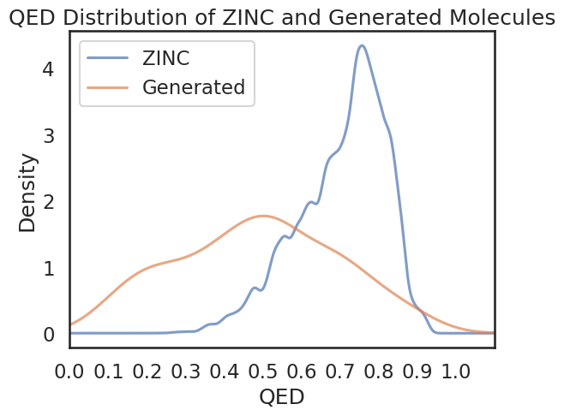

Distribution of SAS (synthetic accessiblity scores)
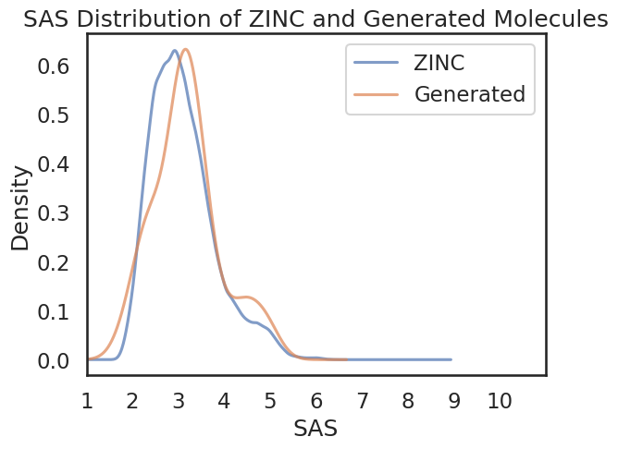

Number of Amides: 70
Number of Esters: 19
Number of Ketones: 1

