ZINC Michael acceptor RNN-LSTM experiments
Tranche (chunk) ”01”
Architecture (LSTM):
Number of layers (‘num_layers’) | 3
Layer size (‘layer_size’) | 512
Cell type (‘cell_type’) | LSTM
Embedding layer size (‘embedding_layer_size’) | 512
Dropout (‘dropout’) | 0.2
Layer normalization (‘layer_normalization’) | True

Training regime
Number of epochs (‘num_epochs’) | 10
Shuffle (‘shuffle’) | True
Training data batch size (‘train_batch_size’) | 1024
Learning rate | 0.0001
Augment (‘augment’) | 3
Learning rate scheduler (‘learning_rate_scheduler’) | “StepLR” (gamma=0.9)
Validation data samples (‘eval_num_samples’) | 256
Validation data batch size (‘eval_batch_size’) | 256

Training time (10 epochs) ~ 30 mins
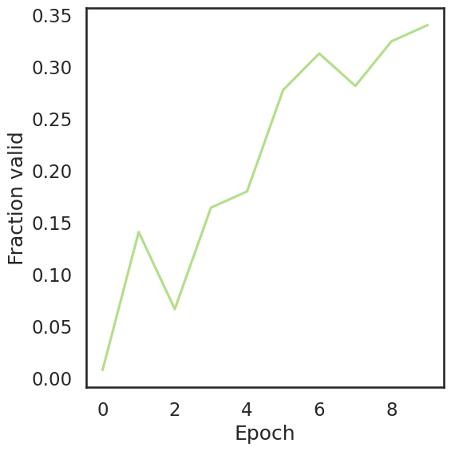
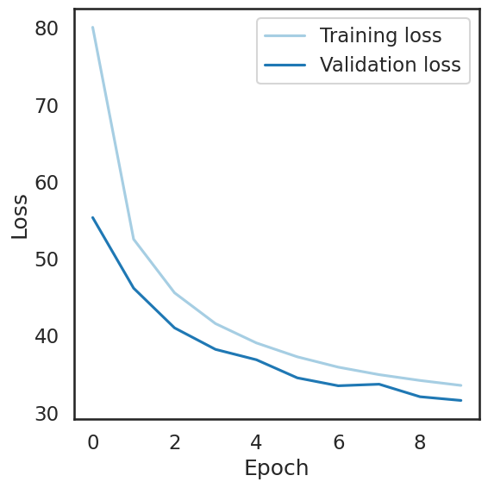

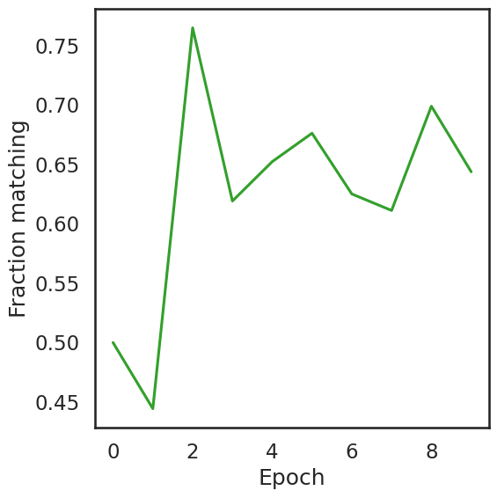
Sample of generated molecules:

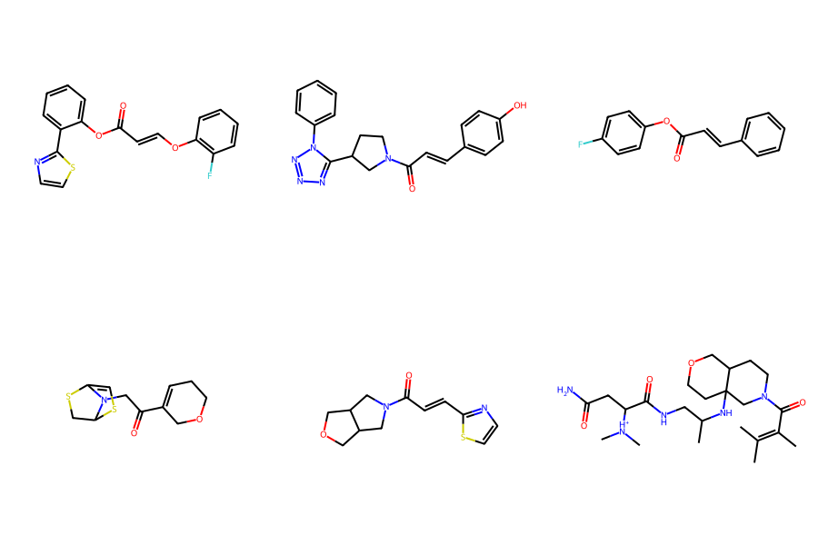

QED (quantitative estimate of drug likeness)
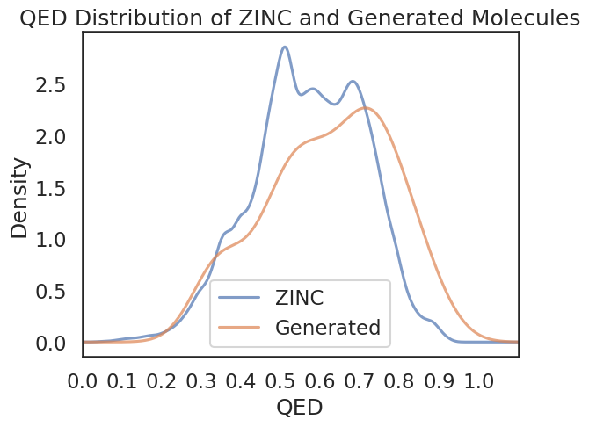

Distribution of SAS (synthetic accessibility scores)
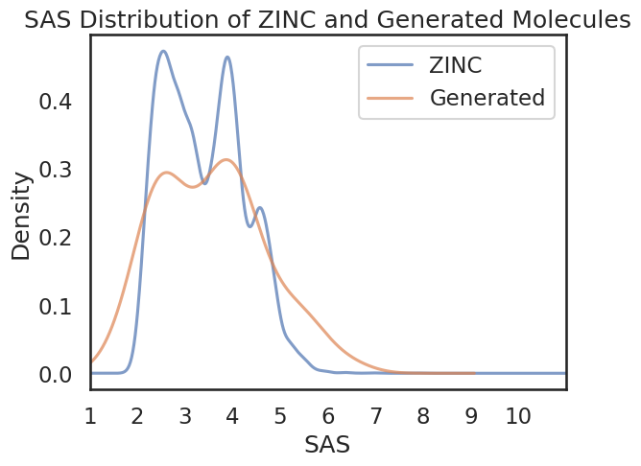

Number of Amides: 42
Number of Esters: 9
Number of Ketones: 17
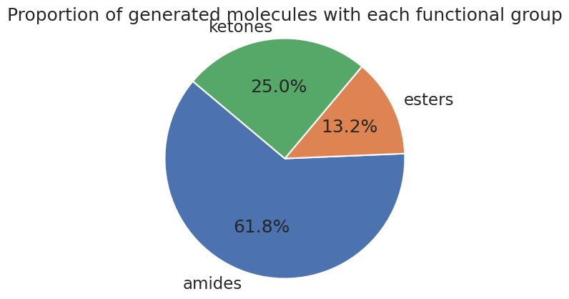

Tranche (chunk) ”01”
Architecture (LSTM):
Number of layers (‘num_layers’) | 3
Layer size (‘layer_size’) | 512
Cell type (‘cell_type’) | LSTM
Embedding layer size (‘embedding_layer_size’) | 512
Dropout (‘dropout’) | 0.2
Layer normalization (‘layer_normalization’) | True

Training regime
Number of epochs (‘num_epochs’) | 20
Shuffle (‘shuffle’) | True
Training data batch size (‘train_batch_size’) | 256
Learning rate | 0.00001
Augment (‘augment’) | 3
Learning rate scheduler (‘learning_rate_scheduler’) | “StepLR” (gamma=0.9)
Validation data samples (‘eval_num_samples’) | 256
Validation data batch size (‘eval_batch_size’) | 256

Training time (20 epochs) ~ 55 mins
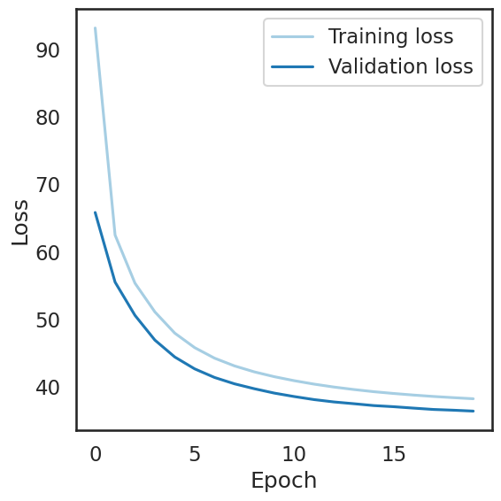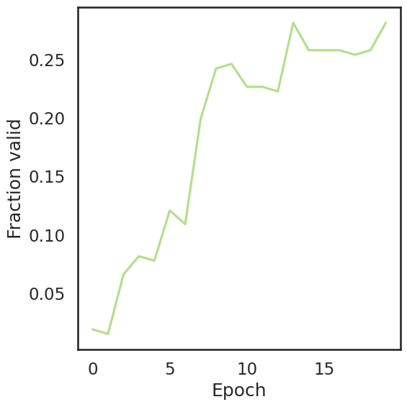
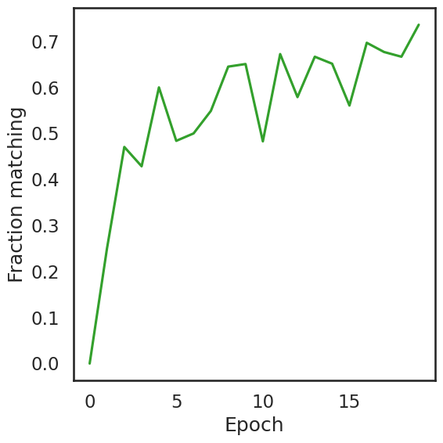
Sample of generated molecules:
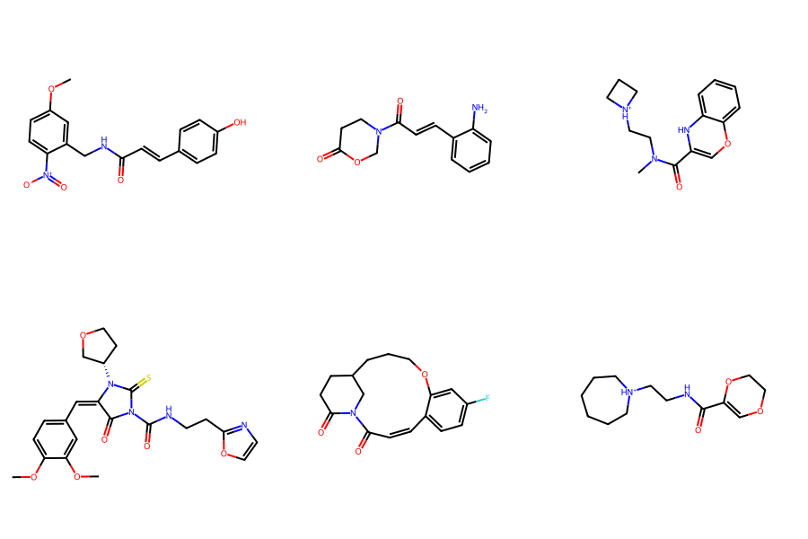
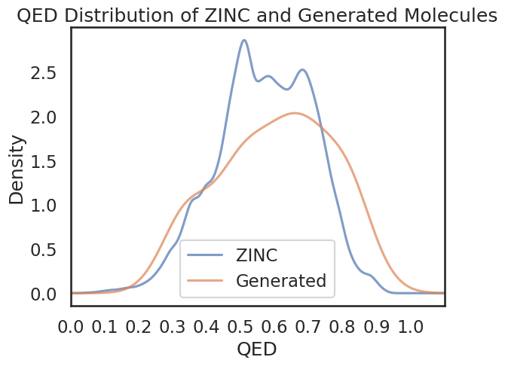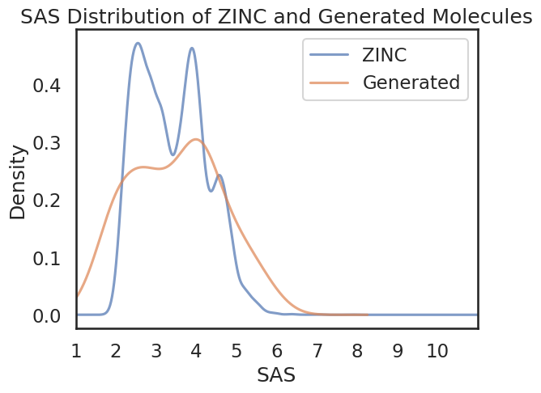

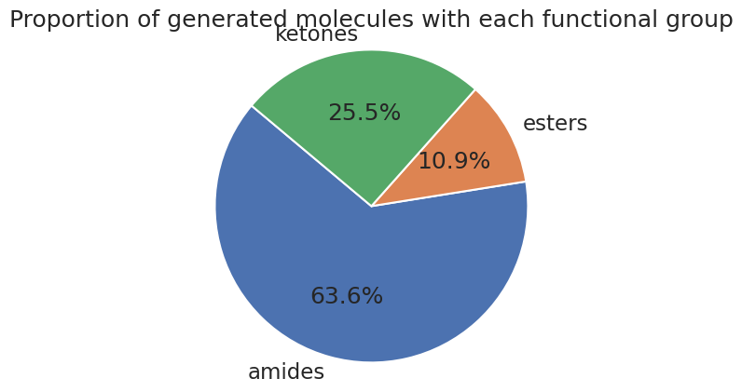

Architecture (LSTM):
Number of layers (‘num_layers’) | 3
Layer size (‘layer_size’) | 512
Cell type (‘cell_type’) | LSTM
Embedding layer size (‘embedding_layer_size’) | 512
Dropout (‘dropout’) | 0.2
Layer normalization (‘layer_normalization’) | True

Training regime
Number of epochs (‘num_epochs’) | 10
Shuffle (‘shuffle’) | True
Training data batch size (‘train_batch_size’) | 512
Learning rate | 0.00001
Augment (‘augment’) | 3
Learning rate scheduler (‘learning_rate_scheduler’) | “StepLR” (gamma=0.9)
Validation data samples (‘eval_num_samples’) | 256
Validation data batch size (‘eval_batch_size’) | 256

Running time (10 epochs) ~ 28 mins
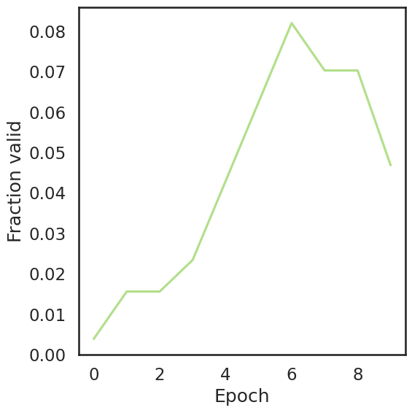
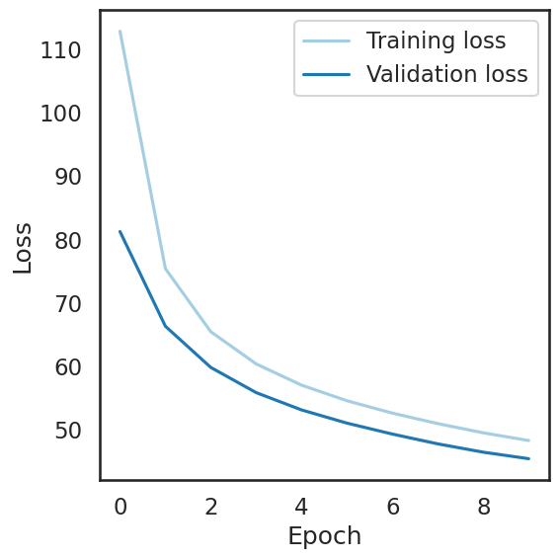

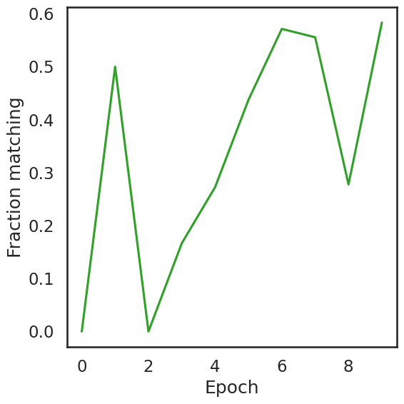
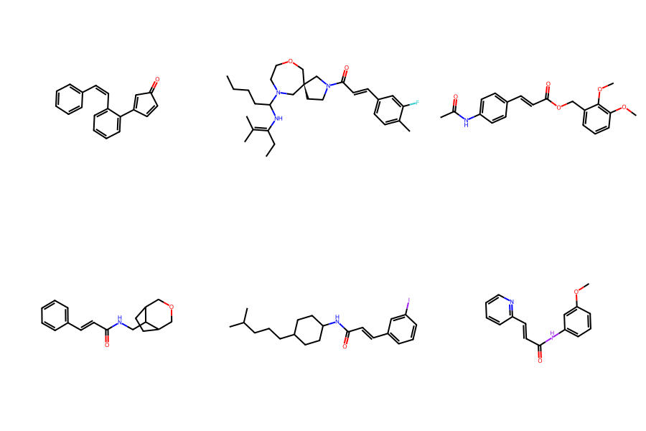
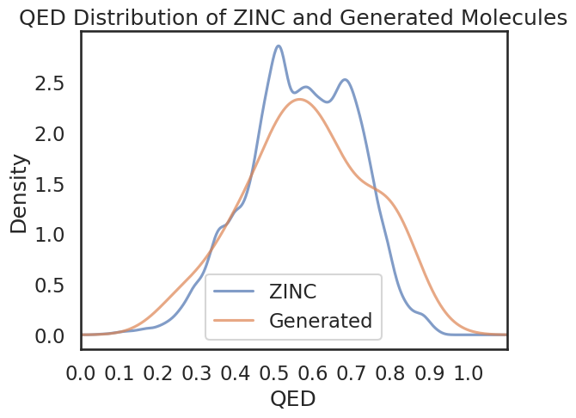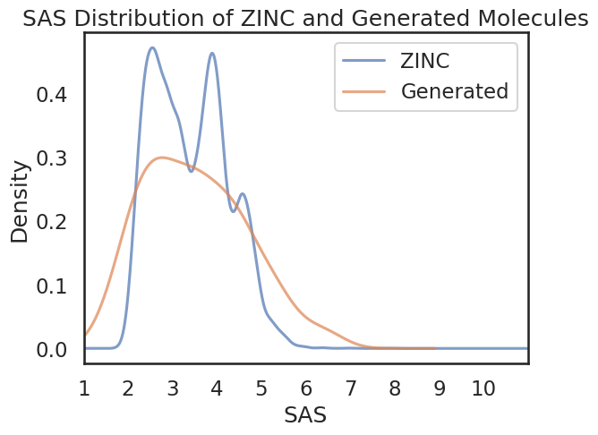
Number of Amides: 19
Number of Esters: 7
Number of Ketones: 19
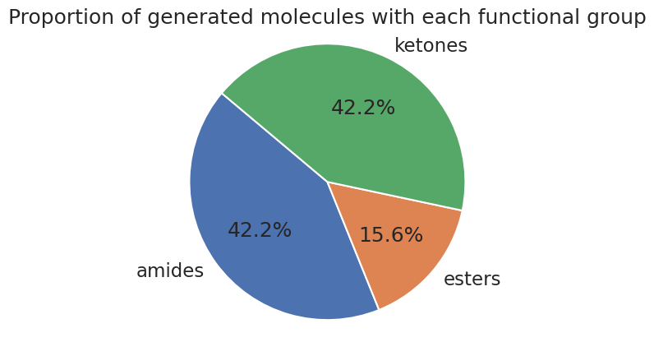

Tranche (chunk) ”01”
Architecture (LSTM):
Number of layers (‘num_layers’) | 3
Layer size (‘layer_size’) | 512
Cell type (‘cell_type’) | LSTM
Embedding layer size (‘embedding_layer_size’) | 512
Dropout (‘dropout’) | 0.2
Layer normalization (‘layer_normalization’) | True

Training regime
Number of epochs (‘num_epochs’) | 10
Shuffle (‘shuffle’) | True
Training data batch size (‘train_batch_size’) | 256
Learning rate | 0.0001
Augment (‘augment’) | 3
Learning rate scheduler (‘learning_rate_scheduler’) | “StepLR” (gamma=0.9)
Validation data samples (‘eval_num_samples’) | 256
Validation data batch size (‘eval_batch_size’) | 256

Training time (10 epochs) ~ 28 mins
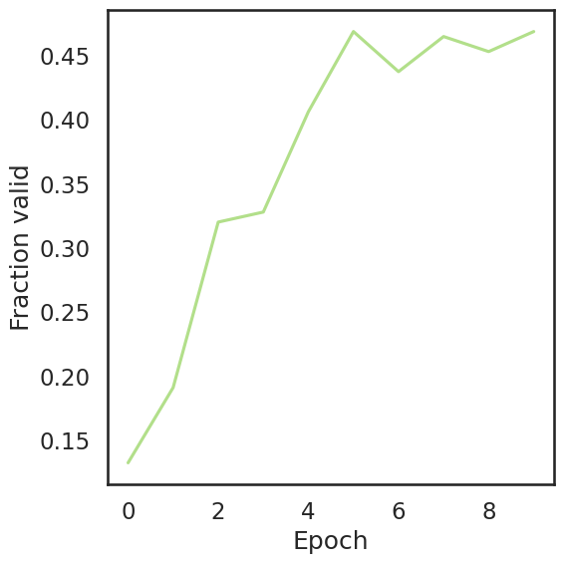
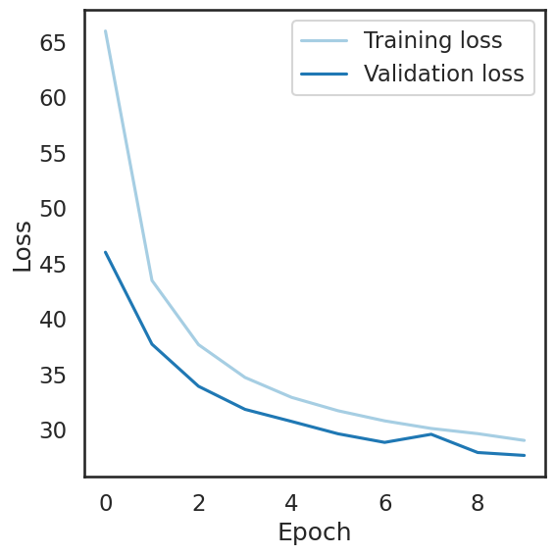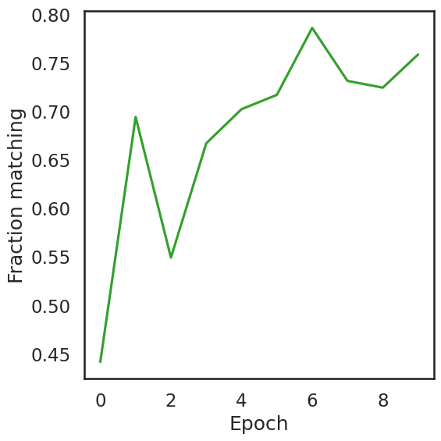
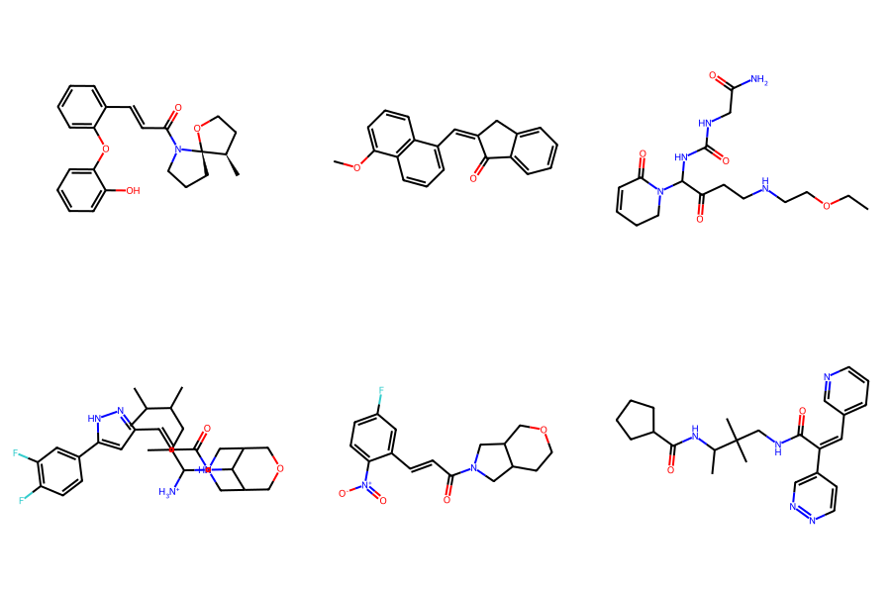
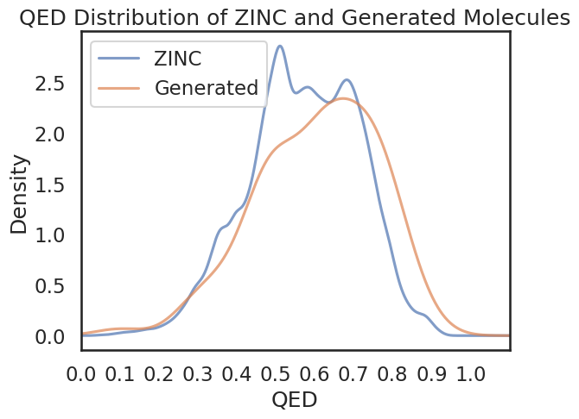
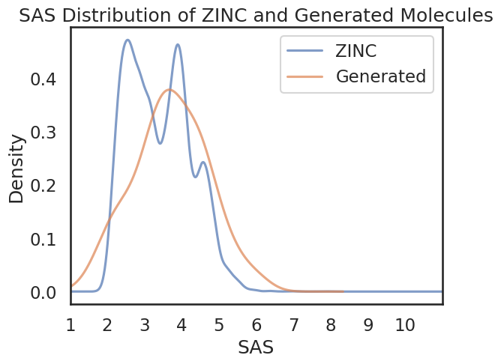
Number of Amides: 61
Number of Esters: 5
Number of Ketones: 5
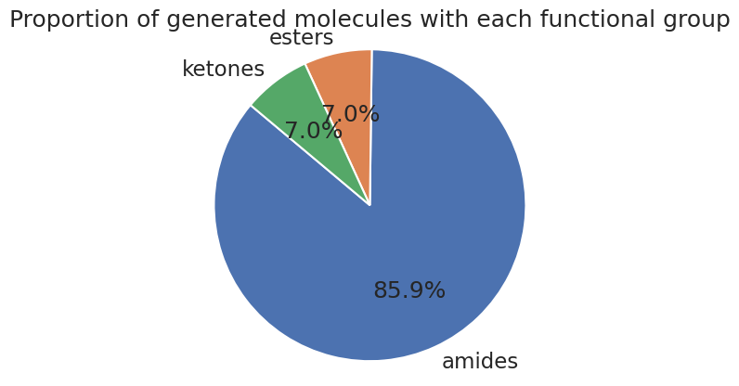

Tranche (chunk) ”01”
Architecture (LSTM):
Number of layers (‘num_layers’) | 3
Layer size (‘layer_size’) | 512
Cell type (‘cell_type’) | LSTM
Embedding layer size (‘embedding_layer_size’) | 512
Dropout (‘dropout’) | 0.2
Layer normalization (‘layer_normalization’) | True

Training regime
Number of epochs (‘num_epochs’) | 10
Shuffle (‘shuffle’) | True
Training data batch size (‘train_batch_size’) | 1024
Learning rate | 0.00001
Augment (‘augment’) | 3
Learning rate scheduler (‘learning_rate_scheduler’) | “StepLR” (gamma=0.9)
Validation data samples (‘eval_num_samples’) | 256
Validation data batch size (‘eval_batch_size’) | 256

Running time (10 epochs): 30 mins
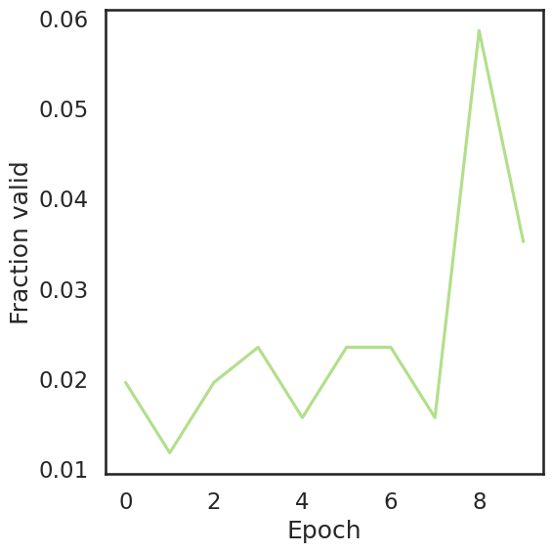
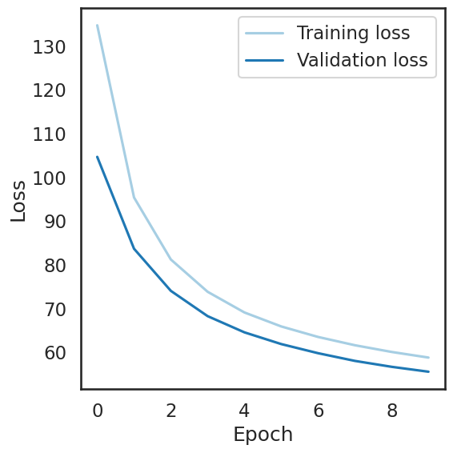

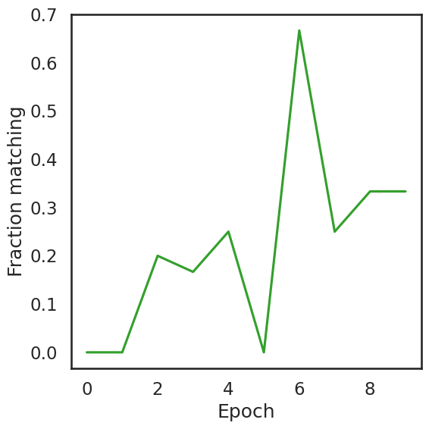
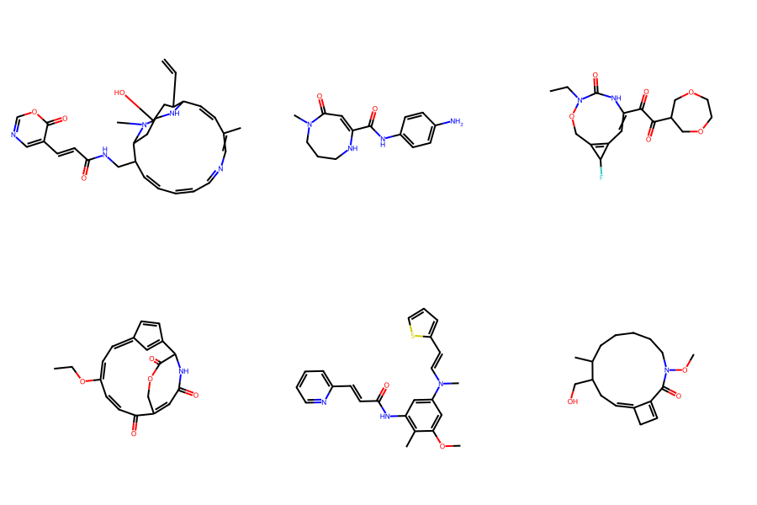
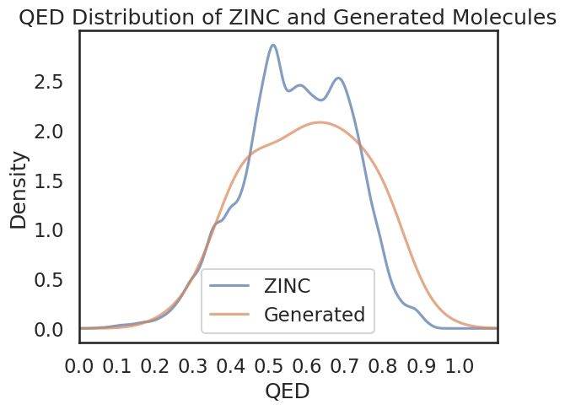
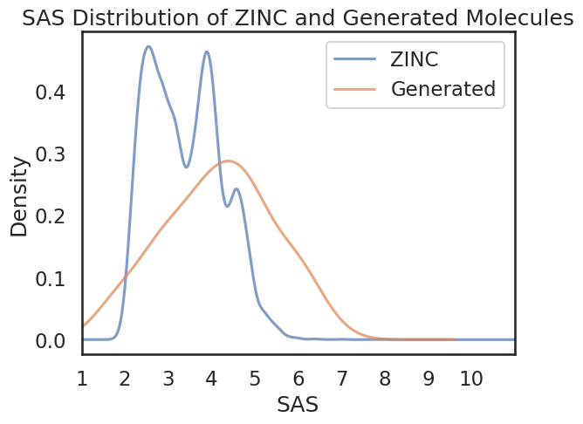

Number of Amides: 19
Number of Esters: 4
Number of Ketones: 16
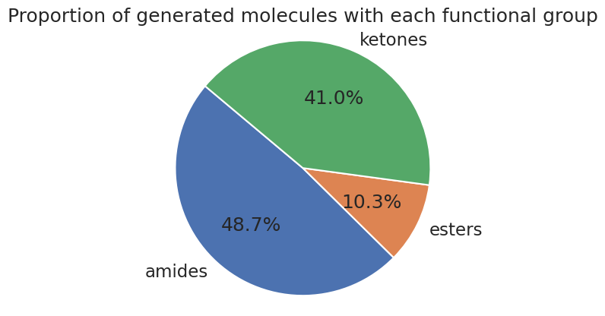

Tranche (chunk) ”01”
Architecture (LSTM):
Number of layers (‘num_layers’) | 3
Layer size (‘layer_size’) | 512
Cell type (‘cell_type’) | LSTM
Embedding layer size (‘embedding_layer_size’) | 512
Dropout (‘dropout’) | 0.2
Layer normalization (‘layer_normalization’) | True

Training regime
Number of epochs (‘num_epochs’) | 20
Shuffle (‘shuffle’) | True
Training data batch size (‘train_batch_size’) | 256
Learning rate | 0.0001
Augment (‘augment’) | 3
Learning rate scheduler (‘learning_rate_scheduler’) | “StepLR” (gamma=0.9)
Validation data samples (‘eval_num_samples’) | 256
Validation data batch size (‘eval_batch_size’) | 256

Running time (20 epochs): 55 mins
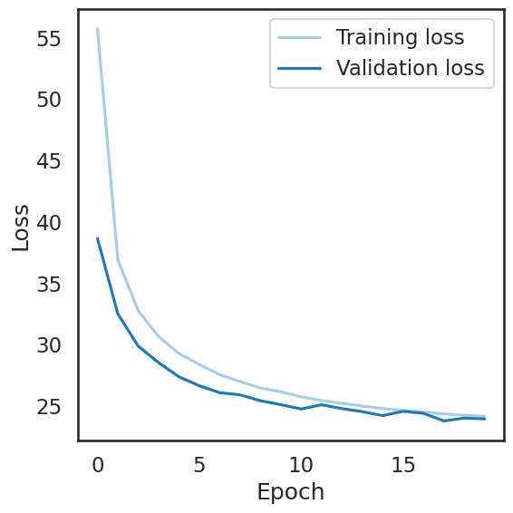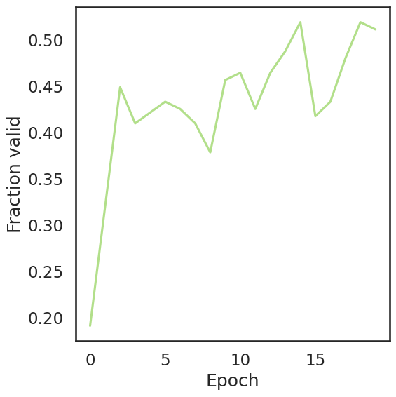
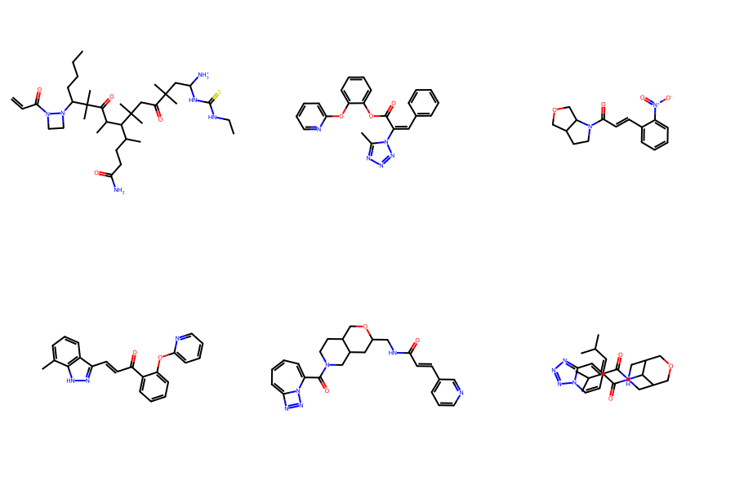
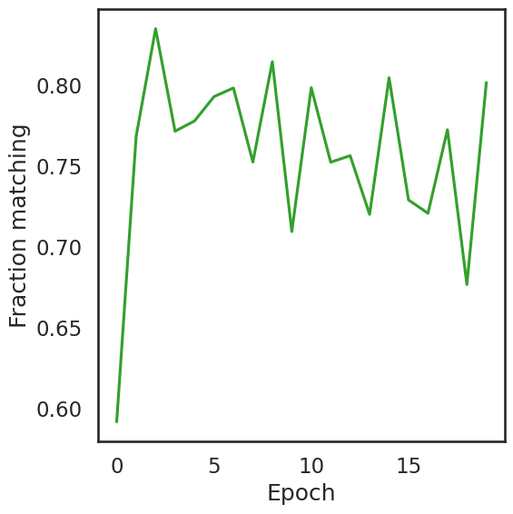

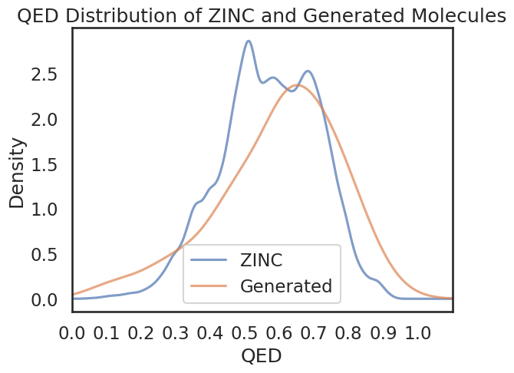
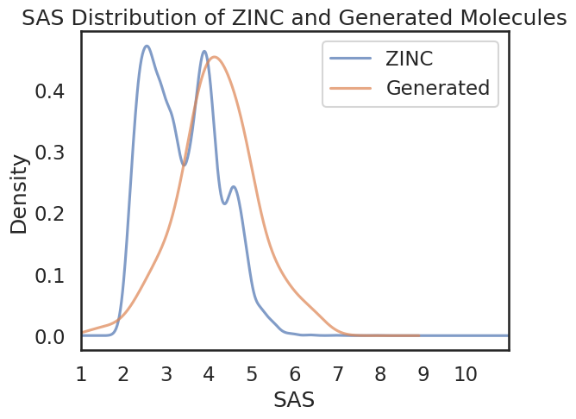

Number of Amides: 69
Number of Esters: 2
Number of Ketones: 3

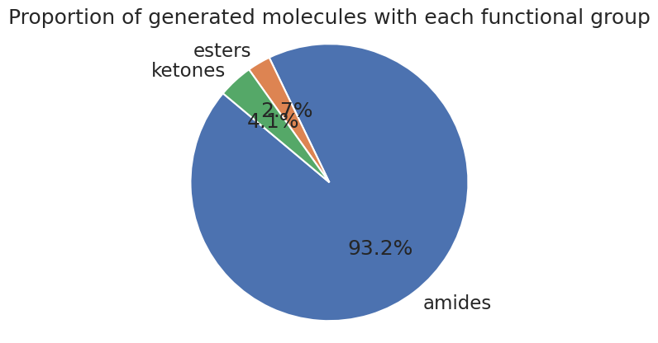

Epochs | Batch Size | Learning Rate | Time to Run | Fraction Valid | Fraction matching
10 | 256 | 1 x 10⁻⁴ | 28 mins | ~ 0.45 | ~ 0.75
10 | 512 | 1 x 10⁻⁵ | 28 mins | ~ 0.08 | ~ 0.60
10 | 1024 | 1 x 10⁻⁴ | 30 mins | ~ 0.35 | ~ 0.65
10 | 1024 | 1 x 10⁻⁵ | 30 mins | ~ 0.06 | ~ 0.65
20 | 256 | 1 x 10⁻⁵ | 55 mins | ~ 0.30 | ~ 0.70
20 | 256 | 1 x 10⁻⁴ | 55 mins | ~ 0.50 | ~ 0.80

