CTS — Carpal Tunnel Syndrome Diagnostic Survey
Design & Workflow Overview (Ver. Oct 2026) — prepared by Jamie Kim (FHS MSK-IF)

How to use this document
This document describes what the CTS Diagnostic Survey does, how each section works from the participant's point of view, how results are scored and sent to REDCap, and how the code is organized so that a future maintainer can find and change things safely.
Sections 1–7 describe the application, the REDCap design and the open ethics item, and are intended for anyone involved in the project, including the Principal Investigator (PI). Sections 8–9 are aimed at the person maintaining the code. Getting access to the code, the development workflow, hosting and REDCap setup are covered in the companion CTS GitHub & Server Setup Walkthrough; this document assumes that setup is done.
Screenshots were taken from the current redcap branch using sample data; the study-mode screens (Figures 9–11) use simulated REDCap responses.
Status at handover: the REDCap integration is built on the redcap branch, but its current hosting design (Cloudflare in front of REDCap) is not expected to receive Research Ethics Board (REB) approval. Section 7 explains why and lays out the options. Treat the REDCap code as a working reference, not as a deployable design.

1. Purpose & overview of the application
The CTS Diagnostic Survey is a website that screens for Carpal Tunnel Syndrome (CTS). A participant answers a short questionnaire, draws their symptoms on hand diagrams, and immediately sees two independent scores. Together the two scores give a more robust screening result than either alone.
Section | What it does | Instrument it is based on
1. Diagnostic Questions | Yes/No questions about numbness, tingling and related symptoms | Kamath & Stothard (2003) clinical questionnaire
2. Hand Diagrams | Participant shades areas of pain, tingling and numbness on four hand outlines | Katz & Stirrat (1990) self-administered hand diagram
3. Results | Shows the Kamath-based and Katz-based classifications; print and CSV download | —

The application can run in two modes:
- Standalone mode (no study link). Everything happens inside the browser. Nothing is sent to a server.
- Study (REDCap) mode (opened from a personalised invitation link containing ?k=<access key>). On reaching the Results page, the responses, scores and hand-diagram images are submitted automatically to the study's REDCap project, against the correct participant and timepoint (baseline, 6-week or 3-month). See Section 5.

1.1 Handover logistics
- Code: the GitHub repository (Jamie215/CTS_survey_app) is owned by Jamie Kim. The main branch holds the standalone application; the redcap branch holds the REDCap integration described in Section 5. The successor is expected to fork it into their own account or lab organization (see the Walkthrough, Section 1) and continue the work there.
- Hosting: the MSK-IF demo was hosted on Jamie Kim's personal Cloudflare Pages account. Given the REB concern in Section 7, study data should not go through Cloudflare. The Walkthrough, Section 3, covers hosting for the chosen option: Cloudflare Pages for in-person collection, where nothing is submitted (option 1a), or a Western-managed (WTS) server for remote collection (option 2a).
- Questions: reach out to Jamie Kim (jamiejmkim.jmk@gmail.com).

2. Diagnostic Questions (Kamath-based)

About this section
A scored set of Yes/No questions adapted from the Kamath & Stothard clinical questionnaire. Positive items (night-time waking, median-nerve finger distribution, symptom provocation) add points. Discriminating items (little-finger symptoms, neck pain, toe numbness) subtract points, because they point to other conditions such as cervical radiculopathy or polyneuropathy.

Workflow
- Participant opens the site. A short guided highlight (driver.js) points out how to answer.
- Q1 is a gateway: "Do you ever have numbness and tingling in your fingers?" If No, Q1a–Q1f are hidden and not scored.
- Q7 is a second gateway: "Have you tried a wrist support brace / splint?" Q7a (effectiveness) only appears if Yes.
- Q2 (pregnancy) also offers Not relevant.
- An ease-of-use rating (Very easy → Very difficult) and an optional comment box follow the last question.
- Next checks that every visible question is answered; if not, unanswered items are highlighted and the page scrolls to the first one.
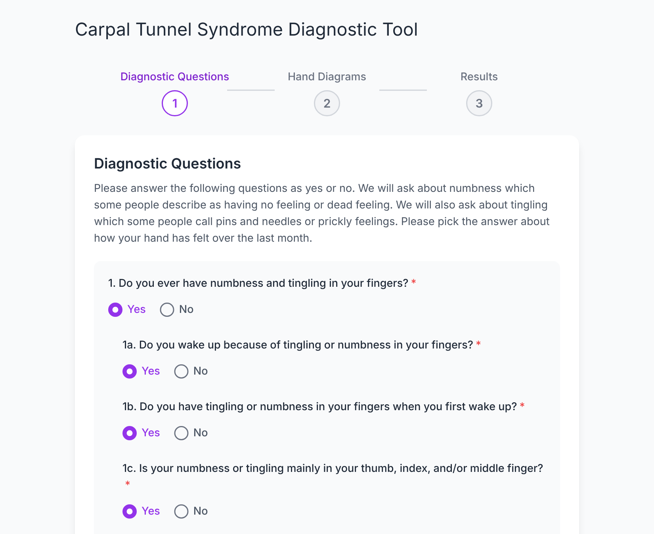
Figure 1. Diagnostic Questions. Answering Yes to Q1 reveals follow-ups 1a–1f.

Scoring logic
# | Question (short) | Yes | No | Not relevant
1 | Numbness/tingling in fingers (gateway) | not scored | not scored | —
1a | Woken by tingling/numbness | +2 | 0 | —
1b | Tingling/numbness on first waking | +1 | 0 | —
1c | Mainly thumb, index and/or middle finger | +2 | 0 | —
1d | Quick movements/positions relieve it | +1 | 0 | —
1e | Little finger affected | −2 | 0 | —
1f | Activities increase it | +1 | 0 | —
2 | Symptoms during pregnancy | +1 | −1 | 0
3 | Wrist pain | +1 | 0 | —
4 | Drops small objects | +1 | 0 | —
5 | Often has neck pain | −1 | 0 | —
6 | Numbness/tingling in toes | −2 | 0 | —
7 | Tried a wrist splint (gateway) | not scored | not scored | —
7a | Splint was effective | +2 | 0 | —

Total score | Classification shown
2 or less | Unlikely CTS
3–4 | Possible CTS: Unclear
5 or more | Classic / Probable CTS

Where it lives in the code
- Questions, gateways and REDCap field names: data/diagnosticQuestions.js
- Weights and classification bands: lib/kamathScoring.js (kamathQuestionWeights, KAMATH_BANDS)
- Page: components/sections/DiagnosticQuestions.js
- Tests: tests/kamathScoring.test.js

3. Hand Diagrams (Katz-based)

About this section
The participant shades where they feel each symptom on outlines of the left and right hand, palm side and back side. The application measures how much of each anatomical zone is shaded and classifies the pattern against median-nerve territory, following the Katz hand diagram method.

Workflow
- A step-by-step guided tour runs the first time the section opens; the ? button replays it.
- One block per symptom, each with four canvases (left/right × palm/back):
  - Pain (orange) — always shown.
  - Tingling (purple) and Numbness (blue) — shown only if Q1 was answered Yes.
- The participant draws freehand with finger, stylus or mouse. Each canvas has a Clear button.
- An ease-of-use rating and an optional comment box follow.
- Calculate CTS Scores moves to Results. If nothing was drawn, a confirmation dialog asks whether to continue anyway.
If the hand outline files fail to load, the section shows an error with a Try again button, and scoring is blocked until they load.
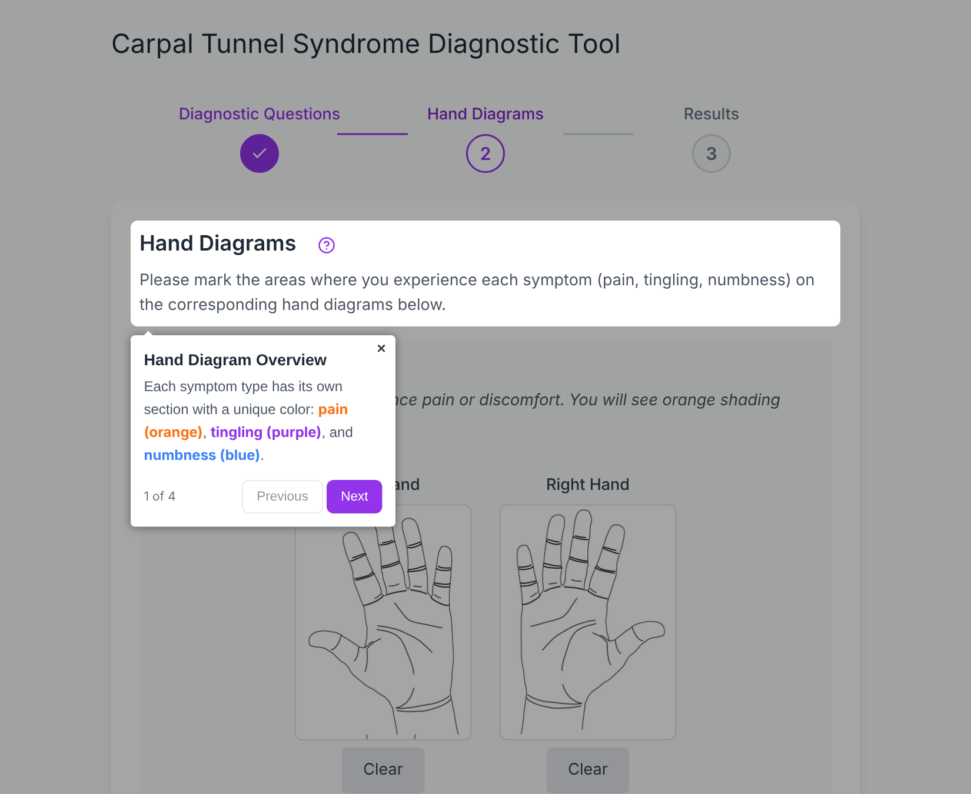
Figure 2. The guided tour that opens with the Hand Diagrams section.
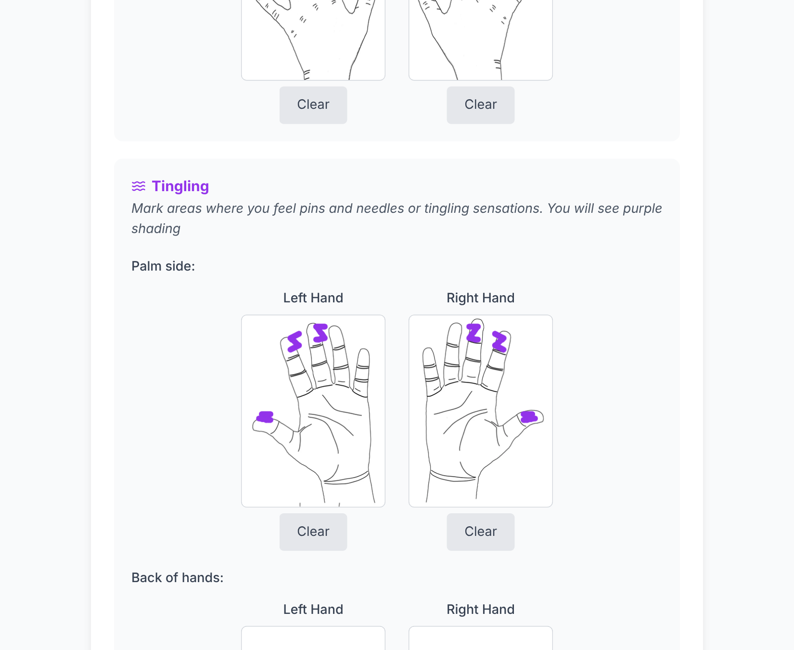
Figure 3. Tingling marked on the median-nerve fingertips of both palms (sample data).

Scoring logic
Each hand outline is an SVG whose named regions (thumb_distal, index_middle, palm_radial, dorsum and so on) are used as pixel masks. For each region the application computes the percentage of pixels covered, per symptom and for all symptoms combined (the union, not the sum, as strokes overlap).
A digit counts as affected when:
- Thumb: distal segment coverage > 5%
- Index / Middle: distal segment > 5%, or middle segment ≥ 50%
Palm (radial, ulnar), wrist and dorsum count as affected above 5%. Each hand is then classified on its own:
Katz score | Classification | Rule
3 | Classic CTS Symptom Distribution | ≥ 2 of thumb/index/middle affected; no palm; no dorsum
2 | Probable CTS Symptom Distribution | ≥ 2 digits affected; palm involved but not confined to the ulnar side; no dorsum
1 | Possible CTS Symptom Distribution | ≥ 1 digit affected (may include dorsum, ulnar-only palm, or only one digit)
0 | Unlikely CTS | No shading on thumb, index or middle

Where it lives in the code
- Hand outlines and region masks: public/hands/*.svg (region names are the SVG inkscape:label values)
- Thresholds (5% and 50%), colours, canvas size: data/constants.js
- Region list used for display and REDCap field names: KATZ_REGIONS in data/constants.js
- Coverage and classification: lib/katzScoring.js
- Drawing and SVG loading: hooks/useCanvasDrawing.js, lib/canvasUtils.js
- Page: components/sections/HandDiagrams.js, components/HandDiagramCanvas.js
- Tour steps: lib/tourConfig.js
- Tests: tests/katzScoring.test.js, tests/deriveSymptomFlags.test.js (the pixel-coverage functions need a real canvas and are verified manually)

4. Results & export

Workflow
- On arriving at Results, a dialog asks the user to choose I'm a Patient or I'm a Healthcare Professional. It cannot be dismissed without a choice.
- A screening disclaimer is always shown at the top.
- The Kamath-based card and one Katz-based card per hand follow, with the combined drawings for that hand (palm and back).
- Print Results and Download Results (CSV) sit at the bottom of the page.
- In study (REDCap) mode, a banner at the top reports the submission status (Section 5).
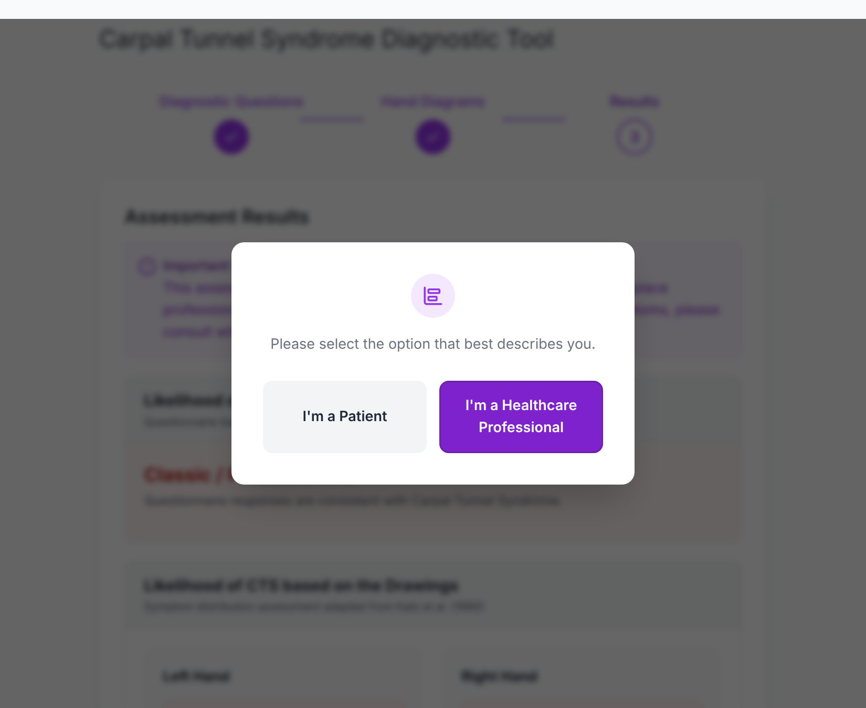
Figure 4. Role choice shown on arriving at Results.

What is shown to whom
Shown on results page | Patient | Healthcare professional
Kamath-based classification and description | Yes | Yes
Kamath total points and band legend | No | Yes
Kamath score breakdown (question, answer, points) | No | Yes
Katz classification per hand + combined drawings | Yes | Yes
Katz rule description, median digits affected, palm and dorsum summary | No | Yes
Katz per-region coverage table (pain, tingling, numbness %) | No | Yes

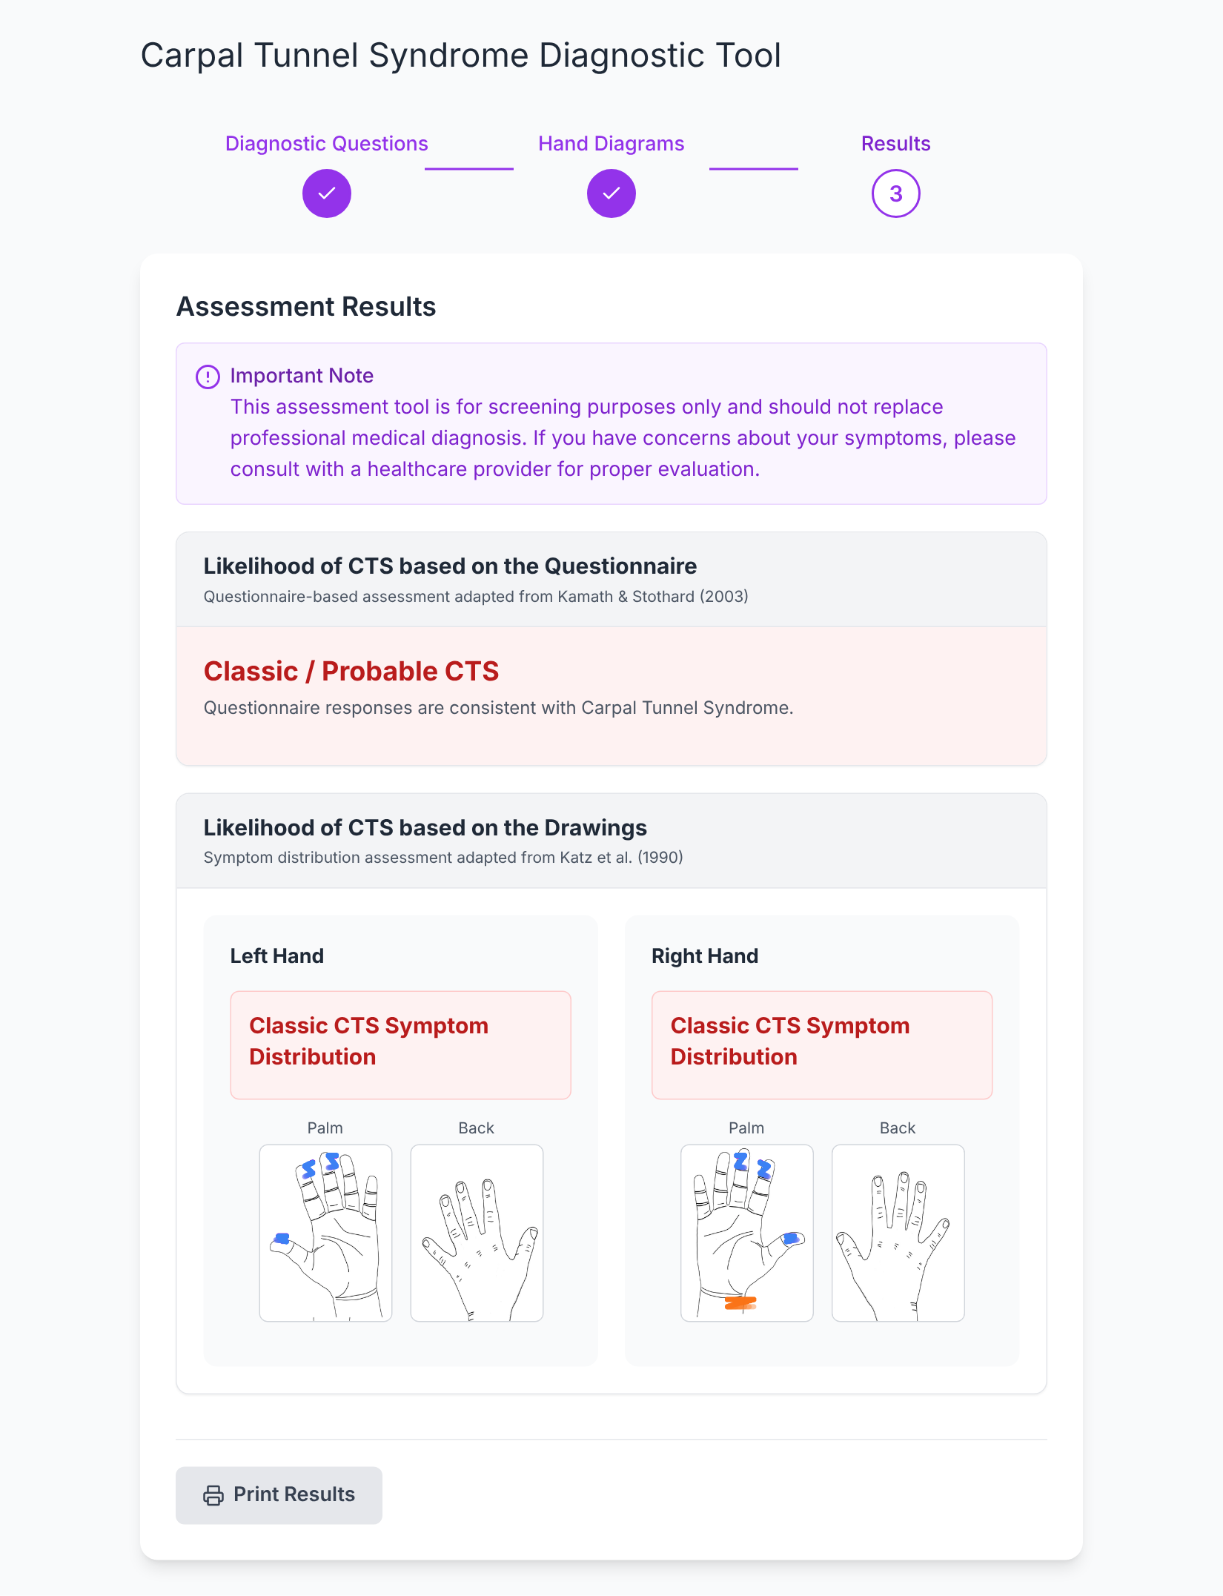
Figure 5. Patient view: classifications and combined drawings only; Print is the only export.
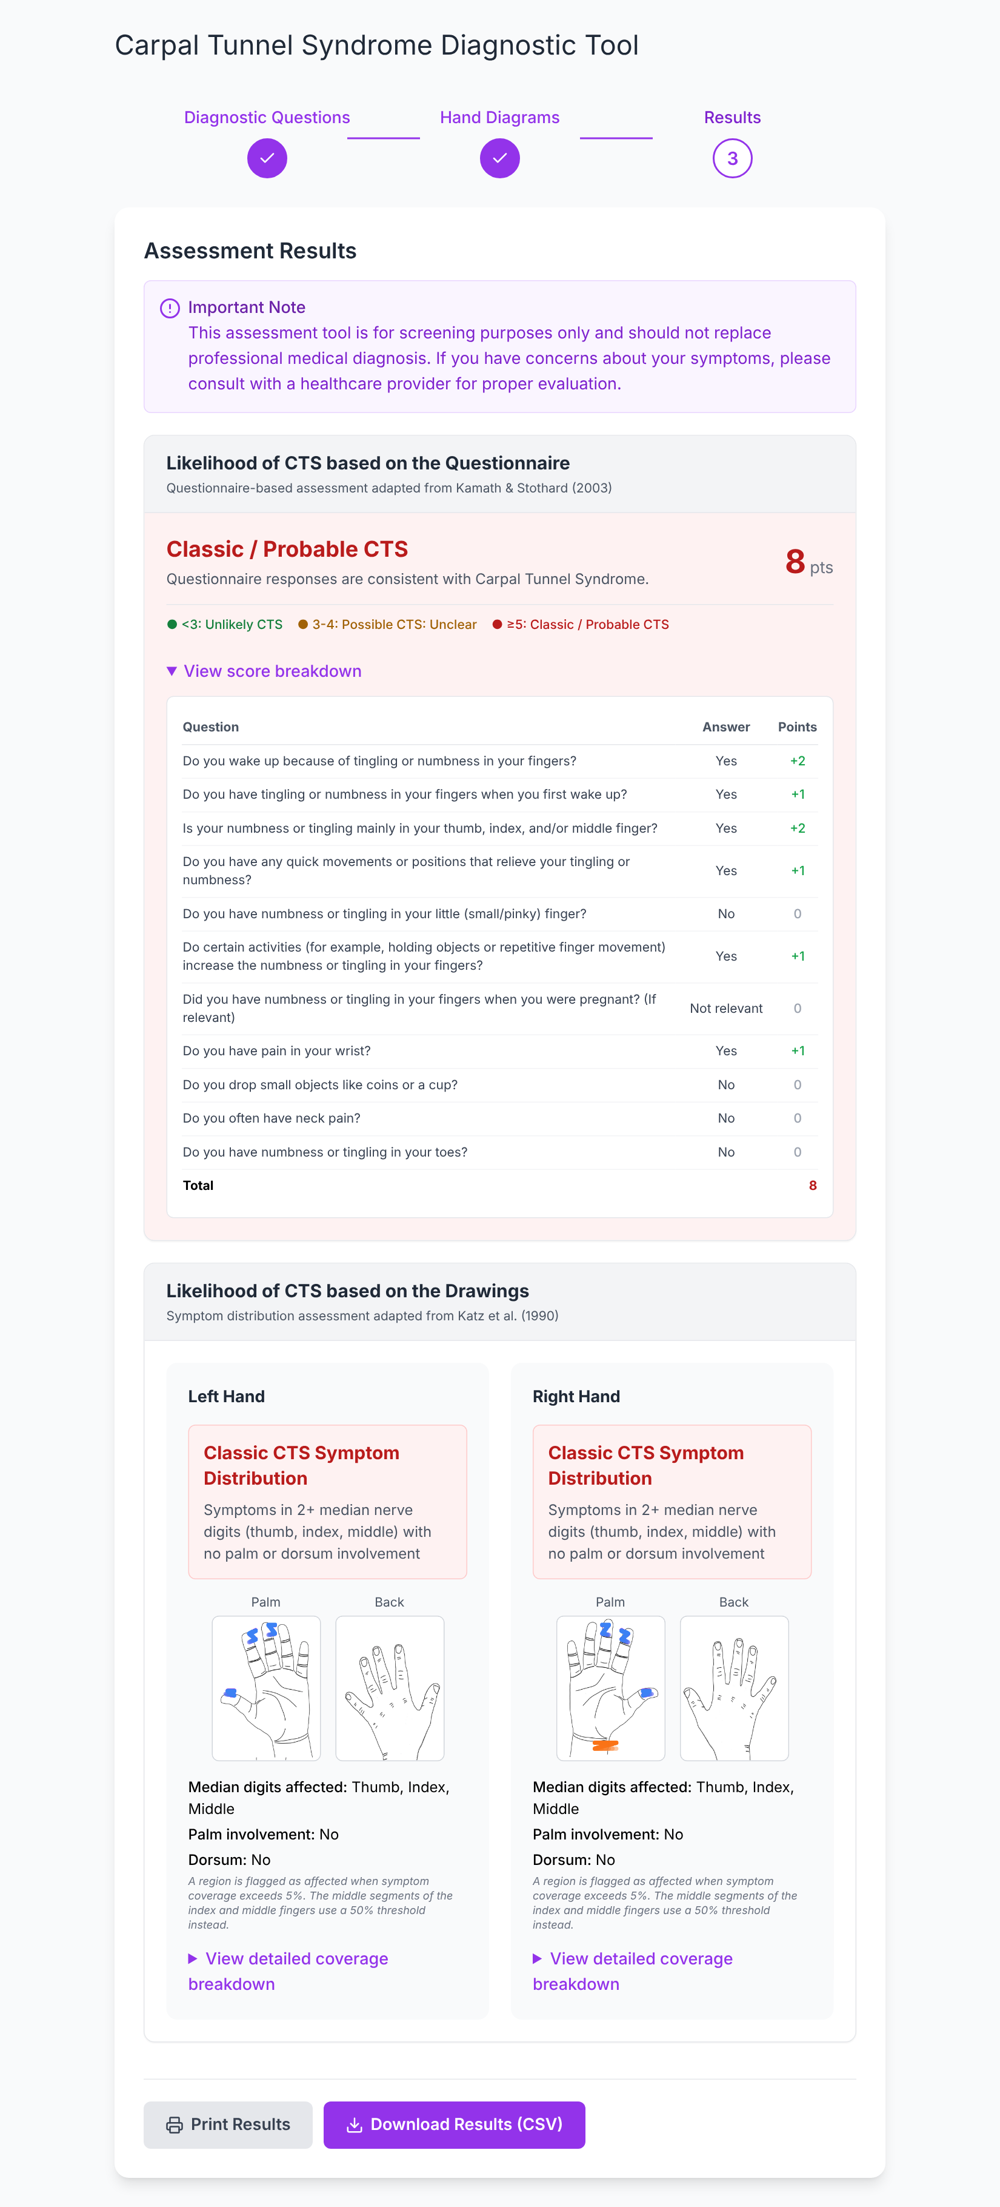
Figure 6. Healthcare professional view: points, score breakdown, digit and palm summaries, and the CSV download.

Export
- CSV download (healthcare professional view only, per PI decision) builds a file named cts_results_<date-time>.csv in the browser. It uses exactly the same field names as the REDCap submission (Section 5), so it can serve as a manual backup or be imported into REDCap.
- Print is intended to print the results page using the print styles in app/globals.css. (Note: this is only available on the redcap branch.)
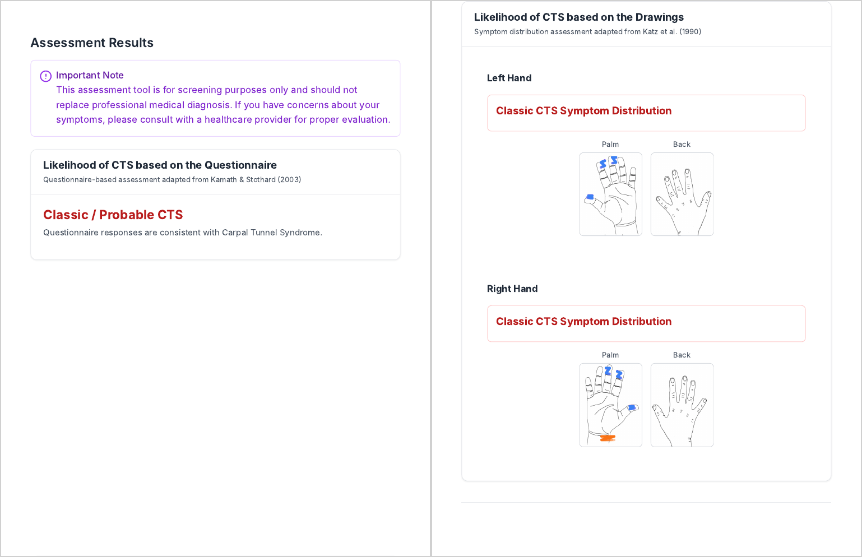
Figure 7. Printed / saved-as-PDF copy of the patient view. Buttons and banners are hidden; the combined hand drawings are included.

Session protection
- Idle timeout. After 10 minutes with no input, a warning appears with a 60-second countdown, then the page reloads and all answers are cleared. Moving the mouse does not count as activity, so a stray movement on a shared device cannot defeat it.
- Error recovery. An unexpected error shows a friendly message with a Reload button rather than a broken page.
- No persistence. Answers live only in the page's memory. Refreshing or closing the tab erases them.

Where it lives in the code
- Results page, role dialog and export buttons: components/sections/Results.js
- CSV builder and REDCap field map: hooks/useExport.js (buildFieldMap, buildCsvRows)
- Idle timeout: hooks/useIdleTimeout.js; durations in data/constants.js (IDLE_TIMEOUT_MS, IDLE_WARNING_MS)
- Error recovery: components/ErrorBoundary.js
- Tests: tests/exportCsv.test.js, tests/useIdleTimeout.test.js

5. REDCap integration (original design, redcap branch)
The website stays a static front end, and the study's data is stored in REDCap. A static site cannot hold the REDCap API token safely, so three small server functions sit between the browser and REDCap: they hold the token, look up participants and forward submissions. In the original design these run as Cloudflare Pages Functions, which is why the design must change before study use (Section 7). The server secrets and REDCap project setup the integration needs are listed in the Walkthrough, Section 4.2.
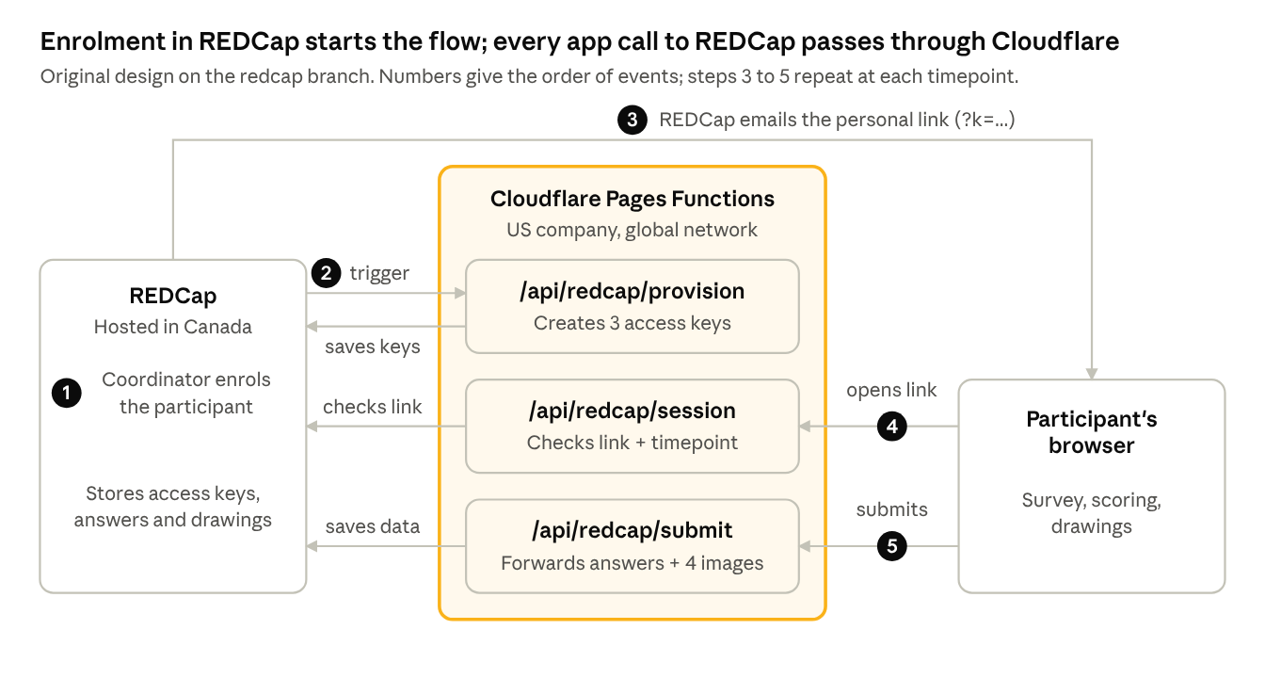
Figure 8. REDCap integration flow in the original design. Step 4 runs when the participant opens the link, before the survey starts: it checks the link and that the timepoint is not yet submitted. Step 5 runs when they reach the Results page.

5.1 Workflow
- Enrol. The coordinator creates a participant record in REDCap. REDCap's Data Entry Trigger calls /api/redcap/provision, which generates one unguessable access key per timepoint (baseline, 6-week, 3-month) and writes it back to the record's access_key field. Existing keys are never changed, so a link already emailed stays valid.
- Invite. A REDCap Alert emails the participant a link of the form https://<site>/?k=[access_key] at each timepoint.
- Open. The browser sends the key to /api/redcap/session. The function finds the matching record and timepoint in REDCap and returns a signed, HttpOnly session cookie (valid 2 hours). The browser only learns the timepoint label (e.g. "6-Week"), never the record ID.
- Complete. The participant fills in the survey as in Sections 2–4. A banner shows which timepoint they are completing.
- Submit. When Results appear, the browser automatically posts the field map plus four PNG images (combined drawings for each hand, palm and back) to /api/redcap/submit. The function reads the record from the cookie and imports the data, then the images.
- Fallback. If submission fails, the banner offers a Try again button and asks the participant to contact the coordinator; in the professional view it also points to the CSV download.
Without a ?k= link the app runs in standalone mode and nothing is submitted.
Responses are final once submitted. After a timepoint is submitted, the participant cannot change it: reopening the link, reloading, or an idle-timeout reset shows an "already submitted" notice instead of the survey, and /api/redcap/submit refuses a second submission even from a session that is still open. A timepoint counts as submitted once its timestamp (time completed) field is filled, which happens when the answers are submitted on reaching the Results page. Opening the link does not close it, so a participant who leaves before finishing can come back. The one exception is a coordinator: clearing that event's timestamp in REDCap reopens the timepoint, and the next submission replaces the earlier answers. Other timepoints for the same participant are unaffected. Verified on the study's REDCap project in October 2026; tests in tests/redcapResubmission.test.js.
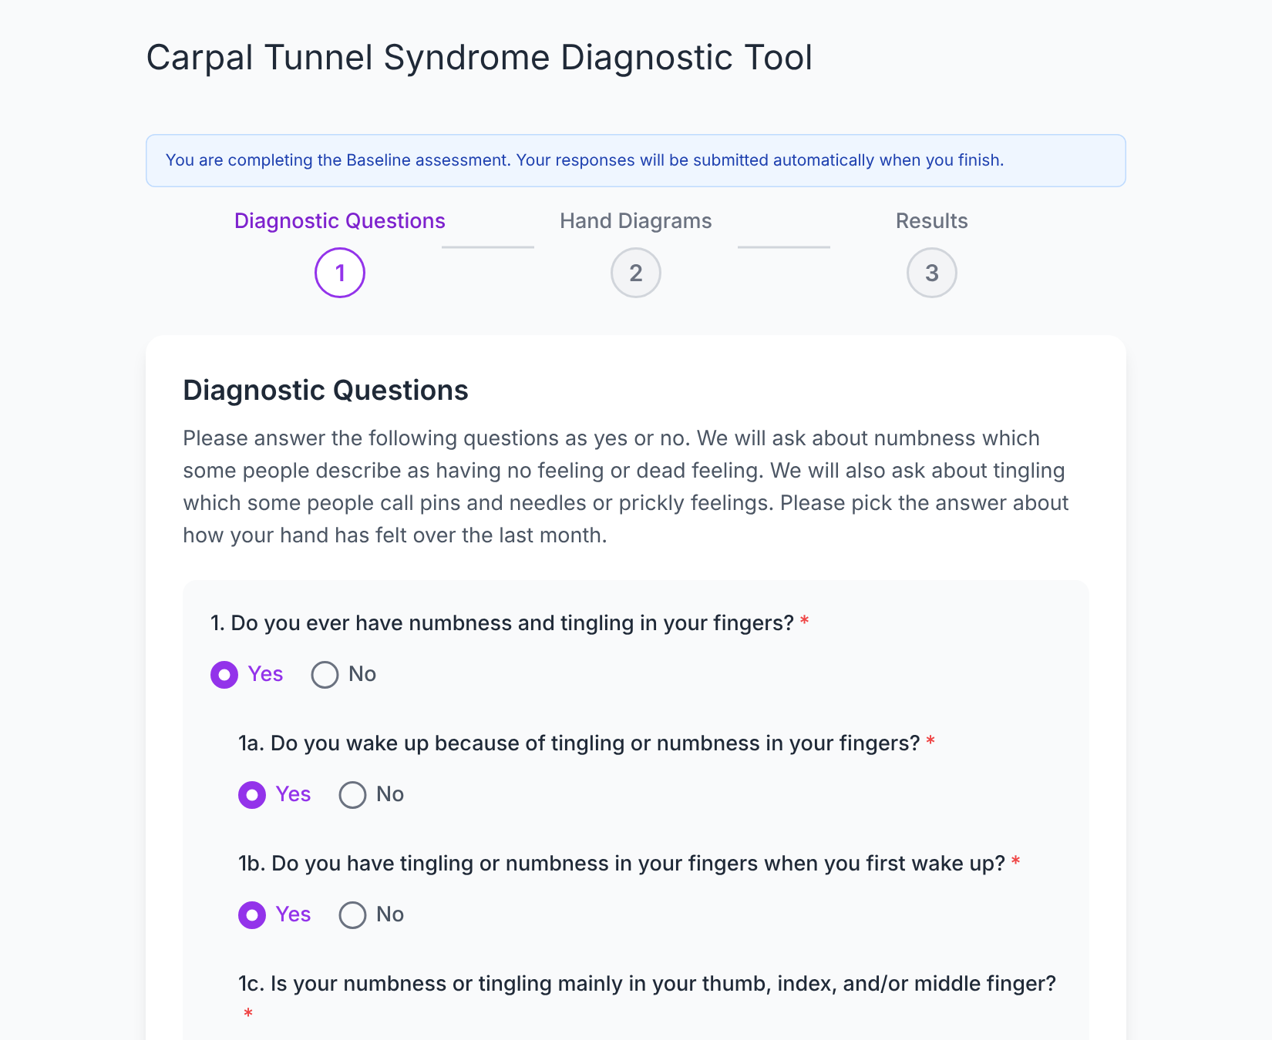
Figure 9. Study mode: the banner names the timepoint being completed.
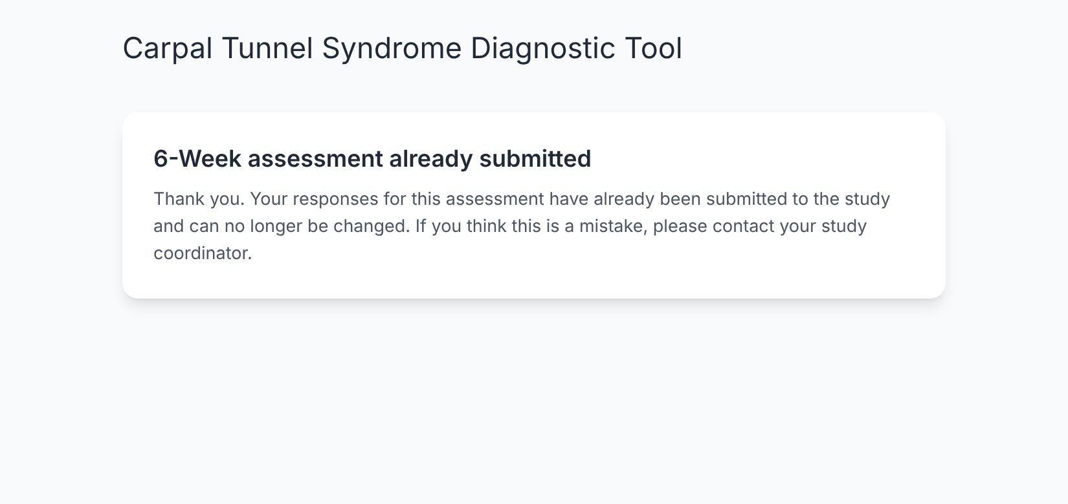
Figure 10. Reopening a link for a timepoint that was already submitted.
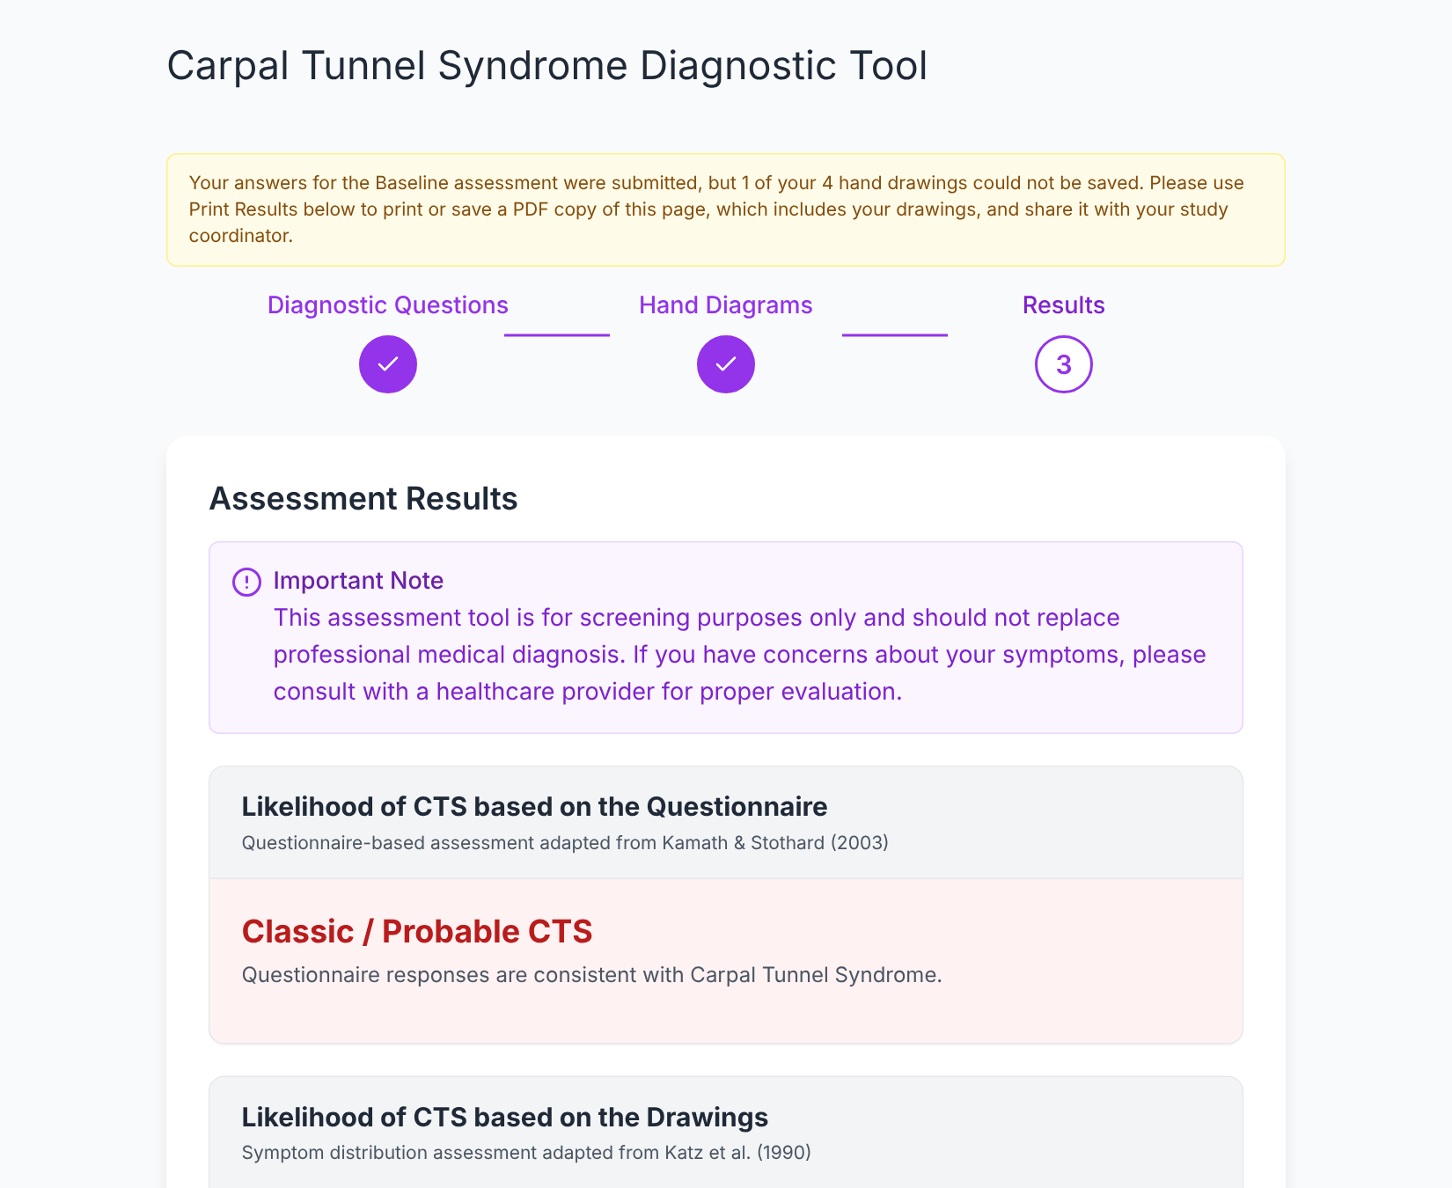
Figure 11. Answers saved but a drawing failed to upload: the participant is asked to print or save the results page and share it with the coordinator.

5.2 Security measures already built in
- The REDCap API token is stored only as a server secret; it never reaches the browser or the code repository.
- Access keys are 192-bit random tokens; the record ID and event name travel only inside the signed cookie.
- The provisioning endpoint rejects any call without the shared secret and, when configured, any call for a different REDCap project.
- Blank values never overwrite existing REDCap data, and the record ID / event fields cannot be set by the browser.

5.3 Where it lives in the code
- Server functions: functions/api/redcap/provision.js, session.js, submit.js
- Shared REDCap helpers, value coding, cookie signing: functions/api/_lib/redcap.js
- Browser side: lib/redcapClient.js, hooks/useRedcapSession.js, hooks/useRedcapSubmit.js
- Status banner: RedcapBanner in components/CTSSurvey.js
- Event names and image field names are listed at the top of provision.js, session.js and submit.js; change them there if the REDCap project uses different names.

6. Data handling & privacy
In standalone mode nothing leaves the device; in study mode one submission of under 1 MB is sent per completed session.

6.1 What a study submission contains
Data element | What it is | Approx. size
Questionnaire answers | 14 Yes/No (or Not relevant) answers, with gated-off items left blank | negligible (text)
Ease ratings and comments | Two 1–4 ratings and two free-text comment boxes | negligible (text)
Kamath result | Total score and classification | negligible (text)
Katz results | Classification per hand, plus % coverage for 12 regions × 3 symptoms and a combined total, per hand | negligible (text)
Hand-diagram images | Four PNGs (left/right × palm/back), 300 × 400 pixels each | tens of kB each
Timestamp | Date and time of submission | negligible (text)

The application itself asks for no name, email, date of birth or health card number; the link to a person exists only inside REDCap. Note: the free-text comment boxes could contain anything a participant types, including identifying details.

6.2 Measures that apply in both modes
- Processing on the device. Scoring, image analysis and CSV generation all run in the browser.
- No storage in the browser. Answers are held in memory only; refresh, idle timeout or closing the tab clears them. This protects data on shared clinic devices.
- Self-hosted assets. Hand outlines, fonts and scripts are served from the application's own site; no third-party trackers or analytics.
- Security headers. A Content-Security-Policy limits every page to the application's own site (connect-src 'self'). Other headers block embedding in other websites and disable camera, microphone, location and payment access.
- Not indexed. robots.txt asks search engines not to list the site.

6.3 Where it lives in the code
- Security headers: public/_headers
- Search-engine exclusion: public/robots.txt
- Field list sent to REDCap: buildFieldMap in hooks/useExport.js

7. Open item: data residency and REB approval
The original Cloudflare + REDCap design is not expected to be approved by the REB, and the hosting design must change before study data is collected. The rest of the application (Sections 2–4) is unaffected.

7.1 Why the original design fails
In the original design a submission travels browser → Cloudflare → REDCap. Cloudflare ends the encrypted (HTTPS) connection at its nearest data centre, which is not guaranteed to be in Canada, and runs the submit function there, so participant data is briefly readable inside the infrastructure of a US-based company. The REB requires the data to stay in Canada and under the institution's control the whole way through, so any option that routes data through a global cloud service has been set aside.
Two smaller exposures exist even before submission: the access key in the invitation link (?k=…) is sent to Cloudflare when the page loads, and so are participants' IP addresses.

7.2 Options
These options follow the Pain & Symptom Application – Data Residency Decision Review, adapted to CTS. All of them keep the data on a local device or on a server in Canada.
Option | How it would work for CTS | Work | Estimated time | REB likelihood | Estimated cost (CAD) | Remote use
1a. Web app → encrypted device | Participant completes the survey in person; the CSV (and the four hand images) is saved to an encrypted, study-owned drive and collected by the team | Small | Days | High | USB: ~$15–40 each | No
1b. Mobile app | Same app packaged for a study-provided tablet; results saved on the device and collected in person | Moderate | Weeks | High | App Store ~$140/yr; Google Play ~$35 once; tablets ~$150–700+ each | No
2a. Western-managed server (WTS) → REDCap | The site and the three REDCap functions are hosted on Western Technology Services infrastructure in Canada; data goes browser → Western server → Western REDCap | Large | Weeks or more | High | ~$64/month (2 cores, 4 GB RAM, 20 GB) | Yes
2b. Commercial cloud, Canadian region → REDCap | Same as 2a, but the server runs on Azure Canada Central or AWS Canada; passes through a provider subject to US law | Large | Weeks or more | Moderate / conditional | ~$20–70/month + storage | Yes

Cost figures for options 1a, 1b and 2b are planning estimates taken from the review; confirm current pricing and REB / TRAC requirements before relying on them.
Option 2a cost. WTS's Virtual Server Hosting page (checked October 2026) lists internal shared-server rates of $40 per server, $3 per CPU core, $4 per GB of RAM and $0.10 per GB of storage. The page does not state the billing period; the review treats it as monthly. The proposed server comes to $64:
Part | What it is | Proposed | Cost | Why this size
Base VM | The virtual server itself; includes operating system licensing, backups and initial setup | 1 | $40 | Fixed charge per server
CPU cores | Processing capacity: how many tasks the server can work on at once | 2 shared | $6 | The app uses little processing; updates just run a little slower
RAM | Short-term working memory used while programs run | 4 GB | $16 | Measured: the app peaks at about 226 MB even with 300 simultaneous submissions, but updating it peaks at 1.1 GB while the app keeps running, plus the operating system and web server. Can be lower to save cost
Storage | Disk space that keeps files permanently | 20 GB | $2 | The app needs about 1 GB; the rest is for the operating system, updates and logs. Study data is stored in REDCap, not on the server
Total |  |  | $64

Memory was measured by running the REDCap functions and the built site in a Node.js test server with a simulated REDCap. Setup steps and the WTS request are in the Walkthrough, Section 3.2.

7.3 What each option means for the code
- 1a is closest to done. The CSV download already uses the exact REDCap field names (Section 4). Its answers are written as words (Yes, No), while REDCap stores codes (1, 0), so the download should apply the same coding as the server before files are imported into REDCap. Remaining work: add the four hand-diagram images to the download (for example as one ZIP), make the download available on the study device (it is currently in the healthcare professional view only), and set a file-naming routine. Deploy from a branch without the functions/ folder: Cloudflare Pages deploys that folder automatically as server code, so leaving it out publishes only the static site and removes the REDCap submission path (Walkthrough, Section 3.1.1).
- 1b reuses the same code inside an app wrapper; saving to the device replaces the browser download.
- 2a / 2b reuse the REDCap logic in functions/api/. It already relies only on standard web features (fetch, FormData, Web Crypto), so it can be moved into a small Node.js server with a thin adapter for the onRequestGet / onRequestPost handler shape. The static site (npm run build → out/) can be served by the same server. The server secrets (Walkthrough, Section 4.2) move to that server's configuration, and REDCap's Data Entry Trigger URL must point at the new address.
- If only the server functions move and the static site stays on Cloudflare, three more changes are needed: (1) the browser must call the new server's address, which means updating connect-src in public/_headers; (2) the session cookie would become cross-site and be blocked by many browsers, so the session should be passed as a token instead; (3) the access key should move from ?k= to the URL fragment (#k=), which browsers never send to the server. Hosting everything on the Western server avoids all three and is simpler to explain to the REB.

7.4 Suggested direction
For a longitudinal study with emailed invitations at baseline, 6 weeks and 3 months, participants are likely to complete the survey remotely, which only option 2 supports. Option 2a (Western-managed server) has the highest approval likelihood among the remote options. If the study can collect data in person, option 1a is the fastest route and could serve as an interim solution while the server is requested. The PI and REB should make the final call.
The steps to implement option 2a are drafted in the Walkthrough, Section 3.2; option 1a (Cloudflare Pages, no data submitted) in Section 3.1.

8. Technology stack & project structure
Technology | Purpose | Note
Next.js 15 | Site framework | Static export (output: 'export'); build output is plain files in out/
React 19 | Interactive pages (questions, canvases, results, dialogs) | Runs in the browser
Tailwind CSS 3 | Layout and styling | Responsive for desktop, tablet and phone
driver.js | Guided tours and highlights | Steps in lib/tourConfig.js
lucide-react | Icons | Bundled with the site
Vitest | Unit tests (scoring, symptom flags, CSV, idle timeout, REDCap functions) | Run with npm test
ESLint | Code style checks | Run with npm run lint
GitHub Actions | CI: lint, tests and build | Runs on every push and pull request (.github/workflows/ci.yml)
Cloudflare Pages + Pages Functions | Hosting of the demo, and the REDCap server functions on the redcap branch | To be replaced for study use (Section 7)

Project structure
app/ Next.js entry: layout, page, global + print styles
components/
CTSSurvey.js Main orchestrator: sections, navigation, REDCap banner
sections/ DiagnosticQuestions, HandDiagrams, Results
HandDiagramCanvas.js One drawing canvas + Clear button
*Modal.js Idle warning, empty-diagram confirmation, base modal
ErrorBoundary.js Friendly error page with Reload
data/ Questions, thresholds, colours, region list, timeouts
hooks/ Drawing, scoring, export, tours, idle timeout, REDCap
lib/ Pure logic: scoring, canvas, tours, REDCap client
functions/api/ Cloudflare Pages Functions for REDCap (redcap branch)
public/ Hand outlines, security headers, robots.txt
tests/ Vitest unit tests

Where common changes are made
The Walkthrough, Section 2, covers running the app locally and the change-and-review workflow. This table maps common changes to the files involved.
Change | Where
Question wording, order, gateways, REDCap field names | data/diagnosticQuestions.js
Kamath weights and cut-offs | lib/kamathScoring.js (kamathQuestionWeights, KAMATH_BANDS)
Katz thresholds (5%, 50%) | data/constants.js (MIN_THRESHOLD, HALF_THRESHOLD)
Katz classification rules | calculateKatzScore in lib/katzScoring.js
Hand regions | public/hands/*.svg labels and KATZ_REGIONS in data/constants.js (keep both in sync)
Symptom colours, brush size | data/constants.js, lib/canvasUtils.js
Idle timeout duration | IDLE_TIMEOUT_MS, IDLE_WARNING_MS in data/constants.js
Tour steps | lib/tourConfig.js
CSV / REDCap field names and coding | hooks/useExport.js, functions/api/_lib/redcap.js
REDCap event names | functions/api/redcap/provision.js, session.js
Allowed outside websites (CSP), security headers | public/_headers
Deploying under a sub-path | basePath in next.config.mjs

If a clinical value or field name is changed, re-run npm test. The scoring and CSV tests will flag unintended changes. Field-name changes must also be made in the REDCap data dictionary.

9. Open items
Decisions (PI / REB)
- Hosting and data residency. Choose an option from Section 7 (suggested: 2a Western-managed server, with 1a as an interim if in-person collection is possible). Confirm pricing, Western internal rates and REB / TRAC requirements.
- Free-text comments. Decide whether the two comment boxes are kept in study mode, given that participants may type identifying details (Section 6.1). If kept, add a short instruction not to include personal information.
- Clinical cut-offs. Confirm the Kamath bands (≤ 2 / 3–4 / ≥ 5) and the Katz thresholds (5% coverage, 50% for index/middle middle segments) for the study.
Development
- Move the REDCap functions off Cloudflare to the chosen host. Steps for a Western-managed server are drafted in the Walkthrough, Section 3.2. Update the Data Entry Trigger URL and the REDCap Alert link to the new address.
- Merge redcap into main once the new hosting design is in place, so there is a single source of truth. Until then, main still has the Print button bug fixed on redcap.
- Timestamp source. The submission timestamp comes from the participant's device clock and time zone. Consider stamping it on the server instead.

