Dual-IMU Knee Goniometer — Project Handover
State at transition, design decisions and their rationale, and directions to explore
Drafted in October 2026, prepared by Jamie Kim

About this document
This is the handover record for the dual-IMU knee goniometer proof of concept (August–October 2026). It is composed of the following:
- Handover summary (§1): the state of the project at transition, open issues, and what to do next. Read this first.
- Design decisions (§2–§8): what was decided, why, and which alternatives were considered; §8 describes what the software can do.
- Testing and future directions (§9–§10): the preliminary stationary test results and a summary of the areas to explore.
- Areas to explore (Appendices A–D): longer analyses of directions that were weighed but not pursued yet.
Companion documents (the SOP, the README and the test report) are listed in §1.4.

Key terms
Term | Meaning
IMU (inertial measurement unit) | A small motion-sensor chip. The one used here (BMI270) contains an accelerometer and a gyroscope.
Accelerometer | Measures acceleration, including gravity. When the board is still, it shows which way is down.
Gyroscope (“gyro”) | Measures how fast the board is rotating. Good for quick movements, but small errors add up over time.
Magnetometer | Measures the magnetic field, like a compass. Present on the board (BMM150) but not used.
Orientation | How a board is tilted and turned in space. Stored as a quaternion, a set of four numbers.
6-DOF / 9-DOF | Fusion from accelerometer + gyroscope (6 measured axes), or with the magnetometer as well (9).
Drift | A slow, steady error that builds up over time even when nothing moves.
Gyro bias | The small rotation a gyroscope reports when it is actually still; the main cause of drift.
Heading (yaw) | Which way a board faces when turned about the vertical, like a compass direction. Gravity cannot tell this.
Central / peripheral | The thigh board (central) collects data from the shank board (peripheral) and sends both to the PC.
Firmware | The program running on each Arduino board (an Arduino “sketch”). Changing it means reflashing the board.
UART / serial link | The simple wired connection between the two boards; baud is its speed in bits per second.
Packet / checksum | One message sent between the boards / a check number that reveals a corrupted message.
Calibration (zeroing, sweep) | The short routine at the start of each session that tells the software how the boards sit on the leg (§5.3).
GUI / CLI | Graphical user interface (the windowed program) / command-line interface (text commands in a terminal).

1. State at transition (October 2026)

1.1 Current state
- Working bench prototype. Two Arduino Nano 33 BLE Rev2 boards (thigh = central, shank = peripheral) in 3D printed cases (DualIMU_Goniometer.stl), joined by soldered UART wires, each powered over USB; the central streams to a PC at 50 Hz.
- Interface built for testing. Live Graphical User Interface (GUI) with guided calibration and auto-saved sessions; command-line (CLI) collector; self-tests pass. The GUI is released as a Windows program, KneeGoniometerGUI.exe (Link).
- Preliminary stationary testing done. ≈0.01–0.02° noise, ≈ −0.001 °/min drift on healthy hardware; 45°/90° rigs read 45.0°/89.0° (preliminary; §9).
- Standard Operating Procedure (SOP) developed (docs/SOP_Build_and_Use.docx): build, setup, sessions and troubleshooting for operators; Python setup and releasing a new GUI version are in its appendices.

1.2 Open issues
- Faulty board. One board’s BMI270 fails after 20–40 min (§9). It must be identified and replaced. It should be the board without the red wire soldered to the 3.3 V pin; confirm before replacing it.
- Raw test data not preserved. The stationary-test CSVs and diagnostic logs were not archived (*.csv / *.log are git-ignored intentionally during development phase). Plan data storage once testing moves beyond the preliminary stage.
- Peripheral-only fault guard. The sensor-fault guard runs on the peripheral only; the central has no equivalent (§7.2).
- Angle log resolution. Angles are written to 0.01°, which limits how low a noise floor can be measured.

1.3 Recommended next steps
- Replace the faulty board; repeat a one-hour stationary run on two healthy boards for a clean baseline.
- Sweep both nodes during calibration so the angle uses both sensors (§5.3)
- Try the strap placement in the SOP on a person and refine it if the boards shift during movement.
- Controlled accuracy test: repeated 0°/45°/90° placements on a precise rig or against a goniometer.
- Dynamic range-of-motion testing (tune TWO_KP and the soft accel gate, §4.3, if fast reps lag or overshoot).
- Consider the longer-term directions in §10 and Appendices A–D (battery + Bluetooth for an untethered device; absolute angle via functional calibration).

1.4 Documents & files reference
Document | Use it for
docs/SOP_Build_and_Use.docx (master; .md mirror) | Building the device and running a session
docs/Project_Handover.md (+ .docx) | This document: state, design rationale, future directions
analysis/static_test/Static_Stability_Test_Report.docx | Preliminary Stationary Test Report
analysis/static_test/FINDINGS.md | Detailed working record behind the report
README.md | Technical reference: math, wire protocol, commands

File / folder | Contents
central_imu/central_imu.ino | Thigh board firmware
peripheral_imu/peripheral_imu.ino | Shank board firmware
knee_collector_uart.py | Angle math, calibration, CLI collector, --selftest
knee_gui.py | Live GUI (uses knee_collector_uart.py)
requirements.txt | Python dependencies
DualIMU_Goniometer.stl | 3D printable board case (base + lid)
analysis/static_test/ | Stationary Test Report, its figures, and the analysis scripts behind them (reusable for future stationary tests)
analysis/diagnostics/parse_diag.py | Diagnostic log → tables
docs/ | SOP, this document, and its figures (docs/images/handover/)
docs/build_docs.sh | Regenerates this document’s .docx from its Markdown
.github/workflows/release.yml | Builds KneeGoniometerGUI.exe on a v* tag

2. Problem and goals
The goal is a low-cost wearable that measures knee flexion angle from two inertial sensors, one above and one below the knee.
Goal | Explanation
Placement independence | The boards should not need to be mounted at a precise or repeatable orientation on the limb.
Robust signal | The collected signals should be stable at rest, smooth through motion. There should be no drift in the angle.
Simple design | Prefer the smallest system as a proof of concept that can be easily built and tested.
Usable in testing sessions | A GUI that drives calibration, shows live data, and saves every session automatically.
Scope: sagittal-plane knee flexion (standing range of motion, gait, sit-to-stand), relative to a calibration pose. Absolute anatomical angles and 3D kinematics are out of scope (see §5.5 and §10).

3. System architecture
One motion sensor is placed on the thigh while the other is mounted on the shank. The shank board sends its readings to the thigh board through a wire; the thigh board adds its own and passes both to the PC, which works out the knee angle, shows it live and saves it (Figures 1 and 2).
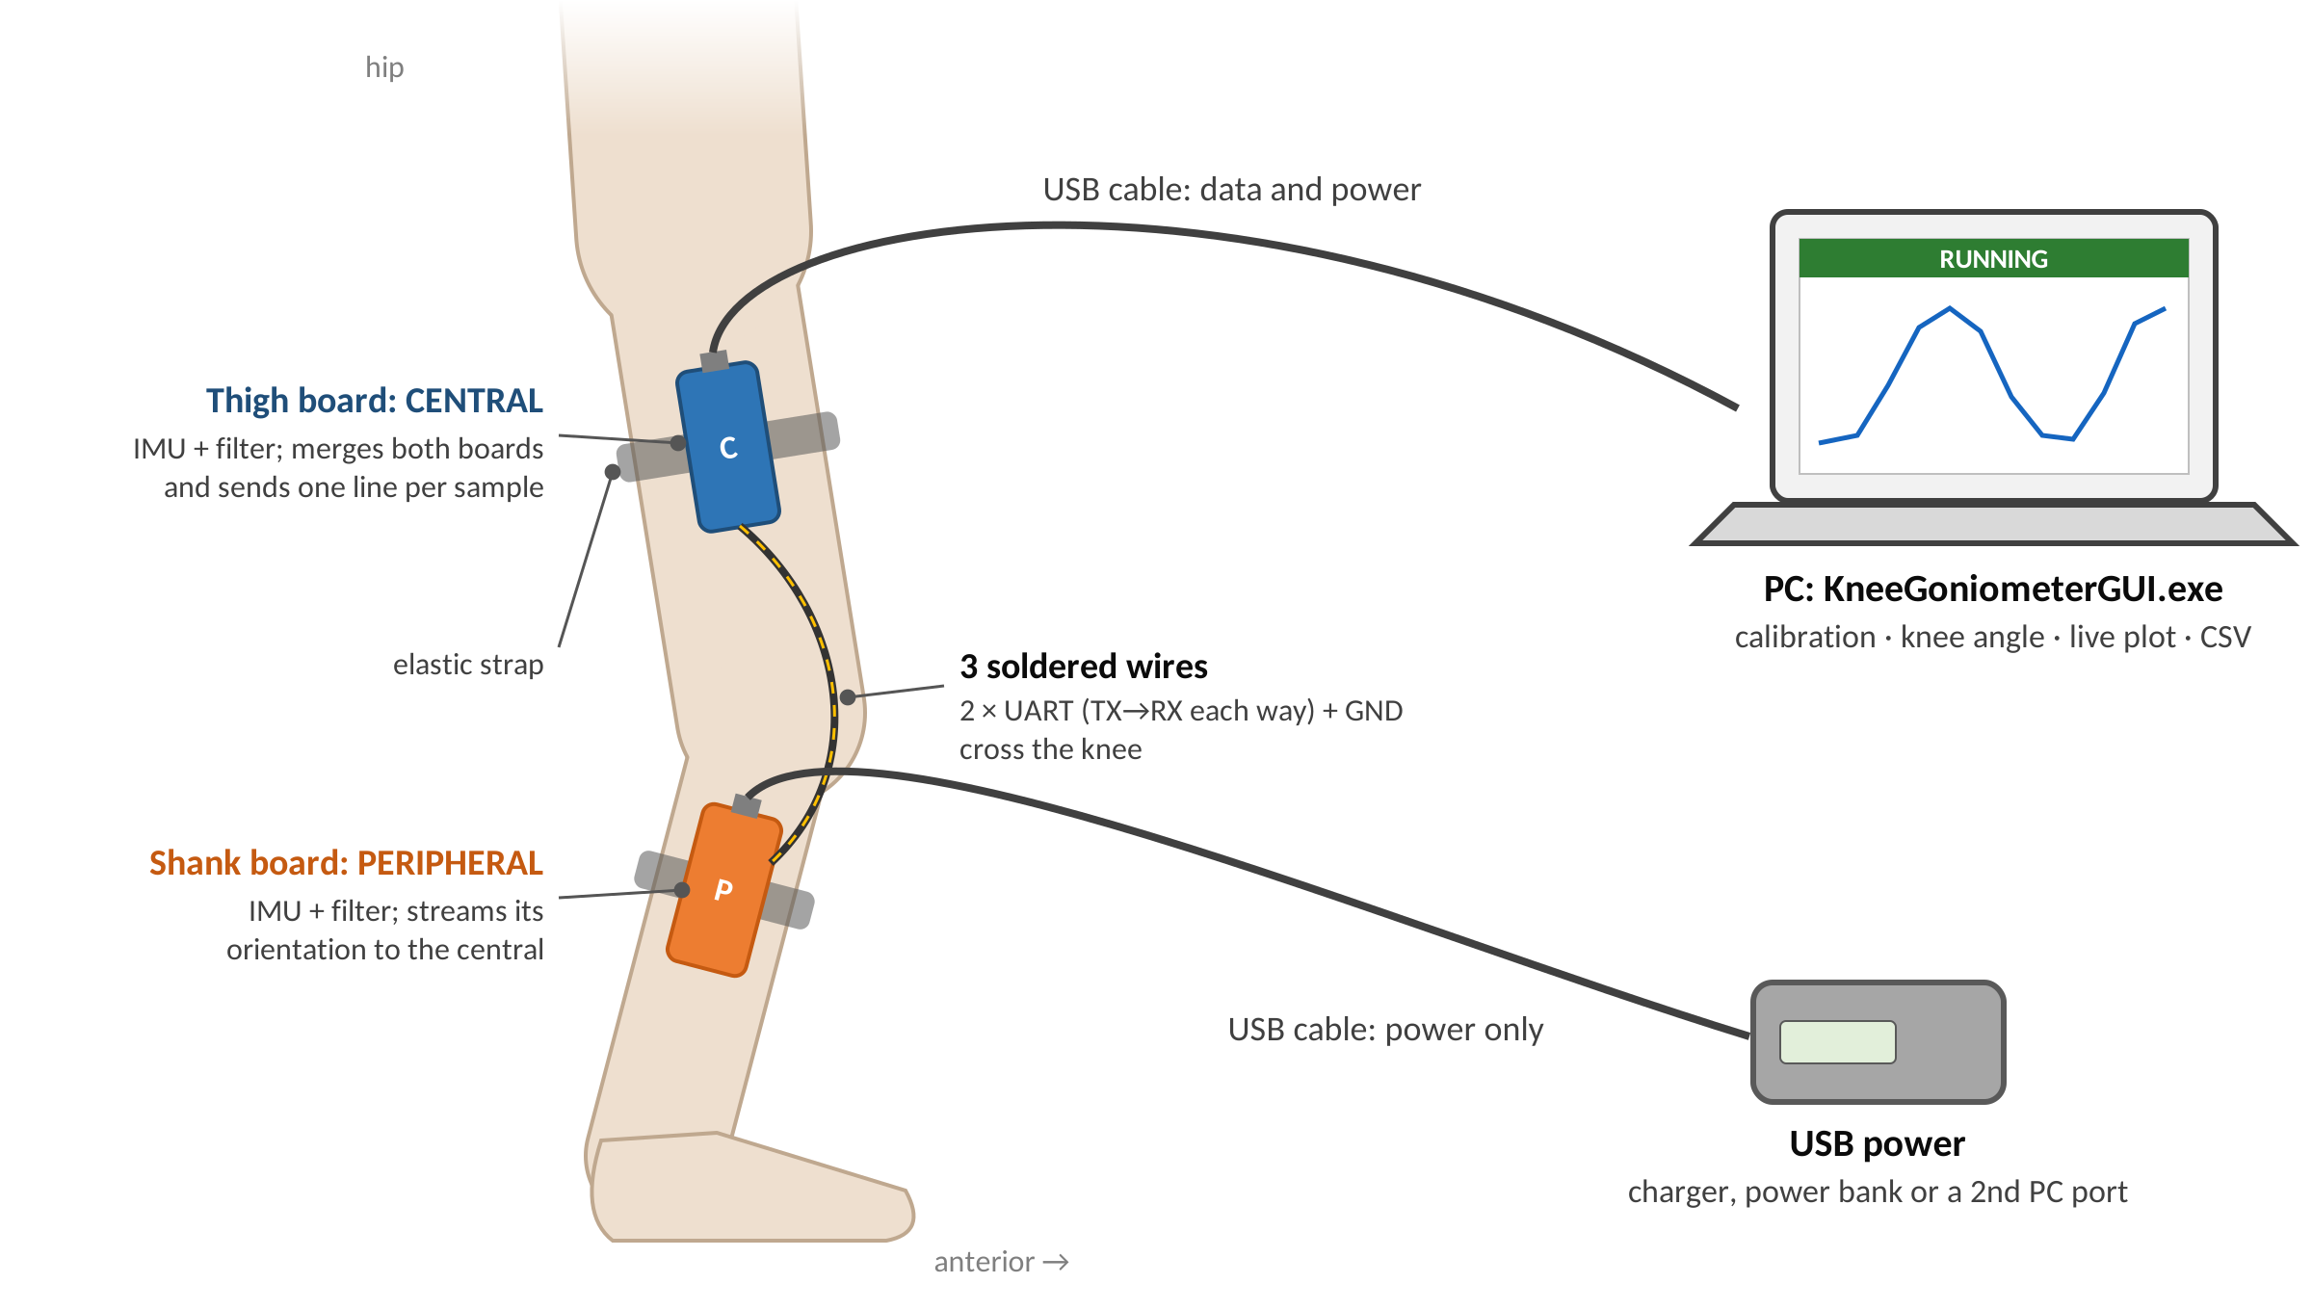
Figure 1. The prototype on the leg (side view). Each board sits in a printed case, held by an elastic strap. Pointing the USB ports toward the hip is a convention for tidy cables and consistent placement; the calibration does not depend on it.
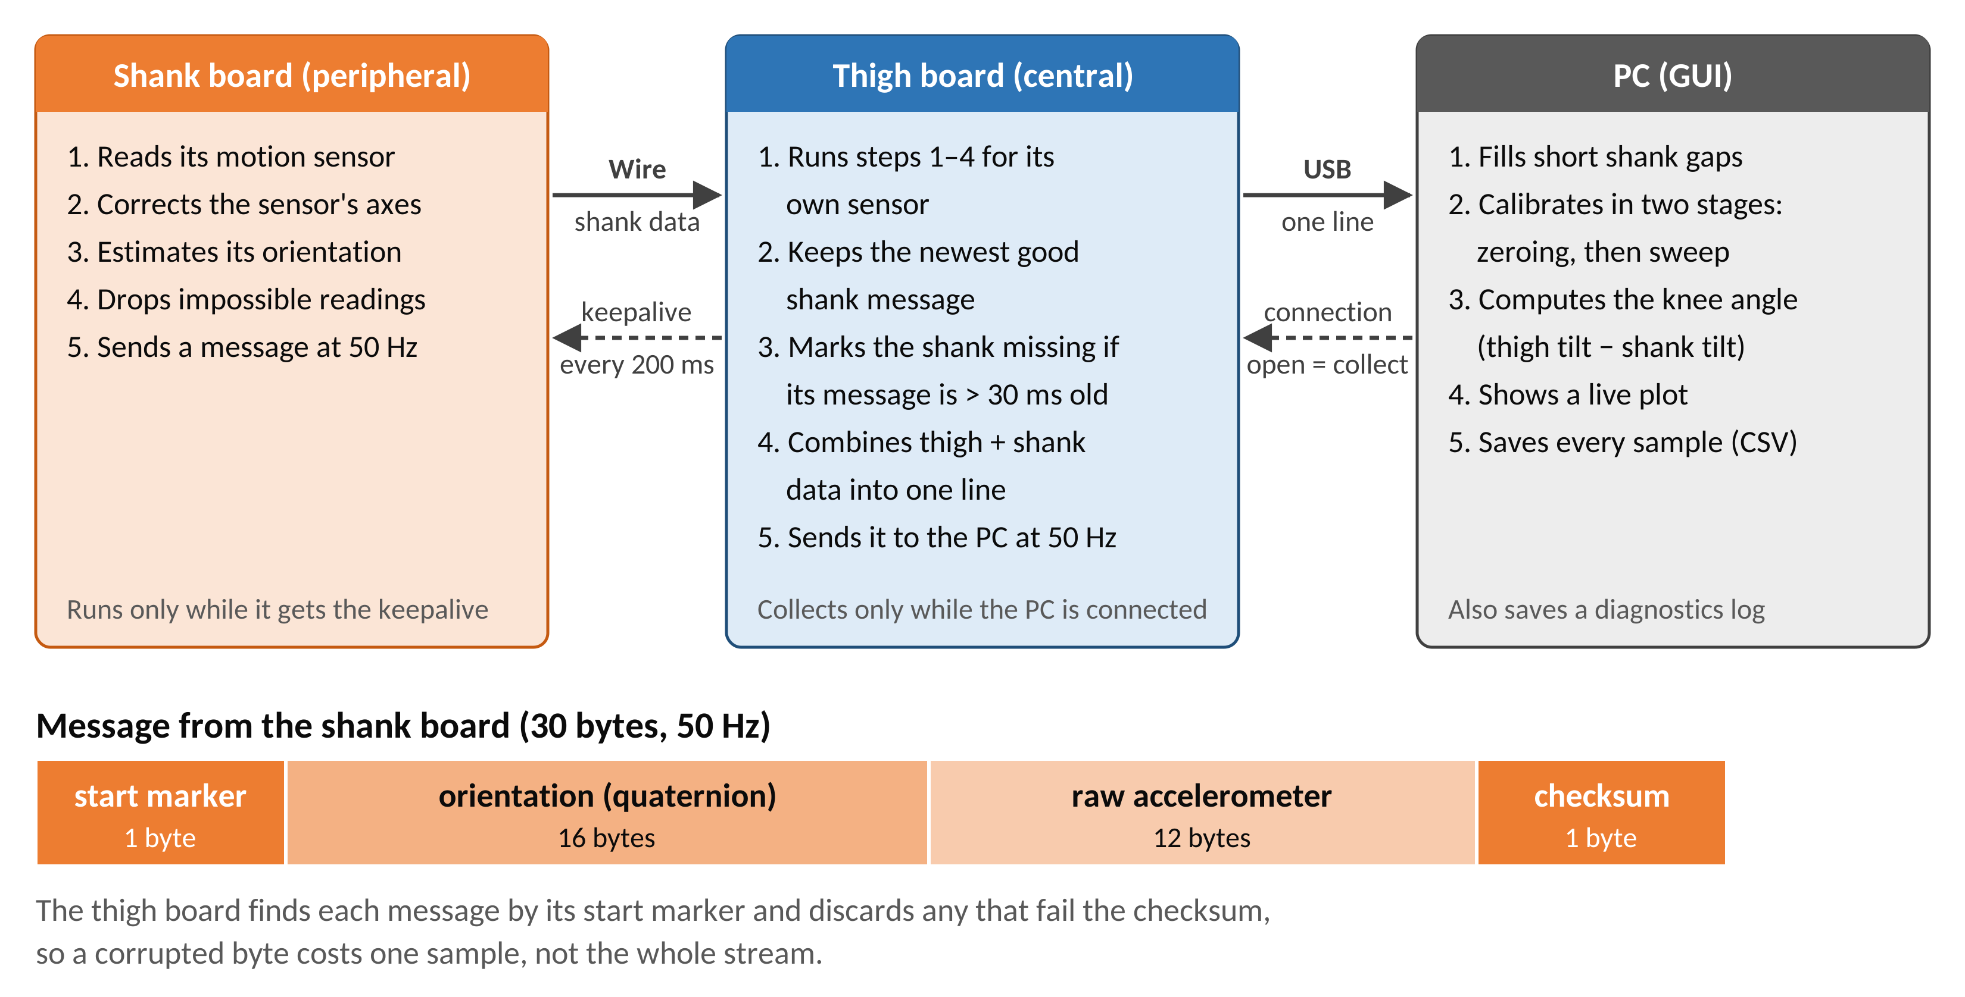
Figure 2. Data flow for one sample, and the shank packet sent over the wire.

3.1 Two boards, one connection to the PC
- Design Decision: The thigh board (central) works out its own orientation, receives the shank board’s (peripheral) orientation over a wire, and sends both to the PC as one line per sample. The PC calculates the angle.
- Why: The thigh and shank readings must belong to the same moment. At 50 samples per second, a new sample arrives every 20 ms, so even a small mismatch between the two boards would pair readings taken at different times and distort the angle during movement. Merging on the thigh board means each line already holds a matched pair when it reaches the PC. Of the ways to keep the two in step, this was the simplest and the most reliable. It also means only one board is plugged into the PC, and the angle calculation stays on the PC, where it can be tested and changed without reprogramming the boards.
- Alternatives: Plugging each board into the PC separately, which would leave the PC to line up two independent streams in time; calculating the angle on the board (harder to test and change).

3.2 Hardware
- Design Decision: Arduino Nano 33 BLE Rev2, using its built-in BMI270 motion sensor (accelerometer + gyroscope). Its built-in magnetometer is not used (§4.1).
- Why: Off-the-shelf and inexpensive, with the sensor already on the board, familiar Arduino tools, and a Bluetooth radio for a future wireless version.

3.3 Physical build
- Design Decision: Printed cases and elastic straps; the boards are joined by three soldered wires. The thigh board is powered and read through one USB cable to the PC; the shank board has its own USB power.
- Why: The simple, quickest way to a working, reliable bench prototype.
- Trade-offs: The person is tied to the PC and to power, and a wire runs across the knee. Batteries and wireless links are future work (Appendix C).

4. Sensor fusion
Each board turns its raw sensor readings into a steady estimate of how it is tilted. These choices keep that estimate stable at rest and accurate during movement (Figure 3).
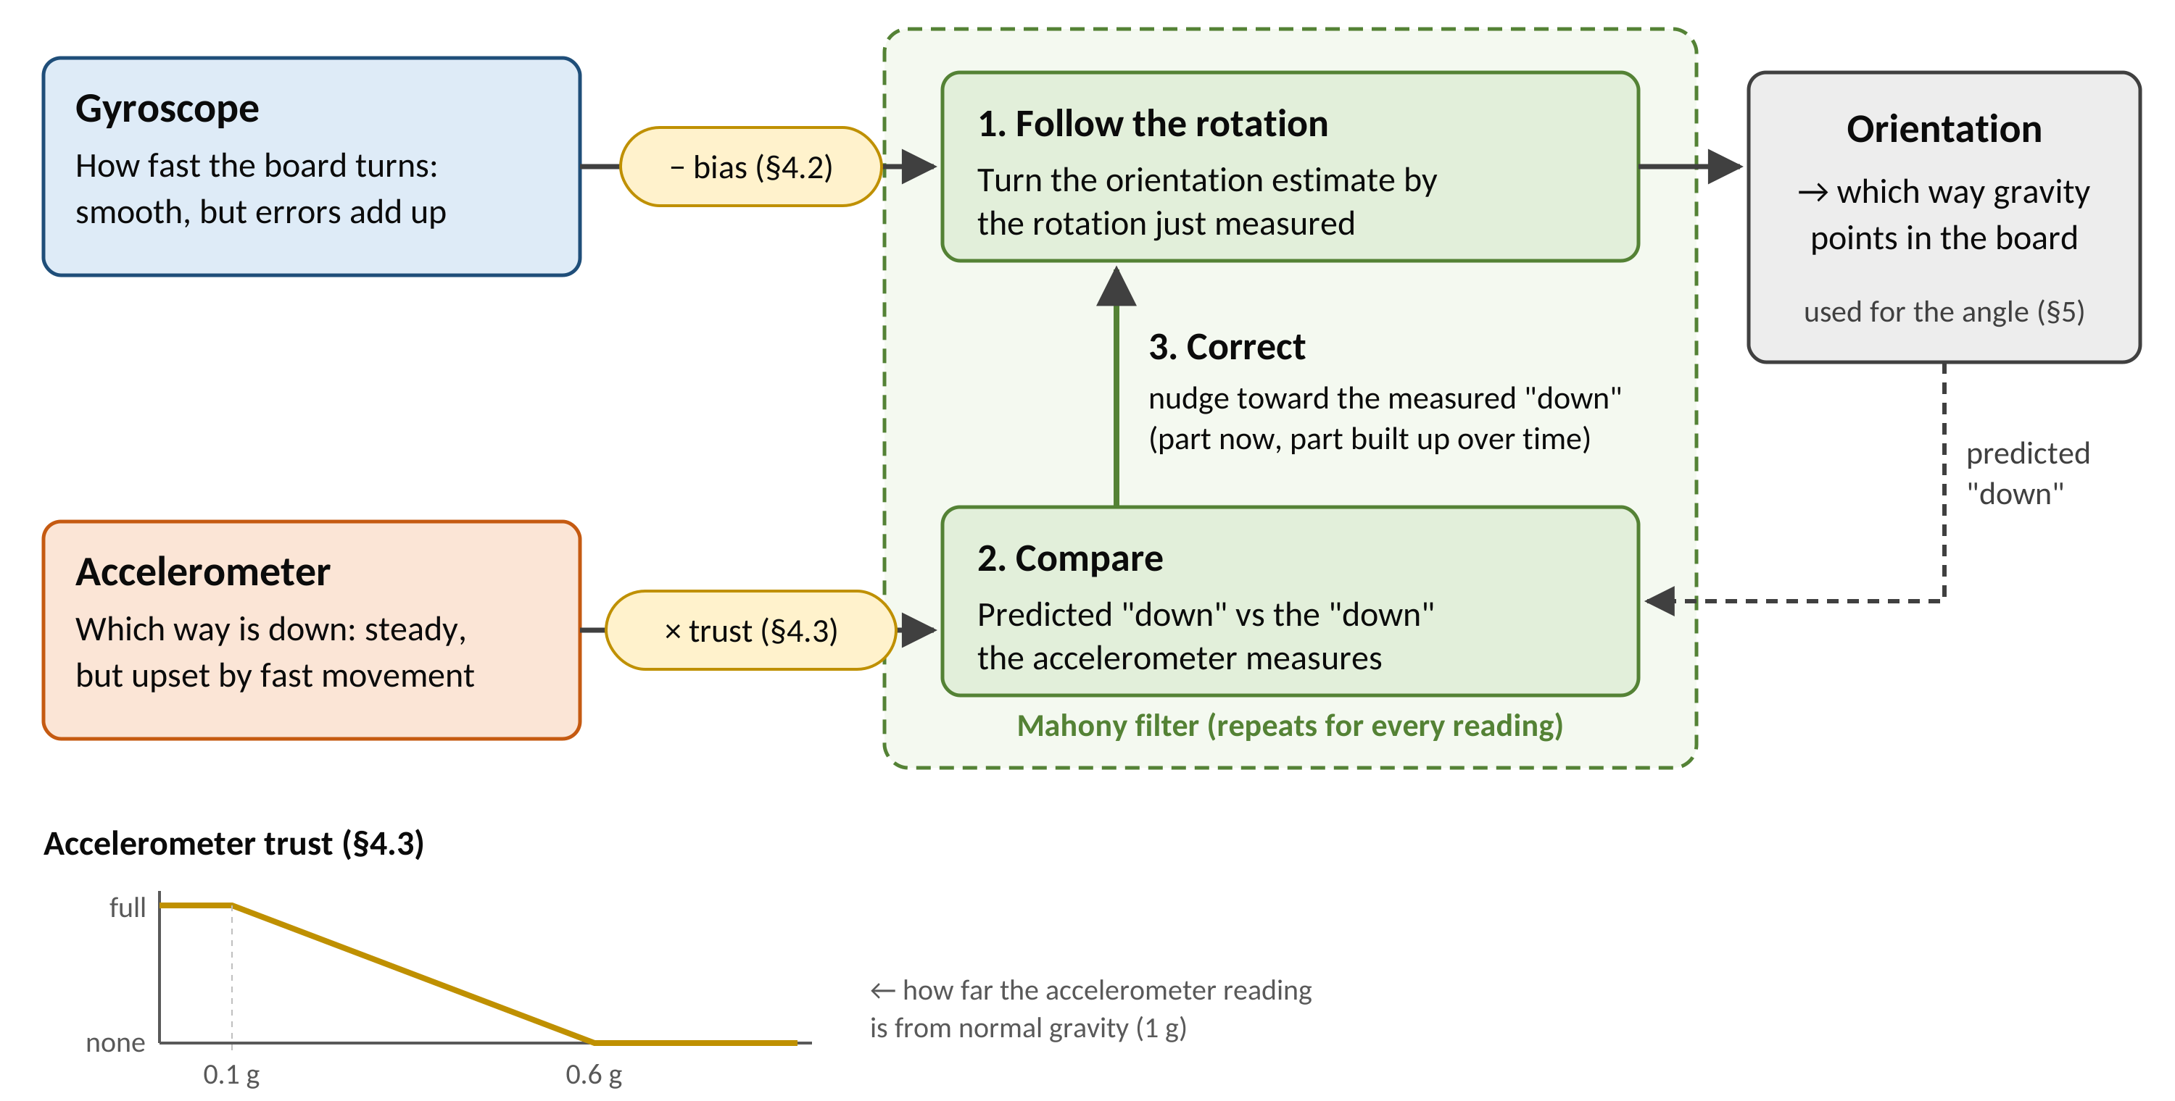
Figure 3. How each board’s Mahony filter estimates its orientation: it follows the gyroscope, compares the predicted “down” with the accelerometer, and corrects toward it. The gyroscope’s bias is removed first (§4.2), and the accelerometer counts for less during fast movement (§4.3).
How the filter works. The Mahony filter repeats three steps every time a new reading arrives:
- Follow the rotation. It turns its current orientation estimate by the rotation the gyroscope just measured. This follows quick movements smoothly, but any small gyroscope error is carried forward and slowly adds up.
- Compare. From that estimate it predicts which way “down” should be, and compares this with the direction of gravity the accelerometer actually measures.
- Correct. It nudges the estimate a little toward the measured “down”. One part of the correction acts straight away (TWO_KP); a second part builds up slowly while the same error persists and cancels any remaining gyroscope bias (TWO_KI).
The result keeps the gyroscope’s smoothness over short periods and the accelerometer’s steadiness over long ones. Gravity cannot reveal rotation about the vertical (heading), so that part is not corrected and may drift; the angle method does not use it (§5.1).
Note: the Arduino library for this sensor reports its axes as a mirror image of the real directions, so the firmware flips one axis (x) of the accelerometer and gyroscope after reading them. This is a bug fix where any new firmware must keep it (README, finding #1).

4.1 Accelerometer + gyroscope only, no magnetometer
- Design Decision: The filter uses only the accelerometer and gyroscope (6-DOF; settings TWO_KP = 1.0, TWO_KI = 0.04).
- Why: The angle method (§5) only needs to know which way gravity points for each board, which these two sensors give without drift. A magnetometer is sensitive to the nearby environment (furniture, treadmills, cables, the other board) and needs extra calibration for each board.

4.2 Measuring gyroscope bias at the start, with a safety check
- Design Decision: When a collection starts, the board averages about 300 gyroscope readings (up to 4 s) and subtracts that as the bias. If the result is larger than 3 °/s on any axis, it is thrown away instead.
- Why: Bias is the main source of drift. A result that large means the board was moving rather than still, and using it would make things worse.

4.3 Trusting the accelerometer less during fast movement
- Design Decision: The accelerometer’s influence is gradually reduced the further its reading is from normal gravity: full trust within 0.10 g of 1 g, none beyond 0.60 g.
- Why: During quick movements the accelerometer feels the movement as well as gravity, so it no longer points cleanly “down”. Switching it fully off and on instead would let the angle drift during a fast move and then jump back.
- Status: Not yet tuned on real movement data.

5. Knee-angle calculation (GUI)
The application (GUI) measures how far each segment has tilted from the pose held at the start, using the direction of gravity seen by each board. The knee angle is the thigh’s tilt minus the shank’s tilt (Figure 4). Because only tilt relative to gravity is used, the boards do not need to be placed precisely.

5.1 Measuring each segment’s tilt against gravity
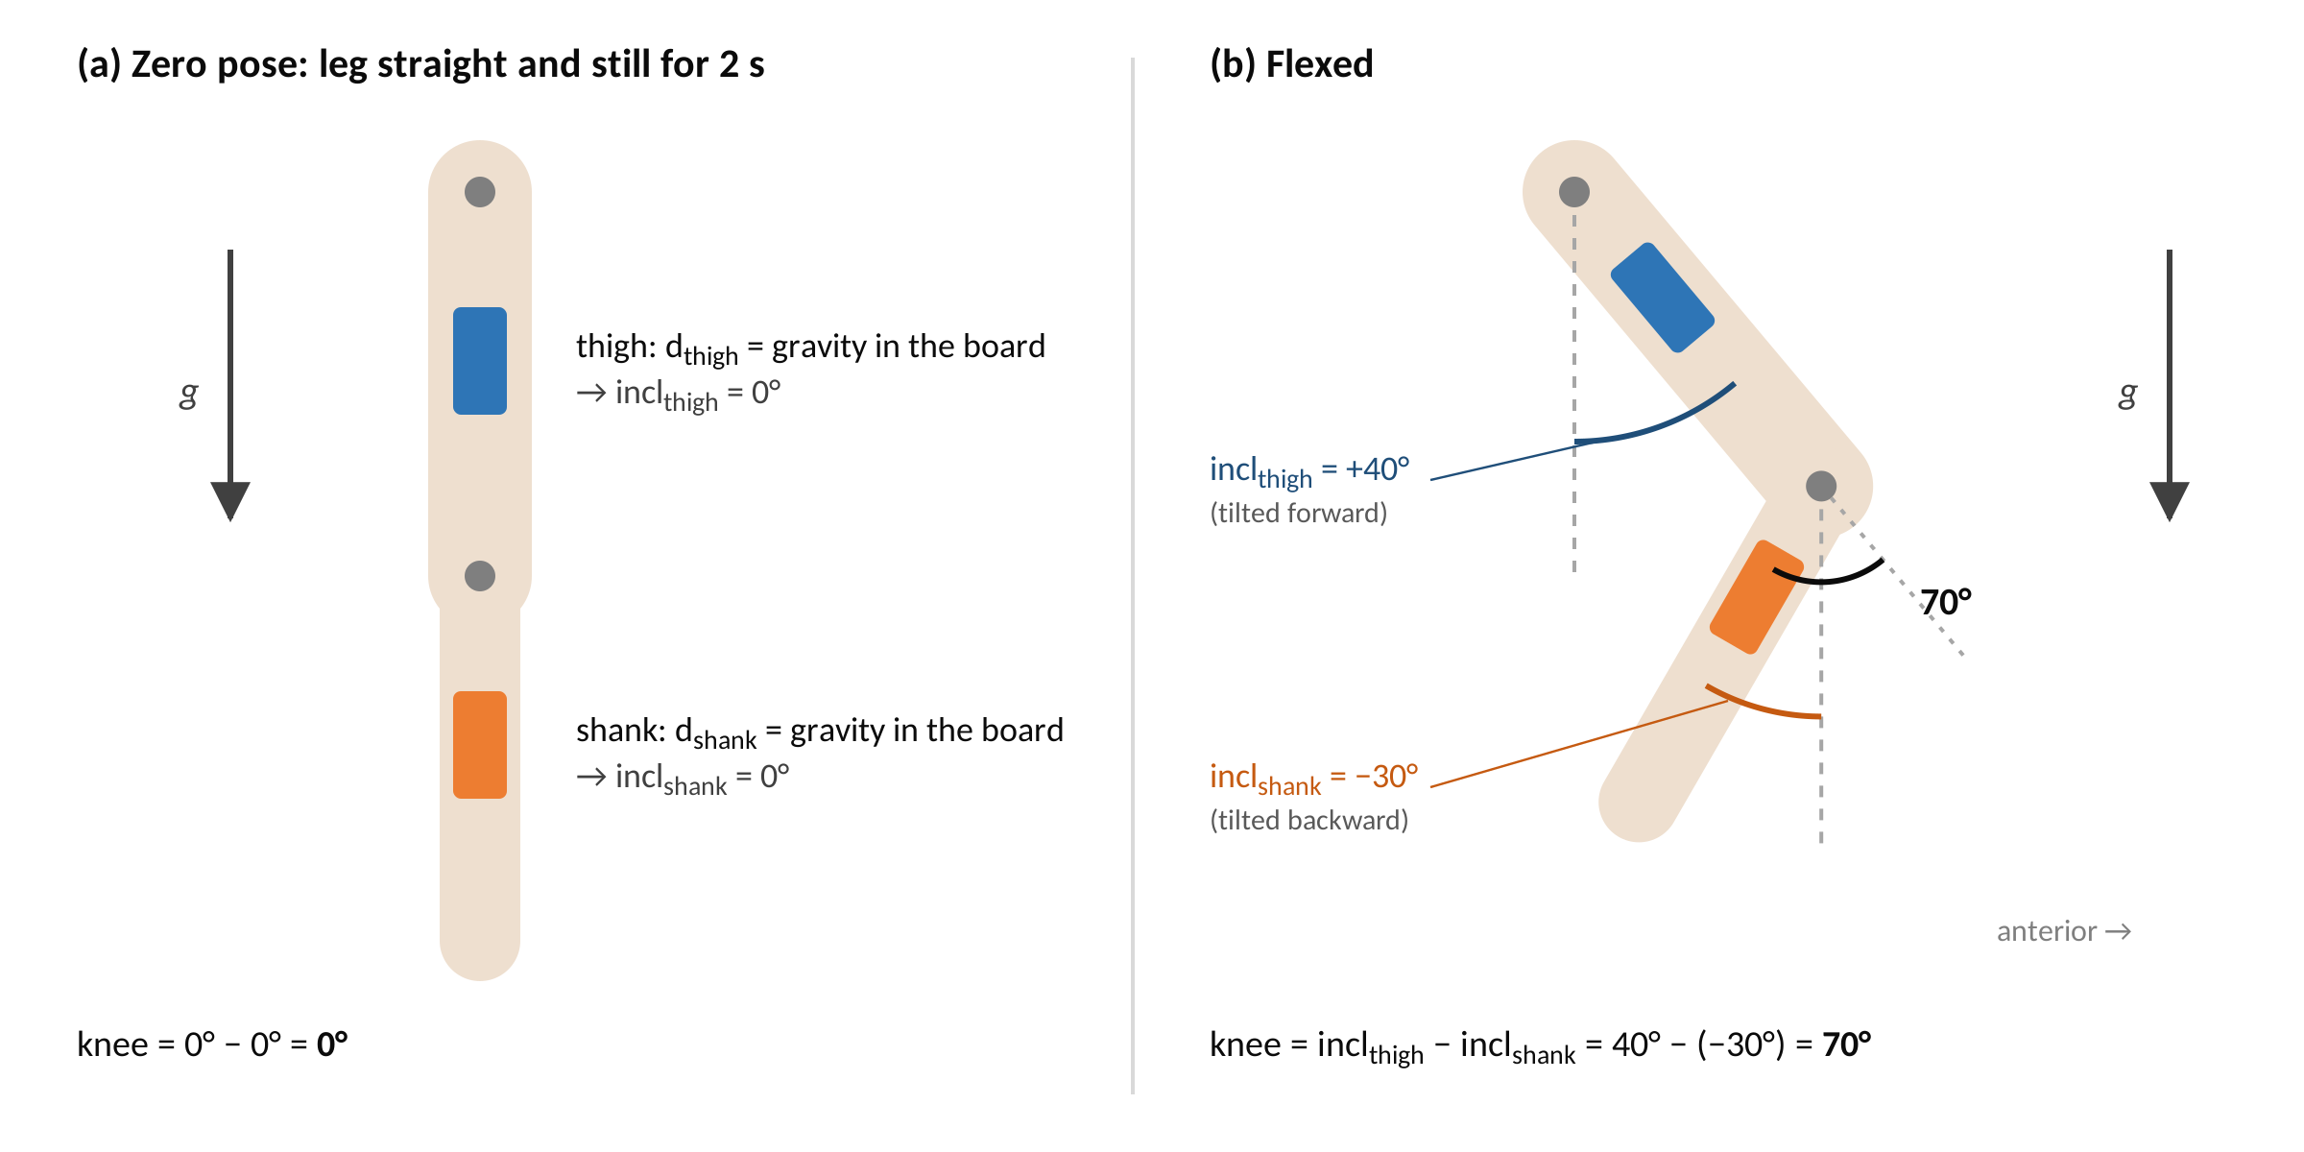
Figure 4. How the knee angle is computed. Each segment’s inclination is its tilt from the zero pose, measured from gravity in its own board; the knee angle is their difference.
- Design Decision: For each board, find which way gravity points in that board’s own frame, turn that into a signed tilt (inclination) in the side-view plane, and take the knee angle as incl_thigh − incl_shank (Figure 4).
- Why: Tilt measured against gravity does not drift, and it does not depend on which way the person is facing (heading), the one thing these sensors cannot track reliably. How each board is mounted cancels out, so placement does not need to be exact.
- Alternatives: Comparing the two boards’ full orientations directly was rejected because each board’s heading drifts separately; the angle drifted even with both boards fixed to one ruler.

5.2 Gravity from the filter, not the raw accelerometer
- Design Decision: Take the gravity direction from the filtered orientation (§4.1). The raw accelerometer readings are still saved, as an independent check.
- Why: The raw accelerometer is disturbed by movement; the filtered orientation is not (§4).

5.3 Two-step calibration: hold still, then move
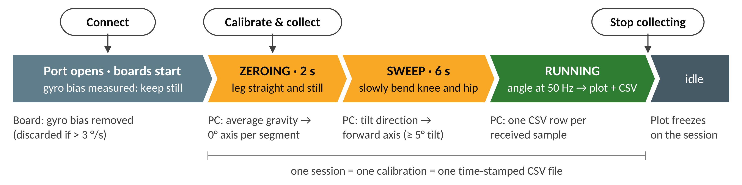
Figure 5. A session in the GUI, from connecting to stopping.
- Design Decision: Each session starts with (Figure 5):
  - Zeroing (2 s): leg straight and still. The gravity direction each board sees becomes its 0°.
  - Sweep (6 s): a few slow movements bending the knee and hip. The direction each board tilts becomes its “forward”.
- Why: Together these tell the software how each board sits on its segment, without anyone having to measure the mounting.
- Detail: A segment that tilts less than 5° during the sweep is treated as not moving and contributes 0°. In all bench tests only the shank was moved, so the angle came from the shank alone; moving both segments is a required next step (§1.3).

5.4 Signed, continuous angle
- Design Decision: Bending reads positive and over-straightening reads negative, with no jumps anywhere in the range (calculated as atan2(g·f, g·d)).
- Why: It tells bending apart from over-straightening and gives the same readings on the way back from deep bending (checked by the self-test with a 0° → 130° → 0° movement).

5.5 Angles relative to the start pose, not anatomical angles
- Design Decision: Accept that 0° means “the pose held during zeroing”, not “the leg is anatomically straight”.
- Why: Range of motion, repetition counting, gait and movement quality all use differences between angles, so the starting point cancels out. A true anatomical angle (for example, measuring a knee that cannot fully straighten) needs an outside reference that sees the anatomy.

5.6 Accepted limitation: side-view plane only
Gravity shows tilt but not rotation about the vertical. The method therefore under-reads movement well outside the side-view plane (for example, lying down with the hip turned a lot). This is accepted because the target is ordinary knee bending while upright.

6. Board-to-board link and data protocol
This section focuses on how the two boards talk to each other and to the PC. The choices favour reliability: a lost or corrupted message costs one sample instead of breaking the stream.

6.1 Wired serial link at 115 200 baud
- Design Decision: A wired UART link at 115 200 bits per second in both directions: shank data to the thigh board, and a “keep going” signal (keepalive) back to the shank board (Figure 2).
- Why: Simple and predictable. 115 200 is far more than needed (about 15 000 bits per second) while leaving a wide timing margin; faster speeds were less reliable as the boards warmed up.

6.2 Messages with a start marker and a check number
- Design Decision: Each 30-byte message (packet) starts with a fixed marker byte and ends with a checksum (Figure 2). The thigh board finds the start of each message by its marker and discards any message whose checksum is wrong.
- Why: Without a marker, one lost byte would scramble every message after it; with it, a glitch costs a single sample.

6.3 The shank board keeps sending; the thigh board never waits
- Design Decision: The shank board sends a message 50 times a second without being asked; the thigh board always uses the newest good one. If that is more than 30 ms old, the shank reading is marked missing and the PC fills the gap (§8).
- Why: If the thigh board had to ask and wait, any short pause on the shank board would lose samples or hold up the thigh board. Streaming keeps the two boards independent.

6.4 A steady 50 samples per second
- Design Decision: Both boards send at a fixed 50 Hz; the sensors and filters still run faster internally. The thigh board sends each line to the PC in a single write (~1–1.8 ms), well within the 20 ms between samples.
- Why: 50 Hz is plenty for knee movement and leaves comfortable timing margin on both boards.

6.5 Health reports (diagnostics)
- Design Decision: Both boards report a short health summary once a second (on by default). The GUI saves these to knee_diag_<timestamp>.log, and analysis/diagnostics/parse_diag.py turns them into tables.
- Why: These reports found the sample-rate shortfall and the faulty sensor.
- Constraint: Both boards must run firmware from the same version, because the report format must match exactly.

7. Robustness and fault handling
The shank board watches its own sensor and restarts it when it misbehaves, and it sends a gap rather than a wrong reading. The LEDs show what each board is doing.

7.1 Shank board self-repair
- Slow start: if the sensor delivers fewer than 30 readings in its first second (it occasionally starts at ~10 Hz), it is restarted.
- Stalled sensor: if no reading arrives for 250 ms, the LED stays on and the sensor is restarted every 500 ms.
- Sensor not found at power-up: the LED blinks fast for ~3 s and the board restarts.

7.2 Rejecting impossible readings
- Design Decision: The shank board rejects a reading that took too long (over 50 ms) or is physically implausible (acceleration below 0.25 g or above 4 g, or very fast rotation while the board is otherwise near rest). A rejected reading is sent as a gap. If no good reading arrives for 5 s, the board restarts.
- Why: In long tests one board’s sensor began returning nonsense after 20–38 min and then stopped; this turns wrong angles into visible gaps.

7.3 LED indicators
Board | Pattern | Meaning
Central | On | Collecting (USB port open)
Central | Off | Idle
Peripheral | 3 quick flashes | Starting up
Peripheral | Slow blink | Idle, waiting for the start signal
Peripheral | Fast blink (~3 Hz) | Active, sending data
Peripheral | Solid on | Sensor stalled (being restarted)
Peripheral | Off / frozen | No power or a serious fault

8. PC software (GUI) features
KneeGoniometerGUI.exe is a Windows program that walks operators through calibration, shows the angle live and saves every session to its own file; it needs no Python installation. The same functions are available from the command line (knee_collector_uart.py) for development.
- Connect with one click. The program lists the available USB ports, connects to the thigh board, and confirms that data are arriving from both boards before a session can start.
- Guided calibration. A large colour-coded banner tells the operator what to do (hold still, then sweep) with a countdown for each stage (Figure 5).
- Live view. The knee angle and each segment’s tilt are plotted as they are measured. When a session is stopped, the plot freezes on the whole session for review.
- Automatic saving. Each “Calibrate & collect” starts a new session with a fresh calibration and a new time-stamped CSV file, so every file holds exactly one calibration. One row is saved for every reading received, timed by the board’s own clock. Health reports from the boards go to a separate diagnostics log.
- Honest gaps. If up to 10 shank readings in a row are missing, the last good value is repeated; longer gaps are left empty. Every row records whether it is valid, filled or missing, and the plot can show either a continuous line or the individual points.
- Clear error messages. If no good data arrive, a red banner names the failing part: nothing coming from the USB port, wrong or out-of-date firmware, or no data from the shank board.
- Built-in self-test. --selftest checks the angle math against known answers. A new version of the Windows program is built and published automatically when a version is tagged, and only if the self-test passes (README “Releasing an updated GUI”, SOP Appendix B).

9. Preliminary Stationary Testing
With the sensors held still, the angle was very steady (changes of a few hundredths of a degree) and did not drift on healthy hardware. Long runs exposed one faulty board. Movement and on-body testing have not been done yet (§1.3).
Full results are in the Preliminary Stationary Test Report.
Test | Result
Stability (6 holds of ~5 min) | ~0.01–0.02° noise; no growth in noise over longer periods
Endurance (24–60 min) | Stable for 33 min on healthy hardware; ≈ −0.001 °/min drift
45° / 90° rigs (preliminary) | Read 45.0° and 89.0°
Sample rate | ~40 Hz found (slow line writing on the thigh board, uneven PC timer); fixed to a true 50 Hz (§6.4, §8)
Data loss in long runs | Traced to a faulty sensor on one board; the other ran over 1 h without problems in either role
Methods worth mentioning:
- Left out the first 20 s of each session when analysing still holds (calibration and settling).
- Swapped the boards to tell a hardware fault from a software fault — the fault followed the board.
- Used the raw accelerometer as an independent check of real movement; it showed that a slow creep in one session was the test rig settling, not the sensors drifting.

10. Directions considered but not pursued
Refer to Appendices A–D for more information on each area.
Area | Recommendation
A. Magnetometer | Do not add for knee bending; only worth it if full 3D movement must be measured, after checking the room for magnetic interference.
B. Anatomical angle | Use a calibration movement that finds the knee’s hinge axis, or a known straight pose; not built yet.
C. Wireless (Bluetooth) | Start with the board-to-PC link; needs time stamps on each reading and batteries. Main benefit is safety and ethics approval.
D. More sensors / joints | Needs sensor IDs, a more general data format and time matching across sensors; Bluetooth suits a hub layout.

Appendix A — Magnetometer: accuracy, and absolute vs. relative angle
Adding the board’s compass sensor would not make the knee angle more accurate, and it cannot give a true anatomical angle either. It is only worth revisiting if full 3D movement ever needs to be measured.
Status: Investigated (preliminary analysis only). Not recommended for the current use.

A.1 The proposal
The boards carry a magnetometer (BMM150) that is not used (§4.1). The proposal was to use it to (a) improve accuracy, and/or (b) get an absolute joint angle instead of the current one, which is relative to the start pose — on the idea that “the magnetometer points to north, so it can be a reference for the angle between the segments.”

A.2 What a magnetometer actually measures
- The direction and strength of the local magnetic field, as seen by the board. Turning the board changes the reading; that change is what reveals its orientation.
- The field points to magnetic north and also dips steeply into the ground (about 60–70° at mid latitudes). It is not a neat horizontal arrow; a compass hides this by using only the horizontal part.
- The angle between the magnetic field and gravity depends only on where you are on Earth, not on the leg, so it says nothing about the joint.

A.3 Two separate jobs: a scale and a zero
Measuring any angle needs two things:
- A scale — how far apart two directions are (like the markings on a ruler).
- A zero — which position counts as 0°.
Sensors on the body are good at the scale. The zero is a question about the person’s anatomy, not about the sensors. This split is the heart of the magnetometer question.

A.4 What the magnetometer would add
- Heading. Gravity shows tilt but not which way a board faces; the magnetometer supplies that, like a compass.
- With gravity and the magnetic field, each board’s full 3D orientation is known, and so is the full, drift-free rotation between the two boards.
- In practice: its only unique contribution is movement outside the side-view plane. For ordinary knee bending, gravity alone is enough because both boards share the same “down”.

A.5 Why it does not give an anatomical angle
The joint angle is between the bones, not between the boards. Each board sits on skin at an unknown angle to its bone. In symbols, with R_rel the rotation between the boards and M_thigh, M_shank each board’s unknown mounting:
joint = M_thigh⁻¹ · R_rel · M_shank
The magnetometer pins down R_rel but tells nothing about the mountings.
- Two meanings of “absolute”: absolute heading (which way you face), which the magnetometer gives; and an absolute anatomical zero (the true angle between thigh bone and shin bone), which it does not.
- The deciding example: two people can hold their legs so that both boards give identical readings — accelerometer and magnetometer — while one is a healthy knee bent 10° and the other a knee that cannot straighten past 10°. Same data, different clinical truth, so no calculation on the sensor data can tell them apart.
- “Straight” is not a direction in the room. A joint angle does not change when the person turns around; which way the person faces is the only thing the magnetometer adds.
The current method is relative because of the zeroing hold (§5.3): whatever pose is held becomes 0°, and the unknown mounting cancels out.

A.6 Trade-offs
- The basic choice: either measure how each board sits on its bone (an anatomical zero, but placement must then be careful) or cancel it by re-zeroing every session (relative zero, placement does not matter). The current design cancels it, which is why placement is not critical. The magnetometer helps with neither.
- Magnetic interference: table and chair legs, treadmills, wheelchairs, steel in floors, batteries, the USB cable and the other board all distort the field. Clinics and gyms are full of these.
- Extra calibration: each board would need a figure-of-eight calibration, repeated whenever conditions change.
- Accuracy gain for knee bending, gait and sit-to-stand: about none.

A.7 Next experiments (if revived)
- Check the room first: record the raw magnetic field during a normal session in the actual test space and plot its strength. If it stays roughly constant (~25–65 µT) as the leg moves, the space is clean enough; large swings mean the magnetometer would add error.
- Compare in 3D: bring back the old magnetometer code as an option and compare it with the current method on sideways and twisting movements, not ordinary bending.
- Go further only if (1) passes and a 3D requirement actually exists.

Appendix B — Anatomical angle via functional calibration
To report true anatomical angles (for example, a knee that cannot fully straighten), the software must learn how each board sits on its bone. A short calibration movement that reveals the knee’s hinge axis can do this.
Status: Identified as the right approach. Not yet prototyped.

B.1 Motivation
The current angle is relative to the start pose (§5.5), so it cannot report a clinical angle such as a knee that stops 10° short of straight, or compare sessions that were zeroed in different poses. As Appendix A shows, this needs a reference that sees the anatomy.

B.2 Candidate approaches
- Hinge-axis (functional) calibration: the person does a few pure knee-bending movements. The knee’s hinge axis then shows up in each board’s gyroscope as the main axis of rotation, which reveals how the board sits on the bone. No magnetometer is needed; research-grade motion-sensor systems use this approach.
- Known pose / outside reference: define true full straightening once (with a straight-leg fixture, a manual goniometer or imaging) and anchor the zero to it.

B.3 Trade-offs
- Gains an anatomical angle that can be compared across sessions and can show a knee that cannot fully straighten.
- Costs more careful placement and a repeatable calibration routine for each person (the “measure the mounting” choice in A.6).
- Accuracy depends on how purely the calibration movement bends only the knee; it needs checking against a goniometer or another reference method.

B.4 Next steps
- Build a hinge-axis estimate from a bending-only recording and compare its zero with a manually measured angle at known poses.
- Decide whether the clinical use needs anatomical angles at all, or whether differences (range of motion, repetitions, gait, movement quality) are enough.

Appendix C — Wireless (Bluetooth) links
The boards already have Bluetooth radios. Using them would remove the wires, mainly for safety and ethics approval, at the cost of batteries and less predictable timing.
Status: Idea raised; not investigated in depth.

C.1 Motivation
Two connections could go wireless (Figure 2):
- Link A — shank board ↔ thigh board: today the wire that crosses the knee.
- Link B — thigh board ↔ PC: today the USB cable.
Main reason: safety and ethics approval. Removing wires — especially one across the joint or one tying the person to a PC — reduces the risk of tripping, tangling and electrical hazards. It also lets people walk and stand up more naturally.

C.2 How
- Bluetooth software on the boards, and a Bluetooth library (such as Python bleak) on the PC in place of the USB serial connection. Each link can be replaced on its own.
- Link B first: it removes the tie to the PC without changing the board-to-board link. Link A removes the wire across the knee.

C.3 Things to watch
- Lost data: the existing gap handling (§6.3, §8) helps, but Bluetooth has its own dropouts and reconnections.
- Timing: Bluetooth delivers data in bursts (at least 7.5 ms apart) with uneven delays, so each reading should carry its own time stamp from the board.
- Capacity: 50 Hz is possible but with less spare room than the wire; several readings may need to be sent together, or the rate lowered.
- Simpler messages: Bluetooth already separates messages, so the start-marker logic (§6.2) is not needed; the checksum is still worth keeping.
- Power: wireless means a battery on each board (which would also disturb a magnetometer if one were ever used).
- Interference from other 2.4 GHz devices, and reliable reconnection.

C.4 Next steps
- Build one link at a time, starting with Link B. Measure the rate, lost data and timing against the wired version, and compare the angle traces.
- Decide for each link whether the safety benefit is worth the extra variability for the planned study.

Appendix D — More sensors and joints
Measuring more than one joint (for example hip, knee and ankle, or both knees) needs more boards, a way to tell them apart, and careful time matching between them.
Status: Idea raised; not investigated in depth.

D.1 Motivation
Today one pair of boards measures one knee. Studies may want a chain on one leg (thigh + shank + foot for hip, knee and ankle), both legs, or more of the lower body. Two layouts were suggested:
- Hub: several sensor boards send to one hub board, which sends a single stream to the PC.
- Independent pairs: several of today’s two-board units, each measuring one joint, combined on the PC.

D.2 Things to consider
- Wiring points to Bluetooth (Appendix C). Each board has only one wired serial link, so a wired hub cannot connect several boards; a Bluetooth hub can.
- Telling sensors apart: each message needs a sensor ID, and the saved files need a general layout for any number of segments and joints.
- Time matching is the biggest risk: an angle between two segments needs readings taken at the same moment, so all boards need time stamps from a shared clock.
- Capacity: many sensors at 50 Hz share one link, which may limit the rate or the number of sensors.
- Calibration gets longer with each segment, so the routine and the GUI must scale with it.

D.3 Layout trade-off
Layout | For | Against
Hub | One stream and one clock at the hub; simple on the PC | The hub’s capacity is the limit, and if it fails everything stops
Independent pairs | Modular; reuses today’s firmware | The PC must time-match several streams; more radios or USB ports and more hardware

D.4 Next steps
- Define a message with a sensor ID and a general data layout (any number of segments and joints) before choosing a layout.
- Build time matching across boards and measure how closely it aligns, against the accuracy the study needs.
- Choose by study size: a Bluetooth hub for a compact multi-segment setup; independent pairs when modularity matters more.

