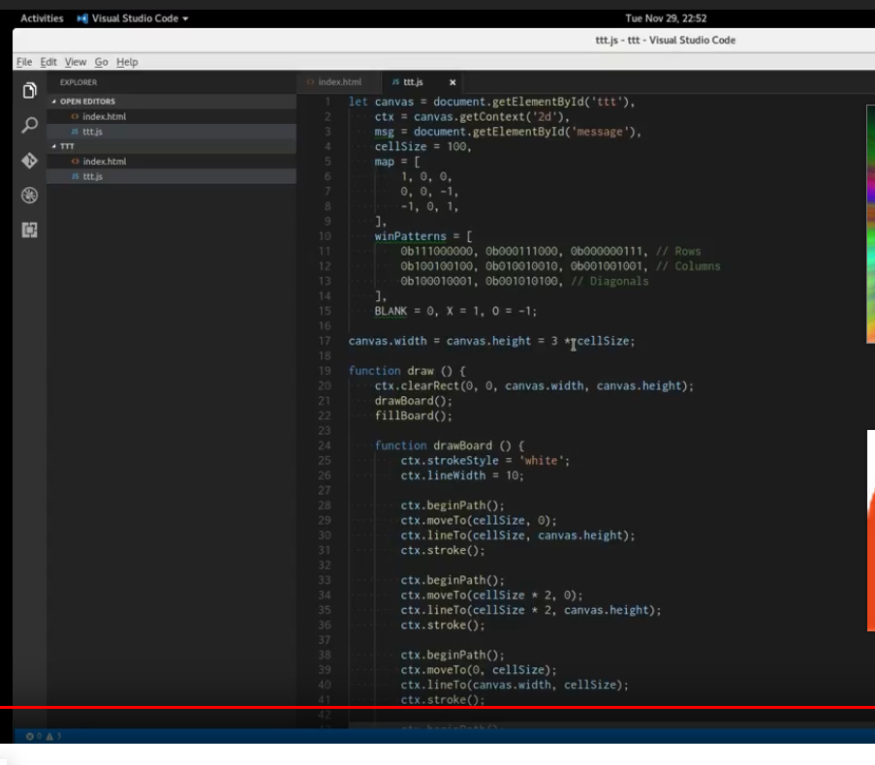

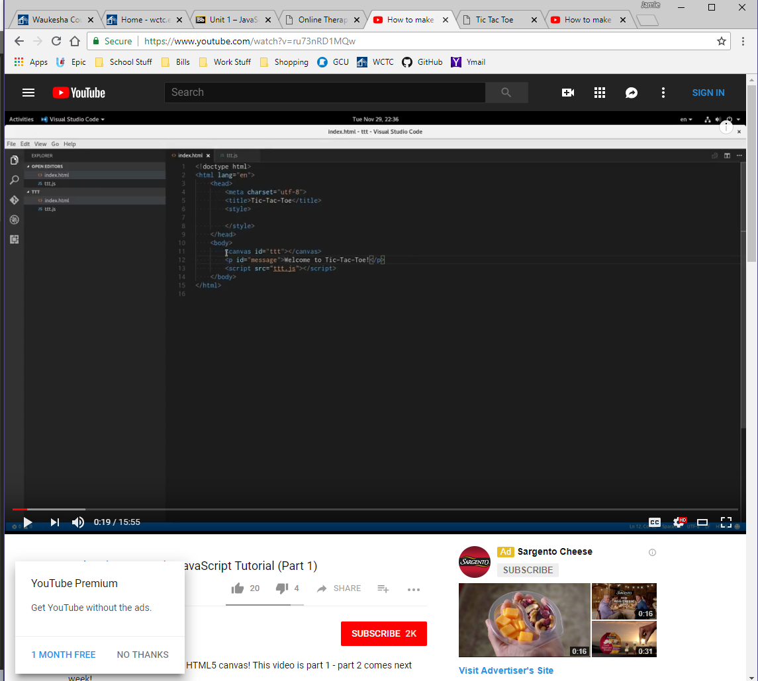

EXAMPLE 1 _____________________________________________

<!DOCTYPE html>

<html>

<body>

<p>Display some text when the checkbox is checked:</p>

Checkbox: <input type="checkbox" id="myCheck" onclick="myFunction()">

<p id="text" style="display:none">Checkbox is CHECKED!</p>

<script>

function myFunction() {

var checkBox = document.getElementById("myCheck");

var text = document.getElementById("text");

if (checkBox.checked == true){

text.style.display = "block";

} else {

text.style.display = "none";

}

}

</script>

</body>

</html>

<form id="hideme"></form>

/*

EXAMPLE _____________________________________________

$('#submit').on('click', function() {

if ($('#container').css('opacity') == 0) {

$('#container').css('opacity', 1);

}

else {

$('#container').css('opacity', 0);

}

});

PRACTICE WITH EXAMPLE 2

/*$('#hideme').on('checked', function() {

if ($('#divhide').css('opacity') == 0)

{

$('#axiety').css('opacity', 2);

}

if {

($('#sadness').css('opacity', 2);

}

else{

($('#gstress').css('opacity', 2)

});

});

/*

This is kinda cool. If this gets embedded into any div id that section will hide.

<div id="hidediv" style ="display:none"></div>