|  |  |
| --- | --- |
| A picture of a winding road and trees  Technical Games Production  Game Design Document | Abstract  A document which shows how the game should be created and the order of priorities.  Angharad Hill and Jamie Coogan |

**Contents**

Technical Games Production: Game Design Document 2

Game Description 2

Moscow 3

Must Have 3

Should Have 3

Could Have 3

Would Have 3

Data Flow Diagram 4

Visual Design / Mood Board 5

Pseudocode 6

# Technical Games Production: Game Design Document

## Game Description

This game is based on the Dynasty Warriors franchise, specifically the Hyrule Warriors game. The main features we want to use are the hack and slash system, where the player mows down all the basic enemies and then must attempt to fight the stronger, more equally powered bosses. Other features that will make the project a more enjoyable game is adding forts for the player to capture. Multiplayer so that multiple people can play at once and work together to win, different character types so that there is more for the player to experience, special moves so that the player has more options to choose from when fighting and finally the game would be more enjoyable if we added more player movement options and had enemies designed around these movement options so that the game is unique and fun.

## Moscow

### Must Have

* Basic Player Movement / Attack
* Basic Enemy Movement / Attack

### Should Have

* Multiplayer
* Multiple Enemy Types, Including Bosses
* Multiple Player Attacks
* Win Condition (Final Boss / Capture Point)

### Could Have

* Capturable Forts
* Super Cool Player Finisher Moves
* Multiple Game Modes
* Item Pickups (Stat Buffs / Heals)
* Useable Items (Throwable Bombs etc.)

### Would Have

* Multiple Player Types
* Complicated Player Movement Options

## UML Class Diagram

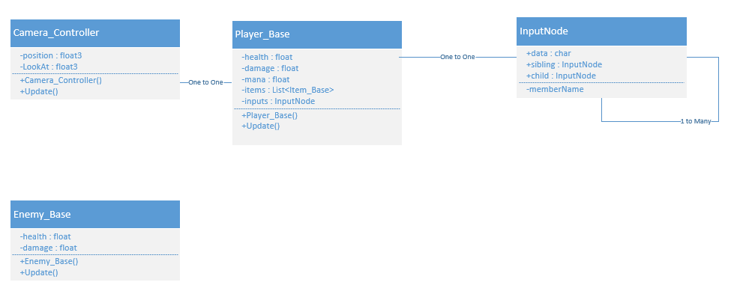

## Visual Design / Mood Board

<https://www.pinterest.co.uk/minatoman10/tgppairproject/>