IoT Project 1 - Deliverables

**Student Name:** Jamie Creevy-Crerand, Philip Hamilton

**Course:** (Bsc) Hons. In Computing

**Student ID Number:** S00172003

**Project Title**:  Arcade Style Basketball Game

**Background:**

The idea from our project kind of sparked from Philip’s heavy interest in basketball and Jamie’s prior experience with using circuit boards and various sensors in technology during my leaving cert. We then decided on the idea of a basketball hoop that would replicate that of an arcade still game, with points being added for every score made. We both agreed that this project was well within our capabilities and thus commenced our work.

From a hardware standpoint, we contemplated using motion sensors at the start of our thinking process to capture the ball coming in, however we debunked this idea after realising that the net would also cause the sensors to go off. So instead we opted for an LDR (Light dependant Resistor) and programmed it so that the shadow of the ball passing through the hoop would trigger a score. This method was fairly accurate but if given more time we believe we could get much more accurate readings. We also interpreted an LCD display to display the score of the current game.

**Requirements**

The requirements for our project was a rather short list with the hoop, ball, Arduino board, Arduino IDE, LDR and LCD being all that was necessary to make the game function.

The ball and board was the primary focus of the requirements as we needed to find ones suitable for our needs which included having an appropriately sized ball to fill the hoop and a place to tuck away the LDR. After a half hour browsing on amazon we found one that we believed to be up to par and we were satisfied with our decision.

The Arduino board was the brains of the project which powered the game and held the code necessary for the game to be successful. The LDR and LCD were connected to out Arduino board and received instructions from the code.

The Arduino IDE was the program used to write and upload code for our game. We could also edit the code and re-upload it at a very fat rate meaning we were capable of rigorous testing.

**Methodology**

There was no real design to implement into our board as it was bought on the internet and had no customisation options upon purchase however in the future could be decorated with either stickers or other kinds of designs. The only part of the project that was made to be designed was the formatting and colour of the LCD display.

We implemented the LDR by placing it just under the rim of the hoop as we declared after testing that this was the most successful spot. We instructed the LDR to record a score every time the reading went under a certain figure. The average reading for the hoop without the ball being passed through was 700. And the average reading for the hoop when the ball was passing through was 650. So with this in mind, we made an if statement that declared a score if the light reading was to dip under the lower average.

The LCD was just a means of getting it to work and formatting it to suit the needs of the output which did not take much time.

**Pictures**

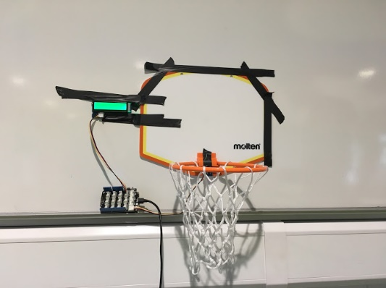 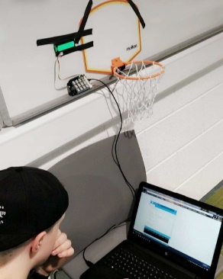



**Criteria**

We asked ourselves during the project “**How will we know whether or not this is a project living up to the billing”.**

When we completed the project, we set out our own checklist to make sure the vital components were in order.

-If the LDR was picking up accurate readings.

-If the LCD was displaying the correct score.

-If the code was instructing what we intended it to.

-Was this fun?

We both agreed at the end of the project that it checked out all of these headings.

**References**

[www.amazon.co.uk](http://www.amazon.co.uk)

[www.forefront.io](http://www.forefront.io)

[www.arduino.cc](http://www.arduino.cc)

**Source Code**

<https://github.com/JamieCrerand/IOT-Project1.git>

#include "rgb_lcd.h"

int sensorPin = A3; //input pin

int sensorValue = 0; //variable to store value coming from sensor

int score = 0;

rgb_lcd lcd;

void setup() {

Serial.begin(9600); //sets serial port for communication

lcd.begin(1, 1);

lcd.setRGB(0,255,0);

lcd.clear();

}

void loop() {

sensorValue = analogRead(sensorPin); //read the value

Serial.println(sensorValue); //prints values

delay(200);

if (sensorValue < 600)

{

score++;

//Serial.println(score);

}

lcd.clear();

lcd.print(score);

}