**Dear Parents**,

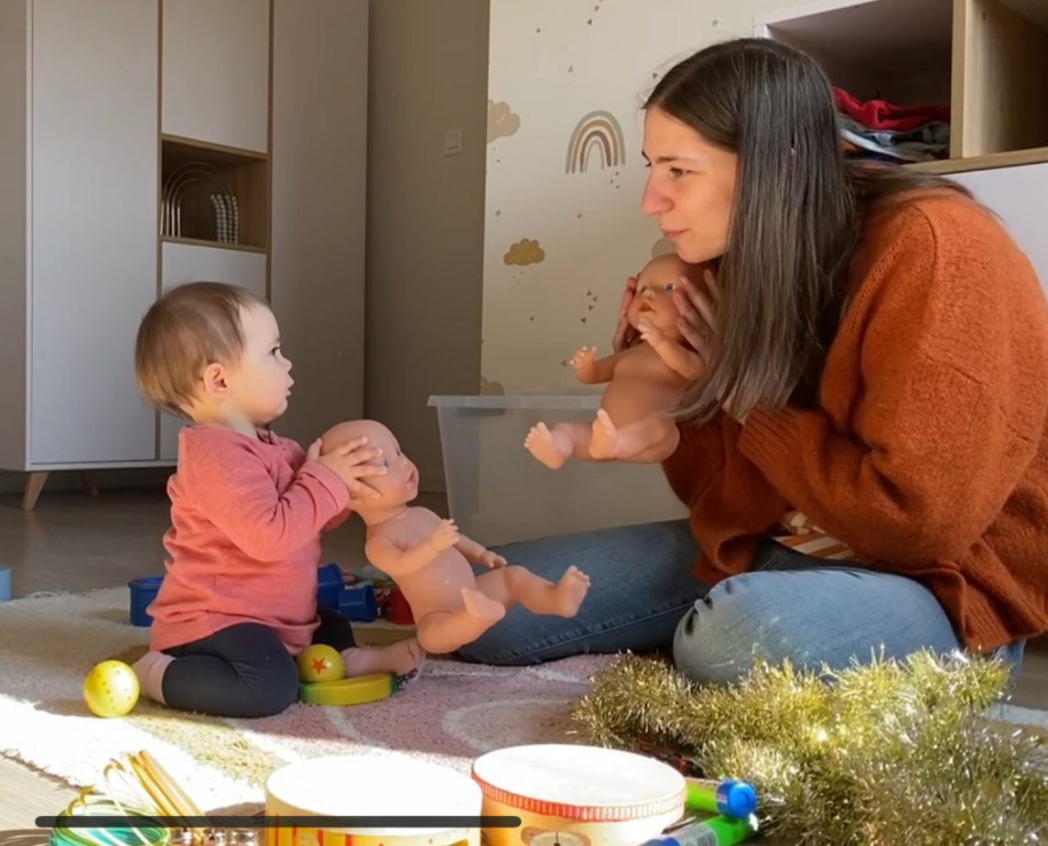

**The research will take place at:**

Faculteit Psychologie en Pedagogische Wetenschappen

Henri Dunantlaan 2

9000 Gent

If you would like to participate or if you have any questions, please contact us at:

Email: [sapiens.impact@ugent.be](mailto:sapiens.impact@ugent.be)

Gsm: 0478 96 30 40

**research on the impact-programme as a prodromal intervention**

With this letter, we would like to find out whether you would be interested in participating in a parent-training programme to improve your child's social communication skills. This training is based on the ImPACT programme. In the ImPACT programme, parents learn how to stimulate social engagement, language, imitation and play with their children during daily routines. Research has already shown that this programme is effective for children with Autism Spectrum Disorder (ASD). Children who have an older (half-)brother or (half-)sister with ASD or who were born prematurely, have a higher chance of learning social-communicative skills more slowly. Therefore, in this new study, we want to examine the effect of the ImPACT programme when it is provided to these children at a very young age. We hope that in this way, we can contribute to the prevention of later developmental difficulties. The Research in Developmental Disorders Lab of Ghent University and the Flemish home-based Autism counselling services are therefore joining forces.

**Who can participate?**

This study is addressed to families with 6-to-16 month old children who have an older sibling with diagnosed ASD or who were born preterm (before 30 gestational weeks). The child shouldn’t have a diagnosis of other physical, neurological or developmental disorders.

**How will the study take place?**

To investigate the effects of the ImPACT programme, we will compare two groups of children: one group in which the families receive ImPACT training and one group in which the families do not receive this training. You will be randomly assigned to one of the two groups. In order to draw scientific conclusions about the effectiveness of the training, you cannot choose to which group you are assigned. If you are assigned to the ImPACT group, you and your child will receive 12 individual sessions over a period of approximately 12 weeks. Depending on where you live and the home counselling service in your province, these sessions will take place at your home or at the home counselling service. The children of both groups will be invited 3 times to be examined:

* Before the beginning of the intervention;
* Right after the end intervention;
* Around 6 months after the end of the intervention.

Since the examination takes quite a lot of time, we will divide the first and third session over 2 test moments of 1 to 2 hours (preferably with only few days or a week in between).

In case of difficulties, it will be possible to reschedule a limited amount of appointments or sessions. However, we kindly ask you to consistently participate to the program after the its start to ensure its reliability.

**What is going to be tested in your child?**

We will administer some tests to assess your child's broader development, play, social engagement, language, imitation through play observations in which your child interacts with the researcher or with you. We will also ask you to complete some short questionnaires, which will help us to evaluate your child's progress at home. The examination will be recorded on video in order to be able to analyse your and your child’s behaviour afterwards.

In order to assess your child's brain activity and attention skills we will also use two methods (EEG and Eye-Tracking). EEG measures the electrical activity of the brain. Your child will wear a cap to which electrodes (EEG) are attached in order to take the measurement. This method is not invasive and does not send any waves or radiation into your child's brain. It only measures what happens in the brain as your child watches and listens to images and sounds presented on a computer screen. Eye-tracking is used to record the direction of your child's gaze while looking at some images. This method uses a light source to follow the movement of the eyes. This allows us to see what your child is paying attention to on the screen.

**What happens if I am not assigned to the ImPACT group?**

In order to examine the effects of the training, we will compare two groups: one group in which the families receive the ImPACT training and one group in which the families do not receive any training. If you are not assigned to the ImPACT group, you will not receive any intervention, but you will receive an individual report on your child's development after the last test moment. You will also receive two gifts for your child.

**Do I have to pay for the study?**

All examinations will take at the university and are free of charge. In addition, if you are assigned to the ImPACT group, you will receive the parent manual of the ImPACT programme from us. At the end of the study, both groups will be informed about the results. The basic cost of the sessions provided by the therapists is € 5.43 per session.

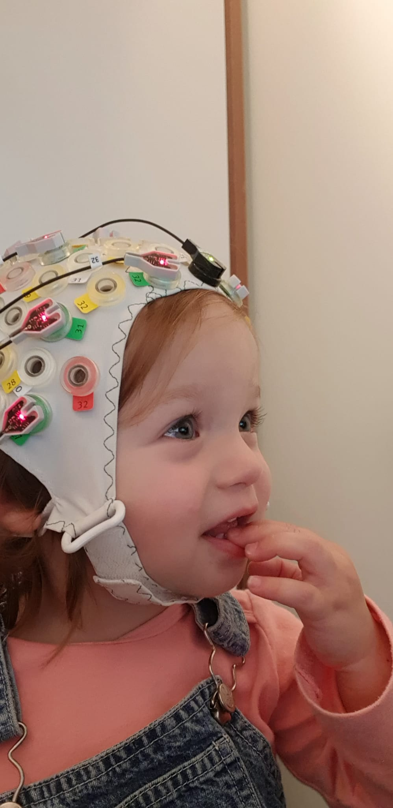

**Thank you in advance for your interest!**

Arianna Zanatta

Dr. Sara Van der Paelt

Prof. dr. Petra Warreyn

Prof. dr. Herbert Roeyers

**research on the impact-programme as a prodromal intervention**