The individual-level precision of implicit measures

# Abstract

Implicit measures are used extensively in psychological science. One fundamental goal of these measures is to provide information diagnostic of an individual’s attitudes or beliefs. After 25 years of research this goal has not been achieved. We argue this is because psychologists have not yet even quantified the individual-level precision of these tasks, much less been able to calibrate measures towards it. In this paper, we examine the individual-level precision of six different implicit measures across three different attitude domains (race, politics, and self-esteem) using a very large open dataset. Despite some variation, we find that the implicit measures were extremely imprecise as measures of individual attitudes. We recommend that researchers who wish to make theoretical inferences about individuals should use metrics of individual-level precision to calibrate their tasks, both in the context of implicit measures and with tasks in psychological science more broadly.

# Introduction

## Implicit measures and individual-level measurement

Implicit measures are widely used in psychological science and beyond as measures of attitudes, beliefs, and stereotypes [(Greenwald et al., 2022; Kurdi et al., 2019)](https://www.zotero.org/google-docs/?pxRQ52). An often repeated aspiration for these measures is that they may eventually allow us to make inferences about the attitudes/beliefs of individuals [(Fiedler et al., 2006; Greenwald et al., 1998; Greenwald & Banaji, 1995)](https://www.zotero.org/google-docs/?0UexJt) which is still heavily emphasized in present-day reviews [(Greenwald & Lai, 2020)](https://www.zotero.org/google-docs/?GM2E8L). These aspirations are also visible in the public face of these measures; the website Project Implicit ([implicit.harvard.edu/implicit](https://implicit.harvard.edu/implicit/)) has allowed individuals to complete Implicit Association Tests (IATs) online and receive individual feedback about their level of bias (see Figure 1).

**Figure 1**. Screenshot of the feedback provided to a participant on the Project Implicit website in January 2023.

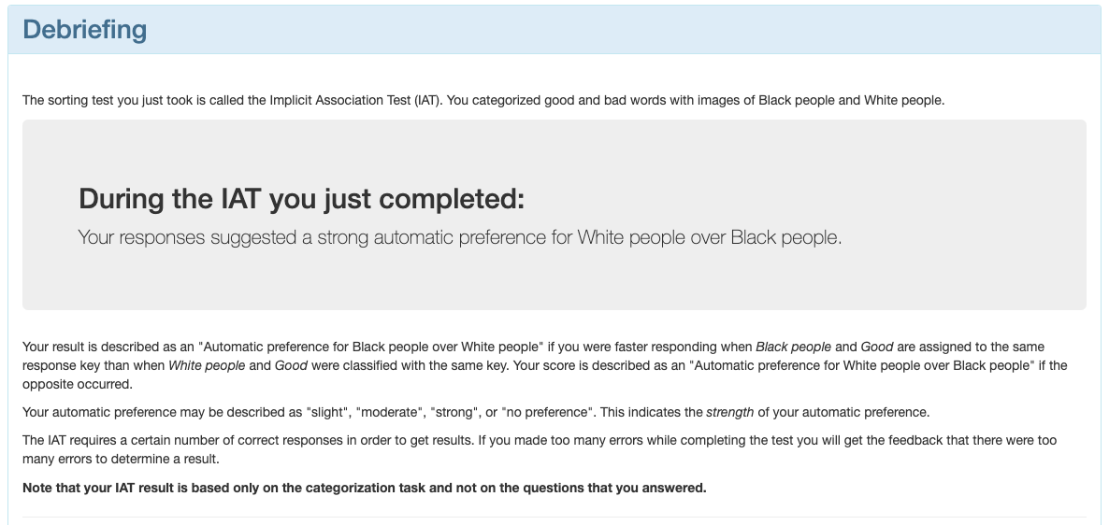

Based on the fact that feedback about individual-level bias is actively given on the flagship website of the most popular implicit measure, it would be reasonable to assume that meaningful inferences about individual participant’s implicit biases can be made using current methods. Surprisingly and concerningly, this is not the case. In their recent review of meta-analyses, Greenwald and Lai (2020) noted that there have not yet been *any* high-precision implicit measures developed which can make diagnostic claims about (i) the traits of individuals, or (ii) precise trait differences between individuals. Despite the long-standing aspirations for individual-level precision the field has generally made little progress towards this goal. Indeed, it is easier to find examples of attempts to shorten these tasks than to lengthen them (the Brief IAT, [Sriram & Greenwald, 2009](https://www.zotero.org/google-docs/?RJE2a6); shortened Death IAT, [Millner et al., 2018)](https://www.zotero.org/google-docs/?PtuS5c). This might make the tasks easier to administer to individuals, but it also makes individuals’ scores less useful for individual predictions [(Streiner, 2003)](https://www.zotero.org/google-docs/?3dKbyE).

A significant factor contributing to this stagnation is the lack of direct quantification of individual-level precision. Although some argue that precision can be improved by enhancing test-retest reliability [(Greenwald & Lai, 2020)](https://www.zotero.org/google-docs/?r7d6sg), this alone does not quantify individual-level precision. [Scheel (2022)](https://www.zotero.org/google-docs/?O2y7JG) recently argued that many claims in psychological research are   
“not even wrong”, as they are so underspecified that to be wrong would be an improvement. We would similarly argue that implicit measures are currently ‘not even imprecise’; the field lacks tools to even estimate their precision.

When conducting group-level comparisons, the assertion that (for example) a *given sample* demonstrated “moderate bias” would need to be substantiated not merely by the presentation of a mean score, but by an inference method such as a *p*-value or confidence interval. If we consistently applied our otherwise ubiquitous analytic practices to inferences made *in individuals*, we would only say that an individual demonstrated a bias on an IAT if we had reason to reject the null hypothesis that they did not. For example, suppose an individual registers a *D* score of 0.40 on the IAT. Based on the criteria above, they would be given the feedback that they demonstrated a “moderate” bias for White people over Black people. However, if one were to find that the 95% Confidence Intervals associated with this estimate vary between -0.10 and 0.90, then the interpretation falters: this score may represent anywhere between “little-to-no bias” and “a strong bias”.

## The Standard Error of Measurement

It is clear that the field would benefit from an inference method for individuals; one which directly quantifies the measurement (im)precision associated with an individual’s score. Fortunately, such a “precision” metric is well established in the psychological assessment literature: the Standard Error of Measurement (SEm; [Dudek, 1979)](https://www.zotero.org/google-docs/?xqgJ8L). The SEm is defined as:

SEm = SD $×\sqrt{1-r}$

where *SD* refers to the standard deviation, and *r* refers to the test-retest reliability of the measure. 95% Confidence Intervals can be estimated for an individual’s score as ± (1.96 * SEm). The SEm therefore not only represents a metric of individual-level precision, but also clarifies the precise link between this precision and the group-level property of test-retest reliability.

Only two studies have used methods similar to SEm to estimate individual-level precision in implicit measures, both of which assessed the IAT in the context of racial bias. [Schimmack (2021)](https://www.zotero.org/google-docs/?hJk18p) used a variant SEm (substituting test-retest reliability with measure validity) and found that an IAT *D* score of .30 would have accompanying confidence intervals ranging from -0.51 to 1.11. Given the bounded nature of the IAT *D* score (from -2 to 2), this is extremely poor measurement precision. [Klein (2020)](https://www.zotero.org/google-docs/?WDSy87) estimated CIs in terms of individual-level Cohen’s *d* effect sizes (rather than IAT *D* scores), and found a median width of 0.76.

The SEm method is not without its drawbacks. As noted above, the test-retest reliability of the measure is needed in order to estimate the SEm; however, implicit measures are not monoliths. The test-retest of implicit measures can vary due to a whole host of other features of stimuli and participants [(Cummins et al., 2022)](https://www.zotero.org/google-docs/?3SPfzQ). Individual participants are also not monoliths. The SEm assumes that the precision of individual scores on a measure will be identical for all individuals; however, it is almost always the case that some individuals’ scores will be better-estimated than others [(Cummins, 2023; Mollenkopf, 1949; Schmukle, 2023)](https://www.zotero.org/google-docs/?4NqaLe). This reliance on the test-retest statistic leads to assumptions about generalizability at both the domain- and individual-levels that are often not met.

## Bootstrapped confidence intervals for implicit measures

Fortunately, an alternative method can be used which does not rely on access to test-retest coefficients: namely, by bootstrapping confidence intervals around individuals’ scores. [Hussey (2020)](https://www.zotero.org/google-docs/?DGQzvq) utilised this method to estimate implicit measure confidence intervals, specifically around scores on the Implicit Relational Assessment Procedure (IRAP) across 18 different domains. Although the method of estimation was slightly different to the previous two studies, results were similarly poor. Researchers in other contexts have also used this approach to estimate individual-level precision, for example in the assessment of relational reasoning (Cummins, 2023) and inhibitory control (Lee et al., 2023).

At this point, two facts should be clear: individual-level precision is an important feature of implicit measures, and the limited research which has been done on this matter has been impeded by its methods (Klein, 2020; whose method inappropriately conflated Cohen’s *d* effect sizes with IAT *D* scores), scope of measurement procedures (Schimmack, 2021; Klein, 2020; Hussey, 2022; each of which examined only a single implicit measure) and scope of domains examined (Schimmack, 2021; Klein, 2020; each of which examined the IAT’s precision only in the context of racial bias). A more comprehensive and rigorous investigation into individual-level precision would address a more than 25-year-old problem for one of the most widely-employed classes of measures in psychological science.

Using a very large open dataset [(Bar-Anan & Nosek, 2014)](https://www.zotero.org/google-docs/?W20mqZ), we investigated the individual-level precision of 6 different implicit measures administered across three distinct domains using the estimation method employed by Hussey (2020). In this preregistered study, we specifically set out to determine (i) how well measures can detect non-zero effects within individuals; (ii) how well measures could discriminate *between individuals*, and (iii) the width of the range of scores that the confidence intervals of individual’s scores tended to cover.

# Method

## Data source

This study uses openly available data collected on Project Implicit (<https://implicit.harvard.edu>), originally collected by Bar-Anan and Nosek [(2014; data available from osf.io/qf9jx)](https://www.zotero.org/google-docs/?GiIHSD). The data, code, and preregistration for our analyses can be found on the Open Science Framework (https://osf.io/pq6nf/?view_only=6210f667c39e4a64b7cfd98a8b15539f).

## Sample

The sample used for these analyses was taken from Bar-Anan & Nosek’s (2014) data, collected via the Project Implicit website. A total of 23,413 unique individuals participated in this study (63% women, 36% men, 1% unknown; mean age = 29.1, SD = 12.0). Of this figure, 8.7% completed only one measure, 4.9% completed 2 measures, 7.7% completed three measures, and 31% completed four measures. 45.1% completed more than four measures, of which 10% completed more than ten measures. Detailed information regarding the collection of these data can be found in Bar-Anan and Nosek [(2014)](https://www.zotero.org/google-docs/?pHQyy5). The data used in our analytic sample,composed of participants who completed at least one measure in the overall study and met common accuracy and latency performance exclusion criteria (full details in supplementary materials), leading to 21060 observations in total (i.e., some participants may have completed more than one of the measures). Within this, 6902 participants completed the Implicit Association Test (IAT), 7238 completed the Affect Misattribution Procedure (AMP), 6039 completed the Brief IAT (BIAT), 6795 completed the Evaluative Priming Task (EPT), 6529 completed the Go-No Go Association Test (GNAT), and 6626 completed the Single-Target IAT (ST-IAT). These completions were divided approximately evenly across the three domains of race, politics, and self-esteem, to which they were assigned randomly within the original study.

In their original study, Bar-Anan and Nosek [(2014)](https://www.zotero.org/google-docs/?wHss69) also included a seventh implicit measure, the sorting paired-features task (SPF, [Bar-Anan et al., 2009)](https://www.zotero.org/google-docs/?JSNpir). We did not include this task on the basis that (a) it has seen much less use than the other tasks, and more importantly (b) effects on the task are typically quantified using more than one score for each individual. In contrast, the other 6 tasks are quantified using a single score.

## Measures

For more detailed descriptions, see Bar-Anan and Nosek [(2014)](https://www.zotero.org/google-docs/?ucBThP) and the associated references provided under each measure.

**Implicit Association Test (IAT)**

The IAT used in this study followed the procedure outlined in [Nosek et al. (2007)](https://www.zotero.org/google-docs/?CXSWFm). A single attitude-object-only practice block of 20 trials was followed by a second practice block of 20 trials involving only evaluative stimuli. The third (20 trials) and fourth (40 trials) blocks involved a combination of the required responses on the two previous blocks. Block 5 was identical to block 1 but with the required response directions switched, and the sixth (20 trials) and seventh (40 trials) blocks incorporated this new configuration in blocks otherwise identical to the third and fourth blocks. The order of required response configurations was randomised between participants.

**Brief Implicit Association Test (BIAT)**

The BIAT was developed to be a version of the IAT with a shorter administration time and slightly easier instructions for the participant. It requires only two (rather than four) responses on each critical block [(Sriram & Greenwald, 2009)](https://www.zotero.org/google-docs/?yXdqo6).

**Single-Target Implicit Association Test (ST-IAT)**

The ST-IAT was identical to the IAT but with only one attitude-object (rather than two) investigated on each critical block [(Karpinski & Steinman, 2006)](https://www.zotero.org/google-docs/?llFvHy).

**Affect Misattribution Procedure (AMP)**

The AMP followed the procedure described by Payne et al. (2005).

**Go-No Go Association Task (GNAT)**

The GNAT here followed the procedure described by Nosek and Banaji (2001), with scores computed based on response latencies.

**Evaluative Priming Task (EPT)**

The EPT followed the procedure outlined by [Fazio et al. (1995)](https://www.zotero.org/google-docs/?s8Vrtd).

## Procedure

For all participants, each session lasted approximately 15 minutes. Within each session, participants were presented with two “long-duration” and two “short-duration” measures (the implicit measures were divided across these two categories; see Bar-Anan and Nosek, 2014). There were no constraints on participants in terms of the measures they would receive beyond the fact that the same exact measure/domain combination could not be presented twice in one session.

## Research Questions

As mentioned above, we addressed three primary research questions in this study.

### RQ1

For each measure, meta-analyzed across domains, what proportion of individual participants’ scores were detectably different from the neutral point of zero effect (i.e., PI = 0.50)? How do these proportions differ between measures?

### RQ2

For each measure, meta-analyzed across domains, what proportion of other participants’ scores were individual participants’ scores detectably different from? In contrast to RQ1, we compared each participant’s score against all other participants’ scores within the same measure and domain. How do these proportions differ between measures?

### RQ3

For each measure, meta-analyzed across domains, what proportion of the observed range of scores did individuals’ 95% Confidence Interval typically cover? How do these proportions differ between measures?

# Results

## Data processing

### Scoring algorithm

The implicit measures we compared typically use different methods and metrics for scoring. The IAT, ST-IAT, and B-IAT tend to use a *D* score based on response times [(Greenwald et al., 2003)](https://www.zotero.org/google-docs/?55ywtW); the AMP tends to use proportion of prime-consistent evaluative responses [(Payne et al., 2005)](https://www.zotero.org/google-docs/?f8258z); the GNAT and EPT tend to be scored based on differential response latencies (although the GNAT can also be scored based on accuracy differentials; [Fazio et al., 1995; Gomez et al., 2007; Nosek & Banaji, 2001)](https://www.zotero.org/google-docs/?1rjjfx). These different methods of scoring, and the corresponding differences in scales, score ranges, and error variances associated with them, would limit direct comparisons between the measures. We therefore opted to score every measure using the same analytic method: namely, using probabilistic index (PI) scores [(De Schryver et al., 2018)](https://www.zotero.org/google-docs/?yVLcvi). This metric has been referred to by many names, including Ruscio’s A [(2008)](https://www.zotero.org/google-docs/?1Emzg8) and the common language effect size [(McGraw & Wong, 1992)](https://www.zotero.org/google-docs/?qD6QKD). We refer to it here as the PI on the basis that this is the term used in papers related to the current one and when scoring data from implicit measures (e.g., Hussey, 2020; De Schryver et al., 2018). PI scores estimate the probability of a randomly selected response in one block type being superior (e.g., a longer reaction time, or more positive evaluation) to a randomly selected response in the other block type. PI scores also provide a standardized method of scoring data from tasks that are typically derived from different properties of participants' responses (e.g., accuracy, response times), providing an ideal scoring method to compare multiple measures (see also [Cummins et al., 2021)](https://www.zotero.org/google-docs/?ArKdAo). As a probability value, PIs can range from 0 to 1, with the neutral point of zero effect being 0.50 (i.e., equal probability). In this manner, using a single robust and interpretable scoring method allowed for direct comparisons between the measures. Usefully, PI scores nonetheless correlate highly with *D* scores (*r* = .88; [De Schryver et al., 2018)](https://www.zotero.org/google-docs/?IKxbnn), which many readers are likely more familiar with.

### Confidence intervals around individuals’ scores

Confidence intervals around individuals’ scores were calculated by bootstrapping confidence intervals using the basic method and 2000 resamples. This was implemented in R using the *boot* package [(Canty & Ripley, 2021)](https://www.zotero.org/google-docs/?zU3sZw).

## Analyses

### Descriptive statistics

PI Scores

We first aimed to gauge the modal CI width for each measure across each domain using maximum a posteriori estimation (i.e., computing the mode of the posterior distribution of CI width values). These results are presented in Table 1.

**Table 1.** Maximum a posteriori values for each measure across each domain.

| Measure | Domain | | |
| --- | --- | --- | --- |
|  | Politics | Race | Self |
| IAT | 0.21 | 0.21 | 0.21 |
| B-IAT | 0.20 | 0.20 | 0.20 |
| ST-IAT | 0.17 | 0.17 | 0.16 |
| AMP | 0.28 | 0.28 | 0.28 |
| GNAT | 0.19 | 0.19 | 0.19 |
| EPT | 0.17 | 0.17 | 0.17 |

#### 

#### IAT D Scores

Although we focus on PI scores in the measures here in order to make comparisons on the same scale across measures, the inspiration for this work came in part from the criteria associated with the IAT *D* score on Project Implicit, as described in the Introduction. Therefore, as an additional descriptive analysis, we also estimated confidence intervals around the *D* score of the IAT in the context of implicit racial attitudes at each of the cut-offs given by Project Implicit (0, 0.15, 0.35, and 0.65 respectively for no bias, weak bias, moderate bias, and strong bias). We also provide updated interpretations of these cut-offs in line with the values covered by the associated confidence intervals. These results are presented in Table 2.

**Table 2.** Project Implicit cut-off values for each of the three IATs in the context of racial attitudes, their corresponding confidence intervals, and the updated interpretations based on these confidence intervals.

|  |  |  |  |
| --- | --- | --- | --- |
| **Project Implicit cut-off** | **Interpretation of cut-off** | **Associated Confidence Intervals** | **Appropriate updated interpretation** |
| 0 | No bias | -0.38, 0.38 | Moderately negative to moderately positive bias |
| 0.15 (weak bias) | Weak bias | -0.21, 0.51 | Weak negative to moderate positive bias |
| 0.35 (moderate bias) | Moderate bias | 0.02, 0.68 | No bias to strong positive bias |
| 0.65 (strong bias) | Strong bias | 0.36, 0.94 | Moderate positive bias to strong positive bias |

### RQ1. Proportion of effects detectable from zero effect

#### Calculation of scores

95% CIs on individuals’ scores were used to assess whether each individual excluded the neutral point of zero effect on the task (i.e., PI = 0.50). Intervals that excluded the neutral point (PI = 0.50) were scored as a detectable effect. A caterpillar plot of individual participants’ scores and their CIs, split by measure and domain, can be found in Figure 1.

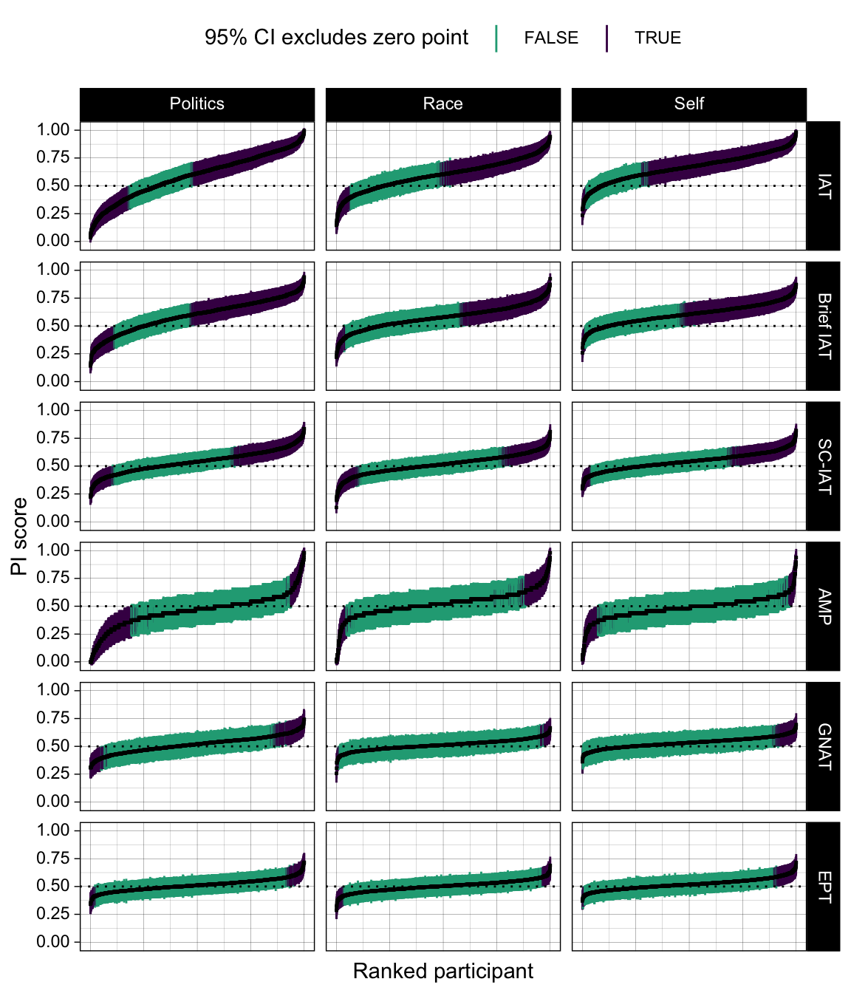

**Figure 1.** Caterpillar plot of the distribution of PI scores, and their associated confidence intervals, for each participant across each measure and domain.

#### Meta-analytic model

In order to compare the proportion of detectable effects between measures, the data from individuals was meta-analyzed. For each measure and domain, we calculated the proportion of detectable effects and its variance. We then entered the proportions into a linear mixed-effects model using the R package lme4 [(Bates et al., 2015)](https://www.zotero.org/google-docs/?bgjNbN). The Wilkinson notation for the model was as follows:

proportion_diff_zero ~ 1 + measure + (1 | domain),

weights = 1/variance

That is, we entered measure as a fixed effect in order to estimate the proportions for each measure and make inferences about differences between them (i.e., measures are an exhaustive set for our purposes). Domain was entered as a random intercept in order to acknowledge the non-independence of attitudes within each domain, and the fact that there are other domains to be generalized to in principle (i.e., domain is non-exhaustive, and attitude domain is the data generating signal). We weighted by inverse variance, as is common in meta-analytic models [(Viechtbauer, 2005)](https://www.zotero.org/google-docs/?wjiJFY). A forest plot of the individual effect sizes for each domain and the meta-analyzed effect size for each measure can be found in Figure 2A. Tables containing full results from this and all subsequent models, along with the data presented in the figures in table format, can be found in the online supplementary materials.

Results of the meta-analysis were interpreted with the aid of pairwise comparisons between the measures. These were calculated using the emmeans R package [(Lenth, 2022)](https://www.zotero.org/google-docs/?IRm5x1) while also controlling error rates using Holm correction. Results from these pairwise comparisons are presented in Table 3.

**Table 3.** Pairwise comparisons of the estimated marginal means of the proportions of participants discriminable from 0.50 for each measure.

|  |  |  |  |  |
| --- | --- | --- | --- | --- |
| Measure 1 | Measure 2 | Estimated marginal mean difference | 95% CIs | p-value |
| IAT | B-IAT | 0.12 | 0.03, 0.22 | < .001 |
| IAT | ST-IAT | 0.30 | 0.21, 0.39 | < .001 |
| IAT | AMP | 0.49 | 0.41, 0.57 | < .001 |
| IAT | GNAT | 0.57 | 0.49, 0.64 | < .001 |
| IAT | EPT | 0.58 | 0.50, 0.65 | < .001 |
| B-IAT | ST-IAT | 0.18 | 0.08, 0.28 | < .001 |
| B-IAT | AMP | 0.37 | 0.28, 0.45 | < .001 |
| B-IAT | GNAT | 0.44 | 0.36, 0.53 | < .001 |
| B-IAT | EPT | 0.45 | 0.37, 0.53 | < .001 |
| ST-IAT | AMP | 0.19 | 0.10, 0.27 | < .001 |
| ST-IAT | GNAT | 0.26 | 0.18, 0.34 | < .001 |
| ST-IAT | EPT | 0.27 | 0.20, 0.35 | < .001 |
| AMP | GNAT | 0.08 | 0.01, 0.14 | .022 |
| AMP | EPT | 0.09 | 0.02, 0.15 | .007 |
| GNAT | EPT | 0.01 | -0.05, 0.07 | .713 |

### RQ2. Proportion of scores discriminable from other scores

#### Calculation of scores

95% CIs on individuals’ scores were also used to assess the proportion of other participants’ scores from which each individual’s score was detectibly different. Pairwise comparisons between each participant and every other participant (separately for each measure and domain) were calculated using the 95% Confidence Interval on the difference scores between them via bootstrapping, to create one proportion for each participant and its variance. For this and all subsequent analyses, if proportions of 0 or 1 or variances of 0 were obtained, these values were offset by 0.001 in order to allow for meta-analysis.

#### Meta-analytic model

The individual level proportions were entered into a similar linear mixed-effects model to the previous one:

proportion_discriminable ~ 1 + measure + (1 | domain),

weights = 1/variance

A forest plot of the individual effect sizes for each domain and the meta-analyzed effect size for each measure can be found in Figure 2B. Similar to the previous analysis, results from the forest plot were interpreted with the aid of pairwise comparisons between the measures, again using Holm correction. These pairwise comparisons are presented in Table 4.

**Table 4.** Pairwise comparisons of the estimated marginal means of participants who could be discriminated from one another for each measure.

|  |  |  |  |  |
| --- | --- | --- | --- | --- |
| Measure 1 | Measure 2 | Estimated marginal mean difference | 95% CIs | p-value |
| IAT | B-IAT | 0.14 | 0.06, 0.22 | < .001 |
| IAT | ST-IAT | 0.19 | 0.11, 0.26 | < .001 |
| IAT | AMP | 0.30 | 0.23, 0.38 | < .001 |
| IAT | GNAT | 0.43 | 0.38, 0.49 | < .001 |
| IAT | EPT | 0.42 | 0.36, 0.48 | < .001 |
| B-IAT | ST-IAT | 0.05 | -0.04, 0.13 | .261 |
| B-IAT | AMP | 0.17 | 0.08, 0.25 | < .001 |
| B-IAT | GNAT | 0.29 | 0.23, 0.36 | < .001 |
| B-IAT | EPT | 0.28 | 0.21, 0.35 | < .001 |
| ST-IAT | AMP | 0.12 | 0.18, 0.31 | .005 |
| ST-IAT | GNAT | 0.25 | 0.18, 0.31 | < .001 |
| ST-IAT | EPT | 0.24 | 0.17, 0.30 | < .001 |
| AMP | GNAT | 0.13 | 0.06, 0.20 | < .001 |
| AMP | EPT | 0.12 | 0.05, 0.19 | < .001 |
| GNAT | EPT | -0.01 | -0.06, 0.04 | .646 |

### RQ3. Coverage of Individuals’ Confidence Intervals

#### Calculation of scores

95% CIs on individuals’ scores were also used to assess the typical proportion of the observed range covered by an individual interval. First, the observed range of intervals was calculated for each domain and measure. Then, each interval was divided by this observed range to calculate a proportion. In order to meta-analyze these proportions, their mean and variance were then calculated.

#### Meta-analytic model

The proportions were entered into a similar linear mixed-effects model to the previous two:

ci_width_proportion_mean ~ 1 + measure + (1 | domain),

weights = 1/variance

A forest plot of the individual effect sizes for each domain and the meta-analyzed effect size for each measure can be found in Figure 2C. Tables containing the numerical result can be found in the supplementary materials. Results were again interpreted with the aid of pairwise comparisons between the measures using Holm corrections, which can be found in Table 5.

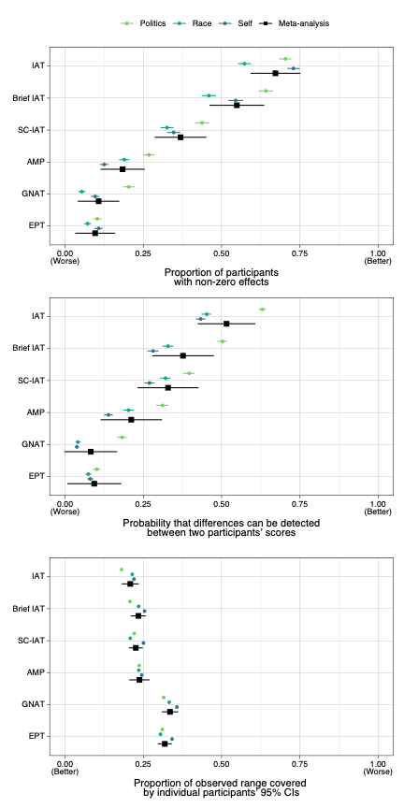

**Figure 2.** Forest plot for the meta-analytic models associated with the three research questions. The upper third of the plot shows the meta-analytic model for the proportion of participants whose scores differed detectably from zero; the middle third of the plot shows the meta-analytic model for the probability of detectable difference between two participants; and the lower third shows the meta-analytic model for the coverage of the confidence intervals.

**Table 5.** Pairwise comparisons of the estimated marginal means of the coverage of participants’ CIs for each measure.

|  |  |  |  |  |
| --- | --- | --- | --- | --- |
| Measure 1 | Measure 2 | Estimated marginal mean difference | 95% CIs | p-value |
| IAT | B-IAT | -0.03 | -0.05, 0.00 | .019 |
| IAT | ST-IAT | -0.02 | -0.04, 0.00 | .073 |
| IAT | AMP | -0.03 | -0.06, 0.00 | .06 |
| IAT | GNAT | -0.13 | -0.15, -0.10 | < .001 |
| IAT | EPT | -0.11 | -0.13, -0.09 | < .001 |
| B-IAT | ST-IAT | 0.01 | -0.01, 0.02 | .274 |
| B-IAT | AMP | 0.00 | -0.03, 0.02 | .807 |
| B-IAT | GNAT | -0.10 | -0.12, -0.08 | < .001 |
| B-IAT | EPT | -0.08 | -0.10, -0.07 | < .001 |
| ST-IAT | AMP | -0.01 | -0.04, 0.01 | .381 |
| ST-IAT | GNAT | -0.11 | -0.13, -0.09 | < .001 |
| ST-IAT | EPT | -0.09 | -0.10, -0.08 | < .001 |
| AMP | GNAT | -0.10 | -0.13, -0.07 | < .001 |
| AMP | EPT | -0.08 | -0.11, -0.05 | < .001 |
| GNAT | EPT | 0.02 | 0.00, 0.03 | .058 |

# Discussion

A central aim of the implicit measures field has been to use these measures to make predictions or inferences about the implicit biases of individual participants. Researchers using implicit measures have been acutely aware that these measures are currently insufficient to do so [(Greenwald & Lai, 2020)](https://www.zotero.org/google-docs/?HeY5E9). To date, we have had little sense of exactly how precise these measures are, and no sense of how one measure compares to another. We attempted to unpack this by estimating and comparing the precision of six different implicit measures across three different domains. Our results were stark: none of the implicit measures appeared suitable for precise individual level inferences, although some measures (particularly the IAT and its variants) were superior to others.

## Implicit measures should be calibrated for individual-level precision

While these comparative assessments of the individual utility of six common implicit measures are useful in and of themselves, the most important aspect of this work is that it provides researchers with a framework with which to assess the precision of their implicit measures. This has until now been sorely lacking in the implicit social cognition literature. Researchers may now have a sense of how exactly to interpret individual scores on implicit measures. In the context of *D* scores in the IAT as highlighted in Table 2, scores of 0 in the IAT can indicate anywhere between moderate negative and moderate positive bias, rather than no bias (as is stated on the Project Implicit website), and it is only at a score of around 0.35 that one can reliably conclude that that individual has a non-zero bias (and even then, this bias may barely differ from zero).

This work highlights the importance of a detailed focus on measurement within implicit measures research; a need which is echoing throughout psychological science [(Flake & Fried, 2020; Hussey & Hughes, 2020)](https://www.zotero.org/google-docs/?7BkT7M). Whereas the goal of individual-level prediction has been present in the field of implicit measures for 25 years, actually measuring this has been neglected. Indeed, the disconnection between our stated goals and measurement practices is alarming. We hope this can serve as an illustration for other research domains; if we aspire to certain goals, we must be able to quantify whether those goals are being achieved.

## Individual-level precision beyond implicit measures

Many other fields of psychology aim to make claims about individuals without estimating individual-level effects. [McManus et al. (2023)](https://www.zotero.org/google-docs/?ajR3o0) recently noted that the majority of psychological researchers wish to make claims about at least a majority of individuals when conducting experiments. Others have proposed that the presence or absence of effects within individual participants represents a more meaningful effect size metric than group-level approaches (Grice et al., 2020). The use of bootstrapping for individual-level estimation can be applied robustly across research areas; it can be done with any performance-based task which consists of response times and/or accuracy scores. If the goal of using a task is to make individual-level inferences, then researchers should strongly consider quantifying individual-level precision as early as possible in the process of developing their measure.

## Limitations

A limit on the generalisability of our findings relates to our selection of measures. The tasks examined here may not be representative of all implicit measures. Even within those we tested, our results may not generalize to those measures in all contexts; we investigated the properties of the measures across three domains, but there are countless others which may lead to differences in the psychometric properties of the tasks. We advocate strongly for tests of the generalisability of these results across other implicit measures, domains, and psychological tasks more generally in future research.

Although a powerful approach to estimation, bootstrapping is also not without its limitations. For procedures with a limited number of trials these approaches may produce biased estimates [(Mostofian & Zuckerman, 2019)](https://www.zotero.org/google-docs/?To16oV). Although other bootstrapping methods exist which can correct for bias due to small samples (e.g., bias-corrected and accelerated bootstrapping; [Puth et al., 2015)](https://www.zotero.org/google-docs/?hkkM8o), these methods can suffer from convergence issues, or may produce scores in some bootstrap samples which fall outside of the possible bounds of the scale (e.g., outside of 0 and 1 in the PI). Although our findings were relatively robust across different bootstrapping methods, it is critical to carefully consider the method of choice when using this approach.

## Conclusion

This work represents the first comparison of multiple implicit measures in terms of their individual-level measurement precision. Although we hope that our results will be informative and useful to researchers who have used, are using, or will use implicit measures in their research, our ultimate hope is that psychological researchers *in general* will explicitly usemetrics of individual level precision as benchmarks to improve their tasks where applicable. Psychological science cannot be a science of persons without the precise measurement of persons.

**Research Transparency Statement**

**General Disclosures**

**Conflicts of interest:** All authors declare no conflicts of interest. **Funding**: JC was supported by FWO grant 1202624N. **Artificial intelligence:** No artificial intelligence assisted technologies were used in this research or the creation of this article. **Ethics:** This research received approval from a local ethics board (ID: 424242). **Computational reproducibility:** [The authors are applying for a Computational Reproducibility Badge which will be awarded pending checks by the STAR Team.]

**Experiment 1:**

**Preregistration:** The hypotheses and analysis plan/code were preregistered (https://osf.io/qk9ar) on 31/08/2022, prior to the commencement of the analysis of the data. There were minor deviations from the preregistration (for details see Supplementary Table 1). **Materials:** We did not conduct the original study or data collection. However, the study materials were made openly available by the original authors; a copy of the relevant materials can be found here (https://osf.io/pq6nf/?view_only=6210f667c39e4a64b7cfd98a8b15539f). **Data:** All primary data are publicly available (https://osf.io/pq6nf/?view_only=6210f667c39e4a64b7cfd98a8b15539f). **Analysis scripts:** All analysis scripts are publicly available (<https://osf.io/pq6nf/?view_only=6210f667c39e4a64b7cfd98a8b15539f>).

**Note:** Specific links have been changed in-text to the general view-only link to preserve anonymity for double-blinded review; however, all linked materials should be easily findable through this link.

**References**

[Bar-Anan, Y., & Nosek, B. A. (2014). A comparative investigation of seven indirect attitude measures. *Behavior Research Methods*, *46*(3), 668–688. https://doi.org/10.3758/s13428-013-0410-6](https://www.zotero.org/google-docs/?4ao8mI)

[Bar-Anan, Y., Nosek, B. A., & Vianello, M. (2009). The sorting paired features task: A measure of association strengths. *Experimental Psychology*, *56*(5), 329–343. https://doi.org/10.1027/1618-3169.56.5.329](https://www.zotero.org/google-docs/?4ao8mI)

[Bates, D., Mächler, M., Bolker, B., & Walker, S. (2015). Fitting Linear Mixed-Effects Models Using lme4. *Journal of Statistical Software*, *67*, 1–48. https://doi.org/10.18637/jss.v067.i01](https://www.zotero.org/google-docs/?4ao8mI)

[Canty, A., & Ripley, B. (2021). *boot: Bootstrap R (S-Plus) Functions* (1.3-28) [R].](https://www.zotero.org/google-docs/?4ao8mI)

[Cummins, J. (2023). On the measurement of relational responding. *Journal of Contextual Behavioral Science*. https://doi.org/10.1016/j.jcbs.2023.10.003](https://www.zotero.org/google-docs/?4ao8mI)

[Cummins, J., Hussey, I., & Spruyt, A. (2022). The role of attitude features in the reliability of IAT scores. *Journal of Experimental Social Psychology*, *101*, 104330. https://doi.org/10.1016/j.jesp.2022.104330](https://www.zotero.org/google-docs/?4ao8mI)

[Cummins, J., Lindgren, K. P., & De Houwer, J. (2021). On the role of (implicit) drinking self-identity in alcohol use and problematic drinking: A comparison of five measures. *Psychology of Addictive Behaviors : Journal of the Society of Psychologists in Addictive Behaviors*, *35*(4), 458–471. https://doi.org/10.1037/adb0000643](https://www.zotero.org/google-docs/?4ao8mI)

[De Schryver, M., Hussey, I., De Neve, J., Cartwright, A., & Barnes-Holmes, D. (2018). The PIIRAP: An alternative scoring algorithm for the IRAP using a probabilistic semiparametric effect size measure. *Journal of Contextual Behavioral Science*, *7*, 97–103. https://doi.org/10.1016/j.jcbs.2018.01.001](https://www.zotero.org/google-docs/?4ao8mI)

[Dudek, F. J. (1979). The continuing misinterpretation of the standard error of measurement. *Psychological Bulletin*, *86*(2), 335–337. https://doi.org/10.1037/0033-2909.86.2.335](https://www.zotero.org/google-docs/?4ao8mI)

[Fazio, R. H., Jackson, J. R., Dunton, B. C., & Williams, C. J. (1995). Variability in automatic activation as an unobtrusive measure of racial attitudes: A bona fide pipeline? *Journal of Personality and Social Psychology*, *69*(6), 1013–1027. https://doi.org/10.1037/0022-3514.69.6.1013](https://www.zotero.org/google-docs/?4ao8mI)

[Fiedler, K., Messner, C., & Bluemke, M. (2006). Unresolved problems with the “I”, the “A”, and the “T”: A logical and psychometric critique of the Implicit Association Test (IAT). *European Review of Social Psychology*, *17*(1), 74–147. https://doi.org/10.1080/10463280600681248](https://www.zotero.org/google-docs/?4ao8mI)

[Flake, J. K., & Fried, E. I. (2020). Measurement Schmeasurement: Questionable Measurement Practices and How to Avoid Them. *Advances in Methods and Practices in Psychological Science*, *3*(4), 456–465. https://doi.org/10.1177/2515245920952393](https://www.zotero.org/google-docs/?4ao8mI)

[Gomez, P., Ratcliff, R., & Perea, M. (2007). A Model of the Go/No-Go Task. *Journal of Experimental Psychology. General*, *136*(3), 389–413. https://doi.org/10.1037/0096-3445.136.3.389](https://www.zotero.org/google-docs/?4ao8mI)

[Greenwald, A. G., & Banaji, M. R. (1995). Implicit social cognition: Attitudes, self-esteem, and stereotypes. *Psychological Review*, *102*(1), 4–27. https://doi.org/10.1037/0033-295X.102.1.4](https://www.zotero.org/google-docs/?4ao8mI)

[Greenwald, A. G., Brendl, M., Cai, H., Cvencek, D., Dovidio, J. F., Friese, M., Hahn, A., Hehman, E., Hofmann, W., Hughes, S., Hussey, I., Jordan, C., Kirby, T. A., Lai, C. K., Lang, J. W. B., Lindgren, K. P., Maison, D., Ostafin, B. D., Rae, J. R., … Wiers, R. W. (2022). Best research practices for using the Implicit Association Test. *Behavior Research Methods*, *54*(3), 1161–1180. https://doi.org/10.3758/s13428-021-01624-3](https://www.zotero.org/google-docs/?4ao8mI)

[Greenwald, A. G., & Lai, C. K. (2020). Implicit Social Cognition. *Annual Review of Psychology*, *71*(1), 419–445. https://doi.org/10.1146/annurev-psych-010419-050837](https://www.zotero.org/google-docs/?4ao8mI)

[Greenwald, A. G., McGhee, D. E., & Schwartz, J. L. K. (1998). Measuring individual differences in implicit cognition: The implicit association test. *Journal of Personality and Social Psychology*, *74*(6), 1464–1480. https://doi.org/10.1037/0022-3514.74.6.1464](https://www.zotero.org/google-docs/?4ao8mI)

[Greenwald, A. G., Nosek, B. A., & Banaji, M. R. (2003). Understanding and using the Implicit Association Test: I. An improved scoring algorithm. *Journal of Personality and Social Psychology*, *85*(2), 197–216. https://doi.org/10.1037/0022-3514.85.2.197](https://www.zotero.org/google-docs/?4ao8mI)

[Hussey, I. (2020). *The Implicit Relational Assessment Procedure is not suitable for individual use*. PsyArXiv. https://doi.org/10.31234/osf.io/w2ygr](https://www.zotero.org/google-docs/?4ao8mI)

[Hussey, I., & Hughes, S. (2020). Hidden Invalidity Among 15 Commonly Used Measures in Social and Personality Psychology. *Advances in Methods and Practices in Psychological Science*, *3*(2), 166–184. https://doi.org/10.1177/2515245919882903](https://www.zotero.org/google-docs/?4ao8mI)

[Karpinski, A., & Steinman, R. B. (2006). The single category implicit association test as a measure of implicit social cognition. *Journal of Personality and Social Psychology*, *91*(1), 16–32. https://doi.org/10.1037/0022-3514.91.1.16](https://www.zotero.org/google-docs/?4ao8mI)

[Klein, C. (2020). *Confidence Intervals on Implicit Association Test Scores Are Really Rather Large*. PsyArXiv. https://doi.org/10.31234/osf.io/5djkh](https://www.zotero.org/google-docs/?4ao8mI)

[Kurdi, B., Seitchik, A. E., Axt, J. R., Carroll, T. J., Karapetyan, A., Kaushik, N., Tomezsko, D., Greenwald, A. G., & Banaji, M. R. (2019). Relationship between the Implicit Association Test and intergroup behavior: A meta-analysis. *American Psychologist*, *74*(5), 569–586. https://doi.org/10.1037/amp0000364](https://www.zotero.org/google-docs/?4ao8mI)

[Lenth, R. (2022). *emmeans: Estimated Marginal Means, aka Least-Squares Means* (1.8.2) [R].](https://www.zotero.org/google-docs/?4ao8mI)

[McGraw, K. O., & Wong, S. (1992). A common language effect size statistic. *Psychological Bulletin*, *111*(2), 361.](https://www.zotero.org/google-docs/?4ao8mI)

[McManus, R., Young, L., & Sweetman, J. (2023). Psychology is a Property of Persons, Not Averages or Distributions: Confronting the Group-to-Person Generalizability Problem in Experimental Psychology. *Advances in Methods and Practices in Psychological Science*.](https://www.zotero.org/google-docs/?4ao8mI)

[Millner, A. J., Coppersmith, D. D. L., Teachman, B. A., & Nock, M. K. (2018). The Brief Death Implicit Association Test: Scoring recommendations, reliability, validity, and comparisons with the Death Implicit Association Test. *Psychological Assessment*, *30*(10), 1356–1366. https://doi.org/10.1037/pas0000580](https://www.zotero.org/google-docs/?4ao8mI)

[Mollenkopf, W. G. (1949). Variation of the standard error of measurement. *Psychometrika*, *14*(3), 189–229. https://doi.org/10.1007/BF02289153](https://www.zotero.org/google-docs/?4ao8mI)

[Mostofian, B., & Zuckerman, D. M. (2019). Statistical uncertainty analysis for small-sample, high log-variance data: Cautions for bootstrapping and Bayesian bootstrapping. *Journal of Chemical Theory and Computation*, *15*(6), 3499–3509. https://doi.org/10.1021/acs.jctc.9b00015](https://www.zotero.org/google-docs/?4ao8mI)

[Nosek, B. A., & Banaji, M. R. (2001). The Go/No-go Association Task. *Social Cognition*, *19*(6), 625–666. https://doi.org/10.1521/soco.19.6.625.20886](https://www.zotero.org/google-docs/?4ao8mI)

[Nosek, B. A., Greenwald, A. G., & Banaji, M. R. (2007). The Implicit Association Test at Age 7: A Methodological and Conceptual Review. In J. A. Bargh, *Automatic processes in social thinking and behavior* (pp. 265–292). Psychology Press.](https://www.zotero.org/google-docs/?4ao8mI)

[Payne, B. K., Cheng, C. M., Govorun, O., & Stewart, B. D. (2005). An inkblot for attitudes: Affect misattribution as implicit measurement. *Journal of Personality and Social Psychology*, *89*(3), 277–293. https://doi.org/10.1037/0022-3514.89.3.277](https://www.zotero.org/google-docs/?4ao8mI)

[Puth, M.-T., Neuhäuser, M., & Ruxton, G. D. (2015). On the variety of methods for calculating confidence intervals by bootstrapping. *Journal of Animal Ecology*, *84*(4), 892–897. https://doi.org/10.1111/1365-2656.12382](https://www.zotero.org/google-docs/?4ao8mI)

[Ruscio, J. (2008). A probability-based measure of effect size: Robustness to base rates and other factors. *Psychological Methods*, *13*(1), 19–30. https://doi.org/10.1037/1082-989X.13.1.19](https://www.zotero.org/google-docs/?4ao8mI)

[Scheel, A. M. (2022). Why most psychological research findings are not even wrong. *Infant and Child Development*, *31*(1), e2295. https://doi.org/10.1002/icd.2295](https://www.zotero.org/google-docs/?4ao8mI)

[Schimmack, U. (2021). The Implicit Association Test: A Method in Search of a Construct. *Perspectives on Psychological Science*, *16*(2), 396–414. https://doi.org/10.1177/1745691619863798](https://www.zotero.org/google-docs/?4ao8mI)

[Schmukle, S. C. (2023). *Unbiased Confidence Intervals for Individual Scores in Psychological Testing: The Rescaled Estimated True Score (RETS) Approach*. unpublished manuscript.](https://www.zotero.org/google-docs/?4ao8mI)

[Sriram, N., & Greenwald, A. G. (2009). The Brief Implicit Association Test. *Experimental Psychology*, *56*(4), 283–294. https://doi.org/10.1027/1618-3169.56.4.283](https://www.zotero.org/google-docs/?4ao8mI)

[Streiner, D. L. (2003). Starting at the Beginning: An Introduction to Coefficient Alpha and Internal Consistency. *Journal of Personality Assessment*, *80*(1), 99–103. https://doi.org/10.1207/S15327752JPA8001_18](https://www.zotero.org/google-docs/?4ao8mI)

[Viechtbauer, W. (2005). Bias and Efficiency of Meta-Analytic Variance Estimators in the Random-Effects Model. *Journal of Educational and Behavioral Statistics*, *30*(3), 261–293.](https://www.zotero.org/google-docs/?4ao8mI)