Here is a screenshot of the database tables I’m going to be using to explain how to do everything in this program.

Table 1 called test1:

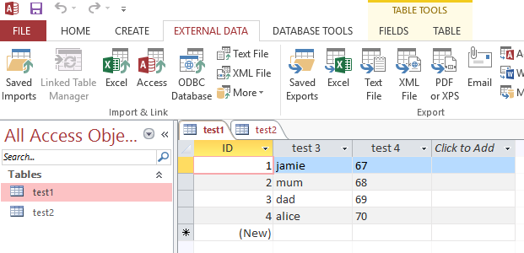

Table 2 called test2:

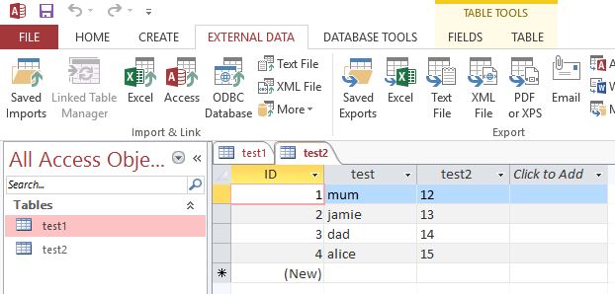

Save the export from the database in the Data folder which is in the same folder as the program (my program not the database program) so, for example this is the export wizard in Access:

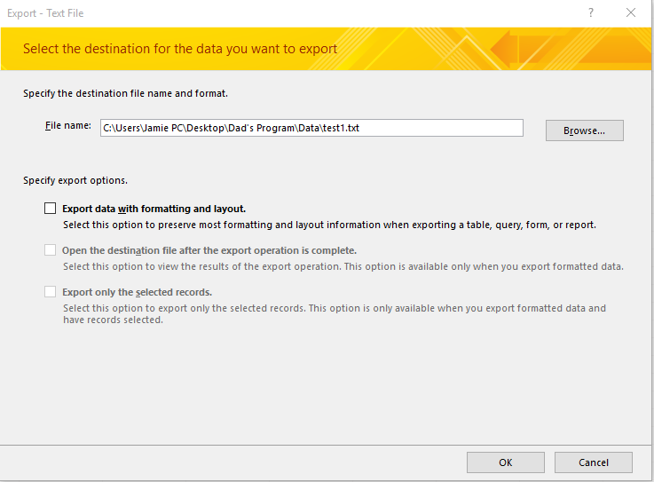

In this example the program is located in a folder on my desktop so click browse and locate where your folder is, then open the data folder and save the file. The default download location is “my downloads”, you’ll need to move it out of that folder and put it somewhere else.

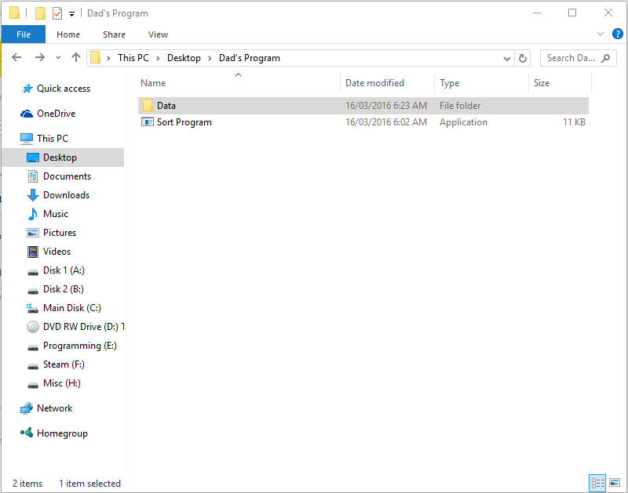

Once you do this for all of the tables, open the program. You’ll see this interface.

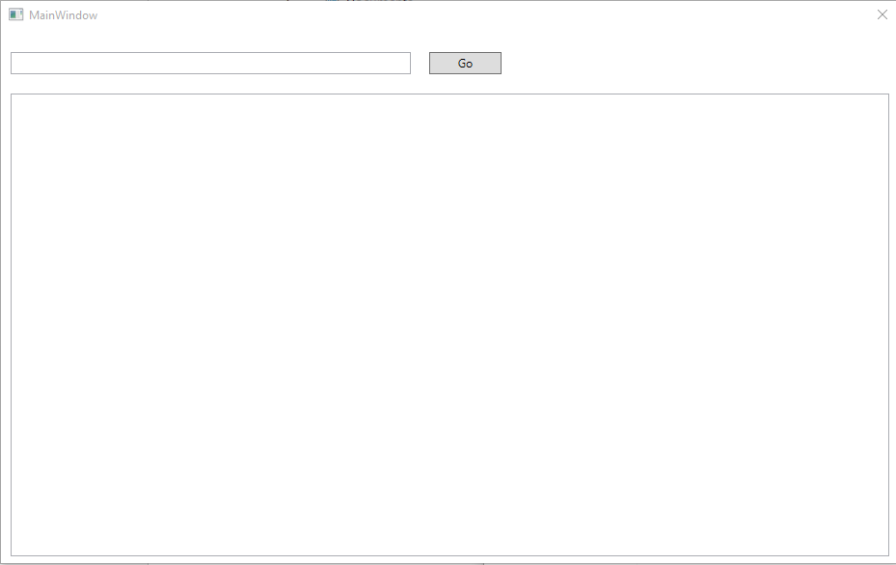

To search for an item (for example the name of someone in the database) type in the input into the text box and click the button. Every entry that is associated with your input will now be listed. Keep in mind the input is case sensitive. So if you type in Mum or MuM instead of mum, it won’t work.

