WORLD DOMINATION RISK®

OBJECT OF THE GAME
To conquer the world by occupying every territory on the board, thus eliminating all your opponents.

SETUP
Unlike most games, RISK demands careful planning before you actually start to play. This Initial Army Placement sets the stage for the battles you ’ll fight later on.
INITIAL ARMY PLACEMENT consists of these steps:
- Select a color and, depending on the number of players, count out the “armies” you’ll need to start the game.
If 2 are playing, see instructions on page 11.
If 3 are playing, each player counts out 35 Infantry. If 4 are playing, each player counts out 30 Infantry. If 5 are playing, each player counts out 25 Infantry. If 6 are playing, each player counts out 20 Infantry.
- Roll one die. Whoever rolls the highest number takes one Infantry piece from his or her pile and places it onto any territory on the board, thus claiming that territory.
- Starting to the left of the first player, everyone in turn places one army onto any unoccupied territory. Continue until all 42 territories have been claimed.
- After all 42 territories are claimed, each player in turn places one additional army onto any territory he or she already occupies. Continue in this way until everyone has run out of armies. There is no limit to the number of armies you may place onto a single territory.

To complete game SETUP:
- Shuffle the pack of RISK cards (remove the Mission cards) and place it, face down, by the side of the board. This pack forms the draw pile.
- Whoever placed the first army takes the first turn.

PLAYING
On your turn, try to capture territories by defeating your opponents ’ armies. But be careful: Winning battles will depend on careful planning, quick decisions and bold moves. You ’ll have to place your forces wisely, attack at just the right time and fortify your defenses against all enemies. Note: At any time during the game, you may trade in Infantry pieces for the equivalent (see page 4) in Cavalry or Artillery if you need to, or wish to.

Each of your turns consists of three steps, in this order:
- Getting and placing new armies;
- Attacking, if you choose to, by rolling the dice;
- Fortifying your position.

GETTING AND PLACING NEW ARMIES
At the beginning of each turn, calculate how many new armies you ’ll add to your territories based o n . . .
- The number of territories you occupy;
- The value of the continents you control;
- The value of the matched sets of RISK cards you trade in;
- The specific territory pictured on a traded-in card.

Territories. At the beginning of every turn (including your first), count the number of territories you currently occupy, then divide the total by three (ignore any fraction). The answer is the number of armies you receive. Place the new armies on any territory you already occupy.
Example: 11 territories = 3 armies
14 territories = 4 armies
17 territories = 5 armies
You will always receive at least 3 armies on a turn, even if you occupy fewer than 9 territories.


Continents. In addition, at the beginning of your turn you will receive armies for each continent you control. (To control a continent, you must occupy all its territories at the start of your turn.) To find the exact number of armies you ’ll receive for each continent, look at the chart in the lower left-hand corner of the game board.

RISK CARDS
Earning Cards. At the end of any turn in which you have captured at least one territory, you will earn one (and only one) RISK card. You are trying to collect sets of 3 cards in any of the following combinations:

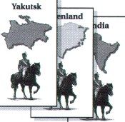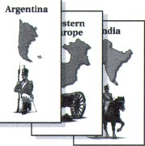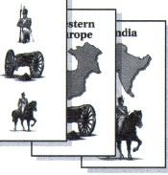

3 cards of same design (Infantry, Cavalry, or Artillery)
1 each of 3 designs any 2 plus a “ wild” card

If you have collected a set of 3 RISK cards, you may turn them in at the beginning of your next turn, or you may wait. But if you have 5 or 6 cards at the beginning of your turn, you must trade in at least one set, and may trade in a second set if you have one.

Trading I n Cards for Armies. At the beginning of subsequent turns, you may trade in matched sets of cards and take additional armies based on the total number of sets anyone has traded in so far. For quick reference, keep traded-in cards face down under the bottom edge of the game board to mark the value (in armies) of the next trade.
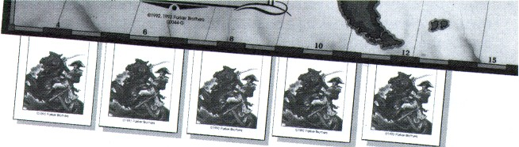

5 sets traded in so far: next set will be worth 15

The first set traded in - 4 armies The second set traded in - 6 armies The third set traded in - 8 armies The fourth set traded in - 10 armies The fifth set traded in - 12 armies The sixth set traded in - 15 armies

After the sixth set has been traded in, each additional set is worth 5 more armies. Example: If you trade in the seventh set, you get 20 armies; if you trade in the eighth, you get 25 armies, and so on. “First” and “second ” set,
etc., refer to sets traded in by anyone during the game. Thus, if you trade in the third set in the game, you receive 8 armies, even if it ’s the first set you
have traded in.
Occu pied territories. If any of the 3 cards you trade in shows the picture of a territory you occu py, you receive 2 extra armies. You must place both those armies onto that particular territory.
Note: On a single turn, you may receive no more than 2 extra armies above and beyond those you receive for the matched sets of cards you trade in.
Hints: No matter how many armies you receive at the start of your turn,
deploy them carefully-either to prepare for an attack or to defend against one. It is good military strategy to move your armies to the front, heavily fortifying territories that border enemy territories.

ATTACKING
After placing your armies at the beginning of your turn, decide if you wish to attack at this time. The object of an attack is to capture a territory by
defeating all the opposing armies already on it. The battle is fought by a roll of the dice. Study the board for a moment. Do you want to attack?
If you choose not to attack, pass the dice to the player on your left. You may still fortify your position, if you wish (see page 10).
If you choose to attack, you must follow these rules:

You may only attack a territory that ’s adjacent (touching) to one of your own, or connected to it by a dashed line. Examples: Greenland may attack the Northwest Territory, Ontario, Quebec and Iceland. North Africa may attack Egypt, Western Europe and Brazil. At the western and eastern edges of the board, Alaska is considered adjacent to, and may attack, Kamchatka.
You must always have at least two armies in the territory you ’re attacking from.
You may continue attacking one territory until you have eliminated all armies on it, or you may shift your attack from one territory to another, attacking each as often as you like and attacking as many territories as you like during one turn.

TO Attack. First announce both the territory you ’re attacking and the one you ’re attacking from. Then roll the dice against the opponent who occupies the opposing territory.

Before rolling, both you and your opponent must announce the number of dice you intend to roll, and you both must roll at the same time.
You, the attacker, will roll 1,2 or 3 red dice: You must have at least one more army in your territory than the number of dice you roll. Hint: The more dice you roll, the greater your odds of winning. Yet the more dice you roll, the more armies you may lose, or be required to move into a captured territory.

The defender will roll either 1 or 2 white dice: To roll 2 dice, he or she must have at least 2 armies on the territory under attack. Hint: The more dice the defender rolls, the greater his or her odds of winning-but the more armies he or she may lose.
To Decide a Battle. Compare the highest die each of you rolled. If yours (the attacker ’s) is higher, the defender loses one army from the territory under attack. But if the defender ’s die is higher than yours, you lose one army from the territory you attacked from; put it back in your clear plastic box. If each of you rolled more than one die, now compare the two
next-highest dice and repeat the process.

Attacker ’s Die
Defender ’s Die
Attacker ’s Dice
_ - - - - - - - - - - -
Defender ’s Dice
Result: Defender Loses One Army
Result: Attacker Loses Two Armies*
EXAMPLE 1
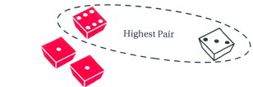

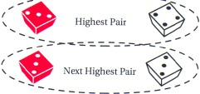EXAMPLE 3
EXAMPLE 2 I EXAMPLE 4
_ - - - - - - - - - - -
_
Pair
Attacker ’s Dice Defender ’s Dice Attacker ’s Die Defender ’s Dice


Next Highest Pair


Notes:
Result: Defender Loses One Army and Attacker Loses One Army ’
Result: Defender Loses One Army

- * In case of a tie, the defender always wins.
- The attacker can never lose more than 2 armies on a single roll.

Capturing territories. As soon as you defeat the last opposing army on a territory, you capture that territory and must occupy it immediately. To do so, move in at least as many armies as the number of dice you rolled in your last battle. Remember: In most cases, moving as many armies as you can to the front is advantageous, because armies left behind can ’t help
you when you are attacking. Also remember you must always leave at least one army behind on the territory you attacked from. During the game, every territory must always be occupied by at least one army.

Ending your attack. You may end your attack(s) at any time. If you have captured at least one territory, first take the top RISK card from the draw pile. (No matter how many territories you ’ve captured on your turn, you may take only one RISK card.) Your last step is to fortify your position, if you wish (see below). Finally, pass the dice.
Eliminating an opponent. If during your turn you eliminate an opponent by defeating his or her last army on the game board, you win any RISK cards that player has collected.

If winning them gives you 6 or more cards, you must immediately trade in enough sets to reduce your hand to 4 or fewer cards, but once your hand is reduced to 4,3, or 2 cards, you must stop trading.
But if winning them gives you fewer than 6, you must wait until the beginning of your next turn to trade in a set.
Note: When you draw a card from the deck at the end of your turn (for having won a battle), if this brings your total to 6, you must wait until your next turn to trade in.

FORTIFYING YOUR POSITION
No matter what you ’ve done on your turn, you may, if you wish, end your turn by fortifying your position. You are not required to win a battle or even to try an attack to do so. Some players refer to this as the “free move.”
To fortify your position, move as many armies as you ’d like from one (and only one) of your territories into one (and only one) of your adjacent territories. Remember to move troops towards borders where they can help in an attack!
In moving your armies from one territory to another, you must leave at least one army behind.

WINNING
The winner is the first player to eliminate every opponent by capturing all 42 territories on the board.

