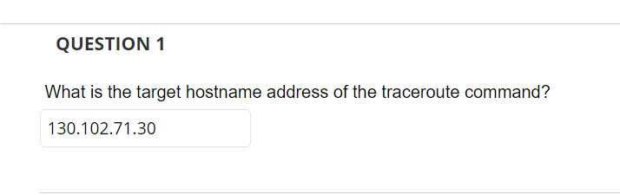

Search “icmp” which shows icmp packets being sent with increasing TTLs in sets of 3.

OR

DNS response in packet 84 shows coms3200.uqcloud.net type A record of 130.102.71.30

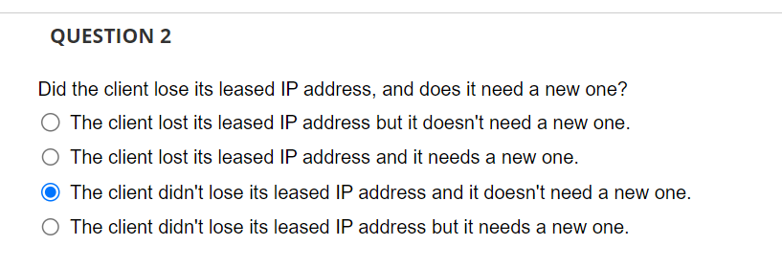

If you search ‘dhcp’ you see that the client received its ip (192.168.0.103) with a lease time of 7200s = 2hrs, and the total packet capture time is for 80 secs so it still has the address and doesn’t need a new one



Mac of client 192.168.0.103 is Netgear_2b:41:66 (9c:c9:eb:2b:41:66)

Search arp and see how many arp requests are sent from host to client???

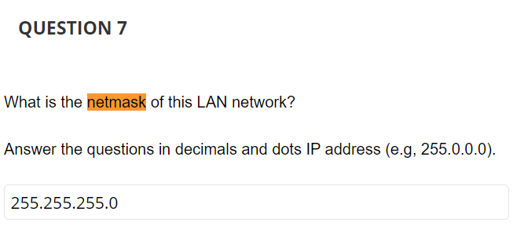

DHCP offer packet

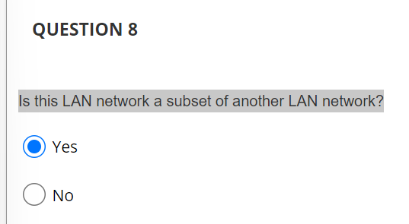

Second response from the trace route icmp packets is from 192.168.1.0 which is the second router outside our immediate one at 192.168.0.0

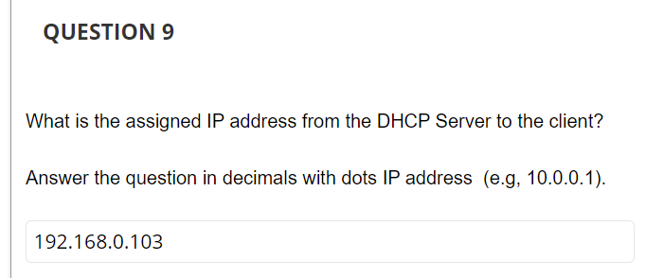

Look up dhcp and check

Look up dhcp

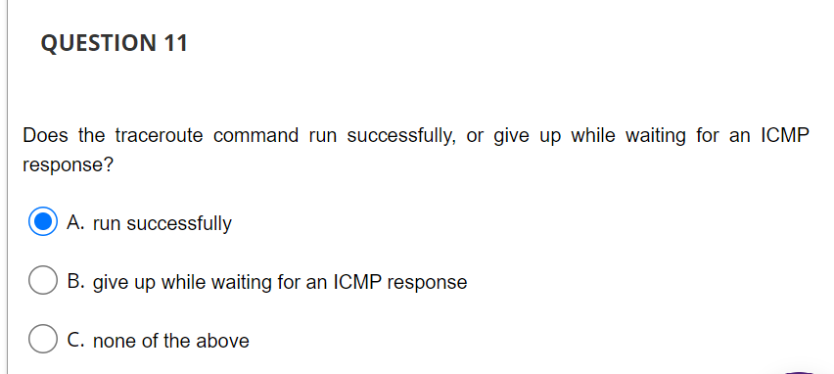

Final trace route icmp packets get responses from the target server

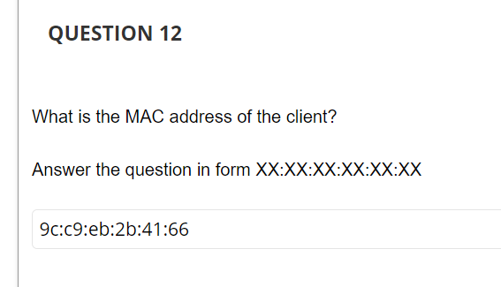

Look up first dhcp packet

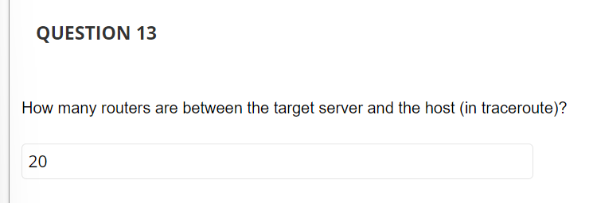

Final traceroute packet has ttl of 21. Ttl starts at 0 so therefore there are 20 routers between

Look up icmp

<https://osqa-ask.wireshark.org/questions/41152/how-to-check-if-fragmentation-is-happening/>

ip.flags.mf ==1 or ip.frag_offset gt 0