Spacescape

By Jamie Jasmine Koh

101233988

Spacescape is a simple story-based shooting game coded using C# programming language. When the game is first run, a start page appears, and the introduction music starts playing. The game will not navigate away from this page until the user presses the spacebar.

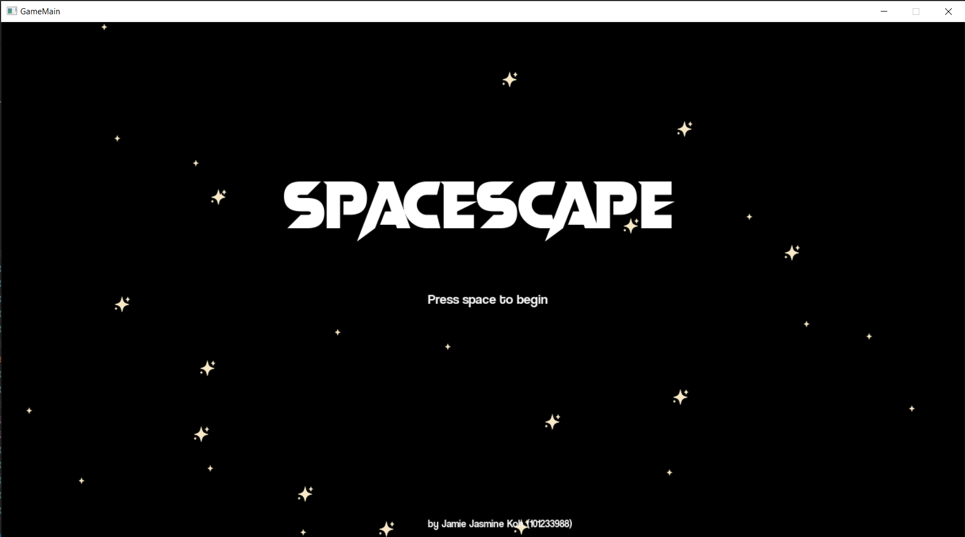

Upon pressing the spacebar, the introduction page will be displayed. It features a paragraph of text that moves slowly up the screen. It was inspired by my mother who said, “Make it like the openings of Star Wars movies.” Players can skip this screen by pressing the spacebar.

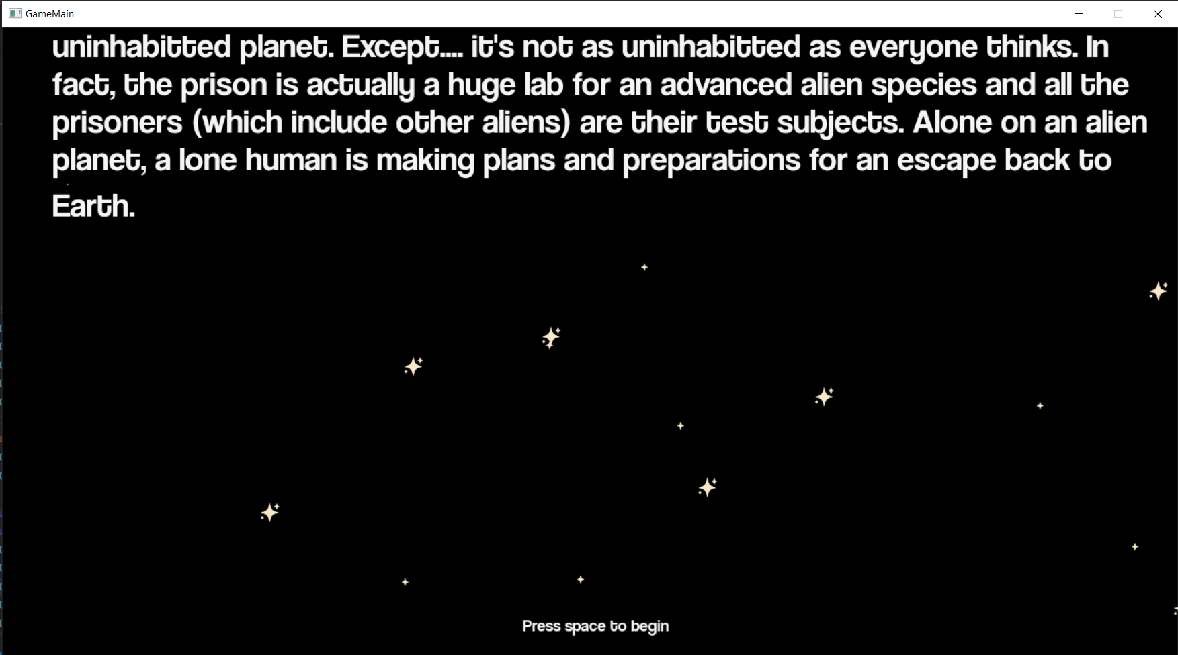

After the introduction screen, the game begins. Before every level of gameplay, there will be cutscenes that tell the story of two main characters. Users can choose to skip these scenes by pressing the S key or they could enjoy the cutscenes one by one like a comic by clicking anywhere on the screen to go to the next part. If the player fails a level, the game will play back the cutscenes before the level that they failed. If the player passes a level, the cutscenes will be new ones that continue the story in preparation of the next level. There is also eerie music that plays repeatedly during cutscenes because most of them take place in a ship so I thought it would help to set the atmosphere. Furthermore, I wanted my simple game to be as immersive and enjoyable as possible, so I did not want the player to have to read the cutscenes in silence.

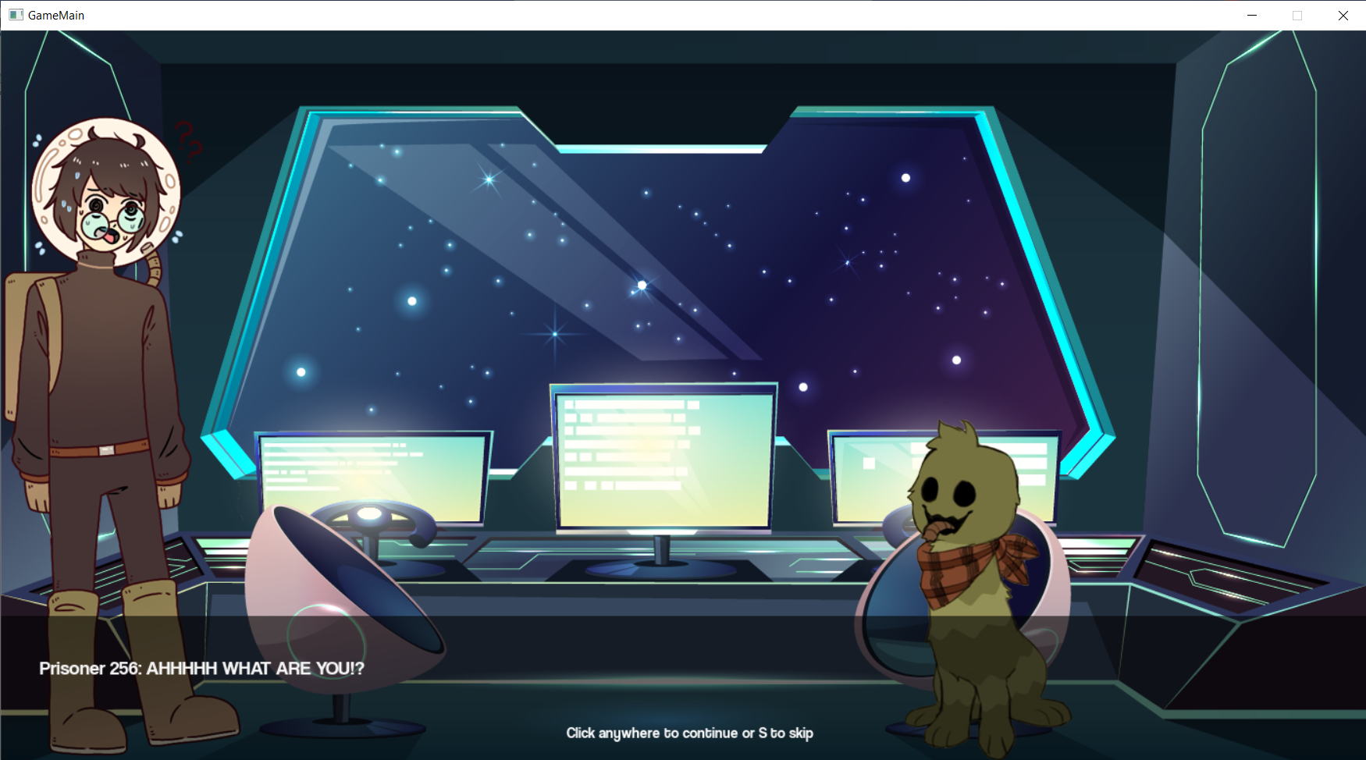

Each level consists of the player using the left and right arrow keys to move a spaceship at the bottom of the game window to simultaneously avoid and shoot obstacles and enemies. The enemies will appear at the top of the screen and move down towards the spaceship to give the impression that the ship is moving through space and in a forward direction.

As the player progresses through the levels, different types of enemies are randomly generated, and their movement speeds and directions vary to increase the difficulty of each level going up.

On the top left of the screen of every level except the last level, there will be heart icons displayed to indicate the number of “lives” the spaceship has left. Each level starts with three, and every time the spaceship gets hit by an enemy, the number of lives decreases by one. If the number of lives reaches 0, the player will fail the level.

On the other hand, for each level, there is a target number of enemies that must be defeated by the player shooting them. This number increases as the levels get higher.

Only the final level, a bonus level takes place inside the spaceship and there is only one target that does not move and a first-person shooter style gun that cannot be moved. In this level, the only thing the user can do is press the spacebar to shoot.

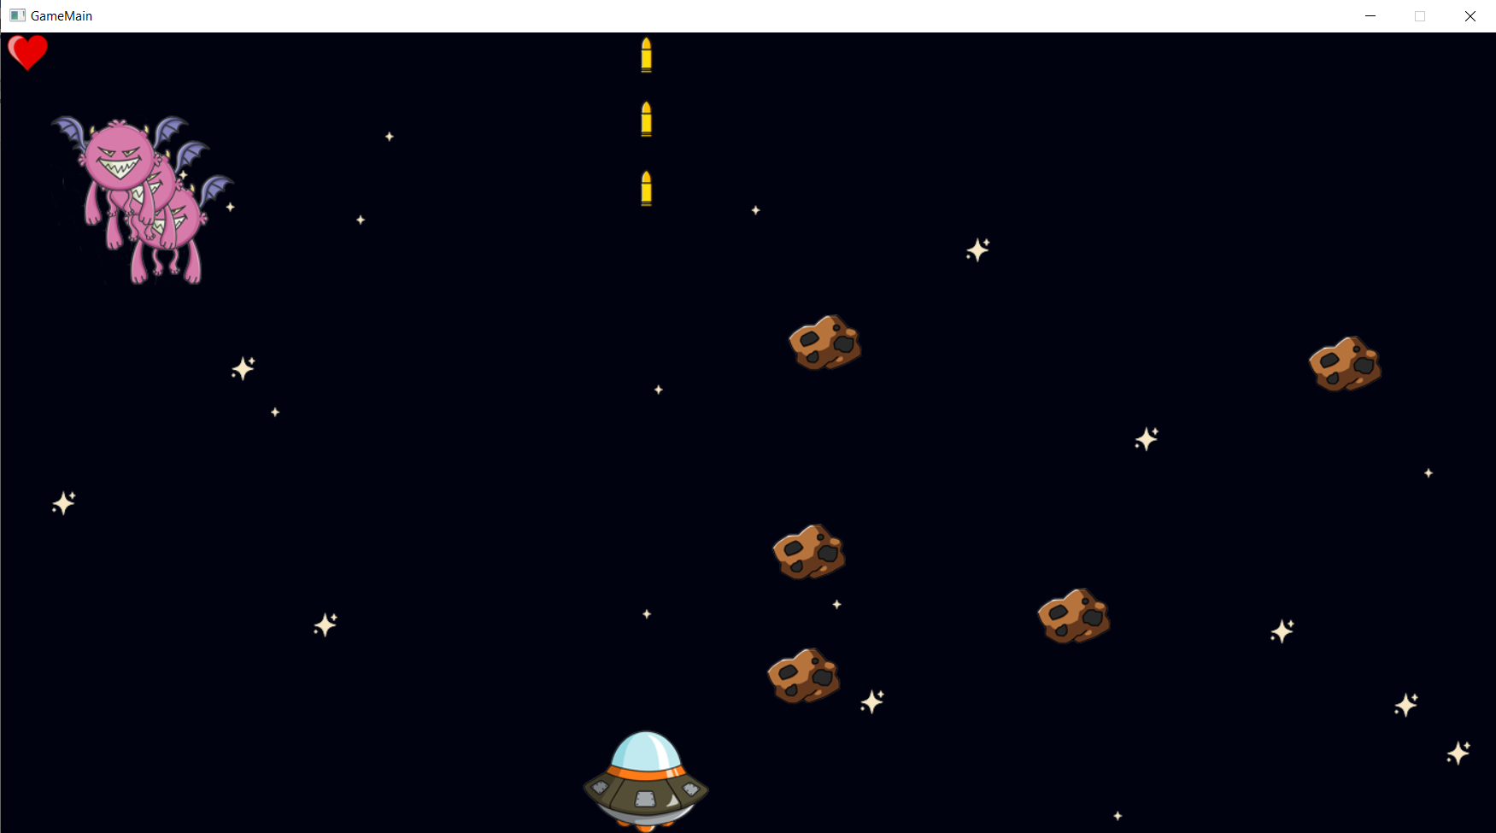

Once the player finishes the game, the ending screen will be displayed and the player must click anywhere to close the program.