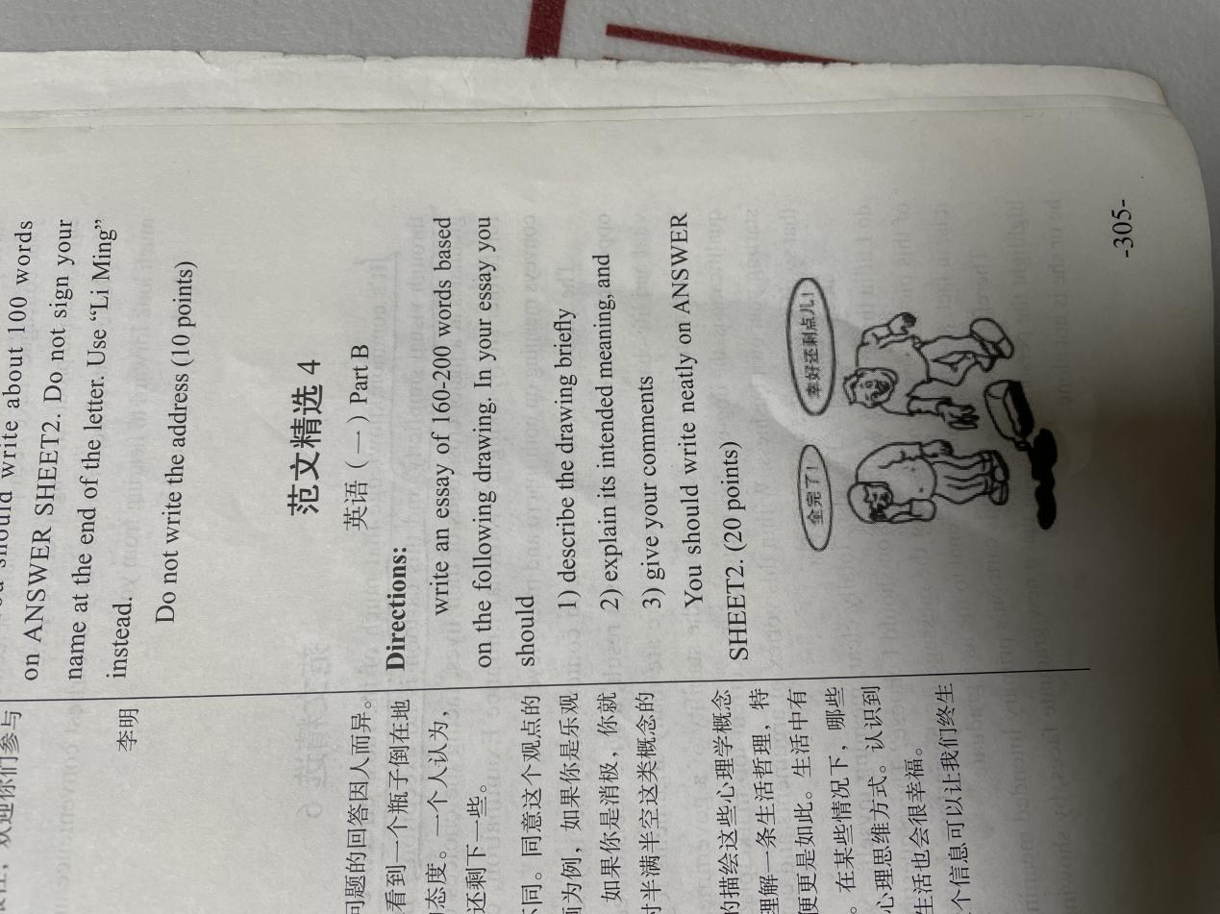

The drawing depicted a scene that is considerably insignificant to everyone. Two people have diffient perspectives to a same condation. One thinks of that water be upsetted is a very depressive thing though water had a half in vessel still. Another one feels optimistic to the same thing.

It is obvious that the picture try to convey the conception that the attitude of everybody treating dissatisfactions is different. You will do nothing if you are just negative and moaning. But most of difficult things have upsides as well when we treat it with a positive attitude, like the one in drawing see remaining a half of water as a lucky.

In my opinion that we should take the states seriously, if a thing have two perspectives, we need to choose the optimistic attitude clearly. Existing a lot of frustrations in our life, owning a good point of view can help us to weather bad time.