unifi-profile
Revision:
September 26, 2008
Approval
The original of this document is approved and signed by:
Name:
Surname:
Title:
Date:
Signature:
Revision History
Revision | Date | Description | Author
 | September 26, 2008

Table of Contents
Microsoft Word users please click here and press F9 to create Table of Contents.
OpenOffice.org users please remove this text and select Insert Table of Content from menu.

Table of Figures
Microsoft Word users please click here and press F9 to create Table of Contents.
OpenOffice.org users please remove this text and select Insert Table of Content from menu.

Introduction

Purpose

Scope

Overview

Package Profile
Description

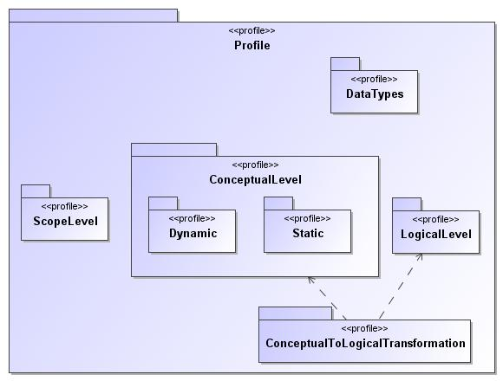
- Profile

Name | Profile
Qualified Name | Profile

Stereotype BusinessProcessCatalogue
Description

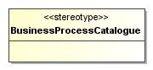
- BusinessProcessCatalogue

Name | BusinessProcessCatalogue
Abstract | false
Base Stereotype

Attribute Detail

base_Package
Description

Type | Package
Default Value
Multiplicity

Constraint Detail

BusinessProcessCatalogueLegalOwner
Description
A <<BusinessProcessCatalogue>>-stereotyped Package can be owned only by a <<BusinessProcessCatalogue>>-stereotyped Package
Body | not(base_Package.nestingPackage.oclIsUndefined()) implies  base_Package.nestingPackage.appliedStereotypeInstance.classifier.name -> includes('BusinessProcessCatalogue')

BusinessProcessCatalogueLegalToOwn
Description
All sub-Packages of a <<BusinessProcessCatalogue>>--stereotyped Package must be <<BusinessProcessCatalogue>>-stereotyped
Body | base_Package.nestedPackage -> forAll (pkg | pkg.appliedStereotypeInstance.classifier.name -> includes('BusinessProcessCatalogue'))

Stereotype CodeSet
Description

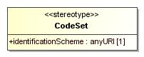
- CodeSet

Name | CodeSet
Abstract | false
Base Stereotype | TopLevelDictionaryEntry

Attribute Detail

base_Enumeration
Description

Type | Enumeration
Default Value
Multiplicity

identificationScheme
Description

Type | anyURI
Default Value
Multiplicity | 1

Stereotype CodeSetLiteral
Description

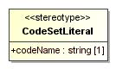
- CodeSetLiteral

Name | CodeSetLiteral
Abstract | false
Base Stereotype | RepositoryConcept

Attribute Detail

base_EnumerationLiteral
Description

Type | EnumerationLiteral
Default Value
Multiplicity

codeName
Description

Type | string
Default Value
Multiplicity | 1

Constraint Detail

MustBeLiteralOfCodeSetEnumeration
Description
A <<CodeSetLiteral>>-stereotyped EnumerationLiteral must be part of a <<CodeSet>>-stereotyped Enumeration
Body | base_EnumerationLiteral.owner.appliedStereotypeInstance.classifier.name -> includes('CodeSet')

Stereotype DataDictionary
Description

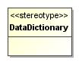
- DataDictionary

Name | DataDictionary
Abstract | false
Base Stereotype

Attribute Detail

base_Package
Description

Type | Package
Default Value
Multiplicity

Constraint Detail

DataDictionaryLegalOwner
Description
A <<DataDictionary>>-stereotyped Package can be owned only by a <<DataDictionary>>-stereotyped Package
Body | not(base_Package.nestingPackage.oclIsUndefined()) implies  base_Package.nestingPackage.appliedStereotypeInstance.classifier.name -> includes('DataDictionary')

DataDictionaryLegalToOwn
Description
All sub-Packages of a <<DataDictionary>>--stereotyped Package must be <<DataDictionary>>-stereotyped
Body | base_Package.nestedPackage -> forAll (pkg | pkg.appliedStereotypeInstance.classifier.name -> includes('DataDictionary'))

Stereotype IdentifierSet
Description

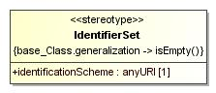
- IdentifierSet

Name | IdentifierSet
Abstract | false
Base Stereotype | TopLevelDictionaryEntry

Attribute Detail

base_Class
Description

Type | Class
Default Value
Multiplicity

identificationScheme
Description

Type | anyURI
Default Value
Multiplicity | 1

Constraint Detail

IdentifierSetSubclassingProhibited
Description

Body | base_Class.generalization -> isEmpty()

Stereotype RepositoryConcept
Description

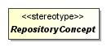
- RepositoryConcept

Name | RepositoryConcept
Abstract | true
Base Stereotype

Attribute Detail

base_NamedElement
Description

Type | NamedElement
Default Value
Multiplicity

example
Description

Type | string
Default Value
Multiplicity | 0..*

registrationStatus
Description

Type | RegistrationStatus
Default Value | PROVISIONALLY_REGISTERED
Multiplicity | 1

removalDate
Description
Cionforming Tagged Values shall be formatted yyyy-mm-dd
Type | string
Default Value
Multiplicity | 0..1

semanticMarkup
Description
Each semanticMarkup string is a TupleValue. A TupleValue is formatted as defined by the following EBNF:
<TupleValue> ::= <TupleTypeName>” : ”<TupleElement>[“ ,”<TupleElement>]*
<TupleElement> ::= <TupleElementName>" = "<TupleElementValue>
In essence, a TupleValue is a string starting with a name that identifies a TupleType, followed by a colon character, followed by one or more comma-separated TupleElements. A TupleElement is a name-value pair, where the name of the TupleElement and the value of the TupleElement are separated by an equal sign character, with the name of the TupleElement on the left side of the equal sign.
UNIFI users can apply to register TupleTypes in the UNIFI repository. A TupleType definition specifies a TupleTypeName and one or more TupleElementNames.
TupleTypeNames, TupleElementNames, and TupleElementValues are case sensitive and may not contain whitespace. They may contain any character that is legal in a UML Tagged Value.
There is one predefined TupleType. Its name is “Synonym” and it defines two TupleElements named “name” and “context”, as illustrated by the following:
TupleTypeName = Synonym
TupleElementName = name
TupleElementName = context
An example of a TupleValue that is a valid instance of the predefined Synonym TupleType is the following string:
Synonym : name = Instrument, context = EuropeanUnion
An example of a TupleType that could be defined is a reference to an element of an OWL Ontology:
TupleTypeName = OWLResourceId
TupleElementName = URI
Another example of a TupleType that could be defined is a specification of underlying semantic concepts in a manner that promotes alignment with the UN./CEFACT Core Component method:
TupleTypeName = UnqualifiedBusinessElement
TupleElementName = PropertyTerm
TupleElementName = RepresentationTerm
NOTE semanticMarkup is a mult-valued Property, so it can contain multiple semanticMarkup strings
Type | string
Default Value
Multiplicity | 0..*

Constraint Detail

NameCannotEndInQuantity
Description
Name must not end in "quantity"
Body | --Name must not end in "quantity"  let nameLength : Integer = base_NamedElement.name -> size() in  base_NamedElement.name.substring( (nameLength - 7), nameLength ) <> 'quantity'

NoOperationsInClassExtensions
Description
Stereotypes extending the meta-class Class (MessageComponentType, BusinessComponent, MessageSet, IdentifierSet, BusinessArea) may not contain operations
Body | base_NamedElement.oclIsKindOf(Class)  implies  base_NamedElement.oclAsType(Class).ownedOperation -> isEmpty()

RemovalDateImplication
Description
If a removalDate is specified then the registrationStatus must be OBSOLETE
Body | --If a removalDate is specified then the registrationStatus must be OBSOLETE  (not removalDate.oclIsUndefined()) implies registrationStatus = RegistrationStatus::OBSOLETE

Stereotype TopLevelCatalogueEntry
Description

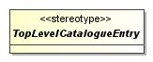
- TopLevelCatalogueEntry

Name | TopLevelCatalogueEntry
Abstract | true
Base Stereotype | RepositoryConcept

Constraint Detail

CatalogueEntryOwnership
Description
A <<TopLevelCatalogueEntry>>-stereotyped UML Element must be owned by a <<BusinessProcessCatalogue>>-stereotyped Package.
Body | owner.appliedStereotypeInstance.classifier.name -> includes('BusinessProcessCatalogue')

Stereotype TopLevelDictionaryEntry
Description

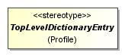
- TopLevelDictionaryEntry

Name | TopLevelDictionaryEntry
Abstract | true
Base Stereotype | RepositoryConcept

Constraint Detail

DictionaryOwnership
Description
A <<TopLevelDictionaryEntry>>-stereotyped UML Element must be owned by a <<DataDictionary>>-stereotyped Package.
Body | owner.appliedStereotypeInstance.classifier.name -> includes('DataDictionary')

Stereotype UNIFIConstraint
Description

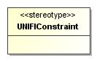
- UNIFIConstraint

Name | UNIFIConstraint
Abstract | false
Base Stereotype | RepositoryConcept

Attribute Detail

base_Constraint
Description

Type | Constraint
Default Value
Multiplicity

Constraint Detail

MustBeOpaqueExpression
Description
A <<UNIFIConstraint>>-stereotyped Constraint’s “specification” property must be an OpaqueExpression
Body | base_Constraint.specification.oclIsKindOf(OpaqueExpression)

Package Profile::ConceptualLevel
Description

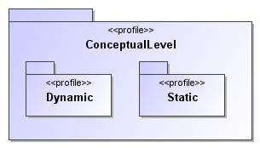
- ConceptualLevel

Name | ConceptualLevel
Qualified Name | Profile::ConceptualLevel

Package Profile::ConceptualLevel::Dynamic
Description

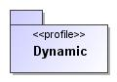
- Dynamic

Name | Dynamic
Qualified Name | Profile::ConceptualLevel::Dynamic

Stereotype BusinessTransaction
Description

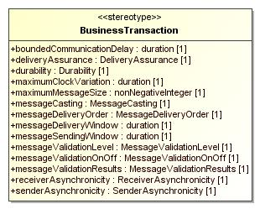
- BusinessTransaction

Name | BusinessTransaction
Abstract | false
Base Stereotype | TopLevelCatalogueEntry

Attribute Detail

base_Interaction
Description

Type | Interaction
Default Value
Multiplicity

boundedCommunicationDelay
Description

Type | duration
Default Value
Multiplicity | 1

deliveryAssurance
Description

Type | DeliveryAssurance
Default Value
Multiplicity | 1

durability
Description

Type | Durability
Default Value
Multiplicity | 1

maximumClockVariation
Description

Type | duration
Default Value
Multiplicity | 1

maximumMessageSize
Description

Type | nonNegativeInteger
Default Value
Multiplicity | 1

messageCasting
Description

Type | MessageCasting
Default Value
Multiplicity | 1

messageDeliveryOrder
Description

Type | MessageDeliveryOrder
Default Value
Multiplicity | 1

messageDeliveryWindow
Description

Type | duration
Default Value
Multiplicity | 1

messageSendingWindow
Description

Type | duration
Default Value
Multiplicity | 1

messageValidationLevel
Description

Type | MessageValidationLevel
Default Value
Multiplicity | 1

messageValidationOnOff
Description

Type | MessageValidationOnOff
Default Value
Multiplicity | 1

messageValidationResults
Description

Type | MessageValidationResults
Default Value
Multiplicity | 1

receiverAsynchronicity
Description

Type | ReceiverAsynchronicity
Default Value
Multiplicity | 1

senderAsynchronicity
Description

Type | SenderAsynchronicity
Default Value
Multiplicity | 1

Stereotype MessageTransmission
Description

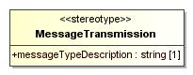
- MessageTransmission

Name | MessageTransmission
Abstract | false
Base Stereotype | RepositoryConcept

Attribute Detail

base_Message
Description

Type | Message
Default Value
Multiplicity

messageTypeDescription
Description

Type | string
Default Value
Multiplicity | 1

Stereotype Participant
Description

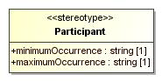
- Participant

Name | Participant
Abstract | false
Base Stereotype | RepositoryConcept

Attribute Detail

base_Lifeline
Description

Type | Lifeline
Default Value
Multiplicity

maximumOccurrence
Description

Type | string
Default Value
Multiplicity | 1

minimumOccurrence
Description

Type | string
Default Value
Multiplicity | 1

Package Profile::ConceptualLevel::Static
Description

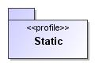
- Static

Name | Static
Qualified Name | Profile::ConceptualLevel::Static

Stereotype BusinessComponent
Description

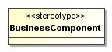
- BusinessComponent

Name | BusinessComponent
Abstract | false
Base Stereotype | TopLevelDictionaryEntry

Attribute Detail

base_Class
Description

Type | Class
Default Value
Multiplicity

Constraint Detail

BusinessComponentOperationsProhibited
Description
Operations are not allowed in Business Components
Body | base_Class.ownedOperation -> isEmpty()

GeneralizationsMustBeAmongBusinessComponents
Description
If a <<BusinessComponent>>-stereotyped Class is a participant in a Generalization, the other participant must also be a <<BusinessComponent>>-stereotyped Class
Body | base_Class.generalization -> forAll(  general.appliedStereotypeInstance.classifier.name -> includes('BusinessComponent') and  specific.appliedStereotypeInstance.classifier.name -> includes('BusinessComponent')  )

PropertiesMustBeBusinessElements
Description
The Properties of a <<BusinessComponent>>-stereotyped Class must be stereotyped by a concrete subclass of <<BusinessElement>>
Body | base_Class.ownedAttribute -> forAll  (attribute |attribute.appliedStereotypeInstance.classifier.name -> includes('BusinessElement'))

Stereotype BusinessElement
Description

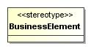
- BusinessElement

Name | BusinessElement
Abstract | false
Base Stereotype | RepositoryConcept

Attribute Detail

base_Property
Description

Type | Property
Default Value
Multiplicity

Constraint Detail

AssociationEndsMustBeNavigable
Description
A <<BusinessElement>>-stereotyped association end must be navigable and the opposite end must also be stereotyped <<BusinessElement>>
Body | not(base_Property.association.oclIsUndefined()) implies  (base_Property.association.navigableOwnedEnd -> includes(base_Property) and  base_Property.opposite.appliedStereotypeInstance.classifier.name -> includes('BusinessElement')  )

OwnerIsABusinessComponent
Description
A <<BusinessElement>>-stereotyped Property must be a Property of a <<BusinessComponent>>-stereotyped Class
Body | base_Property.owner.appliedStereotypeInstance.classifier.name -> includes('BusinessComponent')

TypeOfAnAssociationEndIsABusinessComponent
Description
The type of a <<BusinessElement>>-stereotyped association end must be a <<BusinessComponent>>-stereotyped Class
Body | not(base_Property.association.oclIsUndefined()) implies base_Property.type.appliedStereotypeInstance.classifier.name -> includes('BusinessComponent')

Package Profile::ConceptualToLogicalTransformation
Description

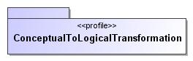
- ConceptualToLogicalTransformation

Name | ConceptualToLogicalTransformation
Qualified Name | Profile::ConceptualToLogicalTransformation

Stereotype UNIFITrace
Description

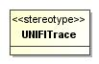
- UNIFITrace

Name | UNIFITrace
Abstract | false
Base Stereotype | TopLevelDictionaryEntry

Attribute Detail

base_Dependency
Description

Type | Dependency
Default Value
Multiplicity

Constraint Detail

CardinalityAlignment
Description
A <<UNIFITrace>> from a MessageElement to a BusinessElement can only raise the minimum cardinality and can only lower the maximum cardinality
Body | -- more than one client and more than one supplier, cardinalityAlignment  -- must therefore be verified for all clients and suppliers (although  -- in practice there will most of the time only be one  -- From UML Superstructure spec, MultiplicityElement has  -- a query (includesMultiplicity) to check cardinality compliance  base_Dependency.client ->  forAll(cl : NamedElement|  (cl.oclIsKindOf(MultiplicityElement)  and cl.appliedStereotypeInstance.classifier.name -> includes('MessageElement')  )  implies  base_Dependency.supplier ->  forAll(sup : NamedElement |  (sup.oclIsKindOf(MultiplicityElement)  and sup.appliedStereotypeInstance.classifier.name -> includes('BusinessElement')  )  implies  (sup.oclAsType(MultiplicityElement).  includesMultiplicity(cl.oclAsType(MultiplicityElement))  )  )  )

LegalTraces
Description
The following <<UNIFITrace>>-stereotyped Dependencies are the only ones that are legal:
- A <<MessageComponentType>> dependent on a <<BusinessComponent>>
- A <<MessageElement>> dependent on a <<BusinessElement>>
- A <<MessageElement>> dependent on a <<BusinessComponent>>
- A <<CodeSet>> dependent on a <<CodeSet>>
- A <<MessageSet>> dependent on a <<MessageDefinition>>
Body | let c:Bag(String) = base_Dependency.client.appliedStereotypeInstance.classifier.name in  let s:Bag(String) = base_Dependency.supplier.appliedStereotypeInstance.classifier.name in  ( (c -> includes('MessageComponent') or c -> includes('ChoiceComponent')) and s -> includes('BusinessComponent')) or  ( c -> includes('MessageElement') and s -> includes('BusinessElement')) or  (c -> includes('MessageElement') and s -> includes('BusinessComponent')) or  (c -> includes('CodeSet') and s -> includes('CodeSet'))

Package Profile::DataTypes
Description

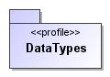
- DataTypes

Name | DataTypes
Qualified Name | Profile::DataTypes

Stereotype Amount
Description

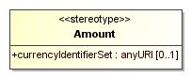
- Amount

Name | Amount
Abstract | false
Base Stereotype | Decimal

Attribute Detail

base_DataType
Description

Type | DataType
Default Value
Multiplicity

currencyIdentifierSet
Description

Type | anyURI
Default Value
Multiplicity | 0..1

Stereotype Binary
Description

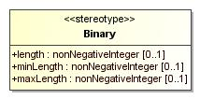
- Binary

Name | Binary
Abstract | false
Base Stereotype | UNIFIDatatype

Attribute Detail

base_DataType
Description

Type | DataType
Default Value
Multiplicity

length
Description

Type | nonNegativeInteger
Default Value
Multiplicity | 0..1

maxLength
Description

Type | nonNegativeInteger
Default Value
Multiplicity | 0..1

minLength
Description

Type | nonNegativeInteger
Default Value
Multiplicity | 0..1

Stereotype Boolean
Description

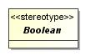
- Boolean

Name | Boolean
Abstract | true
Base Stereotype | UNIFIDatatype

Attribute Detail

base_DataType
Description

Type | DataType
Default Value
Multiplicity

Stereotype Date
Description

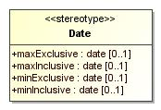
- Date

Name | Date
Abstract | false
Base Stereotype | UNIFIDatatype

Attribute Detail

base_DataType
Description

Type | DataType
Default Value
Multiplicity

maxExclusive
Description

Type | date
Default Value
Multiplicity | 0..1

maxInclusive
Description

Type | date
Default Value
Multiplicity | 0..1

minExclusive
Description

Type | date
Default Value
Multiplicity | 0..1

minInclusive
Description

Type | date
Default Value
Multiplicity | 0..1

Stereotype DateTime
Description

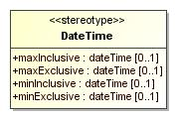
- DateTime

Name | DateTime
Abstract | false
Base Stereotype | UNIFIDatatype

Attribute Detail

base_DataType
Description

Type | DataType
Default Value
Multiplicity

maxExclusive
Description

Type | dateTime
Default Value
Multiplicity | 0..1

maxInclusive
Description

Type | dateTime
Default Value
Multiplicity | 0..1

minExclusive
Description

Type | dateTime
Default Value
Multiplicity | 0..1

minInclusive
Description

Type | dateTime
Default Value
Multiplicity | 0..1

Stereotype Day
Description

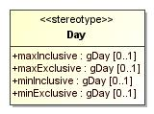
- Day

Name | Day
Abstract | false
Base Stereotype | UNIFIDatatype

Attribute Detail

base_DataType
Description

Type | DataType
Default Value
Multiplicity

maxExclusive
Description

Type | gDay
Default Value
Multiplicity | 0..1

maxInclusive
Description

Type | gDay
Default Value
Multiplicity | 0..1

minExclusive
Description

Type | gDay
Default Value
Multiplicity | 0..1

minInclusive
Description

Type | gDay
Default Value
Multiplicity | 0..1

Stereotype Decimal
Description

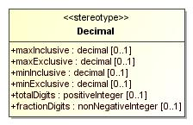
- Decimal

Name | Decimal
Abstract | false
Base Stereotype | UNIFIDatatype

Attribute Detail

base_DataType
Description

Type | DataType
Default Value
Multiplicity

fractionDigits
Description

Type | nonNegativeInteger
Default Value
Multiplicity | 0..1

maxExclusive
Description

Type | decimal
Default Value
Multiplicity | 0..1

maxInclusive
Description

Type | decimal
Default Value
Multiplicity | 0..1

minExclusive
Description

Type | decimal
Default Value
Multiplicity | 0..1

minInclusive
Description

Type | decimal
Default Value
Multiplicity | 0..1

totalDigits
Description

Type | positiveInteger
Default Value
Multiplicity | 0..1

Stereotype Duration
Description

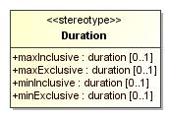
- Duration

Name | Duration
Abstract | false
Base Stereotype | UNIFIDatatype

Attribute Detail

base_DataType
Description

Type | DataType
Default Value
Multiplicity

maxExclusive
Description

Type | duration
Default Value
Multiplicity | 0..1

maxInclusive
Description

Type | duration
Default Value
Multiplicity | 0..1

minExclusive
Description

Type | duration
Default Value
Multiplicity | 0..1

minInclusive
Description

Type | duration
Default Value
Multiplicity | 0..1

Stereotype Indicator
Description

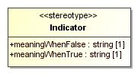
- Indicator

Name | Indicator
Abstract | false
Base Stereotype | Boolean

Attribute Detail

base_DataType
Description

Type | DataType
Default Value
Multiplicity

meaningWhenFalse
Description

Type | string
Default Value
Multiplicity | 1

meaningWhenTrue
Description

Type | string
Default Value
Multiplicity | 1

Stereotype Integer
Description

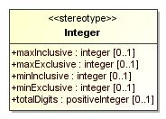
- Integer

Name | Integer
Abstract | false
Base Stereotype | UNIFIDatatype

Attribute Detail

base_DataType
Description

Type | DataType
Default Value
Multiplicity

maxExclusive
Description

Type | integer
Default Value
Multiplicity | 0..1

maxInclusive
Description

Type | integer
Default Value
Multiplicity | 0..1

minExclusive
Description

Type | integer
Default Value
Multiplicity | 0..1

minInclusive
Description

Type | integer
Default Value
Multiplicity | 0..1

totalDigits
Description

Type | positiveInteger
Default Value
Multiplicity | 0..1

Stereotype Month
Description

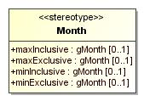
- Month

Name | Month
Abstract | false
Base Stereotype | UNIFIDatatype

Attribute Detail

base_DataType
Description

Type | DataType
Default Value
Multiplicity

maxExclusive
Description

Type | gMonth
Default Value
Multiplicity | 0..1

maxInclusive
Description

Type | gMonth
Default Value
Multiplicity | 0..1

minExclusive
Description

Type | gMonth
Default Value
Multiplicity | 0..1

minInclusive
Description

Type | gMonth
Default Value
Multiplicity | 0..1

Stereotype MonthDay
Description

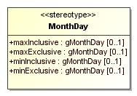
- MonthDay

Name | MonthDay
Abstract | false
Base Stereotype | UNIFIDatatype

Attribute Detail

base_DataType
Description

Type | DataType
Default Value
Multiplicity

maxExclusive
Description

Type | gMonthDay
Default Value
Multiplicity | 0..1

maxInclusive
Description

Type | gMonthDay
Default Value
Multiplicity | 0..1

minExclusive
Description

Type | gMonthDay
Default Value
Multiplicity | 0..1

minInclusive
Description

Type | gMonthDay
Default Value
Multiplicity | 0..1

Stereotype Quantity
Description

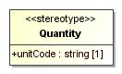
- Quantity

Name | Quantity
Abstract | false
Base Stereotype | Decimal

Attribute Detail

base_DataType
Description

Type | DataType
Default Value
Multiplicity

unitCode
Description

Type | string
Default Value
Multiplicity | 1

Stereotype Rate
Description

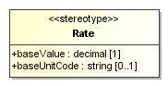
- Rate

Name | Rate
Abstract | false
Base Stereotype | Decimal

Attribute Detail

baseUnitCode
Description

Type | string
Default Value
Multiplicity | 0..1

baseValue
Description

Type | decimal
Default Value
Multiplicity | 1

base_DataType
Description

Type | DataType
Default Value
Multiplicity

Stereotype String
Description

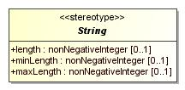
- String

Name | String
Abstract | true
Base Stereotype | UNIFIDatatype

Attribute Detail

base_DataType
Description

Type | DataType
Default Value
Multiplicity

length
Description

Type | nonNegativeInteger
Default Value
Multiplicity | 0..1

maxLength
Description

Type | nonNegativeInteger
Default Value
Multiplicity | 0..1

minLength
Description

Type | nonNegativeInteger
Default Value
Multiplicity | 0..1

Stereotype Text
Description

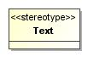
- Text

Name | Text
Abstract | false
Base Stereotype | String

Attribute Detail

base_DataType
Description

Type | DataType
Default Value
Multiplicity

Stereotype Time
Description

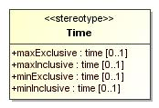
- Time

Name | Time
Abstract | false
Base Stereotype | UNIFIDatatype

Attribute Detail

base_DataType
Description

Type | DataType
Default Value
Multiplicity

maxExclusive
Description

Type | time
Default Value
Multiplicity | 0..1

maxInclusive
Description

Type | time
Default Value
Multiplicity | 0..1

minExclusive
Description

Type | time
Default Value
Multiplicity | 0..1

minInclusive
Description

Type | time
Default Value
Multiplicity | 0..1

Stereotype UNIFIDatatype
Description

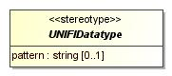
- UNIFIDatatype

Name | UNIFIDatatype
Abstract | true
Base Stereotype | TopLevelDictionaryEntry

Attribute Detail

base_DataType
Description

Type | DataType
Default Value
Multiplicity

pattern
Description

Type | string
Default Value
Multiplicity | 0..1

Constraint Detail

COLLAPSEisMandatory
Description
When the abstract Stereotype <<DataType>>'s "whiteSpace" tagged value is set, its value must be COLLAPSE unless the <<Text>> Stereotype is the concrete Stereotype being used.
Body | --When the abstract Stereotype <<DataType>>'s "whiteSpace" tagged value is set, its value must be COLLAPSE unless the <<Text>> Stereotype is the concrete Stereotype being used.  not self.oclIsKindOf(Text) and whiteSpace -> notEmpty( ) implies  whiteSpace = WhiteSpace::COLLAPSE

Stereotype Year
Description

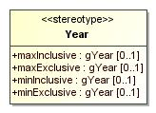
- Year

Name | Year
Abstract | false
Base Stereotype | UNIFIDatatype

Attribute Detail

base_DataType
Description

Type | DataType
Default Value
Multiplicity

maxExclusive
Description

Type | gYear
Default Value
Multiplicity | 0..1

maxInclusive
Description

Type | gYear
Default Value
Multiplicity | 0..1

minExclusive
Description

Type | gYear
Default Value
Multiplicity | 0..1

minInclusive
Description

Type | gYear
Default Value
Multiplicity | 0..1

Stereotype YearMonth
Description

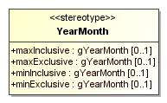
- YearMonth

Name | YearMonth
Abstract | false
Base Stereotype | UNIFIDatatype

Attribute Detail

base_DataType
Description

Type | DataType
Default Value
Multiplicity

maxExclusive
Description

Type | gYearMonth
Default Value
Multiplicity | 0..1

maxInclusive
Description

Type | gYearMonth
Default Value
Multiplicity | 0..1

minExclusive
Description

Type | gYearMonth
Default Value
Multiplicity | 0..1

minInclusive
Description

Type | gYearMonth
Default Value
Multiplicity | 0..1

Package Profile::LogicalLevel
Description

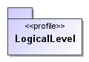
- LogicalLevel

Name | LogicalLevel
Qualified Name | Profile::LogicalLevel

Stereotype BusinessArea
Description

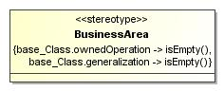
- BusinessArea

Name | BusinessArea
Abstract | false
Base Stereotype | TopLevelCatalogueEntry

Attribute Detail

base_Class
Description

Type | Class
Default Value
Multiplicity

Constraint Detail

BusinessAreaOperationsProhibited
Description
Operations are not allowed in Business Areas
Body | base_Class.ownedOperation -> isEmpty()

BusinessAreaSubclassingProhibited
Description

Body | base_Class.generalization -> isEmpty()

Stereotype ChoiceComponent
Description

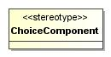
- ChoiceComponent

Name | ChoiceComponent
Abstract | false
Base Stereotype | MessageComponentType

Constraint Detail

AtLeastOneProperty
Description
A <<ChoiceComponent>>-stereotyped Class must have at least one Property
Body | base_Class.ownedAttribute -> notEmpty( )

Stereotype ExternalSchema
Description

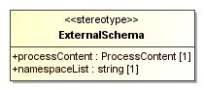
- ExternalSchema

Name | ExternalSchema
Abstract | false
Base Stereotype | MessageComponentType

Attribute Detail

base_Class
Description

Type | Class
Default Value
Multiplicity

namespaceList
Description

Type | string
Default Value
Multiplicity | 1

processContent
Description

Type | ProcessContent
Default Value
Multiplicity | 1

Stereotype MessageBuildingBlock
Description

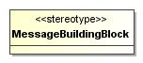
- MessageBuildingBlock

Name | MessageBuildingBlock
Abstract | false
Base Stereotype | RepositoryConcept

Attribute Detail

base_Property
Description

Type | Property
Default Value
Multiplicity

Constraint Detail

MessageDefinitionMessageComponentType
Description
A <<MessageBuildingBlock>>-stereotyped Property must be a memberEnd of an Association between a <<MessageDefinition>>-stereotyped Signal and a <<MessageComponentType>>-stereotyped Class, and it specifically must be the memberEnd on the <<MessageComponentType>-stereotyped Class's side of the Association.
Body | (base_Property.type.appliedStereotypeInstance.classifier.name -> includes('MessageComponent') or  base_Property.type.appliedStereotypeInstance.classifier.name -> includes('ChoiceComponent') or  base_Property.type.appliedStereotypeInstance.classifier.name -> includes('ExternalSchema')  ) and  base_Property.opposite.type.appliedStereotypeInstance.classifier.name -> includes('MessageDefinition')

NavigabilityRequired
Description
A <<MessageBuildingBlock>>-stereotyped association end must be navigable
Body | not(base_Property.association.oclIsUndefined()) implies base_Property.association.navigableOwnedEnd -> includes(base_Property)

Stereotype MessageComponent
Description

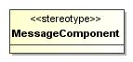
- MessageComponent

Name | MessageComponent
Abstract | false
Base Stereotype | MessageComponentType

Attribute Detail

base_Class
Description

Type | Class
Default Value
Multiplicity

Stereotype MessageComponentType
Description

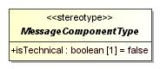
- MessageComponentType

Name | MessageComponentType
Abstract | true
Base Stereotype | TopLevelDictionaryEntry

Attribute Detail

base_Class
Description

Type | Class
Default Value
Multiplicity

isTechnical
Description

Type | boolean
Default Value | false
Multiplicity | 1

Constraint Detail

AllPropertiesAreMessageElements
Description
All Properties of a <<MessageComponentType>>-stereotyped Class must be <<MessageElement>>-stereotyped
Body | base_Class.ownedAttribute -> forAll(property | property.appliedStereotypeInstance.classifier.name -> includes('MessageElement'))

IsTechnicalDerivationRule
Description
The value of the “isTechnical” Tagged Value is true if and only if the <<MessageComponentType>>-stereotyped Class is not the client in a <<UNIFITrace>>-stereotyped Dependency
Body | --The value of the “isTechnical” Tagged Value is true if and only if the <<MessageComponentType>>-  --stereotyped Class is not the client in a <<UNIFITrace>>-stereotyped Dependency  isTechnical = not  (base_Class.clientDependency -> exists  (dependency | dependency.appliedStereotypeInstance.classifier.name -> includes('UNIFITrace'))  )

MessageComponentTypeOperationsProhibited
Description

Body | base_Class.ownedOperation -> isEmpty()

SubclassingProhibited
Description
A <<MessageComponentType>>-stereotyped Class cannot participate in Generalization relationships
Body | base_Class.generalization -> isEmpty( )

Stereotype MessageDefinition
Description

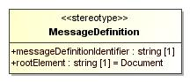
- MessageDefinition

Name | MessageDefinition
Abstract | false
Base Stereotype | RepositoryConcept

Attribute Detail

base_Signal
Description

Type | Signal
Default Value
Multiplicity

messageDefinitionIdentifier
Description

Type | string
Default Value
Multiplicity | 1

rootElement
Description

Type | string
Default Value | Document
Multiplicity | 1

Constraint Detail

AssociationWithBusinessArea
Description
A <<MessageDefinition>> may only be associated to one <<BusinessArea>>
Body | -- A <<MessageDefinition>> may only be associated to one <<BusinessArea>>  base_Signal.attribute -> select(at | not at.association.oclIsUndefined()).type -> select(t : Type | t.appliedStereotypeInstance.classifier.name -> includes('BusinessArea')) -> size() = 1

MessageDefinitionSubclassingProhibited
Description

Body | base_Signal.general -> isEmpty()

Stereotype MessageElement
Description

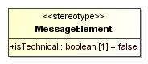
- MessageElement

Name | MessageElement
Abstract | false
Base Stereotype | RepositoryConcept

Attribute Detail

base_Property
Description

Type | Property
Default Value
Multiplicity

isTechnical
Description

Type | boolean
Default Value | false
Multiplicity | 1

Constraint Detail

IsTechnicalRule
Description
The value of the “isTechnical” Tagged Value is true if and only if the <<MessageElement>>-stereotyped Property is not the client in a <<UNIFITrace>>-stereotyped Dependency
Body | --The value of the “isTechnical” Tagged Value is true if and only if the <<MessageElement>>-stereotyped Property is not the client in a <<UNIFITrace>>-stereotyped Dependency  isTechnical = not  (base_Property.clientDependency -> exists  (dependency | dependency.appliedStereotypeInstance.classifier.name -> includes('UNIFITrace'))  )

LegalOwners
Description
A <<MessageElement>>-stereotyped Property must be a Property of a <<MessageComponent>>-stereotyped Class or of a <<ChoiceComponent>>-stereotyped Class
Body | --A <<MessageElement>>-stereotyped Property must be a Property of a <<MessageComponent>>-stereotyped Class or of a <<ChoiceComponent>>-stereotyped Class  base_Property.owner.appliedStereotypeInstance.classifier.name -> includes('MessageComponent') or  base_Property.owner.appliedStereotypeInstance.classifier.name -> includes('ChoiceComponent')

SharedAggregationNotAllowed
Description
A <<MessageElement>>-stereotyped association end may not be a shared aggregation
Body | --A <<MessageElement>>-stereotyped association end may not be a shared aggregation  base_Property.association -> notEmpty( ) implies not (base_Property.aggregation = AggegationKind::shared)

TypeOfAssociationEnd
Description
The type of a <<MessageElement>>-stereotyped association end must be a <<MessageComponent>>-stereotyped Class or a <<ChoiceComponent>>-stereotyped Class
Body | --The type of a <<MessageElement>>-stereotyped association end must be a <<MessageComponent>>-stereotyped Class or a <<ChoiceComponent>>-stereotyped Class  not(base_Property.association.oclIsUndefined()) implies  base_Property.type.appliedStereotypeInstance.classifier.name -> includes('MessageComponent') or base_Property.type.appliedStereotypeInstance.classifier.name -> includes('ChoiceComponent')

Stereotype MessageSet
Description

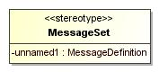
- MessageSet

Name | MessageSet
Abstract | false
Base Stereotype | TopLevelCatalogueEntry

Attribute Detail

base_Class
Description

Type | Class
Default Value
Multiplicity

unnamed1
Description

Type | MessageDefinition
Default Value
Multiplicity

Constraint Detail

MessageSetOperationsProhibited
Description
Operations are not allowed in Message Sets
Body | base_Class.ownedOperation -> isEmpty()

MessageSetSubclassingProhibited
Description

Body | base_Class.generalization -> isEmpty()

SharedAggregation
Description
All Properties of a <<MessageSet>>-stereotyped Class must be members of a shared aggregation Association, where the <<MessageSet>>-stereotyped Class is the aggregate, the <<MessageDefinition>>-stereotyped Signal is the aggregee.
Body | base_Class.ownedAttribute -> forAll  (aggregation = AggregationKind::shared and association.memberEnd -> exists  (assocMember | assocMember.class.appliedStereotypeInstance.classifier.name -> includes('MessageDefinition’')  )  )

Enumeration ProcessContent
Description

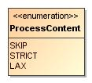
- ProcessContent

Name | ProcessContent
Qualified Name | Profile::LogicalLevel::ProcessContent
Visibility | public
Base Classifier

Package Profile::ScopeLevel
Description

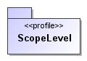
- ScopeLevel

Name | ScopeLevel
Qualified Name | Profile::ScopeLevel

Stereotype BusinessProcess
Description

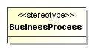
- BusinessProcess

Name | BusinessProcess
Abstract | false
Base Stereotype | TopLevelCatalogueEntry

Attribute Detail

base_UseCase
Description

Type | UseCase
Default Value
Multiplicity

Stereotype BusinessRole
Description

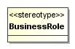
- BusinessRole

Name | BusinessRole
Abstract | false
Base Stereotype | RepositoryConcept

Attribute Detail

base_Actor
Description

Type | Actor
Default Value
Multiplicity

Appendix A. Diagram

Conceptual Dynamic Stereotypes
Description

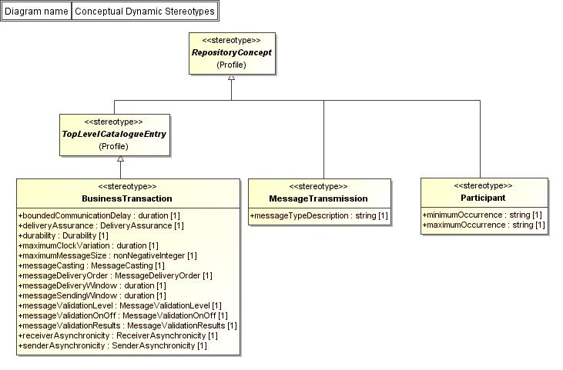
- Conceptual Dynamic Stereotypes

Conceptual Static Stereotypes
Description

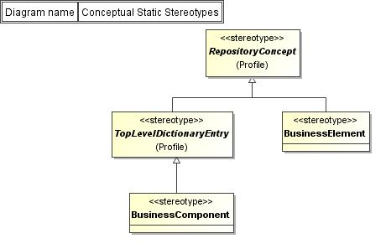
- Conceptual Static Stereotypes

Conceptual To Logical Stereotypes
Description

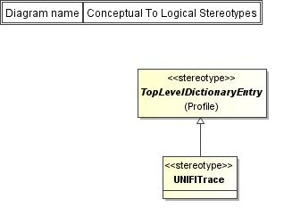
- Conceptual To Logical Stereotypes

Logical Level Stereotypes
Description

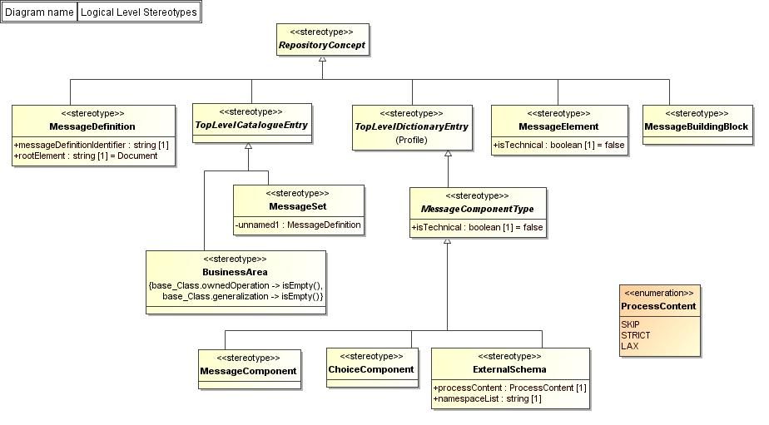
- Logical Level Stereotypes

Profile Packages
Description

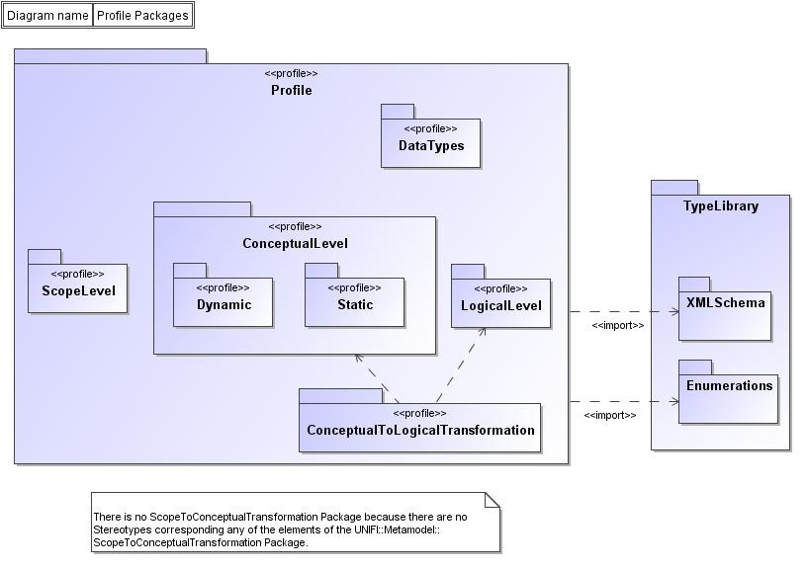
- Profile Packages

Scope Level Stereotypes
Description

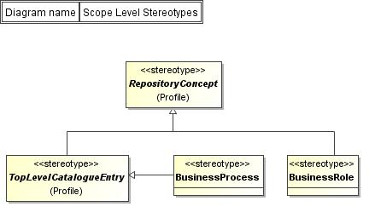
- Scope Level Stereotypes

Stereotypes of DataType
Description

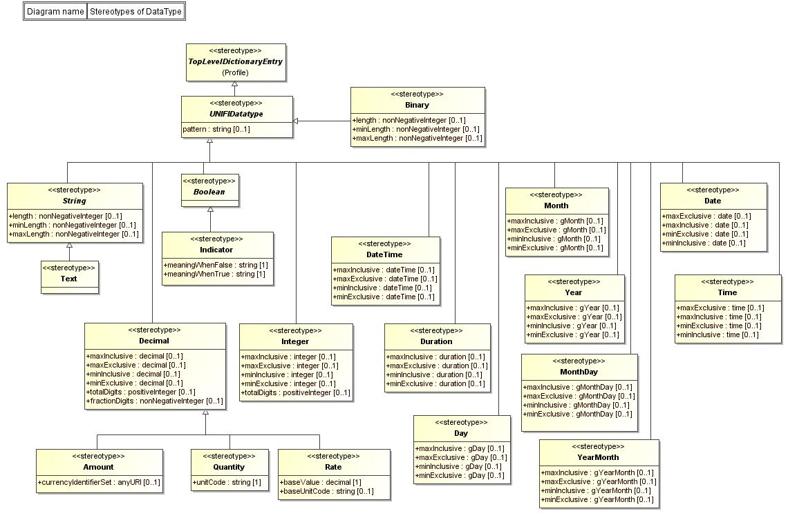
- Stereotypes of DataType

UNIFI Level Stereotypes
Description

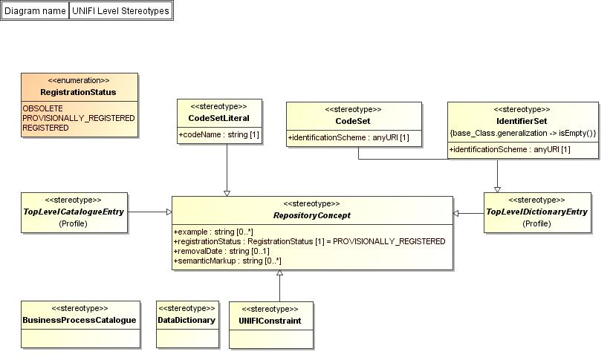
- UNIFI Level Stereotypes

