Dinner Chat

The Dinner Chat System is written as a Java Application program. It consists of 2 major components: Chat Server Application and a Dinner Order Application. The Dinner Order application has a UI which lets the user first select the kind of dinner, Pizza, Hero, or Burrito.

The users then select for example pizza toppings and size, and It also has a chat window so the users can discuss which toppings they like….

Java Chat Server – The Java Chat Server functions as an intermediary.

1. It Listens for Dinner Order Clients
2. It Requests the name of the client
3. If this is the first client it registers the kind of dinner that is being created
4. It sends “SYNC: name” to all connected clients
5. It registers the incoming socket information and associates that with the name
6. It Creates a new Handler Thread for each incoming connection
   1. Handler Thread
      1. Reads Client requests/commands
      2. Writes Server Commands to all clients
         1. Eg. It receives “+Onion”, it sends “STUFF: +Onion”, to all connected clients
         2. It receives “^+Small:, it sends “SIZE: ^+Small”, to all connected clients

Server Flow Control

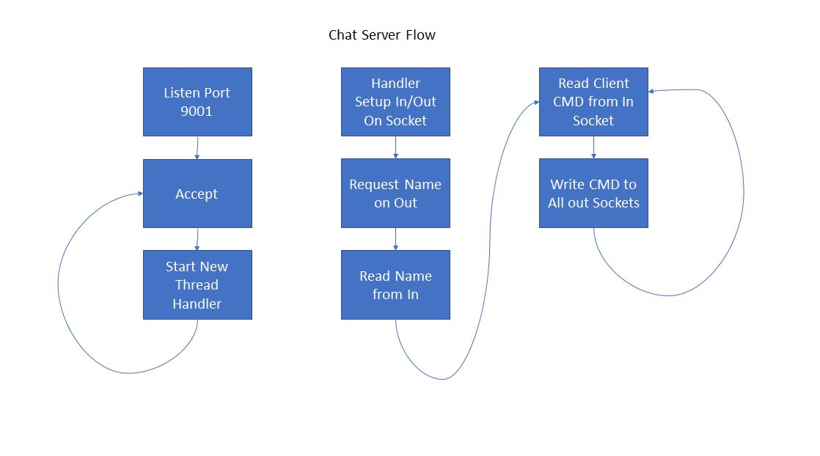Dinner Order Client

1. It requests server IP address from User
2. It connects to server
3. It requests name from User
4. It sends name to Server
5. If the client is the first on the chat it will ask the user to choose Pizza,Hero or Burrito
6. It stores all the state information as UI components.
   1. Eg. Toppings, Size
7. It responds to User input by sending a command to the Server
   1. User selects Size small, client sends “^+Small” to server
   2. User selects “Meatballs”, client sends “+Meatballs” to server
   3. User types in chat windows, client sends text to server
   4. User presses Refresh, client sends all state commands to server
   5. User presses Place Order, client writes the current order in the Order Message area
8. It also receives commands from the server
   1. It receives “SIZE: Small”, it updates the UI with Small selection
   2. It receives “STUFF: +Onion”, it selects the Onion top in the UI
   3. It receives “MESSAGE name : chat message”, it types “name : chat message” in the UI’s message area
   4. It receives “SYNC: name”, client sends all state commands to server and announces new client name in UI

Client/Server Protocol

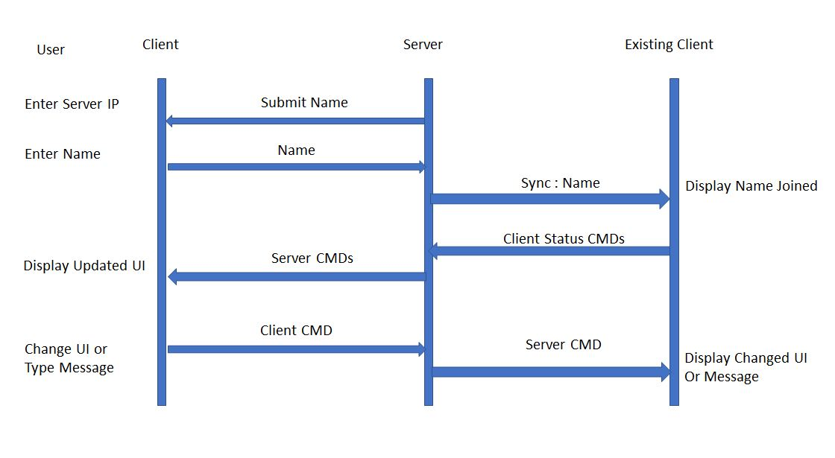

Ask for Server IP address

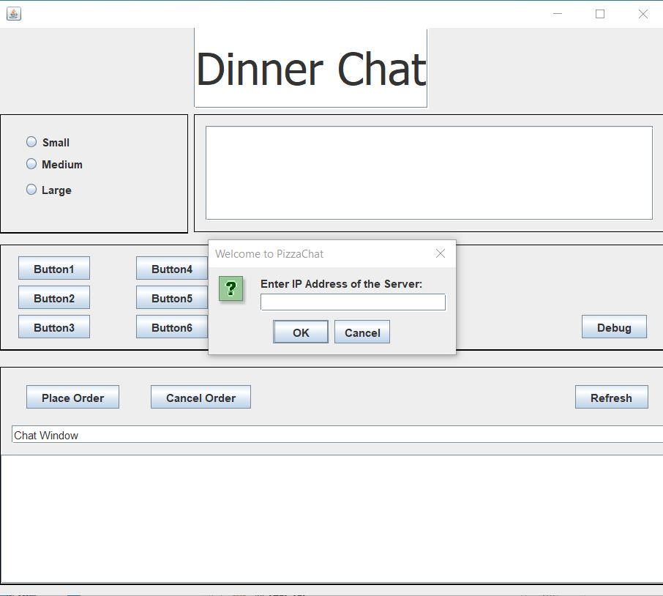

Ask for Name

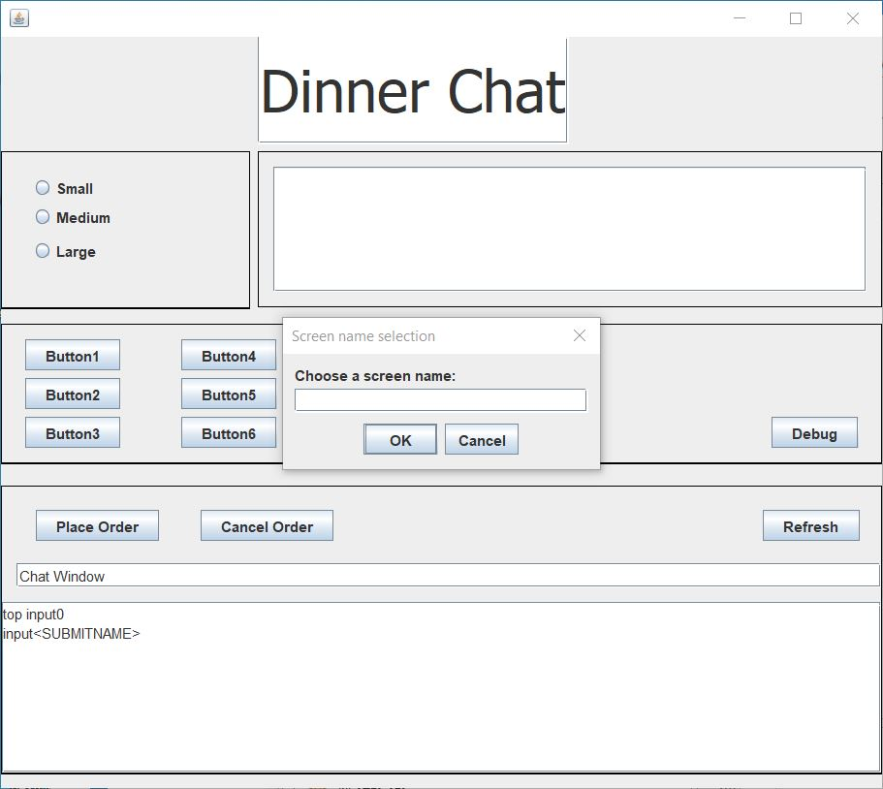

Ask for Type of dinner

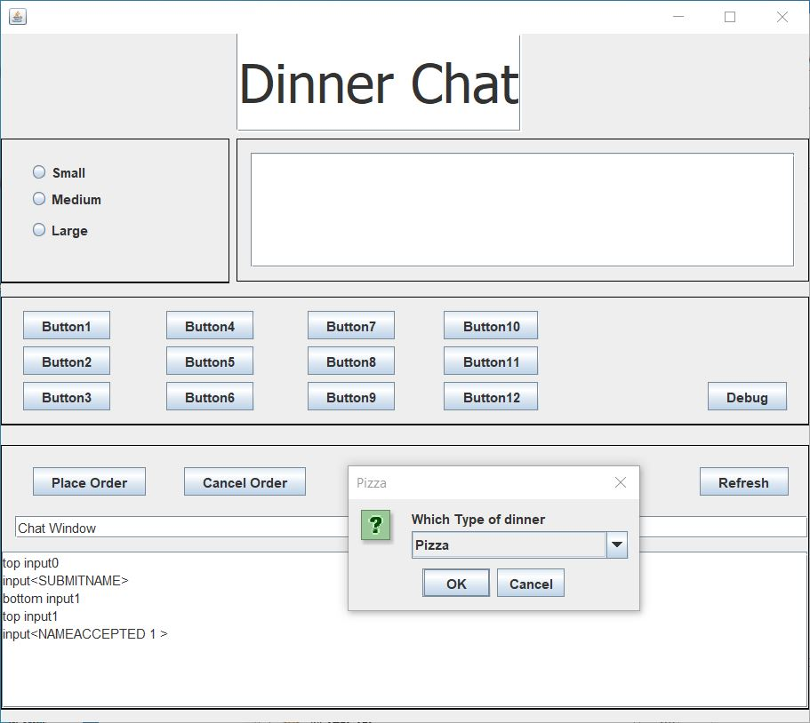

Start Pizza Order

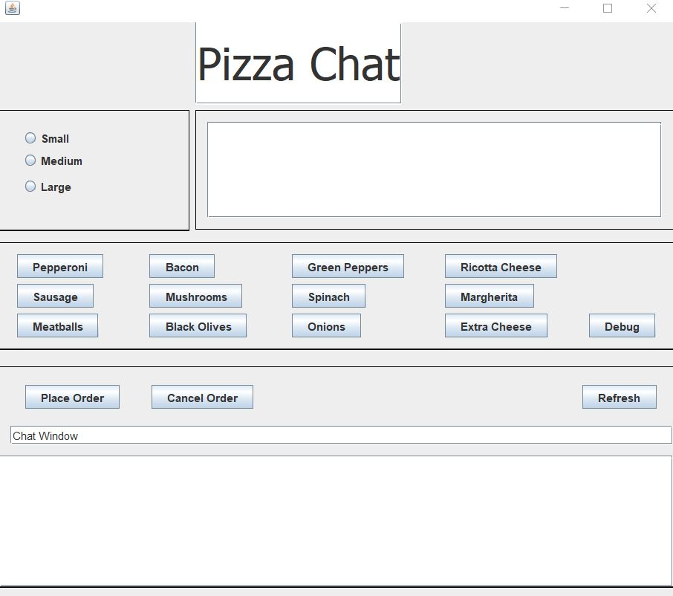

Select Size, Toppings

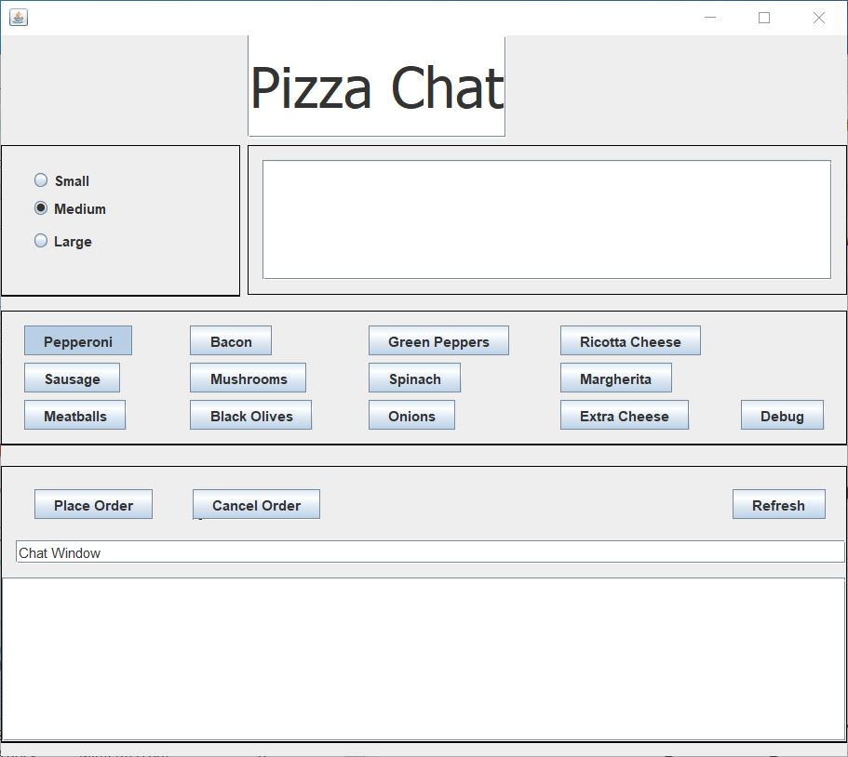

Add a new Client

(John Just Joined the Chat)

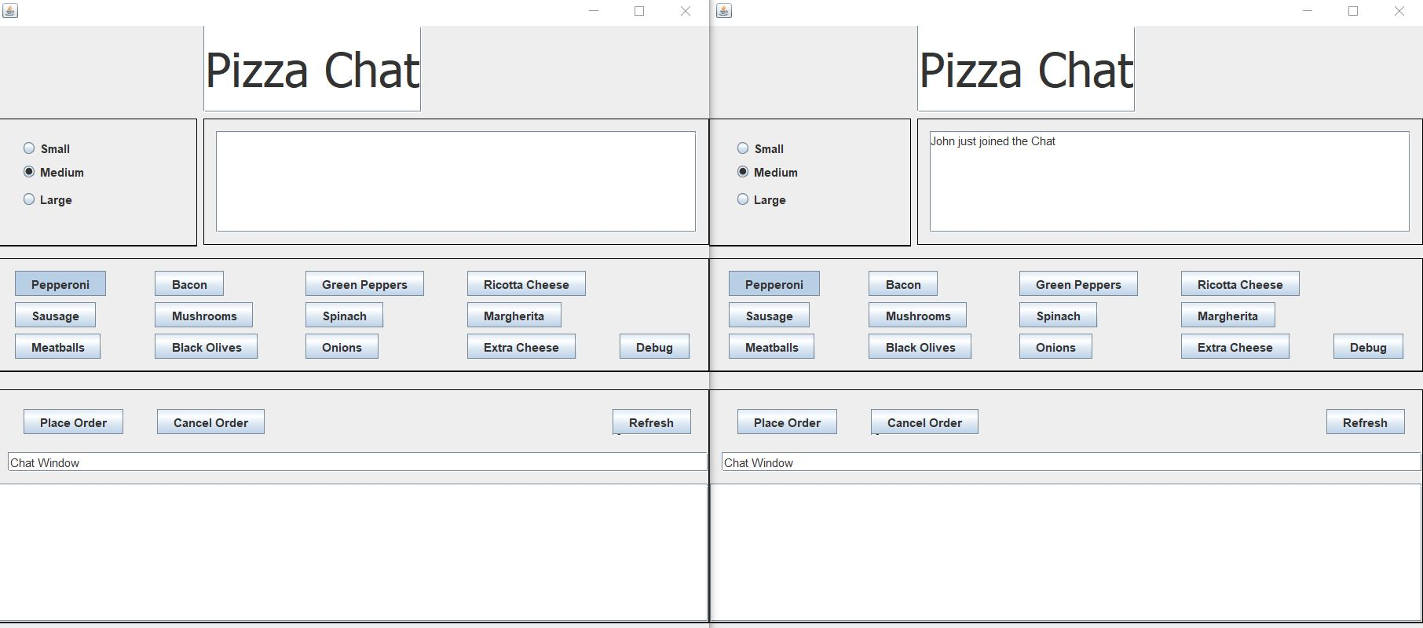

Chat Window ….lets them text back and forth

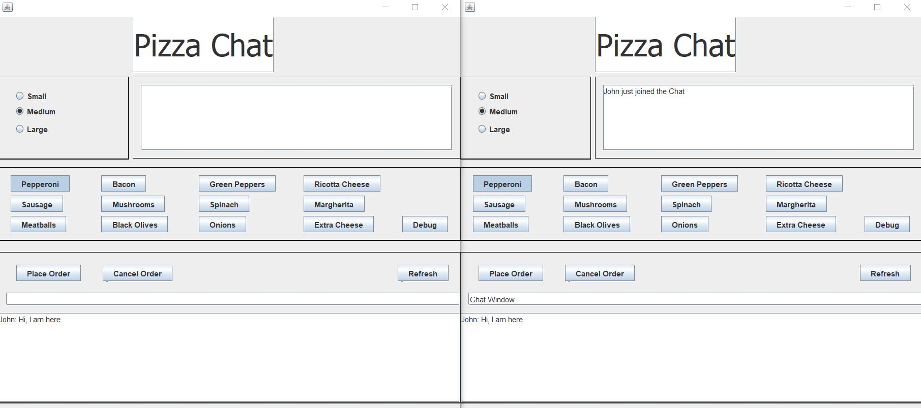

Add a third Client … Mary

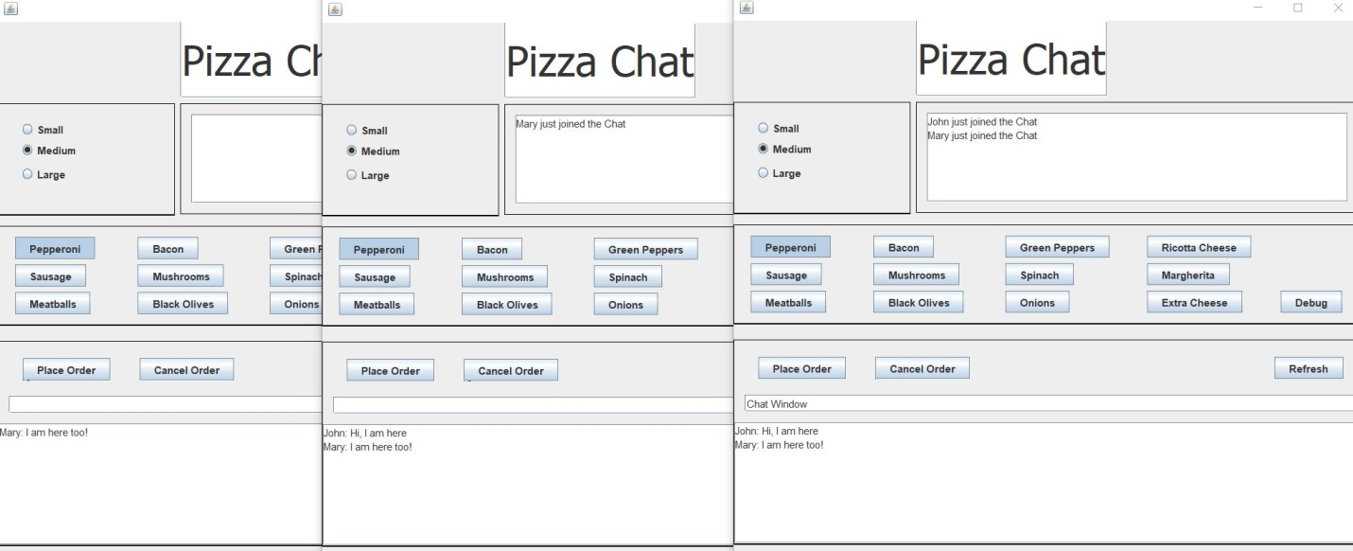

Place the Order…

